Department: Cyber Security |  | Program: BS (CB)
The Campus Canteen Ordering System
Announced date: 5/12/2025 | Due Date: 12/01/2026 | Total Marks = 10

Complex Computing Problem (CCP)
Mapped CLO | SDG | Complex Problem Solving Mapped
CLO3 | 4 | WP1 (Depth of Analysis required) WP2 (Depth of Knowledge required)

Group Member:

Name | Registration ID
Mahendar Dev | 71355

Problem Statement:
The problem statement for The Campus Canteen Ordering System, based on the requirements for the Complex Computing Problem (CCP) is to: Design a backend simulation of a simplified e-commerce order processing system that handles user management, product catalog, order processing, and invoice generation using core data structures.
The system must implement the following operation using specific data structure User Accounts stored in an Array.
Order Queue for pending orders (Queue).
Inventory Management using a Linked List.
Product Recommendations for using a Binary Search Tree (BST).
Order-User Mapping and Invoice Generation using a Graph.

Objective and Scope:

Additionally, the objective of the project is to design and implement a backend simulation for a simplified Campus Canteen Order Processing System. Moreover, the system handles user management, a product catalog, order processing, and invoice generation using core data structures as mandated by the Complex Computing Problem (CCP) requirements. Furthermore, the scope of the project focuses on implementing the following data structure operations:

User Accounts: Stored in an Array.
Order Processing: Uses a Queue for pending orders (FIFO). Moreover,
Inventory Management: Utilizes a Linked List.
Menu Display/Recommendations: Managed by a Binary Search Tree (BST).
Order History/Invoice: Achieve through a Graph structure.

System Description:
Hence, the system is developed in Java using the JavaFX framework for the GUI, simulating user and administrator interaction. Additionally, the core business logic and data structure implementations are encapsulated within the static data-holder “DataStore.java” class.

Feature | Data Structure Used | Operation
User Login/Management | Array (userArray) | Insertion (Add User) and Linear Search
Canteen Menu Display | Binary Search Tree (BST) (menuBST) | In-order Traversal (sorted by itemId)
Placing an Order | Queue (pendingOrderQueue) | Enqueue
Inventory Update | Linked List (inventoryLinkedList) | Linear search and update (setStock)
Order History/Invoice | Graph (userOrderGraph) | Graph Traversal (match users with orders)
Processing Order | Queue (pendingOrderQueue) | Dequeue

UML Class Diagram

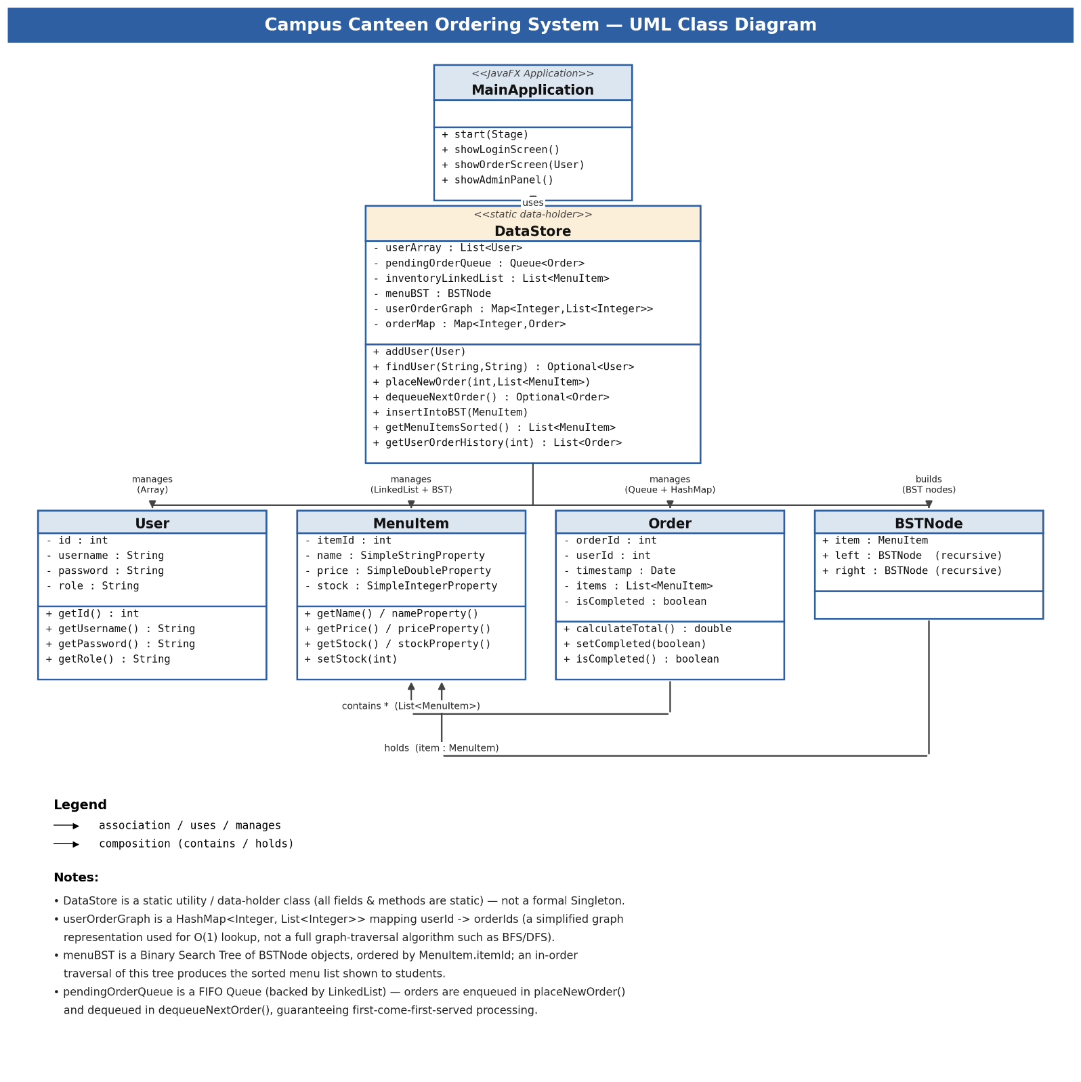

Codebase Description and User Guide
Consequently, the system is implemented in Java with a modular structure using the package canteen.

Core Data Structure Implementation Summary

Data Structure | Implementation Detail | Key Functions
User Accounts | java.util.ArrayList<User> | DataStore.findUser(): Searches the array sequentially to authenticate users.
Inventory | java.util.LinkedList<MenuItem> | DataStore.getInventoryList(): Provides quick access to all items for inventory viewing and updates.
Order Queue | java.util.Queue<Order> (implemented with LinkedList) | DataStore.placeNewOrder(): Uses .offer() for FIFO Enqueue. DataStore.dequeueNextOrder(): Uses .poll() for Dequeue.
Product BST | Custom BSTNode (sorted by itemId) | DataStore.getMenuItemsSorted(): Executes In-Order Traversal to display items in ascending order , fulfilling the product suggestion requirement.
Order Graph | java.util.Map<Integer, List<Integer>> (User ID → List of Order IDs) | DataStore.getUserOrderHistory(): Implements a HashMap-based mapping (simplified graph representation) to match a user with their order history, acting as the invoice map.

User Guide for Simulation
Role | Operations | Interface/Screen
Student | Login, Place Order, View History | showOrderScreen()
Admin | Login, Process Order, View Inventory | showAdminView()

Key Operational Steps:
Consequently, Login: Start the application and log in using the pre-loaded users (e.g., abdulrafay/student1 for student, mahendardev/admin1 for admin). Hence, Order Placement (Student):

The menu is displayed using BST traversal. Additionally, add an item adds it to the cartItems list. Clicking "Place Order (Enqueue)" calls DataStore.placeNewOrder(), enqueuing the order and simultaneously updating the Graph and decrementing stock in the Linked List. Order Processing (Admin):

The Admin Panel displays the Order Queue (FIFO). Clicking "Process Next Order (Dequeue)" calls DataStore.dequeueNextOrder(), simulating the order preparation and completion. Hence, Invoice Generation:

A student clicks "View Order History (Graph Traversal)". The system uses the Graph to retrieve all orders linked to the user’s ID and displays the full invoice history.

Test Cases & Output
The following test case verifies the core mandated operations and data structure interactions.

3.1 Sample Input Scenario

User “abdulrafay” logs in (User ID 2).
“abdulrafay” places an order for "Classic Burger" (Item ID 101) and "Cola Soda" (Item ID 103).
User “farzainali” logs in (User ID 3).
“farzainali” places an order for "French Fries" (Item ID 102).
Admin “mahendardev” logs in and processes one order.
“abdulrafay” views their order history/invoice.

Matching Output
Operation | Expected Output | Data Structure Verification
Initial Login | Welcome, abdulrafay (STUDENT) | Array Lookup (findUser)
Display Menu | Menu items displayed: Burger (5.99), Fries (2.99), Soda (1.50)... | BST In-order Traversal
Place Order (abdulrafay) | Order Placed! Total: Rs: 7.49 | Queue (Order 1001) Enqueued. Graph updated: User 2 → [1001]. Inventory Linked List updated.
Place Order (farzainali) | Order Placed! Total: Rs: 2.99 | Queue (Order 1002) Enqueued. Graph updated: User 3 → [1002].
Admin Processes Order | Order #1001 for User ID 2 has been processed and removed from the queue. | Queue Dequeued (FIFO). Order #1001 marked completed.
Generate Invoice (abdulrafay) | Order #1001 - Total: Rs: 7.49 (COMPLETED) | Graph Traversal retrieves abdulrafay's order.
Suggested Products | Menu Items (BST Sorted) displayed. | BST Traversal.

Virtual Outputs
User Login System
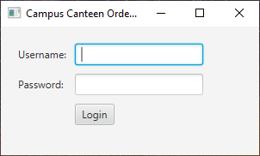

Main Menu Student Panel
BST, Enqueue & Graph Traversal Implementation
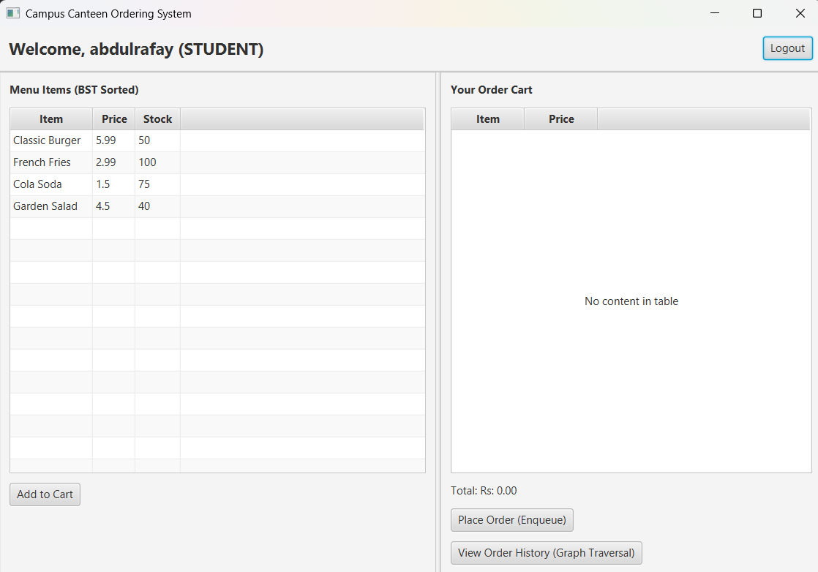
Enqueue Implemented
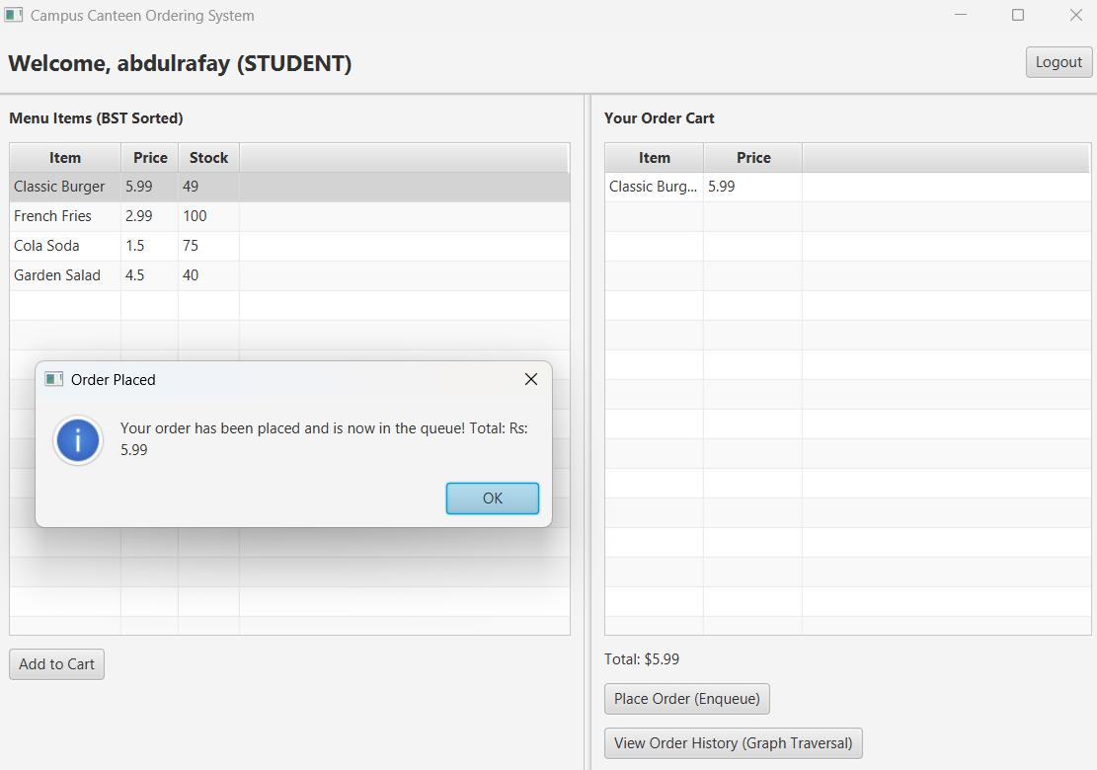
Graph Traversal Implemented
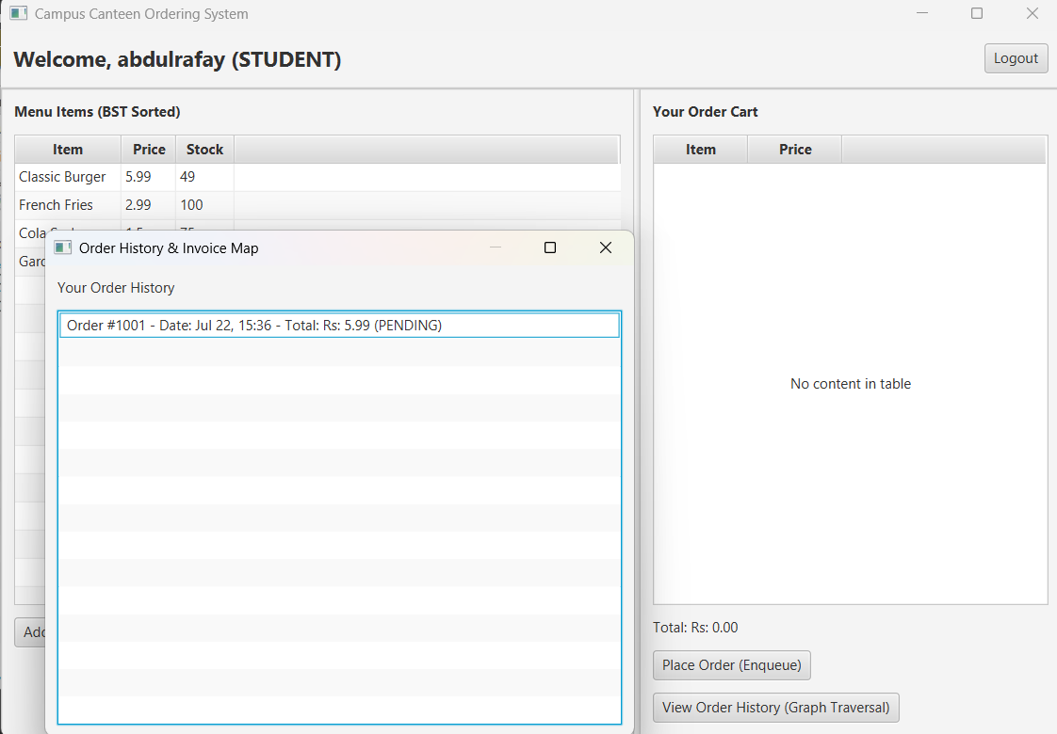

Admin Panel
FIFO, Dequeue and Linked List
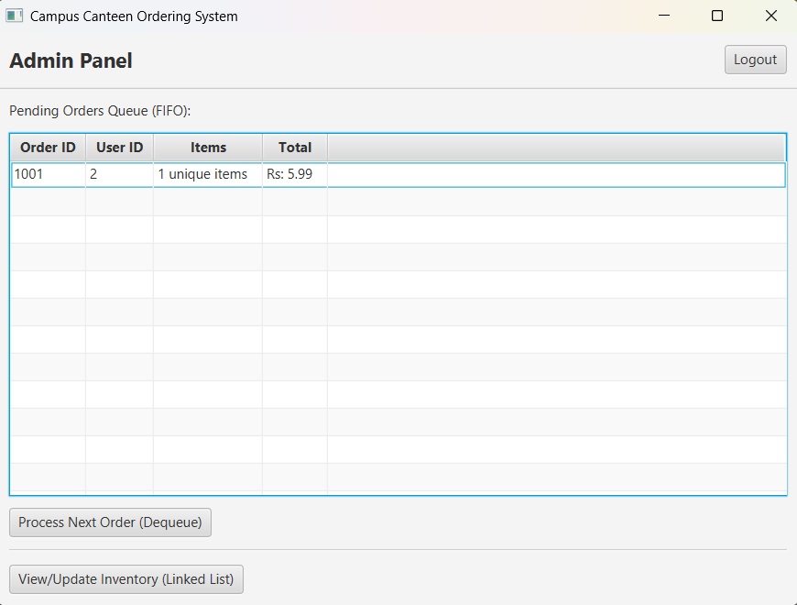
Linked List Implementation
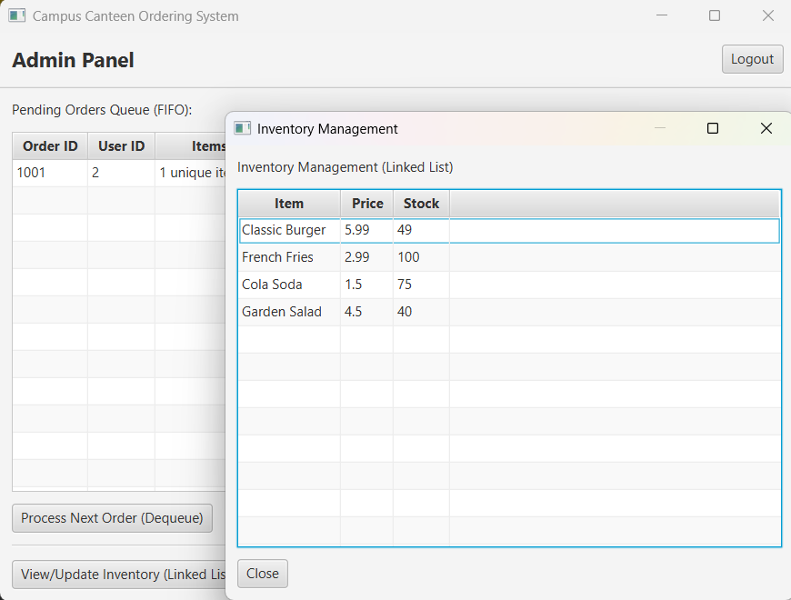

Dequeue Implementation
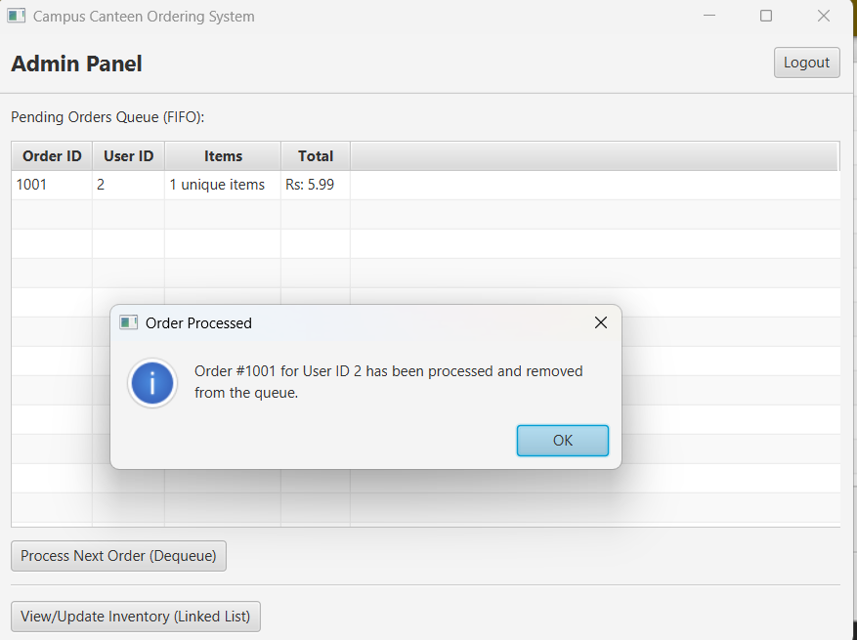
CCP Attributes mapped
Attributes of Complex Problem Solving |  | Justification
WP1 | Depth of Analysis required | Requires analyzing interdependency of data structures like how order queue affects inventory and invoice graph
WP2 | Depth of Knowledge required | Involves use of arrays, queues, linked lists, graphs, and BSTs in one project
WP3 | Range of Conflicting Requirements | NA

