Project Title: Real-Time Bank Loan Fraud Detection System
Submitted To: [Teacher's Name]
Submitted By: [Your Name] #[Roll Number]
Date: 01/08/2026

1. Abstract
The “Real-Time Bank Loan Fraud Detection System” is a project we built to improve how banks and lending institutions process loan applications. Right now, most lenders rely on slow, manual fraud review, which delays genuine applicants and leaves a window open for fraud rings to exploit — reusing the same phone number, device, or identity across several applications before anyone notices.
Our system automates this process end-to-end. Bank agents submit loan applications online on behalf of applicants, the system instantly validates the application against the applicant’s pre-approved credit account, and a rule-based fraud engine calculates a real-time “risk score” for every single application. Loan officers see high-risk applications flagged live on their dashboard — via WebSockets — the moment they are submitted, closing the fraud detection window from hours to milliseconds.

2. Letter of Acknowledgment
To,
[Teacher's Name],
We want to thank you for your guidance and support during the development of this Complex Computing Problem (CCP) project. Your Software Engineering classes gave us the direction we needed to design, build, and document this system. This project wouldn’t have been possible without your feedback along the way. Thank you for pushing us to think practically about real-world fraud scenarios instead of just theoretical ones.
Sincerely,
[Your Name]

3. Problem Statement
A bank or lending institution receives thousands of loan applications from different agents and branches every month. The current process at most institutions is almost entirely manual. Loan officers have to manually check applicant details, account eligibility, and credit limits for every single application.
Because of this, the process has huge delays and administrative burden. It is also very difficult to spot fraudulent applications quickly — by the time a fraud analyst reviews a batch of applications, a fraud ring may have already submitted several duplicate or identity-reused applications across multiple agents. There is no central, real-time system connecting agents, applicants, and the loan officers who make the final decision. This results in financial losses from fraud and frustrated genuine customers who wait days for approval. Our project aims to build a centralized, real-time software system to fix this.

4. Scope of the System

Included:
- A web portal for bank agents to submit loan applications online.
- Automated logic to validate an applicant’s account and pre-approved credit limit.
- A rule-based, fully explainable fraud risk scoring system (7 rules).
- A live dashboard for loan officers to approve/reject applications in real time.
- Separate, role-based dashboards for Agents, Applicants, and Officers.
- Secure PDF document upload and authenticated download.

Excluded:
- Integration with a real core-banking / national credit bureau system.
- Advanced Machine Learning or AI-based scoring models (rule-based scoring only, for transparency).
- Real fund disbursement or payment gateway integration.

5. Features
- Agents can easily submit application details and PDFs. Online Application Submission:
- Instantly checks if the applicant’s account covers the requested loan amount. Automated Validation:
- Flags suspicious applications automatically, with a full explanation of every triggered rule. Fraud Risk Scoring:
- Secure, separate interfaces for Agents, Applicants, and Officers. Role-Based Dashboards:
- Applicants can log in and see their application status update live. Application Tracking:
- Status changes push instantly to every relevant screen via Socket.IO. Real-Time Notifications:

6. Requirements

Functional Requirements
- The system shall allow bank agents to submit loan applications.
- Agents must be able to upload supporting PDF documents.
- The system shall verify the application against the applicant’s account and credit limit.
- The system shall assign a fraud risk score (Low, Medium, High) with named triggered rules.
- Loan Officers can approve, reject, or review any submitted application.
- Applicants get a portal to view their own application status only.

Non-Functional Requirements
- Performance: The system shall calculate risk scores instantly (within milliseconds).
- Security: Role-Based Access Control (RBAC) so agents/applicants can never access officer-only risk data, enforced on both the REST API and the real-time socket layer.
- Availability: The system should remain available for continuous use.
- Usability: The UI should be simple enough that any bank agent or applicant can use it without training.

7. Meta Data and Use Case Diagram
Meta Data:
The system stores:
- Name, Email, Role (Agent / Applicant / Officer / Admin). User Data:
- Account ID, Pre-Approved Credit Limit, KYC Expiry Date. Account Data:
- Application ID, Purpose, Loan Amount, Status. Application Data:
- Officer ID, Approval/Rejection History. Officer Data:
- Risk Score, Risk Level, Triggered Rules. Risk Data:

Use Case Diagram
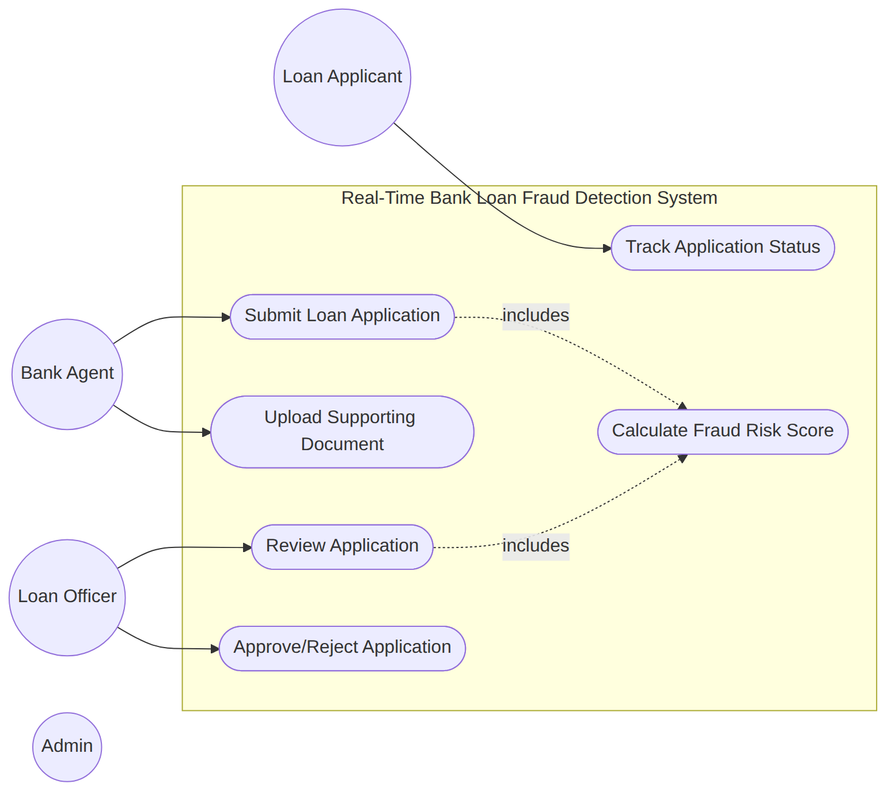
Figure 1: Use Case Diagram

8. Data Flow Diagrams (DFDs)

Context Diagram (Level 0)
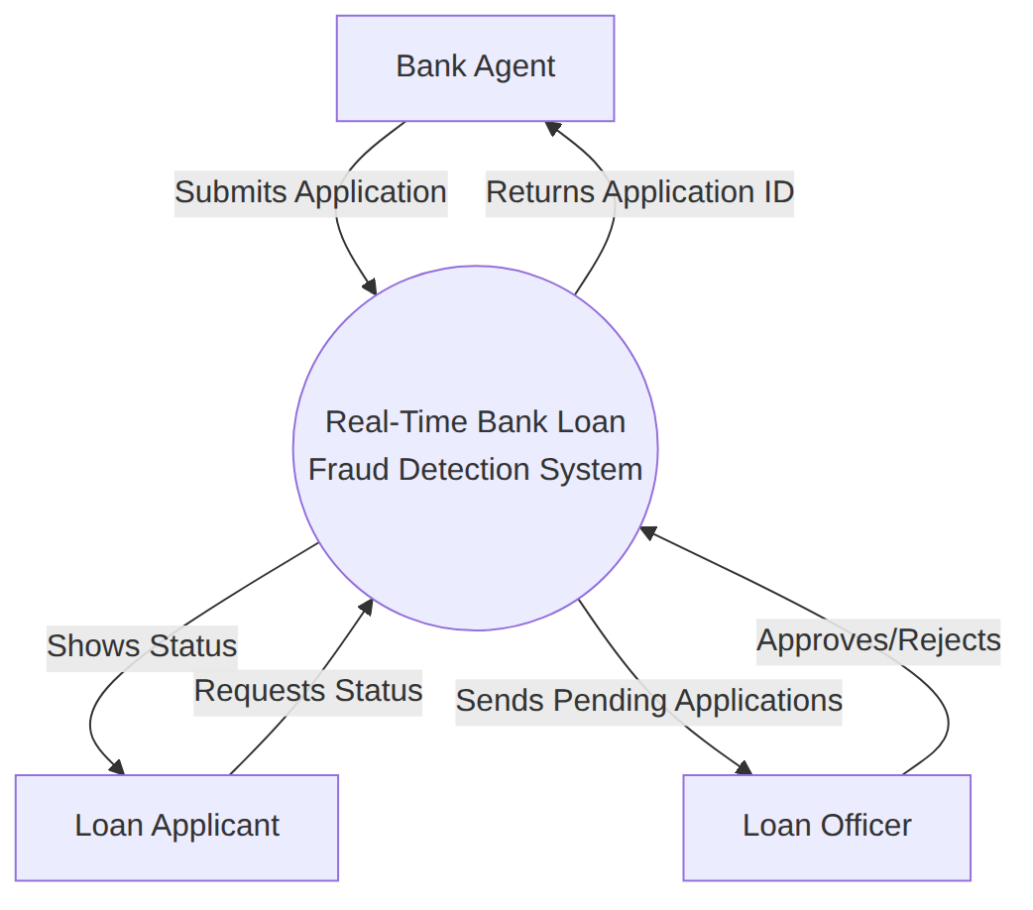
Figure 2: Context-Level DFD

Level 1 DFD
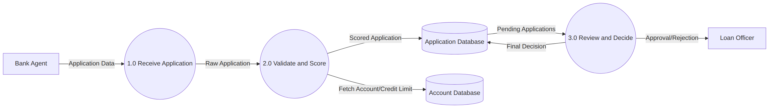
Figure 3: Level 1 DFD

9. Suggested Process Model
Chosen Model: Agile Model
We chose Agile because requirements changed as we built the system — for example, the fraud rules were refined after we mapped out real fraud patterns. Instead of designing everything upfront like Waterfall, Agile let us build the app in small pieces (sprints): first authentication and dashboards, then the real-time layer, then the fraud scoring engine, and finally file upload. Each piece was testable on its own before moving to the next, which made the project far easier to manage as a small team.
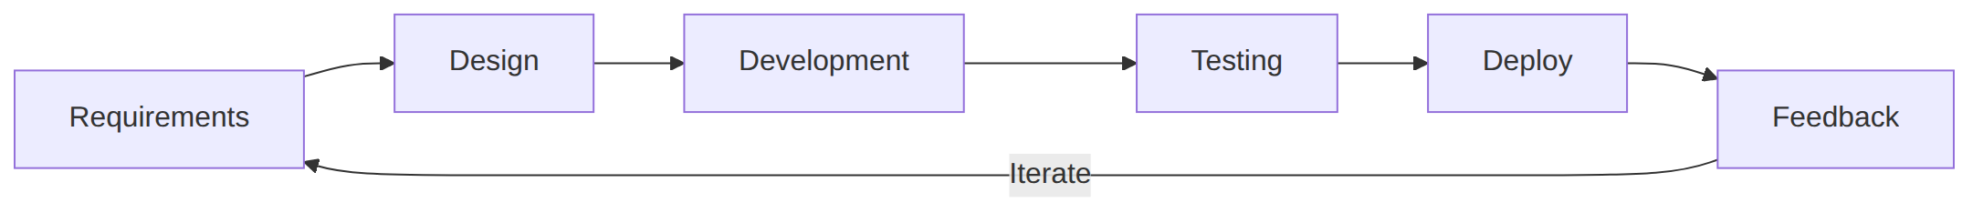
Figure 4: Agile Process Model

10. Prototype Screenshots

1. Login Screen
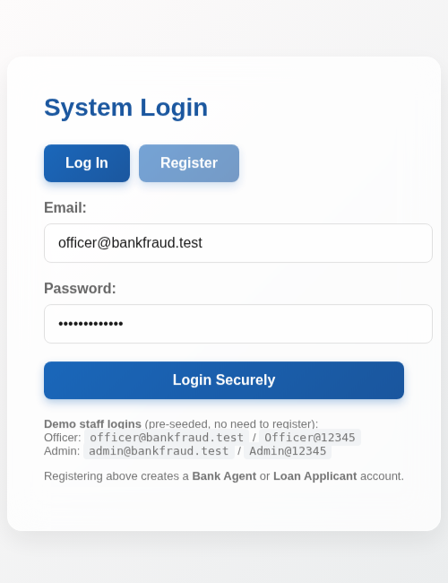
Figure 5: Login / Register Screen

2. Bank Agent Dashboard
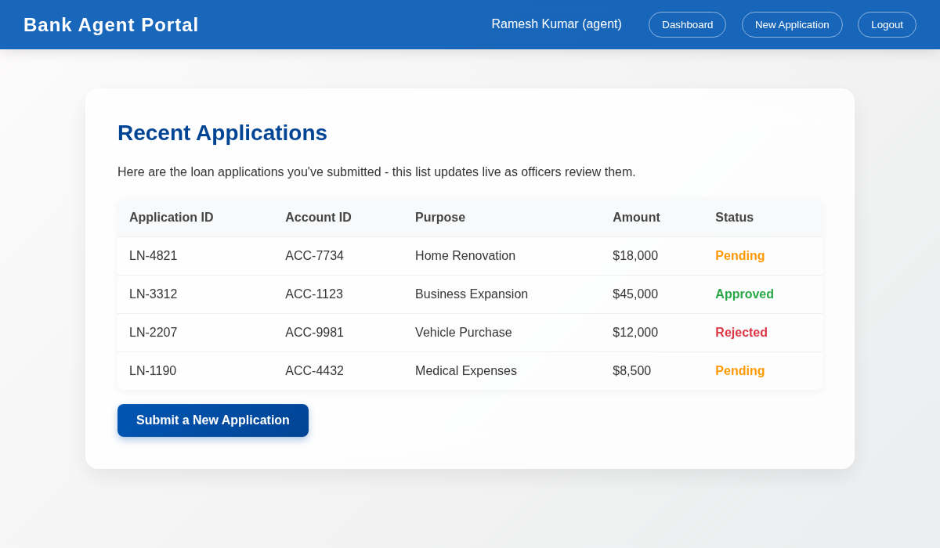
Figure 6: Agent Dashboard — Live Application List

3. Loan Application Submission Form
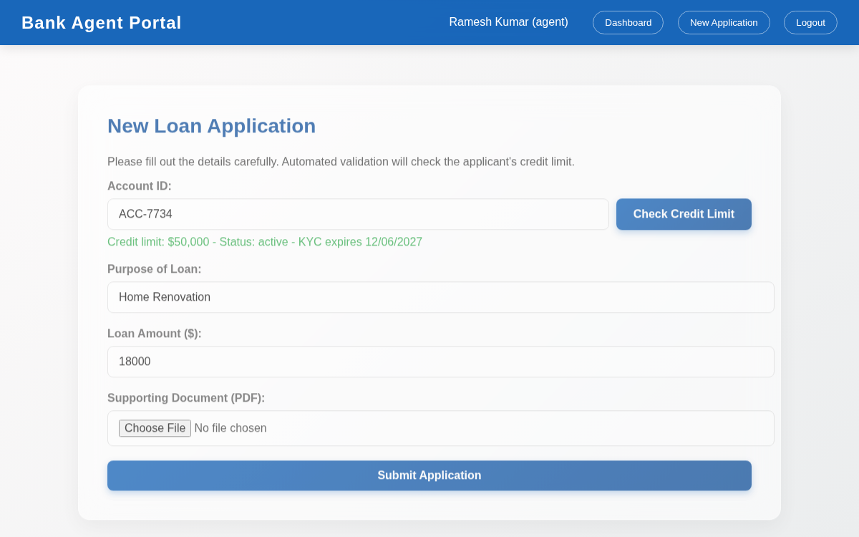
Figure 7: Application Form with Credit Limit Check + PDF Upload

4. Officer Review Screen
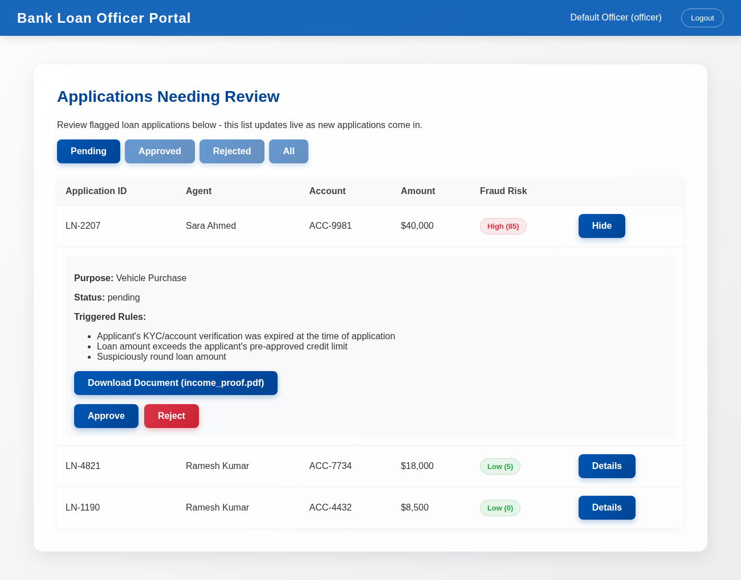
Figure 8: Officer Review — Live Risk Queue with Triggered Rules

5. Applicant Account Tracking Screen
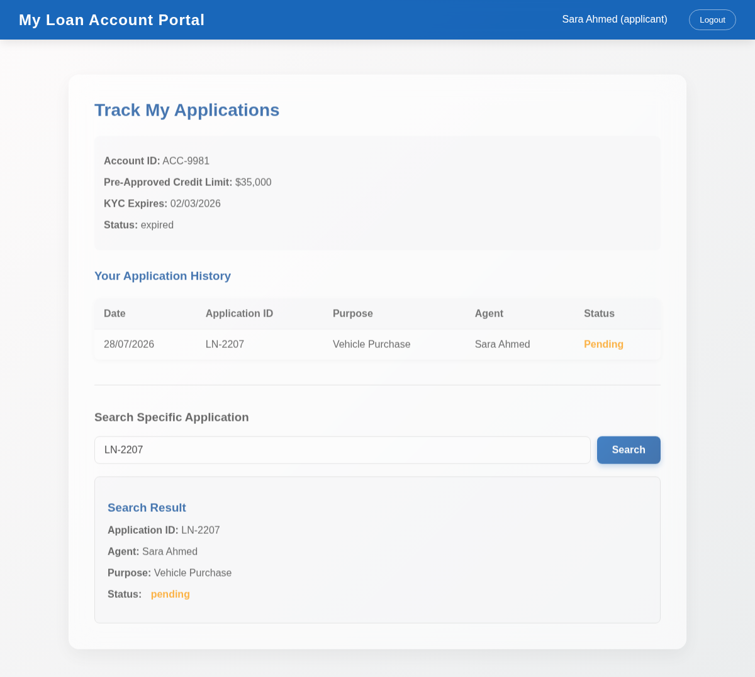
Figure 9: Applicant’s Account + Application History

11. CCP Attributes Mapped
Attribute | Justification
WP1 (Conflicting Requirements) | Agents want fast approvals to keep customers happy, but the bank needs strict fraud checks to avoid losses. We balanced this by automating the checks so genuine low-risk applications move fast, while only high-risk ones are held for manual review.
WP2 (Depth of Analysis) | We had to analyze how real loan fraud rings operate — reusing accounts, submitting duplicate applications, or exploiting expired KYC — and translate these patterns into concrete, testable scoring rules.
WP3 (Depth of Knowledge) | Building this required solid knowledge of React, Node.js/Express, WebSocket-based real-time systems (Socket.IO), Role-Based Access Control design, and basic lending/credit domain concepts.
WP4 (Familiarity of issues) | NA
WP5 (Extent of applicable codes) | NA
WP6 (Extent of stakeholder involvement) | NA
WP7 (Consequences) | Auto-approving a fraudulent application costs the bank real money, while auto-rejecting a genuine applicant harms a real customer. So the system never auto-decides — every application, however high its risk score, is still routed to a human Loan Officer for the final call.
WP8 (Interdependence) | Every layer depends on the others: the fraud engine depends entirely on account and application data, and the real-time layer depends on correct RBAC room assignment at login. A break in any one layer (auth, scoring, or sockets) stops the whole live-review flow, so these had to be designed together from the start.

12. References
- Sommerville, I. (2015). Software Engineering (10th ed.). Pearson.
- Express.js Documentation — https://expressjs.com/
- Socket.IO Documentation — https://socket.io/docs/
- React Documentation — https://react.dev/
- [Teacher's Name]'s Software Engineering Lecture Slides.

