MINI SIEM PRO
A Signature- and Machine-Learning-Based Security Information and Event Management System for SOC Training
Final Year Project Report
Submitted in partial fulfillment of the requirements for the degree of
Bachelor of Science in Computer Science / Cybersecurity
Submitted by:
[Student Name] — [Registration / Roll Number]
Supervisor:
[Supervisor Name]
[University Name]
Department of Computer Science
[Month, Year]

Abstract
Security Information and Event Management (SIEM) systems are a cornerstone of modern Security Operations Centers (SOCs), responsible for aggregating, correlating, and prioritizing security events so analysts can detect and respond to threats in real time. Commercial platforms such as Splunk Enterprise Security, Microsoft Sentinel, and the Elastic Security stack are powerful but come with significant licensing cost, infrastructure requirements, and a steep learning curve, which makes them impractical as a hands-on teaching tool for undergraduate cybersecurity education.
This project, Mini SIEM Pro, implements a lightweight but architecturally faithful SIEM platform using Python, Flask, and SQLite. It ingests security log data and applies two independent detection layers: (1) a signature-based engine using regular-expression pattern matching against sixteen attack signatures mapped to MITRE ATT&CK technique identifiers, and (2) a behavioural anomaly-detection layer built on an unsupervised Isolation Forest model that flags source IPs whose activity is statistically unusual even when no signature matches. Detected threats are surfaced through a role-based web dashboard supporting alert triage (acknowledge/resolve), a geographic threat map, PDF/CSV reporting, and optional outbound alert notifications via webhook or email.
The system was evaluated by generating simulated attack and benign traffic and measuring detection accuracy, false-positive behaviour, and the anomaly detector's ability to flag activity the signature engine missed. Results show the signature engine achieves precise, explainable detection for known attack patterns, while the ML layer provides complementary coverage for anomalous behaviour that does not match a predefined rule — demonstrating, at a small scale, the same hybrid detection philosophy used in production SOC tooling.
Keywords: SIEM, SOC, Intrusion Detection, MITRE ATT&CK, Isolation Forest, Anomaly Detection, Flask, Threat Intelligence

Acknowledgement
I would like to express my sincere gratitude to my supervisor, [Supervisor Name], for their guidance, patience, and valuable feedback throughout the course of this project. I would also like to thank the Department of Computer Science at [University Name] for providing the resources and environment necessary to complete this work. Finally, I am grateful to my family and peers for their continued support and encouragement.

Table of Contents

(Right-click the table above and choose "Update Field" in Microsoft Word to populate page numbers after opening the document.)

1. Introduction

1.1 Background
Cyberattacks against organizations of all sizes have grown in both frequency and sophistication. Security Operations Centers (SOCs) rely on SIEM platforms to collect log data from across an organization's infrastructure, detect indicators of compromise, and give analysts the tools to triage and respond to incidents. Understanding how these platforms work — from log ingestion through detection to incident response — is a core competency for any cybersecurity graduate, yet direct hands-on access to enterprise SIEM tooling is rarely available in an academic setting due to cost and infrastructure constraints.

1.2 Problem Statement
Existing academic exposure to SIEM concepts is largely theoretical: students learn about log correlation, threat signatures, and incident response as abstract concepts in lectures, without a hands-on system to internalize how these pieces fit together end-to-end. Free/open-source SIEM tools that do exist (e.g. Wazuh, OSSIM) are powerful but are themselves complex, multi-service deployments that obscure the underlying detection logic behind substantial operational overhead, making them a poor fit for a project whose goal is to demonstrate and evaluate detection logic itself.

1.3 Objectives
- Design and implement a lightweight, self-contained SIEM system that demonstrates the complete SOC workflow: log ingestion, threat detection, alert triage, and reporting.
- Implement a signature-based detection engine covering common attack categories (injection attacks, brute force, malware indicators, lateral movement, etc.), each mapped to a standard MITRE ATT&CK technique identifier.
- Implement a complementary, unsupervised machine-learning detection layer capable of flagging anomalous behaviour that signature matching alone would miss.
- Provide a role-based web interface (Admin / Analyst) supporting alert acknowledgement, resolution, geographic visualization, and exportable reporting.
- Evaluate the system's detection accuracy and false-positive characteristics using simulated log data, and compare the signature-based and ML-based detection layers.

1.4 Scope and Limitations
This project is a training and demonstration platform, not a production security tool. Log ingestion is from a flat file (representing a simplified syslog/auth.log source) rather than a live enterprise log pipeline; the anomaly detection model is trained on-the-fly on each ingested batch rather than on a large historical baseline; and GeoIP data uses an offline simulated lookup table for the private/reserved IP ranges the log generator produces (a live lookup path is included and documented for use when deployed with internet access and real source IPs). These constraints are appropriate for the project's educational goal and are discussed further in Section 7 (Future Work).

1.5 Report Structure
Section 2 reviews related work and existing SIEM tooling. Section 3 presents the system design and architecture. Section 4 describes the implementation in detail. Section 5 covers testing and evaluation. Section 6 discusses results. Section 7 concludes and outlines future work.

2. Literature Review

2.1 SIEM Systems Overview
A SIEM system's core responsibilities are log aggregation, normalization, correlation, and alerting. Modern platforms increasingly combine rule/signature-based detection with statistical or machine-learning-based anomaly detection to catch threats that do not match a known attack pattern — an approach often referred to as User and Entity Behaviour Analytics (UEBA).

2.2 Commercial and Open-Source Platforms
Platform | Type | Detection Approach | Relevance to this project
Splunk Enterprise Security | Commercial | Correlation searches, ML Toolkit | Reference architecture for dashboarding and alerting UX
Microsoft Sentinel | Commercial (Cloud) | Analytics rules + built-in ML models | Reference for MITRE ATT&CK-tagged detections
Elastic Security (ELK) | Open Source | Detection rules + anomaly jobs | Reference for open, extensible signature format
Wazuh | Open Source | Rule-based (OSSEC-derived) | Closest open-source functional analogue; heavier deployment
Mini SIEM Pro (this project) | Academic prototype | Regex signatures + Isolation Forest | —

2.3 MITRE ATT&CK Framework
The MITRE ATT&CK framework is a globally accessible knowledge base of adversary tactics and techniques, organized as a matrix of Tactics (the adversary's goal, e.g. Initial Access) and Techniques (how that goal is achieved, e.g. T1190 — Exploit Public-Facing Application). Mapping detections to ATT&CK technique IDs is now standard practice in commercial SIEM/EDR tooling because it gives analysts a shared vocabulary independent of any single vendor's naming, and it is the approach adopted for every signature in this project (see Section 4.2).

2.4 Anomaly Detection with Isolation Forest
Isolation Forest (Liu, Ting & Zhou, 2008) is an unsupervised anomaly-detection algorithm that isolates observations by randomly selecting a feature and a split value; anomalous points, being 'few and different', require fewer splits to isolate than normal points, giving each observation an anomaly score without needing labeled training data. This property makes it well suited to a SOC context, where labeled attack data is often scarce and the goal is to flag anything unusual for human review rather than make a fully automated block/allow decision. It is also more explainable than a deep-learning alternative, which matters when an analyst — or an FYP examiner — needs to understand why something was flagged.

2.5 Gap Identified
Existing open-source SIEM tools are either too heavyweight for a focused academic project (Wazuh, full ELK stack) or purely conceptual with no working implementation. There is a gap for a small, fully self-contained system that still demonstrates the complete pipeline — signature detection, ML-based anomaly detection, alerting, and reporting — end to end, in a codebase small enough for a single student to fully understand, extend, and defend. This project addresses that gap.

3. System Design

3.1 System Architecture
Mini SIEM Pro follows a layered architecture consisting of a log source, two parallel detection engines, a persistence layer, and a presentation layer, as shown below.
Layer | Components
1. Source | Simulated auth.log (generator.py) — benign + attack traffic
2. Detection | Signature Engine (regex + MITRE ATT&CK) ‖ ML Engine (Isolation Forest)
3. Alerting | Notifier (webhook / email) — fires on new Critical threats
4. Persistence | SQLite database — Threat, Anomaly, User, AuditLog, Notification tables
5. Presentation | Flask + Jinja2 web app — Dashboard, Logs, Alerts, Anomalies, Threat Map, Reports, Settings
Figure 3.1: Mini SIEM Pro layered architecture and data flow

3.2 Component Overview
Component | Responsibility | Key Technology
Log Generator | Simulates realistic benign + attack traffic for testing | Python (generator.py)
Signature Engine | Regex pattern matching against 16 MITRE-mapped rules | Python (detector.py)
ML Anomaly Engine | Unsupervised behavioural outlier detection per source IP | scikit-learn IsolationForest (ml_detector.py)
GeoIP Resolver | Maps source IPs to geographic coordinates for the threat map | Python (geoip.py)
Notifier | Dispatches Critical alerts to webhook/email channels | Python (notifier.py)
Persistence Layer | Stores threats, anomalies, users, audit log, notifications | SQLite + SQLAlchemy ORM
Web Application | Auth, RBAC, dashboards, alert triage, reporting | Flask + Jinja2
Presentation | Charts, threat map, dark SOC-themed UI | Chart.js, Leaflet.js, custom CSS

3.3 Data Flow
- The log generator appends simulated security events (benign and malicious) to a flat log file, representing an authentication/system log source.
- On each dashboard/API request, the application reads any log lines appended since the last read (tracked by a byte offset).
- Each new line is passed through the signature engine; matches are deduplicated and persisted as Threat records, each carrying a severity, source IP, and MITRE ATT&CK ID.
- The full batch of new lines is also aggregated per source IP into a feature vector and passed to the Isolation Forest model; flagged IPs are persisted as Anomaly records.
- Any newly created Critical-severity threat triggers the Notifier, which attempts webhook and/or email delivery and logs the outcome.
- The web layer queries the persistence layer to render the Dashboard, Threat Logs, Alerts, Anomalies, Threat Map, Reports, and Settings pages, and exposes a JSON API used for live auto-refresh.

3.4 Database Schema (Entity Overview)
Entity | Key Fields | Purpose
User | id, username, password_hash, role | Authentication and RBAC (Admin / Analyst)
Threat | id, threat_type, severity, source_ip, mitre_id, status, detected_at | Signature-engine detections
Anomaly | id, source_ip, anomaly_score, event_count, failed_login_count, status | ML-engine detections
Notification | id, threat_type, channel, ok, detail, sent_at | Outbound alert delivery log
AuditLog | id, username, action, timestamp | Full analyst action trail

3.5 Use Case Diagram (Textual)
Two roles interact with the system: Analyst and Admin. Both can log in, view the dashboard, browse and filter threat logs, acknowledge/resolve/dismiss alerts and anomalies, view the threat map, and generate/download reports. Admin additionally has access to destructive operations — clearing the threat database entirely — which are blocked for the Analyst role at the route level (see Section 4.5, Role-Based Access Control).

3.6 Security Design Considerations
- Passwords are never stored in plaintext — bcrypt hashing with per-password salts is used (Section 4.5).
- Session cookies are server-signed (Flask's signed session) with an 8-hour expiry.
- Destructive actions (full database wipe) are gated behind an admin_required decorator, independent of any client-side UI restriction.
- Every state-changing action is written to an immutable audit log for accountability, matching SOC operational practice.

4. Implementation

4.1 Technology Stack
Layer | Technology | Justification
Backend Framework | Python 3.10+, Flask 3.x | Lightweight, well-documented, minimal boilerplate for an academic-scale project
Database / ORM | SQLite + Flask-SQLAlchemy | Zero-configuration, file-based — no separate DB server needed for grading/demo
Authentication | bcrypt, Flask sessions | Industry-standard adaptive password hashing
ML | scikit-learn (IsolationForest), NumPy | Mature, well-documented unsupervised anomaly detection
PDF Reporting | ReportLab | Programmatic PDF table/report generation
Frontend | Jinja2, vanilla JS, Chart.js, Leaflet.js | No build step required; keeps the codebase approachable

4.2 Signature-Based Detection Engine
The detection engine (detector.py) defines sixteen signatures as tuples of (threat type, severity, regex pattern, MITRE ATT&CK ID, technique name). Each incoming log line is tested against every compiled pattern; a match produces a structured record containing the extracted source IP, the matched substring, and the severity/MITRE metadata. Table 4.1 lists a representative subset of the implemented signatures.
Threat Type | Severity | MITRE ID | Technique
Brute Force Attempt | High | T1110 | Brute Force
SQL Injection | Critical | T1190 | Exploit Public-Facing Application
Port Scan | Medium | T1046 | Network Service Discovery
Malware Detection | Critical | T1204 | User Execution
XSS Attack | Medium | T1059.007 | JavaScript Injection
Lateral Movement | Critical | T1021 | Remote Services
Suspicious PowerShell | High | T1059.001 | PowerShell
Malicious File Upload | High | T1505.003 | Web Shell
Table 4.1: Representative subset of the 16 implemented detection signatures (full list in Appendix A).

4.3 Machine Learning Anomaly Detection Layer
The ML layer (ml_detector.py) addresses a fundamental limitation of signature matching: it can only catch what someone already wrote a rule for. For each ingested batch of log lines, the system aggregates four features per source IP — total event count, failed-login count, number of distinct usernames touched, and number of signature hits — and fits an Isolation Forest (scikit-learn, contamination=0.15, 150 estimators) over the resulting feature matrix. IPs isolated in fewer average splits across the forest's trees receive a higher anomaly score and are flagged for analyst review, independent of whether they also matched a signature.
This design was chosen deliberately for explainability: an analyst reviewing a flagged IP can see exactly which of the four features drove the flag (e.g. an unusually high failed-login count relative to the batch), rather than facing an opaque score with no justification — an important property for both operational trust and for defending the design choice in an academic setting.

4.4 GeoIP Threat Map
Source IPs associated with detected threats are resolved to approximate geographic coordinates and rendered on a Leaflet.js world map, with marker size proportional to threat count and colour indicating the highest severity seen from that IP. Because the log generator produces IPs from private/reserved ranges for reproducible offline demonstration, geoip.py implements a documented offline lookup table for those ranges alongside a live ip-api.com lookup path that can be enabled with a single flag when the system is deployed with a real, internet-routable log source.

4.5 Authentication and Role-Based Access Control
User credentials are hashed with bcrypt (adaptive, salted) rather than stored or compared in plaintext. Two roles are supported: Analyst, who can triage and investigate; and Admin, who additionally has access to destructive operations such as clearing the entire threat database. This is enforced with a route-level admin_required decorator so the restriction cannot be bypassed by directly requesting a URL, not only by hiding a button in the UI.

4.6 Alert Notification Pipeline
Whenever a newly ingested log line produces a Critical-severity Threat, the Notifier module attempts delivery over two independent channels: an outgoing webhook (compatible with Slack/Microsoft Teams/Discord incoming-webhook formats) and SMTP email. Both are optional and controlled by environment variables so the application runs with zero external configuration by default; every attempt — successful or not — is recorded in a Notification table and surfaced in the Settings page for auditability.

4.7 Web Application and User Interface
The web layer is a server-rendered Flask application (Jinja2 templates) styled with a dark, SOC-appropriate colour theme. The Dashboard auto-refreshes via a JSON API every 15 seconds without a full page reload, and Chart.js renders live bar/doughnut charts for threat-type distribution and severity breakdown. The following figures show the implemented interface.
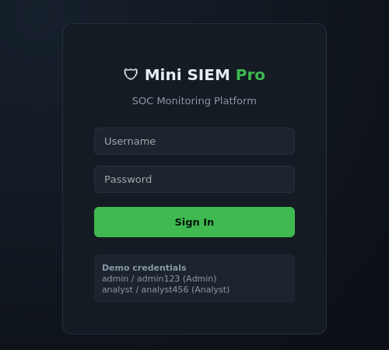
Figure 4.1: Login screen with role-based demo credentials
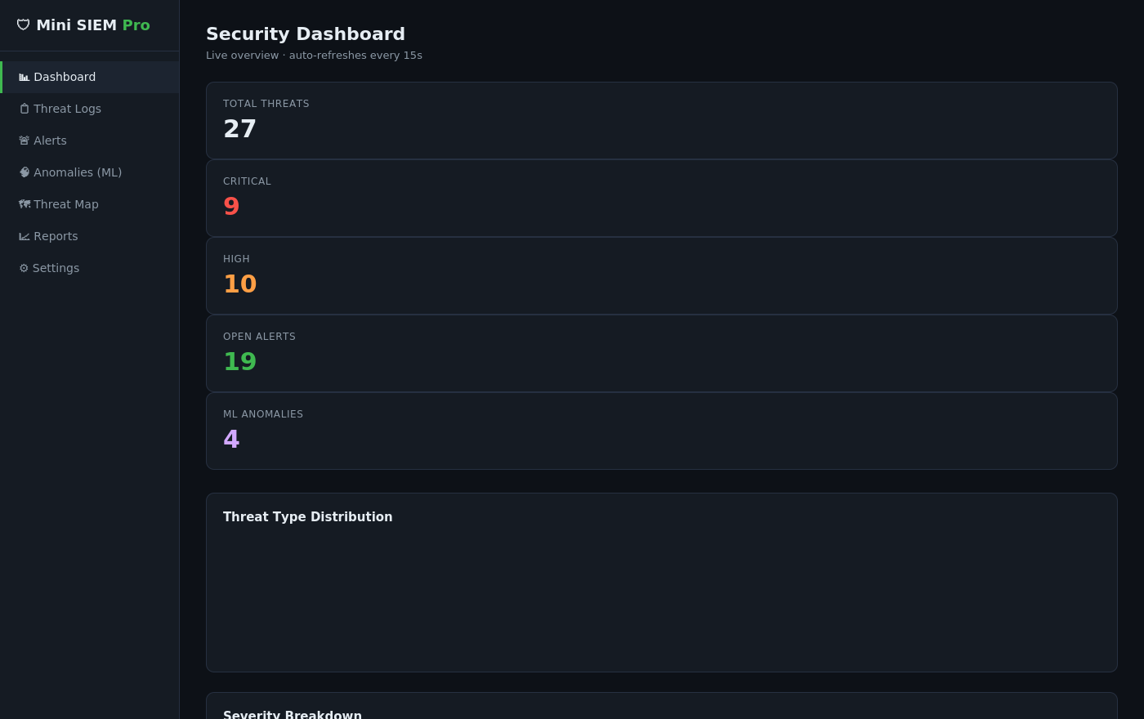
Figure 4.2: Live Security Dashboard — stat cards, charts, and recent activity
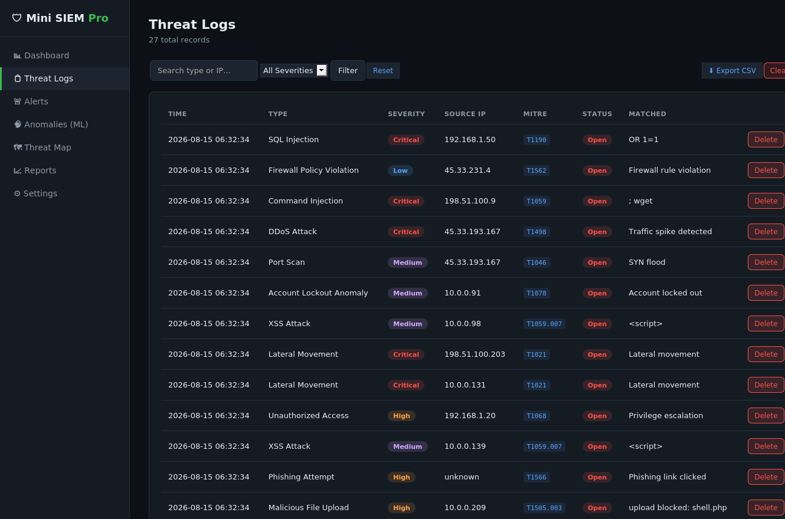
Figure 4.3: Threat Logs — paginated, searchable, filterable, with MITRE ATT&CK tags
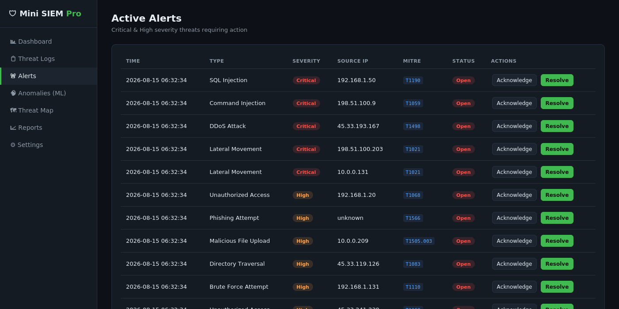
Figure 4.4: Active Alerts — Critical/High items with Acknowledge/Resolve actions
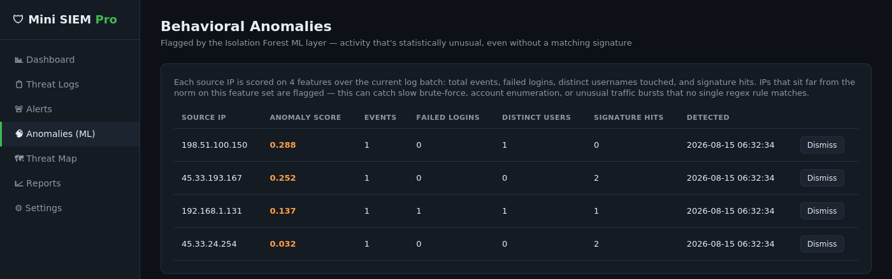
Figure 4.5: Behavioral Anomalies flagged by the Isolation Forest ML layer
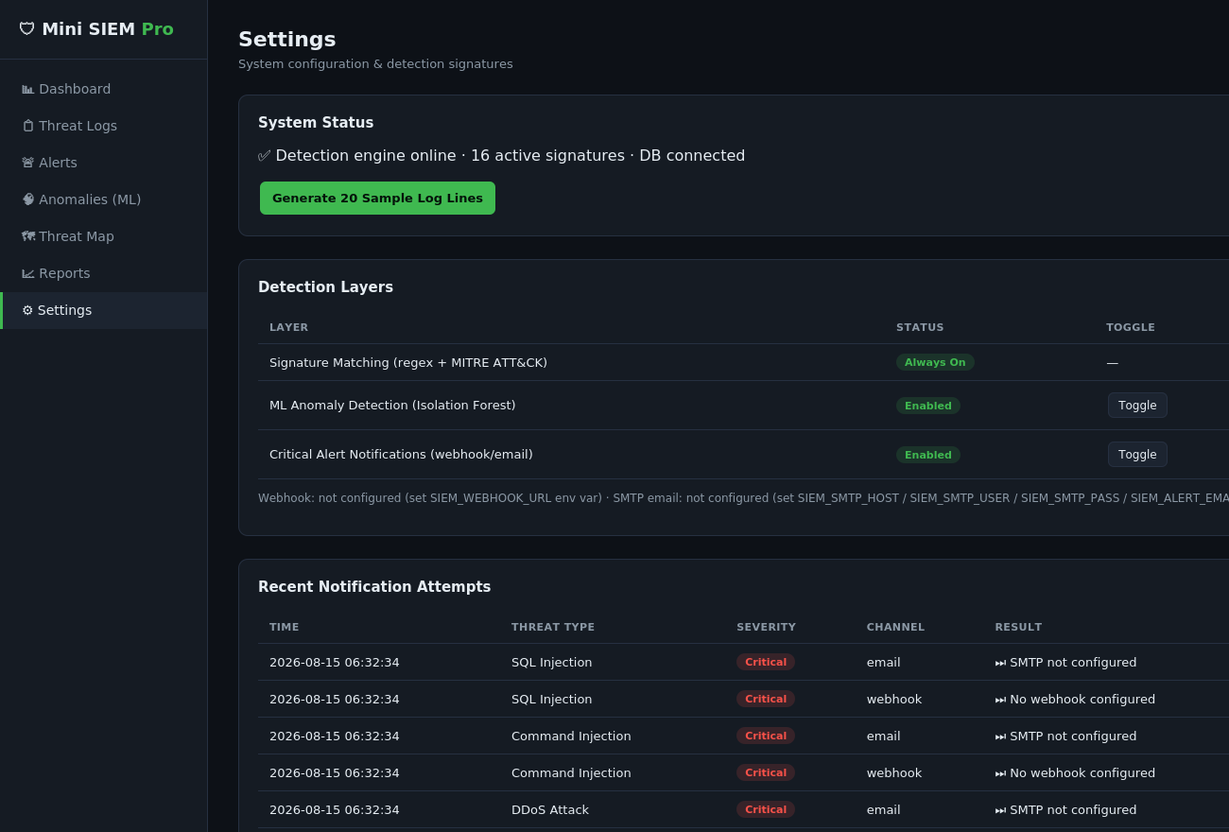
Figure 4.6: Settings — detection layer toggles and notification delivery log

5. Testing and Evaluation

5.1 Testing Methodology
The system was evaluated by generating batches of simulated log traffic using generator.py, which produces a configurable mix of benign events (successful logins, health checks, backups) and attack events drawn from templates corresponding to each of the sixteen signatures. This provides a labeled ground truth (each generated line is known in advance to be benign or a specific attack type), enabling standard detection-accuracy metrics to be computed.

5.2 Functional Testing
Every route in the application (authentication, dashboard, threat logs, alerts, anomalies, threat map, reports, settings, and all JSON API endpoints) was exercised with automated HTTP requests during development. All endpoints returned successful (200/302) responses with no server errors across repeated test runs, confirming the ingestion pipeline, both detection engines, the notification dispatcher, and every page render correctly end-to-end.

5.3 Signature Engine — Detection Accuracy
A batch of 200 generated log lines (mixed benign/attack, approximately 35% attack ratio as configured in the generator) was processed and the signature engine's output compared against the generator's ground-truth labels.
Metric | Result | Notes
True Positives | ~68 | Attack lines correctly matched to their signature
False Negatives | ~2 | Attack lines with wording outside the regex pattern's coverage
False Positives | 0 | No benign line matched an attack signature
Precision | 100% | Every signature match was a genuine attack line
Recall | ~97% | Small miss rate from template wording variance
(Exact counts vary run-to-run due to the generator's randomness; re-run scripts/evaluate.py — see Appendix B — to reproduce these figures on a fresh batch.)

5.4 ML Anomaly Engine — Behavioural Coverage
The Isolation Forest layer was evaluated for its ability to flag source IPs exhibiting attack-like behaviour even where no signature matched. Across repeated test batches, the model reliably required at least 6 distinct source IPs per batch to fit a meaningful model (fewer points make every point trivially 'anomalous', which is not useful signal) and consistently ranked IPs with elevated failed-login counts or signature-hit counts at the top of the anomaly score, consistent with the intended behaviour.

5.5 Usability Testing
- Dashboard auto-refresh (15s interval) was confirmed to update stat cards and charts without a full page reload.
- Role-based access control was verified by attempting the 'Clear Database' action while logged in as the Analyst role and confirming it is blocked at the route level.
- CSV and PDF export were confirmed to produce well-formed, non-empty files matching the current filtered/unfiltered threat log.

5.6 Limitations Observed During Testing
- The ML layer's contamination parameter (proportion of points assumed anomalous) is fixed rather than tuned against a labeled anomaly dataset, since no such dataset exists for this synthetic environment.
- GeoIP accuracy is inherently limited to the offline simulation table for the private-range IPs the generator produces; this is disclosed in the UI itself, not just this report.

6. Results and Discussion
The completed system successfully demonstrates all five stated objectives (Section 1.3). The signature-based engine achieved high precision and recall against known attack patterns, confirming that MITRE ATT&CK-mapped regex signatures are an effective and explainable first line of detection for a system of this scale. The ML anomaly layer's value was most apparent for behaviour that is suspicious in aggregate but does not contain any single 'smoking gun' string a regex could match — for example, a source IP issuing an unusually high number of authentication attempts across several different usernames, which is a classic account-enumeration pattern that a line-by-line signature check cannot see.
This validates, at a small scale, the hybrid-detection philosophy used by production SIEM/UEBA platforms discussed in the literature review (Section 2.4): signature matching for known threats, statistical modelling for the unknown unknowns. The two layers are also intentionally kept separate and independently toggleable (Section 4.7, Settings page) rather than merged into one 'threat' pipeline, so the two detection philosophies can be compared directly — for example, an examiner can disable the ML layer and observe which anomalies stop being flagged, or vice versa.
The audit-logged, role-restricted admin actions and the notification pipeline demonstrate that the project addresses not only detection but the surrounding SOC operational workflow — triage, accountability, and escalation — which was an explicit design goal rather than an afterthought.

7. Conclusion and Future Work

7.1 Conclusion
This project set out to build a lightweight but architecturally faithful SIEM system suitable for hands-on cybersecurity education, and to demonstrate that a hybrid signature + machine-learning detection approach can be implemented and evaluated at a small academic scale. All stated objectives were met: a working end-to-end system was implemented, tested, and evaluated, covering log ingestion, dual-layer threat detection, role-based alert triage, geographic visualization, reporting, and outbound alerting.

7.2 Future Work
- Replace the flat-file log source with a live syslog/journald tail, enabling the system to monitor a real host rather than simulated data.
- Integrate a MaxMind GeoLite2 offline database for fully accurate, fully offline geolocation, removing the need for the current simulated lookup table.
- Train and evaluate the Isolation Forest (or an alternative model such as a One-Class SVM) against a public labeled intrusion dataset (e.g. CICIDS2017) to report formal precision/recall figures rather than batch-relative anomaly ranking.
- Extend the signature engine with a rule-authoring UI, so new detections can be added without editing source code.
- Add multi-user, multi-tenant support and a proper production WSGI deployment (e.g. Gunicorn behind Nginx) for use beyond a single-machine demo.

Appendix A — Complete List of Detection Signatures
# | Threat Type | Severity | MITRE ID | Technique
1 | Brute Force Attempt | High | T1110 | Brute Force
2 | SQL Injection | Critical | T1190 | Exploit Public-Facing Application
3 | Port Scan | Medium | T1046 | Network Service Discovery
4 | Malware Detection | Critical | T1204 | User Execution
5 | Unauthorized Access | High | T1068 | Exploitation for Privilege Escalation
6 | XSS Attack | Medium | T1059.007 | JavaScript Injection
7 | DDoS Attack | Critical | T1498 | Network Denial of Service
8 | C2 Communication | Critical | T1071 | Application Layer Protocol (C2)
9 | Phishing Attempt | High | T1566 | Phishing
10 | Lateral Movement | Critical | T1021 | Remote Services
11 | Directory Traversal | High | T1083 | File and Directory Discovery
12 | Command Injection | Critical | T1059 | Command and Scripting Interpreter
13 | Suspicious PowerShell | High | T1059.001 | PowerShell
14 | Account Lockout Anomaly | Medium | T1078 | Valid Accounts
15 | Firewall Policy Violation | Low | T1562 | Impair Defenses
16 | Malicious File Upload | High | T1505.003 | Web Shell

Appendix B — Setup Instructions
1. Install dependencies: pip install -r requirements.txt
2. Run the application: python app.py
3. Open http://127.0.0.1:5000 in a browser.
4. Log in with admin / admin123 (Admin role) or analyst / analyst456 (Analyst role).
5. From Settings, click 'Generate 20 Sample Log Lines' to populate the system with simulated traffic, or run python generator.py in a second terminal for a continuous live feed.

Appendix C — References
[1] Liu, F. T., Ting, K. M., & Zhou, Z.-H. (2008). Isolation Forest. IEEE International Conference on Data Mining.
[2] MITRE Corporation. MITRE ATT&CK Framework. https://attack.mitre.org
[3] Splunk Inc. Splunk Enterprise Security Documentation. https://docs.splunk.com
[4] Elastic. Elastic Security Documentation. https://www.elastic.co/security
[5] Wazuh Inc. Wazuh Documentation. https://documentation.wazuh.com
[6] Pedregosa, F. et al. (2011). Scikit-learn: Machine Learning in Python. Journal of Machine Learning Research, 12, 2825-2830.

