VAULTAP
A Play-to-Earn Blockchain Gaming Platform
Full-Stack Web Application with Real Blockchain Integration
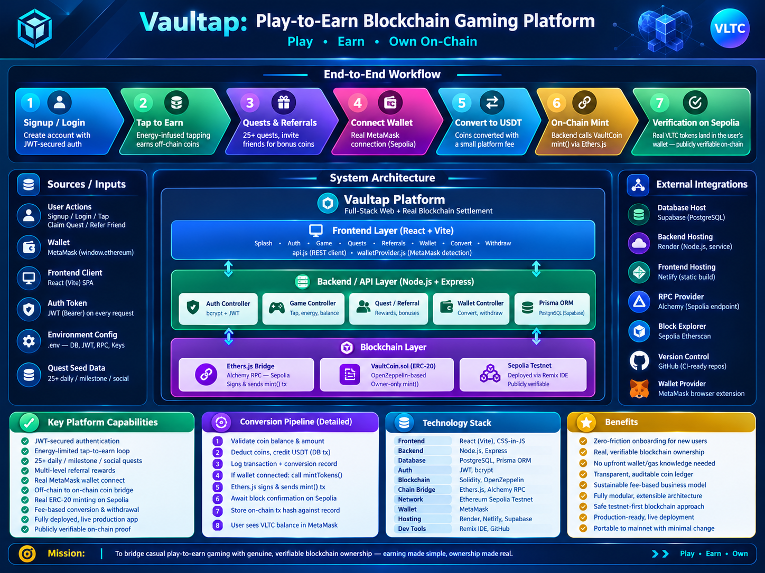

A Project Report Submitted in Partial Fulfillment of the
Requirements for the Complex Computing Problem (CCP)
Live Application: snazzy-brigadeiros-601eaf.netlify.app
Source Code: github.com/Mahendar-Dev/Vaultap
Deployed Smart Contract (Sepolia): 0x46A69108BFF85a0b64708d00184502cEf0D0B2De

Abstract
Vaultap is a full-stack Play-to-Earn (P2E) gaming platform designed to bridge casual, low-friction mobile gameplay with genuine, verifiable blockchain ownership. Users earn in-app coins through a tap-to-earn mechanic, daily/milestone/social quests, and a referral program, all recorded in a relational off-chain database for speed and zero-cost interaction. When a user chooses to convert their earned coins into value, the platform connects to their MetaMask wallet and mints real ERC-20 VaultCoin (VLTC) tokens to their address on the Ethereum Sepolia testnet — a fully verifiable, on-chain transaction. The system was built end-to-end: a React (Vite) frontend, a Node.js/Express REST API backend, a PostgreSQL database managed through Prisma ORM, and a Solidity smart contract integrated via Ethers.js. The complete application is deployed to production (frontend on Netlify, backend on Render, database on Supabase) and is publicly accessible. This report documents the problem motivation, requirements, system design, implementation details across all layers, testing performed, and the deployment process, along with supporting screenshots and on-chain proof of the blockchain integration.

1. Introduction

1.1 Background
Play-to-Earn gaming has emerged as a popular category that blends casual gameplay with the promise of real economic value. However, most existing implementations fall into one of two flawed extremes. Purely off-chain point systems give users coins that can never be proven, transferred, or verified outside the app — they are marketing gimmicks with no real backing. On the other end, fully on-chain-first products force users to acquire a wallet, understand gas fees, and interact with smart contracts before they have even tried the core game — a significant barrier for non-technical users.

1.2 Problem Statement
There is a need for a gaming platform that allows users to begin earning value immediately with zero technical setup, while still offering a genuine, auditable bridge to real blockchain ownership for users who choose to take that step. The challenge is architectural: the system must support fast, free, off-chain interactions for everyday gameplay, but must also be capable of triggering real, secure, verifiable on-chain transactions when a user converts their earnings.

1.3 Objectives
1. Design and implement a secure user authentication system using industry-standard practices (password hashing, JWT-based sessions).
2. Build a tap-to-earn game loop with server-side validation to prevent client-side manipulation of rewards.
3. Implement a quest system (daily, milestone, and social quests) and a multi-level referral program to drive engagement and retention.
4. Integrate real cryptocurrency wallet connectivity (MetaMask) and enable users to convert in-app coins into a real, on-chain ERC-20 token.
5. Design, write, and deploy a Solidity smart contract to a public testnet, and connect it to the backend via a Web3 library.
6. Deploy the complete system to production infrastructure and document the entire development and deployment process.

1.4 Scope
The scope of this project covers the complete application stack: frontend user interface, backend REST API, relational database design, and blockchain smart contract development and integration. For safety and cost reasons, all blockchain operations in this version are performed on the Ethereum Sepolia public testnet rather than mainnet, using test currency with no real monetary value. The withdrawal-to-external-exchange flow is implemented as a simulated transaction (a realistic placeholder), while the coin-to-token conversion flow performs a genuine on-chain mint operation.

2. Technology Overview
This project draws on several established technologies and architectural patterns, summarized below.
Layer | Technology | Purpose
Frontend | React 18 (Vite) | Component-based single-page application UI
Backend | Node.js, Express.js | RESTful API server and business logic
Database | PostgreSQL (Supabase), Prisma ORM | Relational persistence for users, coins, quests, transactions
Authentication | bcrypt, JSON Web Tokens (JWT) | Secure password storage and stateless session management
Blockchain | Solidity, OpenZeppelin, Sepolia Testnet | ERC-20 smart contract for on-chain token representation
Chain Bridge | Ethers.js, Alchemy RPC | Backend-to-blockchain communication and transaction signing
Wallet | MetaMask (window.ethereum / EIP-1193) | User wallet connection and address verification
Hosting | Render, Netlify, Supabase | Production deployment of backend, frontend, and database

3. System Requirements

3.1 Functional Requirements
- Users shall be able to create an account and authenticate using an email and password.
- Users shall be able to earn coins by tapping, limited by a regenerating energy resource.
- The system shall present a list of quests with type-specific rewards and track completion progress per user.
- Users shall be able to generate and share a unique referral code, and receive bonus coins when referred users sign up.
- Users shall be able to connect a MetaMask wallet to their account.
- Users shall be able to convert off-chain coins into USDT-equivalent value, which shall trigger a real on-chain minting transaction to the user's connected wallet.
- Users shall be able to initiate a withdrawal of converted balance to their wallet address.

3.2 Non-Functional Requirements
- Passwords must never be stored in plaintext; bcrypt hashing with salting shall be used.
- All authenticated API endpoints must validate a JWT before granting access.
- Server-side game logic must independently verify energy and progress; the client is not trusted for reward calculations.
- Database writes affecting balances must be atomic (wrapped in transactions) to prevent partial or inconsistent state.
- The blockchain private key used for signing transactions must never be committed to version control.
- The system must remain functional even if a blockchain transaction fails; the off-chain balance update must not be blocked by an on-chain failure.

4. System Architecture and Design
The system follows a three-tier architecture extended with a blockchain settlement layer. The frontend communicates with the backend exclusively through a versioned REST API secured by JWT bearer tokens. The backend is the single source of truth for game logic and coordinates both the PostgreSQL database (for off-chain state) and the Ethereum Sepolia network (for on-chain settlement) through an Ethers.js bridge module.
Figure 1: Vaultap system architecture, workflow, and technology stack overview.

4.1 Frontend Layer
Built with React and Vite, the frontend is organized into discrete screen components: Splash, Auth (login/signup), Game (tap-to-earn), Quests, Referrals, Wallet, Convert, and Withdraw. A single api.js module centralizes all HTTP communication with the backend, and a dedicated walletProvider.js module handles MetaMask-specific detection to avoid ambiguity when multiple browser wallet extensions are installed.

4.2 Backend / API Layer
The backend is implemented with Node.js and Express, organized into controllers by domain: authController (signup/login), gameController (tap mechanics), questController, referralController, and walletController (connect, convert, withdraw). A middleware function verifies JWT tokens on every protected route. Database access is performed exclusively through Prisma ORM, which also manages schema migrations.

4.3 Database Layer
The relational schema (PostgreSQL, hosted on Supabase) includes the following core models: User, CoinBalance, Transaction, Quest, UserQuest, Referral, ReferralEarning, Conversion, and Withdrawal. Coin balance changes are always performed inside a database transaction alongside a corresponding ledger entry in the Transaction table, ensuring every balance change is auditable.

4.4 Blockchain Layer
A Solidity smart contract, VaultCoin.sol, implements the ERC-20 token standard (via OpenZeppelin base contracts) with an owner-restricted mint() function. It was compiled and deployed using the Remix IDE to the Ethereum Sepolia public testnet. The backend holds the deploying wallet's private key (kept out of version control via environment variables) and uses the Ethers.js library, connected through an Alchemy-provided RPC endpoint, to sign and broadcast mint transactions whenever a user with a connected wallet performs a coin-to-USDT conversion.

5. Implementation Details

5.1 Authentication
User passwords are hashed using bcrypt with a salt round of 10 before storage. On successful login, the server issues a JSON Web Token signed with a server-side secret, valid for seven days. This token is sent as a Bearer token in the Authorization header on every subsequent request and validated by an Express middleware before the request reaches any controller logic.

5.2 Tap-to-Earn Mechanics
Each tap request is validated server-side against the user's current energy value stored in the database — the client cannot forge additional coins by manipulating local state. A single Prisma database transaction atomically decrements energy, increments the coin balance, records a ledger entry, and updates progress on any active milestone-type quests.

5.3 Quest and Referral Systems
Twenty-five quests were seeded across three categories: daily (e.g. login streaks), milestone (tap-count targets), and social (e.g. inviting friends, connecting a wallet). The referral system generates a unique alphanumeric code per user at signup; when a new user registers with a valid referral code, both the referrer and the new user receive a coin bonus, and the relationship is recorded for future reference.

5.4 Wallet Integration and On-Chain Minting
When a user initiates a coin-to-USDT conversion, the backend first performs the off-chain database update (deduct coins, credit USDT balance, log the conversion). If — and only if — the user has a connected wallet address on file, the backend then calls a mintTokens() function in its blockchain module. This function constructs an Ethers.js contract instance pointed at the deployed VaultCoin address, calls its mint() method with the user's wallet address and the converted amount, and awaits transaction confirmation on Sepolia. The resulting transaction hash is stored against the conversion record. This on-chain step is wrapped in a try/catch block so that a blockchain failure (e.g. network delay) never blocks or corrupts the off-chain balance update — the two operations are deliberately decoupled for resilience.

5.5 Smart Contract
The VaultCoin contract inherits from OpenZeppelin's ERC20 and Ownable contracts. Its constructor sets the token name ("VaultCoin") and symbol ("VLTC") with an initial supply of zero; tokens only come into existence through the owner-restricted mint() function, ensuring only the backend's deployer wallet can create new tokens.

6. Testing
Testing was performed manually and incrementally, feature by feature, using a combination of direct API calls (via curl), the deployed frontend interface, database inspection (via the Supabase Table Editor), and on-chain verification (via MetaMask and Sepolia Etherscan).
Feature | Test Method | Result
Signup / Login | curl requests + frontend form | Pass — account created, JWT issued and validated
Tap-to-earn | Repeated frontend taps | Pass — balance and energy update correctly, server-validated
Quest claim | Complete milestone, claim reward | Pass — reward credited once, re-claim blocked
Referral bonus | Signup with referral code | Pass — both users credited, verified in database
Wallet connect | MetaMask connection flow | Pass — address stored and displayed
Coin conversion | Convert coins to USDT | Pass — off-chain balances updated correctly
On-chain mint | Convert with wallet connected | Pass — VLTC balance visible in MetaMask, verified on Etherscan

A representative issue encountered during testing was Prisma interactive transaction timeouts under variable network latency to the remote Supabase database; this was resolved by increasing the transaction timeout window and, separately, by switching from a direct database connection string to Supabase's session pooler endpoint for improved connection reliability.

7. On-Chain Verification
To confirm that the blockchain integration performs genuine on-chain operations rather than a simulation, a live conversion was performed and the resulting transaction was independently verified on the public Sepolia block explorer.
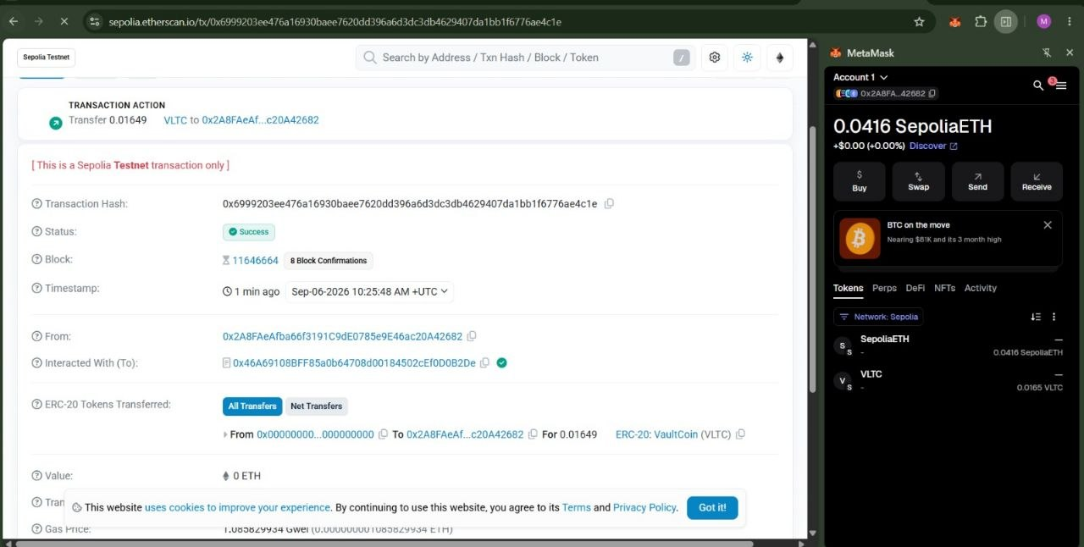
Figure 2: Sepolia Etherscan record confirming a successful VaultCoin (VLTC) mint transaction, showing "Status: Success", the interacting contract address, and the ERC-20 transfer from the zero address (indicating a fresh mint).
Key verifiable facts from this transaction record:
- Status: Success, confirmed in block 11646664 on the Sepolia testnet.
- Interacted contract address matches the deployed VaultCoin.sol address: 0x46A69108BFF85a0b64708d00184502cEf0D0B2De.
- The ERC-20 transfer originates from the zero address (0x000...000), confirming this is a genuine mint operation, not a transfer of existing tokens.
- The resulting VLTC balance is independently visible in the user's own MetaMask wallet interface.

8. Deployment
The completed application was deployed to production infrastructure using free-tier cloud services, with all sensitive configuration values (database credentials, JWT secret, blockchain private key, RPC URL) supplied as environment variables rather than committed to source control.
Component | Platform | Notes
Frontend | Netlify | Static build served via CDN, auto-deployed from GitHub
Backend | Render | Node.js web service, environment variables configured in dashboard
Database | Supabase | Managed PostgreSQL, connected via session pooler for reliability
Smart Contract | Ethereum Sepolia | Deployed via Remix IDE, verified on Etherscan
Source Control | GitHub (public) | Monorepo with Backend, Frontend, and documentation

Version control hygiene was maintained throughout: a .gitignore file excludes node_modules and the .env file containing secrets from every repository, and an .env.example file documents the required configuration keys without exposing real values.

9. Application Walkthrough
The following screenshots, captured from the live deployed application, illustrate the core user journey from first launch through wallet-based token conversion.

9.1 Splash Screen
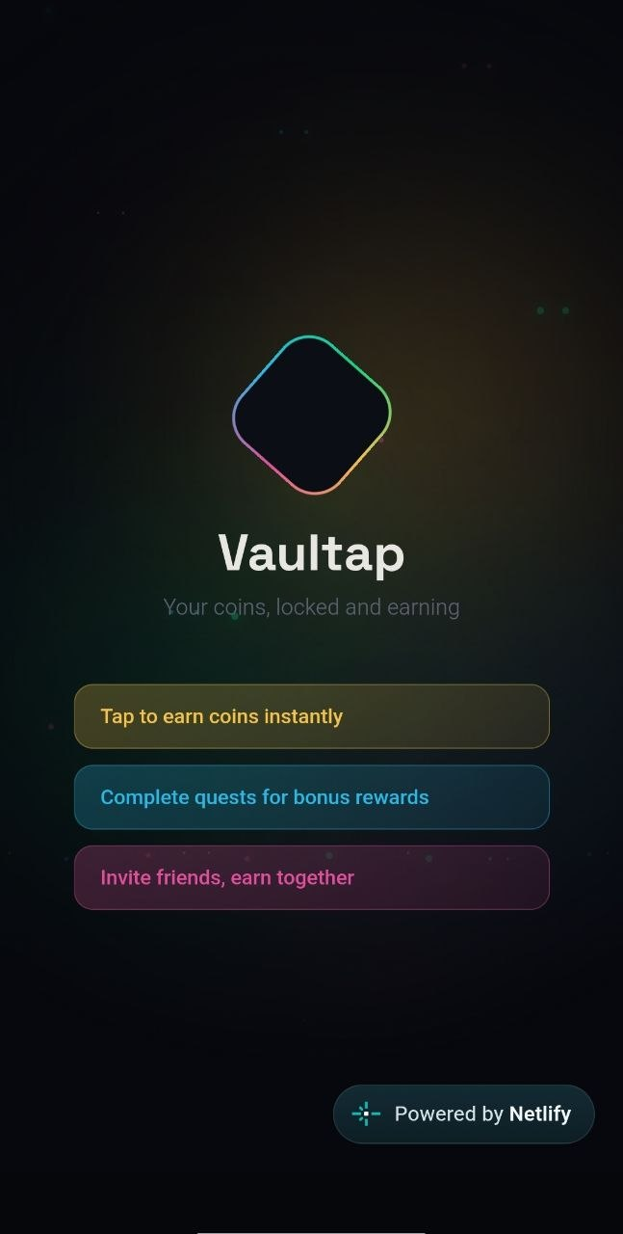
Figure 3: Animated splash screen shown on application launch, introducing core features.

9.2 Authentication
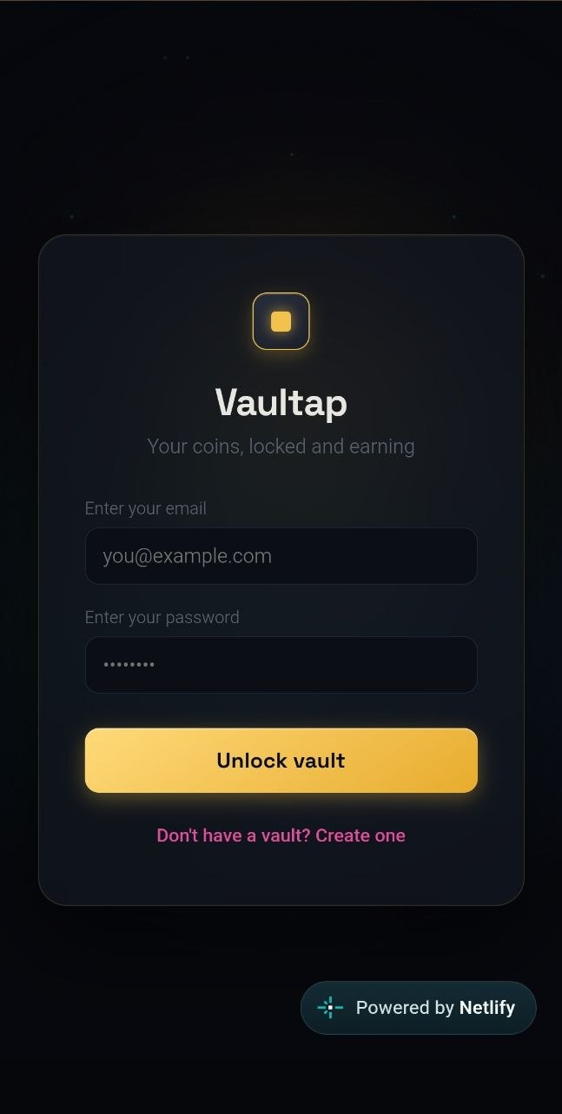
Figure 4: Login screen with email and password fields.

9.3 Tap-to-Earn Game Screen
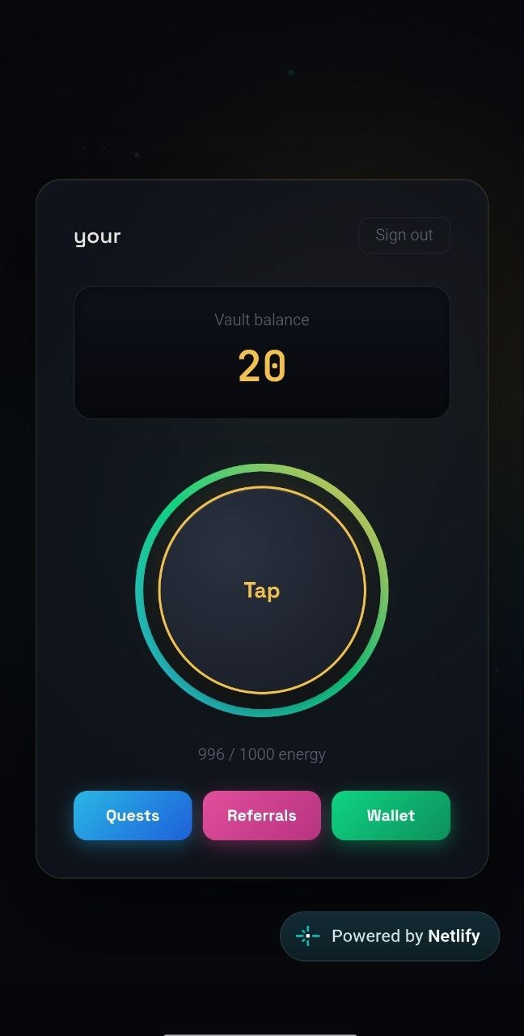
Figure 5: Main game screen showing coin balance, the tap button with an energy ring, and navigation to Quests, Referrals, and Wallet.

9.4 Quests
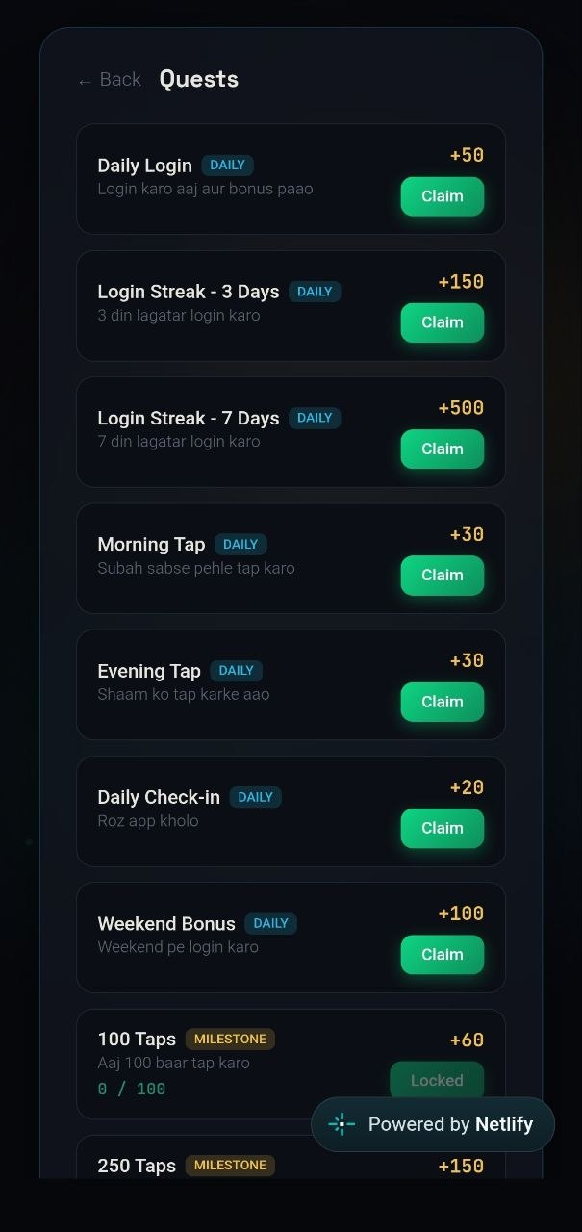
Figure 6: Quest list with daily, milestone, and social categories, each showing progress and reward amount.

9.5 Referrals
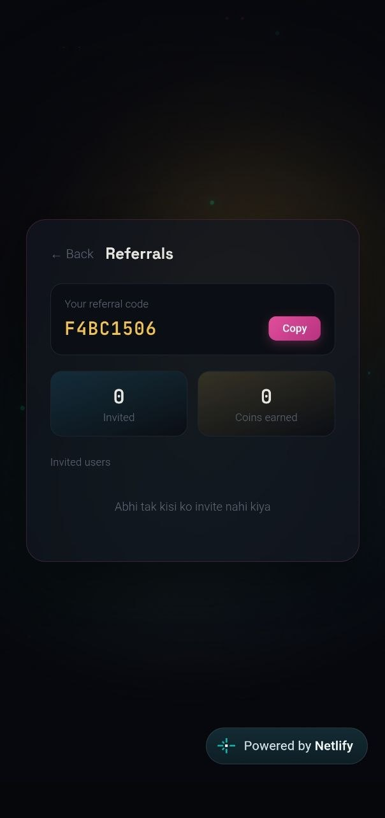
Figure 7: Referral screen displaying the user's unique code, invited-friend count, and coins earned from referrals.

9.6 Wallet and Conversion
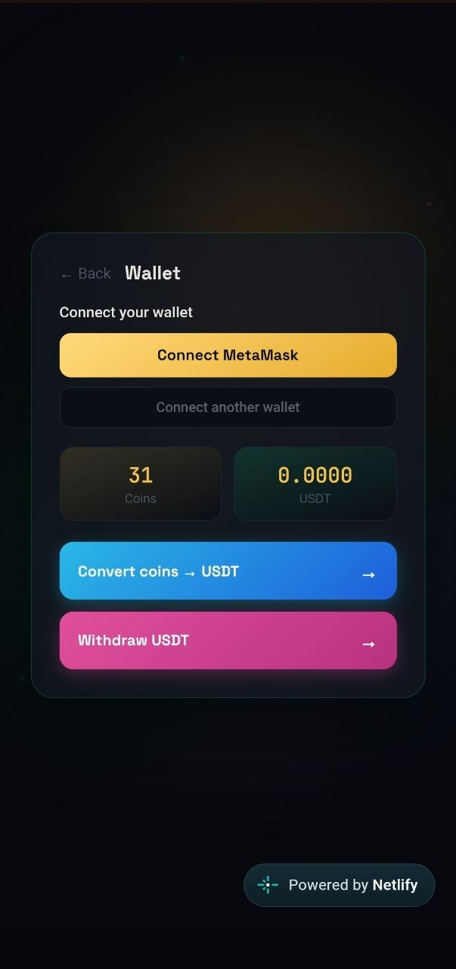
Figure 8: Wallet screen showing MetaMask connection status and navigation to the Convert and Withdraw flows.

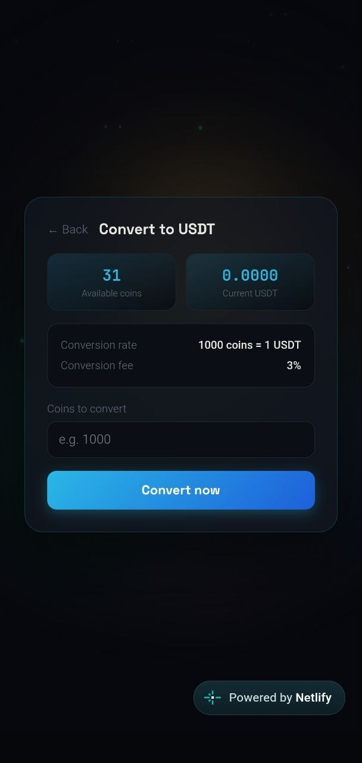
Figure 9: Coin-to-USDT conversion screen, showing conversion rate, applicable fee, and live preview of the resulting amount.

10. Conclusion and Future Work

10.1 Conclusion
This project successfully delivers a complete, production-deployed, full-stack Play-to-Earn gaming platform that satisfies all required components of the assignment: a functional frontend, a REST API backend, a relational database, genuine API integration between the two, and — critically — real, verifiable blockchain code in the form of a deployed and actively-used Solidity smart contract. The system demonstrates a practical design pattern for bridging casual, zero-friction gameplay with authentic blockchain ownership, decoupling off-chain game state from on-chain settlement so that each can fail or succeed independently without compromising the other.

10.2 Limitations
- All blockchain operations currently target the Sepolia testnet; the tokens minted have no real monetary value.
- The withdrawal-to-external-wallet flow is currently simulated (a realistic placeholder transaction) rather than a genuine outbound transfer, due to the cost and risk of funding a production hot wallet.
- The backend currently runs on a free hosting tier that suspends after a period of inactivity, introducing a brief cold-start delay on the first request.

10.3 Future Work
- Migrate the smart contract to an Ethereum Layer-2 network (e.g. Polygon or Base) for low-cost mainnet deployment with real economic value.
- Implement a genuine on-chain withdrawal mechanism using a securely managed, rate-limited hot wallet or a smart-contract-based escrow pattern.
- Add automated unit and integration tests (e.g. Jest, Supertest) to formalize the manual testing performed in this iteration.
- Introduce NFT-based cosmetic items or achievement badges, leveraging the same Ethers.js integration pattern already established.

References
1. OpenZeppelin Contracts Documentation. https://docs.openzeppelin.com/contracts
2. Ethers.js Documentation. https://docs.ethers.org
3. Prisma ORM Documentation. https://www.prisma.io/docs
4. Ethereum Sepolia Testnet. https://sepolia.dev
5. React Documentation. https://react.dev
6. Express.js Documentation. https://expressjs.com
7. Vaultap Live Application: https://snazzy-brigadeiros-601eaf.netlify.app
8. Vaultap Source Repository: https://github.com/Mahendar-Dev/Vaultap
9. Deployed Smart Contract on Sepolia Etherscan: https://sepolia.etherscan.io/address/0x46A69108BFF85a0b64708d00184502cEf0D0B2De

