RBNT holder report, Q3 2026
How RBNT holdings, staking and the publicly named wallets changed between 1 July and 30 September 2026, read from the Redbelly chain.
Quarterly on-chain report, edition 1. Blocks 3,025,809 (30 June 2026, 23:57:19 UTC) and 3,209,414 (30 September 2026, 23:57:35 UTC) on Redbelly mainnet. Data read 17 October 2026.
Web version, with the data: https://redbelly-onchain-holder.vercel.app

Read this first
This report describes what the public Redbelly chain shows. It names only wallets that are already public: Redbelly's reserved wallets from the DAO treasury page, the Wrapped RBNT contract and the two Reddex staking pools. Every other address is counted only inside a group. It is not financial advice and it makes no forecast of price.

The quarter in five points
- Staking grew. RBNT staked in the two Reddex pools rose from 635.8 million to 751.3 million, up 18.2%. Most of the growth was in the no lock pool.
- Less RBNT was wrapped. The Wrapped RBNT (WRBNT) supply fell from 1.82 billion to 1.74 billion, and the RBNT backing it fell by exactly the same amount.
- Reserved wallets moved RBNT between themselves. Ecosystem (Locked) released 500 million to Ecosystem 2 (Unlocked), which sent 253.1 million to the Investors wallet. Governance (Locked) released 33.3 million to Governance (Unlocked). Ecosystem (Unlocked) was the only reserved wallet that sent RBNT to addresses outside the reserved group.
- Holdings stayed concentrated. The largest 100 community holders held 87.3% of community holdings at the end of the quarter, against 87.7% at the start.
- The holder count edged up. Addresses holding 1 RBNT or more (outside the named wallets) went from 46,862 to 47,022.

1. Where the RBNT is
At the end of the quarter, 59.5% of all RBNT sat in Redbelly's reserved wallets, 17.4% backed Wrapped RBNT, 7.5% was staked in the Reddex pools and 15.6% sat in all other wallets and contracts.
RBNT is the coin of the Redbelly network. Every coin sits at an address, and anyone can read the balance of any address from the chain. This chart adds up every balance at the two dates and groups them by the kind of address that holds them.
Figure 1. Where the RBNT sits, by kind of address
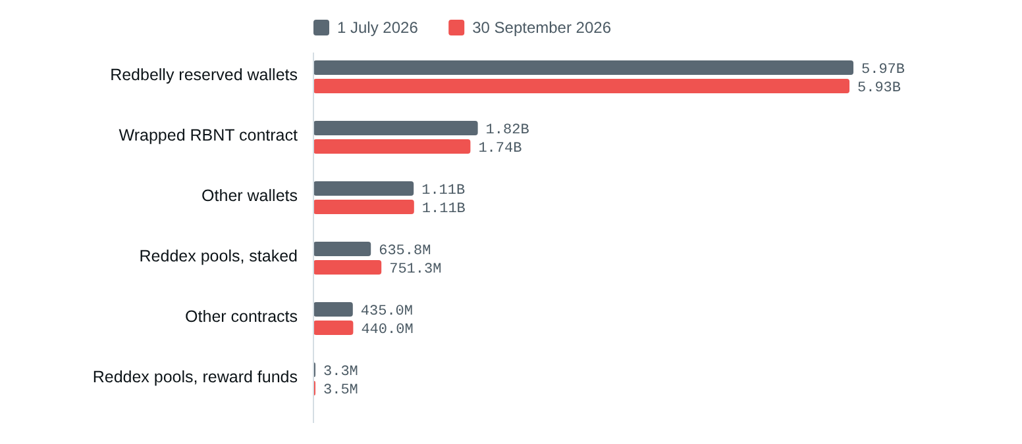
Source: Redbelly mainnet, read at blocks 3,025,809 and 3,209,414. Data: 01_where_the_rbnt_sits.csv
The balances read add up to 9,977,253,041 RBNT at the start and 9,975,816,305 at the end, and the percentages in this report are shares of that total. Routescan quotes a total supply of 10,000,000,000 RBNT; the 22.7 million RBNT (about 0.23%) not found is outside the addresses read (see the method) or no longer in any balance, for example network fees burned since launch.
The Wrapped RBNT contract holds RBNT on behalf of people who hold WRBNT, a token version of RBNT used by apps. Each WRBNT is backed by one RBNT in the contract, so the RBNT is counted once here, where it physically sits. In the rest of the report it is counted with whoever holds the WRBNT.
The Reddex pools hold the RBNT people have staked plus the RBNT the pools use to pay rewards. The chart splits the two using the pools' own record of how much is staked. Other contracts are addresses that run code, such as liquidity pools or multi-signature wallets. Other wallets are ordinary addresses. Routescan publicly labels no exchange wallet on Redbelly, so no exchange group appears; see section 6.
In plain words. Most RBNT has not moved into general circulation. Six in every ten coins are in wallets Redbelly has publicly reserved for the team, investors, the ecosystem, governance, the reserve and research. Of the coins outside those wallets, a growing part is staked.

2. How many holders, and how big
47,022 addresses held 1 RBNT or more at the end of the quarter, up from 46,862. Most hold small amounts: 41,073 hold between 1 and 100 RBNT.
This section looks at every address that is not a named wallet, which we call community holders. For each one we add its RBNT, its WRBNT and any RBNT it has staked in a Reddex pool, so a holder who stakes or wraps is not counted as having sold. Holders are then sorted into size bands.
Figure 2. Community holders by size of holding, number of addresses
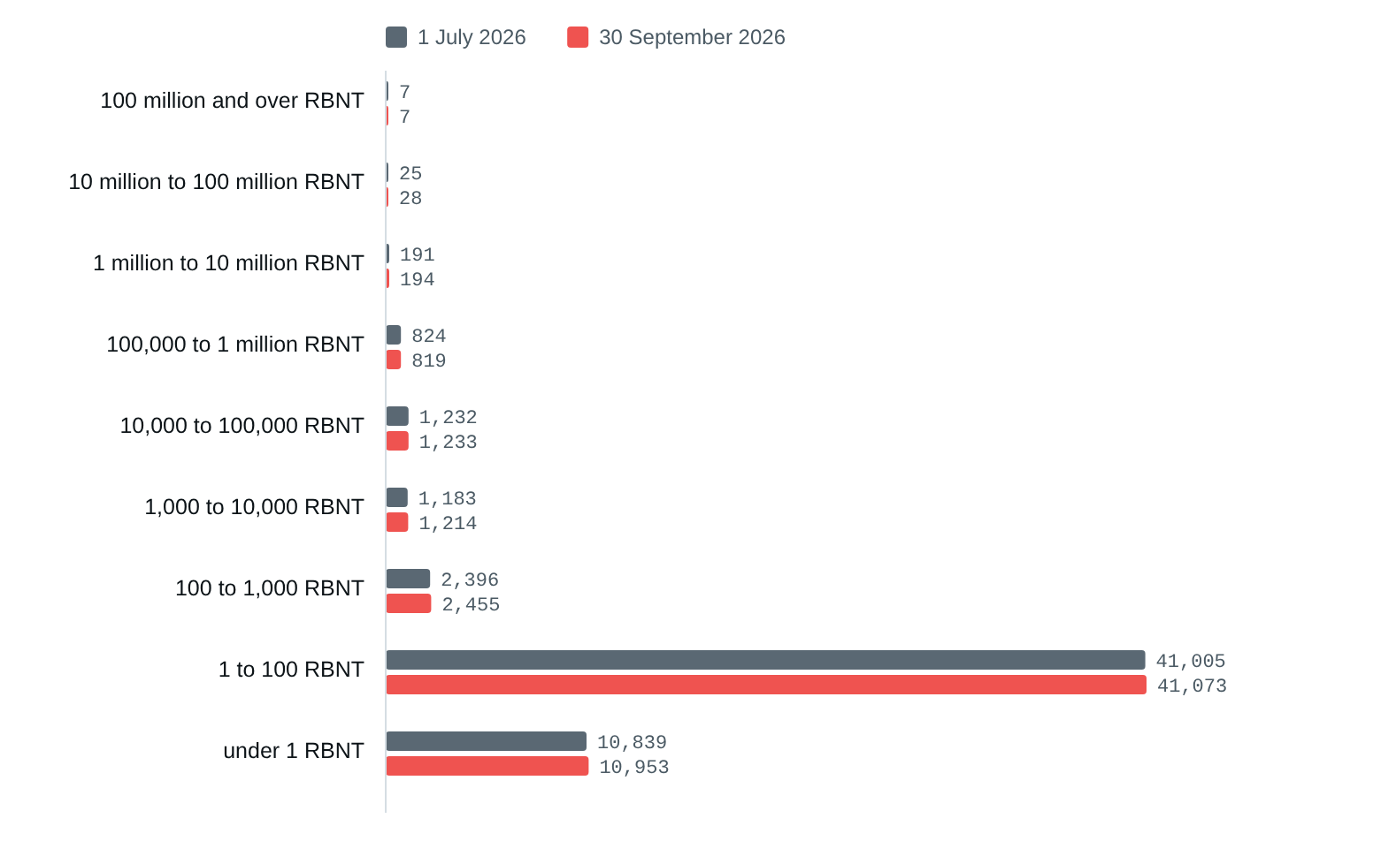
Source: Redbelly mainnet, read at blocks 3,025,809 and 3,209,414. Data: 02_holders_by_size.csv
Between the two dates, 248 addresses reached 1 RBNT or more and 88 fell below it. 46,774 held 1 RBNT or more on both dates. The number of holders rose in 7 of the 9 bands.
One address is not always one person. A person can use many addresses, and one address, such as a contract, can hold RBNT for many people. Counts of addresses are a guide to how widely RBNT is spread, not a count of people.

3. How concentrated holdings are
The largest 10 community holders held 59.4% of community holdings at the end of the quarter, against 61.0% at the start. The largest 1,000 held 98.7%.
Concentration asks how much of the RBNT outside the named wallets sits with the biggest holders. The holders are ranked by size on each date, so the largest 10 at the end are not always the same addresses as the largest 10 at the start.
Figure 3. Share of community holdings held by the largest holders
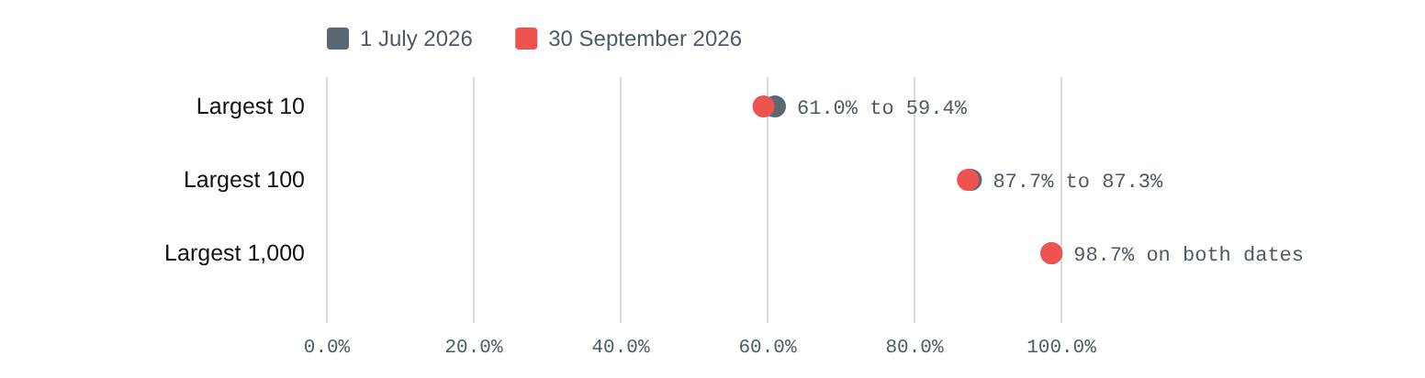
Source: Redbelly mainnet, read at blocks 3,025,809 and 3,209,414. Data: 03_concentration.csv
A second measure, the Gini coefficient, sums up the whole spread in one number between 0 (everyone holds the same) and 1 (one holder has everything). Among community holders with 1 RBNT or more it was 0.9971 at the start and 0.9970 at the end. A value this close to 1 is common for a token that is a few years old with many small holders and a few large ones.
7 addresses were in the largest 100 at the end but not at the start.

4. What the largest holders did
Among the 100 largest community holders at the start, 42 added more than 1% over the quarter and 16 reduced by more than 1%.
To see accumulation and selling without singling anyone out, the community holders are ranked by size at the start of the quarter and put into three groups. For every holder in a group we compare the end of the quarter with the start. A holder who staked or wrapped RBNT keeps the same total, because staked RBNT and WRBNT are counted with the holder.
Figure 4. What the largest holders did over the quarter, number of addresses
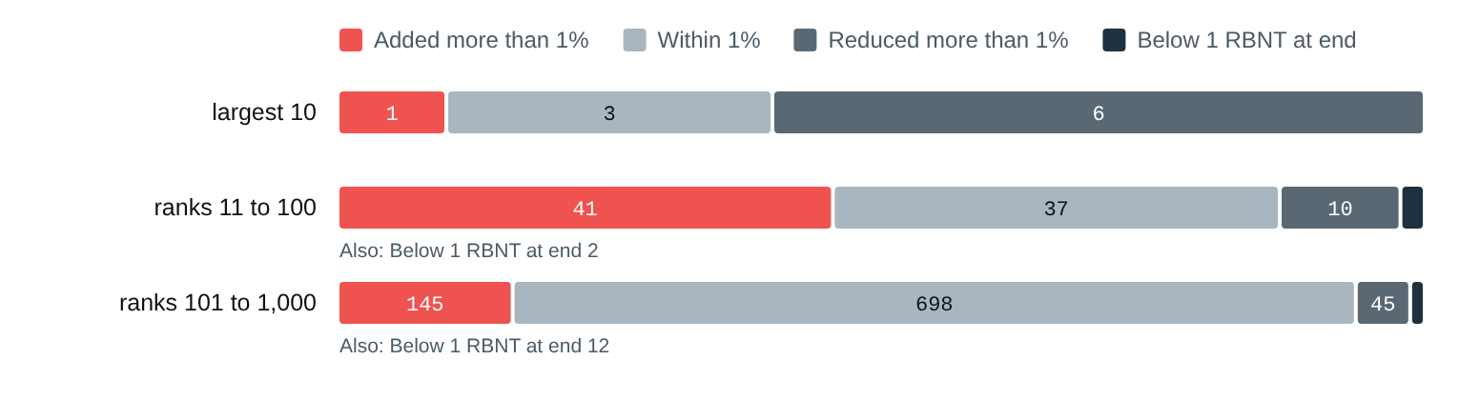
Source: Redbelly mainnet, read at blocks 3,025,809 and 3,209,414. Data: 04_largest_holders.csv
The three groups in numbers
group (ranked by position at start) | holders | added more than 1% | within 1% | reduced more than 1% | under 1 RBNT at end | RBNT at start | RBNT at end | net change | net change (%)
largest 10 | 10 | 1 | 3 | 6 | 0 | 2,439,346,912 | 2,319,269,001 | -120,077,911 | -4.92
ranks 11 to 100 | 90 | 41 | 37 | 10 | 2 | 1,066,516,912 | 1,085,179,221 | 18,662,308 | 1.75
ranks 101 to 1,000 | 900 | 145 | 698 | 45 | 12 | 439,544,185 | 439,159,573 | -384,613 | -0.09
Taken together, the largest 10 went from 2.44 billion to 2.32 billion RBNT, and ranks 11 to 100 went from 1.07 billion to 1.09 billion. A fall in a group's total means RBNT left those addresses; it does not show whether it was sold, moved to another address of the same owner, or put into a contract. The chain records movements, not reasons.

5. Staking in the Reddex pools
Staked RBNT rose by 82.1 million (22.9%) in the no lock pool and by 33.4 million (12.1%) in the 365 day pool.
Staking means locking RBNT in a contract to earn rewards. Reddex runs two RBNT pools: one where RBNT can be taken out at any time, and one where each stake is locked for 365 days. Both pay rewards in RBNT.
Figure 5. RBNT staked in each Reddex pool
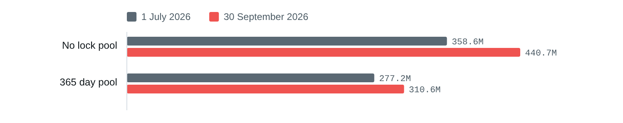
Source: Redbelly mainnet, read at blocks 3,025,809 and 3,209,414. Data: 05_staking_pools.csv
A pool's balance is not the same as the amount staked. Rewards are paid in RBNT from the pool's own balance, so a pool balance may include reward funds as well as stakes. The pools' own counter of staked RBNT (called totalStake) separates the two, and the chart uses it. At the end of the quarter the no lock pool held 443.2 million RBNT, of which 440.7 million was staked; the 365 day pool held 311.5 million, of which 310.6 million was staked.
Figure 6. RBNT staked and unstaked during the quarter
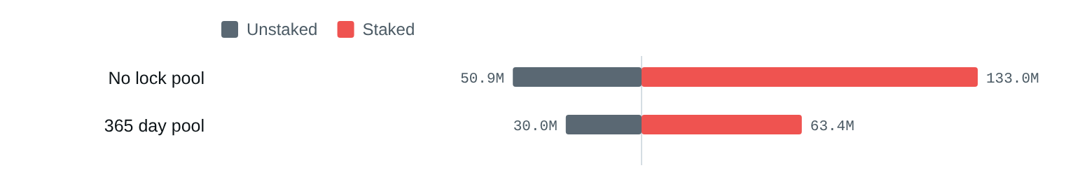
Source: Redbelly mainnet, read at blocks 3,025,809 and 3,209,414. Data: 05_staking_pools.csv
During the quarter, 119 addresses staked into the no lock pool and 63 took stakes out; for the 365 day pool the numbers were 69 and 37. The pools paid out 4.4 million RBNT (no lock) and 10.3 million RBNT (365 day) in claimed rewards. 1,255 addresses had RBNT staked in at least one pool at the end of the quarter.
Staked RBNT was 15.9% of community holdings at the start and 18.6% at the end.
The pools' verified source code names Ecosystem (Unlocked), one of Redbelly's reserved wallets, as their owner. That wallet sent 15 million RBNT to the pools as plain transfers during the quarter, not as stakes (it held no stake in either pool on either date). Those transfers added to the funds the pools pay rewards from.
Both pools in numbers
 | No lock pool | 365 day pool
Lock | none | 365 days
RBNT balance, start | 360,594,599 | 278,467,724
RBNT balance, end | 443,228,206 | 311,548,346
Staked (totalStake), start | 358,606,856 | 277,156,292
Staked (totalStake), end | 440,677,250 | 310,573,758
Change in staked | +82,070,394 (22.9%) | +33,417,466 (12.1%)
Balance minus staked (reward funds), start | 1,987,743 | 1,311,432
Balance minus staked (reward funds), end | 2,550,956 | 974,589
Stakers, start | 1,156 | 223
Stakers, end | 1,140 | 217
RBNT staked in the quarter | 132,965,677 (262 stakes, 119 addresses) | 63,401,240 (227 stakes, 69 addresses)
RBNT unstaked in the quarter | 50,895,283 (102 unstakes, 63 addresses) | 29,983,775 (51 unstakes, 37 addresses)
Rewards claimed in the quarter | 4,436,787 (512 claims, 166 addresses) | 10,336,843 (523 claims, 99 addresses)

6. The publicly named wallets
Redbelly's reserved wallets held 5.97 billion RBNT at the start and 5.93 billion at the end. Most of the movement was between reserved wallets; only Ecosystem (Unlocked) sent RBNT outside the group.
The DAO treasury page lists nine wallets Redbelly has reserved, with the amount each was allocated at launch. Those amounts are allocations, not balances, so this section reads each wallet's balance from the chain on both dates and traces every transfer in between.
Figure 7. Native RBNT in each reserved wallet
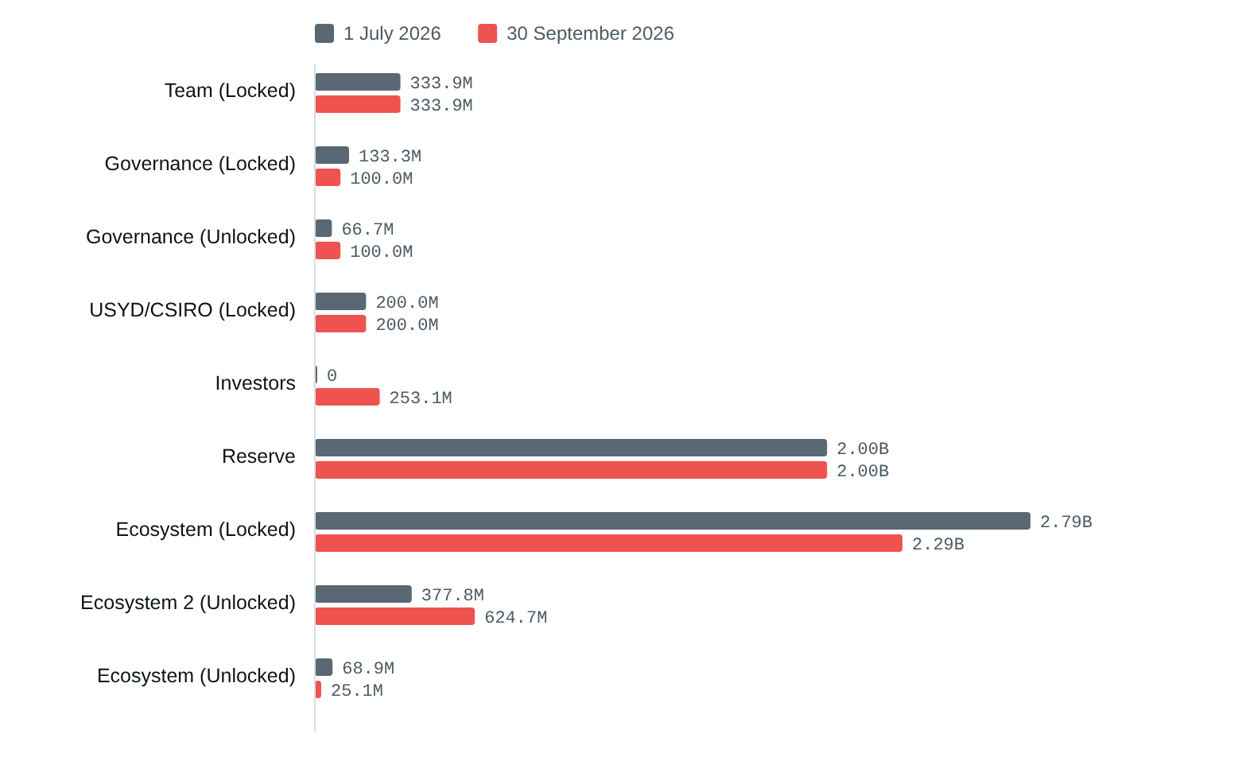
Source: Redbelly mainnet, read at blocks 3,025,809 and 3,209,414. Data: 06_named_wallets.csv
Reserved wallets: allocation, balances and transfers
Wallet | Allocated at launch | Start | End | Change | Transfers in | Transfers out
Team (Locked) | 1,000,000,000 | 333,909,314 | 333,909,314 | 0 | 0 | 0
Governance (Locked) | 200,000,000 | 133,333,334 | 100,000,001 | -33,333,333 | 0 | 1
Governance (Unlocked) | 100,000,000 | 66,666,756 | 100,000,089 | +33,333,333 | 1 | 0
USYD/CSIRO (Locked) | 200,000,000 | 200,000,000 | 200,000,000 | 0 | 0 | 0
Investors | 2,785,987,083 | 0 | 253,115,670 | +253,115,670 | 1 | 0
Reserve | 2,000,000,000 | 2,000,000,000 | 2,000,000,000 | 0 | 0 | 0
Ecosystem (Locked) | 2,794,132,788 | 2,794,132,788 | 2,294,132,788 | -500,000,000 | 0 | 1
Ecosystem 2 (Unlocked) | none listed | 377,838,567 | 624,722,897 | +246,884,330 | 1 | 1
Ecosystem (Unlocked) | 919,880,129 | 68,892,664 | 25,080,271 | -43,812,393 | 0 | 31
The transfers fit together. Ecosystem (Locked) sent 500 million RBNT to Ecosystem 2 (Unlocked), which then sent 253.1 million to the Investors wallet. Governance (Locked) sent 33.3 million to Governance (Unlocked). None of these four transfers left the reserved group.
Figure 8. Where Ecosystem (Unlocked) sent RBNT
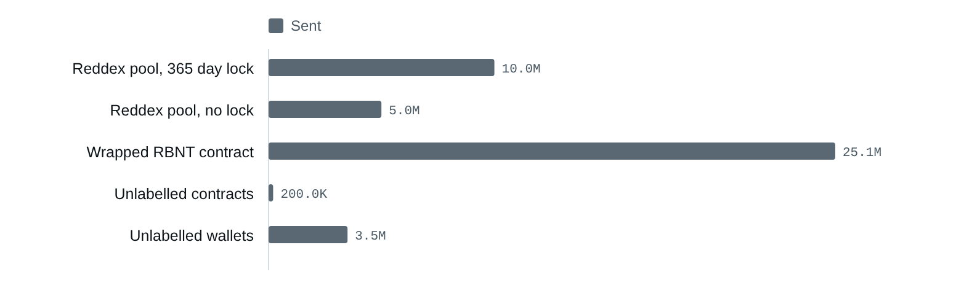
Source: Redbelly mainnet, read at blocks 3,025,809 and 3,209,414. Data: 07_reserved_wallet_transfers.csv
Ecosystem (Unlocked) made 31 transfers out, 43.8 million RBNT in total, and paid 15,724 RBNT in network fees. Of this, 25.1 million went into the Wrapped RBNT contract (wrapping it into WRBNT), 15 million went to the Reddex pools as reward funds, and the rest went to unlabelled wallets and contracts, which this report counts only as a group.

Exchanges
The brief asks for flows in and out of labelled exchange wallets. On 17 October 2026, Routescan's public address list for Redbelly mainnet carried a name for 1 address, the Wrapped RBNT contract, and labelled no exchange wallet. With no public label to go by, this edition reports no exchange flows. Naming an unlabelled address as an exchange would be a guess about who controls it, which this report does not make. The method explains how the next edition picks up labels as soon as Routescan publishes them.

Every named wallet adds up
For each named wallet, the balance at the start plus everything received, minus everything sent and the fees paid, gives the balance at the end exactly. The gap is zero for all twelve named addresses (see the reconciliation column in 06_named_wallets.csv).

7. Method: how to repeat this report
The report compares two moments: the end of 30 June 2026 and the end of 30 September 2026. Each is the last block before midnight UTC: block 3,025,809 (30 June 2026, 23:57:19 UTC) and block 3,209,414 (30 September 2026, 23:57:35 UTC). Every balance, every pool figure and every WRBNT balance is read from the chain at exactly these two blocks.
- Find every address. Take every address that sent or received a transaction or an internal transfer since the start block (read block by block from the RPC, plus Routescan's internal transfers), the named wallets, and Routescan's address list in balance order. Routescan reports about 742,742 addresses; 595,000 were read, down to addresses it lists with 5 RBNT, before its free rate limit stopped further pages on 17 October 2026. Addresses further down the list show 5 RBNT or less, so they can only affect the two smallest size bands, and any of them that moved RBNT during the quarter was read anyway.
- Read balances from the chain. Call eth_getBalance for every address at both blocks on the Redbelly RPC (595,880 addresses). The explorer list is only used to find addresses, never for balances: of the 594,053 listed addresses that did not move during the quarter, the list showed the chain balance exactly for 13,184, rounded for 12,735, and a different balance for 568,134, most of them a balance the chain shows as zero.
- Read WRBNT. Call balanceOf and totalSupply on the WRBNT contract at both blocks for every address that has ever held WRBNT (Routescan's holder list plus every Transfer event since the start block). Check that the WRBNT supply equals the RBNT held by the contract and the sum of all WRBNT balances.
- Read the pools. Call totalStake and lockPeriod on each pool at both blocks, and userInfo for every address that has ever staked (every stake() call to the pool). Check that the stakers' amounts add up to totalStake. Read the Stake, Unstake and ClaimLiquidXReward events in the quarter.
- Build positions. For each address add native RBNT, WRBNT and staked RBNT. Leave out the WRBNT contract and the staked part of each pool, so no RBNT is counted twice.
- Group. Named wallets are reported by name. Every other address is a community holder and appears only in counts and totals of groups (size bands and rank groups). No group of fewer than 5 holders is reported.
- Trace named wallets. List every transaction and internal transfer of each named wallet in the quarter from Routescan's API, leave out failed calls and delegate calls, and check that the start balance plus inflows minus outflows and fees equals the end balance.
Pool balances include reward funds. Rewards in both Reddex pools are paid in RBNT from the pool's own balance. A pool's RBNT balance therefore may include reward funds as well as stakes. This report measures staking with the pools' totalStake figure and the stakers' own amounts, and shows the rest of the balance separately as reward funds.
WRBNT is counted once. Each WRBNT is backed by one RBNT held by the WRBNT contract. Where RBNT physically sits (section 1) counts the contract's RBNT. Everywhere else the contract is left out and the RBNT is counted with whoever holds the WRBNT.
Checks that ran on this data. The WRBNT supply equalled the RBNT in the WRBNT contract and the sum of WRBNT balances on both dates, to the last unit. Each pool's stakers added up to its totalStake on both dates, and the quarter's Stake minus Unstake events equalled the change in totalStake. Every named wallet reconciled to zero. The scripts stop with an error if any of these fail.
What the chain does not show. Who controls an address, why RBNT moved, and whether a transfer was a sale. The report describes movements only. It makes no forecast and gives no advice.
To repeat it: set the quarter in scripts/fetch.py, run python3 scripts/fetch.py, then scripts/analyse.py, scripts/build.py and scripts/check.py. METHOD.md in the repository gives every call in detail.

8. Sources and dates
Every figure is a balance or event on the Redbelly chain at block 3,025,809 (30 June 2026, 23:57:19 UTC) or block 3,209,414 (30 September 2026, 23:57:35 UTC), or an event between them. The data was read on 17 October 2026.
- Redbelly mainnet RPC (chain ID 151). Native balances, WRBNT balances and supply, pool totalStake, lockPeriod and userInfo, block times, every block's transactions, and contract code, all at the two quarter blocks or for the blocks in between. Read 17 October 2026. https://governors.mainnet.redbelly.network
- Routescan explorer API, Etherscan compatible. Transactions and internal transfers of the named wallets and the pools in the quarter; internal transfers of every block since the start block; verified source code of the pools. Read 17 October 2026. https://api.routescan.io/v2/network/mainnet/evm/151/etherscan/api
- Routescan address list. Every address with a balance, used only to find addresses, and the public names Routescan gives addresses. Read 2026-10-17. https://api.routescan.io/v2/network/mainnet/evm/151/addresses
- Routescan WRBNT holder list. Addresses that hold WRBNT, used only to find addresses. Read 17 October 2026. https://api.routescan.io/v2/network/mainnet/evm/151/erc20/0x6ed1f491e2d31536d6561f6bdb2adc8f092a6076/holders
- Redbelly DAO treasury page. Names, addresses and launch allocations of the nine reserved wallets (read from the table in the page's script; its address and SHA-256 are in evidence/manifest.json). Read 17 October 2026. https://redbellydao.network/treasury/
- Reddex staking. The two RBNT pools. Their verified source code is published on Routescan; SHA-256 in evidence/manifest.json. Read 17 October 2026. https://www.reddex.io/stake

9. The data
Every table is published as CSV at https://redbelly-onchain-holder.vercel.app/#data

Words used in this report
- Address: A public account on the chain, written as 0x followed by 40 characters. It can belong to a person, a company or a program.
- Wallet: An address controlled by a private key, usually belonging to a person or an organisation.
- Contract: An address that runs code, such as a staking pool, a token or a multi-signature wallet.
- Block: A batch of transactions. Each block has a number and a time, so a block number fixes a moment.
- Staking: Locking RBNT in a contract to earn rewards.
- WRBNT: Wrapped RBNT, a token backed one to one by RBNT held in the WRBNT contract.
- Reserved wallets: The nine wallets the DAO treasury page lists for team, investors, reserve, ecosystem, governance and USYD/CSIRO.
- Community holders: Every address in this report that is not a named wallet.
- RPC: The public interface to a Redbelly node, used here to read balances at a given block.
- Explorer: A website that shows chain data, here Routescan.

