1. Write a SQL query to retrieve all columns for sales made on '2022-11-05

**🡪 select * from retail_sales where sale_date='2022-11-05'**

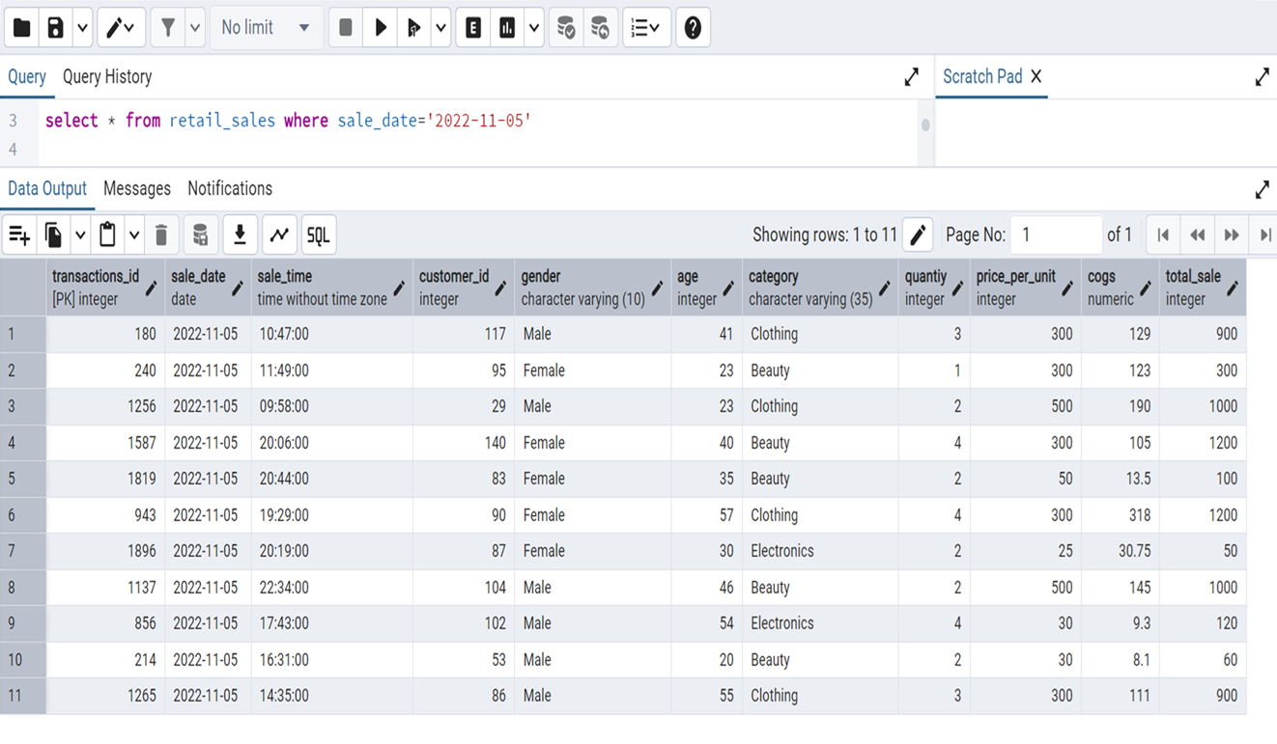

2. Write a SQL query to retrieve all transactions where the category is 'Clothing' and the quantity sold is more than 4 in the month of Nov-2022

**🡪select * from retail_sales where category ='Clothing' and quantiy > 4 and sale_date between '2022-11-01' and '2022-11-30';**

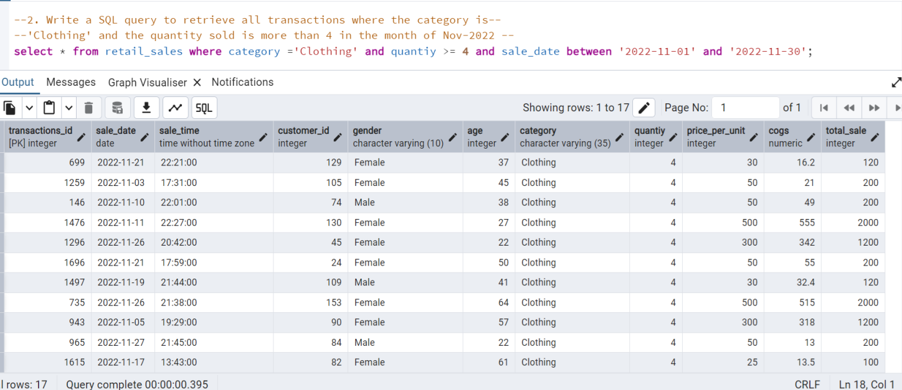

3. Write a SQL query to calculate the total sales (total_sale) for each category.

**🡪 select category, sum(total_sale) as total_sales from retail_sales group by category;**

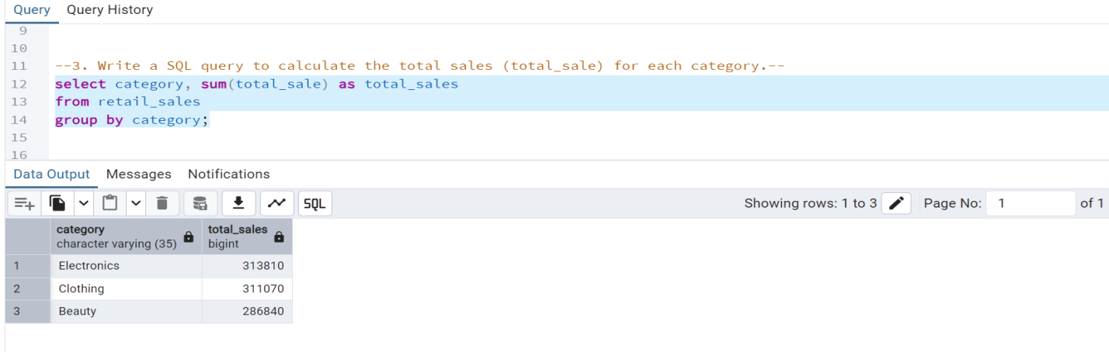

4. Write a SQL query to find the average age of customers who purchased items from the 'Beauty' category.

**🡪select round(avg(age)) as average_age from retail_sales where category='Beauty';**

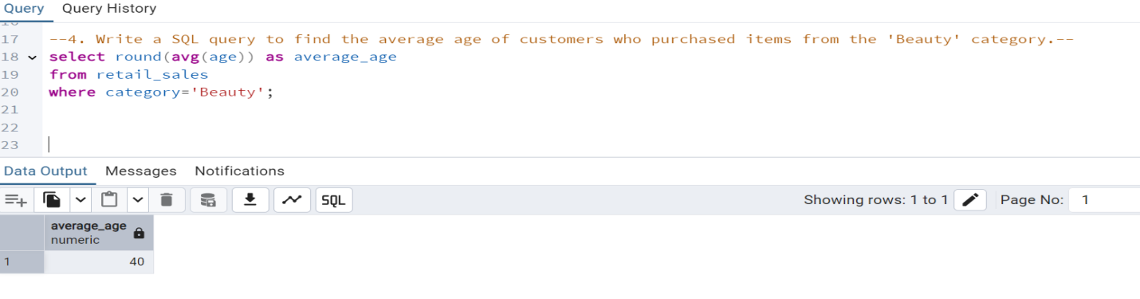

5. Write a SQL query to find all transactions where the total_sale is greater than 1000.

**🡪select * from retail_sales where total_sale > 1000;**

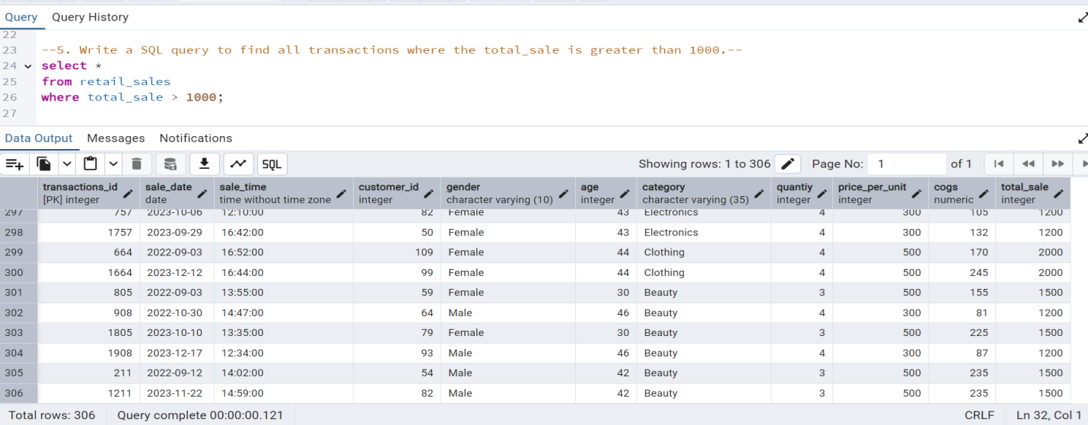

6. Write a SQL query to find the total number of transactions (transaction_id) made by each gender in each category.

**🡪select gender, category, count(transactions_id) as total_transactions from retail_sales group by gender, category order by gender, category;**

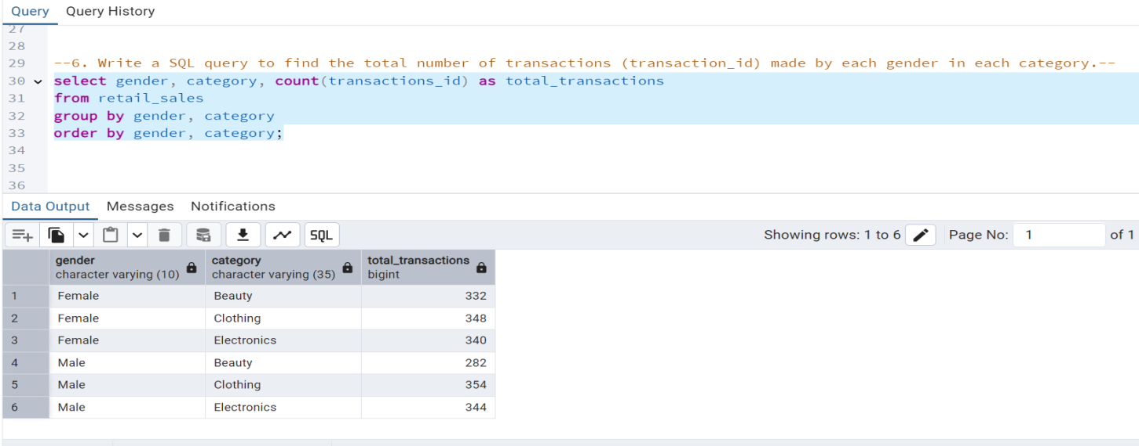

7. Write a SQL query to calculate the average sale for each month. Find out best selling month in each year

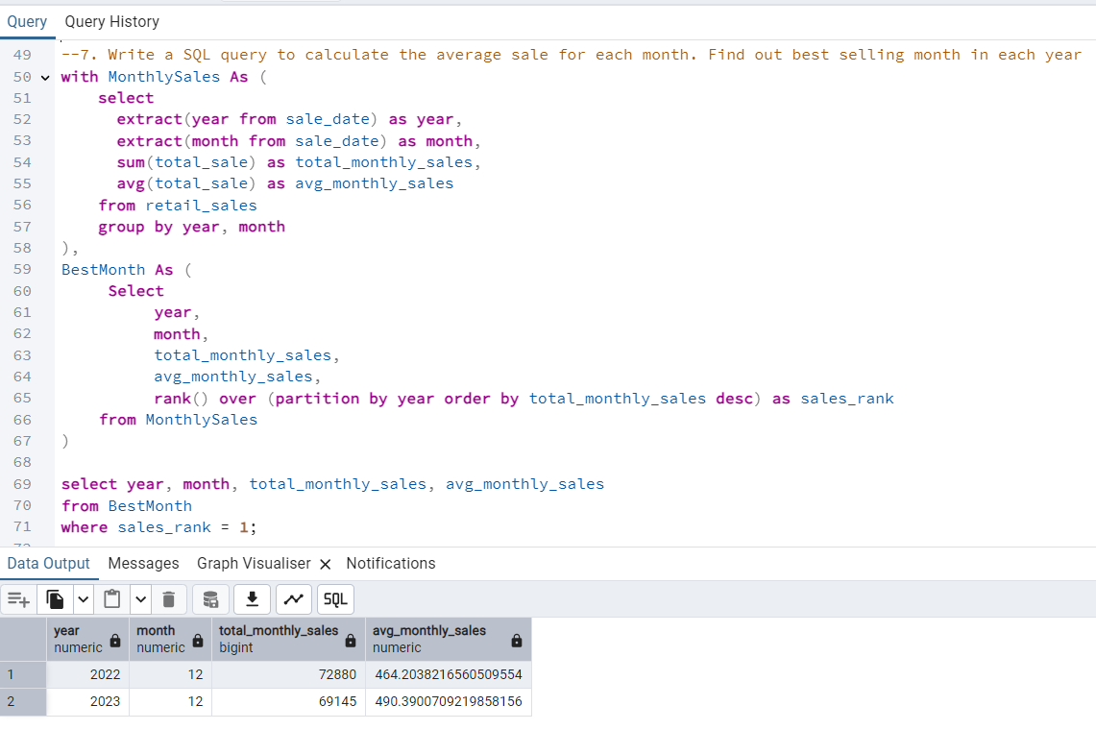

8. Write a SQL query to find the top 5 customers based on the highest total sales

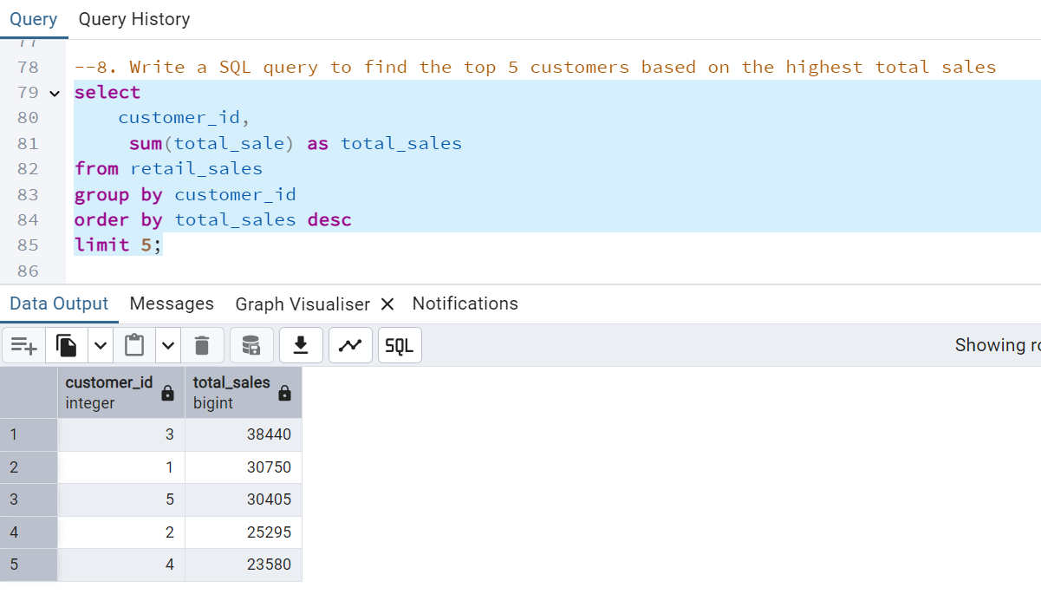

9. Write a SQL query to find the number of unique customers who purchased items from each category.

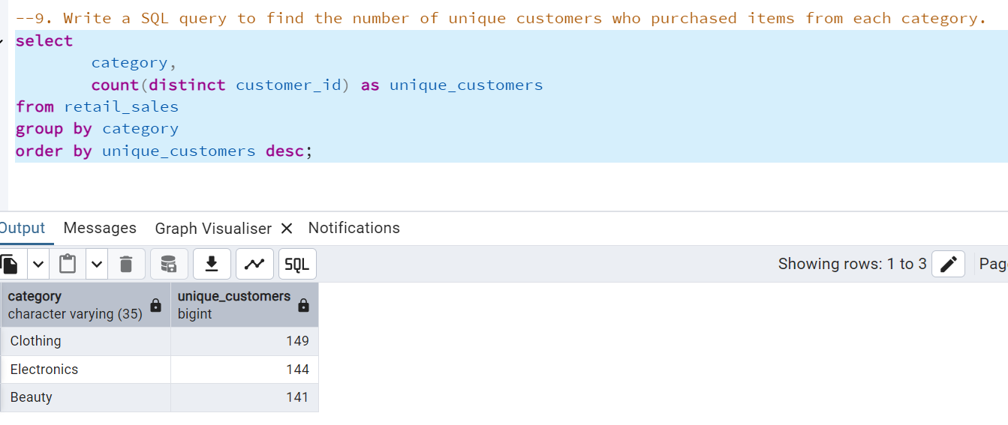

10. Write a SQL query to create each shift and number of orders (Example Morning <12, Afternoon Between 12 & 17, Evening >17)

