Major Project Report

On

**Ai Chat Bot for Polytechnic College Counselling**

Submitted in Partial Fulfillment for the Award

Of

Diploma in Computer Science Engineering (2021-22)

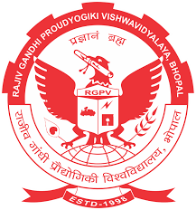

**RAJIV GANDHI PROUDYOGIKI VISHWAVIDYALYA BHOPAL (M.P.)**

Submitted

By

**Abhishek Dwivedi**

Under the Supervision

of

**Mr. Mahendra Gupta**

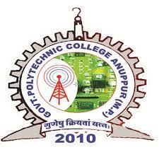

**GOVERNMENT POLYTECHNIC COLLEGE ANUPPUR**

**MP-484224**