PERSONAL INFORMATION | Mahendra Mahat
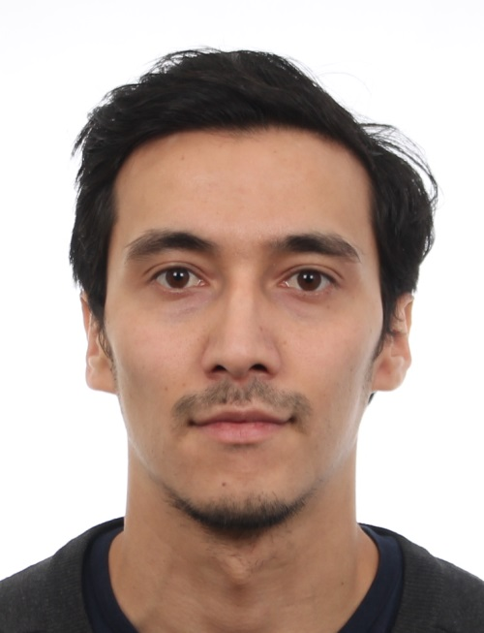 |   076, Kilonrinne 10 , Espoo, 02610, Finland

+358401246085

Mahat.mahen@gmail.com

linkedin.com/in/mahendra-mahat-b1967810b

whatsapp (+358401246085)
 | Sex Male| Date of birth 23/04/1992 | Nationality Nepalese

WORK EXPERIENCE

23 november 2016 onwards | Employee
23 november 2016 onwards | SOL palvelut oy, Helsinki
23 november 2016 onwards | - Work in a warehouse  - Printing and labelling pricetag  - Arranging the items systematically  - Updating the items in the system
23 november 2016 onwards | Service solutions
6 june 2016 to 24 october 2016 | Trainee as IT assistant
6 june 2016 to 24 october 2016 | Global Nepal It solution pvt.ltd, Kathmandu, Nepal.
6 june 2016 to 24 october 2016 | - Marketing and sales of software  - Assisting front desk  - Assisting system administrator
6 june 2016 to 24 october 2016 | IT solutions

April 2012 to September 2012 | Web Designer
April 2012 to September 2012 | Arena Multimedia, Kathmandu, Nepal.
April 2012 to September 2012 | - Designing web sites
April 2012 to September 2012 | IT solutions

EDUCATION AND TRAINING

28 August 2013 to 29 December 2017) | Bachelor Degree in Business Information Technology
28 August 2013 to 29 December 2017) | Lapland University of Applied Sciences , Tornio, Finland.
28 August 2013 to 29 December 2017) | Business courses: ways to start up business, Digital Marketing, Business strategy, service management, Ebusiness, and project management.  - IT: developing website in CMS (specifically Joomla), programming (php, jquery,java,c++,html)

PERSONAL SKILLS

Mother tongue(s) | Nepalese
Other language(s) | UNDERSTANDING |  | SPEAKING |  | WRITING
Other language(s) | Listening | Reading | Spoken interaction | Spoken production
English | C2 | C2 | C2 | C2 | C2
French | B2 | B2 | B2 | B2 | B2
Levels: A1/A2: Basic user - B1/B2: Independent user - C1/C2 Proficient user
Common European Framework of Reference for Languages

Communication skills | Good communication skills gained during my study period as well as through my work experience as a restaurant manager.

Digital skills | SELF-ASSESSMENT
Digital skills | Information processing | Communication | Content creation | Safety | Problem solving
 | Proficient user | Proficient user | Proficient user | Proficient user | Proficient user
Levels: Basic user - Independent user - Proficient user
Digital competences - Self-assessment grid
 | Arena Multimedia-web designer
- good command of office suite (word processor, spread sheet, presentation software)
- good command of photo editing software gained as an amateur photographer

Other skills | Replace with other relevant skills not already mentioned. Specify in what context they were acquired. Example:  - Resturant manager  - Project manager

Driving licence | A  B

