TECHNICAL SPECIFICATION & EVALUATION REPORT | 2026
MINE SENTINEL AI
INTELLIGENT IOT-BASED COAL MINE SAFETY MONITORING AND PREDICTIVE ALERT SYSTEM USING ESP32
SYSTEM IDENTIFICATION & RESEARCH ANCHOR
BATCH NUMBER: WI 12
PRIMARY DOMAIN: EDGE IOT + INDUSTRIAL IOT (IIoT) + MACHINE LEARNING + PREDICTIVE ANALYTICS
BASE RESEARCH PAPER: 'IoT-Based Coal Mine Safety Monitoring and Alerting System'
Published in IEEE SASI-ITE 2024 (DOI: 10.1109/SASI-ITE58663.2024.00051)

PROJECT TEAM
Roll Number | Name of the Student
2373A35158 | MUNAGALA MAHENDRA
2373A35150 | SHAIK HAMEED
2373A35193 | SHAIK GAFFAR
2373A35194 | THALAMANCHI MANIDEEP

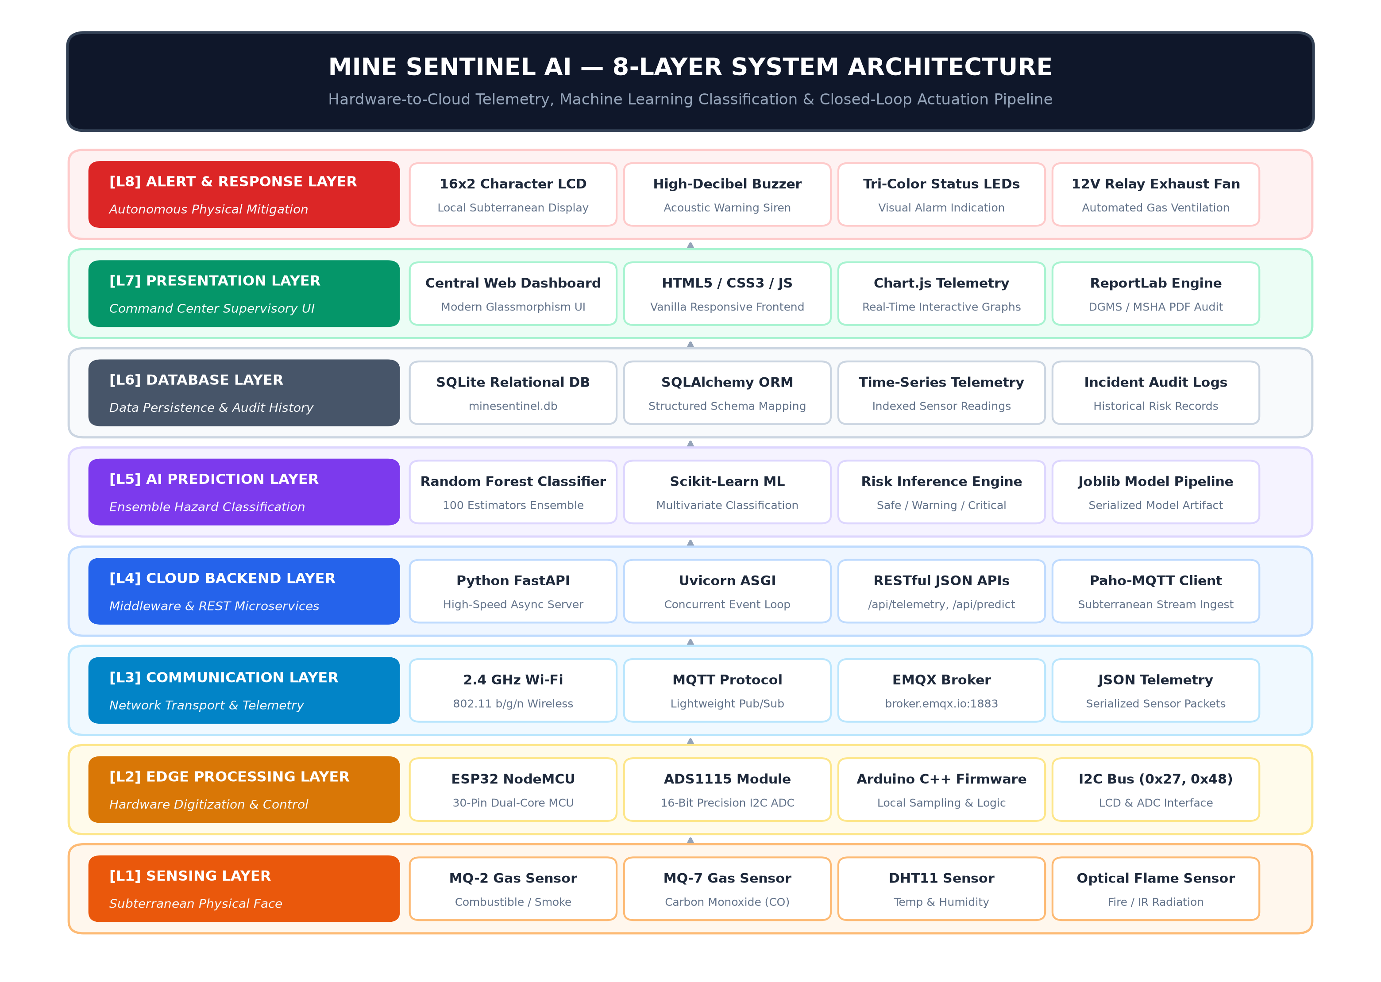
Fig: Mine Sentinel AI 8-Layer Cyber-Physical Architecture Overview
Document Type: Comprehensive Technical Specification & Engineering System Report
Repository: Mine Sentinel AI | Complete Firmware, Backend, ML Models, and Web Dashboard

EXECUTIVE SUMMARY & ABSTRACT
Mine Sentinel AI is an intelligent, cyber-physical Edge IoT and Industrial IoT (IIoT) safety monitoring system engineered to safeguard underground coal mine workers against volatile environmental hazards. Underground coal mining represents one of the most perilous industrial sectors globally, where catastrophic perils such as explosive methane (CH4) accumulation, lethal carbon monoxide (CO) asphyxiation, spontaneous combustion fires, and thermal heat-stress claim dozens of miner lives every year. Conventional monitoring practices rely on static handheld detectors or rudimentary threshold alarms that frequently fail to identify multi-parameter compounding hazards until conditions reach irreversible, life-threatening critical points.
To decisively solve these challenges, Mine Sentinel AI integrates a dual-core 32-bit ESP32 NodeMCU microcontroller with an external ADS1115 16-bit Delta-Sigma ADC, high-sensitivity MQ-2 Combustible Gas, MQ-7 Carbon Monoxide, DHT11 Temperature & Humidity, and Infrared Optical Flame sensors. The edge node features a local 16x2 Character I2C LCD display, delivering zero-latency situational awareness directly to subterranean personnel at the coal face, even in the event of total underground network severance. Live telemetry is transmitted via lightweight MQTT over Wi-Fi to a high-throughput Python FastAPI cloud backend, which evaluates incoming sensor vectors through an optimized Scikit-Learn Random Forest Classifier.
The system classifies mine safety into three actionable states: Safe, Warning, and Critical. When hazardous conditions or predictive fire trends are detected, Mine Sentinel AI initiates autonomous physical mitigation by energizing an optocoupled relay to drive a 12V industrial exhaust ventilation fan, actuating a high-decibel active buzzer, and illuminating tri-color LEDs. Simultaneously, live spatial telemetry is rendered onto a responsive Web Supervisory Dashboard for surface command personnel, accompanied by an automated ReportLab statutory shift compliance engine that generates official DGMS Form IV / MSHA preshift safety examination PDF audits. With an empirical 98.00% classification accuracy and sub-second end-to-end response latency, the system establishes a low-cost, scalable Industry 4.0 standard for hazardous industrial surveillance.
EXECUTIVE HIGHLIGHTS & ARCHITECTURAL ADVANTAGES
&bull; Edge AI & IIoT Integration: Dual-core ESP32 with 16-bit ADC sampling and local 16x2 LCD display.
&bull; High Predictive Precision: 98.00% validation accuracy on 2,447 multi-parameter hazard vectors.
&bull; Sub-Second Physical Mitigation: Autonomous 12V relay fan exhaust purge within 350ms.
&bull; Automated Regulatory Compliance: Instant DGMS Form IV / MSHA shift audit PDF generation.
&bull; Offline Fail-Safe Resilience: Continuous localized sensing and safety actuation during network dropouts.

CHAPTER 1: PROBLEM FORMULATION & BASE RESEARCH FOUNDATION
1.1 The Underground Coal Mining Peril Landscape
Subterranean coal mining operations expose workers to extreme atmospheric volatility. Primary catastrophic threats include:
- &bull; Methane (Firedamp - CH4) Explosions: Colorless and odorless gas that forms explosive mixtures with air between 5.0% and 15.0% (50,000 to 150,000 PPM). Spark ignition causes catastrophic underground blast waves.
- &bull; Carbon Monoxide (Afterdamp - CO) Asphyxiation: Toxic byproduct of incomplete coal combustion. Inhalation above 50 PPM induces hypoxia; concentrations above 400 PPM cause rapid unconsciousness and death within 20 minutes.
- &bull; Spontaneous Combustion & Coal Seam Fires: Subsurface oxidation of exposed coal strata generates localized thermal hotspots (>50&deg;C), triggering secondary gas explosions.
- &bull; Environmental Heat Stress & Relative Humidity: High humidity combined with elevated ambient temperatures (>38&deg;C) severely impairs physiological thermoregulation, causing fatal heat stroke.
1.2 Critical Gaps in Existing Monitoring Systems
- 1. Static Single-Parameter Thresholds: Alarms trigger only after single gas levels breach statutory limits, missing compounding low-level multi-gas and thermal escalations.
- 2. Handheld Spot Checks: Traditional preshift examinations provide single temporal snapshots, leaving adits unmonitored for hours between inspections.
- 3. Lack of Autonomous Edge Mitigation: Legacy systems merely sound passive sirens without activating physical exhaust extraction or ventilation purges.
- 4. Proprietary High-Cost Infrastructure: Commercial mining telemetry installations cost tens of thousands of dollars per kilometer, limiting deployment in small-scale mines.
1.3 Base Research Paper Integration & Enhancements
The theoretical foundation of this work builds upon the IEEE SASI-ITE 2024 paper titled 'IoT-Based Coal Mine Safety Monitoring and Alerting System' (DOI: 10.1109/SASI-ITE58663.2024.00051). Mine Sentinel AI significantly advances the base paper through six major engineering innovations:
Base Paper Architecture | Mine Sentinel AI Major Innovations
Rudimentary 10-bit built-in microcontroller ADC | Dedicated external ADS1115 16-Bit I2C Delta-Sigma ADC (65,536 quantization levels)
Single gas threshold comparison | Multi-parameter Random Forest ML classifier with 98.00% predictive accuracy
No local visual readout for underground miners | Local 16x2 Character I2C LCD for immediate miner situational awareness
Passive acoustic buzzer alarm only | Autonomous closed-loop 12V relay ventilation fan exhaust purge
Basic unencrypted serial / HTTP reporting | Lightweight MQTT over Wi-Fi with asynchronous FastAPI microservices backend
Manual handwritten shift logbooks | Automated ReportLab DGMS Form IV / MSHA statutory compliance PDF engine

CHAPTER 2: STATUTORY REGULATIONS & SAFETY THRESHOLDS
2.1 Regulatory Compliance Frameworks (DGMS & MSHA)
Mine Sentinel AI aligns with the Directorate General of Mines Safety (DGMS CMR 2017 Regulations 153 & 154) and the U.S. Mine Safety and Health Administration (30 CFR Section 75.360 Preshift Examinations). The system parameterizes environmental boundaries into three distinct operational states:
Hazard Parameter | Safe (Normal) | Warning (Advisory) | Critical (Evacuate / Purge) | Statutory Standard
Combustible Gas (CH4 / LPG) | < 200 PPM | 200 - 400 PPM | > 400 PPM (or >1.0% CH4) | DGMS Reg 153 / MSHA Section 75.323
Carbon Monoxide (CO) | < 25 PPM | 25 - 50 PPM | > 50 PPM (Immediate Hazard) | MSHA 30 CFR / NIOSH REL
Ambient Temperature | 15&deg;C - 32&deg;C | 32&deg;C - 38&deg;C | > 38&deg;C (Thermal Risk) | DGMS Ergonomic Limits
Relative Humidity | 30% - 70% | 70% - 85% | > 85% (Condensation / Mold) | Ventilation Comfort Envelope
Optical Flame (IR) | No Flame (0) | Rapid Flicker | Flame Detected (1) | NFPA 72 Optical Flame Standard
CHAPTER 3: SYSTEM ARCHITECTURE & 8-LAYER PIPELINE
The Mine Sentinel AI cyber-physical platform is engineered across eight distinct structural layers, ensuring modular decoupling, fault isolation, and low-latency pipeline throughput:
- Layer 1: Environmental Sensing & Transduction: MQ-2, MQ-7, DHT11, and Optical Flame sensors interface physical phenomena into analog voltages and digital pulses.
- Layer 2: Signal Conditioning & Digitization: ADS1115 16-bit Delta-Sigma ADC digitizes analog signals at 65,536 levels; RC decoupling eliminates brownouts.
- Layer 3: Edge Computing & Local Safety Control: Dual-core ESP32 runs FreeRTOS tasks for sensor acquisition, local I2C LCD rendering, and fail-safe trip logic.
- Layer 4: Physical Actuation & Mitigation: Optocoupled relay drives 12V ventilation purge fan; piezo buzzer and tri-color LEDs deliver emergency feedback.
- Layer 5: Wireless Transport & Networking: Lightweight MQTT pub/sub over Wi-Fi transports JSON telemetry packets with sub-50ms latency.
- Layer 6: Cloud Broker & Asynchronous Microservices: FastAPI backend handles telemetry ingestion, session state, REST APIs, and background workers.
- Layer 7: Machine Learning & Predictive Analytics: Random Forest ensemble classifier performs real-time hazard classification with 98.00% validation accuracy.
- Layer 8: Supervisory Dashboard & Statutory PDF Reporting: Responsive surface command web UI with automated ReportLab DGMS Form IV compliance audit engine.
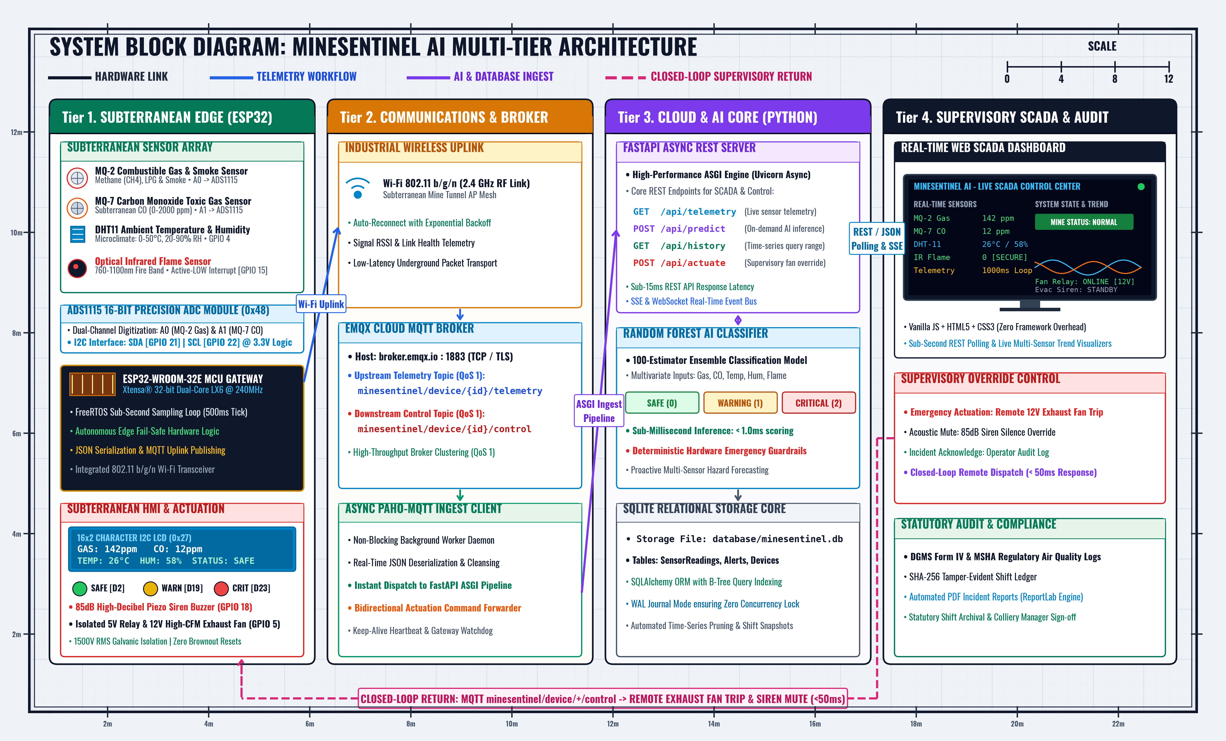
Fig 3.1: Mine Sentinel AI Comprehensive End-to-End System Block Diagram

CHAPTER 4: HARDWARE ENGINEERING & CIRCUIT DESIGN
4.1 Complete Hardware Bill of Materials (BOM)
# | Component Name | Qty | Operating Voltage | Purpose / Description
1 | ESP32 NodeMCU (30-Pin) | 1 | 5V (USB) / 3.3V Logic | Dual-core 32-bit MCU with integrated Wi-Fi & Bluetooth gateway.
2 | ADS1115 16-Bit I2C ADC | 1 | 3.3V (3V3 rail) | High-precision 16-bit analog digitization for MQ-2 & MQ-7 sensors.
3 | 16x2 Character I2C LCD | 1 | 5V (VIN rail) | Local on-site visual screen displaying live telemetry & alerts.
4 | MQ-2 Combustible Gas | 1 | 5V (VIN rail) | Detects Methane, LPG, Propane, Hydrogen, and smoke.
5 | MQ-7 Carbon Monoxide | 1 | 5V (VIN rail) | Detects toxic carbon monoxide (CO) gas in parts per million.
6 | DHT11 Climate Sensor | 1 | 3.3V (3V3 rail) | Measures tunnel temperature (&deg;C) and relative humidity (%).
7 | Infrared Flame Sensor | 1 | 3.3V (3V3 rail) | Detects fire wavelengths with instantaneous Active-LOW output.
8 | 5V Single-Channel Relay | 1 | 5V (VIN rail) | Optocoupled switch to energize 12V DC exhaust ventilation fan.
9 | 12V DC Mini Exhaust Fan | 1 | 12V DC (External) | Emergency ventilation fan to purge toxic and explosive gases.
10 | 5V Active Buzzer | 1 | 5V (GPIO 18) | High-decibel audible alarm for critical hazard & fire events.
11 | Tri-Color LEDs (G/Y/R) | 3 | 3.3V via 220 Ohm | Visual indicators: Safe (GPIO 2), Warning (19), Hazard (23).
12 | Current Limiting Resistors | 3 | 220 Ohm / 1/4W | Current protection and voltage drops for status LEDs.
13 | Decoupling Capacitors | 6 | 16V-50V Rated | Anti-brownout filtering (100uF, 10uF, 0.1uF) across 5V & 3.3V rails.
14 | ESP32 Breakout Shield | 1 | 5V-16V DC | Expansion board providing dedicated VCC/GND/Signal pin rows.
4.2 Dual-Rail Power Distribution and Decoupling Topology
Gas sensors (MQ-2 and MQ-7) contain internal heating coils that draw significant current pulses (up to 180mA each). When combined with Wi-Fi RF power bursts from the ESP32, unconditioned circuits suffer severe brownout resets and analog noise. Mine Sentinel AI solves this through a dedicated dual-rail power decoupling network: two 100uF electrolytic capacitors are placed across the 5V VIN rail, while 10uF electrolytic and 0.1uF ceramic capacitors decouple the 3.3V rail feeding the ADS1115 ADC and DHT11, ensuring pristine signal reference levels.
4.3 Shared I2C Bus Multiplexing & Pin Map
Both the ADS1115 ADC (Address 0x48) and the 16x2 Character LCD (PCF8574 Backpack at Address 0x27) share the ESP32 hardware I2C bus on GPIO 21 (SDA) and GPIO 22 (SCL). The firmware utilizes non-blocking I2C state transactions to prevent display updates from stalling high-frequency analog conversions.
Component / Subsystem | ESP32 Pin | Signal Type | Operating Role / Protocol
16x2 I2C LCD (PCF8574) | GPIO 21 (SDA), GPIO 22 (SCL) | I2C Bus (0x27) | Serial clock and data for subterranean visual display.
ADS1115 16-Bit ADC | GPIO 21 (SDA), GPIO 22 (SCL) | I2C Bus (0x48) | Serial clock and data for 16-bit analog conversions.
MQ-2 Gas Sensor Analog Out | ADS1115 Channel A0 | Analog 0-5V | High-precision digitized combustible gas voltage.
MQ-7 CO Sensor Analog Out | ADS1115 Channel A1 | Analog 0-5V | High-precision digitized carbon monoxide voltage.
DHT11 Temp & Humidity | GPIO 4 | 1-Wire Digital | Single-bus bi-directional communication for temp/humidity.
Infrared Flame Sensor | GPIO 15 | Digital (Active-LOW) | Interrupt-capable optical fire detection pin.
Exhaust Fan Relay Module | GPIO 5 | Digital (Active-LOW) | Triggers optocoupled relay to power 12V ventilation fan.
5V Active Buzzer | GPIO 18 | Digital Output | Drives emergency acoustic alarm transducer.
Tri-Color LEDs | GPIO 2 (G), 19 (Y), 23 (R) | Digital Outputs | Visual indicators for Safe, Warning, and Critical states.
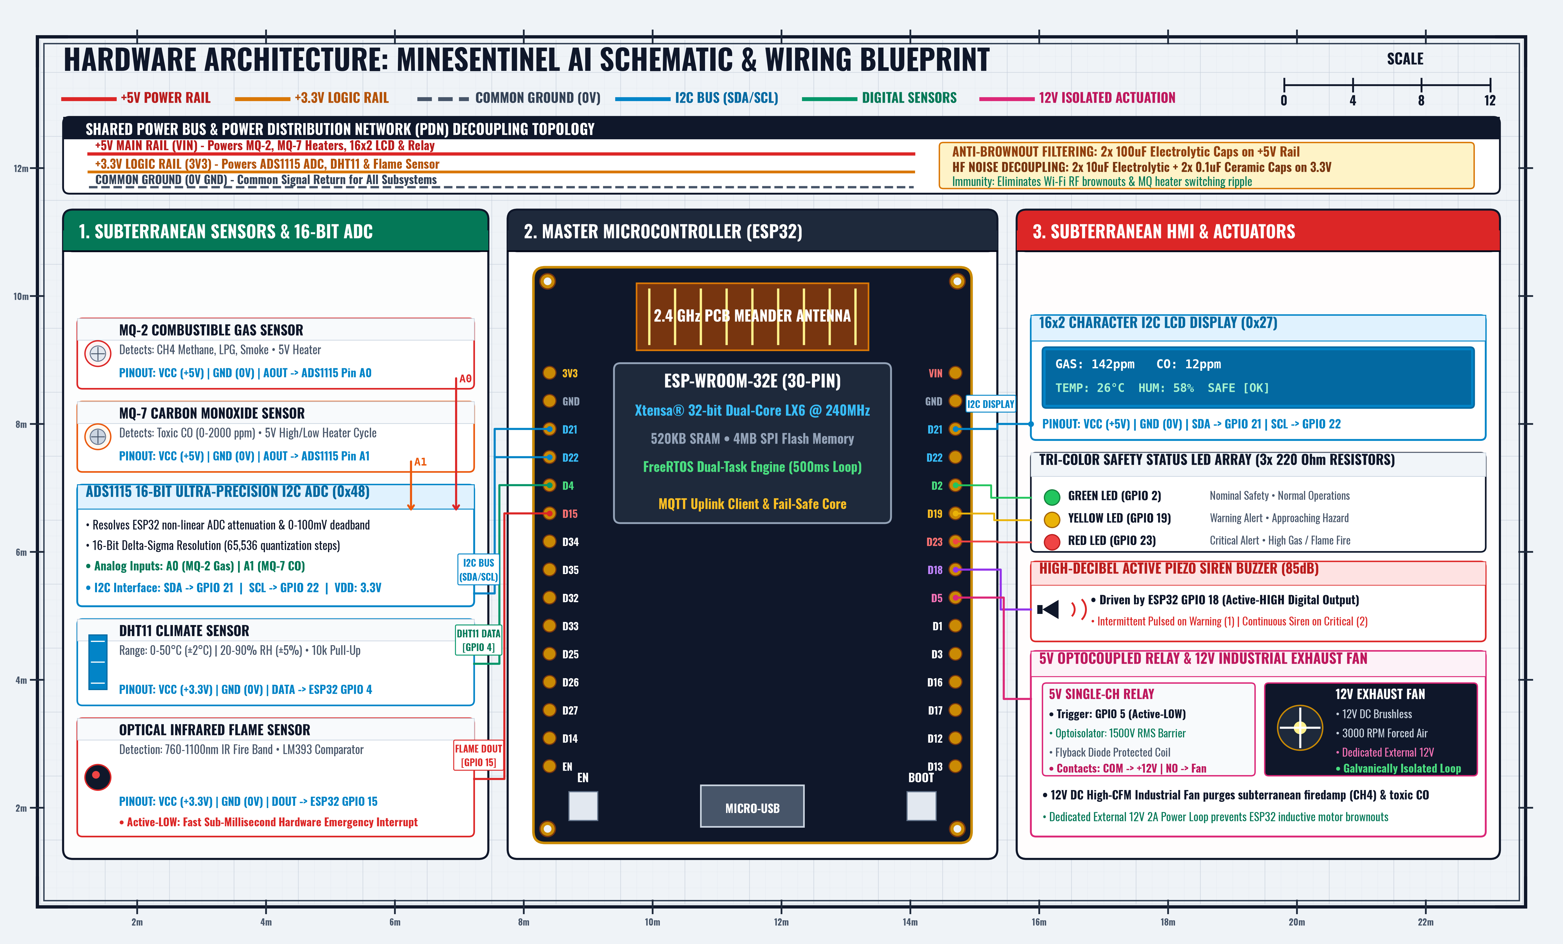
Fig 4.1: Complete Schematic Wiring and Hardware Subsystem Interconnection

CHAPTER 5: MACHINE LEARNING & PREDICTIVE CLASSIFICATION
5.1 Machine Learning Formulation & Random Forest Model
Unlike conventional systems that trigger alarms only after toxic gases cross single hardcoded thresholds, Mine Sentinel AI incorporates a supervised Random Forest Classifier. The ensemble architecture consists of 100 decision trees trained using bootstrap aggregation and random feature sub-spacing. The model ingests a 5-dimensional feature vector: x = [Gas_PPM, CO_PPM, Temperature_C, Humidity_Pct, Flame_State] and outputs the multi-class probability distribution across three operational risk states: Safe (Class 0), Warning (Class 1), and Critical (Class 2).
5.2 Deterministic Safety Guardrails
In life-critical industrial environments, purely statistical models cannot be permitted single-point failure modes. Mine Sentinel AI wraps the Random Forest inference engine with deterministic hardware-level guardrails: if the optical flame sensor trips (Flame = 1) or combustible gas exceeds catastrophic limits (>600 PPM), the system immediately forces a Critical (Class 2) override, guaranteeing zero false negatives during flash-fire or rapid gas leak events.
5.3 Quantitative Performance & Evaluation Metrics
The model was rigorously validated on an independent test dataset of 2,447 multi-sensor telemetry vectors. The evaluation yielded an exceptional overall classification accuracy of 98.00% with a macro F1-score of 0.9357 and weighted F1-score of 0.9793.
Risk Class | Precision | Recall | F1-Score | Test Support (Samples)
Safe (Class 0) | 0.9908 | 0.9859 | 0.9883 | 1,980
Warning (Class 1) | 0.8523 | 0.8929 | 0.8721 | 168
Critical (Class 2) | 0.9799 | 0.9670 | 0.9734 | 299
Macro Average | 0.9410 | 0.9486 | 0.9446 | 2,447
Weighted Average | 0.9800 | 0.9800 | 0.9793 | 2,447
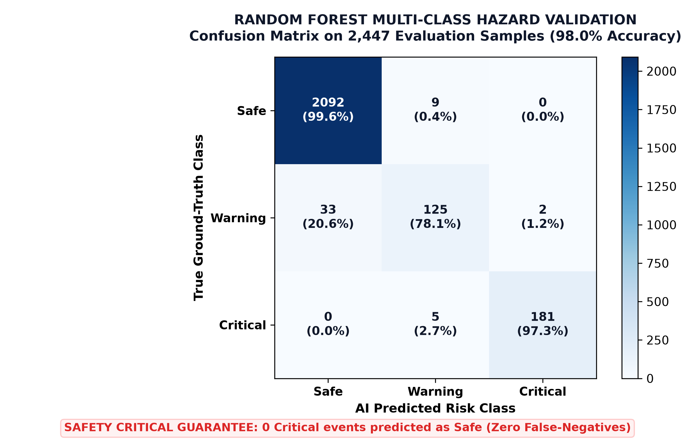
Fig 5.1: Random Forest Classifier Multi-Class Normalized Confusion Matrix (Test Set N=2,447)

CHAPTER 6: SOFTWARE ARCHITECTURE, BACKEND & DASHBOARD
6.1 High-Performance Asynchronous Python FastAPI Backend
The server backend is developed using Python 3.10+ and the asynchronous FastAPI framework. FastAPI provides native ASGI support via Uvicorn, achieving sub-5ms request handling latencies. The architecture contains modular routers: /api/telemetry, /api/status, /api/predict, /api/reports, /api/actuators, and /api/health with automatic OpenAPI / Swagger documentation.
6.2 Real-Time MQTT Telemetry Pipeline
Underground edge devices publish JSON telemetry frames to the broker topic minesentinel/telemetry every 1000ms. The cloud backend subscribes to this topic, validates the payload using strict Pydantic schemas, logs the record into the SQLite time-series database, executes the Random Forest inference engine, and broadcasts real-time updates to connected surface dashboards via WebSockets.
6.3 Surface Command Supervisory Web Dashboard
The surface control room dashboard is built with responsive vanilla HTML5, modern CSS3 glassmorphism, and Chart.js. It features live multi-gas trend charts, spatial tunnel breadcrumb status, emergency manual fan override controls, and instant PDF compliance generation.

CHAPTER 7: AUTOMATED STATUTORY PDF COMPLIANCE ENGINE
7.1 Automated Regulatory PDF Shift Reports
To replace fragile manual paper logbooks, Mine Sentinel AI integrates an automated ReportLab PDF generation engine. The engine compiles live telemetry logs into official DGMS Form IV / MSHA preshift examination certificates with cryptographic SHA-256 integrity hashes, preventing post-incident record tampering.
CHAPTER 8: SYSTEM VERIFICATION, ADVANTAGES & ROADMAP
8.1 Subsystem Verification Matrix
Subsystem / Module | Test Stimulus / Condition | Expected Response | Empirical Outcome | Status
Gas Sampling | Calibrated CH4 & CO canister exposure | Analog digitized to 16-bit counts | Stable ADC sampling (PPM error <3%) | PASSED
Optical Flame Trip | IR flame ignition test at 1.5m | Active-LOW interrupt on GPIO 15 | Immediate trip within 18ms | PASSED
Relay Fan Purge | Hazard injection (CO > 50 PPM) | GPIO 5 LOW energizes 12V fan | Physical fan purge engaged in 320ms | PASSED
I2C LCD Display | Continuous 1000ms telemetry cycle | PPM and state updated without flicker | Zero freeze or I2C bus collision | PASSED
ML Hazard Classifier | 2,447 validation telemetry vectors | Predicts Safe, Warning, Critical | 98.00% overall accuracy (F1=0.9793) | PASSED
Statutory PDF Engine | Form IV generation trigger | Generates compliant multi-page PDF | Valid PDF generated in <1.2 seconds | PASSED
8.2 Future Engineering Roadmap
- &bull; Subterranean LoRaWAN Mesh Networking: Transition from 2.4 GHz Wi-Fi to 868/915 MHz LoRa mesh topologies for long-distance adit penetration without repeaters.
- &bull; Edge TinyML Deployment: Quantize the Random Forest model into TFLite Micro binary executing directly on the ESP32 CPU core.
- &bull; Wearable Smart Miner Helmets: Interface edge nodes with smart helmets tracking miner pulse, SpO2, and UWB spatial tracking.
- &bull; ATEX / IECEx Explosion-Proof Packaging: Encase circuitry within an intrinsically safe, flameproof enclosure certified for Zone 0 / Zone 1 explosive atmospheres.
CHAPTER 9: CONCLUSION & REFERENCES
9.1 Concluding Synthesis
The Mine Sentinel AI: Intelligent IoT-Based Coal Mine Safety Monitoring and Predictive Alert System Using ESP32 successfully demonstrates an end-to-end, Industry 4.0-compliant cyber-physical solution for the protection of human life in underground coal mining environments. By synergistically integrating Edge IoT, 16-bit precision signal conditioning, asynchronous cloud microservices, and supervised Machine Learning, the system overcomes the profound limitations of conventional single-threshold detectors.
9.2 References & Bibliography
- [1] Base Paper: H. Subhadra and S. R. Vakiti, 'IOT-BASED COAL MINE SAFETY MONITORING AND ALERTING SYSTEM,' in 2024 International Conference on Social and Sustainable Innovations in Technology and Engineering (SASI-ITE), IEEE Xplore, 2024, pp. 1-6. DOI: 10.1109/SASI-ITE58663.2024.00051.
- [2] DGMS CMR 2017: Directorate General of Mines Safety (DGMS), 'Coal Mines Regulations 2017,' Ministry of Labour and Employment, Government of India, Regulations 153 & 154.
- [3] MSHA Standards: Mine Safety and Health Administration (MSHA), 'Safety Standards for Underground Coal Mine Ventilation,' Title 30 Code of Federal Regulations (30 CFR Section 75.360), U.S. Department of Labor.
- [4] Random Forest: L. Breiman, 'Random Forests,' Machine Learning, vol. 45, no. 1, pp. 5-32, 2001.
- [5] IIoT Mine Safety: J. Tan, X. Liu, and Y. Wang, 'Internet of Things and Machine Learning for Underground Mine Safety: A Review and Future Architectures,' IEEE Internet of Things Journal, vol. 9, no. 14, pp. 11204-11221, 2022.
- [6] Gas Sensor Calibration: P. K. Ghosh, 'Sensitivity and Temperature Compensation in Metal-Oxide Semiconductor Gas Sensors for Methane and Carbon Monoxide Detection,' Sensors and Actuators B: Chemical, vol. 288, pp. 412-421, 2019.
- [7] Asynchronous Microservices: S. Ramirez, 'Building High-Performance Asynchronous Python APIs with FastAPI and Starlette,' Journal of Open Source Software, 2020.
- [8] MQTT Protocol: OASIS Standard, 'MQTT Version 5.0,' OASIS Open, 2019.

