Technical Story Card

Revision History
Version No. | Date | Prepared by / Modified by | Significant Changes

Glossary
Abbreviation | Description
BSC | Business Story Card
TSC | Technical Story Card

Table of Contents
1 Introduction 3
2 Scope of Change 3
3 List of impacted modules 3
4 Design and Detailed technical updates 4
4.1 Process model 4
4.1.1 Use case Model 4
4.2 Proposed user Interface design 4
4.3 Database design changes 4
4.4 Refactoring related changes 4
4.5 Construction strategy and re-use 4
5 Details of Alternative Design Approach 4
6 Other Technical changes 5
6.1 Automation tasks / changes 5
6.2 CI / Build relates tasks / changes 5
6.3 Non-functional related changes 5
7 Additional details 5
7.1 Open Questions / clarifications / Assumptions 5
7.2 Additional notes to technical team 5
8 References 5

Introduction

.
Food Wastage is a massive problem in our society. In highly populated countries like India, food wastage is a disturbing issue. The streets, garbage bins and landfills have sample proof to prove it. Marriages, canteens, restaurants, social and family get-togethers and functions expel out so much food. Food wastage is not only an indication of hunger or pollution, but also of many economic problems. The high standard of living has resulted in the wastage of food, clothes, etc. because of quick changes in habits and lifestyle. Instead of wasting these things we can put them in use by donating them to various organizations such as orphanages, old age homes, etc. Our aim is to help eradicate the hunger in today's world and provide food to every living individual.

Scope of Change
The purpose of creating this Application is to eradicate hunger in the most possible way.NMFW is a real-time app which aims to reduce wastage of food. In this app,any person can register themselves as a user and either donate or receive food. Whenever a user donates food, it gets sorted in the real-time database. Information is retrieved from the database. Information is retrieved from the database every time any user wants to receive food. The one who wishes to receive is then directed to Google Maps for Location of the donar. The Food waste management app is an Android Application which provides the donars to donate the food and the receivers to receive the food. The donar has to login and then enter the details of the food which includes their name,place, phone number, the name of the food they have and the quantity of the food they have.

List of impacted modules
All the functional modules will be created from scratch. Food wastage management mainly consists of admin and user. User will donate food or things to admin through the app or website. Admin will sent that food to some places to donate that food to poor people.

User will register themselves and then they can login. After they login, they will have a page that will show them options to select after that they donate food. They can delete or update their account.

Design and Detailed technical updates

Process model

Use case Model

Registration
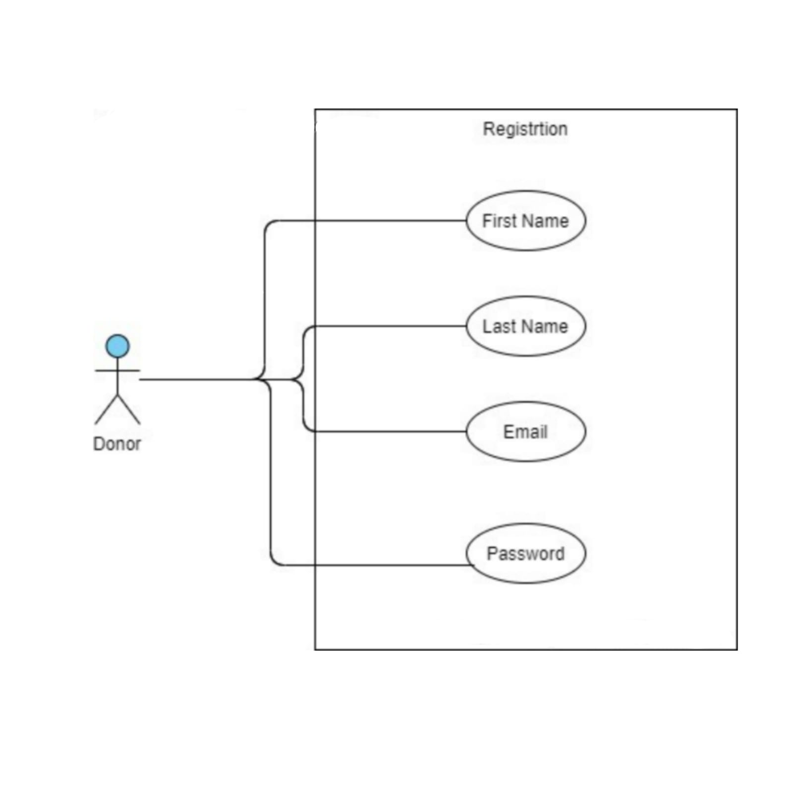

Donation Details:
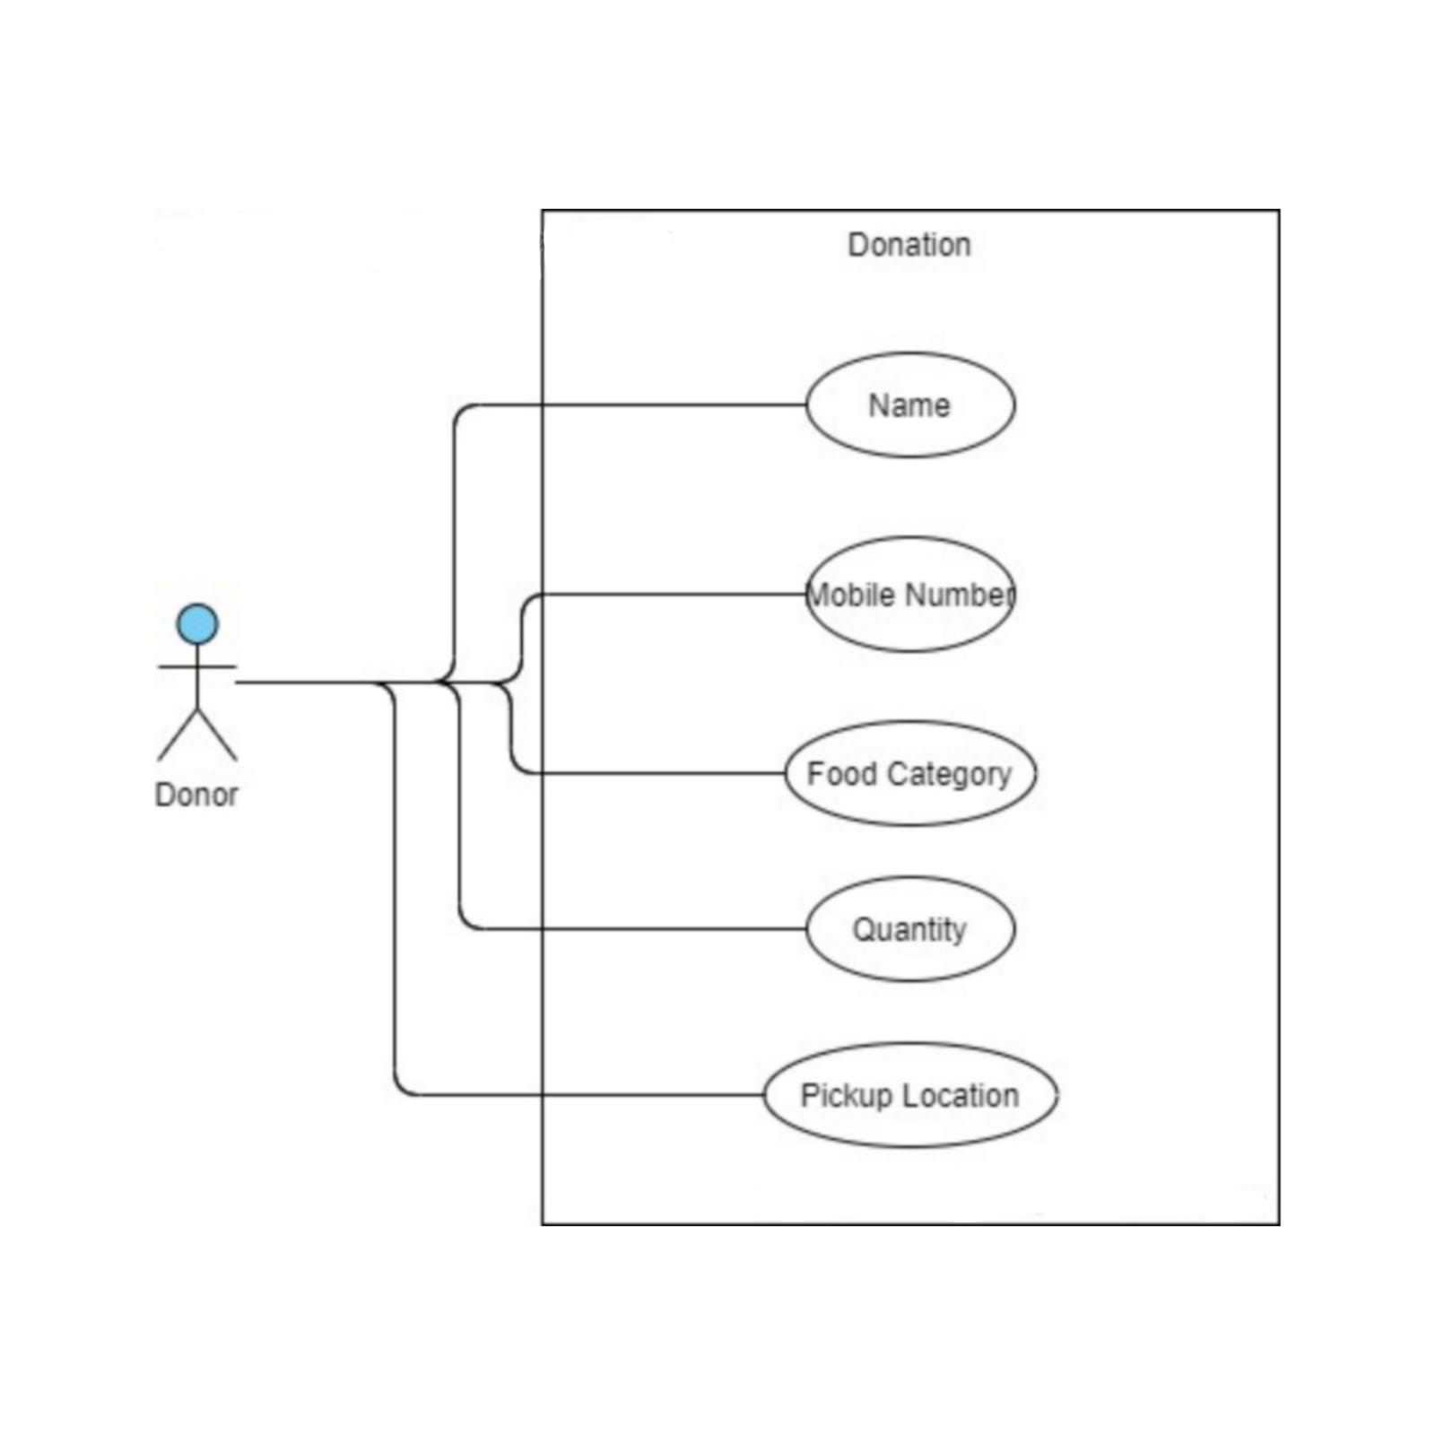

Brief Description | User Registration
Basic Flow | This use case describes how a client register in to the system  - The client has to register himself into the system.  - After the successful registration, client will get a success message.  - The following information is required during registration.  - First Name  - Last Name  - Email  - Password
Alternate Flow | - The system will validate the information provided. If any invalid data is found , the input form will be redirected with error message.
Validation | - Name is required and minimum 3 characters and max 30 characters.  - Address can be alphanumeric.  - City/State/Country/Province should be selected from a drop-down.  - The Email should be valid.  - Mobile Number is Valid.
Pre-Conditions | User should have network access and Browser with latest updates.
Post-Conditions | Success message should be shown.

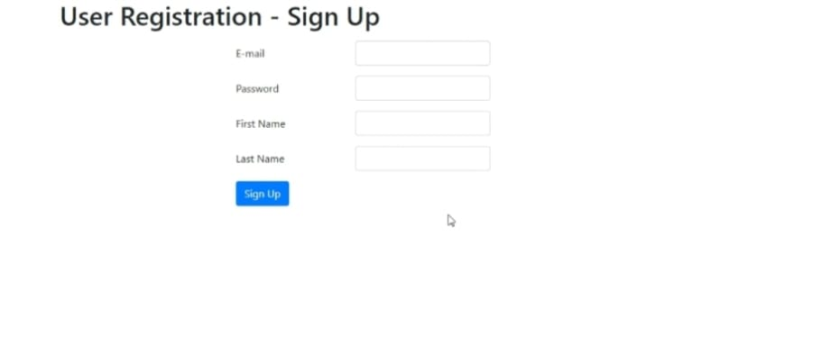

Brief Description | Login
Basic Flow | This use case describes how a user log-in in to the system  - The User has to register himself into the system.  - After the successful login, user will be taken to the appropriate landing page.  - The following information is required to login.  - username  - password
Alternate Flow | - The system will validate the credentials provided. If credentials are invalid, login form will be redirected again with error message.
Validation | - Valid username  - Valid password
Pre-Conditions | User should have network access and Browser with latest updates.
Post-Conditions | Landing page has to be displayed.

Brief Description | Food Donor Details
Basic Flow | This use case describes how a User fill details in to the system  - The User has to login into the system.  - The following information is required during upload invoice.  - Donor Name  - Mobile number  - Address  - Quantity  - Pickup Location
Alternate Flow | - The system will validate the information provided. If any invalid data is found, the input form will be redirected with error message.
Validation | - Validate the correct mobile number.
Pre-Conditions | User should have already logged into the system.
Post-Conditions | Success message should be shown.

Architecture Diagram

Layer
Logical View
Technology/ Framework

UI Components
Presentation Layer
HTML/ CSS/ JavaScript/ AJAX/ Angular
Export (pdf)
Validations
Resources

Report

Web-Server Classes
Java 1.8/ Spring MVC
Application/ Business Layer
Configuration
Controllers

Service
REST Controllers

Entity/ Model Classes

Data Access Layer
Repository classes
Hibernate ORM

Oracle 11g Database

Presentation Layer:
This layer consists of all UI components.
- Export component: The plug-in is used to export the reports in pdf format. It helps to reduce the workload on the web/ application server.
- Validation component: All basic level data validations should be done at UI level.
- Report component: All reports to be generated to the user, will be processed and generated at the browser end.
- Resources: All HTML/CSS/ images, which are required for the page design.
Application Layer:
This layer comprises of all server and business classes.
- Configuration settings (XML or Class based) will define the application and server configuration.
- Spring Controllers defines the server classes, which are required to process the incoming http requests.
- Service classes are required to perform the required business services.
- REST Controllers to process the HTTP AJAX requests.
- Model classes are used the define the functions of the entities present in the system.
Data Layer:
Data layer is implemented through Hibernate ORM. It will contain the repository classes, which provides interface to the table.

Other Technical changes

CI / Build relates tasks
<If the story requirements are about implementation of continuous integration or build, update the details to be done here>

Non-functional related changes
<Non-functional requirements related to response time, System load or Network load>

Additional details

Open Questions / clarifications / Assumptions
<Mention the details of any open technical questions/clarifications or assumptions made, pertaining to story >

Additional notes to technical team
<provide details if any>

References
< Provide reference details if any >

