|  |
| --- |
| Hig Level Architecture |
| Hig Level Architecture |
| |  |  | | --- | --- | |  | Application Type: Business Critical | |
| **Version 1.0** |
|  |

|  |
| --- |
| [This document contains proprietary information of HCL Technologies Ltd. and the filled in information would be for the exclusive use of designated HCL only. No part of this document may be reproduced, stored, copied, or transmitted in any form or by means of electronic, mechanical, photocopying or otherwise, without the express consent of HCL Technologies Ltd.] |

**Revision History**

|  |  |  |  |
| --- | --- | --- | --- |
| Version No. | Date | Prepared/Modified by | Significant Changes |
| 1.0 | 14-04-2021 | Mahendran Suruli/ Kanaiya Lal | Initial draft – ING Reservation Functional Specification Documents |
|  |  |  |  |
|  |  |  |  |
|  |  |  |  |
|  |  |  |  |
|  |  |  |  |
|  |  |  |  |
|  |  |  |  |
|  |  |  |  |
|  |  |  |  |
|  |  |  |  |
|  |  |  |  |

Table of Contents

**INTRODUCTION** 4

Purpose of Document 4

Audience 4

FUNCTIONAL OVERVIEW 4

Login Screen 4

Dashboard Screen 4

ING Workspace Booking Screen 5

Prefence Page 6

My Desk Reservation 6

Cancel Reservation 7

Display Building Map 7

Building Detail Screen 8

Floor Detail Screen 9

Desk/Room Detail Screen 9

Desk/Room Detail Screen 10

Display QuickPickDesk Screen 10

Display QuickPickDesk Detail Screen 10

Display Check-In and Check Out Screen. 11

# **INTRODUCTION**

Purpose of Document

This document provides the functional overview of ING reservation tool and it is to used capture all comprehensive knowledge to develop **ING Reservation Tool** using full stack developmentwhich will be in the scope of the HCL team. Thus, reducing effort of readers to refer multiple documents.

## 

Audience

This document could be referred by following ─

1. HCL IT Team
2. HCL Marketing Team

FUNCTIONAL OVERVIEW

ING reservation portal is used by ING employee to reserve/book the specific desk or specific room for their busines need. The user/ING employee used to log in to the portal using their mail id and corp key. The system validate the user aginst ING active directory, if validation success then user takes into reservation dashboard page otherwise error message will be displayed back to user.

Upon successfully loged in user can perform belwo activities:

* Reserve or book the room/desk
* View list of current/past/future reservation details
* Resever desk/room using the building and floor map.
* Reserve room/desk using QucikReserveDesk
* Cancel Reservation
* Check In/Check out Already Reserved room/desk.

## **Conceptual, Logical, or Physical: How to Use Architecture Levels Effectively**

Conceptual Architecture

Conceptual architecture diagrams effectively function as structural models, so they (ideally should) highlight the relationships between key concepts, not how they work. This means they are not concerned with exposing process flow/sequentiality.

Since conceptual architecture does not go into any technical details, it is very adept for communicating with stakeholders that have a business background, e.g. presenting a business strategy model to management.

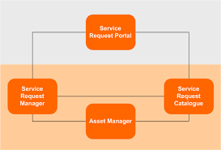

Dashboard Screen

Dashboard screen display the list of existing buildings details. mail id and corp key details in the screen. User select the bulding then system display reservation details

ING Workspace Booking Screen

This page display reservarion assistant, preferance and support link in the left menu.

Prefence Page

The preference page display the reservation details such as type of reservation, date and start and end time so that he can select the date & time than when he want to reserve it. Once user click the save button it will be stored in the back end system.

My Desk Reservation

This screen is used to display user reservation details such as currenr reservation in the top of the left panel , and future reservation in the right top of the panel, list of past desk reservation details in the bottom left panel.In addition there are few button in the bottom of the screen like My Desk Reservation, ING Building Map and Quick Pick Desk.

**Note:** Each window will display below details like Date, start time, end time, desk and building..

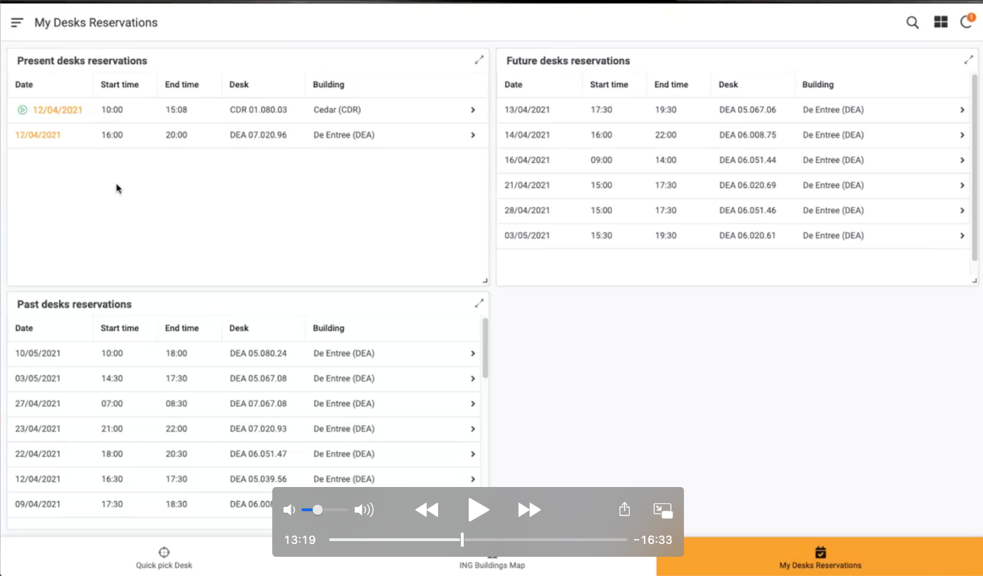

Cancel Reservation

It is used to cancel the already planned reservations(future/present).

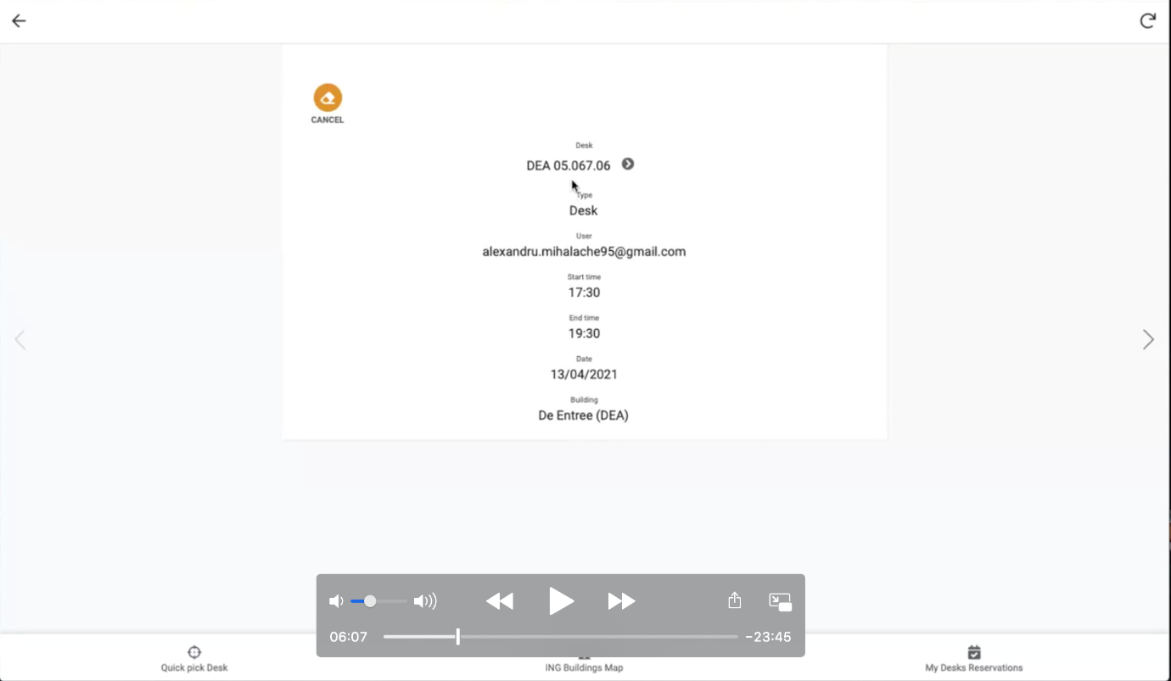

Display Building Map

When user click the ING building map button, then system display the ING whole building map as below:

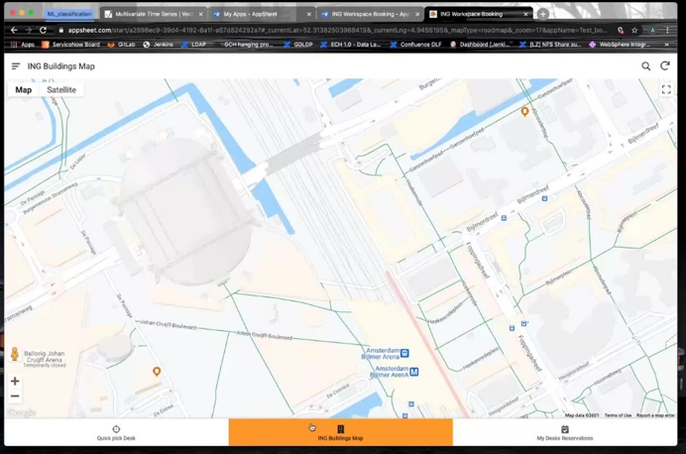

Building Detail Screen

When user click the any ING building, then system display the specific building details such as list of floors available as below:

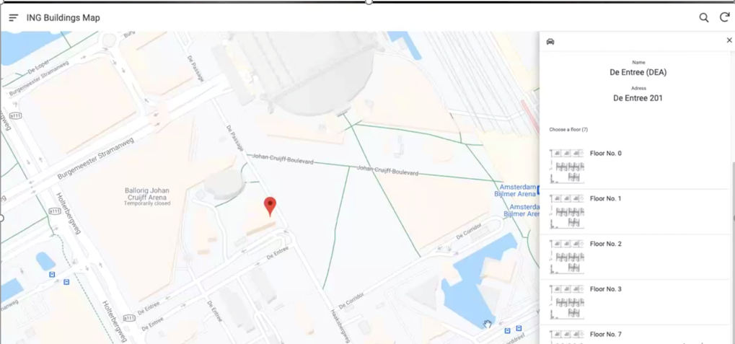

Floor Detail Screen

When user click the any floor in the building, then system display the floor details as below:

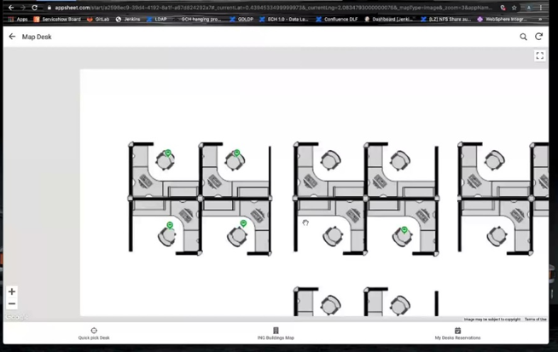

Desk/Room Detail Screen

When user click the desk/room, then system display the desk or room details as below:

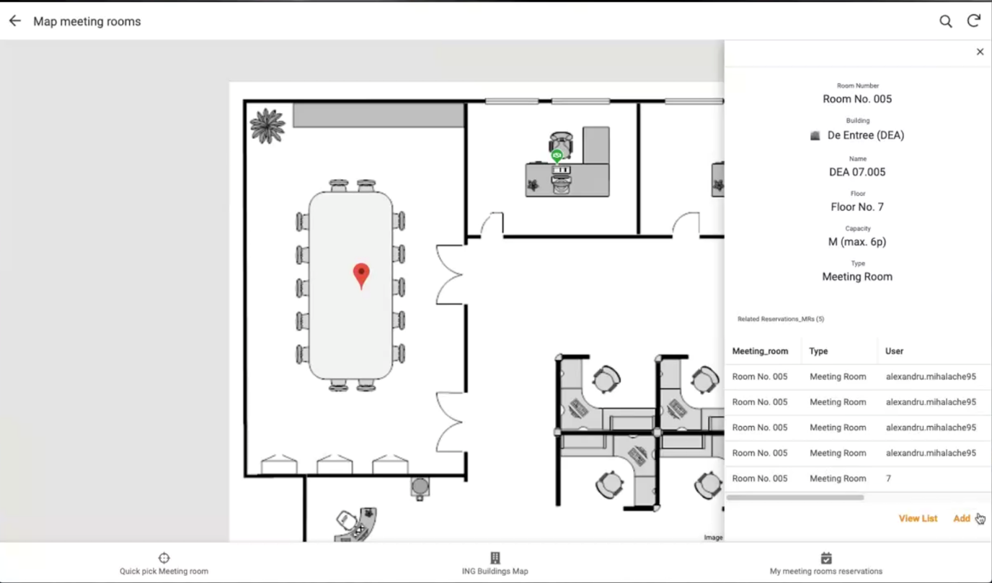

Desk/Room Detail Screen

When user click the add button in the reservation page, then system display the complete reservation deatail as below: , including the date and time selected in the preference page.

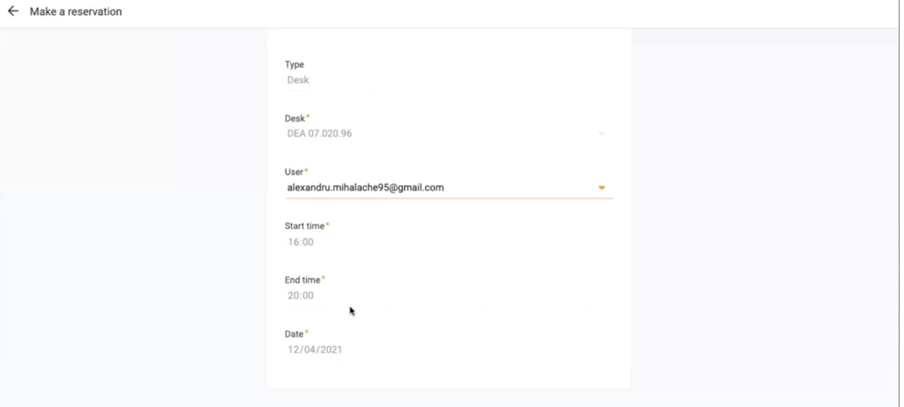

Display QuickPickDesk Screen

Display list of available desk details irrespective of the floor as below:, it is used to reserve quickly rather than searching through ING building map.

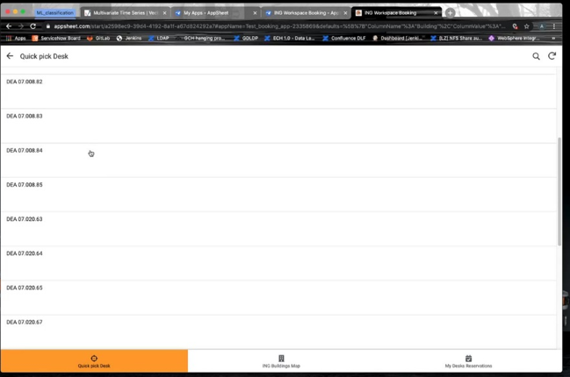

Display QuickPickDesk Detail Screen

Display selected desk details as below:

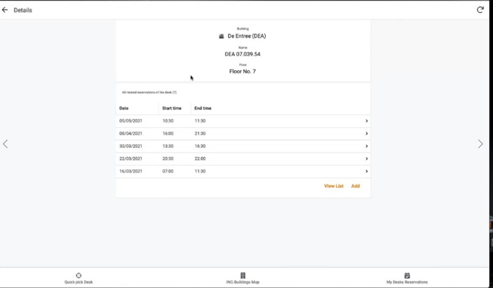

Display Check-In and Check Out Screen.

Display check -in and Check-out option as below , it is used to check in the desk/room once he /she available in the desk in the office, it will be check out once he is done the work or once completed the stipulated time.

