**Estimation**

Functionalities in the app

1.Login

2.Dashboard with list of buildings

3.Left menu with some links

4.(Booking Screen) From left menu link select preferences and go to the booking screen.

**My Desk Reservation**

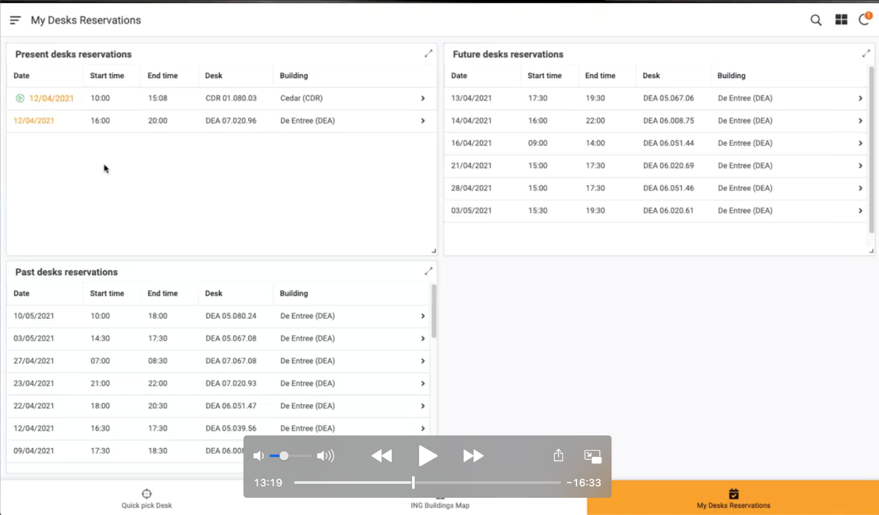

**Cancel Reservation**

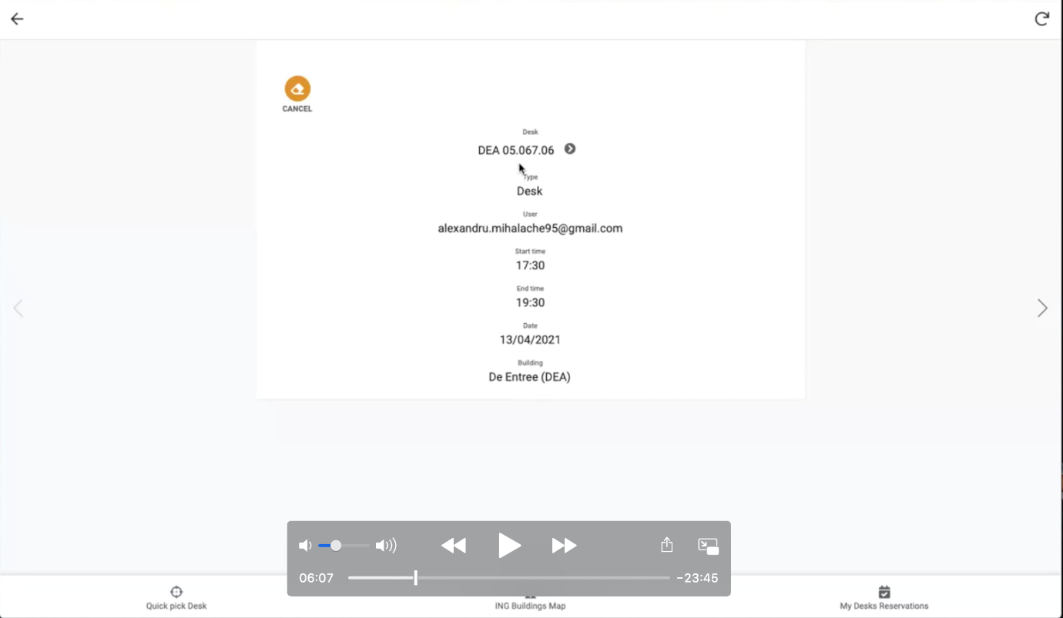

**Display List pf Building Map:**

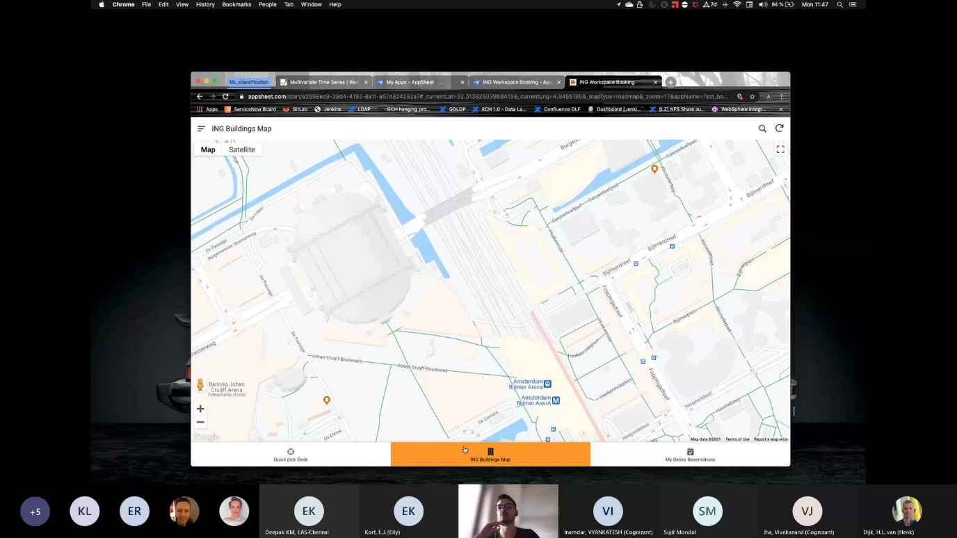

**Display Building Details:**

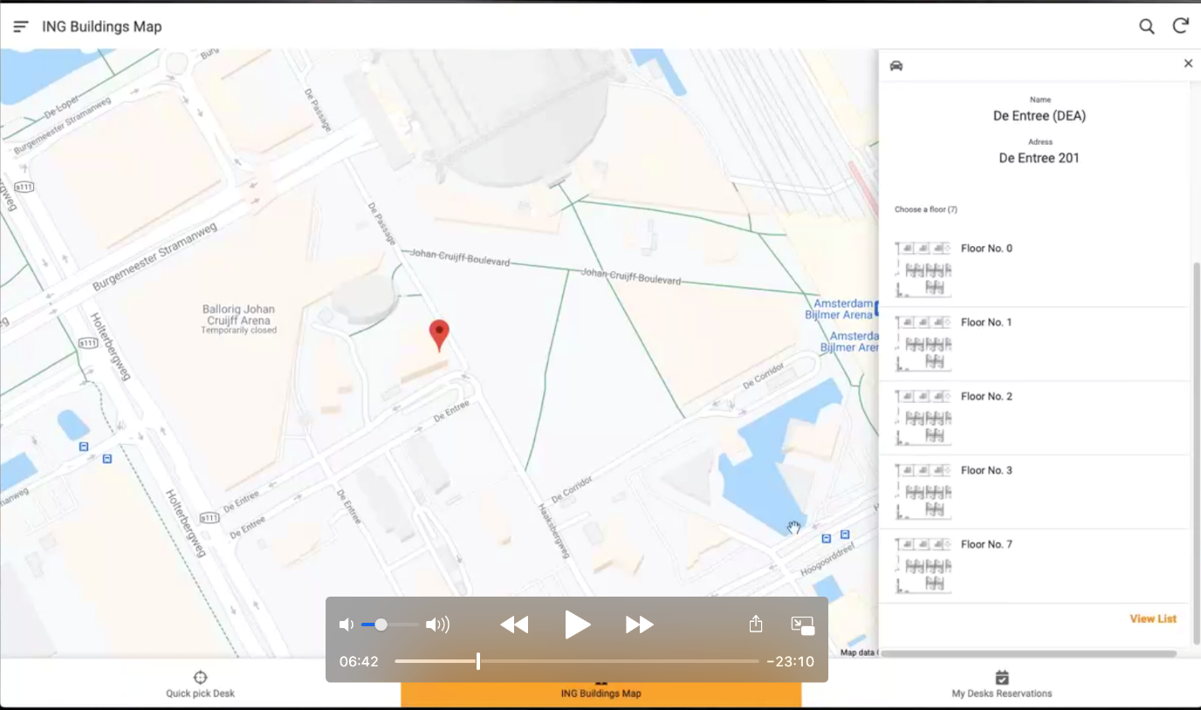

**Display Floor Deatails:**

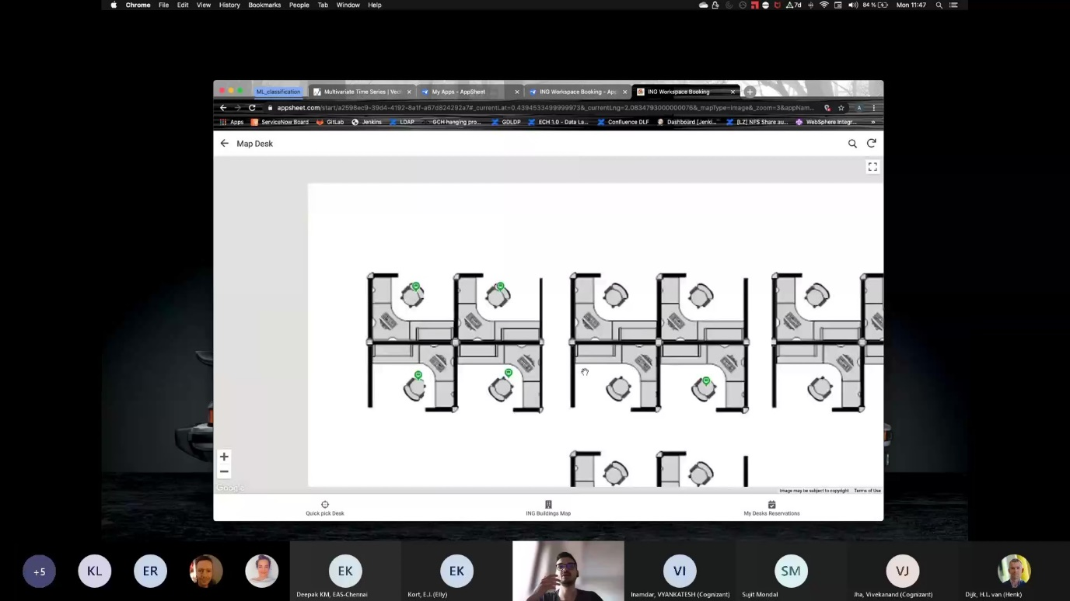

**Display Selected Desk Deatails:**

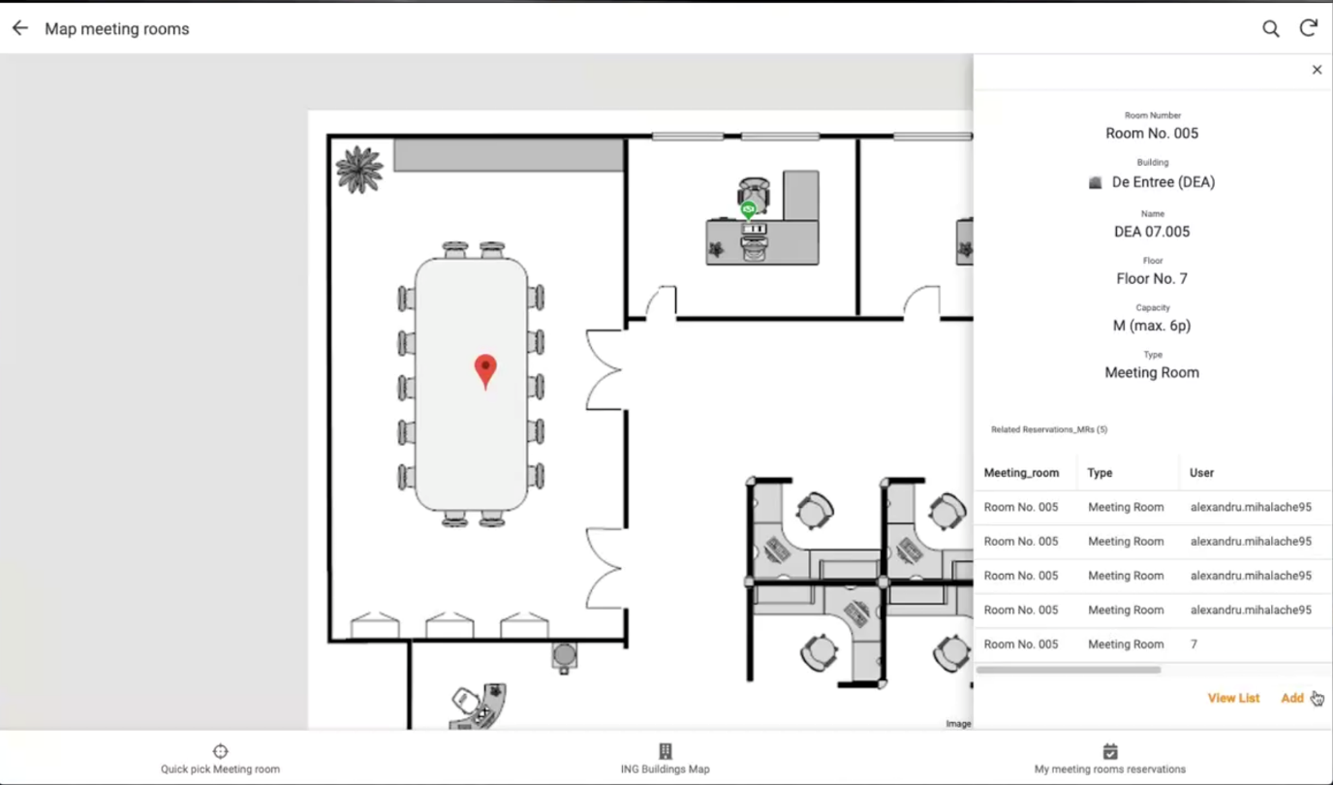

**Make Reservation Page**

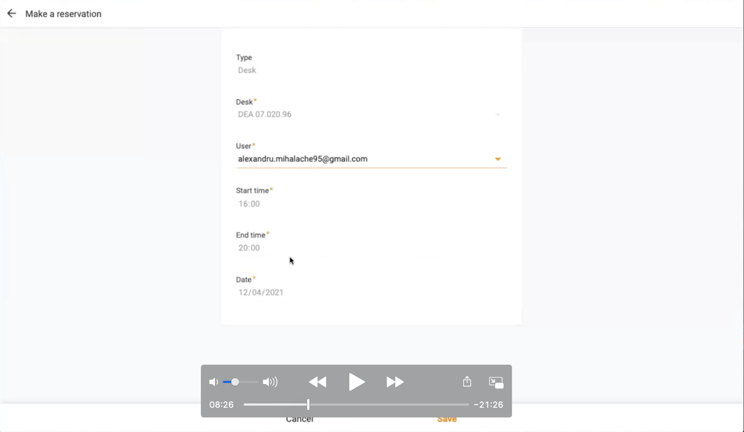

**Display Quick Pick Desk:**

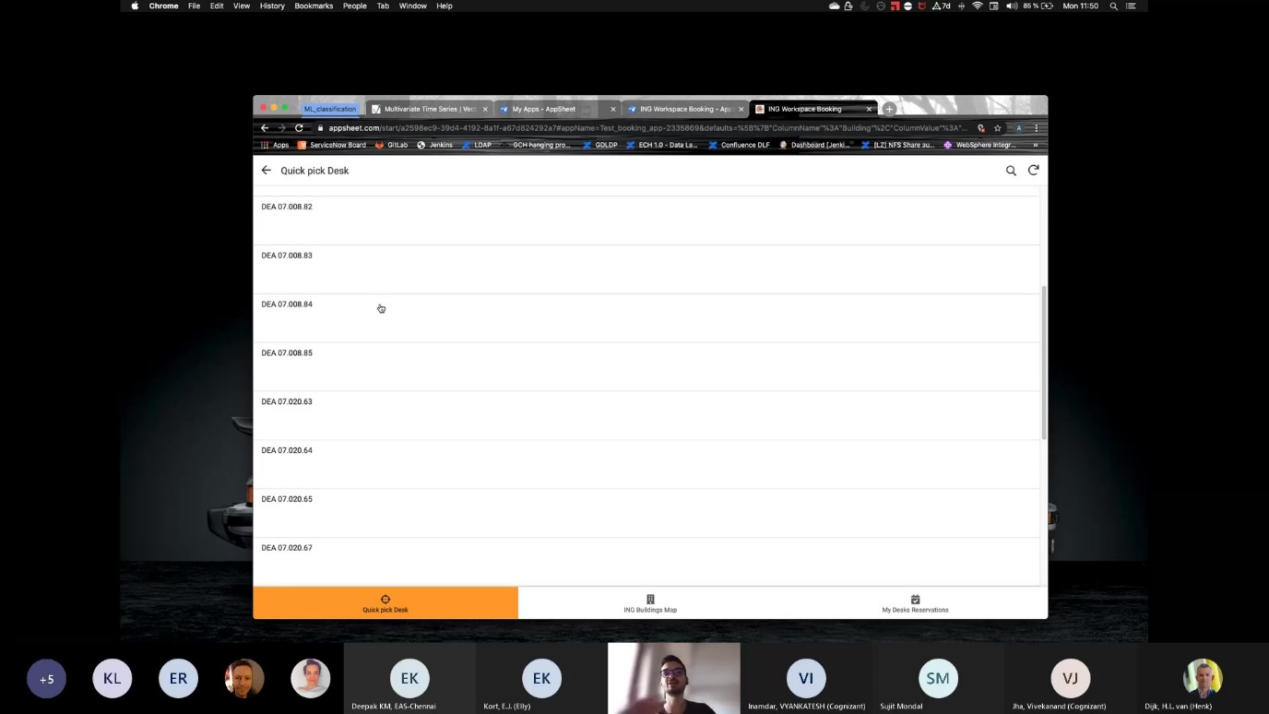

**Display QuickPickDesk Details**

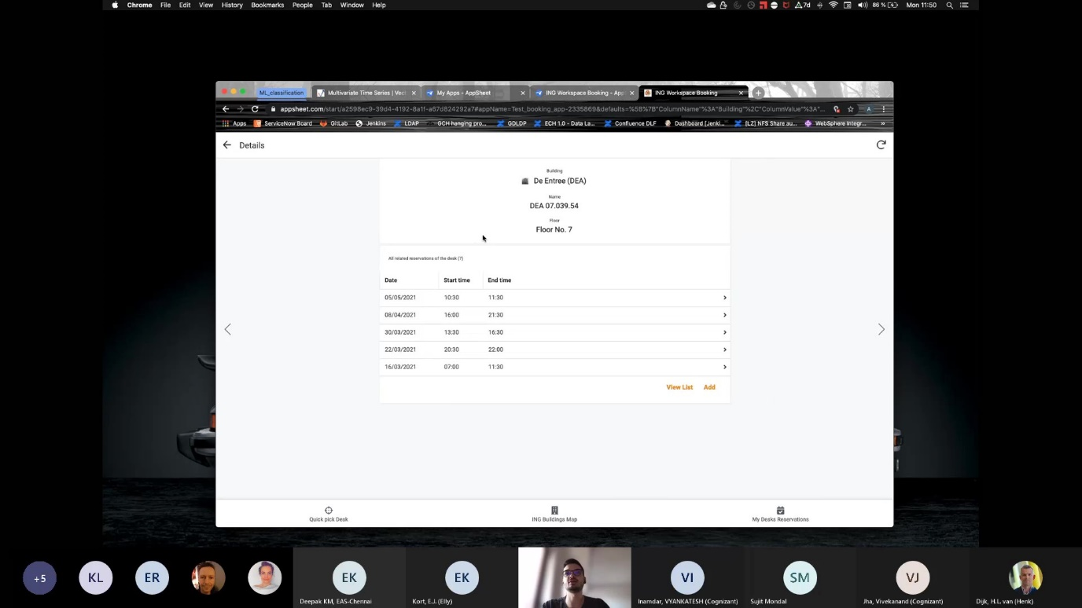

**Check In-Check Out Screen.**

