## Features of Release 1

UI:

1. Startup Login Page:  
   This page asks you for your userid and password and whether you are and external user or an internal user.   
     
   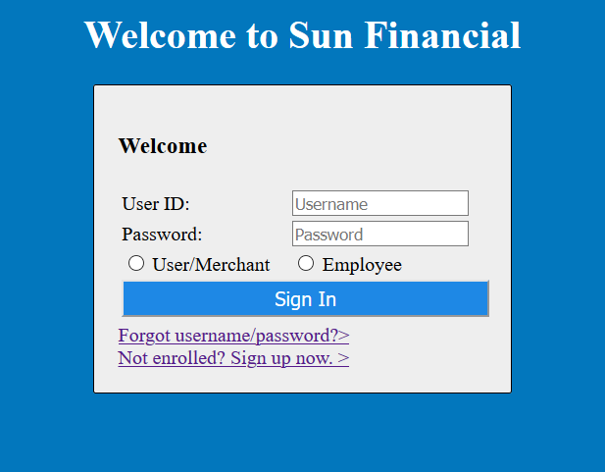
2. Forget username/password page:  
   If the user forgets his password or userid he clicks on the forget username/pasword link. It directs the user to the page below:  
   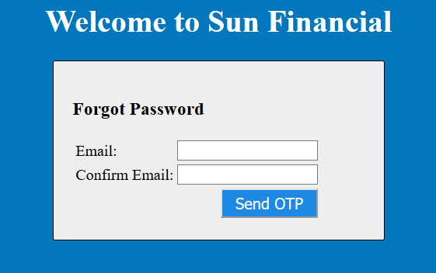  
   It asks the user for his email id and the system sends the user a one time password.   
   Next it takes you to reset password page which looks like this:  
   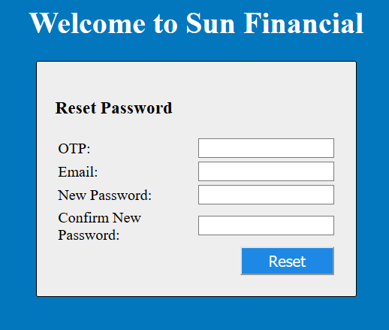   
   Once the password is reset it takes the user back to login page.
3. Sign up page:  
   If a user is not signed up he can click on sign up page to get registered.   
   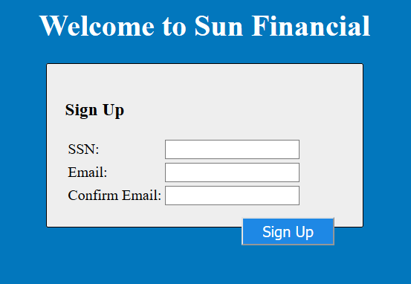  
   The user needs to enter the ssn and email address then click on sign up to get started. The system will send a one-time password to the email. The next page user leads to:   
   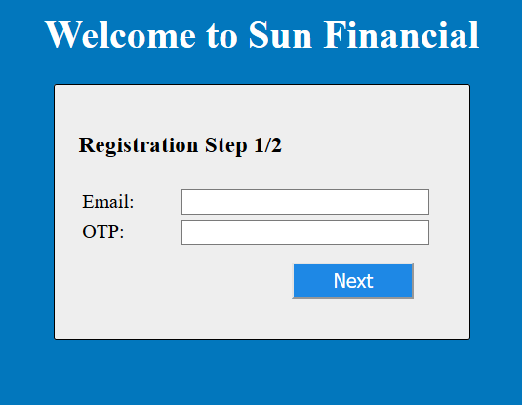  
   The user again enters the email id and otp and presses next. The next step in registration is where all the user details are asked:   
   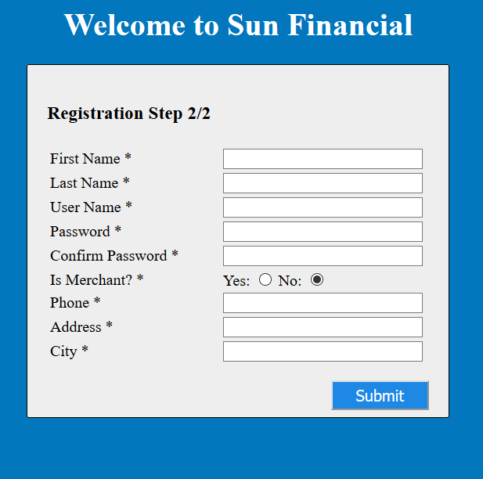  
   Then the user is directed to the login page.
4. Merchant Home:
   1. Account Info:  
      The user can see his funds in all his accounts here.  
      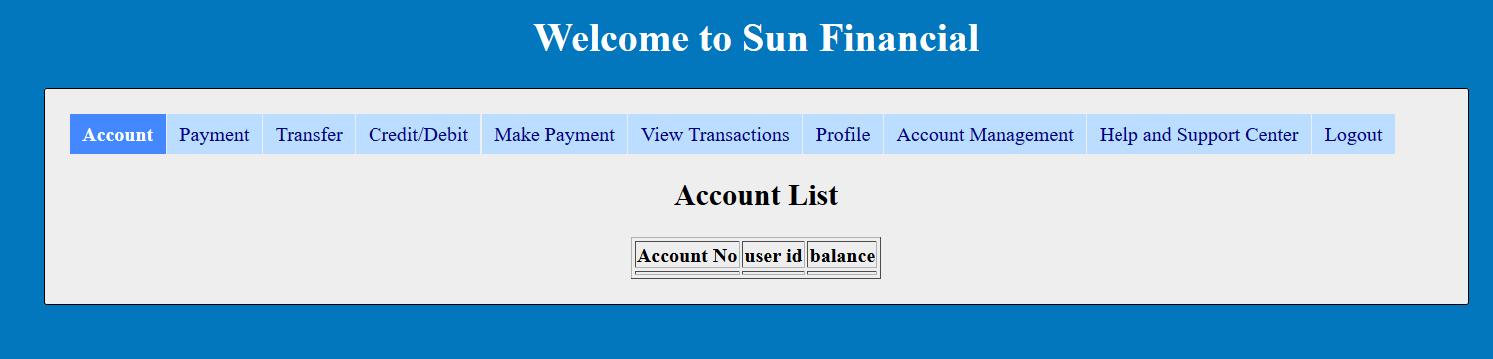
   2. Payment Requests:  
      The user can request funds from any other account.  
      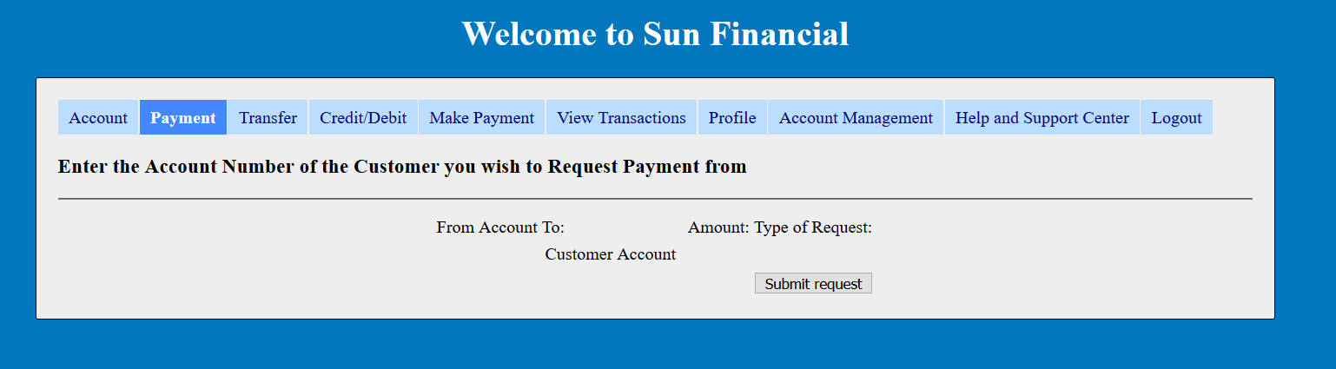
   3. Payment Transfer:  
      The user can transfer funds from one one of his account to any other account number.  
      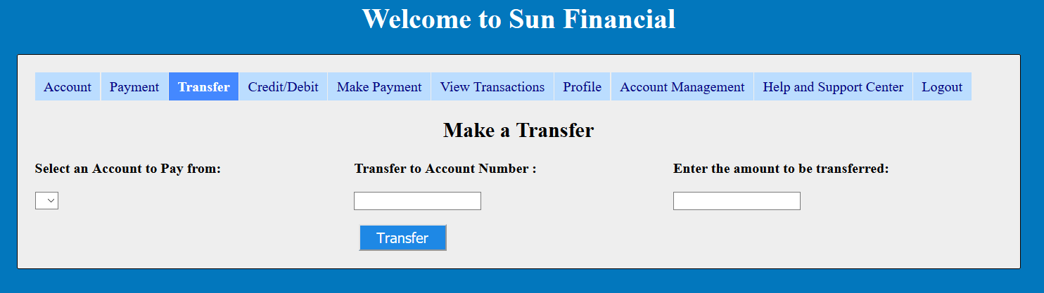
   4. Credit/Debit from an account:  
      The user can debit or credit funds from any one of his accounts.  
      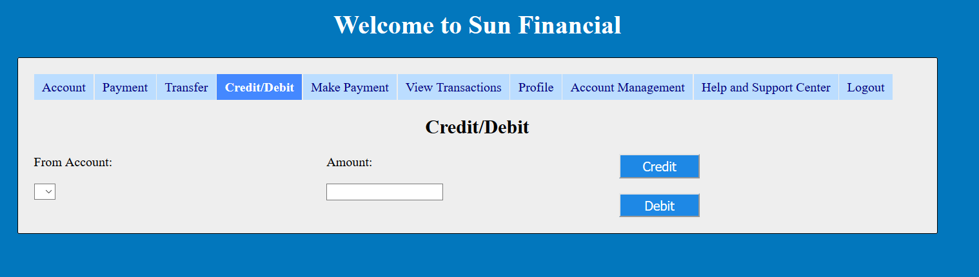
   5. Making a Payment:  
      The user can make a payment which was requested or decline it.  
      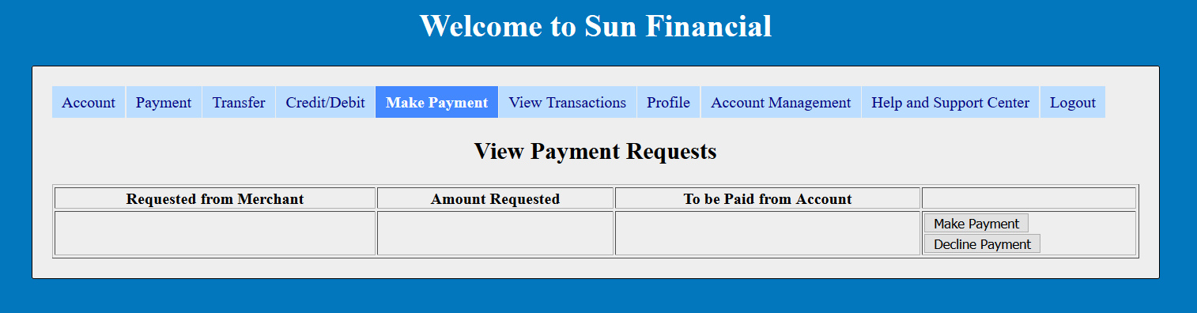
   6. View your previous Transactions:  
      The user can see his transaction history here.  
      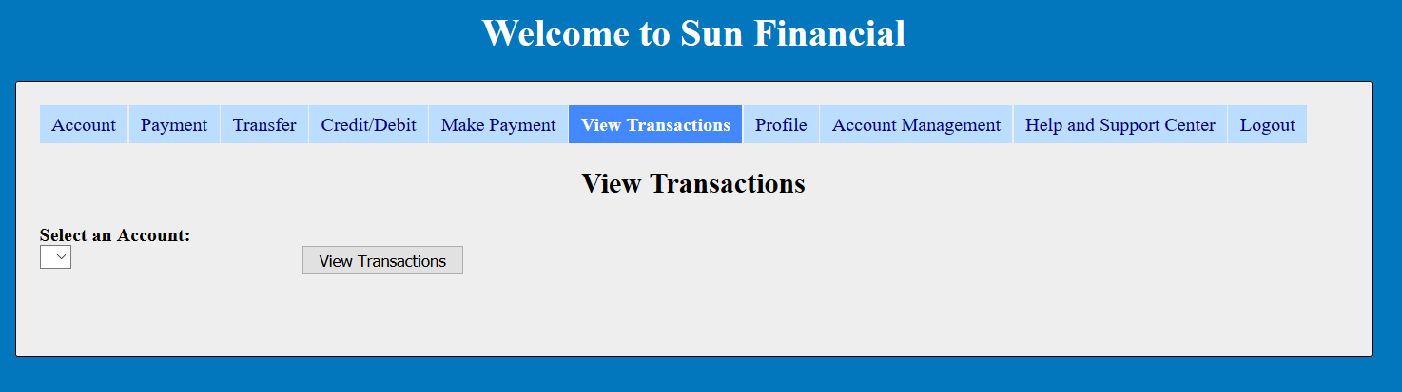
   7. User Profile:  
      The user can edit his profile information here.  
      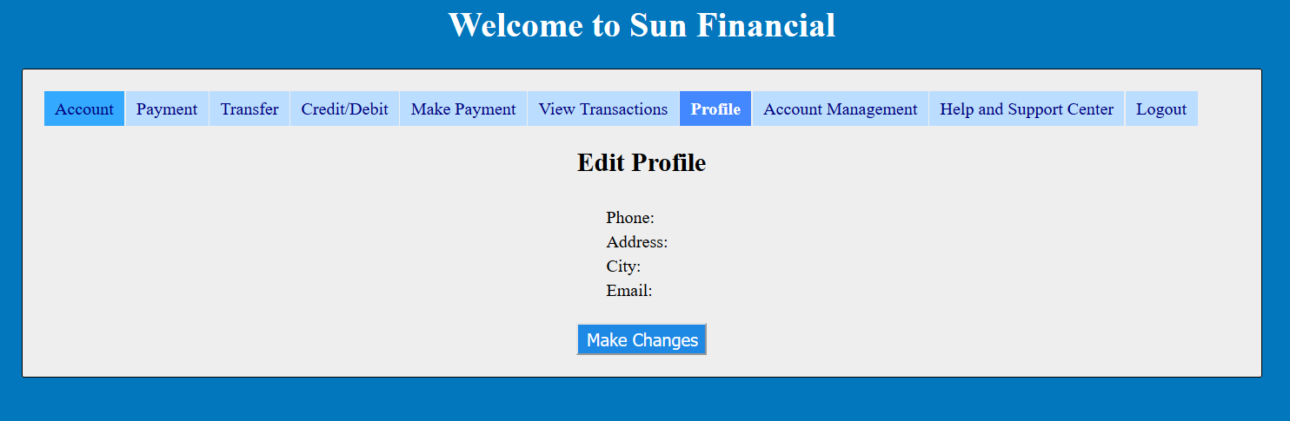
   8. Account Management:  
      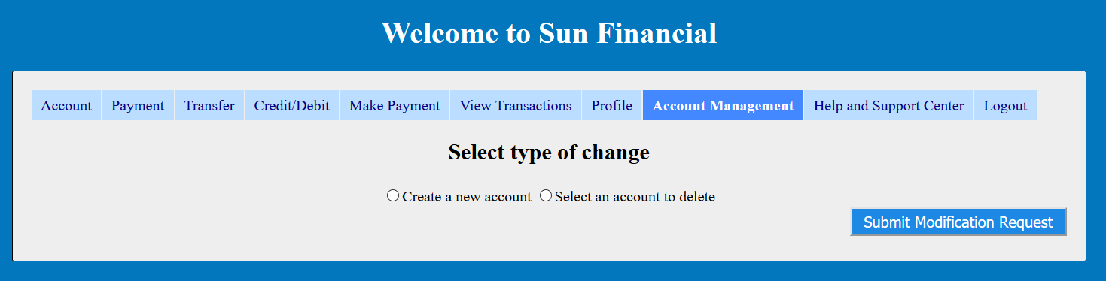
   9. Help and Support Center:  
      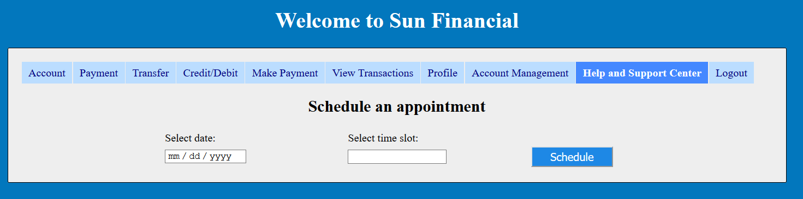
5. Employee Account Home Page: