District summary



Per school summary

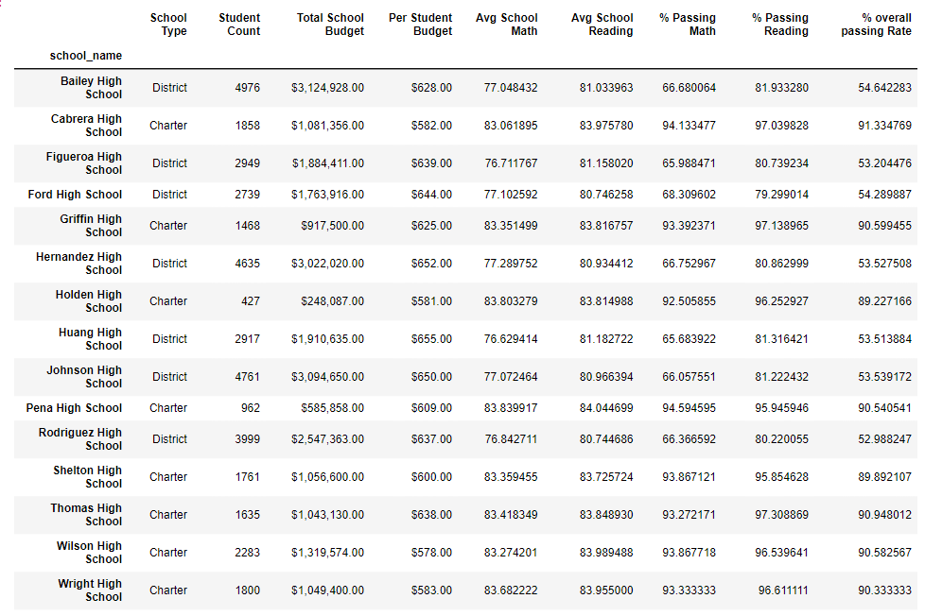

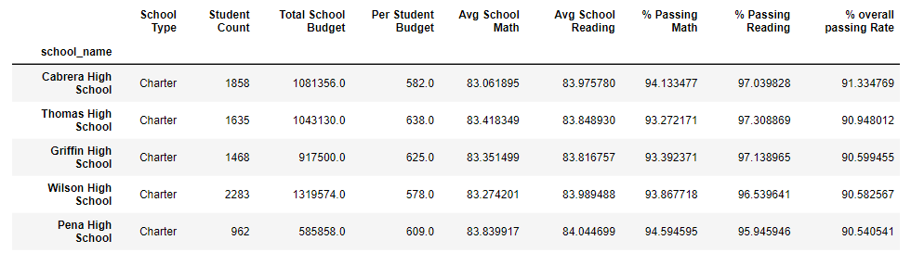**Highest-Performing Schools (by % Overall Passing)**

## Bottom Performing Schools (By % Overall Passing)

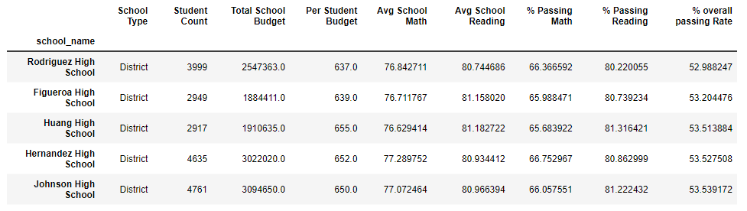

## Math Scores by Grade

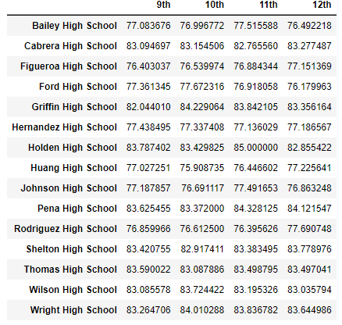

## Reading Score by Grade

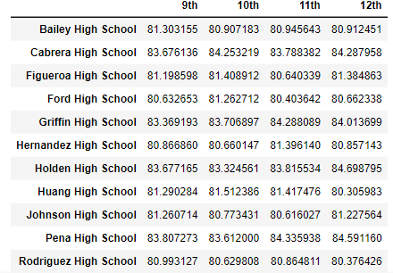

## Scores by School Spending

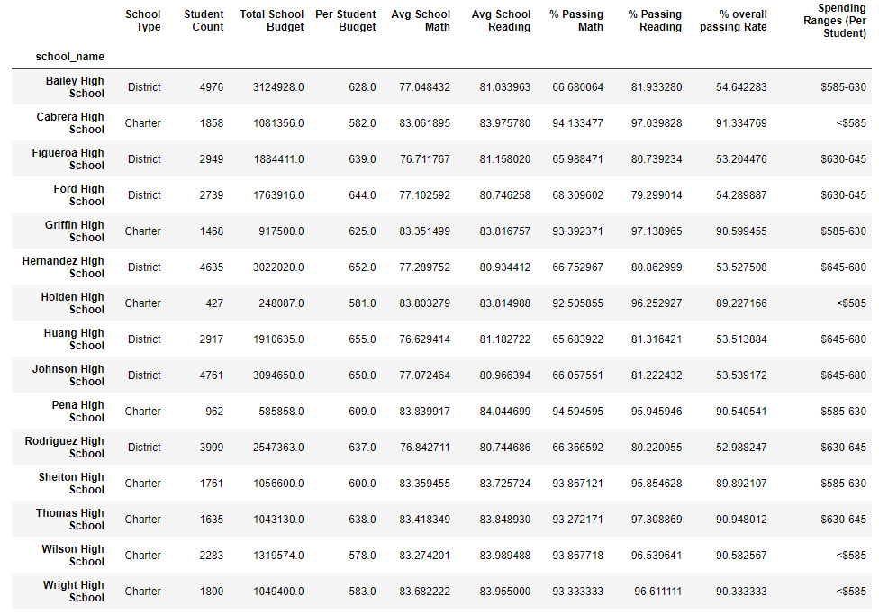

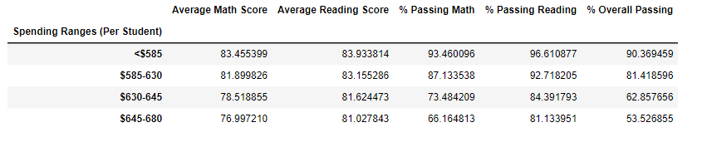

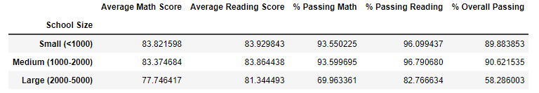

## Scores by School Type

