Model-Based Systems Engineering of a Vision-Guided Pick-and-Place Robot Cell
A complete SysML model from stakeholder needs to verified requirements
Maher Alaa Aldeen, M.Sc. Mechatronics, University of Duisburg-Essen
November 2026
Table of Contents
Abstract 3
1. Introduction 4
1.1 Motivation 4
1.2 Objectives 4
1.3 Scope 4
1.4 How to read this report 4
2. Background 5
2.1 Model-based systems engineering 5
2.2 SysML 5
2.3 The systems-engineering V 5
2.4 Traceability 6
2.5 Verification and validation 6
2.6 Tool 7
3. Methodology 7
3.1 Principles 7
3.2 The work sequence 8
3.3 Model organisation 9
3.3.1 Naming conventions 9
3.4 Quality criteria 9
4. System description 10
4.1 What the cell does 10
4.2 Why a fenced cell 10
4.3 Subsystems 10
5. Stakeholders and operational context 11
5.1 Question 13
5.2 Stakeholders 13
5.3 Systems engineering view 13
5.4 Engineering view 13
5.5 Hand-over 13
6. Requirements 14
6.1 Question 14
6.2 The requirement set 14
6.3 Properties of each requirement 14
6.4 Writing rules 15
6.5 Hazard-based requirements 15
6.6 Derivation 15
6.7 Systems engineering view 15
6.8 Engineering view 15
6.9 What it changed later 16
7. Context and interfaces 16
7.1 Question 16
7.2 What was built 16
7.3 Systems engineering view 17
7.4 Engineering view 17
7.5 Hand-over 17
8. Architecture 18
8.1 Decomposition (D04) 18
8.2 Control and safety architecture (D06) 19
8.3 Safety allocation (D06b) 20
9. Behaviour 21
9.1 The cycle (D07) 21
9.2 Operating modes (D08) 22
9.3 Door open protective stop (D09) 23
9.4 Vision timeout and NOK (D10) 24
10. Analysis 24
10.1 Method 24
10.2 Cycle time and vision latency (D11a) 25
10.3 Safety distance (D11b) 27
10.4 Payload (D12) 29
10.5 Value properties used by the analyses 30
11. Verification and traceability 30
11.1 Test cases 30
11.2 Verify matrix 31
11.3 Satisfy matrix 32
11.4 Systems engineering view 32
11.5 Gap list 32
12. Results and discussion 33
12.1 Summary of results 33
12.2 Coverage 33
12.3 What the model revealed 33
12.4 Feedback between steps 34
13. Decision log 34
14. Assumptions register 34
15. Standards register 35
16. Limitations and threats to validity 35
17. Lessons learned 36
17.1 About the method 36
17.2 About the tool 36
18. Conclusion and next steps 36
Appendix A. Requirements catalogue 37
Appendix B. Value properties and interfaces 39
B.1 Interfaces at the boundary 39
Appendix C. Test cases 39
Appendix D. Glossary 40

Abstract
This report documents a complete model-based systems engineering (MBSE) project. The subject is a fenced robot cell that takes parts from a conveyor, classifies each part with a camera, and places it in an OK bin or a reject bin. The cell was modelled in SysML 1.x with Cameo Systems Modeler (academic licence). The model starts with stakeholders and ends with verified requirements, and in between it holds a requirements baseline, a context and interface definition, a decomposition and architecture, behaviour models, four parametric analyses, and a traceability and coverage check.
The model contains 32 requirements in seven categories, six subsystems, nine typed interfaces, one activity, one state machine with four operating modes, two sequence diagrams, 20 test cases and four analyses. All 32 requirements have a verify relation, and 30 of 32 have a satisfy relation; the two exceptions are explained. The analyses show a cycle time of 2.65 s against a limit of 3.0 s, a vision latency of 0.25 s against 0.30 s, a required safety distance of 608 mm against 800 mm installed, and a payload ratio of 0.26 against 0.50. The cycle-time analysis exposed that the original vision latency limit of 200 ms had no basis, and the requirement was corrected to 300 ms.
The report explains what was built, why each diagram exists, what it shows from a systems-engineering and an engineering point of view, how the steps depend on each other, what the results are, and what the model does not yet prove.

1. Introduction

1.1 Motivation
Machines with safety functions are developed under two pressures. The design has to satisfy many requirements from different people (operators, plant managers, safety officers, IT), and it has to be demonstrated, not just claimed, that each requirement is met. In a document-based process, requirements, architecture, calculations and test plans are separate files. The links between them are written by hand, so they go stale and nobody can count what is missing.
Model-based systems engineering keeps those items as connected elements in one model. A requirement, the block that satisfies it, the calculation that checks it and the test that verifies it are linked by relations, and the tool can count coverage. I chose a robot cell as the subject because it combines mechanics, controls, vision, safety and information technology in a small enough system to model completely.

1.2 Objectives
- Build a consistent SysML model of a pick-and-place cell from stakeholders to verification.
- Make every requirement traceable: where it comes from, what implements it, and how it is verified.
- Use the model, not only describe the system: run calculations on it and let the results change the requirements.
- Show the reasoning behind every diagram, so a reviewer can follow the path from need to proof.
- State openly what is assumed and what is not yet proven.

1.3 Scope
In scope: the cell as a system of interest, its boundary and interfaces, requirements in seven categories, the logical architecture, the operating modes and two key scenarios, four analyses, and verification planning.
Out of scope: detailed mechanical, electrical and software design, a real hazard and risk assessment, validation against real stakeholders, any build of the cell, and any real measurement. Values that would come from these are assumptions and are marked as such.

1.4 How to read this report
Chapter 2 gives the background concepts. Chapter 3 explains the method. Chapters 4 to 11 follow the model in the order it was built, and each describes the question, the systems-engineering view, the engineering view, the result and the hand-over to the next step. Chapters 12 to 18 collect the results, decisions, assumptions, standards, limitations and lessons. The appendices hold the full requirements catalogue, the interface and value tables, the test list and a glossary.

2. Background

2.1 Model-based systems engineering
Systems engineering is the discipline of defining, designing and verifying a system as a whole. Its core activities are understanding what stakeholders need, turning needs into requirements, defining an architecture that can meet them, and showing by analysis and test that it does. MBSE performs these activities on a model instead of on documents. The model is the single source of truth. Diagrams, tables and matrices are views generated from it, and a change in the model shows in every view.

2.2 SysML
SysML is the modelling language used for MBSE. It extends UML with elements for systems: requirements, blocks, ports, flows, constraints and parametric relations. The diagram types used in this project are:
Diagram | Used for
Block definition diagram (BDD) | Decomposition of the cell into subsystems; definition of types
Internal block diagram (IBD) | Context, interfaces and the connection of parts
Requirement diagram | Derivation, satisfy and verify relations
Activity diagram | The pick-and-place cycle, with partitions
State machine diagram | Operating modes
Sequence diagram | Scenarios over time
Parametric diagram | Calculations on value properties
Use case diagram | Actors and goals
Matrices | Coverage of satisfy and verify relations

2.3 The systems-engineering V
The V-model arranges the work as a descent and a climb. On the left side, needs are turned into requirements and then into a design. On the right side, the design is verified step by step against what was specified on the left. The connection is that every left-side item has a right-side check. This project covers the left side completely and plans the right side with verify relations and analyses; it does not include physical tests.
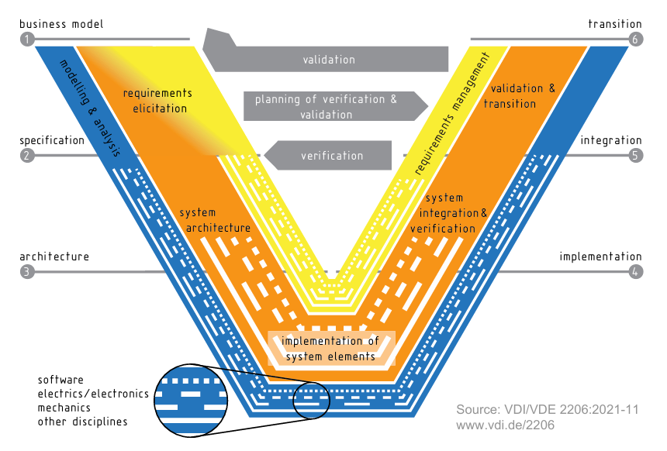

2.4 Traceability
Traceability means that relationships between elements can be followed in both directions. The relations used here are:
Relation | Meaning | Example
Trace | A requirement comes from a stakeholder | REQ-PER-001 traces to the plant manager
DeriveReqt | A requirement is derived from a higher one | REQ-SAF-003 derives from REQ-SAF-001
Satisfy | A block implements a requirement | Door Interlock satisfies the door interlock requirement
Verify | A test or analysis checks a requirement | TC-SAF-003 verifies REQ-SAF-003
A model is complete when no requirement is without an origin, an implementation, or a check. The coverage figures in chapter 11 measure that.

2.5 Verification and validation
Verification asks whether the system was built right, meaning whether it meets its requirements. Validation asks whether the right system was built, meaning whether it meets the real needs. This project works on verification: it plans and partly performs checks against requirements. Validation would need real stakeholders and is outside scope.

2.6 Tool
Cameo Systems Modeler (academic licence) was used. Its simulation function (Simulation, Run) evaluates constraint blocks bound to value properties, which is how the four analyses were run.

3. Methodology

3.1 Principles
- Every diagram answers one question. A diagram without a question is decoration. The question, the reason it is needed, the requirements it supports and the person who reviews it are written in each diagram’s documentation field.
- Source and verification belong to the requirement. A requirement without a source has no reason to exist, and one without a verification method cannot be shown to be met.
- One “shall” per requirement. One requirement gives one pass or fail result.
- Numbers carry their status. A value is plain when it comes from a standard or stakeholder, and marked (A) when assumed or TBC when it must be confirmed.
- Calculate early. An analysis on assumed values still shows where the system is tight and which assumption matters.
- Name the gaps. The gap list and the limitations are part of the result, not a confession.
- One place per value. A value is typed once on a block and every analysis, diagram and requirement reads it from there.

3.2 The work sequence
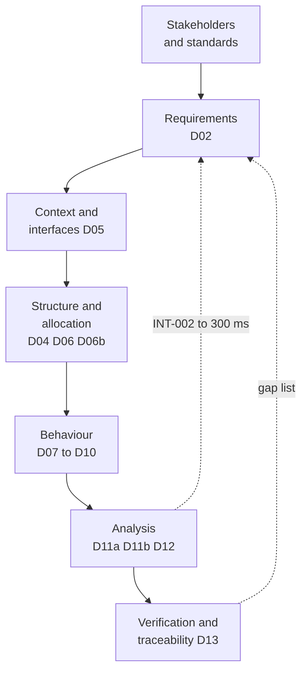

Method map: each step supplies the next, and two later steps fed back into earlier ones
The work followed ten planned days:
Day | Work | Output
1 | Project set-up, stakeholders, glossary, conventions | Package structure, stakeholder list, D01
2 | Scope and use cases | D03
3 | Requirements | 29 requirements, source and verify method, three own requirements
4 | Derivation and decomposition | D02, D04
5 | Context, interfaces, architecture | D05, interface blocks, D06, D06b
6 | Behaviour | D07, D08
7 | Scenarios and verification planning | D09, D10, test cases
8 | Analysis | D11a, D11b, D12
9 | Traceability and review | D13, gap list, documentation check
10 | Write-up and publication | This report, repository, resume bullets

3.3 Model organisation
The model is divided into numbered packages that follow the order of the work:
Package | Content
00_Admin | Glossary and the assumptions list
01_Stakeholders | Stakeholder elements STK-01 to STK-06
02_Requirements | Requirements grouped by category (FUN, PER, SAF, INT, ENV, CYB, MNT)
03_Context | The context block and its diagram
04_Structure | Blocks, interface blocks and signals
05_Behavior | Activity, state machine and sequence diagrams
06_Analysis | Constraint blocks and parametric diagrams
07_Verification | Test cases
08_Views | Requirement diagrams and matrices

3.3.1 Naming conventions
Requirement IDs use a category prefix and a number (REQ-SAF-003). Diagrams are named D01 to D13 with a short title. Test cases use TC followed by the category and number (TC-SAF-003). Ports use the interface name with In or Out. Value properties carry units in their descriptions and are typed with real numbers.

3.4 Quality criteria
The model was reviewed against these criteria before publication:
- Every requirement has a source and a verification method.
- Every requirement has exactly one “shall”.
- Every requirement has a verify relation.
- Every diagram has its four-line documentation.
- Every assumed value is marked (A) or TBC and listed in the assumptions list.
- Names are consistent, and no default names such as Block1 remain.

4. System description

4.1 What the cell does
Parts arrive on a conveyor. A sensor signals that a part is present, and the vision system captures an image and classifies the part as OK or NOK. The robot picks the part with a gripper and places it in the OK bin or the reject bin according to the result. If the classification result is late, the part is treated as NOK and the operator gets a warning. The cell is operated through an HMI panel and supervised by a PLC. A separate safety controller monitors the emergency stop, the door interlock and the light curtain.

4.2 Why a fenced cell
The cell is fenced: a guard separates the robot from people, and access is through an interlocked door or a light curtain opening for bin exchange. This was a deliberate decision. A fenced cell fits the rules for a guarded robot cell in ISO 10218 and leaves out the force and speed limits that collaborative operation would add. It also keeps the safety case small enough to model completely.

4.3 Subsystems
Subsystem | Content | Role
RobotSystem | 6-axis arm, robot controller, gripper | Moves the part; rated payload 5.0 kg, rated reach 850 mm
VisionSystem | Camera, lighting, vision computer | Captures and classifies each part
CellController | PLC | Coordinates the cycle, handles modes and warnings
SafetySystem | E-Stop, door interlock, light curtain, safety controller | Detects hazards and commands the safe stop
CellEquipment | HMI panel, fence, bin stations | Operator interface, guarding, part destination

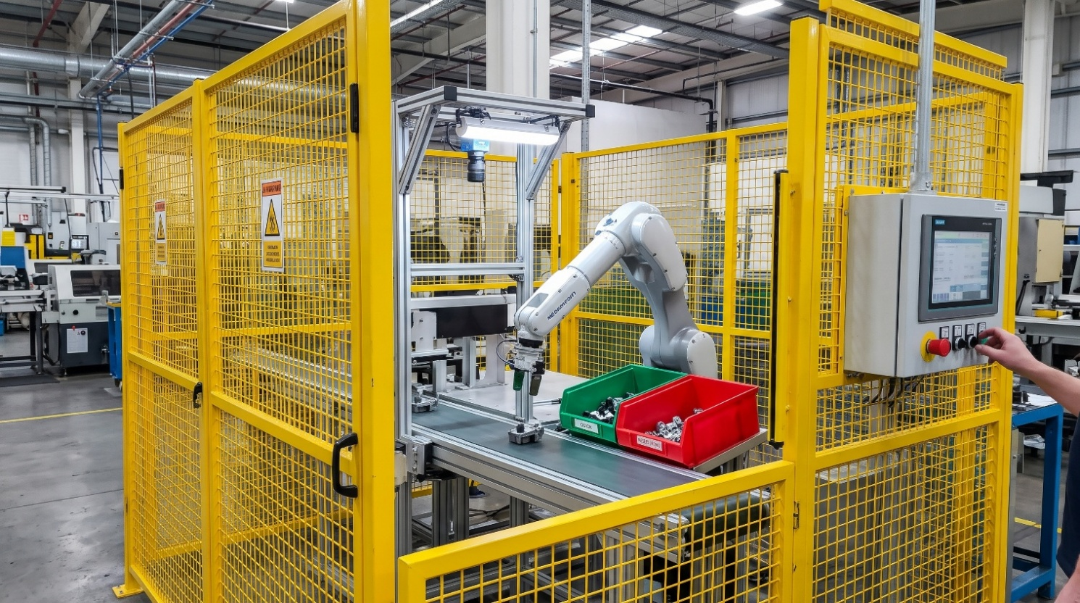

5. Stakeholders and operational context
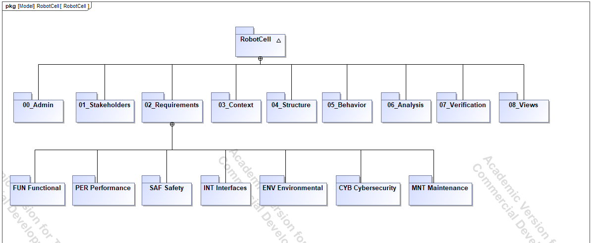
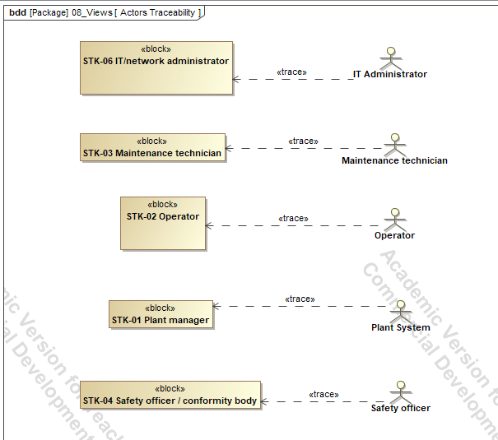
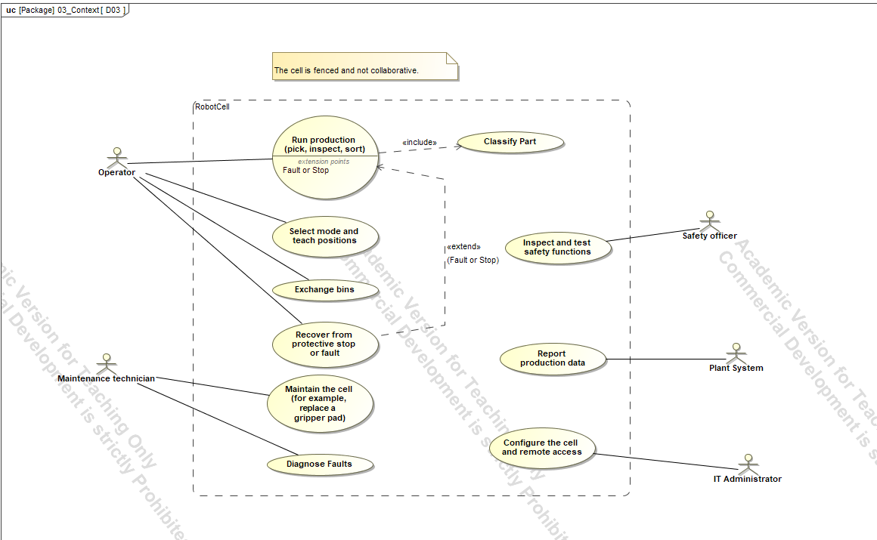

5.1 Question
Who needs the cell, what do they need, and where does the system end?

5.2 Stakeholders
ID | Stakeholder | Main interest
STK-01 | Plant manager | Throughput, cycle time, availability
STK-02 | Operator | Simple start, stop and bin exchange, safely; clear status
STK-03 | Maintenance technician (check against D01) | Easy gripper pad replacement, payload margin
STK-04 | Safety officer (check against D01) | Documented risk assessment, protective stops, performance level
STK-05 | Quality or process engineer (check against D01) | Classification quality, placement accuracy, vision behaviour
STK-06 | IT / network administrator | Secure configuration and data access

5.3 Systems engineering view
Stakeholder analysis comes first because every requirement and interface depends on it. Without it, requirements are written from the designer’s imagination. The stakeholders are modelled as elements so that requirements can be linked to them with trace relations; 21 such traces exist. The system boundary decides what is part of the system of interest and what is environment. Anything outside becomes an actor or an external system and later turns into an interface.
The use case view adds the operational concept: who uses the cell for which goal. Use cases expose functions that requirements must cover (for example bin exchange, which later led to REQ-SAF-013), and they expose actors that need an interface.

5.4 Engineering view
The scope decision to fence the cell matters for the safety case. A fenced cell relies on separation and on stopping the robot when the separation is opened. The relevant standards (ISO 10218-1, -2, ISO 14119 for the interlock and IEC 61496 for the light curtain) apply to exactly that.

5.5 Hand-over
The stakeholders become the sources of requirements (chapter 6), and the actors become boundary interfaces (chapter 7).

6. Requirements
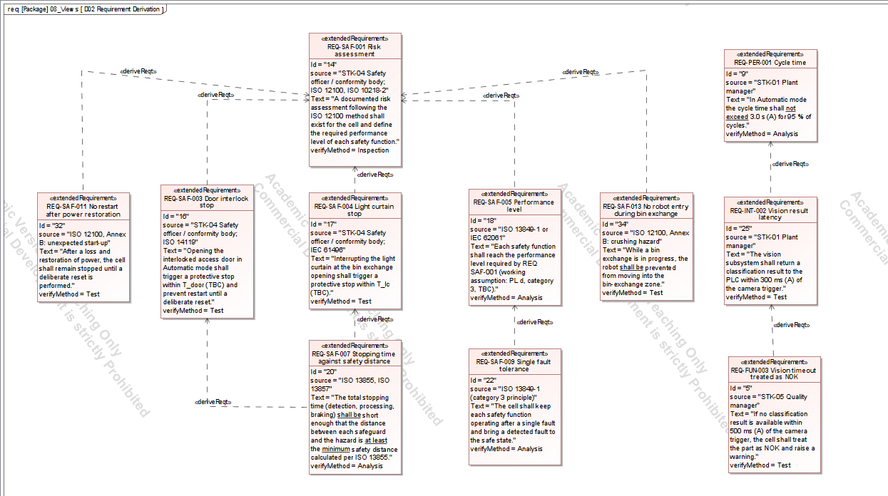

6.1 Question
Where does each requirement come from, and how do requirements relate to each other?

6.2 The requirement set
The baseline has 32 requirements in seven categories. The full catalogue with text, source and verification method is in Appendix A.
Category | Prefix | Count | Typical content
Functional | FUN | 6 | Pick and place by classification, classification before pick, timeout, modes, counting
Performance | PER | 5 | Cycle time, accuracy, classification quality, availability, payload margin
Safety | SAF | 13 | Risk assessment, emergency stop, interlock, light curtain, performance level, speed limit, safety distance
Interface | INT | 3 | Communication, vision latency, supply voltage
Environmental | ENV | 2 | Ambient conditions, EMC
Cybersecurity | CYB | 1 | Authenticated configuration
Maintenance | MNT | 2 | Inspection intervals, pad replacement

6.3 Properties of each requirement
Each requirement is an ExtendedRequirement with three fields beyond its text:
- Source: the stakeholder or standard that the requirement comes from.
- VerifyMethod: test, analysis, inspection or demonstration.
- Risk: how much it matters if the requirement fails.
I first tried to add these as a profile with a stereotype, but the profile option was not available in the tool’s mode. The built-in ExtendedRequirement fields give the same information next to the text. A Status field was left out on purpose, because it adds upkeep and gives nothing in a single-author model.

6.4 Writing rules
- One “shall” per requirement. A requirement with two shall statements has two pass or fail outcomes, and a test can pass one and fail the other. Eight requirements (PER-003, SAF-001, SAF-003, SAF-006, SAF-008, SAF-009, SAF-010, CYB-001) were reworded to carry exactly one “shall”.
- Verifiable wording. A requirement says what is checked and against which limit.
- Marked numbers. Where a number came from my judgement, it carries (A); where it must come from a standard, it carries TBC.
- At most one mode. REQ-FUN-004 first said exactly one mode is active; it now says at most one, because Off and Initializing are system states, not modes. The four modes are Automatic, Manual, Maintenance and Fault.

6.5 Hazard-based requirements
Most of the first 29 requirements come from stakeholders and standards. Three more were written from hazard thinking in the style of ISO 12100: ask what could hurt someone, then state what the design must do.
ID | Requirement | Hazard behind it
REQ-SAF-011 | No restart after power restoration | The robot moves unexpectedly when power comes back
REQ-SAF-012 | Energy isolation for maintenance | Stored or live energy while a person works in the cell
REQ-SAF-013 | No robot entry during bin exchange | A person reaches in while the robot moves
They matter more than their count suggests, because they show that the requirements were not only collected from existing lists.

6.6 Derivation
D02 shows 10 derive relations. REQ-SAF-003, 004, 005, 011 and 013 derive from REQ-SAF-001 (risk assessment). REQ-SAF-007 (stopping time against safety distance) derives from REQ-SAF-003 and 004, because the stopping time is what makes the interlock stop and the light curtain stop effective. REQ-SAF-009 (single fault tolerance) derives from REQ-SAF-005 (performance level). REQ-INT-002 (vision latency) derives from REQ-PER-001 (cycle time) because the latency is part of the cycle, and REQ-FUN-003 (timeout) derives from REQ-INT-002.

6.7 Systems engineering view
Requirements are a hierarchy. A top-level need is derived into requirements specific enough to implement and test. Stakeholder traces connect each requirement upward to its origin, and later satisfy and verify relations connect it downward. Together they give bidirectional traceability, which is what a conformity reviewer checks first.

6.8 Engineering view
The safety requirements follow the logic of ISO 12100: identify hazards, estimate risk, choose measures. They also mirror the structure of the machine standards: stop functions (ISO 13850, IEC 60204-1), interlocking (ISO 14119), protective devices (IEC 61496), safety distance (ISO 13855, ISO 13857) and control reliability (ISO 13849-1, IEC 62061).

6.9 What it changed later
The derive chain INT-002 to PER-001 is what made the cycle-time analysis the right check (chapter 10), and the analysis then corrected REQ-INT-002 from 200 ms to 300 ms.

7. Context and interfaces
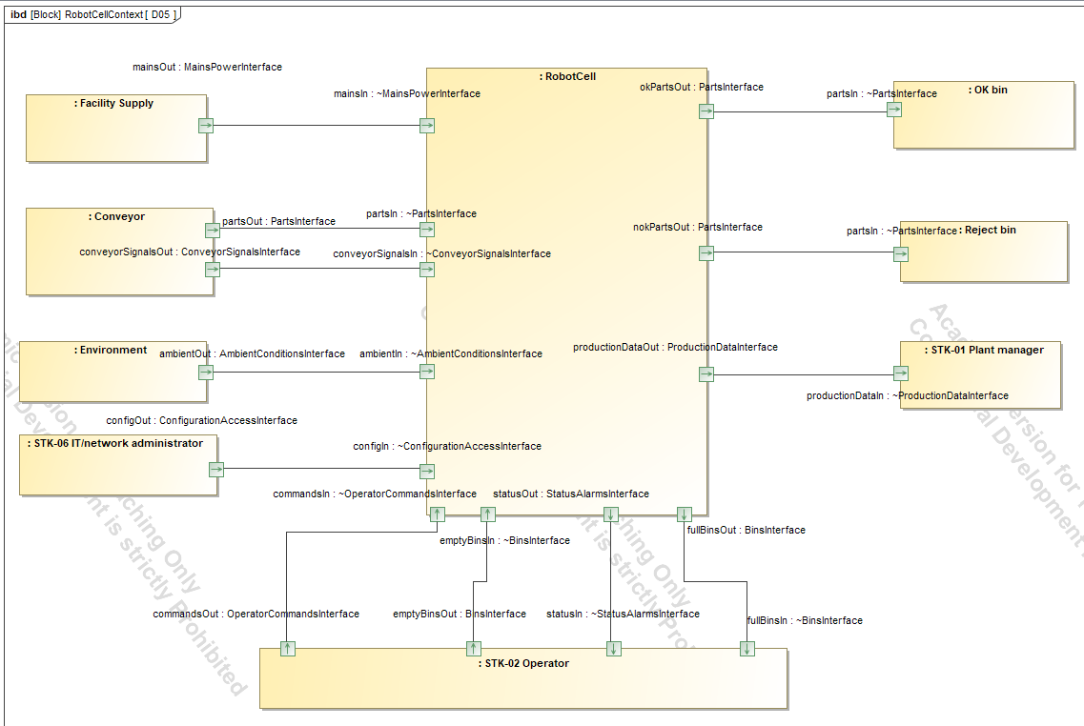

7.1 Question
What crosses the system boundary?

7.2 What was built
The context diagram is an internal block diagram of a context block. It shows the cell, the facility supply, the conveyor, the environment, the OK bin, the reject bin and three stakeholders (plant manager, operator, IT administrator). Twelve connectors cross the boundary, and each uses a typed port.
The ports are typed by nine interface blocks, and each interface block contains flow properties that say what flows and in which direction:
Interface block | Flows (direction out of the sending side)
MainsPowerInterface | MainsPower230VAC
PartsInterface | Part
BinsInterface | Bin
ConveyorSignalsInterface | PartPresent, ConveyorStop
AmbientConditionsInterface | Ambient conditions
ConfigurationAccessInterface | Configuration
OperatorCommandsInterface | StartCommand, StopCommand, ModeCommand
StatusAlarmsInterface | Status, Alarm
ProductionDataInterface | ProductionCount, LogEntry

7.3 Systems engineering view
This is the interface definition at the highest level. Interfaces are where integration problems arise, so they are defined before the internal design, and each is typed so that a mismatch is visible. In SysML two connected ports must be compatible: the sending port is plain, and the receiving port is conjugated, which reverses the flow directions. The tool marks incompatible connections in red. In my first version the connectors were red because the receiving ports were not conjugated; setting conjugation on every receiving port removed the errors. This is a good example of the model finding an interface fault.

7.4 Engineering view
The interfaces name what a plant integrator must provide: a 230 V supply, parts on a conveyor, empty bins, ambient conditions within limits, and a network connection for configuration and data. They also define what the cell offers back: status and alarms, production data and OK and NOK parts in the bins.

7.5 Hand-over
The interface blocks are reused on the cell block in D04 and D06, so the connections inside the cell use the same types.

8. Architecture
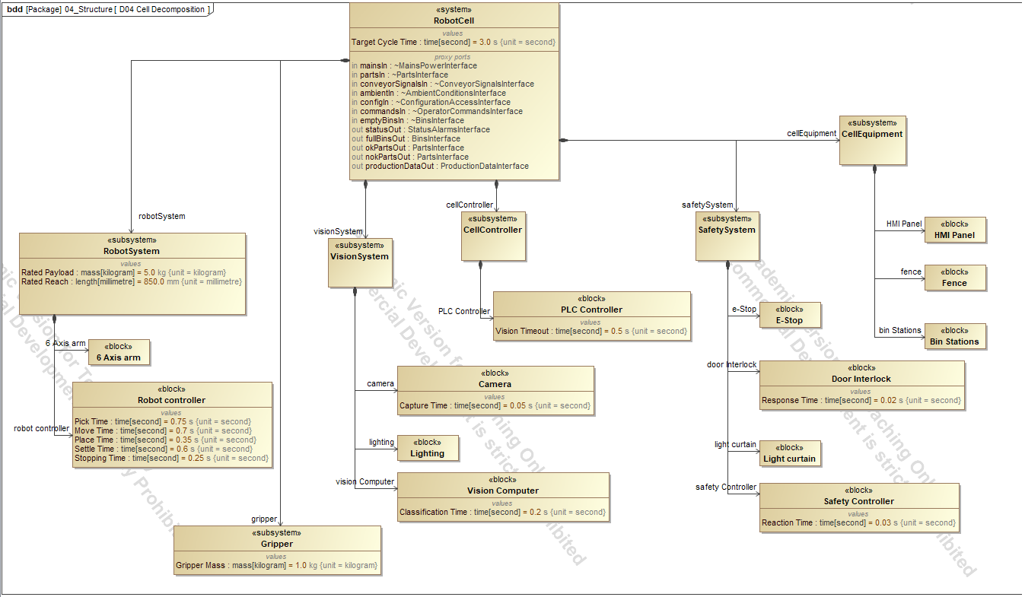

8.1 Decomposition (D04)
Question. What are the parts of the cell?
A block definition diagram decomposes the cell into subsystems, each with its parts, and types the key values: Target Cycle Time 3.0 s on the cell, Rated Payload 5.0 kg and Rated Reach 850 mm on the robot system, Gripper Mass 1.0 kg on the gripper. The cell block also holds the 12 proxy ports defined in chapter 7.
Systems engineering view. Decomposition is the basis for allocation, since a requirement can only be assigned to something that exists. It also creates the places where values live, so analyses read them from one source.
Engineering view. The split into robot, vision, control, safety and equipment matches how such a cell is procured and integrated.
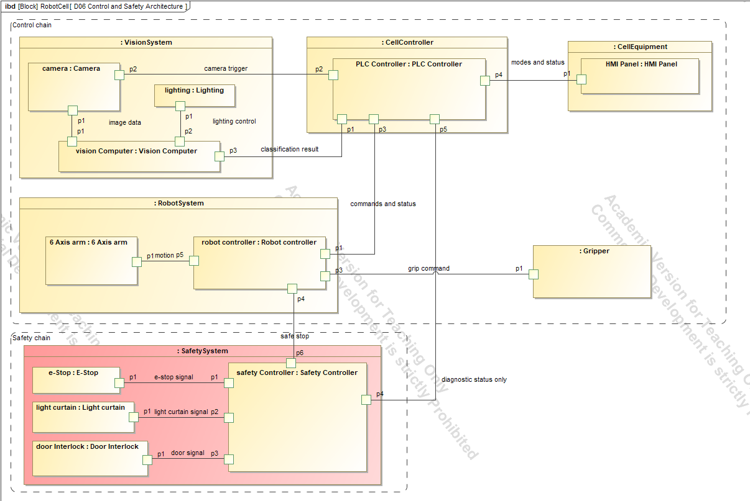

8.2 Control and safety architecture (D06)
Question. How are the subsystems connected, and is the safety chain separate from the control chain?
An internal block diagram of the cell shows 8 control connectors and 5 safety connectors.
Systems engineering view. This is the logical architecture. It is where the main principle for safety functions becomes visible: safety functions must be independent of the control that they supervise, so that a fault in the control cannot disable a safety function.
Engineering view. The safety chain runs from the sensors (E-Stop, door interlock, light curtain) through the safety controller to the safe stop of the robot. It touches the control chain (PLC, robot controller) only at the safe stop and the diagnostic status. This is the architectural idea behind the categories and performance levels of ISO 13849-1, and it is the model form of REQ-SAF-010, which requires that the standard PLC is not relied on for any safety function.
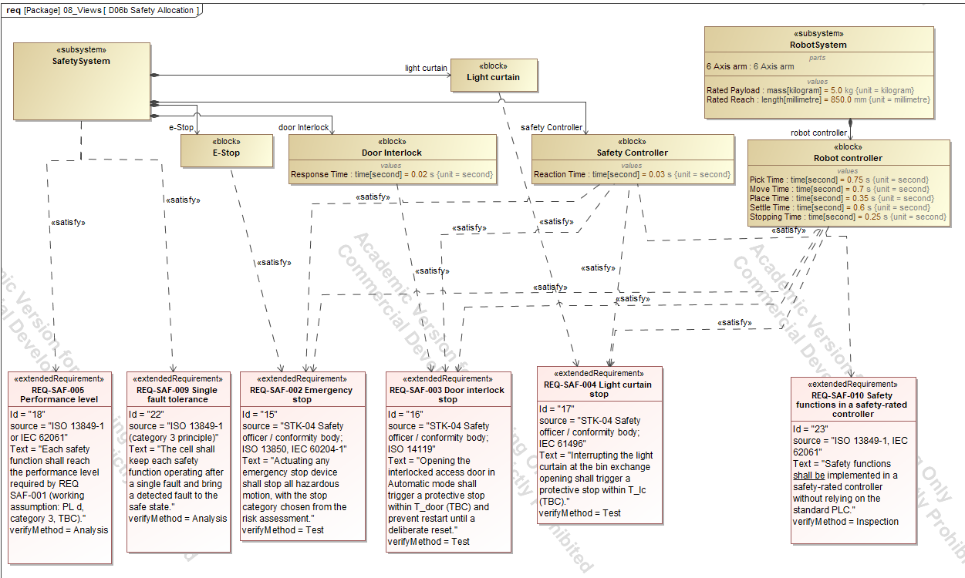

8.3 Safety allocation (D06b)
Question. Which block implements each safety requirement?
Twelve satisfy relations connect safety requirements to the blocks that implement them.
Systems engineering view. Allocation. A requirement with no satisfying block is not implemented, and a block with no requirement has no purpose, so the diagram checks both directions. Together with D06 it shows that safety functions are assigned to the safety system and not to the PLC.

9. Behaviour

9.1 The cycle (D07)
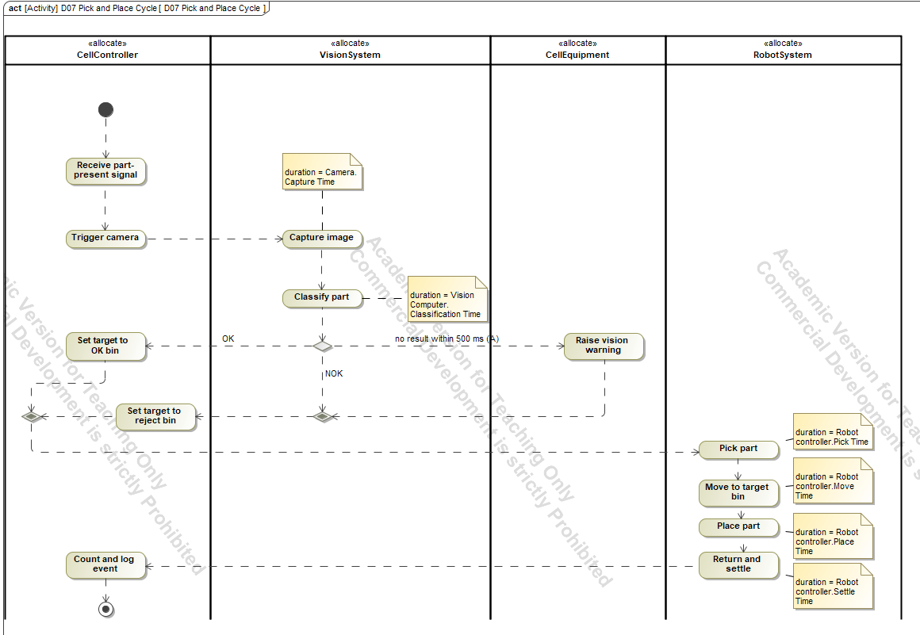
Question. What steps make up one cycle, and who performs each?
An activity diagram with four partitions (CellController, VisionSystem, CellEquipment, RobotSystem) shows the flow from the part-present signal to the placed part, with the vision-timeout branch. Six actions carry a duration note that points to a value property: capture, classification, pick, move, place and settle.
Systems engineering view. Functional allocation: each action sits in the subsystem that performs it, which checks that the structure can perform the functions. The timing is attached to the same value properties that the analysis uses, so behaviour and calculation cannot drift apart.
Engineering view. The cycle is a typical sense-decide-act sequence. Classification happens before the pick (REQ-FUN-002), and a late result does not stall the line but routes the part to the reject bin (REQ-FUN-003).

9.2 Operating modes (D08)
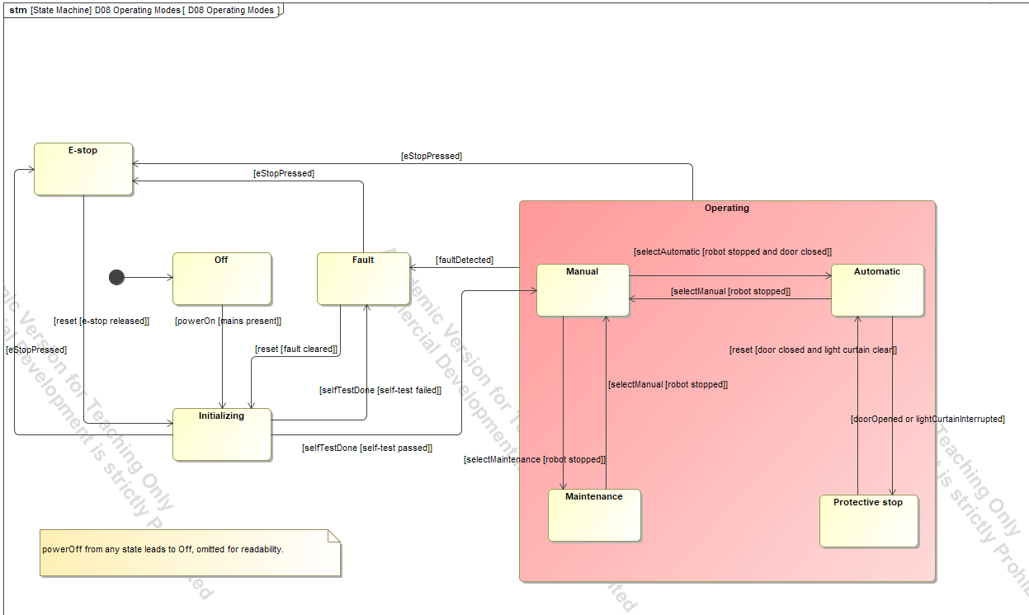
Question. Which modes exist, and which transitions are allowed?
A state machine under the cell block has the states Off, Initializing, E-stop, Fault and a composite Operating state with Manual, Automatic, Maintenance and Protective stop. Fifteen transitions carry guards, for example a mode change guarded by the robot being stopped.
State | Meaning
Off | No power, no motion
Initializing | Start-up checks after power on
Automatic | Normal production
Manual | Reduced speed, enabling device held (teach)
Maintenance | Access for service with energy control
Protective stop | Stopped by door, light curtain or other safeguard
E-stop | Stopped by an emergency stop
Fault | A fault is detected; safe state until reset
Systems engineering view. Mode logic is where hidden faults live, so it is modelled explicitly and reviewed by properties: every state has an exit, no unsafe transition exists, and the set of states is complete. A diagram review that checks these three things is stronger than reading the diagram top to bottom.
Engineering view. Maintenance cannot go directly to Automatic, and every mode change requires the robot to be stopped (REQ-FUN-005). This follows the logic of the operating-mode rules in ISO 10218. REQ-FUN-004 states that at most one mode is active at a time.
Modelling note. The transition names were not shown in the diagram, so each transition’s label was typed into its guard field, which the tool does display.

9.3 Door open protective stop (D09)
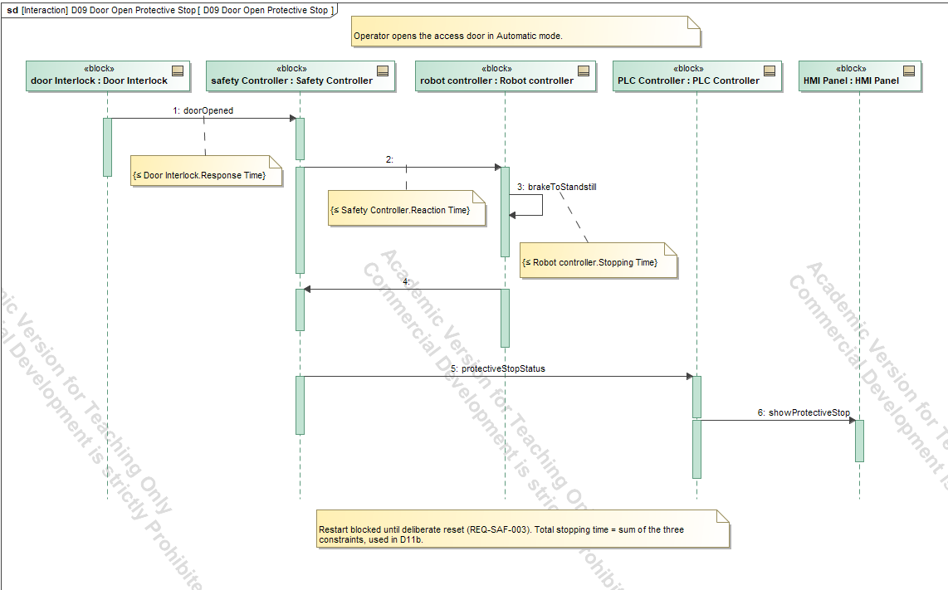
Question. What happens in time when the door opens in Automatic mode?
A sequence diagram shows the door interlock detecting the open door, the safety controller commanding a stop, and the robot reaching standstill. Three time constraints on the messages carry the same values that the safety distance analysis uses.
Systems engineering view. A scenario shows the interaction between subsystems over time, and a time constraint on a message turns a requirement into something checkable. Writing the scenario with the same values as the calculation prevents two versions of the truth.
Engineering view. The total response time (detection, processing and braking) decides how far a person can move before the hazard stops, and therefore the minimum distance of the guard.

9.4 Vision timeout and NOK (D10)
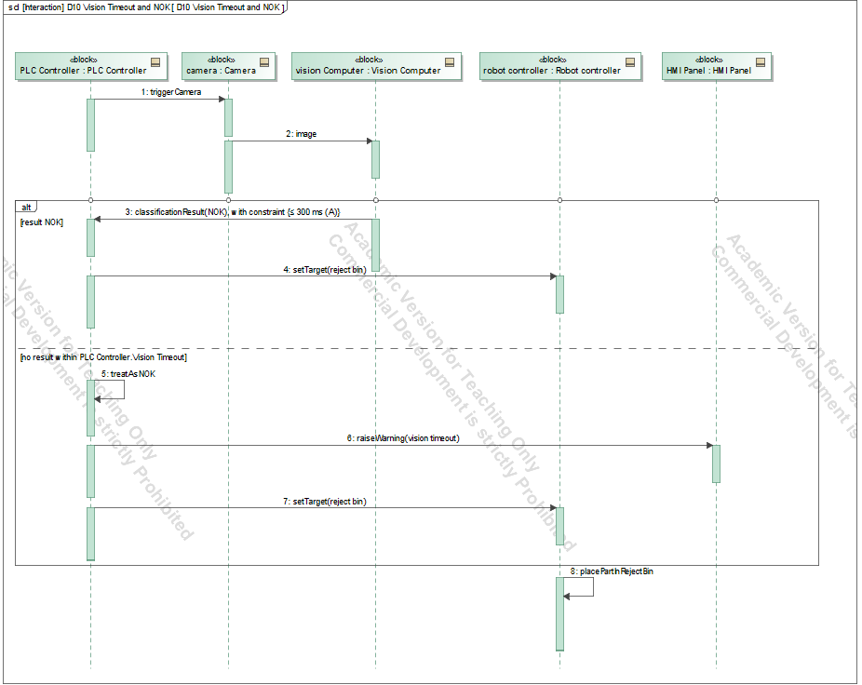
Question. What happens when the vision result is late or the part is NOK?
A sequence diagram with an alternative fragment separates the normal path from the timeout path. The timeout is 0.5 s. On timeout, the PLC raises an HMI warning and the part is placed in the reject bin; a NOK result goes to the reject bin as well. A first draft had one message inside the fragment that belonged after it; moving it fixed the logic.
Systems engineering view. The off-nominal scenario. A requirement set that covers only the normal path leaves a cell that fails unpredictably, so non-nominal behaviour is modelled and tied to requirements (REQ-FUN-003, REQ-PER-003).

10. Analysis

10.1 Method
Four calculations were set up as constraint blocks in 06_Analysis. Each constraint has parameters, and each parameter is bound to a value property of a block, so the inputs are the same values used elsewhere in the model. The calculation was run in Cameo with Simulation, Run, and every result was checked by hand. Results are compared with the limits stated in the requirements, and the margin is reported.
Systems engineering view. Each analysis is a technical performance measure: a value tracked against its limit, with a margin. A budget that is nearly used up is visible early, and an analysis on assumed values still shows which assumptions matter most.

10.2 Cycle time and vision latency (D11a)
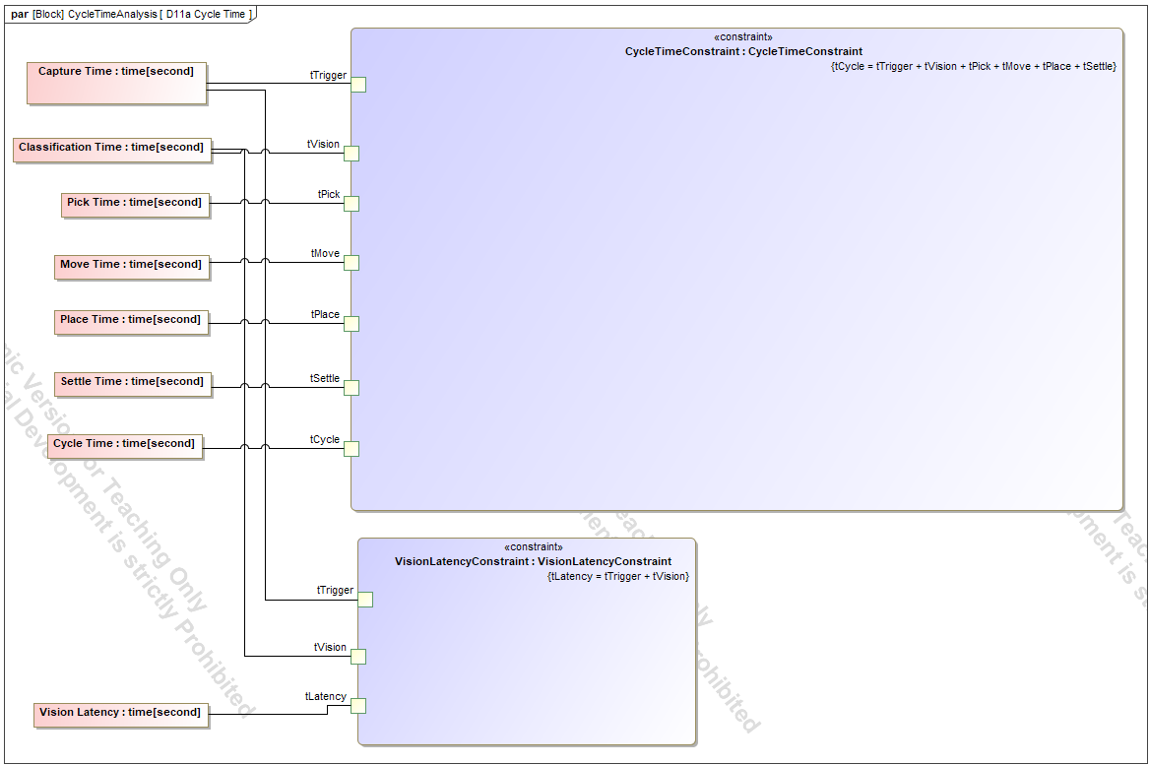
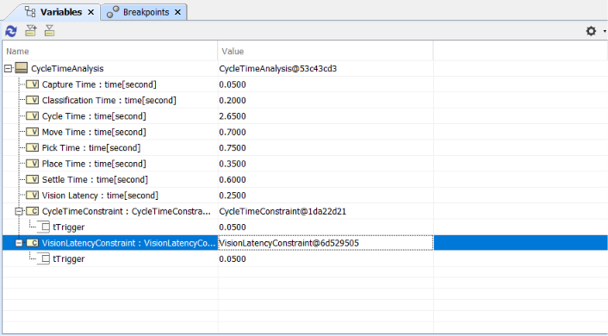
Step | Time | Source
Capture | 0.05 s | Camera, Capture Time
Classification | 0.20 s | Vision Computer, Classification Time
Pick | 0.75 s | Robot controller
Move | 0.70 s | Robot controller
Place | 0.35 s | Robot controller
Settle | 0.60 s | Robot controller
Cycle time | 2.65 s | Sum
Vision latency | 0.25 s | Capture plus classification
The cycle time of 2.65 s is below the limit of 3.0 s (REQ-PER-001) with a margin of +0.35 s. The vision latency is 0.25 s.
Finding. REQ-INT-002 said that the vision result must arrive within 200 ms. That number had no basis: it was a first guess. The analysis shows that the cycle-time budget absorbs 250 ms, so a limit of 200 ms was stricter than the system needs and would have forced a more expensive camera or computer for no benefit. The limit was changed to 300 ms (A), which leaves a margin of +0.05 s. The change is recorded in the decision log and in the assumptions list.
Modelling note. Two constraint parameters were first named after the value properties (Capture Time, Pick Time) instead of the constraint variables (tTrigger, tPick), which stopped the binding; renaming them fixed it.

10.3 Safety distance (D11b)
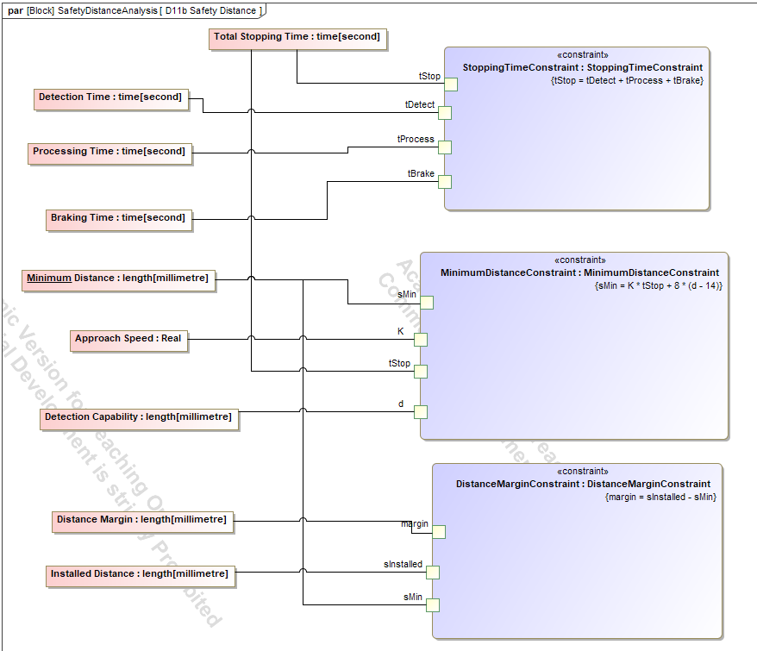
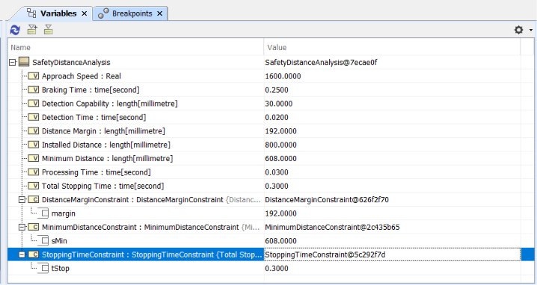
For a light curtain, ISO 13855 gives the minimum distance between the protective device and the hazard as S = K × T + C, where C = 8 × (d − 14) for detection capabilities up to 40 mm. K is the approach speed of the body, T is the total time from detection to standstill, and d is the detection capability of the light curtain.
Quantity | Value | Status
Door interlock response time | 0.02 s | Assumed (TBC)
Safety controller reaction time | 0.03 s | Assumed
Robot stopping time | 0.25 s | Assumed
Total stopping time T | 0.30 s | Sum
Approach speed K | 1600 mm/s | TBC (ISO 13855)
Detection capability d | 30 mm | Assumed
C = 8 × (30 − 14) | 128 mm | Calculated
Minimum distance S | 1600 × 0.30 + 128 = 608 mm
Installed distance | 800 mm | Assumed
Distance margin | +192 mm
Engineering view. The robot stopping time is the dominant term: 0.25 s of the 0.30 s. A shorter braking time would reduce the required distance by 1600 mm/s per second saved, so the stopping behaviour of the robot is the parameter to confirm first with the manufacturer. The margin is comfortable only if the constants are right: K and C are TBC, and the analysis covers the light curtain only, not the door interlock.

10.4 Payload (D12)
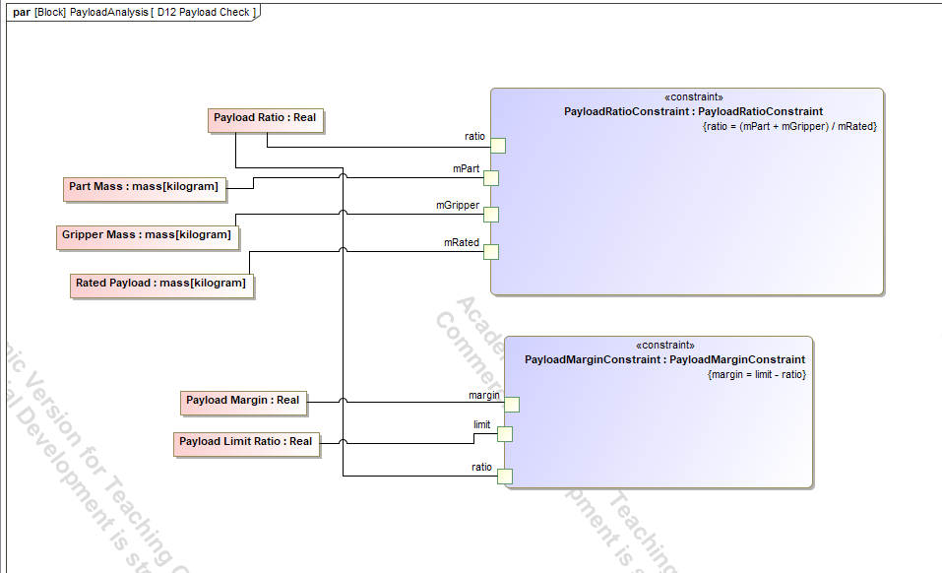
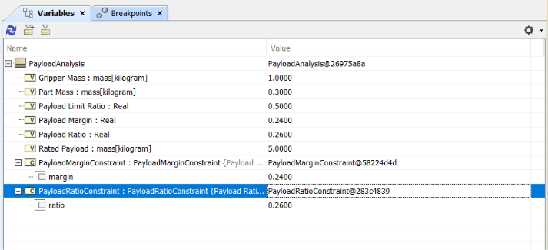
The payload ratio is the mass the robot carries divided by its rated payload: (part mass + gripper mass) / rated payload = 1.3 kg / 5.0 kg = 0.26. REQ-PER-005 limits it to 0.50, so the margin is +0.24. The rated payload of a robot includes the gripper, which is why the gripper mass is part of the sum.
Limitation. This is a simplified mass ratio. It is not a joint-torque analysis, which would also depend on the reach, the orientation and the speed of the movement. It is stated as such in the model.

10.5 Value properties used by the analyses
Block | Value property | Value
RobotCell | Target Cycle Time | 3.0 s
RobotSystem | Rated Payload | 5.0 kg
RobotSystem | Rated Reach | 850 mm
Gripper | Gripper Mass | 1.0 kg
Camera | Capture Time | 0.05 s
Vision Computer | Classification Time | 0.20 s
Robot controller | Pick, Move, Place, Settle | 0.75, 0.70, 0.35, 0.60 s
Door Interlock | Response Time | 0.02 s
Safety Controller | Reaction Time | 0.03 s
Robot controller | Stopping Time | 0.25 s
PLC Controller | Vision Timeout | 0.5 s

11. Verification and traceability

11.1 Test cases
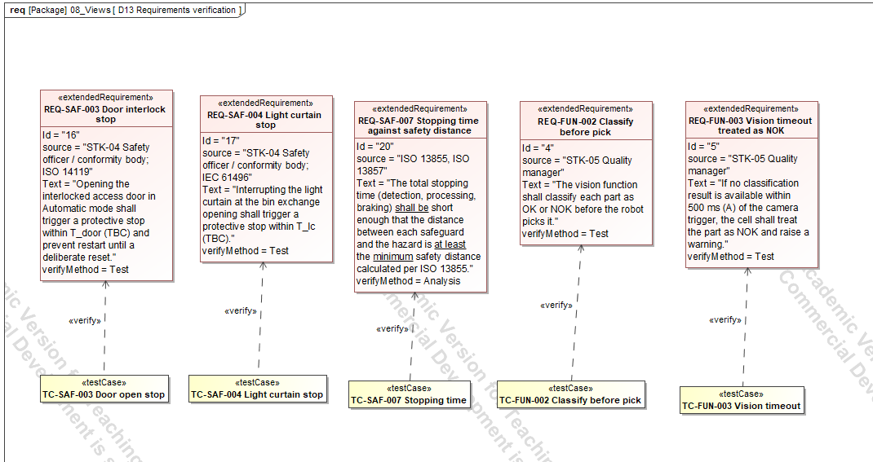
Twenty test cases in 07_Verification are linked to requirements by verify relations. The first five cover the earliest safety and functional requirements (TC-SAF-003, TC-SAF-004, TC-SAF-007, TC-FUN-002, TC-FUN-003). Fifteen more cover the others. The full list is in Appendix C. A verify relation does not mean the test has run; it means the method of proof is defined.

11.2 Verify matrix
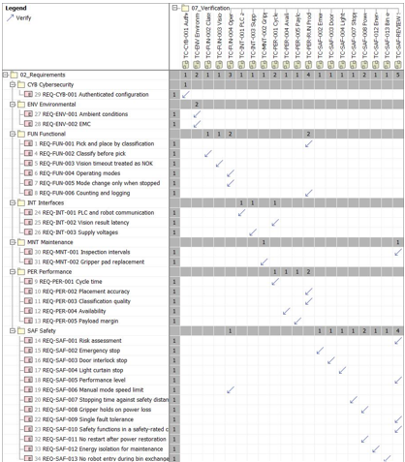
32 of 32 requirements have exactly one verify relation.

11.3 Satisfy matrix
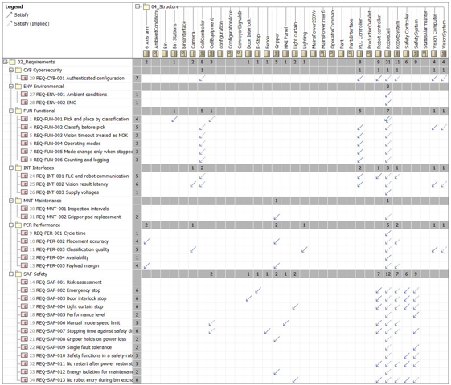
30 of 32 requirements have a satisfy relation, including the implied satisfy through the block hierarchy.
Modelling note. Clicking matrix cells did not work in my tool setup, so the relations were created with the palette tools in requirement diagrams, and the matrices then showed them. Temporary helper diagrams were deleted with the option “diagram only”, so the relations stayed in the model.

11.4 Systems engineering view
This is where the model closes the loop between the left and right side of the V. Every requirement has a defined check, and every requirement is implemented by something or explained. The two matrices make completeness measurable, and the gap list turns the missing items into a statement of what the model does not yet prove.

11.5 Gap list
# | Gap | Reason
1 | REQ-SAF-001 and REQ-MNT-001 have no satisfy relation | Satisfied by project documents (risk assessment, information for use), not by a block
2 | Seven requirements have no stakeholder trace: FUN-005, SAF-006, SAF-010, INT-001, INT-003, ENV-002, SAF-012 | Their source is a standard, recorded in the Source property
3 | RobotSystem, VisionSystem, CellController, CellEquipment satisfy nothing directly | Grouping blocks; their parts do
4 | Source properties hold no clause numbers | The standards have not been read yet
5 | The door interlock distance is not analysed | Only the light curtain was in scope
6 | The ISO 13855 constants K and C are TBC | Standard not read yet

12. Results and discussion

12.1 Summary of results
Requirement | Check | Result | Limit | Margin | Status
REQ-PER-001 | Cycle time | 2.65 s | 3.0 s | +0.35 s | Pass
REQ-INT-002 | Vision latency | 0.25 s | 0.30 s | +0.05 s | Pass after the limit changed from 200 ms
REQ-SAF-007 | Safety distance, light curtain | 608 mm needed | 800 mm installed | +192 mm | Pass, constants TBC
REQ-PER-005 | Payload ratio | 0.26 | 0.50 | +0.24 | Pass, simplified check

12.2 Coverage
Measure | Result
Requirements | 32
With a verify relation | 32 (100 %)
With a satisfy relation | 30 (94 %), 2 explained
With a stakeholder trace | 21 stakeholder traces; 7 requirements have a standard as source
Test cases | 20
Derive relations | 10
Safety allocation relations | 12

12.3 What the model revealed
- A requirement without a basis. The 200 ms vision latency limit looked reasonable but had no basis. Only the calculation showed that the budget allows 300 ms.
- An interface fault caught by the tool. Conjugation errors on the first context diagram showed that the interface definition had a direction problem.
- Dominant terms. The robot stopping time dominates the safety distance, and the pick and settle steps dominate the cycle time. These are the values to confirm or optimise first.
- Hazards missing from the first list. Thinking about hazards produced three requirements that standards and stakeholders alone had not.
- Where the gaps are. The gap list is precise: standards that are not yet read, one safeguard not analysed, and two requirements satisfied by documents.

12.4 Feedback between steps
Two later steps changed earlier ones. The cycle-time analysis changed REQ-INT-002, and the coverage review produced the gap list and led to the explicit statements about documents satisfying SAF-001 and MNT-001. This feedback is the reason to build a connected model: a change in one place can be traced to everything it touches.

13. Decision log
Decision | Reason
Fenced cell, not collaborative | Keeps the safety case within ISO 10218 and guarded-machine rules; collaborative operation adds force and speed limits outside this project
Source, verification method and risk stored in the requirement (ExtendedRequirement) | The profile route was not available; the built-in fields keep the information next to the text
No Status field | Not needed for a single-author model, and it adds upkeep
REQ-INT-002 changed from 200 ms to 300 ms (A) | D11a showed the 2.65 s cycle absorbs the latency, so the original limit was stricter than the system needs and had no basis
REQ-FUN-004 changed to “at most one mode” | Off and Initializing are system states, not modes
One “shall” per requirement | One pass or fail result per requirement; eight were reworded
Separate control and safety chains | Independence is required by REQ-SAF-010 and follows ISO 13849-1
Three own hazard-based requirements | Standards and stakeholder lists alone left hazards uncovered
Requirement diagrams with palette tools to create relations | The matrix cells could not be edited in the tool
Four analyses only | Each checks a requirement with a number; others would need data that is not available
Transition labels typed into the guard field | The name field is not displayed on transitions

14. Assumptions register
Value | Status | How it would be confirmed
Vision timeout 500 ms | Assumed | Camera and vision computer trials
Cycle time target 3.0 s, share 95 % | Assumed | Production requirement
Placement accuracy 1.0 mm | Assumed | Robot accuracy test per ISO 9283
Classification rate 98 %, false-pass rate 0.5 % | Assumed | Labelled validation set
Availability 95 % | Assumed | Operating data
Payload limit ratio 0.5 | Assumed | Robot manufacturer guidance
Communication cycle 10 ms | Assumed | Controller specification
Vision latency limit 300 ms | Assumed (from D11a) | Cycle budget
Supply 230 V AC +/- 10 % | Assumed | Facility data
Ambient 5 to 40 degrees C, humidity 80 % | Assumed | Facility data
Pad replacement 15 min | Assumed | Maintenance trial
Timing of capture, classification, pick, move, place, settle | Assumed | Robot and vision trials
Safety controller reaction 0.03 s, robot stopping time 0.25 s | Assumed | Datasheets and a stopping test
Door interlock response, light curtain response | TBC | Component datasheets
Manual speed limit 250 mm/s | TBC | ISO 10218
Performance level PL d, category 3 | TBC | Risk assessment
Approach speed K = 1600 mm/s | TBC | ISO 13855
Detection capability 30 mm, installed distance 800 mm | Assumed | Light curtain datasheet, cell layout

15. Standards register
Standards are cited by number only; no text from them is reproduced. Each was chosen for its scope. The clauses have not been read yet, so the Source property names the standard but holds no clause number. Editions marked “check” must be confirmed before real use.
Reference | What it covers | Why it was used | Edition
EU Machinery Regulation 2023/1230 | Legal safety requirements for machinery in the EU; replaces Directive 2006/42/EC from January 2027 | The legal basis for a robot cell on the EU market | 2023/1230
ISO 12100 | Risk assessment and risk reduction | Basis for the hazard-based requirements | Check
ISO 10218-1, -2 | Safety of the industrial robot and of the robot cell | The cell uses an industrial robot; sets stops, speed limits and modes | 2025
ISO 13849-1 | Safety-related parts of control systems; performance levels | Independence of the safety chain; performance level | Check
IEC 62061 | Functional safety of safety-related control systems | Alternative route to ISO 13849-1 | Check
ISO 13850 | Emergency stop function | The cell has an E-Stop | Check
IEC 60204-1 | Electrical equipment of machines | Stop categories, isolation, restart | Check
ISO 14119 | Interlocking devices associated with guards | The fence door interlock | Check
IEC 61496 | Electro-sensitive protective equipment | The light curtain | Check
ISO 13855 | Positioning of safeguards by approach speeds | Safety distance formula in D11b | Check
ISO 13857 | Safety distances against reaching hazard zones | Fence height and openings | Check
ISO 9283 | Performance criteria for manipulating industrial robots | Accuracy requirement | Check
IEC 61131-3 | Programming languages for PLCs | The cell controller is a PLC | Check
IEC 62443 | Security for industrial automation and control systems | Configuration access and network security | Check
IEC 61000-6-2, -6-4 | EMC immunity and emission for industrial environments | Environment requirement | Check

16. Limitations and threats to validity
- Assumed values. Timing, mass and stopping values are assumptions, not measurements. The conclusions are only as good as these inputs, though the analyses show which inputs matter most.
- Safety distance. The constants K and C are TBC, and only the light curtain is analysed.
- Standards. Editions are unchecked (except ISO 10218 and the EU regulation), and clauses are not cited.
- Payload. The check is a simplified ratio and not a joint-torque analysis.
- No real hazard assessment. The three own requirements come from hazard thinking, not from a formal risk assessment.
- No validation. Stakeholders did not review the requirements.
- No physical test. Verify relations define how requirements would be checked; the tests were not run.
- No expert review. A safety expert has not reviewed the model.
- Single author. The model reflects one person’s choices, and there was no independent review.

17. Lessons learned

17.1 About the method
- A diagram that starts with a question is easier to build, easier to review and easier to explain than one that starts with a notation.
- Writing a source and a verification method with each requirement costs little and saves a lot at the end.
- A calculation on the model finds problems that reading does. The INT-002 case is the example.
- Number the packages in the order of the work. Reviewers then follow the same path as the author.
- Mark assumptions at the time they are made. Doing it afterwards is much harder.

17.2 About the tool
- Ports must be conjugated on the receiving side, or the connector is red.
- Actors cannot have ports, so stakeholders are placed in the context as standalone elements.
- Transition names are not displayed, but a typed guard is.
- The sequence diagram in the SysML dialog works; the UML option was not needed.
- Constraint parameters must be named as in the constraint, or the binding is lost.
- Temporary helper diagrams must be deleted with the option “diagram only” so the relations stay.

18. Conclusion and next steps
The project produced a connected SysML model of a vision-guided pick-and-place cell: 32 requirements with sources and verification methods, a defined boundary with nine typed interfaces, a decomposition with an independent safety chain, behaviour models for the cycle, the modes and two critical scenarios, four analyses that were checked by hand, 20 test cases, and coverage matrices that show 32 of 32 requirements verified and 30 of 32 satisfied. The analyses fit the requirements with positive margins, and the process itself found a requirement that had no basis.
The model is a baseline, not a finished design. The next steps are:
- Read the relevant clauses of each standard and add clause numbers to the Source properties.
- Replace the TBC and assumed values with values from standards, datasheets and measurements.
- Analyse the door interlock distance in the safety distance check.
- Replace the payload ratio with a joint-torque model.
- Run a formal risk assessment and compare it with the hazard-based requirements.
- Build a simulation or control prototype and compare its timing with the model.
- Review the model with a safety expert and with stakeholders.

Appendix A. Requirements catalogue
The texts are shown as written in the baseline. REQ-INT-002 was later changed to 300 ms (A) and REQ-FUN-004 to “at most one” mode; eight requirements (PER-003, SAF-001, SAF-003, SAF-006, SAF-008, SAF-009, SAF-010, CYB-001) were later reworded to contain one “shall”. REQ-SAF-011 to 013 were added afterwards and are listed at the end. The final wording is in the model.
ID | Requirement text | Source | Verification
REQ-FUN-001 | The cell shall pick each part delivered to the pick position and place it in the OK bin or the reject bin according to its classification. | STK-01 | Demonstration
REQ-FUN-002 | The vision function shall classify each part as OK or NOK before the robot picks it. | STK-05 | Test
REQ-FUN-003 | If no classification result is available within 500 ms (A) of the camera trigger, the cell shall treat the part as NOK and raise a warning. | STK-05 | Test
REQ-FUN-004 | The cell shall provide the modes Automatic, Manual (teach), Maintenance and Fault, with exactly one mode active at any time. | STK-02; ISO 10218-2 (operating modes) | Analysis of D08, Test
REQ-FUN-005 | A mode change shall be possible only while the robot is stopped. | ISO 10218-2 (operating modes) | Test
REQ-FUN-006 | The cell shall count OK, NOK and fault events and log each with a timestamp. | STK-01, STK-05 | Test
REQ-PER-001 | In Automatic mode the cycle time shall not exceed 3.0 s (A) for 95 % of cycles. | STK-01 | Analysis of D11a, Test
REQ-PER-002 | The place position error shall not exceed 1.0 mm (A). | STK-05; ISO 9283 (accuracy criteria) | Test
REQ-PER-003 | The vision function shall classify at least 98 % (A) of parts correctly and shall pass at most 0.5 % (A) of NOK parts as OK. | STK-05 | Test on a labeled validation set
REQ-PER-004 | Availability shall be at least 95 % (A) over an 8 h shift, excluding planned maintenance. | STK-01 | Analysis (availability calculation)
REQ-PER-005 | The mass of part plus gripper shall not exceed 50 % (A) of the robot rated payload. | STK-03 | Analysis of D12
REQ-SAF-001 | A documented risk assessment following the ISO 12100 method shall exist for the cell and shall define the required performance level of each safety function. | STK-04; ISO 12100, ISO 10218-2 | Inspection
REQ-SAF-002 | Actuating any emergency stop device shall stop all hazardous motion, with the stop category chosen from the risk assessment. | STK-04; ISO 13850, IEC 60204-1 | Test
REQ-SAF-003 | Opening the interlocked access door in Automatic mode shall trigger a protective stop within T_door (TBC) and shall prevent restart until a deliberate reset. | STK-04; ISO 14119 | Test
REQ-SAF-004 | Interrupting the light curtain at the bin-exchange opening shall trigger a protective stop within T_lc (TBC). | STK-04; IEC 61496 | Test
REQ-SAF-005 | Each safety function shall reach the performance level required by REQ-SAF-001 (working assumption: PL d, category 3, TBC). | ISO 13849-1 or IEC 62061 | Analysis (calculation)
REQ-SAF-006 | In Manual mode the tool centre point speed shall not exceed 250 mm/s (TBC against ISO 10218) and motion shall require an enabling device held by the operator. | ISO 10218-1 and -2 (reduced speed, enabling device) | Test
REQ-SAF-007 | The total stopping time (detection, processing, braking) shall be short enough that the distance between each safeguard and the hazard is at least the minimum safety distance calculated per ISO 13855. | ISO 13855, ISO 13857 | Analysis of D11b, Test
REQ-SAF-008 | On loss of power or air, the gripper shall retain the part and the robot shall remain stopped. | STK-04; risk assessment | Test
REQ-SAF-009 | A single fault in a safety function shall not cause loss of that safety function, and a detected fault shall lead to the safe state. | ISO 13849-1 (category 3 principle) | Analysis (failure mode analysis)
REQ-SAF-010 | Safety functions shall be implemented in a safety-rated controller; the standard PLC shall not be relied on for any safety function. | ISO 13849-1, IEC 62061 | Inspection of D06
REQ-INT-001 | The PLC and the robot controller shall exchange commands and status over one industrial protocol (to be chosen) with a cycle time of at most 10 ms (A). | ISO 10218-1; IEC 61131-3 | Test
REQ-INT-002 | The vision subsystem shall return a classification result to the PLC within 200 ms (A) of the camera trigger. | STK-01 | Test, Analysis of D11a
REQ-INT-003 | The cell shall operate from a 230 V AC (+/- 10 %, A) mains supply and a 24 V DC control supply. | IEC 60204-1 | Inspection, Test
REQ-ENV-001 | The cell shall operate at 5 to 40 degrees C and at most 80 % relative humidity, non-condensing (A). | STK-01 | Test
REQ-ENV-002 | The cell shall meet the EMC immunity and emission limits for industrial environments. | IEC 61000-6-2, IEC 61000-6-4 | Test
REQ-CYB-001 | Network-connected components shall require authentication for configuration changes and shall have remote access disabled by default. | STK-06; IEC 62443; ISO 10218:2025 (cybersecurity) | Inspection, Test
REQ-MNT-001 | The information for use shall define the inspection and test intervals of every safety function. | STK-04; ISO 10218-2 (information for use) | Inspection
REQ-MNT-002 | A worn gripper pad shall be replaceable within 15 min (A) using standard tools. | STK-03 | Demonstration
REQ-SAF-011 | No restart after power restoration (added later; text in the model) | Own, hazard-based | Test
REQ-SAF-012 | Energy isolation for maintenance (added later; text in the model) | Own, hazard-based | Test or inspection
REQ-SAF-013 | No robot entry during bin exchange (added later; text in the model) | Own, hazard-based | Test

Appendix B. Value properties and interfaces

B.1 Interfaces at the boundary
Connector | Ports (sending / receiving) | Flow
Mains power | mainsOut / mainsIn | 230 V AC supply
Parts | partsOut / partsIn | Parts from the conveyor
Conveyor signals | conveyorSignalsOut / conveyorSignalsIn | Part present, conveyor stop
Ambient | ambientOut / ambientIn | Ambient conditions
Configuration | configOut / configIn | Configuration access
Commands | commandsOut / commandsIn | Start, stop, mode commands
Empty bins | emptyBinsOut / emptyBinsIn | Empty bins to the cell
Status | statusOut / statusIn | Status and alarms
Full bins | fullBinsOut / fullBinsIn | Full bins from the cell
OK parts | okPartsOut / partsIn | Parts to the OK bin
NOK parts | nokPartsOut / partsIn | Parts to the reject bin
Production data | productionDataOut / productionDataIn | Counts and log entries

Appendix C. Test cases
Test case | Verifies
TC-SAF-003 | Door interlock stop
TC-SAF-004 | Light curtain stop
TC-SAF-007 | Stopping time against safety distance
TC-FUN-002 | Classification before pick
TC-FUN-003 | Vision timeout treated as NOK
TC-PER-RUN | Cycle time in a production run
TC-FUN-004 | Operating modes
TC-SAF-002 | Emergency stop
TC-SAF-008 | Gripper holds on power loss
TC-SAF-013 | No robot entry during bin exchange
TC-SAF-012 | Energy isolation for maintenance
TC-SAF-REVIEW | Review of the risk assessment and safety design
TC-INT-001 | PLC and robot communication
TC-INT-003 | Supply voltages
TC-ENV | Ambient conditions and EMC
TC-CYB-001 | Authenticated configuration
TC-MNT-002 | Gripper pad replacement
TC-PER-004 | Availability
TC-PER-001 | Cycle time
TC-PER-005 | Payload margin
The assignment of each test case to a requirement is in the verify matrix; where a test case name covers several requirements, the matrix is authoritative.

Appendix D. Glossary
Term | Meaning
MBSE | Model-based systems engineering
SysML | Systems Modeling Language, a UML extension for systems
BDD / IBD | Block definition diagram / internal block diagram
Block | A SysML element that defines a system, subsystem or component
Port | A point on a block where something flows in or out
Conjugated port | A port with reversed flow directions, used on the receiving side
Flow property | A typed item that flows through a port
Value property | A typed number on a block, such as a mass or a time
Constraint block | A reusable equation with parameters
Parametric diagram | Binds constraint parameters to value properties
Satisfy | A block fulfils a requirement
Verify | A test or analysis checks a requirement
DeriveReqt | A requirement is derived from a higher one
Trace | A general link, here from a requirement to its stakeholder
(A) | Assumed value
TBC | To be confirmed
PL | Performance level, a measure of safety function reliability in ISO 13849-1
TCP | Tool centre point of the robot
EMC | Electromagnetic compatibility
PLC | Programmable logic controller
HMI | Human machine interface

