- Write a query to get unique department ID from employee table.
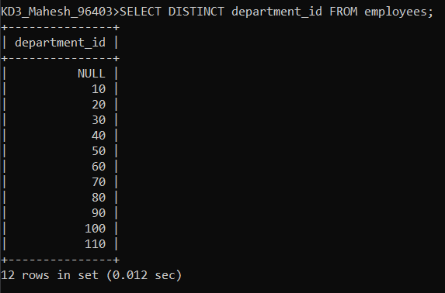
- Write a query to get all the employee’s details from the employees table displaying the first names in descending order.
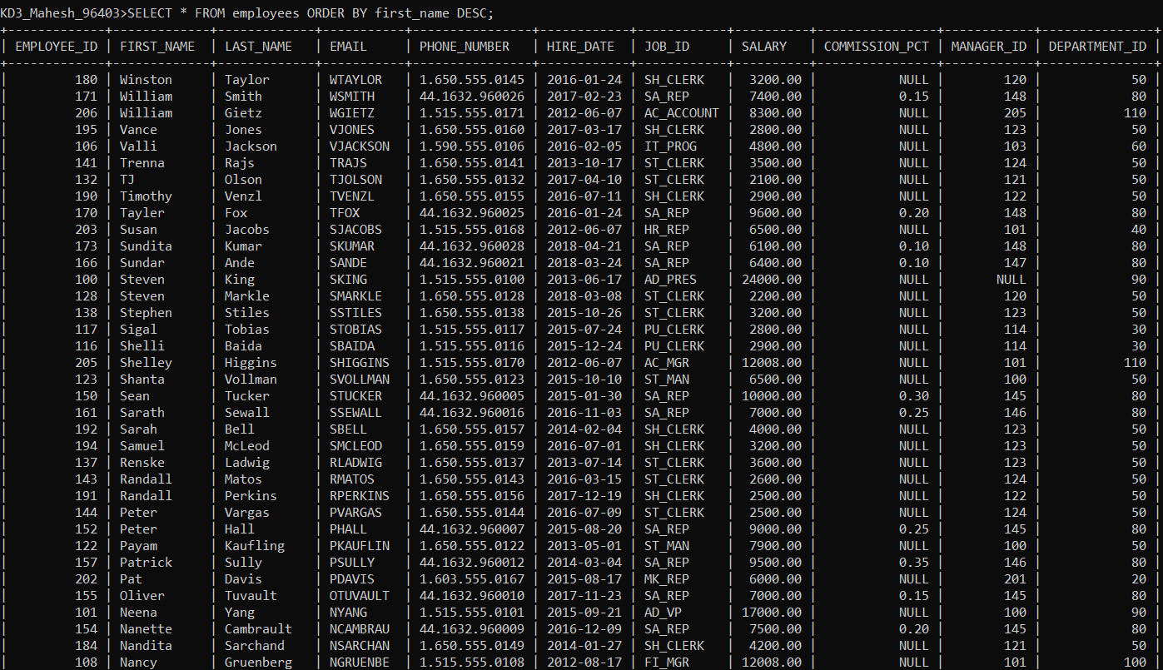

- Write a query to get the employee ID, names (first_name and last_name), salary in ascending order of salary.
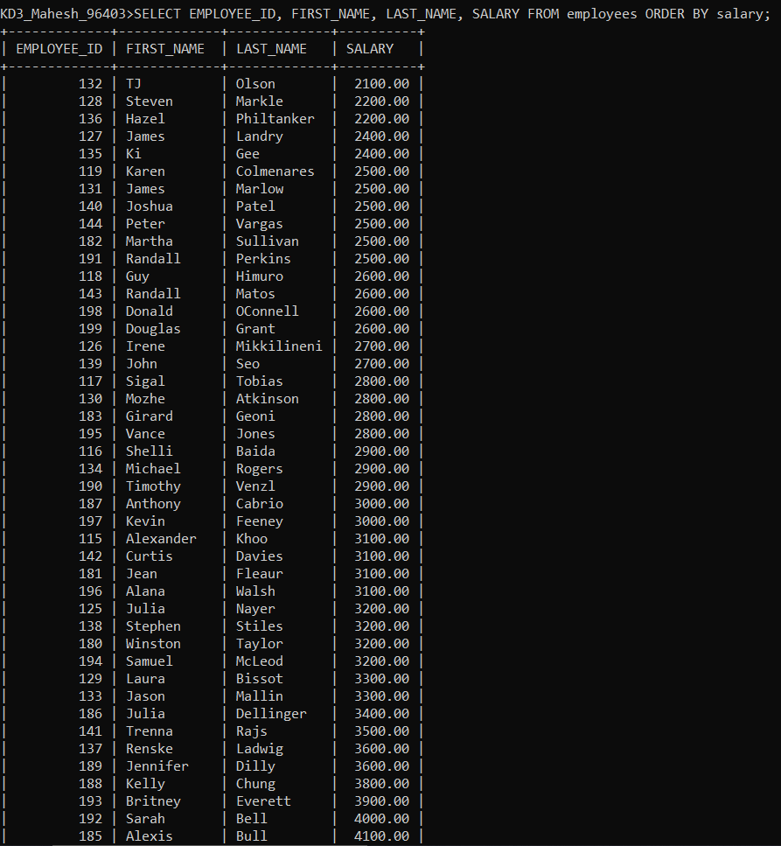
- Display first name and joining date of the employees who are either IT Programmer or Sales Man.
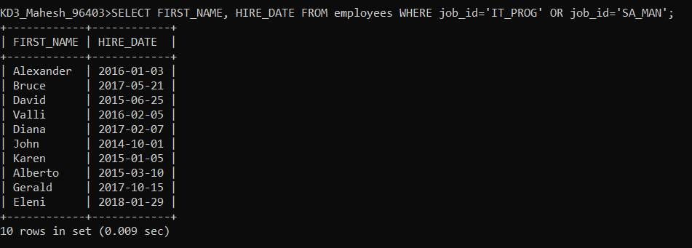
- Display details of employees with employee ID 150 or 160.
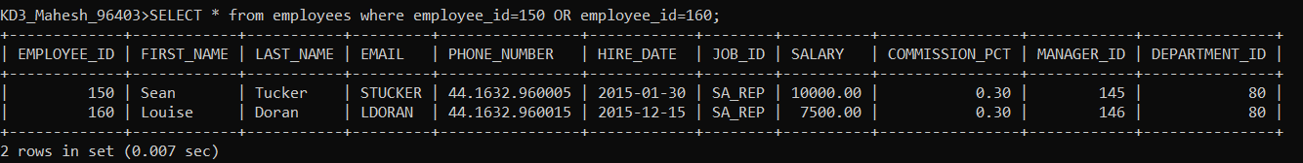
- Display first name, salary, commission pct, and hire date for employees with salary less than 10000.
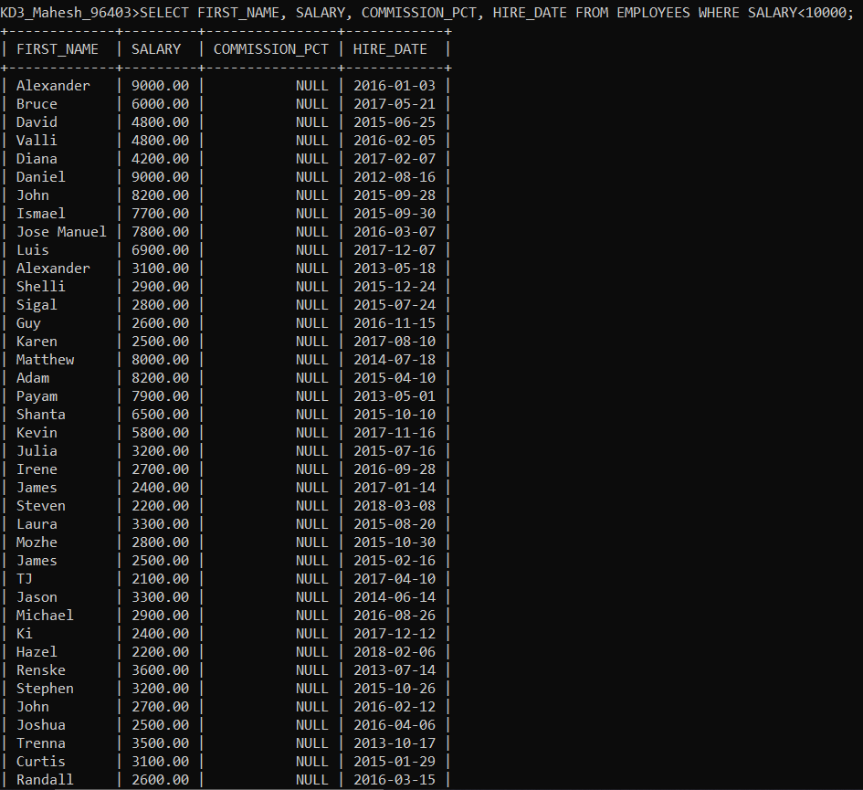
- Display employees where the first name or last name starts with S.
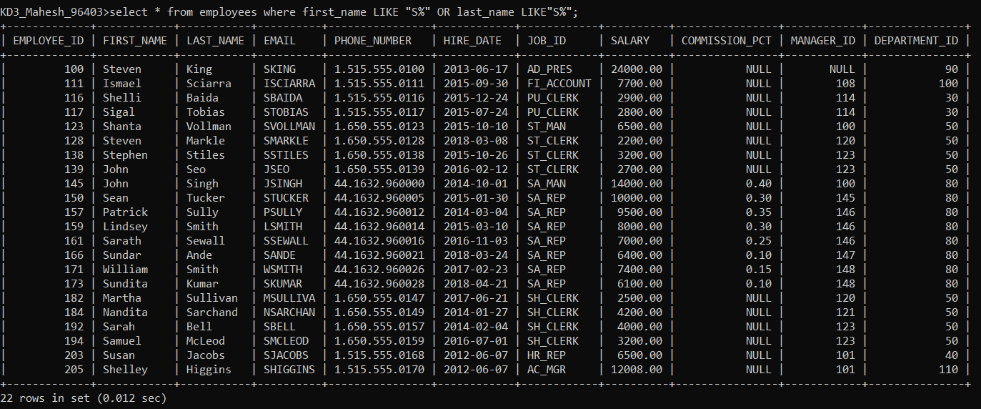
- Display details of jobs in the descending order of the title.
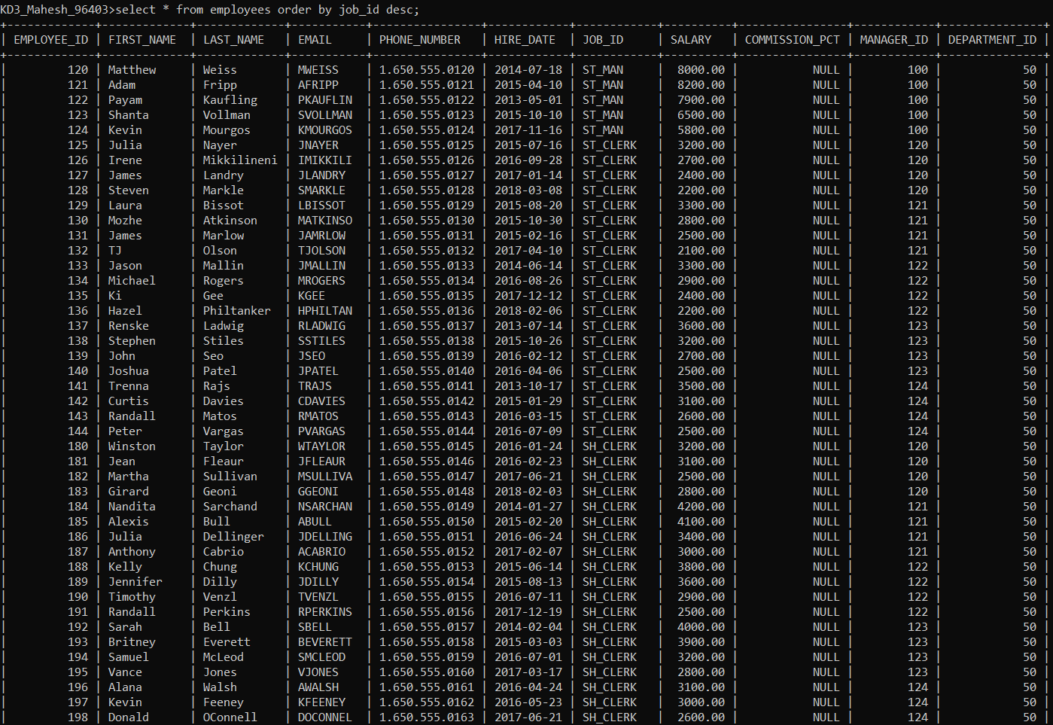
- Display the details of the employees from department 30, earning the salary greater 10000 but do not receive the commission.
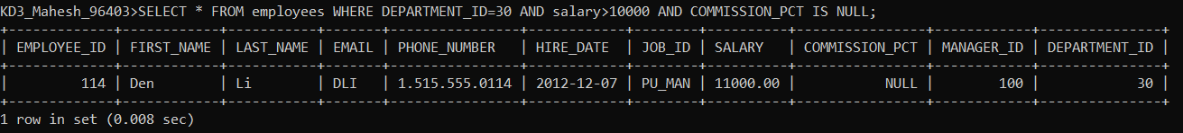
- Display the details of employees reporting to the managers with employee id 100 and 120.
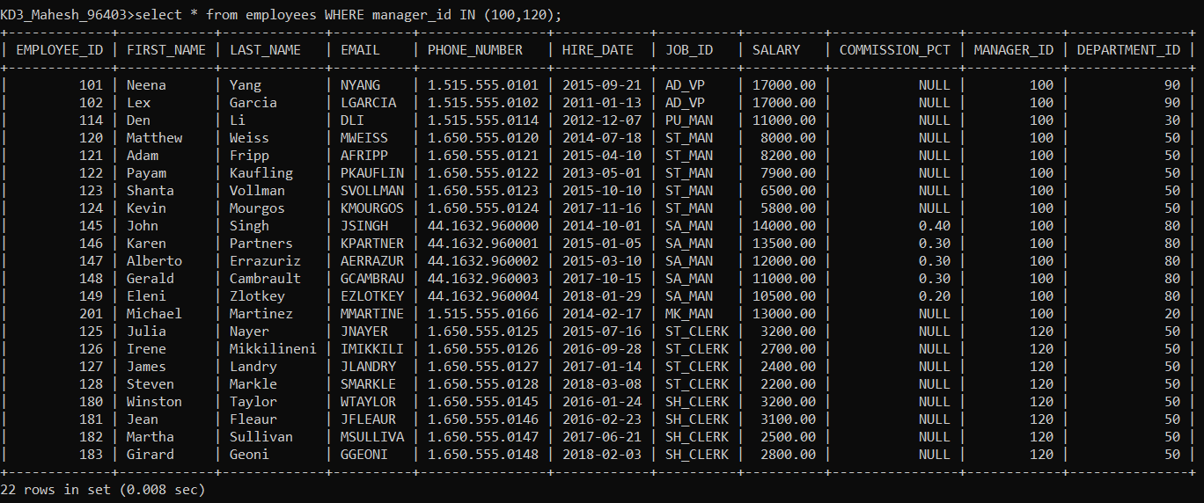
- Display the unique country_id from locations table.
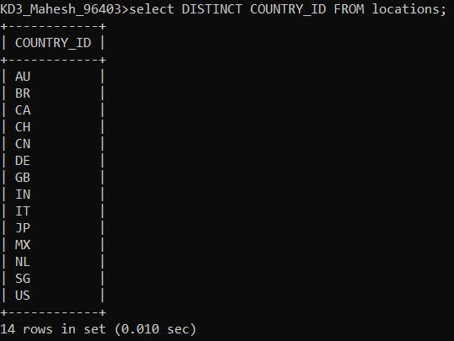
- Display all employees whose have the job_id as IT_PROG and FI_ACCOUNT.
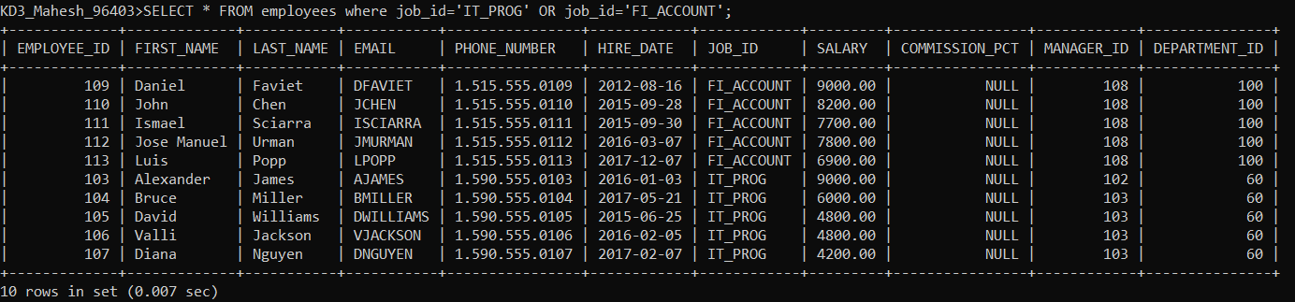
- Display all countries in ascending order.
