**Introduction: The Smart City Sentinel – A Modular PCB for Intelligent Environmental Monitoring**

In the era of rapid urbanization, the need for real-time environmental surveillance has become critical. Smart cities require advanced monitoring systems that seamlessly integrate multiple sensor modules, ensuring efficient data transmission and power management. The **Smart City Sentinel** project aims to develop a modular **Printed Circuit Board (PCB)** that serves as the backbone of an intelligent environmental monitoring system.

List Of Components (Bill of Material):

|  |  |  |
| --- | --- | --- |
| Sr. No: | Component | Specifications |
|  | ESP32 – S3 Dev Module | - ESP32-S3 (Dual-core, Wi-Fi, Bluetooth)  - Operating Voltage: 3.3V  - Flash: 8MB |
|  | MQ – 135 Gas Sensor | - Detects: NH3, NOx, Alcohol, Benzene, CO2  - Operating Voltage: 5V  - Analog Output |
|  | Sound Sensor Module |  |
|  | OLED Display | - Size: 0.96 inch  - Resolution: 128x64  - Interface: I2C/SPI  - Voltage: 3.3V–5V |
|  | BME280 Environmental Sensor | - Measures: Temperature, Humidity, Pressure  - Interface: I2C/SPI  - Voltage: 3.3V |
|  | Solar Panel (used as a connector) |  |
|  | Rechargeable Module (TP4056) | - Charging Current: 1A  - Input Voltage: 5V  - Output Voltage: 4.2V (Li-ion) |
|  | IR Flame Sensor |  |
|  | Battery 3.7v 2500mAh 18560 | - Type: Li-ion  - Voltage: 3.7V  - Capacity: 2500mAh  - Size: 18650 |
|  | Dust Sensor | - Detects PM2.5 and PM10  - Operating Voltage: 5V  - Interface: UART |
|  | Hall Effect Sensor | - Detects Magnetic Fields  - Operating Voltage: 3.3V–5V  - Analog/Digital Output |
|  | MAX471 Current and Voltage Sensor | - Measures Current and Voltage  - Operating Voltage: 3V–36V  - Output: Analog |
|  | Water flow sensor | - Flow Rate: 1–30L/min  - Operating Voltage: 5V  - Output: Pulse Signal |
|  | DHT11 Temperature and Humidity Sensor | - Measures: Temperature (0°C–50°C), Humidity (20%–80%)  - Operating Voltage: 3.3V–5V |
|  | Soil Moisture Sensor | - Measures Soil Moisture  - Operating Voltage: 3.3V–5V  - Output: Analog/Digital |
|  | Relay Module | - Operating Voltage: 5V  - Max Current: 10A  - Interface: Digital Input |
|  | Rain Sensor | - Detects Rain  - Operating Voltage: 3.3V–5V  - Output: Analog/Digital |
|  | RTC DS3231 module | - Real-Time Clock  - Operating Voltage: 3.3V–5V  - Interface: I2C |

Screenshot of Schematic:

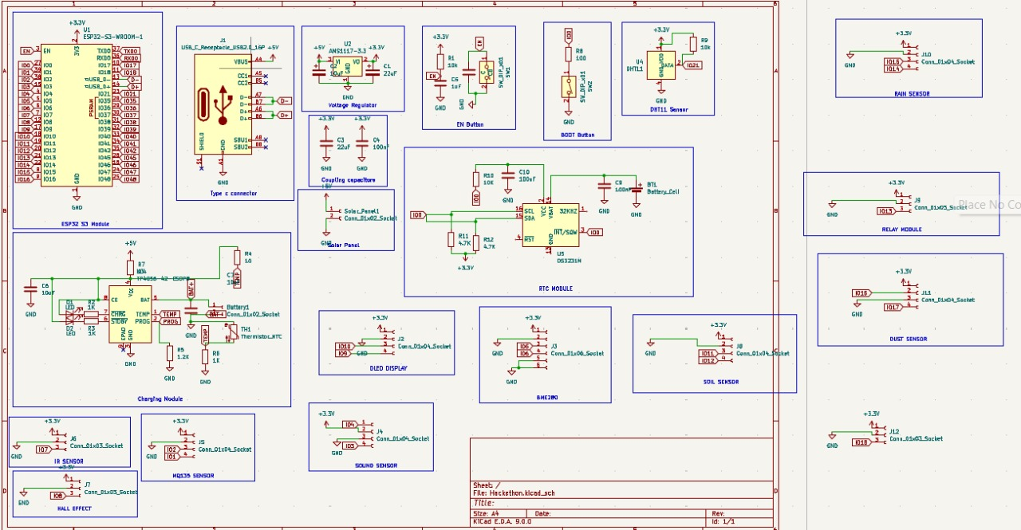

Screenshot of PCB Routing Diagram:

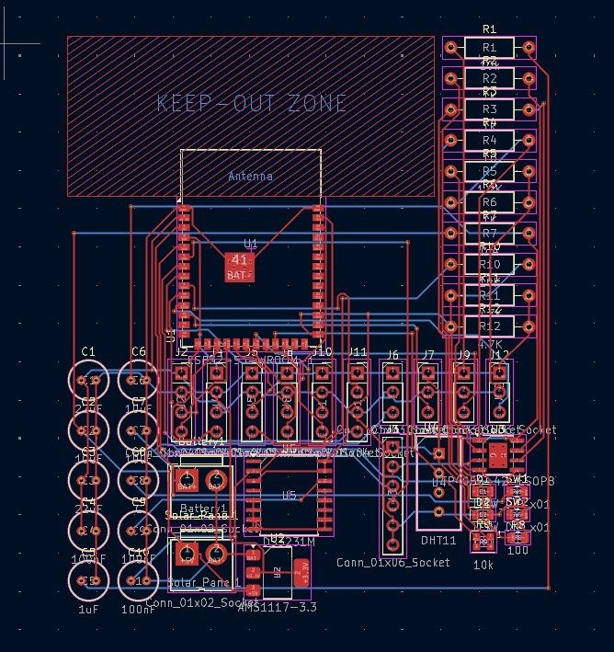

Screenshot Of Front Copper Layer Of PCB:

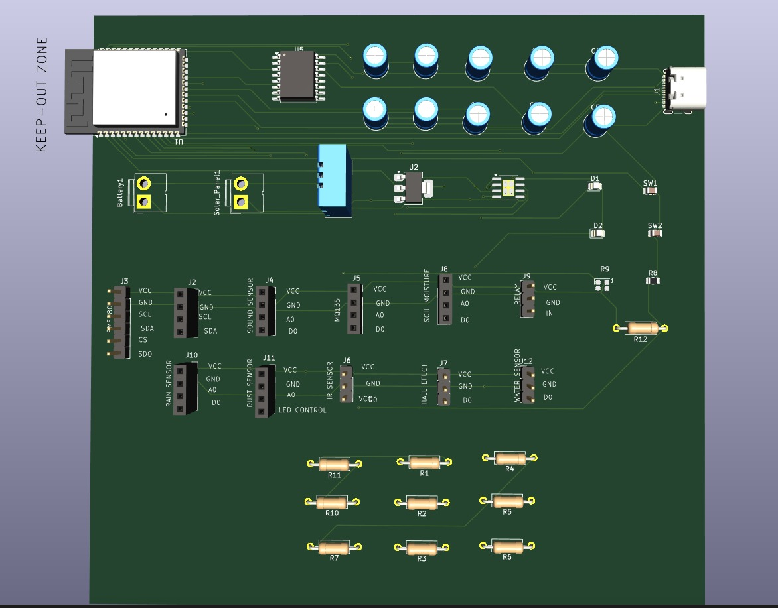

Screenshot Of Back Copper Layer Of PCB:

