INDEPENDENT PRODUCT TEARDOWN
OWNLY — Product Problem Discovery & Solution Case Study
From Customer Signals to Product Decision

PRODUCT Ownly (food delivery, Rapido ecosystem)
DOMAIN Food Delivery / Consumer Marketplace
PREPARED BY Mahesh Kontham
DATE 8 October 2026
EVIDENCE BASE 1,481 Play Store reviews across 3 Ownly apps · Semrush organic data · press (secondary)
This is an independent analysis built only on public signals. It contains no Ownly internal data, and nothing in it has been launched or tested. Every number is labelled by how much it can be trusted.
Contents
02 Executive summary 3
03 Product & business context 4
04 Problem discovery methodology 6
05 Evidence repository 7
06 Customer review analysis 9
07 Signal → pattern analysis 12
08 Competing problem hypotheses 14
09 Root cause analysis 15
10 Customer journey & product funnel 17
11 Problem definition 18
12 Opportunity sizing 19
13 Business → product outcome tree 21
14 Competitive analysis 22
15 Solution space 23
16 Solution prioritization 24
17 MVP definition 26
18 Product experience & wireframes 28
19 PRD — Ownly Promise v1 29
20 Experiment design 31
21 Metrics & instrumentation 33
22 Risks & second-order effects 34
23 Launch & rollout plan 35
24 Expected impact & decision framework 36
25 Future iterations 37
26 Key learnings 38
27 Appendix 39

How to read the evidence labels
Label | Meaning in this document
ACTUAL / FACT | Counted directly from the collected data, or stated in a cited source. Re-computable.
OBSERVATION | Something users describe or that is visible in the data, taken at face value.
INFERENCE | A conclusion drawn by combining observations. Plausible but not proven.
ASSUMPTION | A value or belief adopted so the analysis can proceed. Must be replaced with real data.
HYPOTHESIS | A testable causal claim with a defined way to prove it wrong.
ESTIMATE | A number derived from assumptions with the formula shown.
EXPECTED | A result we expect from a test that has not run. Not an outcome.
UNKNOWN / REQUIRES VALIDATION | We do not have the data. Stated plainly instead of guessed.
SECONDARY | Press or prior notes, recorded in the source pack but not re-verified for this document.

02 Executive summary
31.6%  of 1–2★ customer reviews describe paying and getting no food  ACTUAL | 1.05★  average rating when that happens  ACTUAL | 43%  of reasoned 4–5★ reviews praise price / no fees  ACTUAL | 0  internal order metrics available to size it  UNKNOWN

Context. Ownly is Rapido's food-delivery app. It is reported to charge restaurants no commission and customers no platform fee, and it is prepaid only SECONDARY . It runs three apps: customer, restaurant partner, and captain (rider).
Problem discovered. Across 1,000 customer reviews (27 Sep–4 Oct 2026), the worst-rated experience is not slow food or a bad menu. It is paying and getting nothing: the order is cancelled after payment, no captain arrives, or the order is marked “Delivered” without a handover. 156 of 493 negative reviews (31.6%) describe one of these. When they do, the rating is ~1★ whether or not support is also mentioned ACTUAL .
Why it matters. Ownly's advantage is price, and that is working: even 42 angry reviewers still praise it. But a prepaid, low-margin model cannot absorb a failed order. Every failure costs the full order value plus support time, and generates public “fraud” language (74 negative reviews use fraud/scam wording) ACTUAL . Since July 2026 Rapido's app sends new users to Ownly SECONDARY , so a failure is also a failure of Rapido's distribution.
Triangulation. The restaurant and captain apps describe the same breakdowns from the other side: order alerts that don't ring so orders auto-cancel, captains sent too early, and opaque captain incentive rules. All three apps share one pattern: a manual queue with no visible status and no owner INFERENCE .
Root-cause hypothesis. No step in the order pipeline has to prove a handoff happened, and no rule makes the customer whole automatically when one fails HYPOTHESIS .
Business impact. Cannot be sized from public data. The severe-failure rate per order and the repeat-order gap after a failure are both UNKNOWN . The sensitivity model (Section 12) shows the direct financial return is small at Ownly's thin margin, so the case rests on retention, trust and Rapido brand protection. That makes sizing the failure rate the first deliverable, before building anything.
Recommendation and MVP. Run a 2-week sizing gate. If severe failures are at least 1% of orders, or the 30-day repeat gap is 10 percentage points or more, build Ownly Promise v1: a 4-digit delivery code the captain must enter to mark an order delivered, plus three automatic refund rules (cancelled after payment, no captain within 20 minutes, “not received” on an unverified delivery). Every failure is logged with a cause code.
Validation and success metric. A zone-randomised pilot in one city (Bengaluru, subject to data) for at least 4 weeks. Primary KPI: “not received” claims per 1,000 delivered orders. North Star: weekly promise-kept orders. Guardrails: captain food-order acceptance, handover time, refund cost and abuse rate. Scale on a ≥40% drop with healthy guardrails; reject at <15%.

03 Product & business context

What Ownly is
Topic | What we know | Status
Ownership | Food-delivery product of Rapido (ride-hailing). Piloted in Bengaluru Aug 2025, city-wide launch 3 Mar 2026 | SECONDARY press, via source pack
Distribution | Integrated into the main Rapido app in Jul 2026, still available as a standalone app | SECONDARY
Restaurant offer | Zero commission; ~20,000 restaurants listed | SECONDARY ; one merchant review mentions a “fair commission structure”, so the exact terms are UNKNOWN
Customer offer | Menu prices match the restaurant's own; no platform fee; delivery fee ~₹30 + GST | SECONDARY ; 2 reviews dispute price parity
Payment | Prepaid only (no cash on delivery) | INFERENCE from 12 reviews asking for COD
Scale | ~5,000 orders/day in Bengaluru (Mar 2026). Current volume unknown | SECONDARY (stale) / UNKNOWN
Cities | Bengaluru and Hyderabad appear in reviews; Delhi, Mumbai, Chennai and Lucknow appear only in search keywords | INFERENCE
Three apps | Customer app; restaurant partner app; Ownly Captain rider app (riders compare it with the Rapido Captain app) | ACTUAL from scraped Play Store data

Marketplace structure
Ownly coordinates three sides it does not fully control. A customer pays upfront; the restaurant must accept and prepare the order; a captain must collect and hand it over. Ownly's operations sit in the middle and handle support, refunds, onboarding and dispatch.
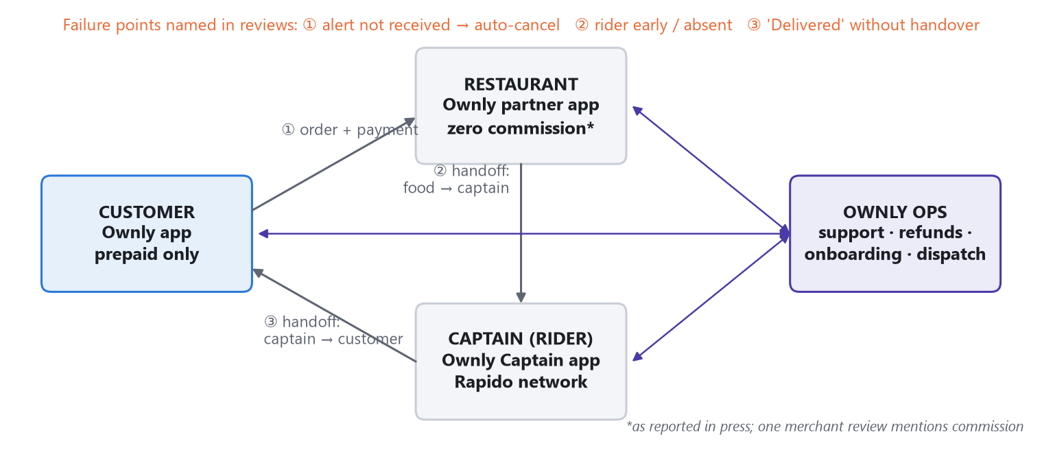
Exhibit 1. Ownly's three-sided marketplace and the three handoffs named in reviews.

Economics that matter for this problem
Incumbents (Swiggy, Zomato) are reported to earn 15–30% commission plus a ₹15–18 platform fee SECONDARY . Ownly gives most of that up and earns mainly the delivery fee. Inference: Ownly's margin per order is thin and roughly fixed, so a failed order (refund + support + captain time) can wipe out the margin of many good orders. A commission model has more room to absorb failures. This is why reliability is more important to Ownly's model than to the incumbents' INFERENCE .
IMPORTANT ASSUMPTION · The economics are not verified
Contribution per order, delivery cost per trip and refund cost are not public. This document uses ₹5 / ₹10 / ₹15 contribution scenarios and a ~₹30 fee only to show how sensitive the conclusion is. Replace them with finance data before any build decision.

Competitive context in one line
Ownly wins on price and, on the evidence, loses on reliability and support. Customers say so directly: “Zomato, Swiggy is way more good than this” (1★, 2 Oct 2026). One reviewer praises the pricing “in the age of institutionalised fleecing by Swiggy and Zomato” and in the same review calls customer service useless (1★, 4 Oct 2026) OBSERVATION .

Why this problem could matter strategically
- Price is the moat, reliability is the leak. Incumbents can improve reliability more easily than they can drop commission, which would cut into their own profit. Ownly needs to be reliable enough, not best in class INFERENCE .
- Rapido's distribution makes first orders the moment of truth. Rapido users arrive at Ownly through its super-app. If their first order fails, that distribution is wasted. First-order reviews average 2.05★ (n=22) ACTUAL , a small sample.
- Brand spillover. 14 customer reviews name Rapido, 10 of them negative, e.g. “side gig in between rapido rides” ACTUAL . A food failure is also a Rapido brand risk.

04 Problem discovery methodology
The problem was not chosen first and then supported. Each source was read for what it can and cannot prove, and only patterns that appeared in more than one independent source were promoted to a problem hypothesis.
Source | What was analysed | What it can tell us | Limitations
Customer app reviews (Play Store) | 1,000 reviews, 27 Sep–4 Oct 2026; 87% on v2.0.4; keyword-coded into 17 themes, then re-checked | What goes wrong, how severely, and in which journey stage | 8 days only; Android only; self-selected (extremes over-represented); keyword tagging has false positives; cannot show frequency per order
Restaurant partner app reviews | 105 reviews, 14 Nov 2025–4 Oct 2026; 33 describe a problem; analyst-coded themes | Supply-side causes of customer failures; onboarding and support friction | Small sample; 37 reviews posted on 2 days; 0 developer replies
Captain (rider) app reviews | 376 reviews, 5 Mar–4 Oct 2026; keyword-coded into 7 themes plus rider stage | Captain supply, onboarding, incentives, dispatch | Most reviewers are applicants, not active captains; bursts of short 5★ reviews
Semrush organic data (ownly.food) | Overview + positions PDFs, India desktop, 5 Oct 2026; Compare Domains screenshot | Brand discovery, search demand, relative scale vs incumbents | Modelled estimates; desktop only in a mobile-first market; the “Top Opportunities” panel uses the US database
Press (secondary) | Business Today (28 Jul 2026), Upstox, as recorded in the source pack | Business model, launch dates, reported scale | Company-sourced claims; order volume is from Mar 2026; not re-verified here
Prior analysis (source pack) | Earlier workbook analyses and strategy notes | Starting hypotheses | Re-tested here; four claims corrected (Appendix C)

Why multiple sources were necessary
- Reviews alone over-sample anger. A customer whose order worked rarely writes 40 words; a customer who lost ₹430 does. The restaurant and captain apps test whether the customer story has a real operational mechanism behind it.
- Different sides see different halves of one failure. A customer sees “cancelled after payment”. A restaurant sees “the ring didn't fire, the order auto-cancelled, and I was blamed”. Only together do they point to a cause.
- Search data tests the growth alternative. If discovery were the constraint, it would show up as a search gap. It does, but the data shows distribution runs through Rapido, not search (Section 8).

Method in four steps
- Code every review into themes (keyword dictionary for customer and captain apps; analyst coding for the restaurant app) and map themes to journey stages.
- Measure each theme on frequency (share of 1–2★ reviews), severity (average rating when mentioned), agreement (thumbs-up), recency and segment.
- Stress-test the coding: check false positives, re-cut the strongest claims, and drop any claim that does not survive (Appendix C).
- Triangulate: promote a pattern only if an independent source shows the same mechanism, then write competing hypotheses before choosing one.

05 Evidence repository
The signals that carry the argument are below, grouped by side. Quotes are verbatim from the scraped reviews (spelling unchanged). The full theme tables are in Appendix A.

Customer app
Source · date · n | Exact observation | Interpretation | Confidence | Limitation
Customer reviews · 27 Sep–4 Oct 2026 · n=1,000 | 47.6% of reviews are 1★ and 44.3% are 5★; average 2.96★ | Polarised by incidents rather than a mediocre product | HIGH | Self-selection exaggerates both ends
Same · n=493 (1–2★) | 104 reviews say the order was marked delivered or never arrived; avg 1.07★. “after 10 mins it showed that the order is delivered And gave me a random number” | Handover is not verified | HIGH | Some claims may be customer error or abuse
Same | 61 reviews describe cancellation after payment; avg 1.00★. “they accepted order first and deducted the amount. After 1hour … they are asking me to cancel” | Payment risk sits with the customer | HIGH | Cause of cancellation is not visible
Same | Refund problems in 113 reviews (avg 1.15★). “refund stuck in initiated no money given this is 527 rs” | Recovery is slow, partial or missing | HIGH | Refund turnaround time unknown
Same | Support unresponsive in 241 (48.9% of 1–2★). Bot complaints: “the bot never lets you connect to a person” | Recovery has no decision authority | MEDIUM-HIGH | Dictionary includes broad words (“mail”, “chat”) so this is inflated
Same · n=188 reasoned 4–5★ | 81 (43.1%) cite price, no platform fee or no hidden charges; 42 negative reviews still praise price | The value proposition lands | MEDIUM-HIGH | 2 reviews dispute price parity
Developer replies · n=1,000 | 99.9% replied; median reply ~14 min; 49.8% of replies redirect to email | Fast acknowledgement, no resolution in the channel | HIGH | Reply content is templated

Restaurant partner app
Source · date · n | Exact observation | Interpretation | Confidence | Limitation
Partner reviews · 7 Aug 2026 · 4★ | “notification of order is not working properly … order getting cancelled without our knowledge. aps not working on background.” | A supply-side cause of “cancelled after payment” | MEDIUM | 3–4 reviews only
Partner reviews · 17 Apr 2026 · 4★ | “riders coming to the restaurant when the order assigned … difficult to prepare in 10 mins” | Dispatch ignores prep time | LOW-MEDIUM | 2 reviews
Partner reviews · 2026 | “submit the same documents more than 10 times”; “called for menu updates more than 50 times”; “9 follow-ups” | Partners depend on a manual ops queue | MEDIUM | Small n (33 problem reviews)
Partner reviews · 9 Jun 2026 · 1★ | “payments were reportedly sent to a bank account that does not belong to me” | Money-movement integrity risk | LOW (n=1) | Single incident; escalate, don't generalise

Captain (rider) app
Source · date · n | Exact observation | Interpretation | Confidence | Limitation
Captain reviews · Mar–Oct 2026 · n=376 | 58.7% of negative reviews are about verification/activation (avg 1.34★); these hold 65% of all thumbs-up | Applicants are stuck before their first delivery | HIGH | Applicants are not yet captains
Same · n=93 stating a wait | Median stated wait 30 days; 29% over 30 days; longest 180 | Activation is a black-box queue | MEDIUM | Self-reported durations
Captain review quoting Ownly social team | “we are not onboarding Captains at the moment, so we won't be able to activate your ID” | Supply intake is paused while sign-up stays open | MEDIUM | Single quoted message
Captain reviews · May–Aug 2026 | “not getting order 12 hrs”; “not getting orders in yelahanka area”; “Orders are coming in very less compared to the Rapido Captain app” | Some captains are idle while customers report no captain | LOW | 3 reviews; needs dispatch data
Captain reviews · Jul–Aug 2026 | “even after a rider goes offline, orders are still being assigned and counted as busy pings” | Incentive rules feel unfair; may reduce food-order acceptance | LOW-MEDIUM | Few reviews; mechanism unverified

Search, market and rating-integrity signals
Source · date · n | Exact observation | Interpretation | Confidence | Limitation
Semrush · 5 Oct 2026 | ~1.1K est. monthly desktop organic visits (India); 163 keywords; #1 for “rapido food delivery bangalore”; ranks for misspellings “only app”, “onely” | Discovery is borrowed from Rapido; the Ownly brand is not yet searched for | MEDIUM | Modelled; desktop only
Semrush Compare Domains | Organic traffic: ownly.food 1.1K vs zomato.com 67.9M vs swiggy.com 15.3M | Scale gap is vast, but irrelevant to the near-term problem | MEDIUM | Worldwide database
Captain + partner apps | Both apps receive review spikes on 2 Jun and 19 Jun 2026 (partner: 19 and 18 reviews, all 5★) | Consistent with solicited review drives; headline ratings are unreliable | MEDIUM | Does not prove any review is fake
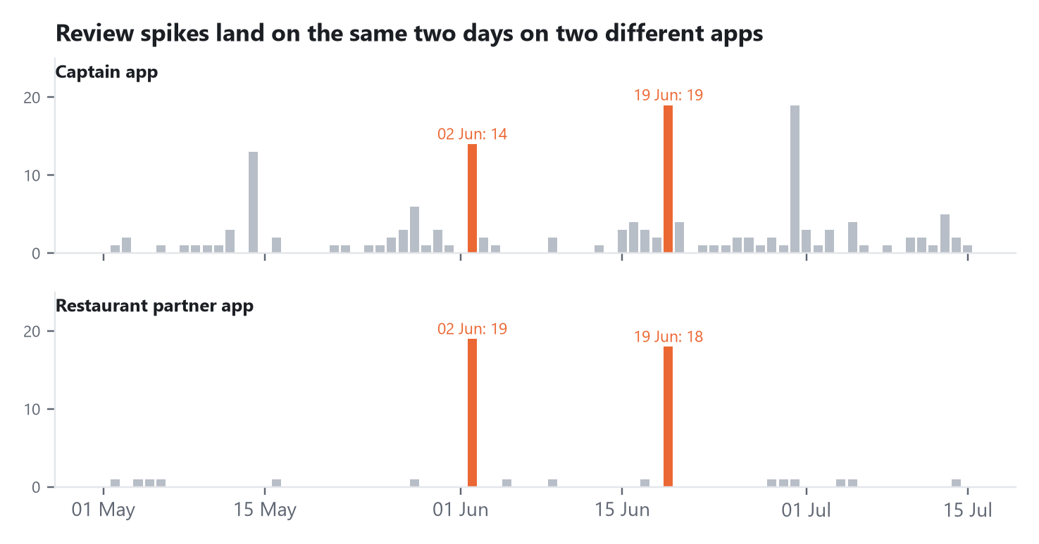
Exhibit 2. Daily review counts, May–Jul 2026. The same two dates spike on two different apps.

06 Customer review analysis
EVIDENCE · Sample and limits
1,000 customer reviews over 8 days (27 Sep–4 Oct 2026), Android only. 493 are 1–2★. 55 negative reviews (11.2%) match no theme (e.g. “worst”, regional language). Percentages are shares of reviews, not shares of orders.

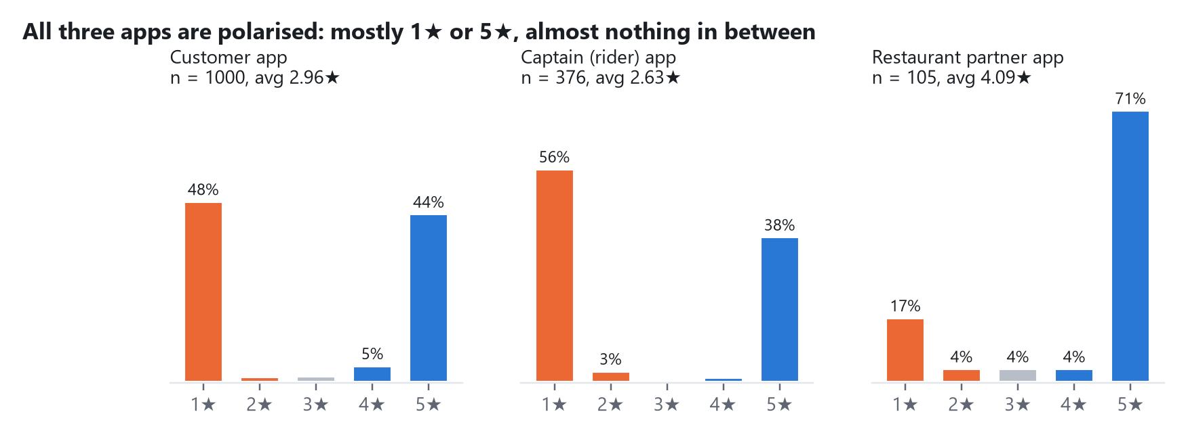
Exhibit 3. Rating distribution on all three Ownly apps.

Taxonomy
The generic taxonomy (delivery, pricing, UX, etc.) was replaced with one that follows the order journey, because the data shows failures cluster after payment. Themes were mapped to seven journey stages; a review can touch several.
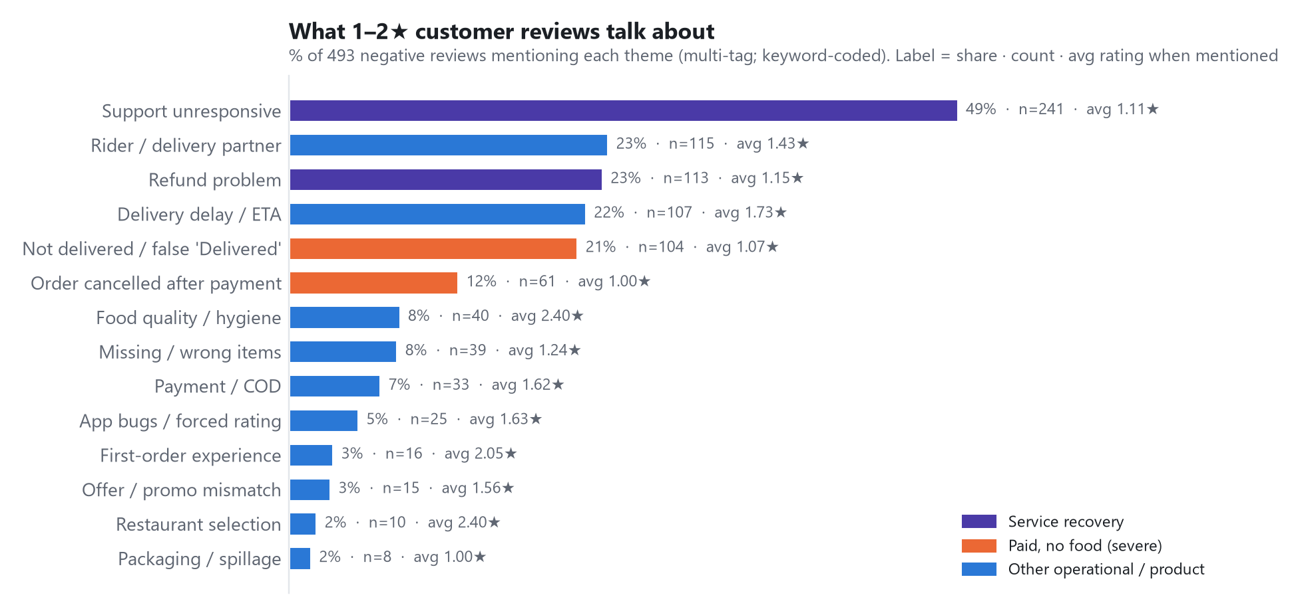
Exhibit 4. Theme frequency in 1–2★ reviews, with count and average rating when mentioned.

Frequency × severity
Frequency alone would make “support” the problem. Adding severity changes the picture: the two paid-no-food themes (orange) sit at the severity floor (1.00–1.07★) with meaningful frequency, while delays and food quality are milder.
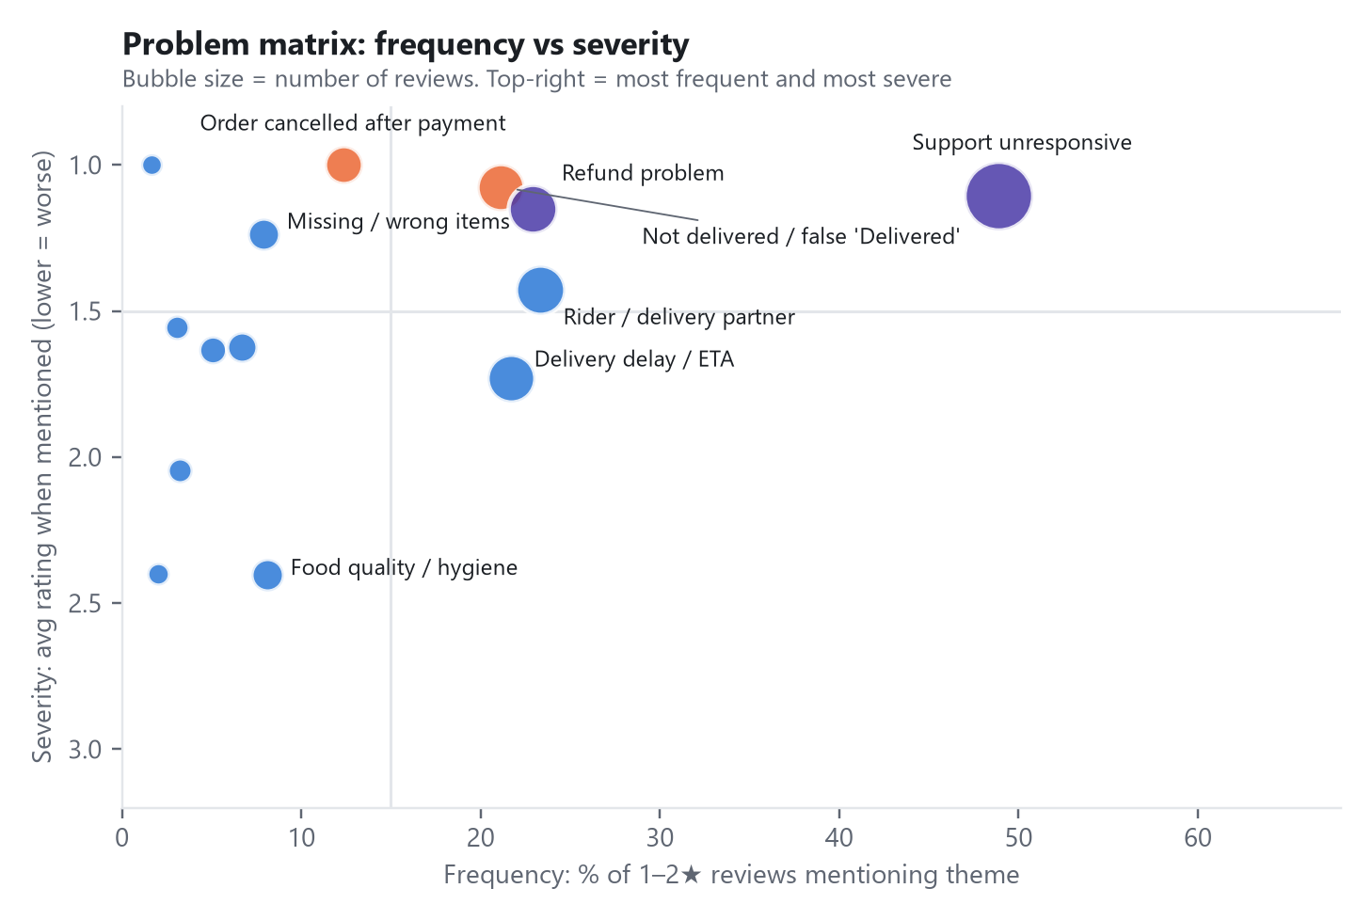
Exhibit 5. Frequency vs severity of customer review themes.

Severity, segment, recency
Dimension | Finding | Label
Severity | Union of “cancelled after payment” and “not delivered / false Delivered”: 156 of 493 negatives (31.6%), avg 1.05★ across all 159 mentions | ACTUAL
Segment | First-order reviews avg 2.05★ (n=22). Rapido-mentioning reviews avg 2.07★ (n=14). Too small to segment reliably | ACTUAL / small n
Recency | Daily share of 1–2★ ranged 42%–56% across the 8 days; no single-day spike explains the pattern | ACTUAL
App version | v2.0.4 = 87% of reviews (3.05★); older v2.0.1 averages 2.21★ (n=24). Fixes may have landed, or it is noise | ACTUAL / inconclusive
Time of day | 12 reviews mention night or late-night timing (e.g. “placed an order around 1 AM, but no rider was assigned”) | INSUFFICIENT EVIDENCE

The failure cascade
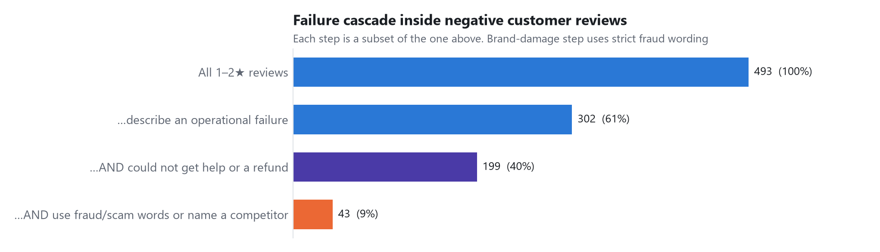
Exhibit 6. Within negative reviews: operational failure → no recovery → brand-damage language.
61% of negative reviews describe an operational failure; two-thirds of those also say they could not get help or a refund; and 43 go on to use fraud/scam words or name a competitor ACTUAL . The cascade shows the order of events in the review text. It does not prove that the lack of recovery caused the brand damage (see the correction below).
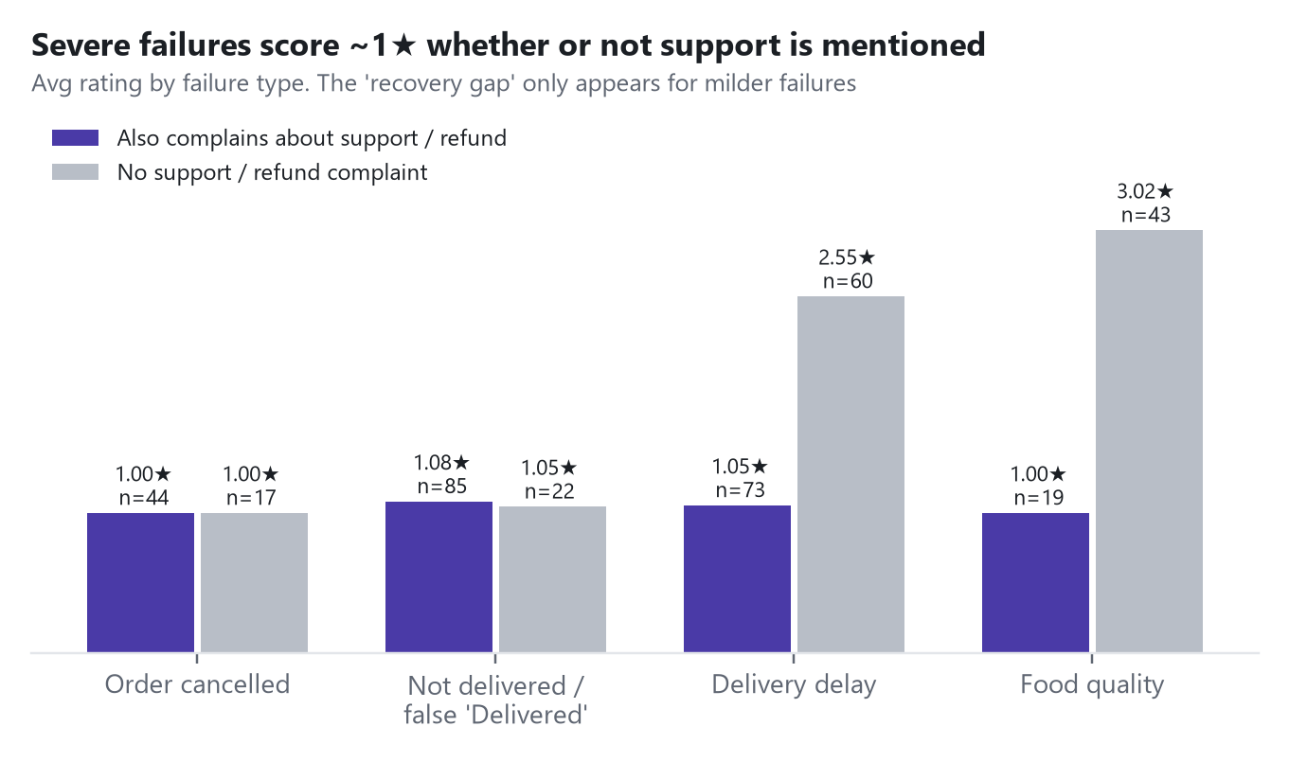
Exhibit 7. Average rating by failure type, split by whether support/refund is also criticised.
CORRECTION · Recovery does not rescue a severe failure
An earlier analysis concluded that “failed recovery costs a full star” (2.33★ vs 1.07★). Split by failure type, that gap disappears for severe failures: cancelled orders are 1.00★ either way, and not-delivered orders are 1.08★ vs 1.05★. The gap only exists for delays and food quality. Even there, the “no recovery complaint” group is inflated by false positives: 53 of those 159 reviews are 4–5★, and the delay dictionary includes positive phrases such as “on time” and “punctual”.
Implication: prevent the severe failure first. Recovery is necessary but will not save the rating on its own.

Cross-source confirmation
Customer pattern | Restaurant app | Captain app | Status
Cancelled after payment | Alerts not ringing → auto-cancel; “order getting cancelled without our knowledge” | — | INFERENCE 2 sources
No rider / rider unreachable | Rider assigned at acceptance, arrives before food is ready | Captains idle (“not getting order 12 hrs”); onboarding paused | INFERENCE 3 sources, small n
False “Delivered” | — | Opaque incentive rules (busy-ping penalties) could encourage shortcuts | HYPOTHESIS unverified
Support doesn't resolve | “9 follow-ups”, “50 times”, 0 public replies | 0 public replies; “verification pending” for months | INFERENCE 3 sources
Price is why people come | “cost-saving food delivery model” (5★) | — | FACT 2 sources

07 Signal → pattern analysis
Each pattern below is built bottom-up from signals, with facts, inferences and assumptions kept apart. Five patterns survive; two candidate patterns were dropped for lack of evidence (listed at the end).

P1 · The money-loss moment is the worst moment
Observation | Evidence |  | Pattern |  | Potential implication
Customers pay, then the order is cancelled, unassigned or falsely marked delivered | 156 negative reviews; avg 1.05★; 74 negatives use fraud/scam words |  | Trust collapses when money disappears, not when food is late |  | Fix the paid-no-food path before speed, menus or discounts
FACT |  | INFERENCE |  | ASSUMPTION
Severity ~1★ for both severe themes |  | Prepaid-only puts all failure risk on the customer |  | Review prevalence roughly tracks the real failure mix

P2 · Failures happen at handoffs between parties
Observation | Evidence |  | Pattern |  | Potential implication
Restaurant → captain → customer transitions break | Customer themes + partner alerts + captain dispatch reviews |  | Ownly coordinates three parties but verifies none of the handoffs |  | The fix is orchestration and verification, not more supply
FACT |  | INFERENCE |  | ASSUMPTION
Same mechanisms are described independently on 2–3 apps |  | No handoff is verified today (no OTP is mentioned anywhere) |  | Captain-app data reflects the same fleet that serves customers

P3 · Every side is stuck in an invisible queue
Observation | Evidence |  | Pattern |  | Potential implication
Refund “initiated” for weeks; captain verification pending for a median 30 days; partner documents requested 10+ times | 3 apps; developer reply rate 99.9% (customer) vs 0% (partner, captain) |  | Manual ops queues with no status, clock or owner |  | A status + SLA layer is a company-wide principle; the customer refund queue is the costliest instance
FACT |  | INFERENCE |  | ASSUMPTION
Reply rates; quoted waits |  | Attention goes to the side where symptoms show, not where causes start |  | Reply behaviour reflects internal resourcing

P4 · Price is the moat on both sides
Observation | Evidence |  | Pattern |  | Potential implication
Customers and restaurants praise the economics | 43% of reasoned praise; 42 angry reviewers still praise price; partner 5★ cites cost saving |  | Demand is not the constraint; reliability is |  | Do not spend on discounts; spend on reliability
FACT |  | INFERENCE |  | ASSUMPTION
Counts above |  | People who leave are not leaving over price |  | Price parity holds for most restaurants (2 disputes)

P5 · The rating signal is distorted
Observation | Evidence |  | Pattern |  | Potential implication
Short 5★ reviews, forced prompts, same-day bursts on two apps | 60.9% of customer 5★ have ≤3 words; partner 37 of 105 reviews on 2 days; captain organic avg 2.19★ vs 2.63★ headline |  | Store ratings cannot be used as a KPI |  | Measure order-level outcomes; stop review drives (Play Store policy risk)
FACT |  | INFERENCE |  | ASSUMPTION
Counts above |  | Bursts are solicited |  | —

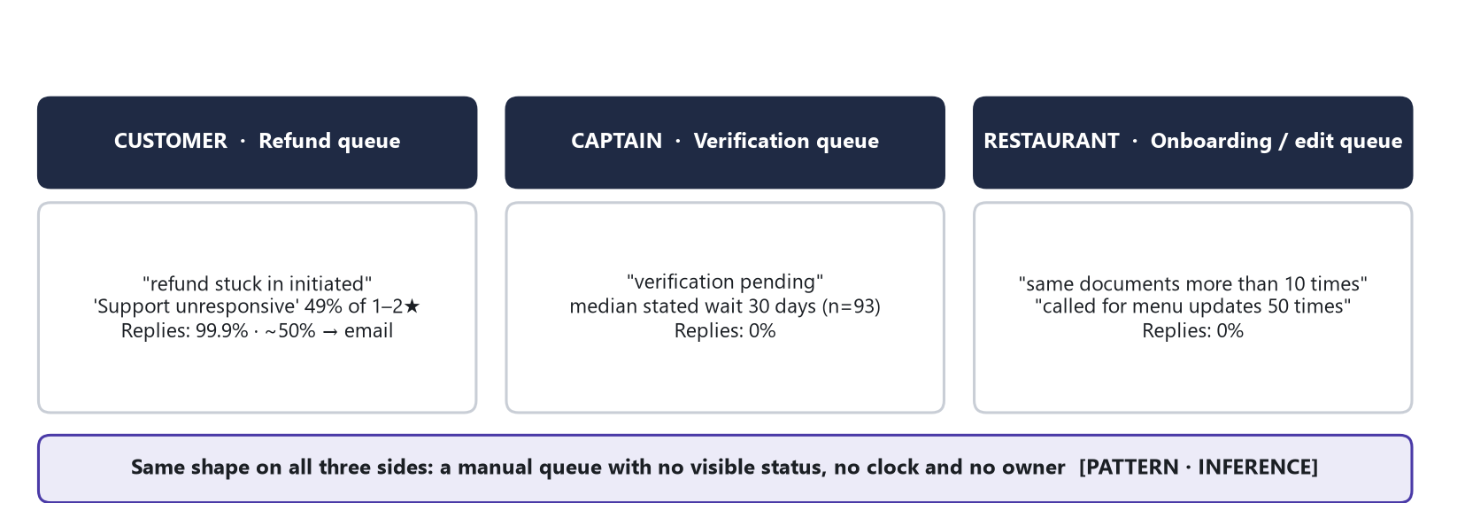
Exhibit 8. Pattern P3: the same invisible-queue shape on all three sides.

Candidate patterns dropped
- “Night-time supply gap.” Only 12 reviews mention night timing. INSUFFICIENT EVIDENCE . Kept as a question for dispatch data.
- “Negative reviews dominate what new users read” (94% of helpful votes). True but based on only 32 thumbs-up across 1,000 reviews (30 on negatives). The base is too small to support the claim, so it was removed from the argument.

08 Competing problem hypotheses
Before settling on reliability, every explanation supported by at least some evidence was written down with the evidence against it. Irrelevant hypotheses (e.g. AOV, which no source speaks to) were not forced in.
# | Hypothesis | Supporting evidence | Contradicting evidence | Confidence | Validation needed
H1 | Delivery reliability: paid orders end with no food, and this drives churn | 156 negatives at ~1★; partner alert and dispatch reviews; fraud language follows | Frequency per order unknown; reviews over-sample failures; some claims may be abuse | MEDIUM-HIGH existence · UNKNOWN size | Order logs: severe-failure rate; cohort repeat gap
H2 | Service recovery is the primary problem | 49% of negatives mention support; 85 negatives cite support with no operational failure | Severe failures are ~1★ with or without support complaints (Exhibit 7); support dictionary is broad | MEDIUM (as amplifier) | Ticket data; resolution time vs repeat
H3 | Captain liquidity: too few captains | “No rider” reviews; late-night examples | Captains report idle hours; onboarding is paused; 150 applicants waiting. Suggests allocation, not headcount | LOW-MEDIUM | Dispatch logs: time-to-assign by zone/hour; idle captain minutes
H4 | Restaurant acceptance failures cause cancellations | Partner reviews: alerts not ringing, auto-cancel, blamed | 3–4 reviews; stock-outs or restaurant choice could also explain it | MEDIUM | Cancellation cause codes; alert delivery receipts
H5 | Restaurant selection / density limits retention | Partners report “one order a day” | Only 2% of customer negatives mention selection | LOW | Repeat rate of customers with clean orders
H6 | Pricing is the problem | 2 price-parity disputes | Price is the #1 praise driver | REJECTED | Price-parity audit (protect the moat)
H7 | Acquisition / discovery is the constraint | 1.1K organic visits vs 15–68M for incumbents | Distribution runs through the Rapido app; fixing acquisition fills a leaky bucket | LOW (for now) | Install → first-order funnel
H8 | App UX / bugs drive dissatisfaction | Forced rating prompt; payment glitches (5–7% of negatives) | Low frequency; ratings 1.6★, milder than the severe themes | LOW | Crash and payment-failure rates
H9 | Retention is weak regardless (clean-order customers don't return either) | None directly; partners' low volume is consistent with it | No data | UNKNOWN | Kill test: if true, H1 is not the binding constraint

PM DECISION · Lead with H1, design to be proven wrong by H9
H1 has the strongest triangulated evidence and the clearest mechanism. But a strong signal in reviews is not proof of business impact. The plan therefore starts with a sizing gate that tests H1 against H9 using two queries. If severe failures are rare and clean-order customers also fail to return, the reliability plan stops and the team pivots to the retention/selection question.

09 Root cause analysis

Business problem → user problem → behaviour → root cause
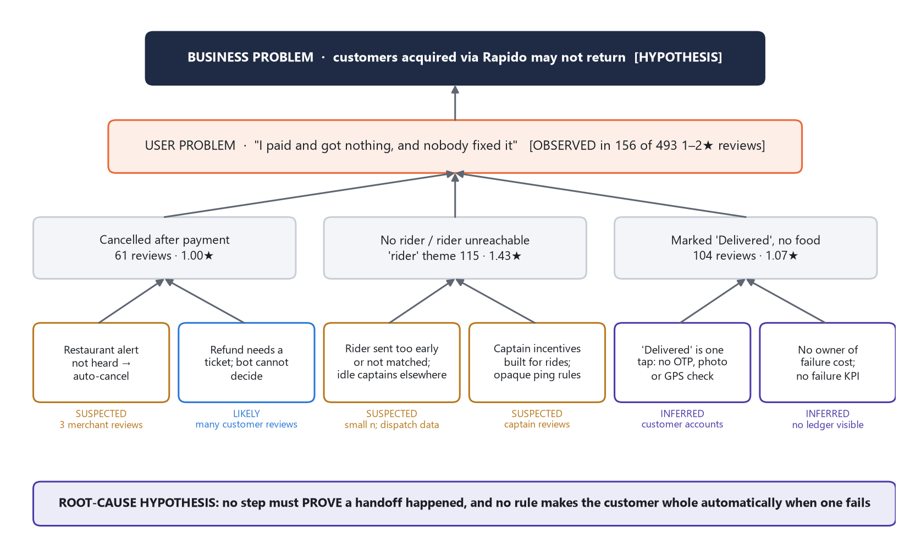
Exhibit 9. Causal tree. Border colour shows confidence: blue = likely, violet = inferred, amber = suspected.

5 Whys: “I paid, it says Delivered, I have no food”
Why? | Answer | Status
1. Why didn't the customer get food? | The order was marked delivered without a handover (wrong address, abandoned order, or bad intent) | OBSERVED in 104 reviews
2. Why could it be marked delivered? | Marking delivered appears to need one tap, with no code, photo or GPS check (“after 10 mins it showed that the order is delivered”) | INFERRED
3. Why wasn't it caught? | No visible anomaly detection (e.g. “delivered” far from the drop pin, or too fast) | SUSPECTED
4. Why wasn't the customer made whole? | Refunds need a ticket, the ticket goes to a bot or email, and the bot cannot decide | LIKELY
5. Why is it designed that way? | Refund liability isn't assigned to the party at fault, so the default is to delay or deny | HYPOTHESIS

Fishbone summary for “paid, no food”
Category | Contributing cause | Evidence strength
Restaurant | Order alert doesn't fire on tablets or in the background → auto-cancel; prep time not captured | SUSPECTED 3–4 partner reviews
Dispatch / captains | Captain assigned at acceptance (too early) or not at all; idle captains elsewhere; incentives tuned for rides; no thermal bags | SUSPECTED small n across 2 apps
Product | No delivery code; status the customer cannot trust; bot with no exit; no one-tap “not received” | INFERRED consistent customer accounts
Policy / payments | Prepaid only; refunds slow, partial or stuck at “initiated” | LIKELY 113 refund reviews
Measurement | No visible failure KPI; distorted store ratings; leadership may be steering on inflated stars | INFERRED

What is confirmed vs suspected
- Confirmed (from data): severe failures exist, recur and score ~1★; customers describe them consistently; recovery is commonly reported as failing.
- Likely: refund and support flows lack decision authority.
- Suspected, needs validation: missed restaurant alerts as a main cause of cancellations; dispatch timing and captain allocation as a cause of no-rider failures; captain incentive design as a cause of shortcuts.
UNKNOWN · Data required before the root cause is accepted
- Severe-failure rate per 1,000 orders, split by cancelled-after-payment / no captain / delivered without GPS match at the drop point.
- Post-payment cancellation cause codes, and alert delivery and acknowledgement receipts per restaurant.
- Time from acceptance to captain assignment by zone and hour; idle captain minutes in the same zones.
- Refund turnaround; share of refunds that are partial, denied or stuck at “initiated” for more than 7 days.
- 30-day repeat rate: customers whose first order failed vs customers whose first order was clean.
- Whether all Ownly deliveries run through the Ownly Captain app (this changes the MVP dependency).

10 Customer journey & product funnel
No funnel data is available, so no conversion rate can be calculated UNKNOWN . What the reviews do show is where the journey breaks. That is overwhelmingly after the customer has paid, when they no longer control the outcome.
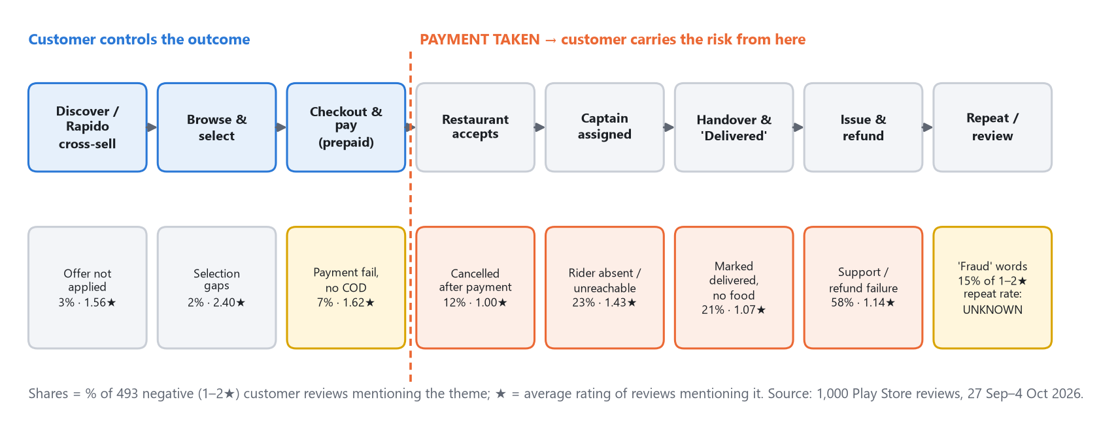
Exhibit 10. Journey map with pain points from reviews.
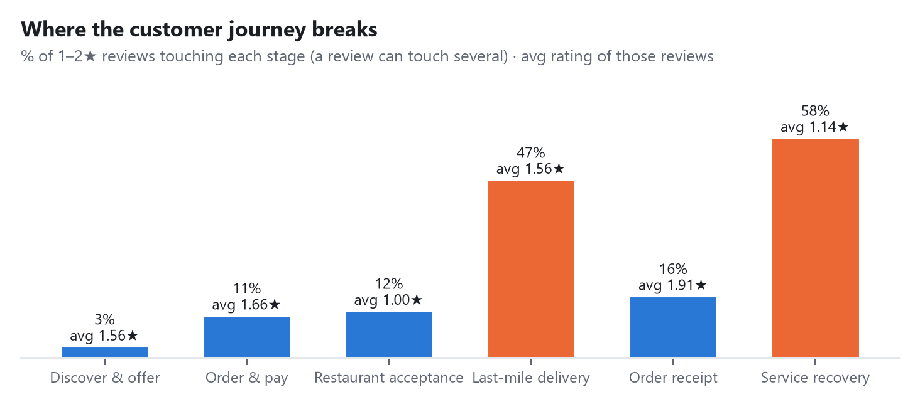
Exhibit 11. Share of negative reviews touching each stage.
Stage | Type | What reviews show | Metric we would need
Discover → install | Bottleneck? | Discovery is via Rapido; brand searched as “rapido food” | Rapido-to-Ownly entry rate UNKNOWN
First order / offer | Friction | 15 negatives say the advertised offer didn't apply | Offer redemption error rate UNKNOWN
Checkout → payment | Friction / drop-off | Payment failures; money deducted with no order; COD requests | Payment success rate UNKNOWN
Restaurant accepts | Failure point | Cancelled after payment (61, 1.00★) | Post-payment cancellation rate by cause
Captain assigned | Failure point | No captain for 40–75 min; captain unreachable | Time to assign; % unassigned at 20 min
Handover | Moment of truth | Marked delivered, no food (104, 1.07★) | % delivered without GPS match
Issue → refund | Moment of truth | Bot loops, email redirects, refunds stuck | Refund turnaround; % auto-resolved
Repeat / review | Outcome | Fraud language; uninstall threats; forced rating prompt | 30-day repeat rate (failed vs clean)

11 Problem definition
KEY INSIGHT · Problem statement
For prepaid Ownly customers, especially those on their first few orders, an order can end with money taken and no food (cancelled after payment, no captain assigned, or marked “Delivered” without a handover) because no step in the order pipeline has to prove the handoff happened and no rule makes the customer whole automatically when it fails, resulting in ~1★ reviews, “fraud” language, and (hypothesised) lost repeat orders from customers Ownly acquired through Rapido's distribution.

Question | Answer | Label
Who experiences it? | Prepaid customers in live cities; likely concentrated among first-time users arriving from the Rapido app | INFERENCE
How frequently? | Present in 31.6% of negative reviews. Per-order frequency is unknown | ACTUAL / UNKNOWN
How severe? | The most severe experience in the dataset: 1.00–1.07★ average | ACTUAL
Why now? | Rapido-app integration (Jul 2026) increases the number of first orders exposed to the weakest step | SECONDARY + INFERENCE
Why should Ownly care? | A failure costs the full order with a thin margin to absorb it, and turns a price-driven customer into a public detractor | INFERENCE
Why strategic? | It protects the one advantage incumbents can't easily copy (fair price) by removing the reason to leave | INFERENCE

Alternative problem framings considered and rejected
Framing | Why it was rejected (for now)
“Support is bad” | Support complaints mostly sit on top of a failure, and do not change the rating of severe failures. Fixing support alone adds cost linearly while the failures continue
“Delivery is slow” | Delay reviews are milder (1.73★) and the theme includes false positives (“on time”). Speed is not what triggers fraud language
“Not enough captains” | Contradicted by idle-captain and paused-onboarding signals. Reframed as allocation and dispatch, pending data
“Not enough restaurants” | Only 2% of negatives mention selection
“Ownly needs more traffic / SEO” | Distribution comes from Rapido; more traffic would increase the number of customers hitting failures
“Customers want COD” | 12 requests. COD would add captain cash risk and does not stop cancellation or false delivery

12 Opportunity sizing
IMPORTANT ASSUMPTION · No internal data was available
Every input below is an ASSUMPTION unless labelled otherwise. The model is built per 10,000 orders/day (300,000/month) as a scaling unit, not as a claim about Ownly's volume. Press reported ~5,000/day in Bengaluru in March 2026 SECONDARY ; current volume is UNKNOWN . The purpose is to show which inputs decide the answer.

Inputs
Input | Conservative | Base | Upside | Label / source
Orders per month (scaling unit) | 300,000 | 300,000 | 300,000 | ASSUMPTION
Severe failure rate f (paid, no food) | 0.75% | 1.5% | 3% | ASSUMPTION ; replaced in week 1
Share of severe failures that are false/not delivered | 40% | 40% | 40% | ASSUMPTION : reviews show ~65% (107 of 164 severe-failure reviews incl. no-rider); 40% used to be conservative, since reviews likely over-represent the most dramatic failure
Delivery code (OTP) cuts false deliveries by | 30% | 50% | 70% | ASSUMPTION
Auto-refund + timeouts cut other severe failures' churn effect by | 15% | 25% | 35% | ASSUMPTION
Average order value | ₹300 | ₹300 | ₹300 | ESTIMATE ; reviews cite ₹135–₹527
Repeat gap: failed vs clean customer (30-day) | 10 pp | 20 pp | 30 pp | ASSUMPTION ; replaced in week 1
Future orders per retained customer (6 months) | 3 | 5 | 8 | ASSUMPTION
Ownly revenue per order (delivery fee) | ₹30 | ₹30 | ₹30 | SECONDARY
Contribution per order | ₹5 | ₹10 | ₹15 | UNKNOWN (delivery cost not public)

Calculation (per month)
Step | Formula | Conservative | Base | Upside
A. Severe failures | 300,000 × f | 2,250 | 4,500 | 9,000
B. GMV in failed orders | A × ₹300 | ₹6.75L | ₹13.5L | ₹27.0L
C. False deliveries prevented | A × 40% × OTP cut | 270 | 900 | 2,520
D. Other failures neutralised | A × 60% × auto-refund effect | 203 | 675 | 1,890
E. Failures prevented or neutralised | C + D | ~473 | 1,575 | 4,410
F. Food value no longer lost to false delivery | C × ₹300 | ₹0.81L | ₹2.70L | ₹7.56L
G. Extra orders over 6 months (retention) | E × repeat gap × future orders | ~142 | 1,575 | ~10,584
H. Extra GMV (6 months) | G × ₹300 | ₹0.43L | ₹4.73L | ₹31.75L
I. Extra Ownly revenue (6 months) | G × ₹30 | ₹4.3K | ₹47K | ₹3.18L
J. Extra contribution (6 months) | G × contribution | ₹0.7K | ₹15.8K | ₹1.59L
Checks: C (base) = 4,500 × 0.4 × 0.5 = 900; D = 4,500 × 0.6 × 0.25 = 675; G = 1,575 × 0.20 × 5 = 1,575; conservative G = 473 × 0.10 × 3 ≈ 142; upside G = 4,410 × 0.30 × 8 = 10,584. ₹1L = ₹100,000. G, H, I and J accrue from one month's cohort of prevented failures, over the following six months. Rounding is to the displayed precision.

What the model says, honestly
- Direct contribution is small. Even in the upside case, extra contribution from retention is ~₹1.6L per monthly cohort per 10k orders/day. On direct financial return alone, the MVP would be hard to justify ESTIMATE .
- Who bears F depends on today's refund policy. If the customer currently absorbs a false delivery (no refund), F is a customer loss that becomes churn, not an Ownly saving. If Ownly refunds it, F is a direct saving. The split is UNKNOWN .
- The real return is unmodelled: store conversion (detailed 1★ reviews are what prospective users read), Rapido brand protection, and restaurant volume (GMV retained flows to restaurants that are deciding whether to keep the Ownly tablet on).
- The two numbers that decide everything are f and the repeat gap. Below f = 0.5% with a repeat gap under 5 pp, this is a CX fix, not a strategy.
PM DECISION · Size before you build
The opportunity cannot be reliably quantified from public data. The first deliverable is therefore two queries on existing order logs (failure rate and repeat gap), not a feature. That costs about two analyst-weeks and decides whether the rest of this plan proceeds.

13 Business → product outcome tree
The tree shows how fixing the root cause would connect to business results, and which link each part of the plan tests.
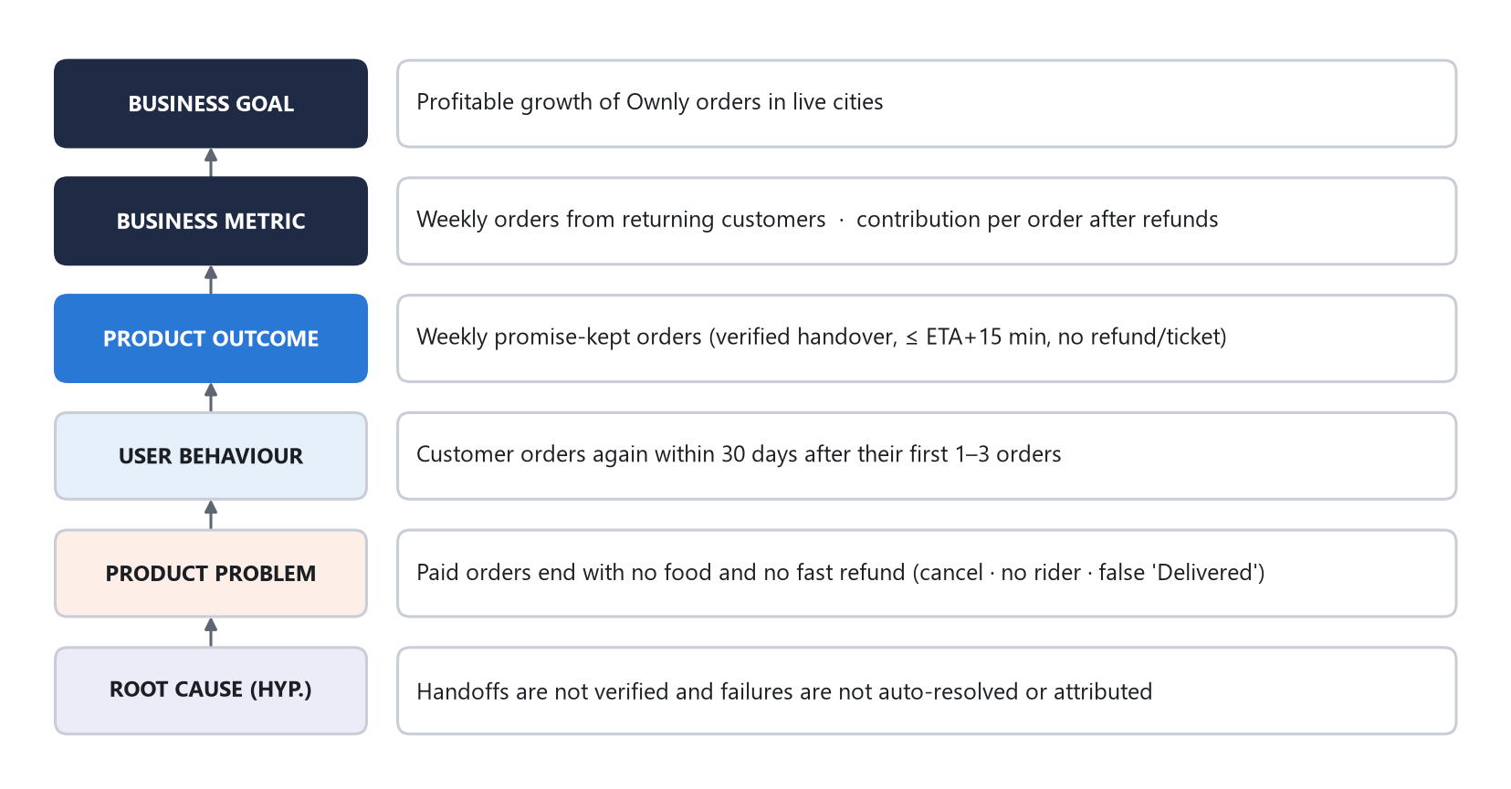
Exhibit 12. Outcome tree. The experiment tests the bottom three links; the sizing gate tests the link between the user behaviour and the business metric.
Link in the tree | What could break it | How we test it
Root cause → product problem | Most “not received” claims are abuse or confusion, not false deliveries | OTP pilot: do claims fall when handover is verified?
Product problem → behaviour | Customers whose orders fail still come back (price beats pain) | Sizing gate: repeat gap, failed vs clean
Behaviour → product outcome | Promise-kept orders rise but refunds or captain friction offset it | Guardrails: refund cost, captain acceptance
Product outcome → business metric | Contribution per order falls after refunds | System rule: stop if contribution after refunds drops > ₹3/order

14 Competitive analysis
This is not a general comparison. It looks only at the parts of the competitive picture that bear on the paid-no-food problem. Claims about competitors' internal workflows were not observed in this research and are marked REQUIRES VALIDATION ; a structured walkthrough is proposed in Appendix F.
Dimension | Ownly | Swiggy / Zomato | Source · confidence
Customer price | Restaurant menu price, no platform fee, ~₹30 delivery fee | Platform fee ~₹15–18; menu mark-ups reported | SECONDARY press; reviews confirm Ownly is seen as cheaper
Restaurant economics | Zero commission (reported) | 15–30% commission | SECONDARY
Delivery fleet | Ownly Captain app on Rapido's network; food can be a side gig between rides | Dedicated fleets with bag and handling standards | Ownly: reviews OBSERVATION ; competitors: REQUIRES VALIDATION
Trust & recovery | Bot-first, email redirects, refunds stuck at “initiated” | Customers say incumbents support better (“not supporting like Zomato and Swiggy”) | Customer and partner reviews OBSERVATION ; incumbent flows REQUIRES VALIDATION
Communication | Fast templated store replies (median ~14 min) that point to email | Not measured | Review metadata ACTUAL
Restaurant tooling | Menu and price edits need Ownly's team; alerts unreliable on tablets | Self-serve menus and analytics (general knowledge) | Partner reviews OBSERVATION
Discovery | 1.1K est. organic visits/month; found as “rapido food delivery” | 67.9M (Zomato) / 15.3M (Swiggy) | Semrush ACTUAL (modelled)
Distribution | Rapido super-app cross-sell | Own apps with large installed bases | SECONDARY

What competitors do better
- Resolve problems and support restaurants. Both customers and partners say so in their own words OBSERVATION .
- Run delivery with dedicated fleets and handling standards REQUIRES VALIDATION .
- Brand trust and search presence: ~1,000× Ownly's modelled organic traffic ACTUAL .

What competitors do worse
- Price. Customers explicitly contrast Ownly's pricing with incumbents' fees OBSERVATION .
- Restaurant take rate. Commission is their profit pool, so matching Ownly's zero-commission offer would hurt them INFERENCE .

Opportunity and realistic differentiation
Ownly cannot out-spend incumbents on brand, and does not need to beat them on speed. Two things it can realistically own:
- Fair price (already working), which incumbents cannot easily copy without cutting into their profit.
- A verifiable handover built on a habit Rapido's users and captains may already have. Rapido rides start with a code the rider shares REQUIRES VALIDATION : widely understood, but not verified in this research. If true, a delivery code is a native behaviour on Ownly's network rather than new friction.
KEY INSIGHT · Positioning
“The fair-price food app you can trust with your money.” Fair price is working. Trust is the missing half, and it is cheaper for Ownly to build trust than for incumbents to copy fair pricing INFERENCE .

15 Solution space
Ten candidate interventions were generated against the validated problem and its suspected causes, before any was chosen. They include options that address symptoms, options that address causes, and options that look attractive but fail on second-order effects.

Value
Solution | Problem addressed | User value | Business value | Expected impact
S1 Delivery code (OTP) at handover | False “Delivered” | Certainty that nobody can claim food was delivered | Fewer false-delivery losses; makes “not received” claims verifiable | High on false deliveries
S2 Automatic refund rules | Money stuck after a failure | Money back in minutes, no ticket | Less support load; less fraud language | High on trust; low reach
S3 Restaurant missed-alert fallback (persistent alarm + automated call at 60 s) | Cancelled after payment | Fewer cancellations | Saves GMV; fewer partners blamed | Medium
S4 Captain-assignment timeout + honest ETA | No captain for 40–75 min | Option to cancel with a refund instead of waiting blind | Caps the worst waits | Medium
S5 Live human for active orders | Bot loop | Someone who can decide | Recovers some failures | Medium; cost grows with orders
S6 Prep-aware dispatch | Captain too early or idle | Better ETA accuracy | Less captain idle time | Medium; needs prep data
S7 Captain onboarding status + zone capacity gate | Captain applicants waiting a median 30 days | Applicants know where they stand | Healthier captain supply; fewer 1★ on captain app | Medium (supply side)
S8 Quick wins: reply copy with outcome, optional rating prompt, offer bug fix | Metric distortion; email redirects | Less irritation | Honest ratings | Low but cheap
S9 Cash on delivery | Payment anxiety | Pay later | Some conversion | Negative: more cancellations, captain cash risk
S10 SEO / discounts | Discovery | — | More traffic into failures | Low now

Feasibility and risk
Solution | Confidence | Eng. | Ops. | Dependencies | Risks / unintended consequences
S1 OTP | MEDIUM-HIGH | Medium | High | Captain app release; customer app | Captains decline food orders; codes asked for early over the phone
S2 Auto-refund | MEDIUM | Medium | Low | Payments, wallet, policy and legal | Abuse; refund cost rises before prevention takes effect
S3 Alert fallback | MEDIUM | Low | Medium | Telephony vendor | Partner annoyance; cost per call
S4 Assign timeout | MEDIUM | Low | Low | Dispatch events | More cancellations if the threshold is too tight
S5 Live human | MEDIUM | Medium | High | CX headcount | Cost scales with orders; treats symptom
S6 Prep-aware dispatch | LOW-MEDIUM | High | Medium | Prep-time data from partners | ETA regressions while it learns
S7 Onboarding status | MEDIUM | Medium | Medium | KYC vendors; supply planning | Exposes backlog publicly
S8 Quick wins | HIGH | Low | Low | None | Visible rating may dip (more honest)
S9 COD | LOW | Medium | High | Captain cash handling | Captains already ask for extra cash; more cancellations
S10 SEO / discounts | LOW | Medium | Low | Marketing budget | Accelerates exposure to failures

16 Solution prioritization
RICE was used as a first pass. Reach is an index (100 = all orders in a quarter); Impact 0.25–3; Confidence 0–1; Effort in person-months. All inputs are ESTIMATE s and are relative, not precise.
Solution | Reach | Impact | Conf. | Effort | RICE | Strategic weight | Tier
S8 Quick wins | 100 | 0.5 | 0.8 | 0.5 | 80.0 | Metric hygiene | Do now (no test)
S1 Delivery OTP | 100 | 2 | 0.7 | 3 | 46.7 | High · root cause | MVP
S3 Alert fallback | 30 | 2 | 0.5 | 1 | 30.0 | High · cancellations | Parallel test
S6 Prep-aware dispatch | 100 | 2 | 0.4 | 6 | 13.3 | High, needs data | Later experiment
S4 Assign timeout | 10 | 2 | 0.6 | 1 | 12.0 | Medium | MVP (rule R2)
S2 Auto-refund | 10 | 3 | 0.7 | 2 | 10.5 | Very high · trust | MVP
S5 Live human | 15 | 2 | 0.5 | 3 | 5.0 | Medium; costly | After MVP readout
S9 COD | 20 | 1 | 0.3 | 2 | 3.0 | Negative | Do not build
S7 Onboarding status | 20 | 1 | 0.4 | 3 | 2.7 | Supply health | Separate track
S10 SEO / discounts | 5 | 0.5 | 0.3 | 3 | 0.25 | Low now | Do not build
RICE = Reach × Impact × Confidence ÷ Effort. Example: S1 = 100 × 2 × 0.7 ÷ 3 = 46.7.
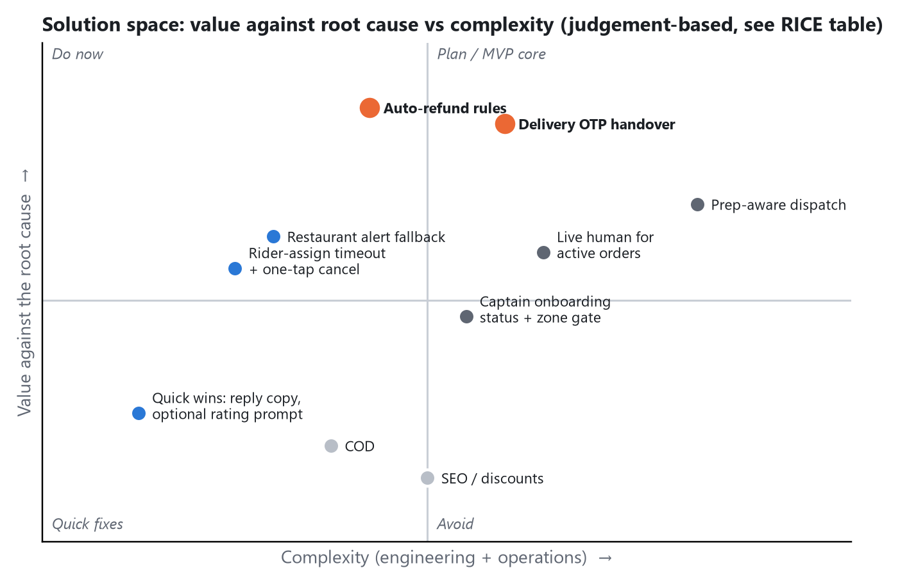
Exhibit 13. Value against the root cause vs complexity. Positions are judgement, consistent with the RICE inputs.

Why the framework does not make the decision
- RICE ranks cheap cosmetic fixes first (S8 = 80) because they reach everyone. They should ship, but they do not touch the root cause.
- RICE ranks auto-refund low (10.5) because few orders fail. Yet it addresses the single moment that creates fraud language, and it is what makes a delivery code visible as protection to the customer.
- S1 and S2 are a system, not two features. The code makes generous auto-refunds affordable, because “not received” claims become checkable. The auto-refund makes the code meaningful to the customer. Shipping one without the other weakens both.
- S3 tests a different cause (restaurant alerts) and needs no captain-app change, so it runs as a separate, cheaper experiment rather than inflating the MVP.
PM DECISION · Selected: S1 + S2 (incl. S4's timeout as rule R2) as the MVP
It is the smallest intervention that tests the core hypothesis: verifying the handoff and resolving failures automatically reduces paid-no-food losses and protects repeat ordering. It uses a habit Rapido's network may already have. Deferred: S5 (until residual ticket volume is known), S6 (needs prep data), S7 (separate supply track). Rejected: S9 COD (worsens the core failure), S10 SEO/discounts (pours users into a leak).

17 MVP definition
Ownly Promise v1  Verified handover + automatic refunds | 1 city  Zone-randomised pilot | ≥ 4 weeks  Minimum read time

Element | Definition
MVP objective | Test whether verifying the handover and auto-resolving eligible failures reduces “not received” claims and narrows the repeat gap for customers who hit a failure
Target user | Prepaid customers in pilot zones; primary focus on customers in their first 1–3 orders
Core problem | Paid, no food, and nobody fixes it
Value proposition | “Your food, or your money back in minutes.” (Shown only in treatment zones; not marketed until proven)
In scope | 4-digit delivery code; captain fallback (photo + GPS ≤ 75 m) when the customer is unreachable; refund rules R1–R3; cause code and owner on every failure; refund receipt screen
Out of scope | Live-agent support redesign; chatbot rebuild; COD; prep-aware dispatch; captain bags and uniforms; merchant self-serve tools; loyalty; new cities; restaurant alert fallback (separate test)

User flow
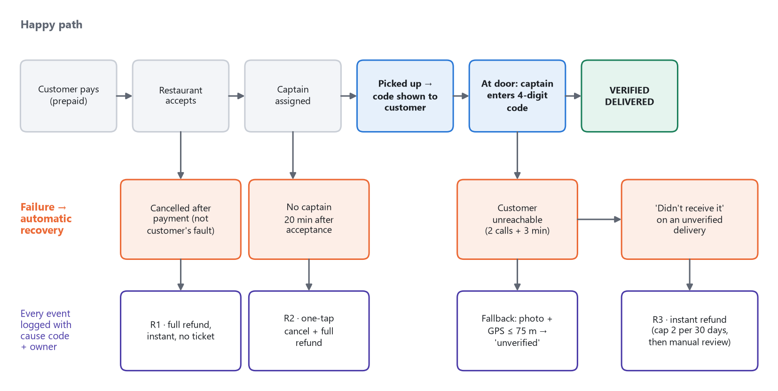
Exhibit 14. MVP flow: happy path, failure states and automatic recovery.

Key functionality
Rule / feature | Trigger | Action
Delivery code | Order picked up | Show 4-digit code on the tracking screen and in a push notification. Captain cannot mark delivered without it
Fallback | Customer unreachable: 2 calls + 3 min at the drop point | Photo + GPS within 75 m → status “Delivered – unverified”
R1 | Cancelled after payment for any non-customer reason | Full refund immediately, no ticket
R2 | No captain 20 min after the restaurant accepts | Offer one-tap cancel with full refund, or keep waiting with an updated ETA
R3 | Customer reports “not received” on an unverified delivery | Instant refund; capped at 2 per customer per 30 days, then manual review
Ledger | Any cancellation, refund or unverified delivery | Record cause code (restaurant / captain / platform / customer), owner and timestamps

User stories and acceptance criteria
User story | Acceptance criteria (Given / When / Then)
As a customer, when my food arrives I share a code, so nobody can claim it was delivered when it wasn't | Given an order is picked up, when I open tracking, then I see a 4-digit code and the copy “Share only when food is in your hands”. When the captain enters the correct code, the status becomes “Delivered – verified” within 2 s
As a customer whose order was cancelled after I paid, I see my money back without asking | Given a non-customer cancellation, when it is recorded, then a refund is issued within 60 s and the receipt shows amount, destination, time and reason
As a customer with no captain after 20 min, I choose whether to wait or cancel | Given acceptance + 20 min with no captain, then I get a push and an in-app card with “Cancel · refund ₹X” and “Keep waiting (new ETA)”
As a captain, I can finish a delivery when the customer doesn't answer | Given 2 unanswered calls and 3 min at the drop point, when I take a photo within 75 m of the pin, then the order closes as “Delivered – unverified”
As an ops analyst, I can see every failure with its cause | Every cancellation, refund and unverified delivery has a cause code and owner; a daily export reconciles to order counts within 0.5%

Edge cases
- Order placed for someone else → share the code to the recipient's number via SMS or WhatsApp.
- Gated community or guard handover → the guard reads out the code; otherwise fallback.
- Customer's phone is dead → fallback (photo + GPS).
- Captain reassigned mid-trip → the code stays valid; the event is logged.
- Captain asks for the code before arriving (“I'm downstairs”) → GPS distance is checked when the code is entered; copy warns the customer.
- Partial or wrong items → out of scope; existing flow.
- Repeat “not received” claimants → R3 cap; device and account linking.

Dependencies and risks
- Captain app release (critical path). Whether Ownly controls the Ownly Captain app end-to-end, or needs Rapido's captain app, is REQUIRES VALIDATION .
- Payments for instant wallet credit; Legal for refund terms; CX for the policy change.
- Top risk: captains quietly decline food orders because the code removes shortcuts. This would turn false deliveries into no-captain failures. It is treated as a hard guardrail (Section 20).

18 Product experience & wireframes
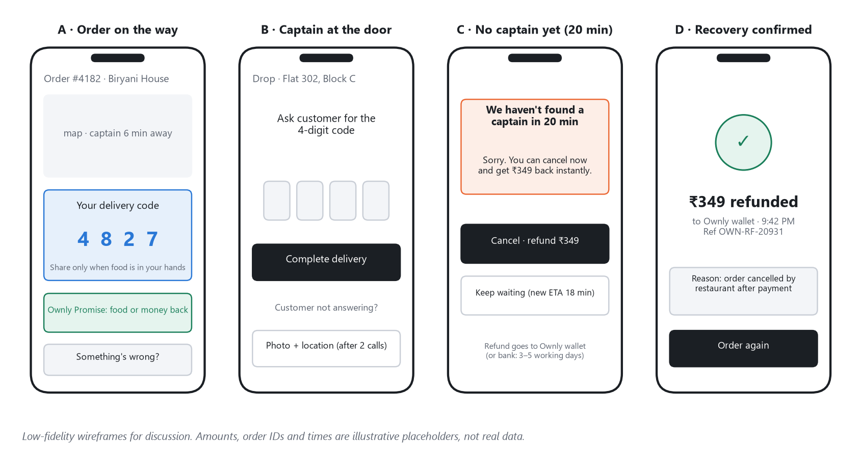
Exhibit 15. Key screens: entry point (A), core interaction (B), failure state (C), recovery/success state (D).
Screen | Purpose | UX decision and reasoning
A · Order on the way (entry point) | Introduce the code at the moment it matters | Code shown large on the tracking screen, not only in SMS, so it is available offline and visible to the person waiting. Copy explains why before asking: “Share only when food is in your hands”. That turns the code into protection rather than friction.
B · Captain at the door (core interaction) | Make verification as quick as starting a ride | Mirrors a familiar 4-box code entry pattern (assumed similar to ride start; REQUIRES VALIDATION ). The fallback is visible but secondary, unlocked only after 2 calls, so it is not the default path.
C · No captain yet (failure state) | Give control back at the worst moment | Shown proactively at 20 min, before the customer has to search for help. Two clear choices; the refund amount is stated, not “initiated”. A new ETA is shown if they choose to wait.
D · Recovery confirmed (success / recovery state) | Replace uncertainty with a fact | A refund is shown as a completed fact with amount, destination, time, reference and reason, which directly answers the “refund stuck in initiated” complaint. Ends with “Order again” to support the repeat behaviour.

KEY INSIGHT · Design principle
Every screen answers one of three questions the reviews show customers cannot answer today: Is my food really with me? Where is my money? What happens next? Visual design is deliberately plain; the work is in the states and the copy.

Languages: English, Hindi, Kannada (pilot), with Telugu for Hyderabad. Accessibility: code digits ≥ 24 pt; not conveyed by colour alone.

19 PRD — Ownly Promise v1
Section | Content
1. Problem | Prepaid orders sometimes end with no food (cancelled after payment, no captain, false “Delivered”), and refunds require chasing. These customers rate ~1★ and use fraud language. Frequency is unknown (sizing gate first).
2. Objective | In pilot zones: reduce “not received” claims per 1,000 delivered orders by ≥40%; refund 90% of eligible failures within 5 minutes; keep the 30-day repeat rate of failed-order customers within 5 pp of clean-order customers.
3. Target users | Customers (primary); captains (must adopt the code); ops/CX (consume the ledger).

4. User stories
See Section 17 (five stories with acceptance criteria).

5. Functional requirements
ID | Requirement | Priority
FR-1 | Generate a 4-digit code per order at pickup; show it on tracking and in a push notification | P0
FR-2 | Captain app blocks “Delivered” until the code is entered; 3 wrong attempts lock the order and alert ops | P0
FR-3 | Fallback: after 2 calls + 3 min at the drop point, photo + GPS ≤ 75 m → “Delivered – unverified” | P0
FR-4 | R1: non-customer cancellation after payment → full refund, no ticket | P0
FR-5 | R2: no captain 20 min after acceptance → push + in-app card offering one-tap cancel and refund | P0
FR-6 | R3: “not received” on an unverified delivery → instant refund; cap 2 per customer per 30 days, then manual review | P0
FR-7 | Refund defaults to Ownly wallet (instant); source refund on request with the bank's expected time shown | P0
FR-8 | Cause code + owner + timestamps on every cancellation, refund and unverified delivery; daily export | P0
FR-9 | Refund receipt screen (amount, destination, time, reference, reason) | P0
FR-10 | “Something's wrong?” entry on active and delivered orders that runs R1–R3 before routing to a person | P1
FR-11 | Treatment-only “Ownly Promise” badge at checkout and on tracking | P1

6. Non-functional requirements
- Code validation ≤ 2 s at p95 on 3G; works with intermittent connectivity (queued validation with a signed token).
- Refund initiation ≤ 60 s at p95 after a rule fires; idempotent (no double refunds).
- Ledger completeness ≥ 99.5% of failure events; immutable audit log; dual approval for manual refunds above ₹500.
- Codes are never written to SMS logs in plain text beyond the delivery window. Photos retained 30 days.
- Localised copy (EN/HI/KN); accessible contrast and sizes.

7. Acceptance criteria
Per user story (Section 17), plus: in internal testing, 100% of orders have a code at pickup; 0 orders reach “Delivered – verified” without a matching code; refund latency meets the NFR on 200 staged failures.

8. Edge cases
See Section 17: recipient differs from orderer, gated communities, dead phone, reassignment, early code requests, partial orders, repeat claimants.

9. Dependencies
Captain app release cycle (critical path); payments/wallet; telephony (for the parallel alert test); CX policy; legal review of refund terms; data engineering for the ledger.

10. Risks
Captain adoption and acceptance; refund abuse; refund cost rising before prevention takes effect; release delays. Details and mitigations in Section 22.

11. Analytics requirements
Events and properties in Section 21. All events carry order_id, zone_id, experiment_arm, city and timestamp.

12. Rollout plan
Internal → small cohort → zone-randomised experiment → expansion → full rollout, gated at each step (Section 23).

20 Experiment design
PM DECISION · Gate A comes first: E0 sizing (weeks 1–2, not an A/B test)
Pull (1) the severe-failure rate per 1,000 orders by type and (2) the 30-day repeat rate of customers whose first order failed vs those whose first order was clean.
Proceed at full scope if severe failures are ≥ 1% of orders or the repeat gap is ≥ 10 pp. Stop and pivot to the retention/selection hypothesis (H9) if failures are < 0.5% and the gap is < 5 pp. In between: ship R1 + ledger + quick wins only, and re-read in 30 days.

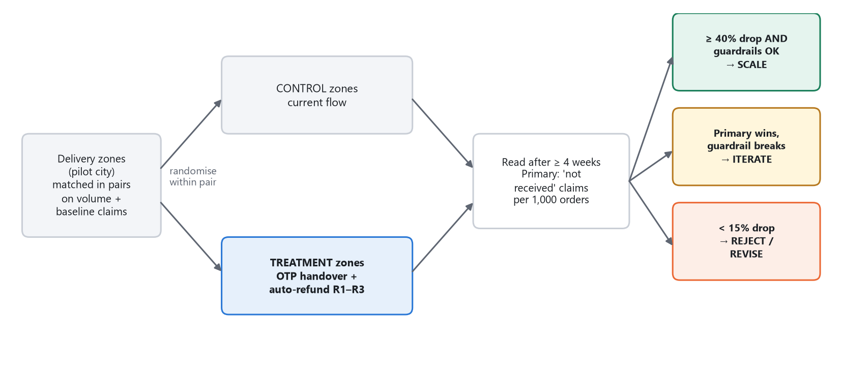
Exhibit 16. E1 design: zone-randomised pilot with pre-agreed decision rules.
Field | E1 · Ownly Promise v1
Hypothesis | If the handover requires the customer's code and eligible failures auto-refund, then “not received” claims per 1,000 delivered orders fall by ≥ 40%, and failed-order customers' 30-day repeat moves closer to clean-order customers', because false deliveries become impossible to hide and money-loss moments resolve in minutes
Type | Cluster-randomised controlled trial by delivery zone (not by user: captains and restaurants are shared within a zone, so user-level randomisation would leak)
Control | Current flow in matched zones
Treatment | Code at handover + R1–R3 + receipt screen
Audience | All prepaid orders in ≥ 6 matched zone pairs in the pilot city (Bengaluru, subject to E0 volume)
Sample | Illustrative: baseline claim rate 1.5%, target 50% relative cut (to 0.75%), α = 0.05, power 0.8 → n ≈ 7.84 × [0.015×0.985 + 0.0075×0.9925] ÷ 0.0075² ≈ 3,100 orders per arm before clustering. With a design effect of 2–3 → ~6,200–9,300 per arm. Recompute with the real baseline from E0
Duration | ≥ 4 weeks (two full weekly cycles plus captain adaptation); repeat-rate read at day 30–45 after the pilot start
Primary metric | “Not received” claims per 1,000 delivered orders
Secondary | Delivered-without-GPS-match %; refund latency; refund cost per 1,000 orders; 30-day repeat of failed-order customers; fraud/scam language per 1,000 orders in post-order feedback
Guardrails | Captain food-order acceptance (≤ 5% relative drop); median handover time added (≤ 45 s); fallback usage (≤ 15% of deliveries); refund abuse rate (≤ 2% of auto-refunds); delivery time; contribution per order after refunds (≤ ₹3 drop)
Success threshold | ≥ 40% relative drop in primary metric with all guardrails intact
Failure threshold | < 15% drop, or captain acceptance down > 5%
Confounders | Rain or festivals; city-wide promos; Rapido incentive changes; novelty effects. Mitigated by matched pairs and difference-in-differences against the pre-period

Decision rules
If… | Then…
Primary improves ≥ 40% AND guardrails healthy | Scale: city-wide in two waves, then the next city
Primary improves but captain acceptance drops > 5% | Iterate: test a targeted compliance bonus in low-supply hours only; simplify the fallback; re-run 2 weeks
Primary improves but refund abuse > 2% | Iterate: tighten R3 eligibility (device linking, lower cap)
Primary improves 15–40% | Iterate: inspect fallback share and early-code requests; extend 2 weeks
Primary < 15% improvement | Reject / revise: most claims were not false deliveries; redirect to cancellations (E2) or H9

E2 · Restaurant alert fallback (parallel, independent)
Randomised by restaurant. Treatment: persistent alarm + automated call if an order is unacknowledged at 60 s, and an ops call at 3 min; never auto-cancel silently. Primary: restaurant-caused cancellations after payment. Guardrail: partner opt-outs and complaints. Two weeks. It needs no captain-app change, so it can start during the E1 build.

21 Metrics & instrumentation
Layer | Metric | Definition
North Star | Weekly promise-kept orders | Orders delivered with a verified handover, ≤ ETA + 15 min, and no refund or ticket. Resistant to gaming: discounts can buy orders and prompts can buy stars, but neither creates kept promises
Primary KPI (pilot) | “Not received” claims per 1,000 delivered orders | Tickets or R3 triggers tagged not-received ÷ delivered orders × 1,000
Retention KPI | 30-day repeat rate, failed vs clean first order | Share of customers placing another order within 30 days, split by whether their first order failed
Input | Code match rate; fallback share; time to captain assignment; post-payment cancellation rate by cause; refund latency p50/p95; share auto-resolved | Leading indicators the team can move directly
Output | Promise-kept orders; repeat rate; contribution per order after refunds; fraud/scam mentions per 1,000 orders | Business-facing results
Guardrail | Captain food-order acceptance; handover time added; refund cost per 1,000 orders; refund abuse rate; delivery time; partner opt-outs | Must not deteriorate beyond thresholds in Section 20

Analytics events (only those the MVP needs)
Event | Trigger | Key properties | Metric supported
order_paid | Payment success | order_id, amount, customer_order_index, zone_id, arm | Denominators; first-order segment
order_accepted | Restaurant accepts | restaurant_id, accept_latency_s | Time to accept
captain_assigned | Captain matched | captain_id, assign_latency_s | Time to assign; R2 trigger
assign_timeout_shown | 20 min without a captain | minutes_waited, choice (cancel/wait) | R2 uptake
picked_up | Captain collects food | captain_id, wait_at_restaurant_s | Idle time
delivery_code_shown | Code displayed to customer | surface (tracking/push) | Code exposure
delivery_code_entered | Captain submits code | success, attempt_no, gps_distance_m | Code match rate; early-entry checks
fallback_delivery | Photo + GPS fallback used | photo_id, gps_distance_m, calls_made | Fallback share
order_delivered | Order closed as delivered | verified (bool), eta_delta_min | North Star; ETA accuracy
order_cancelled | Any cancellation | cause_code, actor, post_payment (bool) | Cancellation rate by cause
issue_reported | Customer uses “Something's wrong?” | issue_type, order_state | Primary KPI
refund_rule_fired | R1/R2/R3 eligibility met | rule_id, amount | Auto-resolution share
refund_issued | Refund executed | amount, destination, latency_s, rule_id or manual | Refund latency; cost
repeat_order | Customer's next order_paid | days_since_prev, prev_order_failed (bool) | Retention KPI

22 Risks & second-order effects
Type | Risk | Prob. | Impact | Mitigation
Marketplace | Captains decline food orders because the code removes the option to abandon; false deliveries turn into no-captain failures | Medium | High | Hard guardrail; code flow mirrors ride start; fast fallback; targeted bonus only in low-supply hours if needed
Abuse / fraud | Customers claim “not received” on unverified deliveries; captains ask for the code early by phone | Medium | Medium | R3 cap + device linking; GPS distance check on code entry; customer copy warning
Financial | Refund cost rises before prevention works | Medium | Medium | Budget envelope agreed up front; ledger attributes cost by cause; chargebacks to the party at fault from week 6
Operational | Ops desk overloaded by escalations and lockouts in week 1 | Medium | Low | Staff peak hours; auto-unlock after review
Technical | Captain app release delays; poor connectivity at doors | Medium | High | Ship R1, ledger and E2 first (no captain-app change); offline code validation token
User | Extra step annoys customers; recipients without the app | Low | Medium | Code in push + SMS to recipient; measure handover time
Adoption | Captains skip to fallback by default | Medium | Medium | Fallback unlocks only after 2 calls + 3 min; fallback share is a guardrail
Business / brand | Promising “food or money back” before it works backfires | Low (if gated) | High | No marketing of the Promise until Gate B; badge only in treatment zones
Partner | Restaurants resent automated calls or chargebacks | Medium | Medium | Share data before chargebacks; dispute flow; chargebacks only after week 6
Cannibalisation | None on GMV; may shift CX headcount plans | Low | Low | —

Second-order effects
- Positive loop (expected): verified handovers → fewer paid-no-food orders → fewer fraud reviews → more repeat orders → more orders per restaurant → partners keep the tablet on and accept faster → fewer cancellations HYPOTHESIS .
- The loop may currently run in reverse: partners report “one order a day”, may deprioritise the tablet, miss alerts, and cause cancellations that suppress demand INFERENCE .
- Liability attribution changes behaviour on all sides. Once failures are charged to the party at fault, marginal partners may leave. That improves quality but reduces listed selection.
- Inversion: how to guarantee failure. Market the Promise before the code works; pay captains per code so costs explode; set loose refund rules that spread on WhatsApp; ignore restaurant-side cancellations so the refund bill grows. The plan is built to avoid each.

23 Launch & rollout plan
Phase | Objective | User group | Metrics | Exit criteria | Decision
0 · Sizing (wk 1–2) | Size the problem | Historical orders | Failure rate; repeat gap | Gate A thresholds (Section 20) | Go / reduced scope / pivot
1 · Internal validation (wk 3–4) | Prove the flow works | Employees + 20 trained captains | Code success rate; refund latency on staged failures | 0 unverified deliveries without code; NFRs met | Proceed to cohort
2 · Small cohort (wk 5) | Catch real-world issues | 1 zone pair | Fallback share; handover time; lockouts | Fallback < 25%; no P0 bugs | Fix, then randomise
3 · Experiment (wk 6–9) | Measure causal impact | ≥ 6 matched zone pairs | Primary, secondary, guardrails | Pre-registered thresholds | Scale / iterate / reject (Gate B)
4 · Expansion (wk 10–13) | Confirm at scale | 50% of city | Same, plus contribution per order | Effects hold within 20% of pilot | City-wide
5 · Full rollout (Q2+) | Make it the default | Full city → next city | North Star; repeat rate | Guardrails stable 4 weeks | Market the Promise; chargebacks live

24 Expected impact & decision framework
IMPORTANT ASSUMPTION · Nothing here has happened
Ownly Promise v1 has not been built or tested. Every result in this section is EXPECTED , conditional on the sizing gate.

Question | Answer
Expected impact | EXPECTED 40–60% fewer “not received” claims in treatment zones; 90% of eligible failures refunded within 5 min; a narrower repeat gap for failed-order customers. Direct financial value per 10k orders/day ranges from ~₹0.8L to ₹7.6L/month in avoided food loss (Section 12), and depends entirely on the real failure rate
What we expect to learn | The true severe-failure rate and its causes; whether false deliveries are captain shortcuts or customer abuse; whether faster recovery changes repeat behaviour; whether captains accept the extra step
What would prove the hypothesis | Claims fall ≥ 40% with guardrails intact, and the repeat gap narrows for treated failed-order customers
What would disprove it | Claims barely move (most claims were not false deliveries); or claims fall but repeat behaviour does not change (failures were not the retention brake); or E0 shows failures < 0.5% with no repeat gap
If successful | Scale city-wide, then Hyderabad; switch on liability chargebacks; start the live-human test for residual issues; then make the Promise a public brand claim
If unsuccessful | Keep the ledger and alert fallback (useful regardless); stop OTP work; redirect the squad to H9 (retention/selection) or to cancellation causes if E2 shows a stronger effect

25 Future iterations
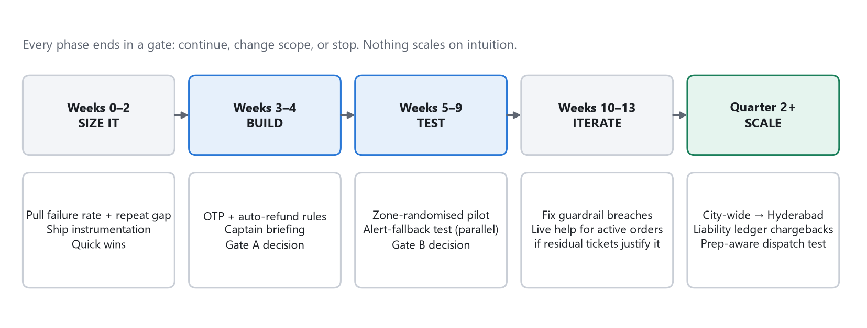
Exhibit 17. Roadmap. Each step depends on what the previous gate learns.
Next step | Only if… | Why it follows
Live human for active orders | E1 shows meaningful residual tickets after auto-rules | Automation should absorb the predictable cases first
Liability ledger chargebacks | Cause codes are accurate (audit ≥ 95%) | Makes generous refunds affordable and aligns incentives
Prep-aware dispatch | Prep-time data is reliable and early dispatch shows up in idle-time data | Attacks no-captain and idle-captain failures at source
Captain onboarding status + zone capacity gate | Dispatch data confirms allocation, not headcount, is the gap | Stops collecting documents from applicants Ownly cannot activate
Partner self-serve menu and payouts | Partner retention becomes the binding constraint | Removes the manual queue on the restaurant side
Public “Promise kept” rate | Rate is consistently high for 8+ weeks | Turns reliability into a differentiator
Deliberately absent: AI chat support, recommendation engines, loyalty schemes. None addresses the validated problem.

26 Key learnings
Area | Learning
The user | Customers come for price and forgive slowness; they do not forgive losing money. The emotional break point is “I paid and nobody helped”, which they express as “fraud”.
The product | The weakest part of the product is not a screen; it is the absence of proof at handoffs and of automatic recovery. Every side, including captains and restaurants, is stuck in an invisible queue.
The business | Zero commission makes reliability existential: there is little margin to absorb failures. Direct ROI from fixing them is modest; the value is retention, trust and Rapido's brand.
Assumptions disproven | “Failed recovery costs a full star” (does not hold for severe failures); “94% of helpful votes sit on complaints” (true, but n = 32); “not enough captains” (contradicted by idle and paused-onboarding signals; reframed); “SEO is a growth lever” (distribution runs through Rapido).
What remains uncertain | Failure rate per order; repeat gap; causes of cancellations; who controls the captain app; competitor recovery flows; iOS and non-reviewer sentiment.
Next PM decision | Request two queries (severe-failure rate and repeat gap) and decide at Gate A on day 14. Build nothing irreversible before then.

PM DECISION · Final quality check
- Is the problem proven? Its existence and severity are, through multiple sources. Its size is not, which is why the plan starts with sizing.
- Could something else explain the evidence? Yes: abuse, H9 (weak retention regardless), restaurant-side causes. Each has a test.
- Is the MVP small and testable? Two mechanisms plus instrumentation, one city, pre-registered thresholds.
- Any invented facts? No internal metrics are claimed; every number is labelled; four earlier claims were corrected (Appendix C).

27 Appendix

A. Customer review theme table (n = 1,000; 493 negative)
Theme | Journey stage | All mentions | In 1–2★ | % of 1–2★ | Avg ★
Support unresponsive | Service recovery | 247 | 241 | 48.9% | 1.11
Rider / delivery partner | Last mile | 131 | 115 | 23.3% | 1.43
Refund problem | Service recovery | 119 | 113 | 22.9% | 1.15
Delivery delay / ETA | Last mile | 133 | 107 | 21.7% | 1.73
Not delivered / false “Delivered” | Last mile | 107 | 104 | 21.1% | 1.07
Fraud / scam (dictionary) | Brand outcome | 90 | 88 | 17.8% | 1.11
Fraud / scam (strict wording) | Brand outcome | 76 | 74 | 15.0% | 1.12
Order cancelled | Restaurant acceptance | 61 | 61 | 12.4% | 1.00
Price / no-fee value (+) | Value driver | 130 | 42 | 8.5% | 3.70
Food quality / hygiene | Order receipt | 62 | 40 | 8.1% | 2.40
Missing / wrong items | Order receipt | 42 | 39 | 7.9% | 1.24
Payment / COD | Order & pay | 40 | 33 | 6.7% | 1.62
Competitor mention | Brand outcome | 57 | 31 | 6.3% | 2.84
App bugs / forced rating | Order & pay | 30 | 25 | 5.1% | 1.63
First-order experience | Segment | 22 | 16 | 3.2% | 2.05
Offer / promo mismatch | Discover & offer | 18 | 15 | 3.0% | 1.56
Restaurant selection | Value driver | 15 | 10 | 2.0% | 2.40
Packaging / spillage | Order receipt | 8 | 8 | 1.6% | 1.00
Method: case-insensitive keyword matching (dictionary in the source workbook), multi-tag. Strict fraud wording = fraud|froud|scam|fake|cheat|chor|loot (excludes “trust”, “trap”, “steal”).

B. Captain and restaurant app summaries
Captain app (n = 376, avg 2.63★; 223 negative) | Neg. mentions | % of neg. | Avg ★
Onboarding / verification delay | 131 | 58.7% | 1.34
Brand trust / “don't download” | 67 | 30.0% | 1.06
Support unresponsive | 43 | 19.3% | 1.59
App stability / login bugs | 34 | 15.2% | 1.71
Incentive & payout trust | 21 | 9.4% | 2.70
Order flow / dispatch | 13 | 5.8% | 1.88
City not live | 5 | 2.2% | 2.90
Burst-day 5★: 59 of 144 5★ reviews; organic average excluding them 2.19★. Developer reply rate 0%. Applicants 150 (40%), active captains 50.
Restaurant app (n = 105, avg 4.09★; organic 3.59★) | Problem reviews | Theme detail
Onboarding & activation | 8 | Documents re-requested; onboarding > 1 month; GSTIN field issue
Order alerts & cancellations | 4 | Ring not firing; background app killed; auto-cancel
Store visibility & availability | 4 | Live but not visible; cannot go online
Support responsiveness | 4 | Follow-ups unanswered
Menu & catalogue control | 3 | Cannot edit items, prices or photos
Rider & dispatch / demand / payouts / other | 10 | Early riders; low orders; payout mismatch

C. Corrections to prior analysis
Prior claim | Re-check | Status
“Failed recovery costs a full star” (2.33★ vs 1.07★) | Severe failures are ~1★ with or without support complaints; the gap comes from milder failures and false positives | REJECTED
“94% of helpful votes sit on negative reviews” | Arithmetically true (30 of 32), but the base is 32 votes across 1,000 reviews | Not meaningful
Fraud theme = 88 negatives | Dictionary includes “trust”, “trap”, “steal”; strict wording gives 74 | Revised
Delay theme = 107 negatives | Dictionary includes “on time”, “punctual”; 21 tagged reviews contain on-time phrases, 15 of them 4–5★ | Inflated
Captains are Rapido-app captains (OTP depends on Rapido) | Data shows a separate Ownly Captain app | REQUIRES VALIDATION
Quote: “since order is delivered we cannot do anything” | Not found verbatim in the scraped reviews | Excluded

D. SEO detail (Semrush, India desktop, 5 Oct 2026)
- Traffic ~1.1K/month; 163 keywords; branded 155 vs non-branded 931; keywords appear only from ~Jun 2026.
- 63.5% of traffic goes to one restaurant brand page (ownly.food/app/brand/BR430482).
- Ranks #1 for “rapido food delivery bangalore” (320/mo) and #3 for “rapido food delivery” (720), “rapido food app” (480), and misspellings “only app” (720), “onely”.
- Organic competitors listed (mrchamparan.com, dojo.app, menew.in) are not real competitors, which confirms how thin the footprint is.
- The “Top Opportunities” panel (“food open near me”, 823K) uses the US database and does not apply to an India-only service.
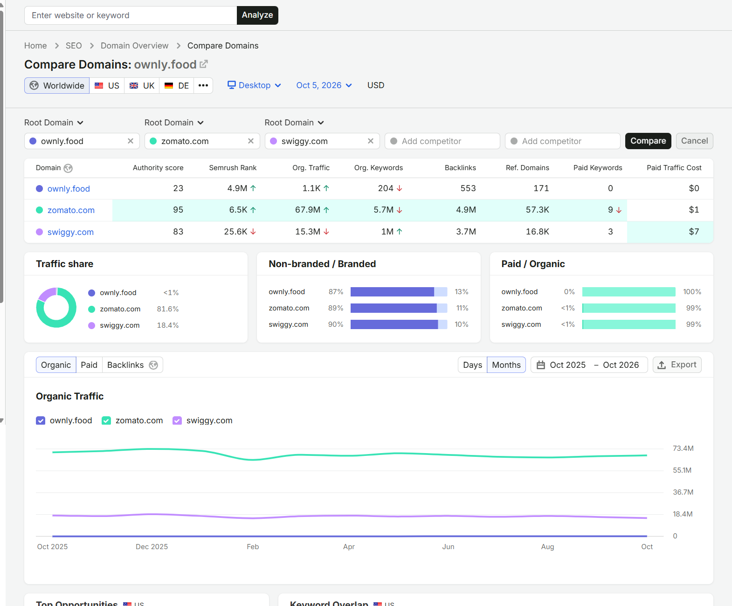
Exhibit A1. Semrush Compare Domains (source screenshot, cropped).
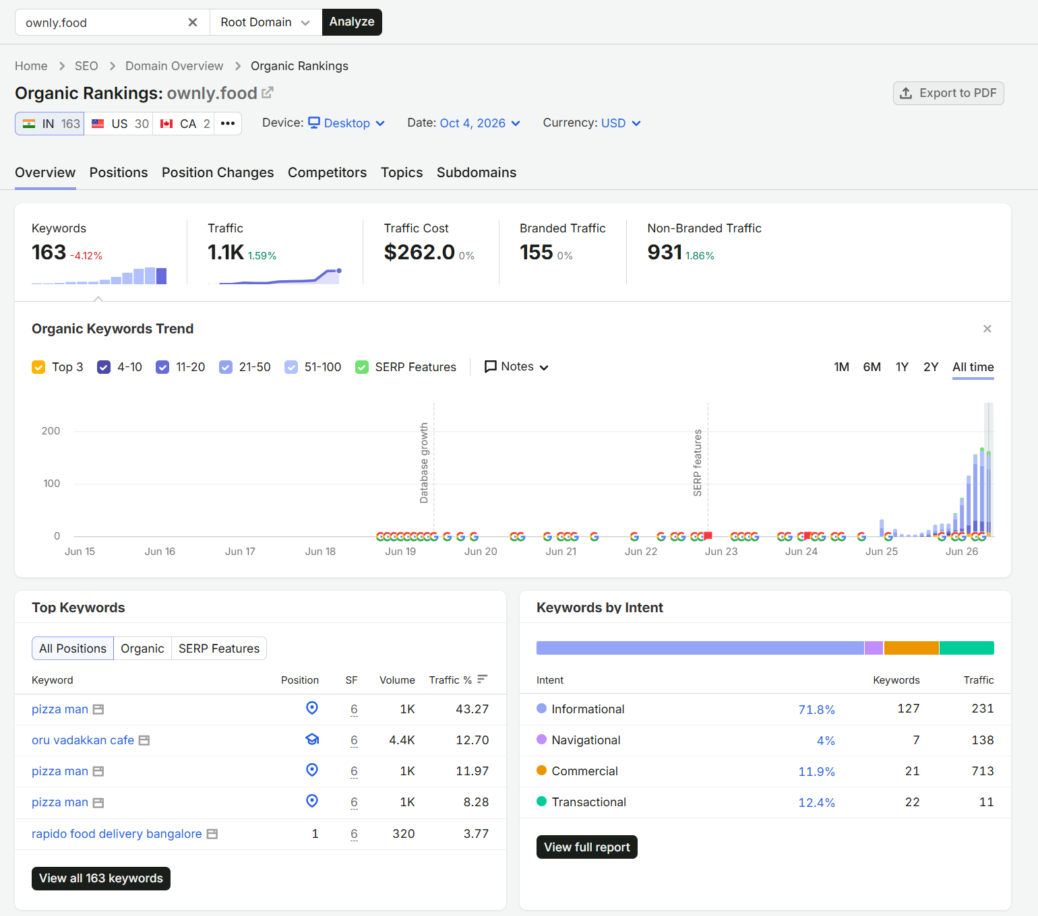
Exhibit A2. Semrush Organic Rankings overview (source screenshot, cropped).

E. Calculations and assumptions
Opportunity model: Section 12 (all formulas shown, with arithmetic checks). Sample size: n per arm = (z₁₋α/₂ + z₁₋β)² × [p₁(1−p₁) + p₂(1−p₂)] ÷ (p₁ − p₂)² = 7.84 × 0.02222 ÷ 0.00005625 ≈ 3,097, rounded to 3,100; × design effect 2–3. RICE: Section 16.
# | Assumption | If wrong | How we check
A1 | Severe failures ≥ ~1% of orders | It is a CX fix, not a strategy | E0 query
A2 | Failed-order customers churn materially more | Reliability isn't the brake (H9) | E0 cohort query
A3 | Ownly can change the captain app quickly | Fallback-only MVP; slower | Confirm app ownership
A4 | Captains accept the code without large drop-off | No-captain failures rise | E1 guardrail
A5 | Refund abuse stays manageable | Leakage | Caps; audit
A6 | Fault can be attributed from event logs | Liability can't be shifted | Ledger audit
A7 | AOV ~₹300; contribution ₹5–15/order | Sizing changes | Finance data

F. Research plan (not conducted; questions only)
No interviews or surveys were run for this study. The following is proposed to close the gaps:
Study | Sample | Key questions
Customer interviews | 12 failed-order + 6 clean-order customers | What happened? How did you get your money back? Did you order again, and why or why not? Would a delivery code feel reassuring or annoying?
Captain interviews | 15 captains, mixed tenure | When and why are food orders abandoned or marked early? How do busy-ping rules affect which orders you accept? Would you accept a code step like at ride start?
Restaurant interviews | 12 high-cancellation restaurants | Why are alerts missed (device, background, staffing)? When do captains arrive relative to food readiness?
Usability test | 8 sessions | Can a customer get from “my order is wrong” to resolution in under 60 s today? With the prototype?
Competitor walkthrough | 5 orders each on Swiggy and Zomato | How do their handover verification, cancellation refunds and live-order help actually work?
Price-parity audit | 50 restaurants × 3 dishes | Does Ownly's price advantage hold across a real basket?

G. Data limitations
- No internal data: no orders, funnel, cancellations, refunds, tickets, dispatch, retention, CAC or unit economics.
- Customer reviews cover 8 days on Android only; one bad week could be over-represented.
- Keyword tagging produces false positives and misses regional-language reviews (11% of negatives untagged).
- Restaurant sample is small (33 problem reviews); captain sample skews to applicants.
- Semrush figures are modelled and desktop-only.
- Press facts were recorded in the source pack and not re-verified for this document.

H. Sources
- Google Play reviews: Ownly customer app (ownly_reviews.xlsx), Ownly partner app com.ownly.store (ownly_resturant.xlsx), Ownly Captain app (ownly_captain_reviews.xlsx). Scraped Oct 2026.
- Semrush: Organic Research Overview and Positions for ownly.food (India, desktop), 5 Oct 2026; Compare Domains and Organic Rankings screenshots.
- Press (secondary, via source pack OWNLY.docx): Business Today, 28 Jul 2026; Upstox, “Rapido's Ownly has early momentum”.
- All charts were computed directly from the review workbooks; scripts are available on request.

