**PROJECT REPORT**

(Project Term AUG-DEC 2021)

**Course code: INT-246**

**Image to Sketch**

Submitted by-

**Mahesh Kumar Pradhan**

**11904325**

Under the Guidence of

**Dr. Sagar Pandey**

**School of Computer science and Engineering**



**DECLARATION**

We hereby declare that the project work entitled (“Image to Sketch”) is an authentic record of my own work carried out as requirements of Project for the award of B.Tech degree in COMPUTER SCIENCE & ENGINEERING from Lovely Professional University, Phagwara, under the guidance of Dr. SAGAR PANDE, during August to December 2021. All the information furnished in this project report is based on our own intensive work and is genuine.

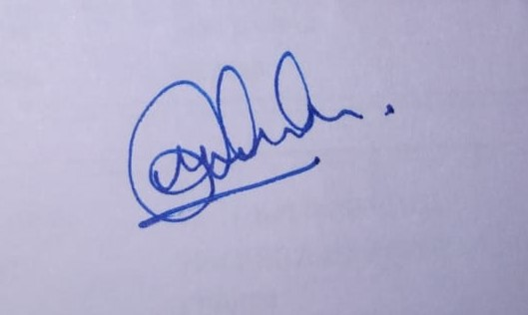

Mahesh kumar Pradhan

Date : 20-11-21

**CERTIFICATE**

This is to certify that the declaration statement made by this group of students is correct to the best of my knowledge and belief. They have completed this Project under my guidance and supervision. The present work is the result of their original investigation, effort and study. No part of the work has ever been submitted for any other degree at any University. The Project is fit for the submission and partial fulfillment of the conditions for the award of B. Tech degree in Computer Science and Engineering from Lovely Professional University, Phagwara.

Dr. Sagar Pande

(Name of the Mentor **) Signature School of Computer Science and Engineering,** Lovely Professional University, Phagwara, Punjab. Date: 20-11-2021

**ACKNOWLEDGEMENT**

*I am overwhelmed in all humbleness and gratefulness to acknowledge my depth to all those who have helped me to put these ideas, well above the level of simplicity and into something concrete.*

*I would like to express my special thanks of gratitude to my teacher* ***DR. SAGAR PANDE*** *who gave me the golden opportunity to do this wonderful project on the topic* ***Image to Sketch****, which also helped me in doing a lot of Research and i came to know about so many new things. I am really thankful to them. Any attempt at any level can‘t be satisfactorily completed without the support and guidance of MY parents and friends. I would like to thank my Friends who helped me a lot in gathering different information, collecting data and guiding me from time to time in making this project, they gave me different ideas in making this project unique.*

**TABLE OF CONTENTS**

Title Page……………………………………………………………………………(1)

Declaration…...……………………………………………………………………..(2)

Certificate……..…….………………………………………………………………(3)

Acknowledgement…………………...………………………………………….......(4)

Table of Contents……………………...……………………………………………(5)

* Introduction
* The Model
* The Dataset
* Execution of Code
* F

**1. INTRODUCTION**

Machine learning is a branch of Artificial Intelligence which is used to analyze the data more smartly. It automates the process using certain algorithms to minimize human intervention in the process.

Machine learning is the practice of building systems, known as models, that can be trained using data to find patterns which can then be used to make predictions on new data.

Unlike a lot of other programming, a machine learning model is not a rules-based system where a series of ‘if/then’ statements are used to determine outcomes (e.g., ‘If a student miss more than 50% of classes then automatically fail them’).

Instead, machine learning model examines the statistical relationships between data points in a data set with defined outcomes, and then applies what it has learned about those relationships to analyze and predict outcomes for a new data set.

In this machine learning project, we are going convert image to sketch. This project will help the creative minded people to have an overview of their imagination so that they can have more broader creativity.

### The Model

### APDrawingGAN : Significant progress has been made with image stylization using deep learning, especially with generative adversarial networks (GANs). However, existing methods fail to produce high quality artistic portrait drawings. Such drawings have a highly abstract style, containing a sparse set of continuous graphical elements such as lines, and so small artifacts are more exposed than for painting styles. Moreover, artists tend to use different strategies to draw different facial features and the lines drawn are only loosely related to obvious image features. To address these challenges, we propose APDrawingGAN, a novel GAN based architecture that builds upon hierarchical generators and discriminators combining both a global network (for images as a *Corresponding author whole) and local networks (for individual facial regions). This allows dedicated drawing strategies to be learned for different facial features. Since artists’ drawings may not have lines perfectly aligned with image features, we develop a novel loss to measure similarity between generated and artists’ drawings based on distance transforms, leading to improved strokes in portrait drawing. To train APDrawingGAN, we construct an artistic drawing dataset containing high-resolution portrait photos and corresponding professional artistic drawings. Extensive experiments, and a user study, show that APDrawingGAN produces significantly better artistic drawings than state-of-the-art methods.

[The Dataset](https://cg.cs.tsinghua.edu.cn/people/~Yongjin/APDrawingDB.zip)

Click on “The Dataset” To access the dataset

**Execution Of Code**

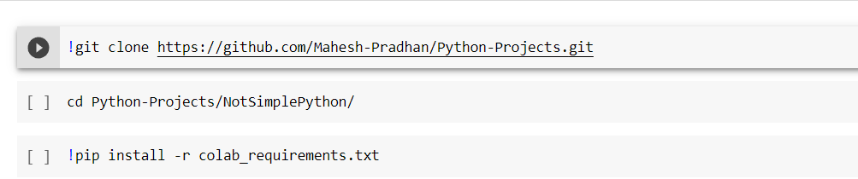

**1st line of code is used to clone the github repository and the second line is used for changing the directory.**

**The 3rd line is used to install the required libraries into the environment.**

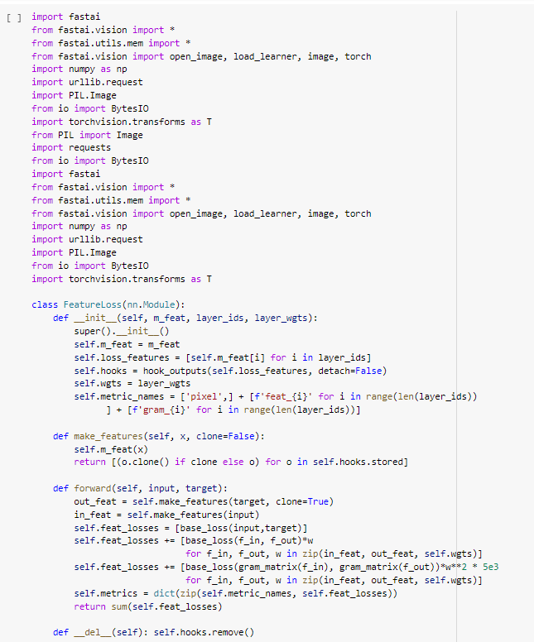

**Importing required libraries**

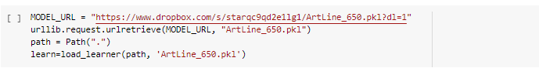

**Loading the pretrained model**

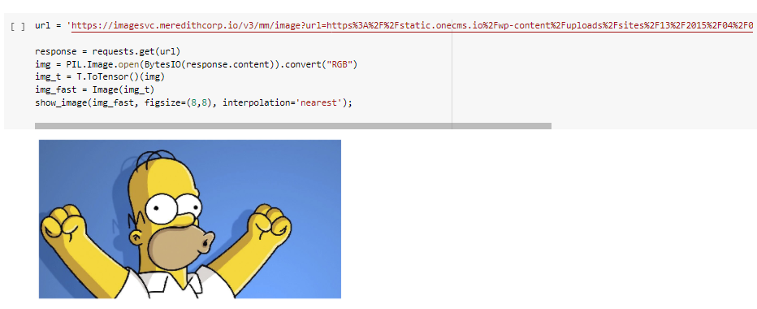

**Entering the URL that you wanted to change**

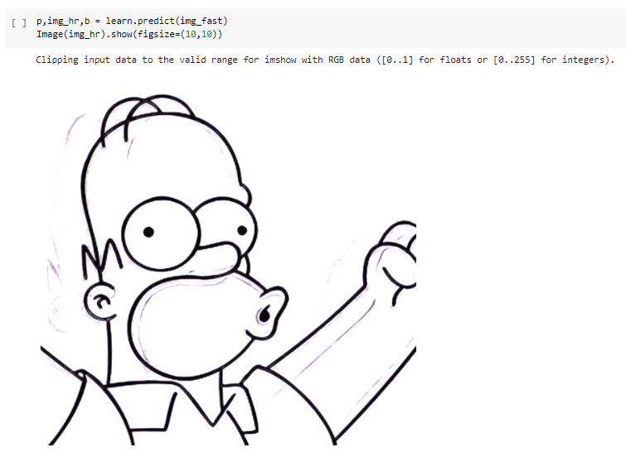

**Now showing the sketch that was build using the model**

**Future Scope/ Future Path**

* **Integrating the project with a website.**
* **Integrating with different project.( The project aims in clearing different unwanted thing in the background or foreground of the picture, and then returning it in its sketch form.** [**Github.link**](https://github.com/initml/cleanup.pictures)**)**
* **Adding different effects in the final result of the picture.**