Trébol eCommerce Platform
Technical Documentation of the Modernised System
Monolith to Microservices | Post-Decommission Architecture
Field | Value
Document | Technical documentation - modernised platform
System | Trébol eCommerce backend
Architecture | Three independently deployable Spring Boot services
Platform | Java 21, Spring Boot 3.2.12, Maven 3.9, MariaDB
Repository state | Four-module Maven reactor, monolith decommissioned
Verification | 495 automated tests, 0 failures, 0 errors, BUILD SUCCESS
Exit criteria | All 11 met
Date | 16 October 2026
Status | Final - transformation complete

Contents

If the table of contents appears empty, right-click it in Word and choose "Update Field".

1 Executive summary
The Trébol eCommerce backend was a single Spring Boot deployable: 21 controllers serving 67 HTTP routes over one shared 22-table database, with cross-domain foreign keys and no service boundaries. It is now three independently deployable services, each owning its tables exclusively, with no shared database and no cross-service foreign key.
The monolith has been decommissioned. It is not retained in a disabled state - the module, its 316 main sources, its 132 test sources and the shared schema were removed from the build. The code remains recoverable from version control, but it is no longer built, tested or deployable.
Measure | Before | After
Deployable units | 1 WAR | 3 Spring Boot services + 1 library jar
HTTP routes | 67 in one application | 67 across three services, each served by exactly one
Database | 1 shared schema, 22 tables | 3 exclusive schemas, 23 tables total
Cross-service foreign keys | n/a - all internal | 0
Automated tests | 363, with 3 permanently failing | 495, all passing
Authority strings | 50 scattered string literals | 0 literals; 54-code generated catalogue
Payment callbacks | unauthenticated, replayable | nonce-authenticated and idempotent

Beyond the decomposition, the programme fixed thirteen catalogued defects in the payment, order lifecycle and notification paths, each with a recorded ruling and a regression test. Those fixes were made inside the monolith first, so that the extraction carried corrected behaviour across a service boundary rather than carrying defects.

1.1 How to read this document
- Sections 2 to 4 describe the architecture and each service as it now stands.
- Sections 5 to 7 cover data ownership, cross-service integration and security.
- Section 8 documents the three behavioural flows that carry the most risk.
- Section 9 is the build, configuration and deployment reference, including the one mandatory operator step.
- Sections 10 and 11 record what changed in observable behaviour and what remains outstanding. Read these before the first production deployment.
- Appendix A is the complete route inventory; Appendix B the environment variable reference.

2 System context and scope
Trébol is an eCommerce backend. It serves a browser single-page application with a product catalogue, user accounts and role-based permissions, and an order lifecycle that includes anonymous guest checkout through an external payment provider.
Two external systems are involved, both outbound only:
- Transbank Webpay Plus - the payment provider. The only third-party call in the critical path. It redirects the customer to a hosted payment page and then calls back to confirm the transaction.
- Mailgun - transactional email. Optional at every call site: with no mailing bean configured the platform sends no mail, raises no error and records no outbox entries.
Nothing calls into the platform other than the SPA and the Transbank callback. There is no inbound integration, no message broker and no scheduled work other than the notification dispatcher introduced by this programme.

2.1 What this document does not cover
- Infrastructure provisioning, container orchestration and network topology - no such assets exist in the repository.
- The front-end application, which was out of scope throughout.
- Live database migration. Section 11 explains why this is the one remaining irreversible step and why it was deliberately not performed.

3 Target architecture
Three services, each a Spring Boot executable jar with its own MariaDB schema, plus one dependency-free library jar carrying the contracts they share. Services communicate over HTTP only, and only in one direction: Orders consumes Catalogue and Identity. Neither of those two calls anything.
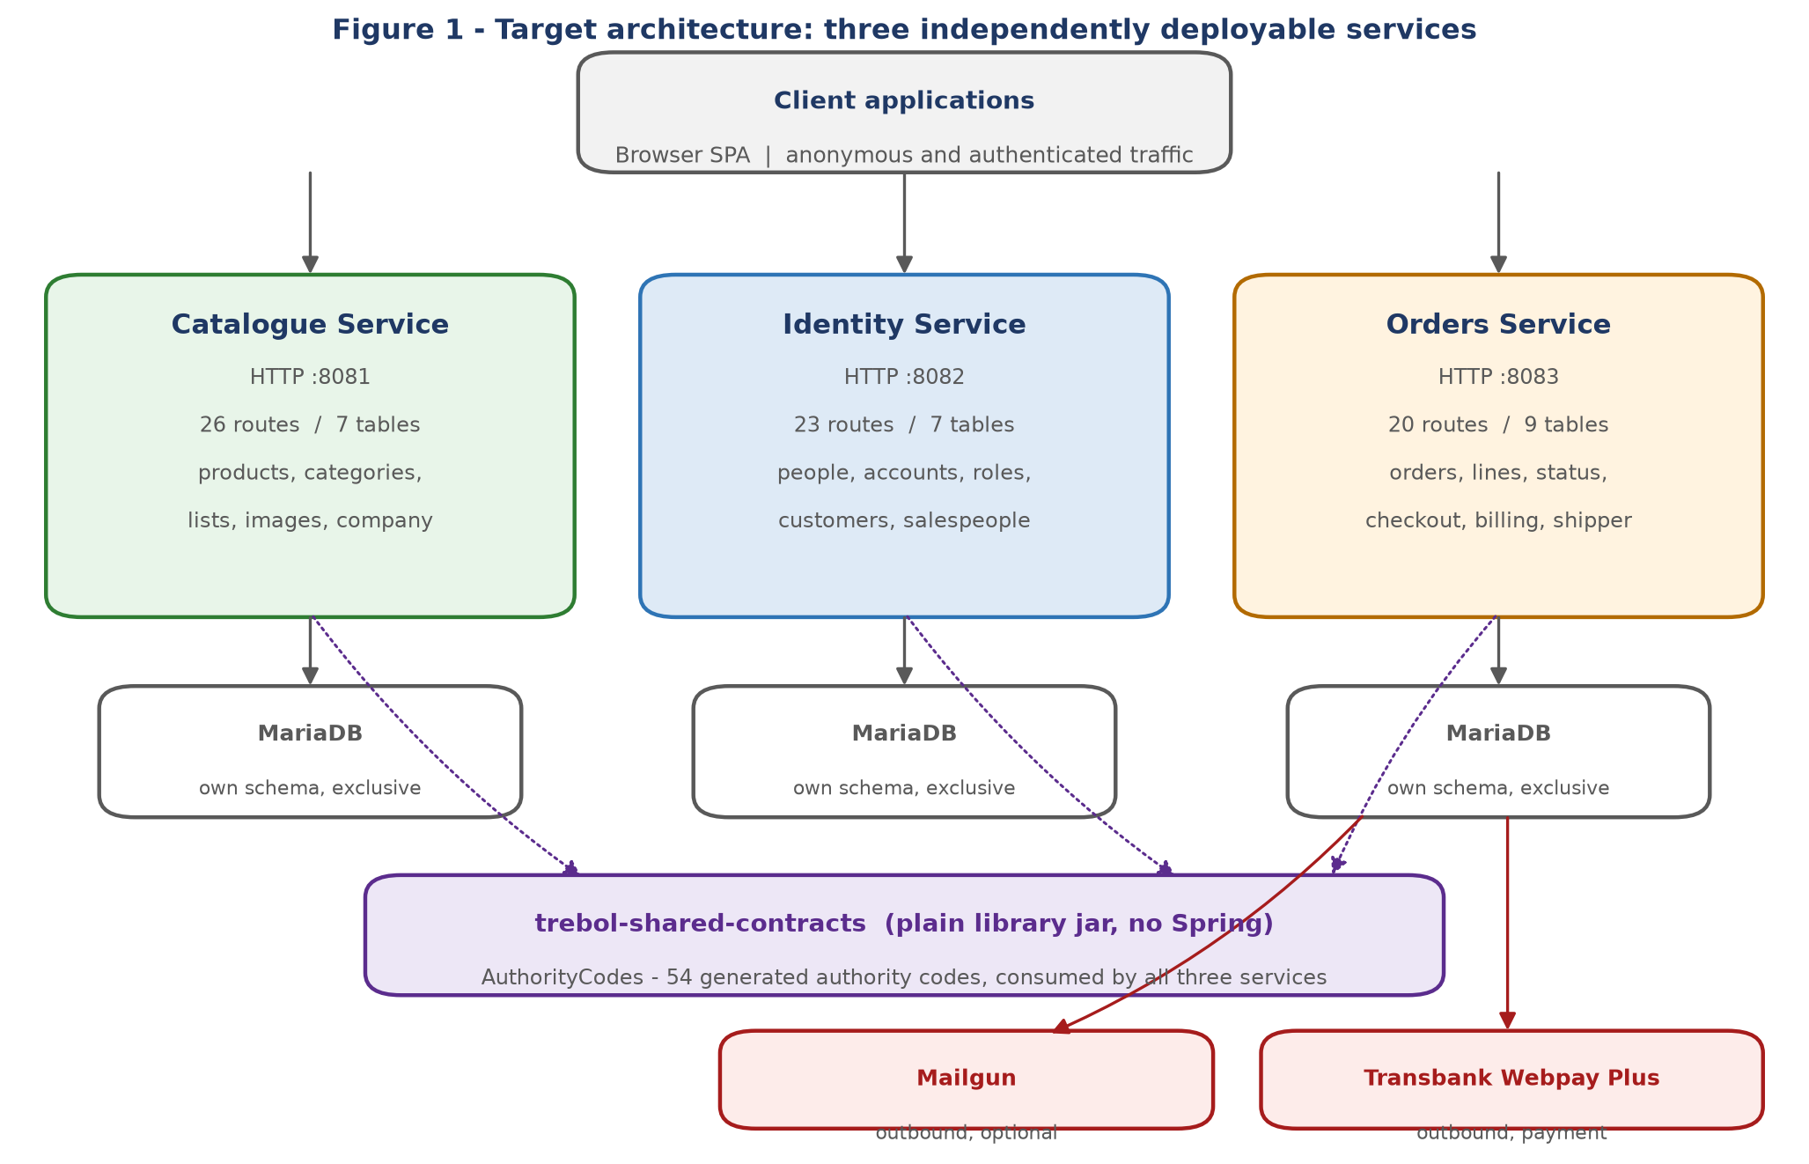
Figure 1 - Target architecture. Each service owns its schema exclusively; no service reads another's database.
The decomposition was chosen over a modular monolith in ADR-003, and executed in four phases: harden the monolith and build the verification gates; extract Catalogue; extract Identity; fix the payment and lifecycle defects, then extract Orders; decommission.
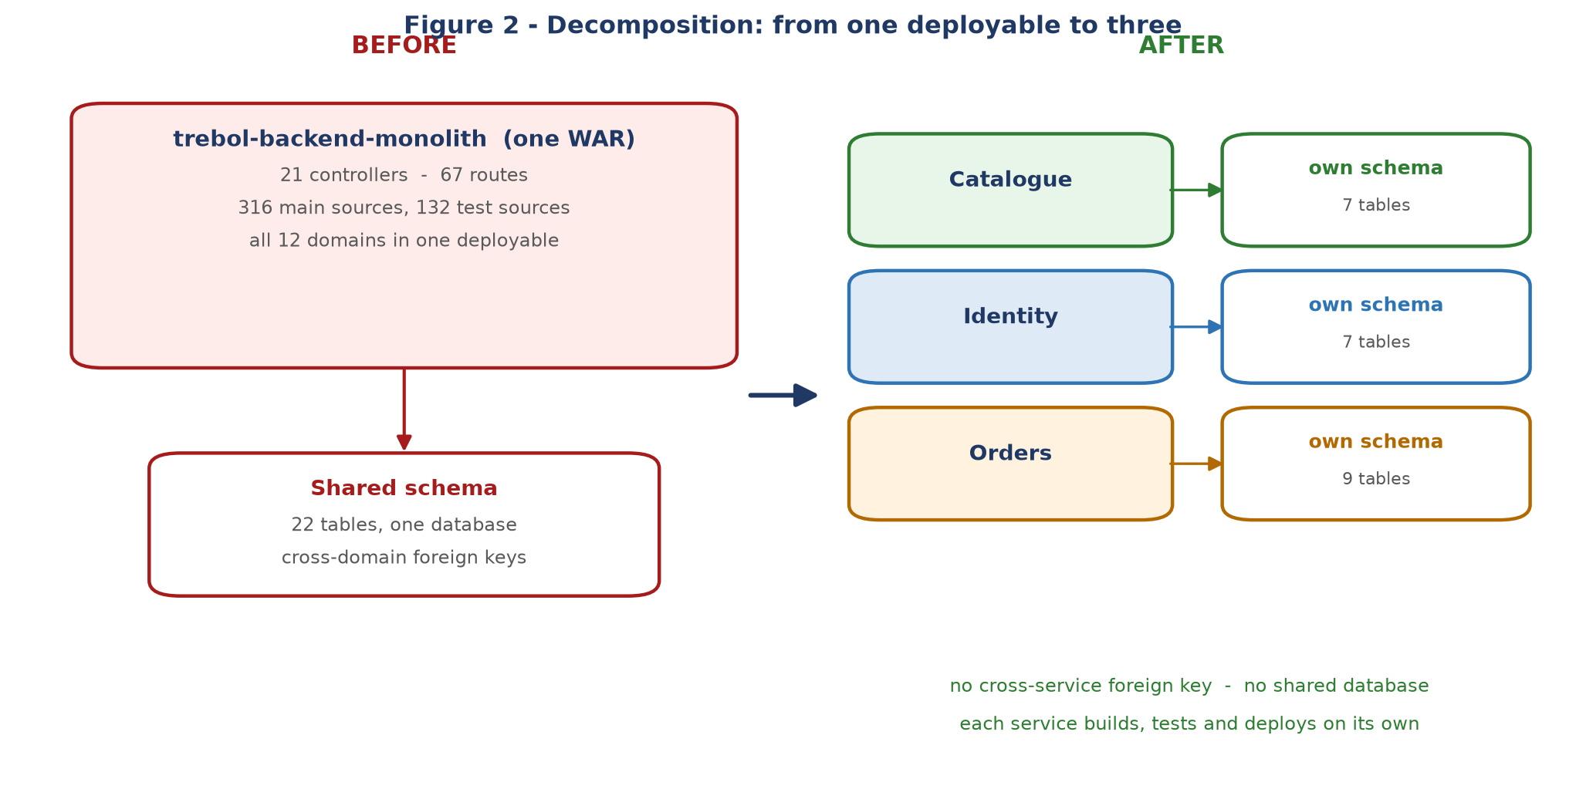
Figure 2 - The shared 22-table schema and its cross-domain foreign keys were the real coupling. Removing them is what made independent deployment possible.

3.1 Boundary principles
Principle | How it is enforced
A service owns its tables exclusively | Each service ships its own schema file. No service holds a repository for another service's table.
No cross-domain repository access | Architecture test fails the build on any repository import outside the owning domain.
No cross-service entity sharing | Architecture test allow-lists the nine entities Orders owns and fails on any other JPA entity import. This closed a leak that a repository-level check could not see.
Cross-service data moves as transport models | Contracts exchange business keys and small records, never JPA entities.
Authorisation is data, not code | 54 authority codes generated from seed data into a versioned artefact; zero string literals in any service.

Each of those principles is asserted by an automated test rather than documented as an intention. That distinction matters: three of them were originally stated as greps, and in two cases the grep passed while the coupling it was meant to prevent was present.

4 Service reference

4.1 Catalogue Service
Attribute | Value
Module | trebol-services/catalogue-service
Default port | 8081 (overridable)
Responsibility | Products, categories, product lists, images and the public company profile.
HTTP routes | 26
Tables owned | 7 - app_params, images, product_lists, product_categories, products, product_images, product_list_items
Main sources | 105
Test classes | 36
Security posture | Verify-only. No login route, no token issuing, no password store. Most reads are anonymous; image routes require authentication.
Outbound dependencies | None. It calls no other service.

4.2 Identity Service
Attribute | Value
Module | trebol-services/identity-service
Default port | 8082 (overridable)
Responsibility | People, user accounts, roles, the 54 authority grants, customers and salespeople.
HTTP routes | 23
Tables owned | 7 - people, app_user_roles, app_permissions, app_users, app_user_role_permissions, customers, salespeople
Main sources | 132
Test classes | 56
Security posture | The sole token issuer. Holds the password store, the authentication manager and the bcrypt encoder. Also issues guest tokens.
Outbound dependencies | None. It calls no other service.

4.3 Orders Service
Attribute | Value
Module | trebol-services/orders-service
Default port | 8083 (overridable)
Responsibility | Orders and lines, the order status lifecycle, checkout, the Webpay Plus adapter, the notification outbox, the public receipt, and the billing and shipper domains.
HTTP routes | 20
Tables owned | 9 - addresses, billing_companies, billing_types, payment_types, order_statuses, shippers, order_mail_outbox, orders, order_details
Main sources | 159
Test classes | 55
Security posture | Verify-only. Carries the only two anonymous write paths in the platform: guest checkout and the payment callback.
Outbound dependencies | Catalogue (product lookup) and Identity (customer provisioning, salesperson lookup).

Route counts sum to 69 while the platform serves 67 distinct routes. The difference is the health check GET /, which is deliberately served by all three services - each independently deployable unit needs its own liveness endpoint. It is the only route served by more than one service.

5 Data architecture
Twenty-three tables, each owned by exactly one service. Twenty-two are the tables of record from the original schema; order_mail_outbox is new infrastructure introduced with the notification outbox.
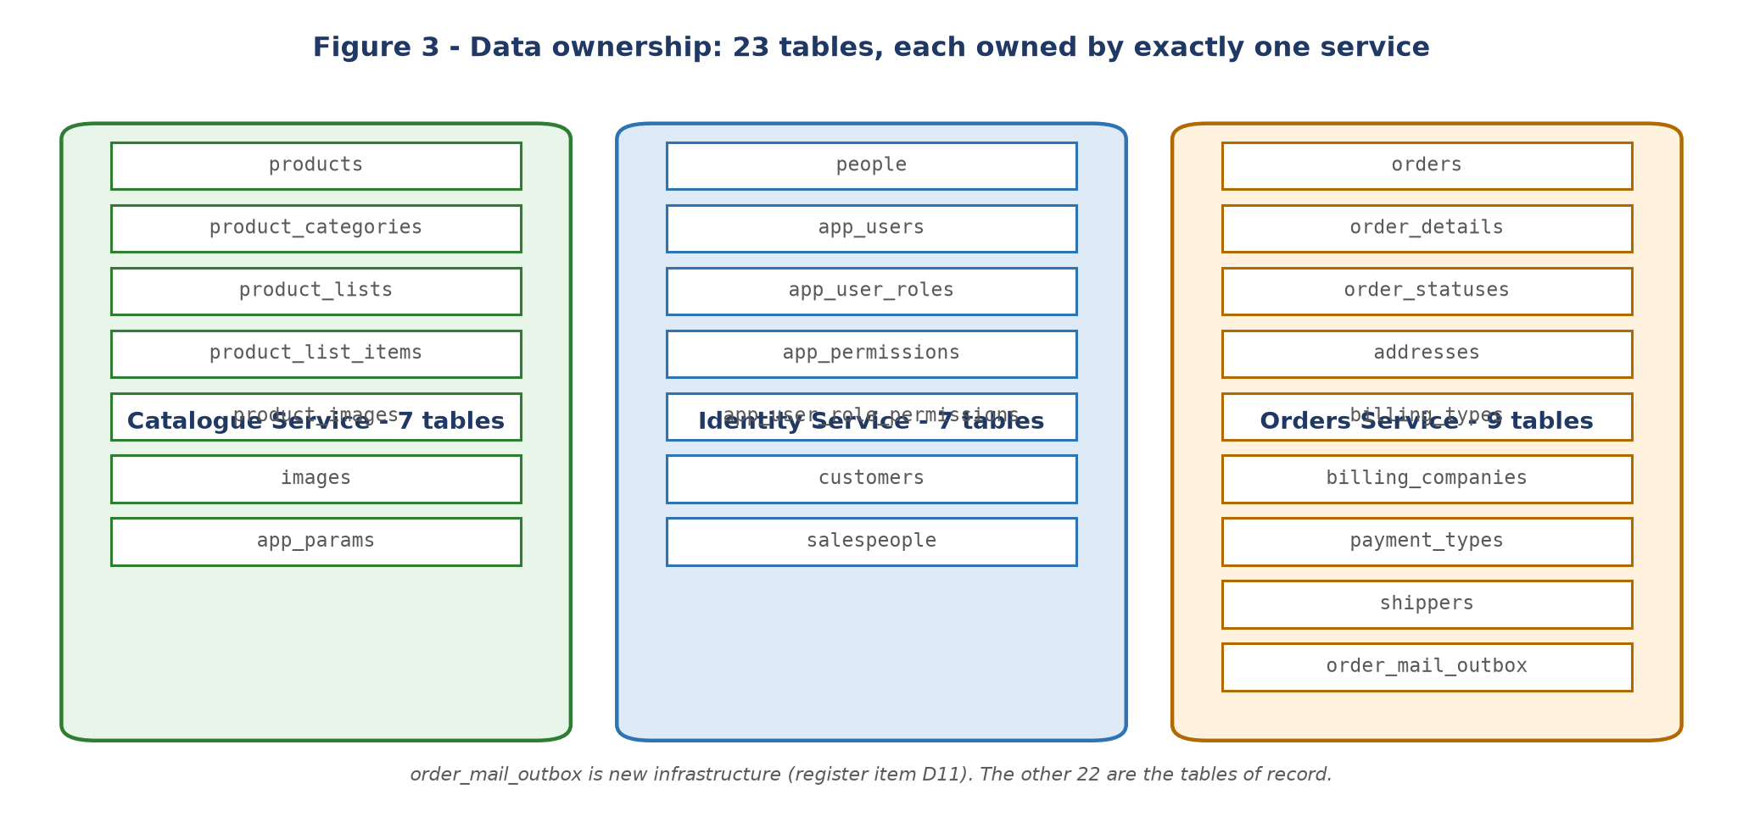
Figure 3 - Table ownership. Every foreign key is internal to the owning service.

5.1 How the cross-service foreign keys were cut
Three foreign keys crossed what became a service boundary: orders to customers, orders to salespeople, and order_details to products. The original plan assumed the constraints could simply be dropped while the surrogate id columns stayed, so that no data would migrate.
That assumption did not hold. Neither sibling service exposes a surrogate id in its public API - the catalogue is keyed by product barcode and Identity by person id number, and neither transport model carries an id field. The columns therefore could not be populated on write or resolved on read.
The resolution was to key the relationships by business key instead:
Table | Column added | Replaces
orders | customer_id_number varchar(20) NOT NULL | FK to customers
orders | salesperson_id_number varchar(20) NULL | FK to salespeople
order_details | order_detail_product_barcode varchar(300) NULL | FK to products

The three legacy surrogate columns were retained, nullable and unmapped, so that no existing data had to migrate. This is a recorded deviation from the original plan, and it produced a better result in two concrete ways:
- The public receipt endpoint makes no remote call at all. The product barcode is stored on the order line, so rendering a receipt no longer needs the Catalogue service. Had the original design been followed, an anonymous public endpoint would have depended on a sibling service being available.
- Customer resolution needs no second round trip, because the submitted id number is itself the key - there is nothing to read back after a create.
Now that nothing reads the three legacy columns, they can be dropped. See section 11.

5.2 Reference data
Each service seeds its own reference data. Orders seeds 12 order statuses, 2 billing types and 1 payment type. Identity seeds 4 roles, 54 permissions and 100 role-permission grants - and deliberately seeds no user accounts. See section 9.3.

6 Cross-service integration
All cross-service access goes through a published contract. There are five contracts; three are remote and two are local to Orders.
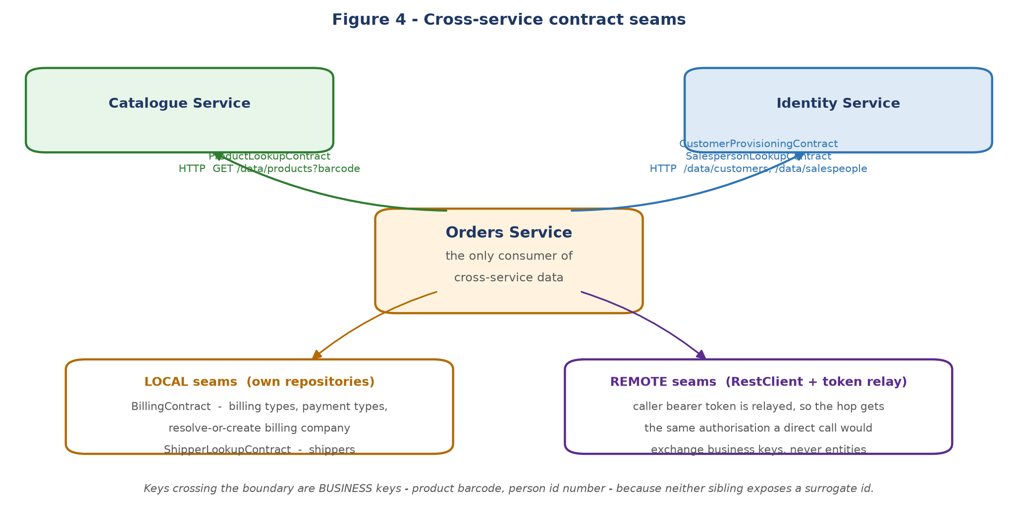
Figure 4 - Contract seams. Only Orders consumes cross-service data, so the dependency graph is acyclic.
Contract | Kind | Resolves | Transport
ProductLookupContract | Remote | Product barcode, name and price as a 3-field snapshot | RestClient to Catalogue
CustomerProvisioningContract | Remote | Resolve-or-create a customer; describe one by id number | RestClient to Identity
SalespersonLookupContract | Remote | Describe a salesperson by id number | RestClient to Identity
BillingContract | Local | Billing type, payment type, resolve-or-create billing company | Own repositories
ShipperLookupContract | Local | Shipper by name; read-only | Own repository

An architecture test asserts the distinction, because conflating the two kinds is the mistake worth catching: the three remote implementations must hold a RestClient and must not import a repository, and the two local ones must delegate to a repository and must not make a network call.

6.1 Authorisation across the hop
The caller's bearer token is relayed across the service hop. This is the conservative choice: the remote call receives exactly the authorisation a direct in-process call would have received, with no escalation to a service account.
It also surfaced a consequence that was invisible in the monolith. Guest checkout provisions a customer record, and in-process that write bypassed authorisation entirely. Remotely it becomes an HTTP call that Identity will authorise, and a guest token carries only the checkout authority. The resolution, taken in the previous phase, was to provision the guest customer at token issue, so that checkout resolves an existing customer rather than creating one.

6.2 Consistency model
There is no distributed transaction and no compensating-action framework. The consistency position is recorded in ADR-001 and is deliberately narrow:
- Within a service, the status transition, its outbox entry and its data changes commit in one local transaction.
- Across services, the administrative order-create path performs two writes in two services with no shared commit. A failure between them can leave a customer record with no order. This is a recorded, accepted window - see section 11.
- Guest and registered checkout are not exposed to that window, because the customer already exists by the time checkout runs.

7 Security architecture

7.1 Authentication
Identity is the sole issuer of tokens. Every other service verifies the signature locally using the shared signing key; no service calls Identity to validate a token. This is ADR-002.
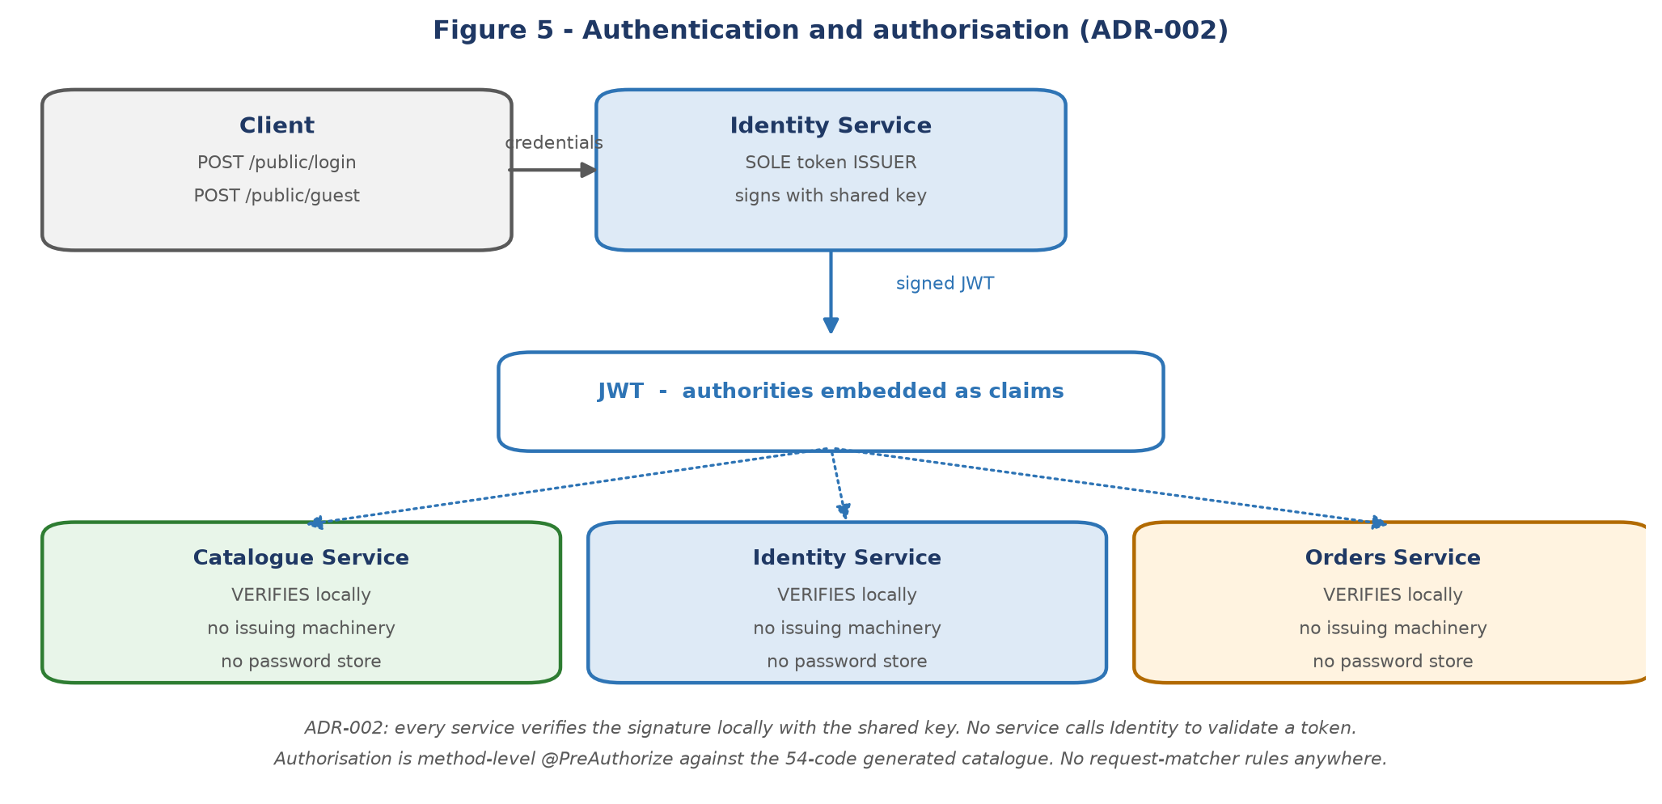
Figure 5 - Token issue and local verification. The two verify-only services carry no credential machinery at all.
The practical consequences are worth stating explicitly, because they are easy to undo by accident:
- Catalogue and Orders have no login route, no UserDetailsService, no authentication manager and no password encoder. Their context tests assert the absence of those beans by type, not by omission.
- The token verification filter passes a request with no Authorization header through unauthenticated rather than rejecting it. Anonymous routes depend on that behaviour.
- The signing key is supplied by the environment with no default in any service.

7.2 Authorisation
Authorisation is entirely method-level. No service declares any request-matcher rule, which means an un-annotated controller method is reachable by anyone - so the class-level and method-level annotations are the whole of the access control model, and both are asserted by tests.
The 54 authority codes are generated from the seed data into a single versioned artefact in the shared library. There are zero authority string literals in any service. An integrity test regenerates the catalogue on every build and fails on any drift, and a per-service architecture test fails if any @PreAuthorize demands an authority that is not in the catalogue, or if the number of authority checks ever falls.
Service | Authority checks | Notes
Catalogue | 20 | Most reads anonymous; images require authentication
Identity | 17 | Four each on users, roles, customers, salespeople, plus one people read
Orders | 14 | Eight on orders, four on shippers, one on statuses, one on checkout

7.3 The two anonymous write paths
These are the highest-risk surfaces in the platform and they are anonymous by necessity rather than by oversight:
- POST /public/checkout - requires the checkout authority, which a guest token carries. A guest token is itself issued anonymously.
- GET and POST /public/checkout/validate - the payment callbacks. These carry no authority because Transbank sends no credential. Their protection is a per-order nonce plus idempotency, described in section 8.1. A well-intentioned change adding an authority check here would make payment confirmation permanently unreachable, which is why a test asserts their anonymity explicitly.
- GET /public/receipt/{token} - anonymous and token-addressed: the token is the credential.

7.4 Secrets and configuration
No secret is committed in any service. The signing key and every database password are environment placeholders with no default, so a service fails to start rather than starting with a weak default. The payment API key defaults to empty and must be supplied by an operator.
One finding from the final phase is worth recording here. Spring Boot auto-configures an in-memory user with a randomly generated password whenever an application declares no UserDetailsService - exactly the state of a verify-only service. Both Catalogue and Orders were therefore starting with an auto-configured account and printing a credential to the log on every boot. It was inert, because neither filter chain configures form login or basic authentication, so the account had no way to authenticate over HTTP. It was nonetheless excluded on both services, because that inertness depended on an absence elsewhere: adding basic authentication for any reason would have promoted it silently to a working account.

8 Key behavioural flows

8.1 Checkout and the payment callback
This is the critical path and the one that changed most. Three defects were fixed here before extraction.
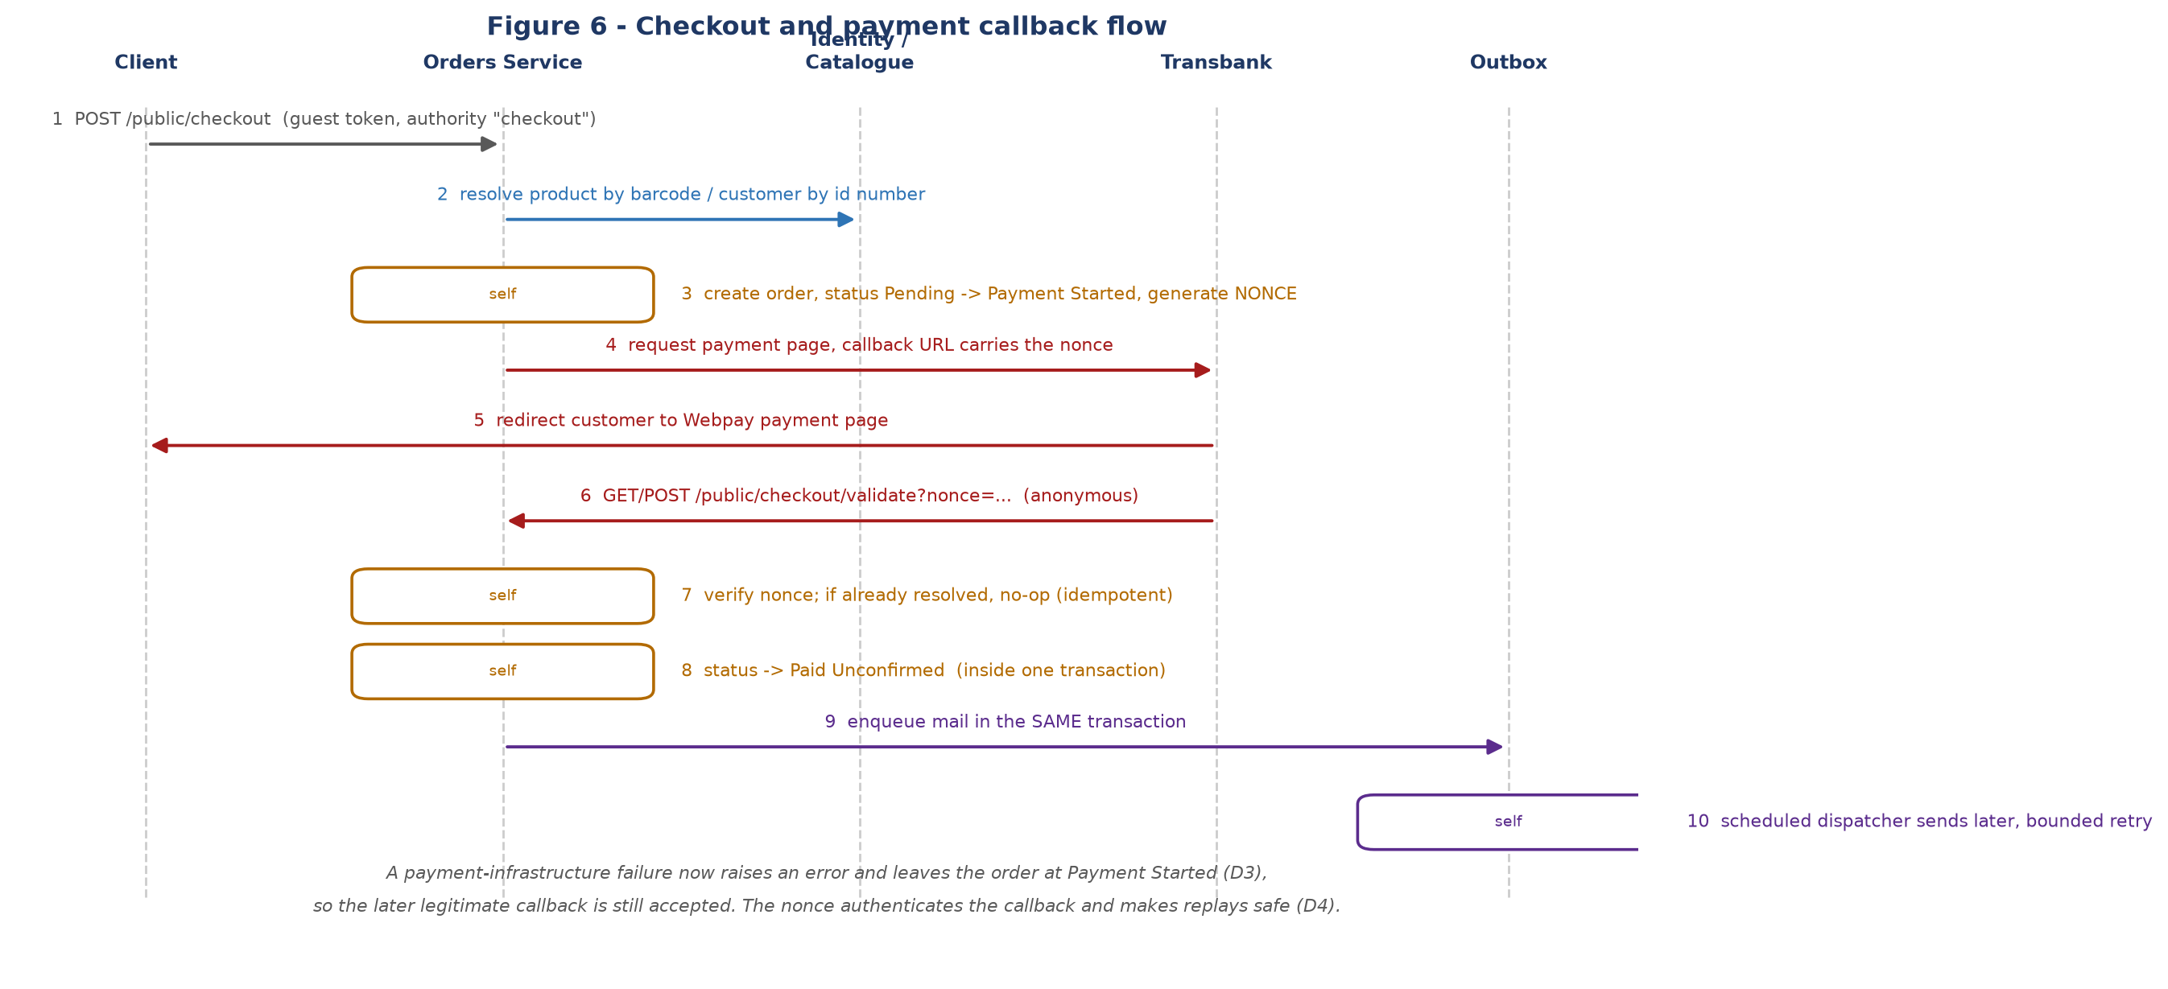
Figure 6 - Checkout through to notification. Steps 7 and 8 are what make a replayed callback safe.
Property | Before | Now
Callback authentication | None. Any caller who knew a token could confirm an order. | A per-order nonce is generated at payment start and must match on callback.
Replay | A replayed callback re-processed the order. The status filter credited with preventing this never worked - the query used an unrecognised parameter name and was silently dropped. | An already-resolved order short-circuits to a no-op.
Provider outage | Returned HTTP 200 and marked the order Payment Failed - a customer decline was recorded for an infrastructure fault. | Raises an error and leaves the order at Payment Started, so the later legitimate callback is still accepted.

8.2 Order status lifecycle
Twelve statuses are seeded; eight are reachable and seven transitions are legal. One transition table is the single source of truth, and all seven transition methods consult it.
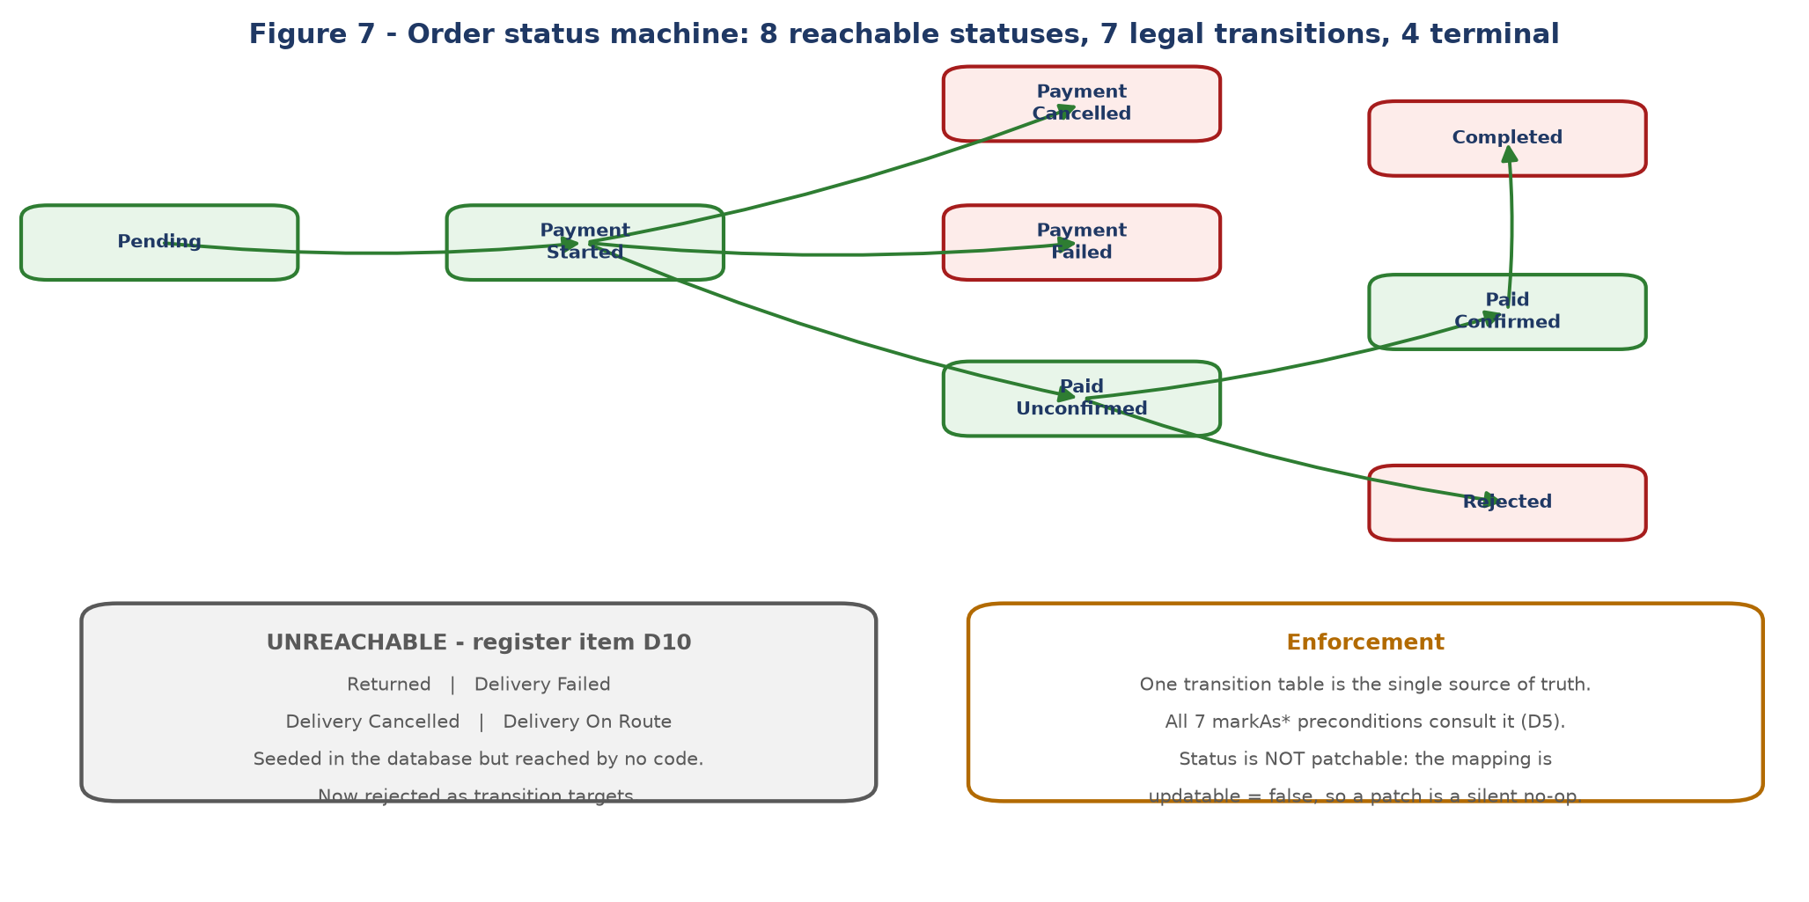
Figure 7 - The order status machine. Red states are terminal.
Two findings here were not what the defect register originally recorded, and both were established by probing behaviour rather than by re-reading the code:
- The order status is not patchable at all. The association is mapped non-updatable, so the column is excluded from every generated UPDATE. A patched status was silently discarded while the request reported success - an invisible no-op rather than a state-machine bypass, and arguably worse, because a bypass would at least appear in the data.
- Four seeded statuses - Returned, Delivery Failed, Delivery Cancelled, Delivery On Route - are reached by no code at all. They are now rejected explicitly as transition targets.

8.3 Notification outbox
Mail was previously sent after the transaction had already committed, with no retry: a failed send meant a silently lost notification. It is now a transactional outbox - the only genuinely new infrastructure in the programme, since no broker, queue or scheduled work existed anywhere before.
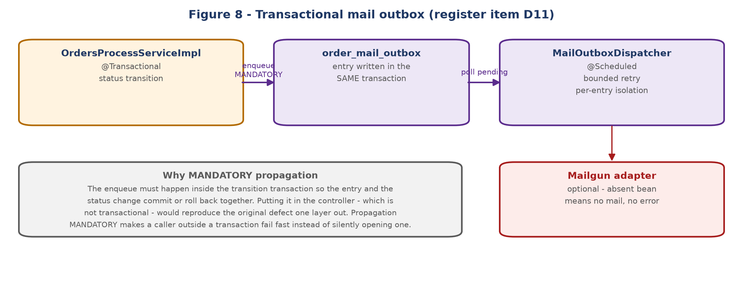
Figure 8 - The outbox. The enqueue is inside the transition transaction by design.
The design decision that makes this an outbox rather than a renamed queue is the placement of the enqueue. It had to be inside the transactional service method so the entry and the status change commit or roll back together. Placing it in the controller - which is not transactional - would have reproduced the original failure mode one layer out. Mandatory transaction propagation enforces this structurally: a caller outside a transaction fails fast instead of silently opening its own.

9 Build, verification and deployment

9.1 Build
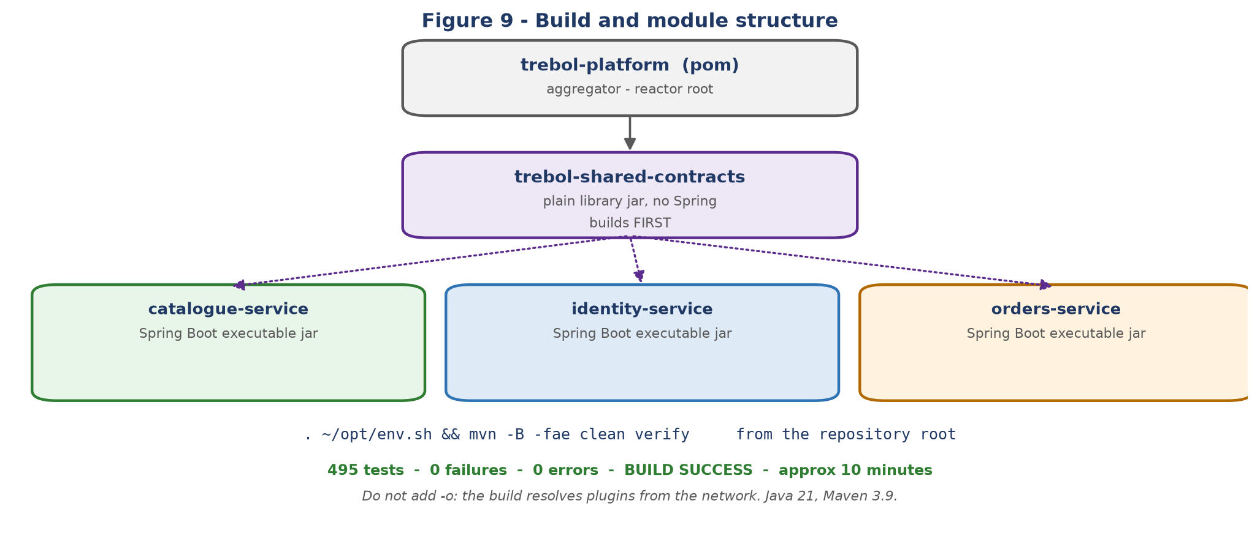
Figure 9 - Four-module reactor. shared-contracts builds first because every service consumes the generated authority catalogue.
. ~/opt/env.sh && mvn -B -fae clean verify # from the repository root
Item | Value
Java | 21 (Amazon Corretto 21.0.12 used for verification)
Maven | 3.9
Spring Boot | 3.2.12
Modules | trebol-platform (aggregator), trebol-shared-contracts, and the three services
Build time | approximately 10 minutes
Result | 495 tests, 0 failures, 0 errors, BUILD SUCCESS
Artefacts | 3 Spring Boot executable jars + 1 library jar

Two practical notes. The -fae flag no longer changes the outcome and is retained only so that a future failure still reports every module. Do not add -o (offline): the build resolves plugins from the network and an offline root build fails at packaging. Also, Surefire prints an [ERROR] line about killing its fork JVM on successful runs; it is a shutdown-timing message, not a test result.

9.2 Verification approach
Guarantee | How it is verified
Route parity | Each service has a route parity test pinning its HTTP surface - path, method and authority value - against the monolith's. Authorities are asserted by value, not by constant name, because the strings are the client-observable contract.
Service boundaries | Architecture tests fail the build on a cross-domain repository import or a foreign JPA entity import.
Authority catalogue | Regenerated and compared on every build; any drift or unknown code fails.
Context startup | Each service has a context-load test. These are disproportionately valuable: they caught a property-prefix error that made a service unstartable, and the auto-configured credential described in section 7.4. No unit test touches either.
Behaviour | 495 tests, including 15 on checkout alone and a full cross-product of the status transition table.

9.3 Deployment and the mandatory operator step
Each service is a self-contained executable jar requiring its own database and its own environment configuration. There is no shared runtime state, no sticky session and no inter-service discovery beyond the two base URLs Orders needs.
One step is mandatory and easy to miss:
Identity's seed data deliberately contains no user accounts. The original monolith shipped four demonstration accounts with committed bcrypt hashes; those were removed rather than carried into a deployable service. A freshly migrated deployment therefore has all four roles and all 54 authorities, but no account to log in with. An operator must create the first administrator directly in the database before the platform can be administered. The SQL for that step is recorded in the phase 2 exit record.
Service-to-service configuration: Orders needs the Catalogue and Identity base URLs and a request timeout. These are plain configuration with code defaults pointing at localhost, so they must be set for any non-local deployment. See Appendix B.

10 Intentional changes in observable behaviour
The programme's default was to preserve behaviour exactly, including defects, unless a change was explicitly ruled. The following are the changes that were ruled, and they are the differences a client or an operator can actually observe.
# | Change | Rationale
1 | A payment-infrastructure failure now returns an error instead of HTTP 200, and the order stays at Payment Started rather than moving to Payment Failed. | An outage is not a customer decline. The order remains eligible for the legitimate callback.
2 | A payment callback without a valid nonce is rejected with HTTP 400. | Callbacks were previously unauthenticated.
3 | A replayed callback is a no-op instead of being re-processed. | Idempotency.
4 | Illegal order status transitions are rejected; the four unreachable statuses are rejected as targets. | The status machine is now authoritative.
5 | Order confirmation mail is sent asynchronously, shortly after the status change, instead of synchronously during the request. | Mail is no longer lost when a send fails.
6 | Sorting orders by customer surname is no longer supported. Eight sort keys remain. | The key required a database join from orders into Identity's people table, which cannot survive the boundary. This is the only capability the conversion removed.
7 | Registration is now transactional and rolls back fully on failure. | It previously could leave a partial record.
8 | A DELETE with no recognised filter parameter is rejected instead of matching all rows. | A match-all delete was reachable.
9 | Identity ships with no user accounts. | Credentials are no longer committed. See section 9.3.

Two client-observable oddities were deliberately preserved rather than fixed, because they are visible contracts and changing them was outside the conversion's remit: a shipper validation error reports the wrong domain name in its message, and company profile fields serialise as explicit nulls rather than being omitted.

11 Known issues and outstanding work
Nothing here blocks the architecture, but the first item should be read before any production migration.

11.1 Live database migration - not performed
This programme removed schema definition files from the repository. It did not touch any live database. Retiring the shared schema against a populated database destroys data that version control never held, and it is the one genuinely irreversible step in the whole migration. Sequence it against a verified backup and a tested migration into the three service schemas.

11.2 Carried-forward items
Item | Description | Severity
Orphaned-customer window | Administrative order-create path only. Identity writes the customer, Orders writes the order, two transactions with no shared commit. Guest and registered checkout are unaffected. | Medium
Bearer token in an exception message | An untrusted-token exception interpolates the whole bearer token into its message. Nothing emits that message today - verified - but the first handler that logs it leaks a live credential. | Medium - security
Legacy surrogate columns | Three retained nullable, unmapped columns on orders and order_details. Nothing reads them; they can now be dropped. | Low
Silent no-op patch fields | Payment type and shipper patches are discarded by the same non-updatable mapping that affected status. The request reports success. | Low
Shared mutable mail request | The Mailgun adapter builds one mutable request object and mutates it per call. Safe only while the dispatcher is single-threaded. Raising dispatcher concurrency makes it live. | Low - latent
Guest name as credential | The guest account name is itself the credential. A product decision, preserved deliberately. | Low
Inert configuration | Two validation regex properties remain in Orders but bind to nothing. | Cosmetic
Repository hygiene | Build output is tracked in version control and .gitignore covers only log files. Pre-existing; deliberately not changed during a conversion phase. | Cosmetic

11.3 Dependency vulnerabilities
QueryDSL 5.0.0 carries CVE-2024-49203 (HIGH) and has no fixed release available, including 5.1.0. It is inherited from the original application, not introduced. The accepted mitigation is that the sort expression passed to the query builder is always drawn from a closed, enumerated map rather than from user input - and that property is now asserted by a test rather than argued from reading the code. It should be re-reviewed whenever a fixed release appears.
Decommissioning the monolith resolved a split that had been open since the first extraction: it was the last module shipping vulnerable versions of the MariaDB client and Apache Commons Lang. All three services pin the fixed versions, so the platform is no longer internally inconsistent on those two.

12 Architecture decision records
ADR | Decision | Status
ADR-001 | Consistency model for registration and checkout. No distributed transactions; local transactions plus explicitly accepted windows. | Accepted
ADR-002 | Authentication propagation. Identity is the sole issuer; every service verifies locally with the shared key. | Accepted
ADR-003 | Target architecture. Three services, chosen over a modular monolith. | Accepted

The decision records, the full defect register with 31 numbered items and their rulings, the five phase exit records and the porting-depth specifications for all twelve domains are in the repository under microservices-conversion/ and detailed-business-specification/. They were moved to the repository root during decommissioning, because they had been stored inside the monolith module and would otherwise have been deleted with it.

Appendix A Route inventory
All 67 distinct routes, grouped by owning service. GET / is served by all three services as a liveness endpoint and is listed once per service.

Catalogue Service - 26 routes
Method | Path | Controller
GET | / | RootController
DELETE | /data/images | DataImagesController
GET | /data/images | DataImagesController
PATCH | /data/images | DataImagesController
POST | /data/images | DataImagesController
PUT | /data/images | DataImagesController
DELETE | /data/product_categories | DataProductCategoriesController
GET | /data/product_categories | DataProductCategoriesController
PATCH | /data/product_categories | DataProductCategoriesController
POST | /data/product_categories | DataProductCategoriesController
PUT | /data/product_categories | DataProductCategoriesController
DELETE | /data/product_list_contents | DataProductListContentsController
GET | /data/product_list_contents | DataProductListContentsController
POST | /data/product_list_contents | DataProductListContentsController
PUT | /data/product_list_contents | DataProductListContentsController
DELETE | /data/product_lists | DataProductListsController
GET | /data/product_lists | DataProductListsController
PATCH | /data/product_lists | DataProductListsController
POST | /data/product_lists | DataProductListsController
PUT | /data/product_lists | DataProductListsController
DELETE | /data/products | DataProductsController
GET | /data/products | DataProductsController
PATCH | /data/products | DataProductsController
POST | /data/products | DataProductsController
PUT | /data/products | DataProductsController
GET | /public/about | PublicAboutController

Identity Service - 23 routes
Method | Path | Controller
GET | / | RootController
GET | /access | AccessController
GET | /access/{apiRoute} | AccessController
GET | /account/profile | AccountProfileController
PUT | /account/profile | AccountProfileController
DELETE | /data/customers | DataCustomersController
GET | /data/customers | DataCustomersController
POST | /data/customers | DataCustomersController
PUT | /data/customers | DataCustomersController
GET | /data/people | DataPeopleController
DELETE | /data/salespeople | DataSalespeopleController
GET | /data/salespeople | DataSalespeopleController
POST | /data/salespeople | DataSalespeopleController
PUT | /data/salespeople | DataSalespeopleController
DELETE | /data/user_roles | DataUserRolesController
GET | /data/user_roles | DataUserRolesController
POST | /data/user_roles | DataUserRolesController
PUT | /data/user_roles | DataUserRolesController
DELETE | /data/users | DataUsersController
GET | /data/users | DataUsersController
POST | /data/users | DataUsersController
PUT | /data/users | DataUsersController
POST | /public/register | PublicRegisterController

Orders Service - 20 routes
Method | Path | Controller
GET | / | RootController
GET | /data/billing_types | DataBillingTypesController
GET | /data/order_statuses | DataOrderStatusesController
DELETE | /data/orders | DataOrdersController
GET | /data/orders | DataOrdersController
PATCH | /data/orders | DataOrdersController
POST | /data/orders | DataOrdersController
PUT | /data/orders | DataOrdersController
POST | /data/orders/completion | DataOrdersController
POST | /data/orders/confirmation | DataOrdersController
POST | /data/orders/rejection | DataOrdersController
DELETE | /data/shippers | DataShippersController
GET | /data/shippers | DataShippersController
PATCH | /data/shippers | DataShippersController
POST | /data/shippers | DataShippersController
PUT | /data/shippers | DataShippersController
POST | /public/checkout | PublicCheckoutController
GET | /public/checkout/validate | PublicCheckoutController
POST | /public/checkout/validate | PublicCheckoutController
GET | /public/receipt/{token} | PublicReceiptController

Appendix B Environment variable reference
Every externalised setting, per service. A blank default means the service will not start without the variable - which is deliberate for secrets.

Catalogue Service
Variable | Property | Default
TREBOL_CATALOGUE_PORT | server.port | 8081
TREBOL_JWT_SECRET_KEY | trebol.security.jwt-secret-key | none - required
TREBOL_CORS_ALLOWED_ORIGINS | trebol.cors.allowed-origins | none - required
TREBOL_CATALOGUE_DB_URL | spring.datasource.url | none - required
TREBOL_CATALOGUE_DB_USER | spring.datasource.username | none - required
TREBOL_CATALOGUE_DB_PASSWORD | spring.datasource.password | none - required

Identity Service
Variable | Property | Default
TREBOL_IDENTITY_PORT | server.port | 8082
TREBOL_JWT_SECRET_KEY | trebol.security.jwt-secret-key | none - required
TREBOL_CORS_ALLOWED_ORIGINS | trebol.cors.allowed-origins | none - required
TREBOL_IDENTITY_DB_URL | spring.datasource.url | none - required
TREBOL_IDENTITY_DB_USER | spring.datasource.username | none - required
TREBOL_IDENTITY_DB_PASSWORD | spring.datasource.password | none - required

Orders Service
Variable | Property | Default
TREBOL_ORDERS_PORT | server.port | 8083
TREBOL_JWT_SECRET_KEY | trebol.security.jwt-secret-key | none - required
TREBOL_CORS_ALLOWED_ORIGINS | trebol.cors.allowed-origins | none - required
TREBOL_ORDERS_DB_URL | spring.datasource.url | none - required
TREBOL_ORDERS_DB_USER | spring.datasource.username | none - required
TREBOL_ORDERS_DB_PASSWORD | spring.datasource.password | none - required
TREBOL_CATALOGUE_URL | trebol.services.catalogue-base-url | http://localhost:8081
TREBOL_IDENTITY_URL | trebol.services.identity-base-url | http://localhost:8082
WEBPAY_COMMERCE_CODE | trebol.payment.webpayplus.commerce-code | 597055555532
WEBPAY_API_KEY | trebol.payment.webpayplus.api-key | empty
WEBPAY_PRODUCTION | trebol.payment.webpayplus.production | false
WEBPAY_CALLBACK_URL | trebol.payment.webpayplus.callback-url | http://localhost:8083/public/checkout/validate
WEBPAY_RESULT_URL | trebol.payment.webpayplus.browser-redirection-url | http://localhost:4200/receipt

Orders additionally requires the Catalogue and Identity base URLs. These are plain properties with code defaults pointing at localhost and must be set for any non-local deployment: trebol.services.catalogue-base-url, trebol.services.identity-base-url and trebol.services.request-timeout-ms.

