Trébol eCommerce Platform
Source and Target Comparison
Architecture and File Structure: Monolith versus Microservices
Field | Value
Purpose | Side-by-side comparison of the source and target systems
Part 1 | Architecture difference, with diagrams
Part 2 | File and package structure difference
Source baseline | trebol-backend-monolith at commit 8f4e22b (recovered from version control)
Target | Four-module Maven reactor, current working tree
Source size | 723 tracked files - 316 main and 132 test Java sources
Target size | 397 main and 149 test Java sources across four modules
Date | 16 October 2026

All counts in this document were extracted programmatically - the source figures from the monolith as it existed in version control, the target figures from the working tree. Nothing is estimated.

Part 1 Architecture difference

1.1 Source: the monolith
One Maven module producing one deployable WAR. All twelve business domains were compiled, tested and deployed together, in a conventional layered structure, over a single shared database.
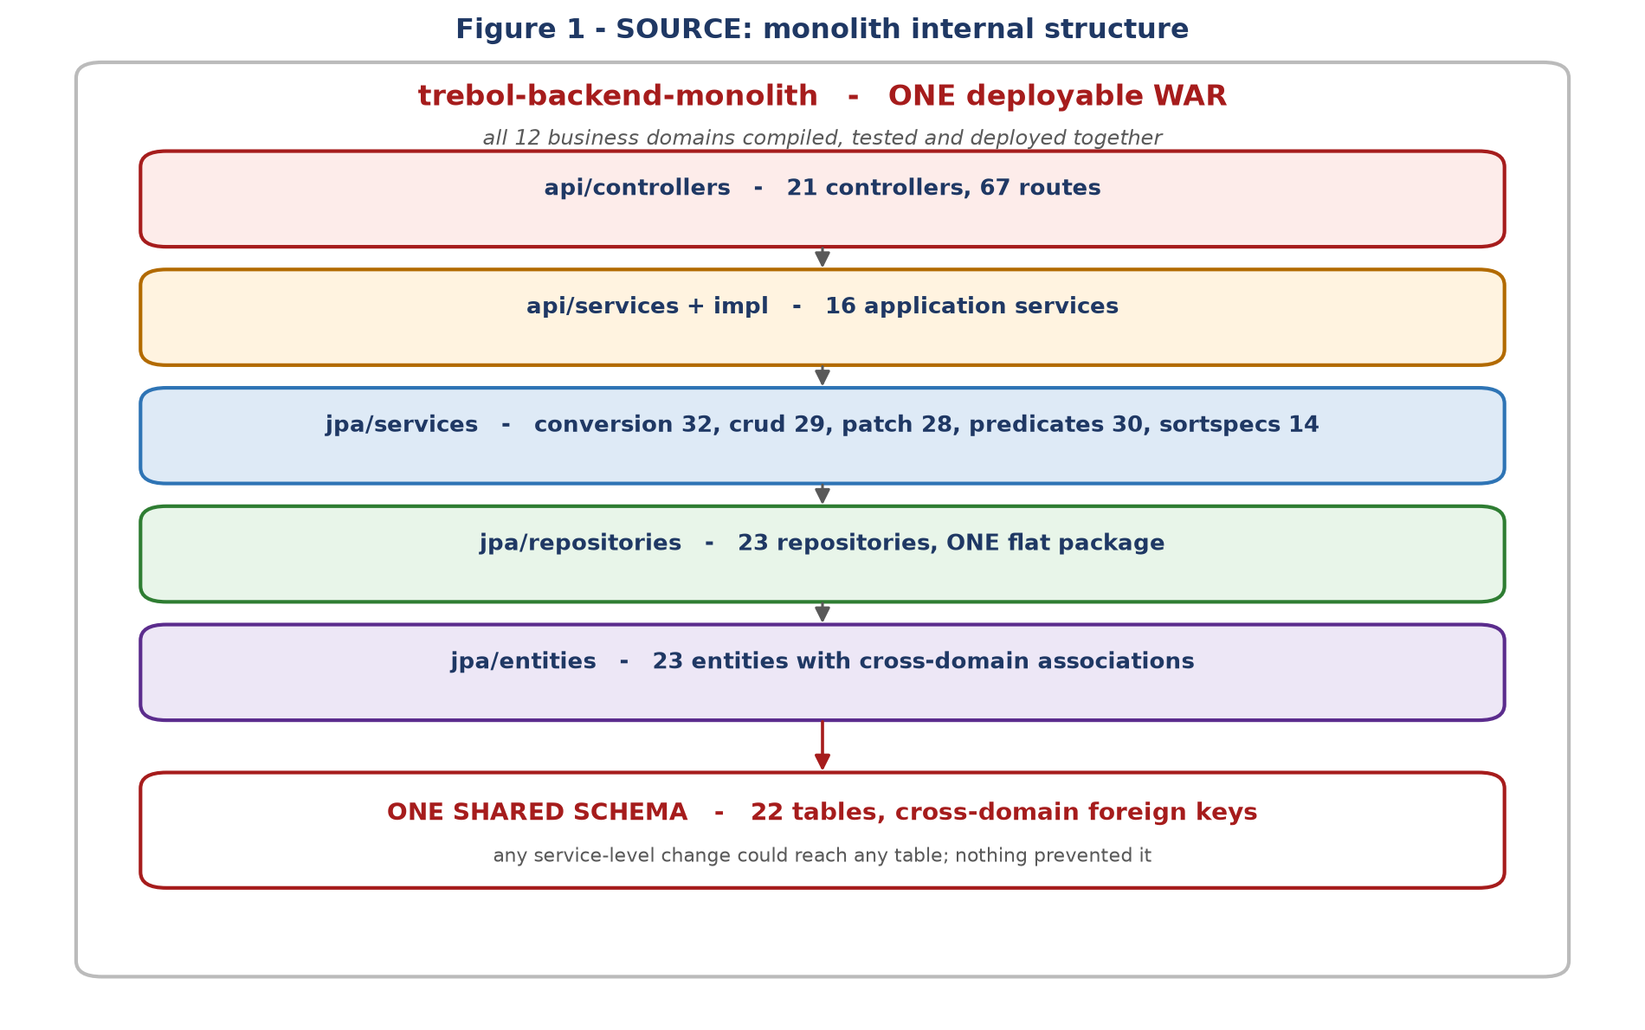
Figure 1 - Source architecture. The layering was clean; the problem was underneath it.
The layering itself was not the problem, and it is worth being precise about what was:
- All 23 repositories lived in one flat package, so there was no package boundary to lean on. Any service could reach any table.
- Entities carried cross-domain associations - an order referenced a customer, a salesperson and, per line, a product - so a single object graph spanned what would become three services.
- One schema with cross-domain foreign keys meant the database itself enforced the coupling.
- Nothing prevented new coupling from being added. The constraint was convention, not structure.

1.2 Target: three services
Three Maven modules, each producing a Spring Boot executable jar with its own schema, plus a dependency-free library jar for the one artefact they genuinely share.
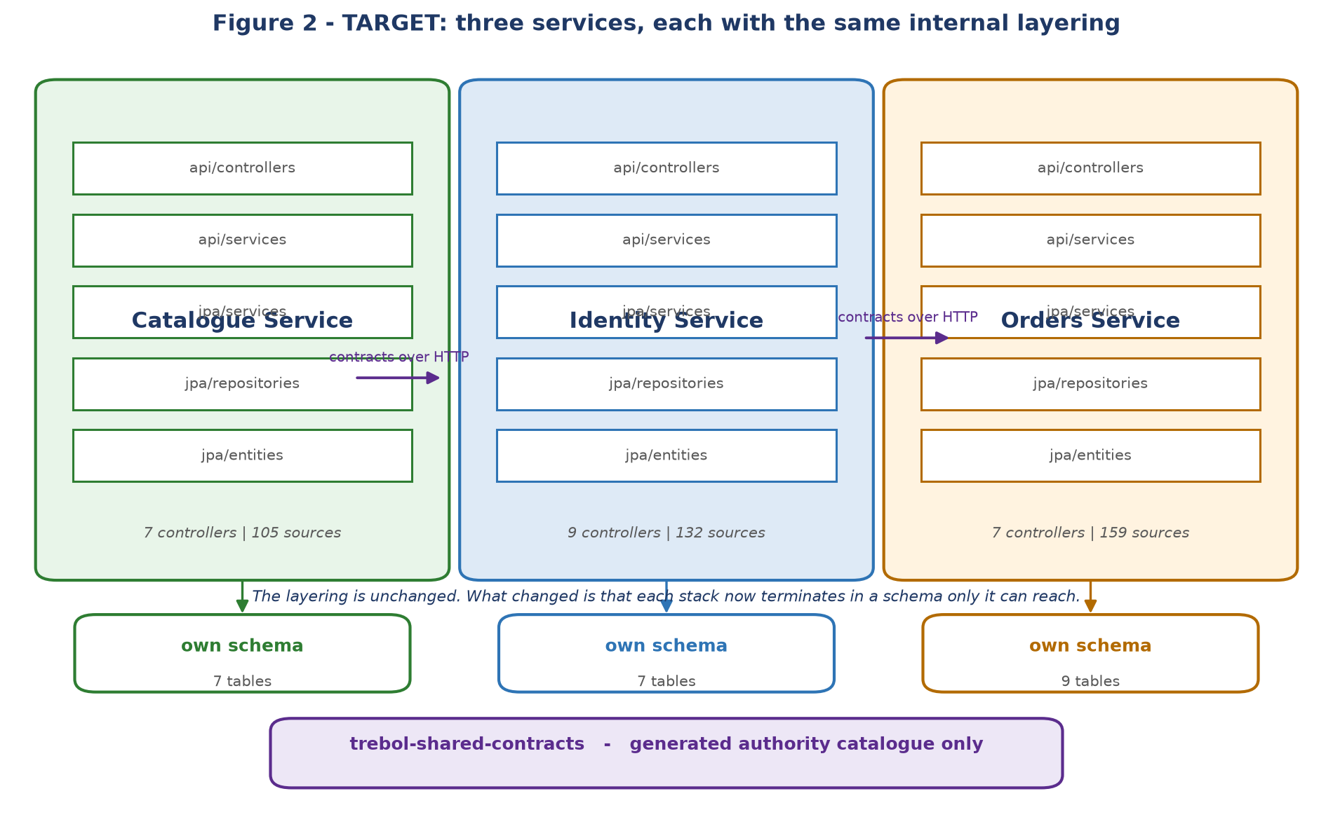
Figure 2 - Target architecture. The internal layering is deliberately unchanged.
The internal layering was kept identical on purpose. A port that also restructures the layers cannot be verified against the original, because every difference becomes a candidate explanation when a test fails. Keeping the layers fixed meant the only variable was the boundary.

1.3 Side by side
Aspect | Source - monolith | Target - three services
Deployable units | 1 WAR | 3 executable jars + 1 library jar
Maven modules | 1 | 4, under one aggregator
HTTP routes | 67, all in one application | 67, each served by exactly one service
Controllers | 21 in one package | 7 + 9 + 7, plus a health check in each
Database | 1 schema, 22 tables | 3 schemas, 23 tables, no shared database
Cross-domain foreign keys | Present and enforced by the database | 0 across services
Cross-domain object graph | Entities referenced other domains directly | Business keys only; no foreign entity is importable
Repositories | 23 in one flat package | 7 + 7 + 9, each private to its service
Authorisation data | 50 authority string literals scattered in controllers | 0 literals; one generated 54-code catalogue in the shared jar
Boundary enforcement | Convention | Architecture tests that fail the build
Deployment coupling | Any change redeploys everything | Each service deploys independently
Failure domain | One process; a fault anywhere affects all routes | Three processes; Catalogue and Identity have no runtime dependency on anything
Scaling | Whole application together | Per service

1.4 How the twelve domains were allocated
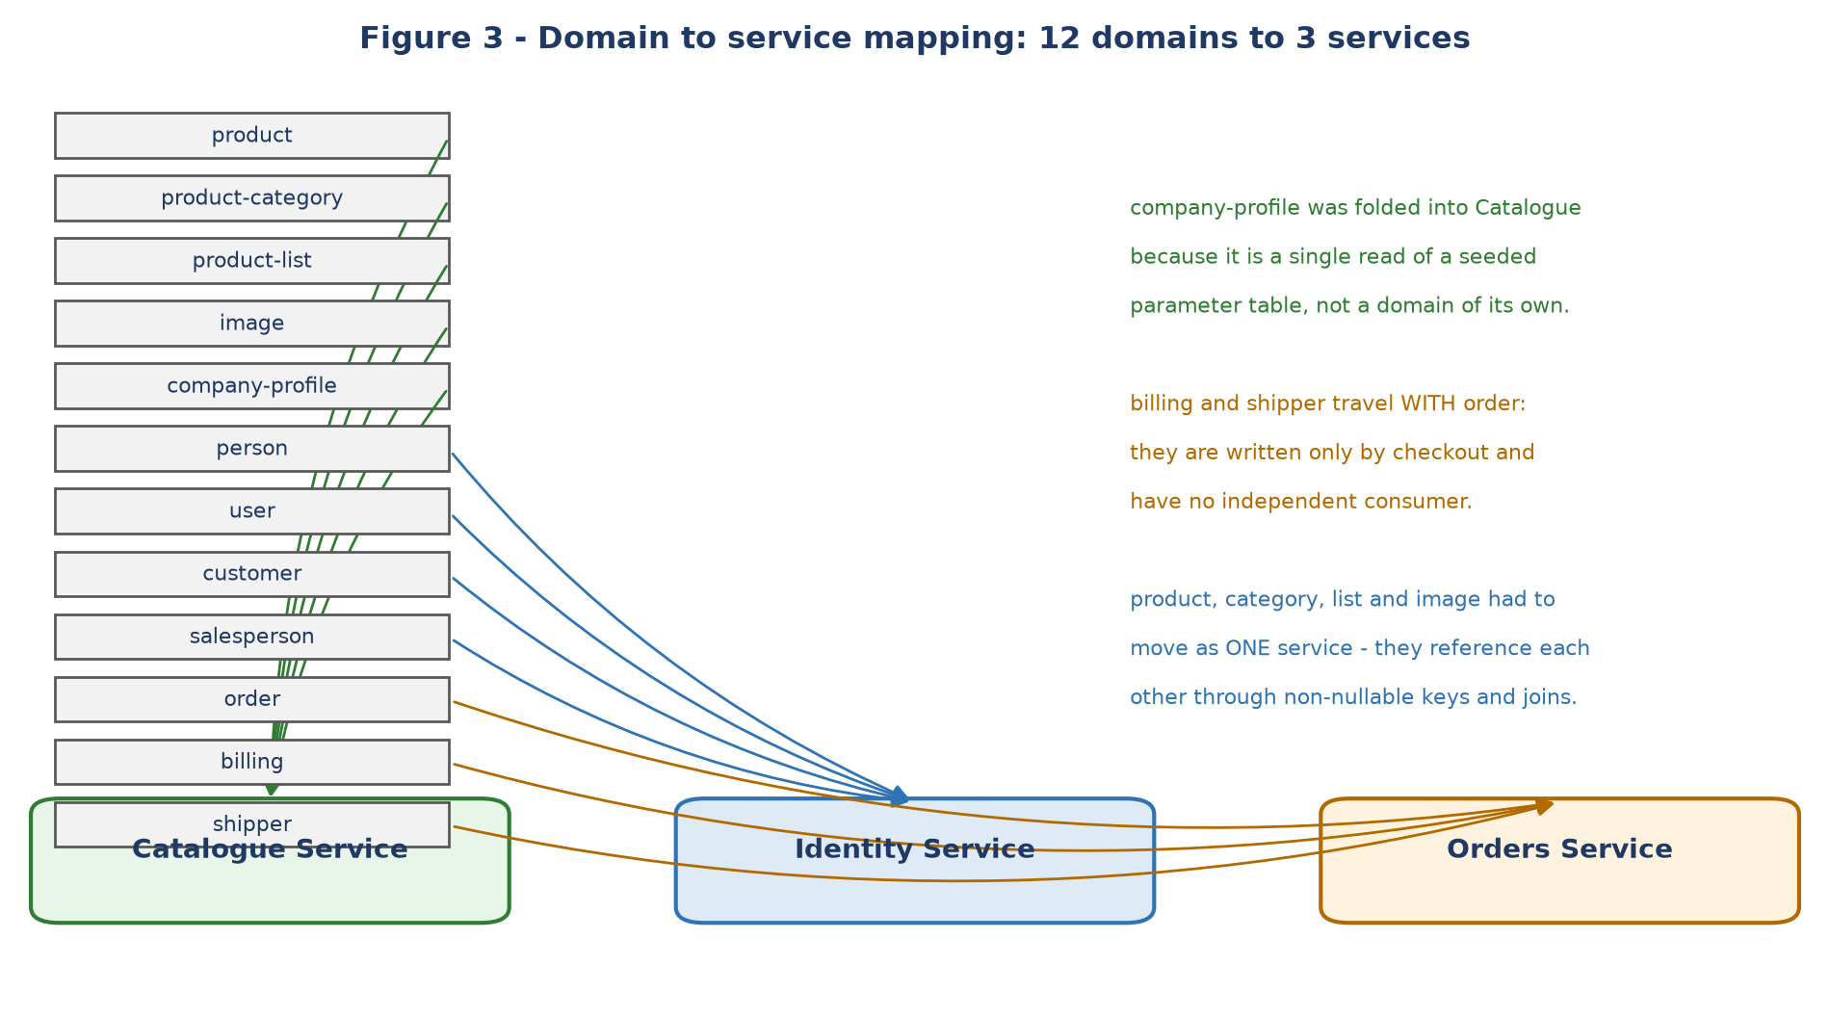
Figure 3 - Domain allocation. Grouping was decided by coupling, not by size.
Three grouping decisions are worth recording, because each was driven by evidence rather than by taste:
- Product, category, list and image became ONE service. A coupling census over all 52 of their source files found they reference each other through QueryDSL path traversal, static sort specifications and a non-nullable foreign key. Splitting them would have created three services that could not function apart.
- Billing and shipper travelled with Orders. They are written only by checkout and have no independent consumer, so giving them their own service would have added two network hops to the critical path for no benefit.
- Company profile folded into Catalogue. It is a single read of a seeded parameter table, not a domain.
The same census found the decisive fact that de-risked the whole first extraction: the catalogue domains had ZERO outbound references to order, person, user, billing, salesperson, shipper or customer. The only apparent matches were a QueryDSL sort class with a coincidentally similar name.

1.5 What did not change
It is as important to be clear about what was deliberately left alone:
- The layered internal structure, package naming and fully-qualified class names of ported code - copied byte-for-byte wherever possible, so that literals could not drift.
- The HTTP contract. All 67 routes keep their paths, methods, request and response shapes and authority requirements, with nine recorded exceptions documented in the main technical documentation.
- The database table and column names, so no data had to be rewritten.
- The technology stack - same Java, Spring Boot, Hibernate, QueryDSL and MariaDB versions.

Part 2 File structure difference

2.1 Repository layout
The most visible structural change is that the repository root is no longer a single module. In the source, everything - including all the documentation and the project governance files - lived inside trebol-backend-monolith/.
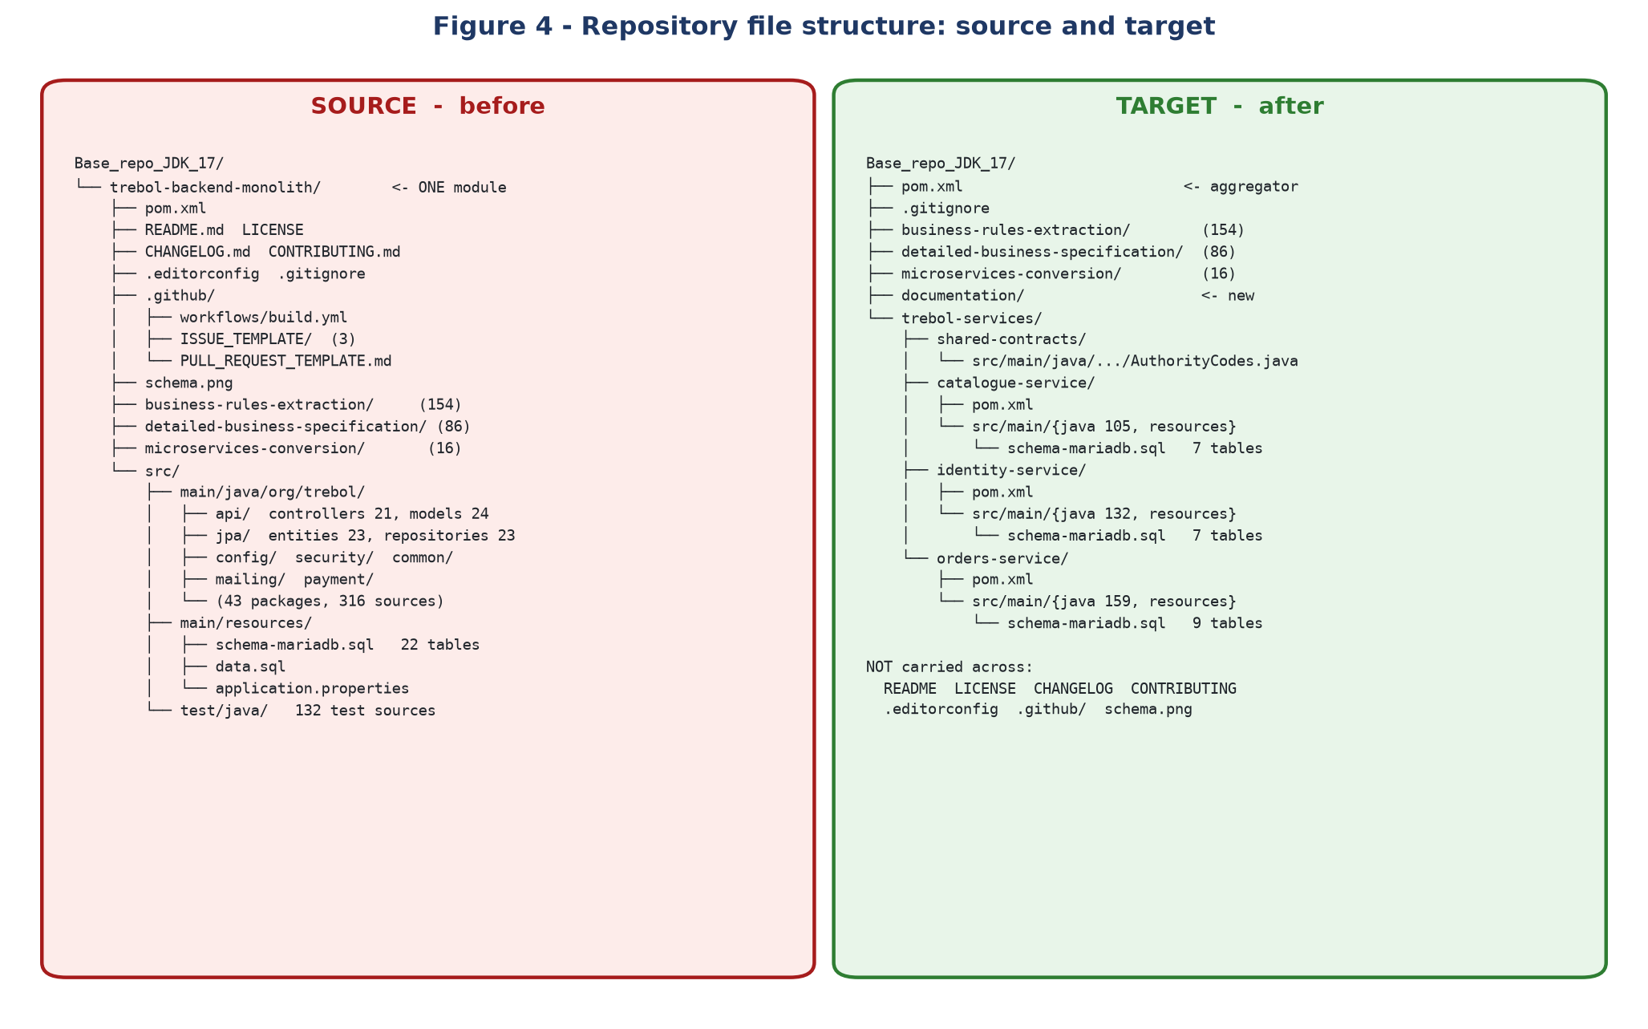
Figure 4 - Repository layout before and after.

2.2 Source tree
trebol-backend-monolith/ 723 tracked files
├── pom.xml
├── src/main/java/org/trebol/ 43 packages, 316 sources
│ ├── api/controllers/ 21
│ ├── api/models/ 24
│ ├── api/services/ + impl/ 16
│ ├── jpa/entities/ 23
│ ├── jpa/repositories/ 23 <- one flat package
│ ├── jpa/services/ conversion 32, crud 29, patch 28,
│ │ predicates 30, contracts 10
│ ├── jpa/sortspecs/ 14
│ ├── config/ 10 security/ 16
│ ├── mailing/ 9 payment/ 6
│ └── common/ 8
├── src/main/resources/
│ ├── schema-mariadb.sql 22 tables, cross-domain FKs
│ ├── data.sql incl. 4 demo accounts with bcrypt hashes
│ └── application.properties one file for the whole system
├── src/test/java/ 132 test sources
├── business-rules-extraction/ 154 files
├── detailed-business-specification/ 86 files
├── microservices-conversion/ 16 files
└── README.md LICENSE CHANGELOG.md CONTRIBUTING.md
.editorconfig .gitignore .github/ schema.png

2.3 Target tree
Base_repo_JDK_17/
├── pom.xml aggregator, 4 modules
├── .gitignore
├── business-rules-extraction/ 154 files <- moved to root
├── detailed-business-specification/ 86 files <- moved to root
├── microservices-conversion/ 16 files <- moved to root
├── documentation/ new in this engagement
│ ├── Trebol-Platform-Technical-Documentation.docx
│ └── diagrams/
└── trebol-services/
├── shared-contracts/ 1 main source, 2 tests
│ └── AuthorityCodes.java generated, 54 codes
├── catalogue-service/ 105 main, 36 test
│ └── schema-mariadb.sql 7 tables
├── identity-service/ 132 main, 56 test
│ └── schema-mariadb.sql 7 tables data.sql has NO accounts
└── orders-service/ 159 main, 55 test
└── schema-mariadb.sql 9 tables
Each service additionally carries its own pom.xml, application.properties and a test-scoped application.properties. That last file is a trap worth knowing about: a test-resources application.properties replaces the main one entirely, whereas data.sql is loaded from a wildcard location and so both copies execute.

2.4 Package-by-package mapping
Every package in the source, and where its contents now live. Counts are Java source files.
Package | Mono | Cat | Idnt | Ord | Shrd | Total | Note
(root) | 1 | 1 | 1 | 1 | 0 | 3 | duplicated per service
api | 5 | 5 | 5 | 5 | 0 | 15 | duplicated per service
api/controllers | 21 | 7 | 9 | 7 | 0 | 23 | duplicated per service
api/models | 24 | 7 | 8 | 17 | 0 | 32 | duplicated per service
api/services | 8 | 2 | 4 | 4 | 0 | 10 | duplicated per service
api/services/impl | 8 | 2 | 4 | 4 | 0 | 10 | duplicated per service
common | 1 | 0 | 1 | 1 | 0 | 2 | duplicated per service
common/annotations | 1 | 0 | 0 | 0 | 0 | 0 | not carried across
common/annotations/validator | 1 | 0 | 0 | 0 | 0 | 0 | not carried across
common/converters | 2 | 0 | 0 | 2 | 0 | 2
common/exceptions | 1 | 1 | 1 | 1 | 0 | 3 | duplicated per service
common/services | 1 | 0 | 1 | 0 | 0 | 1
common/services/impl | 1 | 0 | 1 | 0 | 0 | 1
config | 10 | 8 | 9 | 9 | 0 | 26 | duplicated per service
config/exceptions | 1 | 1 | 1 | 1 | 0 | 3 | duplicated per service
integration | 0 | 0 | 0 | 4 | 0 | 4 | new
jpa | 2 | 2 | 2 | 2 | 0 | 6 | duplicated per service
jpa/entities | 23 | 7 | 7 | 9 | 0 | 23
jpa/exceptions | 2 | 0 | 2 | 0 | 0 | 2
jpa/repositories | 23 | 7 | 7 | 9 | 0 | 23
jpa/services | 7 | 6 | 5 | 6 | 0 | 17 | duplicated per service
jpa/services/contracts | 5 | 1 | 2 | 6 | 0 | 9 | duplicated per service
jpa/services/contracts/impl | 5 | 1 | 2 | 5 | 0 | 8 | duplicated per service
jpa/services/conversion | 16 | 5 | 5 | 6 | 0 | 16
jpa/services/conversion/impl | 16 | 5 | 5 | 6 | 0 | 16
jpa/services/crud | 15 | 5 | 6 | 6 | 0 | 17 | duplicated per service
jpa/services/crud/impl | 14 | 4 | 5 | 5 | 0 | 14
jpa/services/impl | 2 | 2 | 1 | 1 | 0 | 4 | duplicated per service
jpa/services/patch | 14 | 4 | 5 | 5 | 0 | 14
jpa/services/patch/impl | 14 | 4 | 5 | 5 | 0 | 14
jpa/services/predicates | 15 | 5 | 5 | 5 | 0 | 15
jpa/services/predicates/impl | 15 | 5 | 5 | 5 | 0 | 15
jpa/sortspecs | 14 | 5 | 5 | 4 | 0 | 14
mailing | 3 | 0 | 0 | 3 | 0 | 3
mailing/impl/mailgun | 2 | 0 | 0 | 2 | 0 | 2
mailing/outbox | 3 | 0 | 0 | 3 | 0 | 3
mailing/outbox/impl | 1 | 0 | 0 | 1 | 0 | 1
payment | 2 | 0 | 0 | 2 | 0 | 2
payment/impl/webpayplus | 3 | 0 | 0 | 3 | 0 | 3
payment/impl/webpayplus/impl | 1 | 0 | 0 | 1 | 0 | 1
security | 6 | 1 | 6 | 1 | 0 | 8 | duplicated per service
security/authorities | 0 | 0 | 0 | 0 | 1 | 1 | new
security/exceptions | 1 | 0 | 1 | 0 | 0 | 1
security/services | 3 | 1 | 3 | 1 | 0 | 5 | duplicated per service
security/services/impl | 3 | 1 | 3 | 1 | 0 | 5 | duplicated per service

Totals: 316 source files became 397. The increase is the shared kernel - configuration classes, exception types, the generic CRUD and controller bases, the transport models - being duplicated into each service that needs it. That duplication is the deliberate price of independent deployability: a service that shared those classes through a library would be recoupled at build time to every other service.

2.5 Where the growth and the losses are
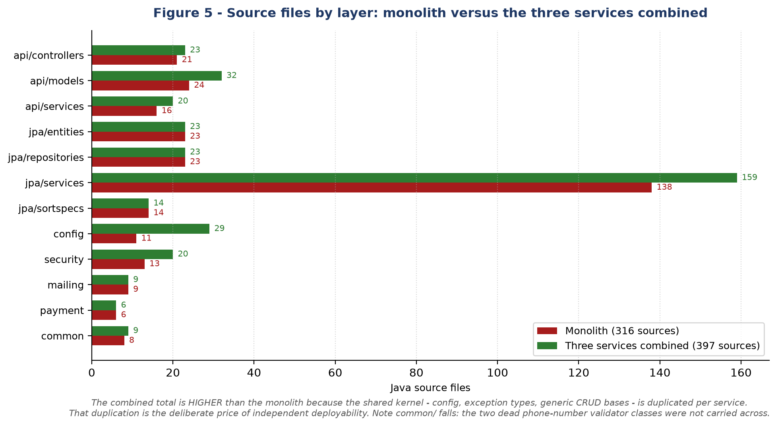
Figure 5 - Source files by layer.
Observation | Detail
config nearly tripled | 10 to 26. Each service needs its own security, CORS, JPA and API configuration. This is the single largest duplication.
api/models grew 24 to 32 | Orders needs the catalogue and person transport models to deserialise contract responses, so some models exist in two services.
jpa/entities stayed at 23 | 7 + 7 + 9. Exactly the original set, each entity now in precisely one service.
jpa/repositories stayed at 23 | Same split. No repository exists in two services.
contracts grew 5 to 9 | Orders redeclared the three cross-service contracts to exchange business keys instead of entities, and kept the two local ones.
integration/ is new | 4 classes in Orders: the RestClient configuration, the endpoint properties and the caller-token relay. The source had no outbound service calls.
mailing/outbox is new | 4 classes. The source sent mail synchronously after commit; there was no broker, queue or scheduled work anywhere.
common/ shrank | The only two packages that went nowhere: common/annotations and its validator - a phone-number annotation that nothing in the source referenced. Dead code, verified before being dropped.

2.6 Resources and schema files
File | Source | Target
schema-mariadb.sql | One file, 22 tables (23 after the outbox was added), with cross-domain foreign keys | Three files - 7, 7 and 9 tables. Every foreign key internal.
data.sql | One file. Included four demonstration accounts with committed bcrypt password hashes. | Three files. Identity seeds roles, permissions and grants but NO accounts - credentials are no longer committed.
application.properties | One file configuring the whole system, with literal values. | One per service. Every secret is an environment placeholder; the signing key and database passwords have no default at all.
application-mailgun.empty.properties | Present | Carried into Orders, the only service that sends mail.

2.7 Files that were not carried across
This is the one finding in this comparison that needs action rather than just recording. The project governance files lived inside the monolith module, not at the repository root, so they were removed when the module was deleted and they were not relocated.
File | What it was | Impact
LICENSE | The project licence text | Every source file in all three services still carries an MIT-style copyright header referring to a licence that is no longer in the repository. This is a licensing hygiene problem and should be restored.
.github/workflows/build.yml | The CI pipeline | There is now no automated build on push. The old workflow also targeted the monolith module, so it needs rewriting for the four-module reactor rather than simply restoring.
README.md | Project overview and build instructions | A new reader has no entry point. Needs rewriting for the three-service architecture, not restoring.
CONTRIBUTING.md, CHANGELOG.md | Contribution guide and history | Should be restored; the changelog deserves an entry for this migration.
.editorconfig | Editor settings, including line-ending policy | Worth restoring - the repository is CRLF throughout and two files have already drifted to mixed endings.
.github/ISSUE_TEMPLATE/ (3), PULL_REQUEST_TEMPLATE.md | Issue and PR templates | Cosmetic.
schema.png | A diagram of the old shared 22-table schema | Obsolete by design. Superseded by the diagrams in this pack.
.gitignore | Module-level ignore rules | A root .gitignore exists but covers only log files. Build output is tracked in version control as a result - a pre-existing issue.

All of these remain recoverable from version control at commit 8f4e22b. Restoring the licence is a one-line operation; the README and CI workflow need to be rewritten for the new structure rather than copied back, because both described a module that no longer exists.

2.8 Test structure
Measure | Source | Target
Test source files | 132 | 149 across four modules
Tests executed | 460 (363 before the programme began, with 3 permanently failing) | 495, all passing
Architecture tests | 2 | 7 - route parity, authority literals and boundary coupling, per service
Context-load tests | 1 (BackendAppTest) | 3, one per service
Authority catalogue tests | In the monolith test tree | Moved into shared-contracts, with the generator, so the catalogue stays a generated artefact

Five test classes covering live code were found missing during decommissioning and restored - including the only executing evidence for the payment callback criterion. The comparison that found them was a test-class diff against the monolith in version control, which is the same technique this document uses for its counts.

