SCHOOL OF COMPUTER SCIENCE AND ARTIFICIAL INTELLIGENCE |  |  |  |  | DEPARTMENT OF COMPUTER SCIENCE ENGINEERING
Program Name: B. Tech |  |  |  | Assignment Type: Lab |  |  | Academic Year:2025-2026
Course Coordinator Name |  |  |  | Dr. Rishabh Mittal
Instructor(s) Name
  Mr. S Naresh Kumar
  Ms. B. Swathi
  Dr. Sasanko Shekhar Gantayat
  Mr. Md Sallauddin
  Dr. Mathivanan
  Mr. Y Srikanth
  Ms. N Shilpa
  Dr. Rishabh Mittal (Coordinator)
  Dr. R. Prashant Kumar
  Mr. Ankushavali MD
  Mr. B Viswanath
  Ms. Sujitha Reddy
  Ms. A. Anitha
  Ms. M.Madhuri
  Ms. Katherashala Swetha
  Ms. Velpula sumalatha
  Mr. Bingi Raju
CourseCode |  |  | 23CS002PC304 | Course Title |  | AI Assisted Coding
Year/Sem |  |  | III/II | Regulation |  | R23
Date and Day  of Assignment |  |  | Week1 – Wednesday | Time(s) |  | 23CSBTB01 To 23CSBTB52
Duration |  |  | 2 Hours | Applicable to  Batches |  | All batches
Assignment Number:1.3(Present assignment number)/24(Total number of assignments)
 | Q.No. | Question |  |  |  |  |  | Expected Time  to complete
 | 1 | Lab 2: Exploring Additional AI Coding Tools beyond Copilot – Gemini (Colab) and Cursor AI  Lab Objectives:  - To explore and evaluate the functionality of Google Gemini for AI-assisted coding within Google Colab.  - To understand and use Cursor AI for code generation, explanation, and refactoring.  - To compare outputs and usability between Gemini, GitHub Copilot, and Cursor AI.  - To perform code optimization and documentation using AI tools.  Lab Outcomes (LOs):  After completing this lab, students will be able to:  - Generate Python code using Google Gemini in Google Colab.  - Analyze the effectiveness of code explanations and suggestions by Gemini.  - Set up and use Cursor AI for AI-powered coding assistance.  - Evaluate and refactor code using Cursor AI features.  - Compare AI tool behavior and code quality across different platforms.  Task 1: Word Frequency from Text File  - Scenario:  You are analyzing log files for keyword frequency.  - Task:  Use Gemini to generate Python code that reads a text file and counts word frequency, then explains the code.  - Expected Output:  - Prompts  Write a Python code to count word frequency from a text file and handling case insensitivity and punctuation give me the optimized code.  - Working code  """Count word frequencies in a log file."""  import argparse  from collections import Counter  from pathlib import Path  def word_frequency(file_path: Path) -> Counter[str]:  text = file_path.read_text(encoding="utf-8")  return Counter(text.lower().split())  def main(argv=None) -> int:  parser = argparse.ArgumentParser(  description="Count word frequencies in a log file.",  epilog="Run without arguments to process logfile.txt in the current directory\nor pass a custom path such as logs/server.log.",  )  parser.add_argument(  "logfile",  nargs="?",  default="logfile.txt",  help="Path to the log file to analyze.",  )  args = parser.parse_args(argv)  file_path = Path(args.logfile)  if not file_path.exists():  parser.error(f"{file_path} does not exist. Create that file or provide another path.")  frequency = word_frequency(file_path)  for word, count in frequency.most_common():  print(f"{word}: {count}")  return 0  if __name__ == "__main__":  raise SystemExit(main())  - Explanation  You give it a text file.  The program reads the whole file.  It changes all the capital letters to small letters.  It breaks the text apart so it has a list of every single word.  It then uses the `Counter` class from the `collections` module to count the frequency  Finally, it prints out a list that shows every word and its total count.  - Screenshot  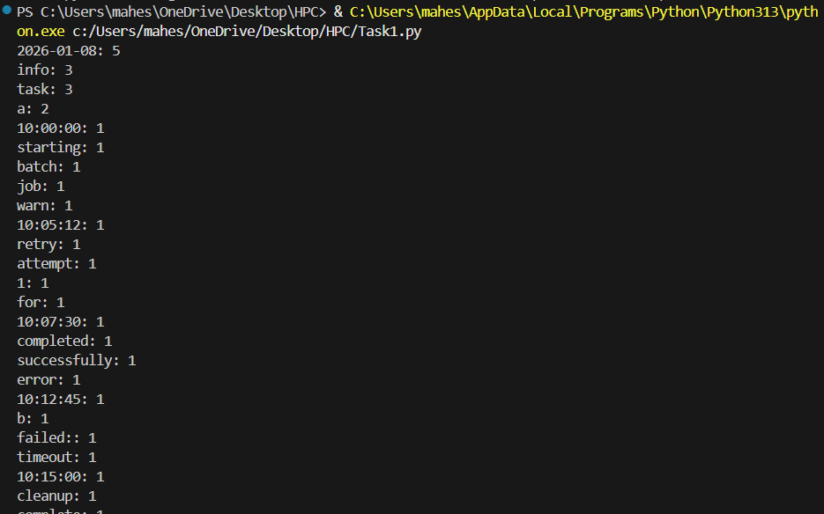  Task 2: File Operations Using Cursor AI  - Scenario:  You are automating basic file operations.  - Task:  Use Cursor AI to generate a program that:  - Creates a text file  - Writes sample text  - Reads and displays the content  - Expected Output:  - Prompts  Write a Python code to creates a file named 'sample.txt', writes three lines of example text to it, then reads the file back and prints the content to the console.  - Functional code  def main() -> None:  file_name = 'sample.txt'  # Writing to the file  with open(file_name, 'w') as file:  file.write("This is the first line of example text.\n")  file.write("This is the second line of example text.\n")  file.write("This is the third line of example text.\n")  # Reading from the file  with open(file_name, 'r') as file:  content = file.read()  # Printing the content to the console  print("Content of 'sample.txt':")  print(content)  if __name__ == "__main__":  main()  - Cursor AI screenshots  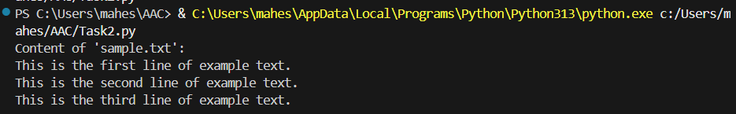  Task 3: CSV Data Analysis  - Scenario:  You are processing structured data from a CSV file.  - Task:  Use Gemini in Colab to read a CSV file and calculate mean, min, and max.  - Expected Output:  - Prompt  Write a Python code that read a CSV file and calculates the mean, min, and max of a specific numerical column.  - Functional code  import csv  def calculate_statistics(file_name: str, column_name: str) -> None:  values = []  # Reading the CSV file  with open(file_name, mode='r') as csvfile:  csvreader = csv.DictReader(csvfile)  for row in csvreader:  try:  value = float(row[column_name])  values.append(value)  except ValueError:  continue # Skip rows where conversion fails  if not values:  print(f"No valid data found in column '{column_name}'.")  return  mean_value = sum(values) / len(values)  min_value = min(values)  max_value = max(values)  print(f"Statistics for column '{column_name}':")  print(f"Mean: {mean_value}")  print(f"Min: {min_value}")  print(f"Max: {max_value}")  if __name__ == "__main__":  # Example usage - Using 'Age' column from data.csv  calculate_statistics('data.csv', 'Age')  - Correct output  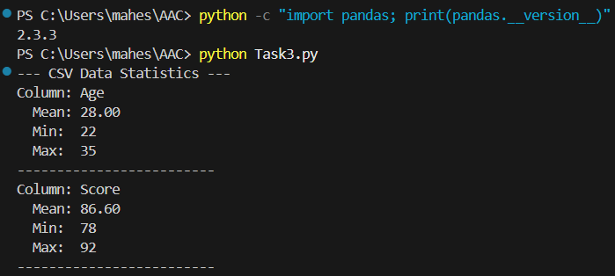  - Screenshot  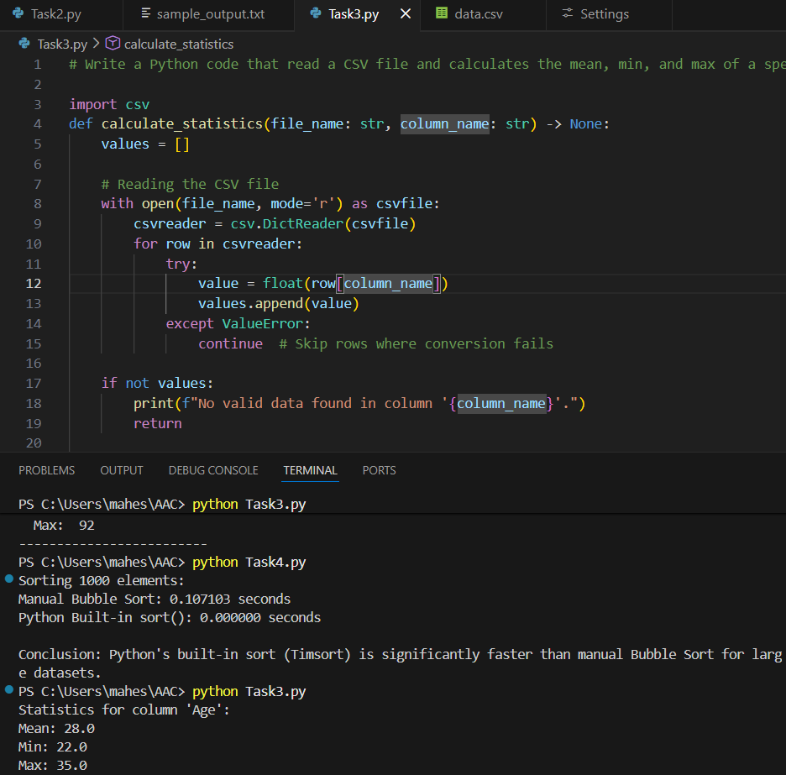  Task 4: Sorting Lists – Manual vs Built-in  - Scenario:  You are reviewing algorithm choices for efficiency.  - Task:  Use Gemini to generate:  - Bubble sort  - Python’s built-in sort()  - Compare both implementations.  - Expected Output:  - Prompt  Write a Python code that implements the Bubble Sort algorithm and compares its execution time with built in sort method using a list of 5000 random integers.  - Two versions of code  import time  import random  def bubble_sort(arr):  n = len(arr)  # Manual Bubble Sort Implementation  for i in range(n):  for j in range(0, n - i - 1):  if arr[j] > arr[j + 1]:  arr[j], arr[j + 1] = arr[j + 1], arr[j]  return arr  def compare_sorting_methods():  # Generate a random list of integers  size = 1000  original_data = [random.randint(0, 5000) for _ in range(size)]  # 1. Bubble Sort (Manual)  data_bubble = original_data.copy()  start_time = time.time()  bubble_sort(data_bubble)  bubble_duration = time.time() - start_time  # 2. Built-in sort() (Timsort)  data_builtin = original_data.copy()  start_time = time.time()  data_builtin.sort()  builtin_duration = time.time() - start_time  print(f"Sorting {size} elements:")  print(f"Manual Bubble Sort: {bubble_duration:.6f} seconds")  print(f"Python Built-in sort(): {builtin_duration:.6f} seconds")  print(f"\nConclusion: Python's built-in sort (Timsort) is significantly "  f"faster than manual Bubble Sort for large datasets.")  if __name__ == "__main__":  compare_sorting_methods()  - Short comparison  Sorting 1000 elements:  Manual Bubble Sort: 0.126919 seconds  Python Built-in sort(): 0.000098 seconds  Conclusion: Python's built-in sort (Timsort) is significantly faster than manual Bubble Sort for large datasets.  Note: Report should be submitted as a word document for all tasks in a single document with prompts, comments & code explanation, and output and if required, screenshots. |  |  |  |  |  | Week1 - Monday

