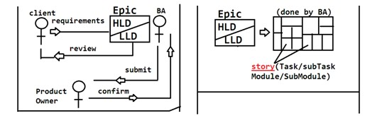

AGILE

It is a SDLC methodology to develop a product in company. It uses Spiral + RAD methods in development, divide and develop parallel. It this process has below Roles :

1. Business Analyst.(BA)
2. Developer (DEV)
3. Quality Analyst.(QA)
4. Architecture (Arch.)
5. **Epic:** End client/customer provides all his requirements to BA. BA prepares the document (known as EPIC). Which contains functional and technical requirements. It is like a reference book to product/project. We need to develop only points provided in document(not more or less) This document needs a final review by End Client and approval by Product Owner.
6. **Epic Conversion:** Epic will be divided into 2 parts initially. Those are
   * High level Design/Document
   * Low level Design/Document

HLDs are constructed for End User(for product understand and usage) and LLDs are done for Programmer View.

1



1. **Scrum Team:** To develop the product Owner creates a Team with DEV,BA,QA & Arch with MASTER and Leads.
2. **Story creations:** A story is a part of project, It can be a module/sub module/task/sub task. A story can be combination of modules/tasks also.

* Size and limits of Stories are defined by BAs.
* Each story Contains "Acceptance Criteria" ie what to implement for given story in point by point to Dev/QA/Arch given by BA.

1. Story points Calculations: Time taken to develop a story is known as "Efforts Estimations". These are guess values(Not exact) given by team members.

1 Story point = 8 Hours , 0.5 Story point = 4 Hours

ex: Story-8560 needs 4.5 story points total time (hours)is:36

1. **Sprint Planning:** "For a period of time what stories we need to implement" is decided in a meeting. Also known as Spring Planning. A sprint is known as milestone/small release/targets. In this meeting BA explains about story to all others. They should understand and provide efforts for those.
   * A sprint can be planned for 10 days,15 days, 1 month... (based on company & project)
   * At a time we cannot plan for all stories. for example, in our project we have 100 stories and we planned as below:
   * Sprint-1 (Story 1 to 12) for 15 days.
   * Sprint-2 (Story 13 to 32) for 25 days.
   * Unplanned stories comes under product backlogs (Story 33 to 100).
   * In Sprint-1 we planned for 12 Stories, but only 10 are finished after 15 days then, 2 will be moved to Product backlogs.

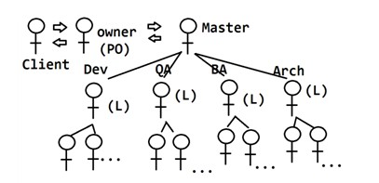

2

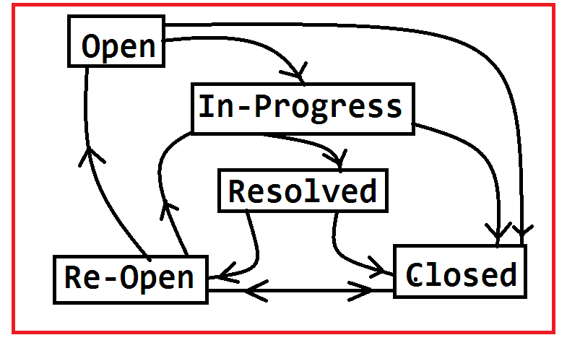

1. **Sprint Evaluation:** From Day-1 coding/implementation is started by developer. To implement any story dev has to code and Test from his side. To represent work status of a story, we follow Story life cycle. Shown as below, (possible values are: Open->In Progress-

>Resolved ->Closed or Re-Open)

* + **Open**: Every developer gets story in Open Status, which indicates ready to start (ready for coding)
  + **In-Progress**: Which indicates story is under implementation ( coding is started)
  + **Ready for testing**: Indicates Coding and Unit Testing is done. Code is available in Repository (ex: GIT).
  + **Closed**: Once Testing done by QA and working fine, then story status will be Closed.
  + **Re-Open**: If code contains Bugs, then story is not complete which will be converted to Re-Open and QA creates a BUG with below priority levels.

**BUG :** It indicates problem in application. Every bug has a level in AGILE process, those are given below with meaning and symbols.

# Blocker: Unable to do any process.

1. **Critical: High level problem (But not stopping complete process)**
2. **Major: Normal/Medium problem (Stopping in one way/ other possible processing ways are available)**
3. **Minor: Small problem or occurs very rare.**
4. **Trivial: Ignorable problem. not makes any problem in process.**

3

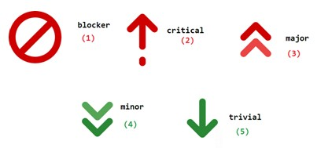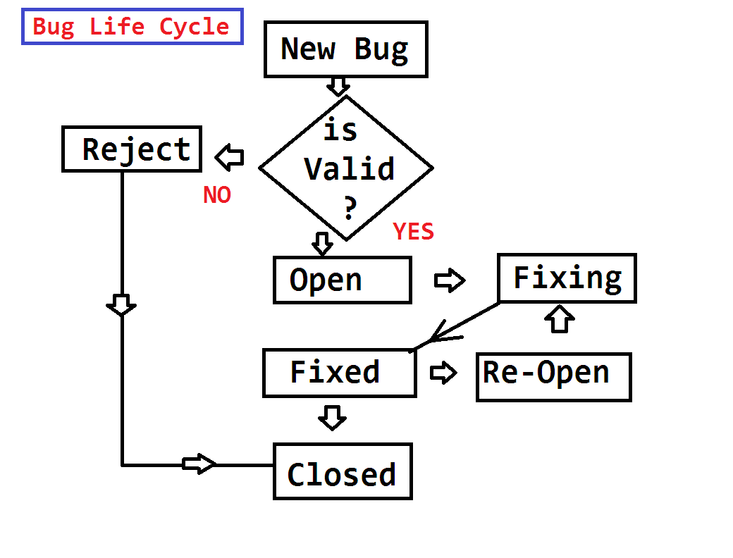

1. **Bug/Defect Life cycle:** While developing a story, it may contain problems (bug) or it is incomplete then QA identifies the bug and reports to Developer. ex: Bug-32( Critical): Email is not sending while vendor registration. Attached to Story-54(Vendor Registration). Developer checks bug and validates , if valid starts fixing else reject the bug.

4

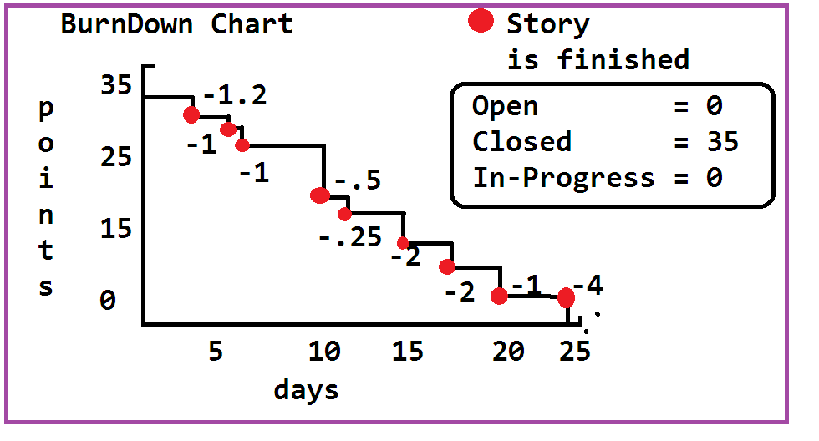

1. **Burn Down Chart:** This is a global chart, constructed to represent status of the sprint/Sprints. Up-to-date what % of work done is shown by this chart. If one story is finished, then it shows -value ex: -3.25 points. At end all stories should be finished. +ve value indicates Work is re-opened.
2. **Scrum Meetings:** On Starting Sprint, every day we need to provide status updates to Scrum Master. For this every day meeting is taken by master mostly 15-20 minutes. ex: 10:45 to 11:00 AM. sometimes 3:00 to 3:25 PM. In this meeting we need to tell "what we did yesterday, what we will do today and tomorrow".

5