Code Repository Tool (Version Management)

To develop app. we write different types of files in projects (like java, xml, jsp etc..). All these files are stored finally in a central server i.e.

Code Repository. It maintains the details of code. like

* How many times code is modified?
* Who modified what code(+/- added/removed)
* Changes done on what date and time? Maintaining these details is known as Version Management/Version Control.

1. In developement mostly used tool is GIT(gitHub).
2. It maintains two level repository process for cross verify and commit.
3. For this we need to create an account in github.com(using email id and verify email after creation).
4. It maintains staging area to select /verify/comment the file while adding to local repository.

# Git Process:

Git Repository Types:

1. Public : Free for every one
2. Private : Paid version.

# Remote Repository(Steps):

1. goto https://github.com/
2. SignUp(Register) with details
3. Goto Email -and verfiy Link
4. login with un and pwd
5. Create Repository Type Public (Companies uses- Private Type)
6. Copy Git Link: https://github.com/abcd/testVen.git it is secured with un,pwd.

# Eclipse Workspace and Local Repository Steps:

In eclipse,

1. Go to window menu
2. Show Views search for "GIT" select GitRepository and GitStaging.
3. Click on Window
4. showView
5. History.

# Creating local repository:

1. Right Click on Project
2. choose "Team" option
3. Share project
4. select checkbox "create or use repository"
5. select option shown below
6. click create repository button
7. finish

# GIT Operations with Flow:

* add file to git staging (Click-drag-drop).
* Commit and Push
* Paste Git Link in URI input box
* enter userName and password.
* next/next/finish.
* right click on project
* Choose team
* Select pull, then ,rebase to update local from remote.

# Some Interview Questions over GIT:

1. Can you provide GIT/Client/Apps URLs? No, Sorry.all details what you are asking is private and confidential. I cannot provide those.
2. Who created your git account ?

Git administrator name-"XYZ", in my company. He handles all permission and auth. details.

1. What type of Account Repository areyou using? It is private account handled by company.
2. When you check-in or push your code?

After Implementation of complete module and UnitTesting code in my local, I'll push to remote.

1. How will you find about one file all modification?? We use history option in eclipse

->right click->team->shown in history.

we can also choose any two files to compare with each other ex:select any history options->right click->compare with each other.

1. How do you identify code modifications in GIT? Using Symbols (+) code is added (-) code is removed. 7)What is the difference between commit and push?

commit: update code from workspace to Local Repository push :Update code from local to remote repository.

8)How can you update you workspace/local with remote? By using pull and rebase operations.

Screens Help For Complete Process: <https://github.com/>

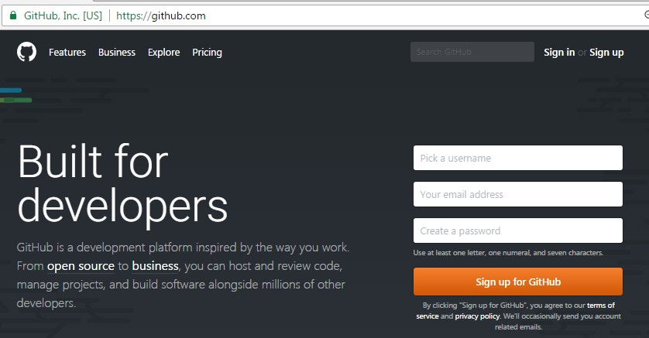

Goto email account and click on verify link. Click on signin

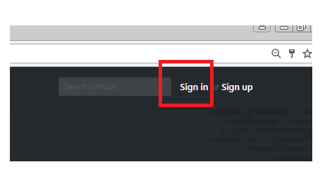

Enter user name and password.

Got Eclipse:

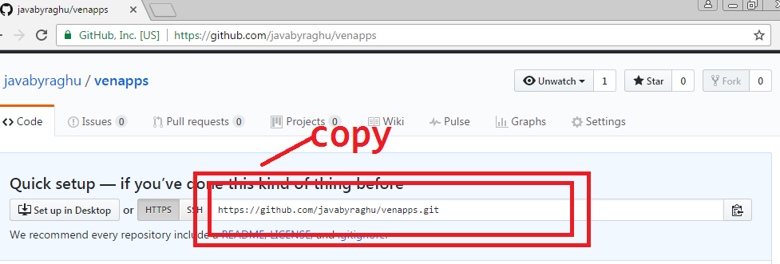

* Create A new Java Project **(project name and repository name Should be same )**
* Add Git Views

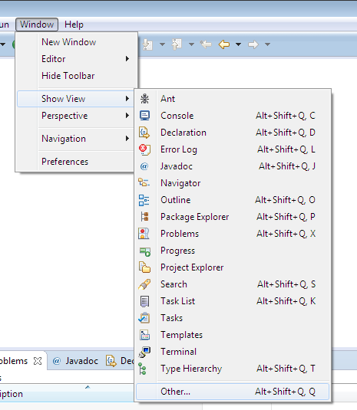

Serach with Git, select Git Repository, Staging

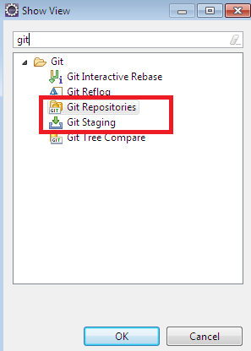

Observer options like

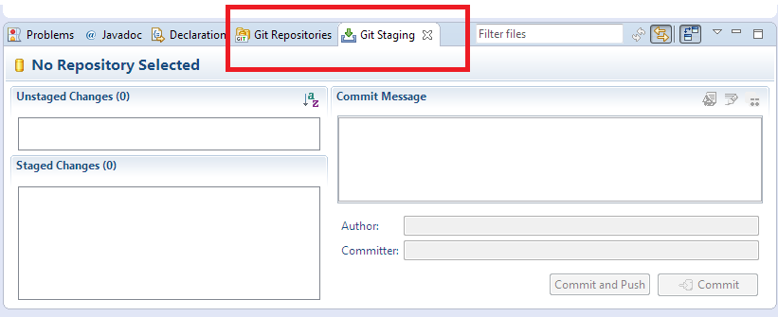

After writing of some code ex: Employee.java

>right click on project > tem > share project

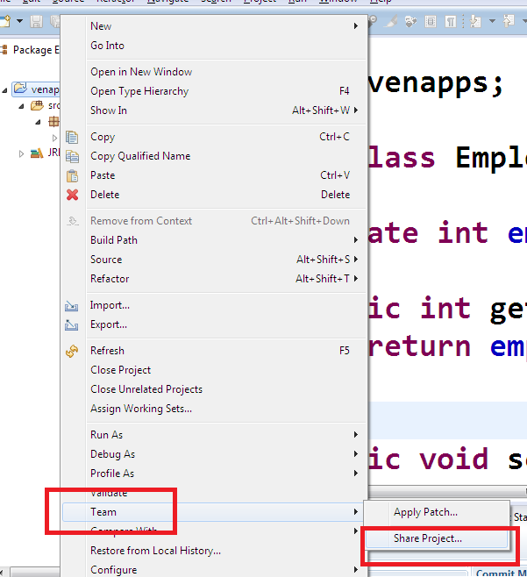

looks as below:

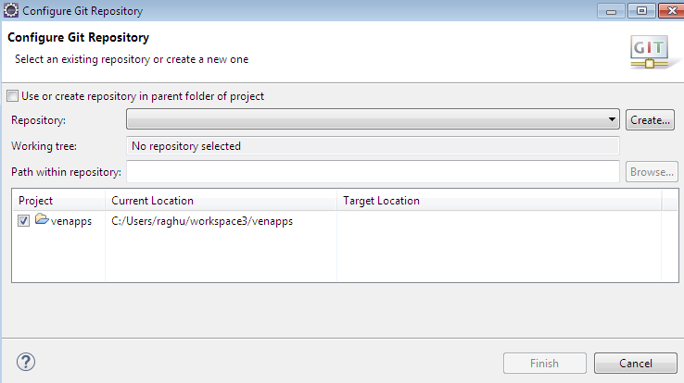

Click on check box:

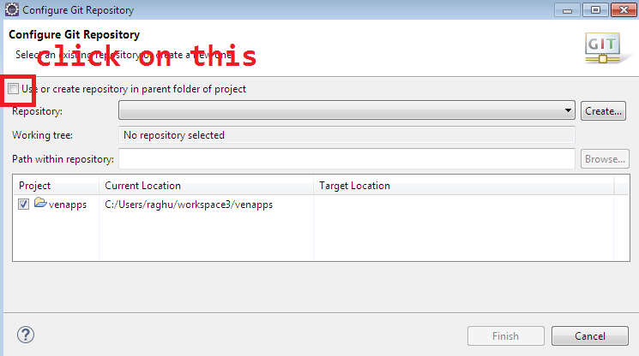

looks as below:

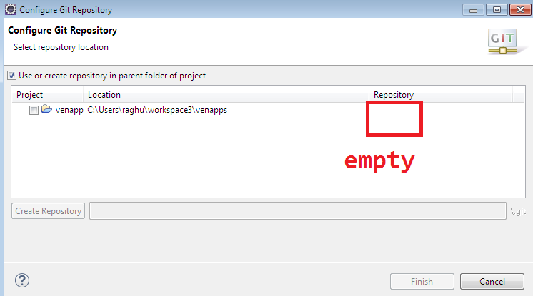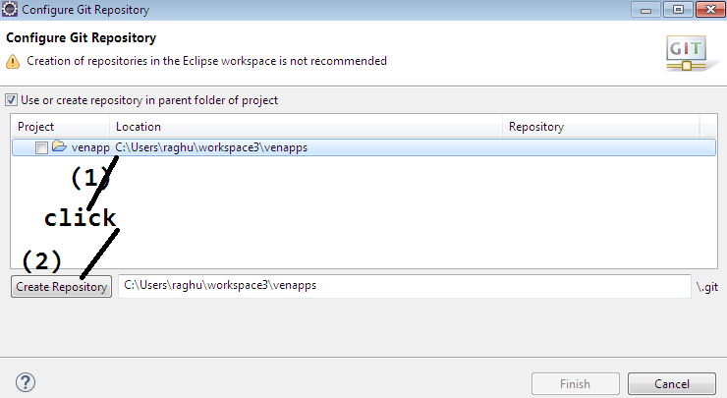

then observe repository name:

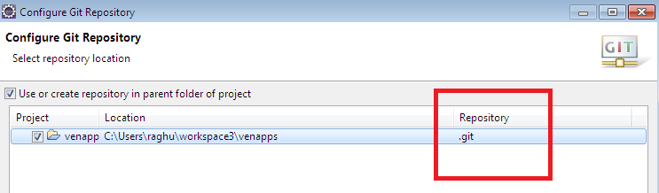

click on finish.

By this we created local and remote repositories.

Now link local and remote, using firsh commit and push. Come to git repositoes

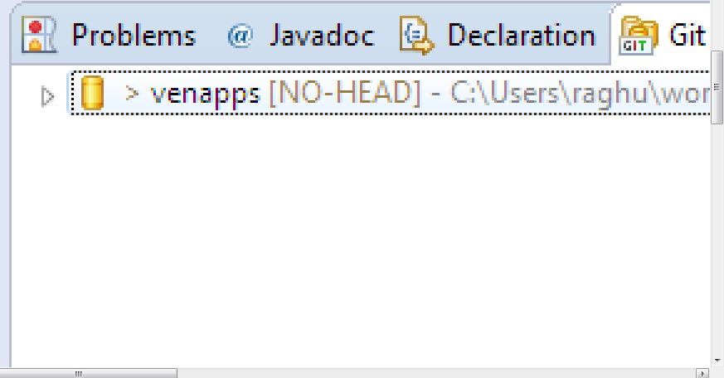

In staging are:

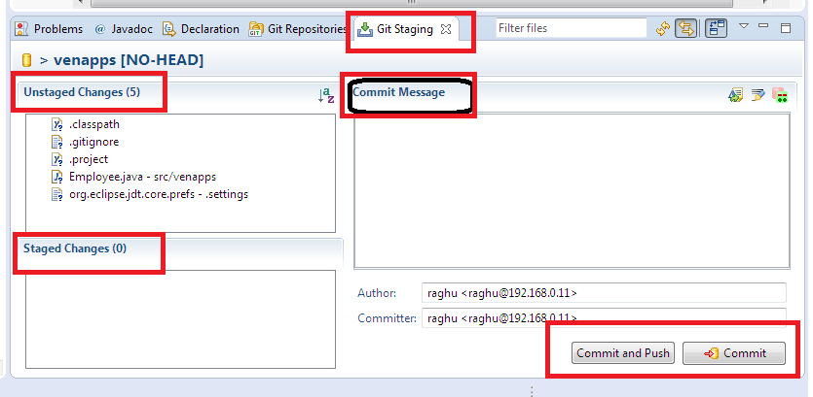

1)Unstaged changes : files which are not ready to send to local 2)staged chages: file which needs to move to local/remote 3)commit message: what is the purpose specify here as message for sending of this code.

1. click commit/ commit & push to send the code.

*)Click on a file in unstage drag and drop into stage. Click and Drag:

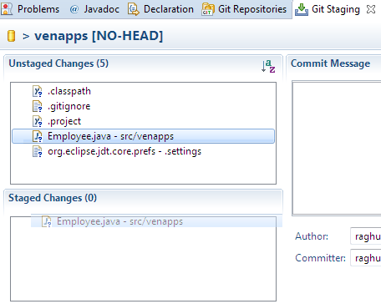

After drop

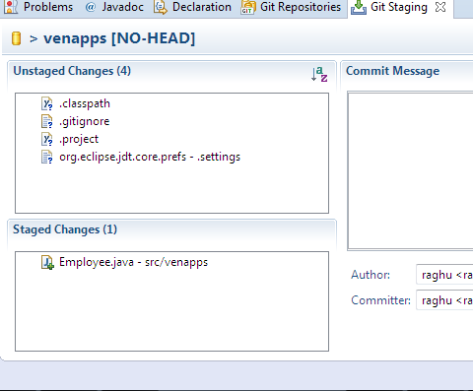

Enter commit message

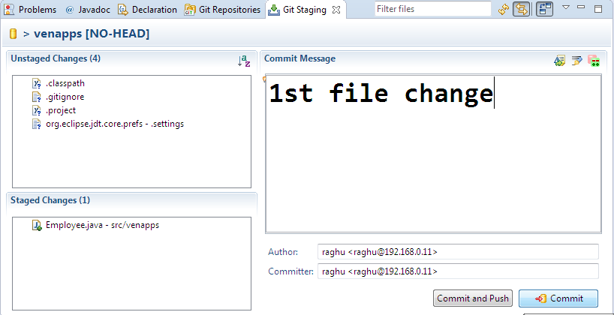

And click on commit.

In GitRepository , right click on projectName>choose Push Branch master

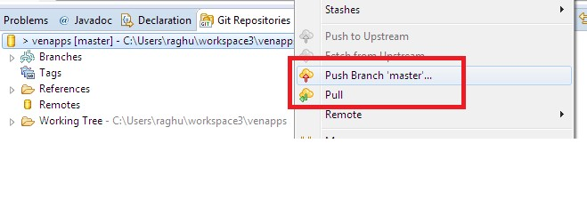

After Push option one screen looks below, there enter URI (Repository link)

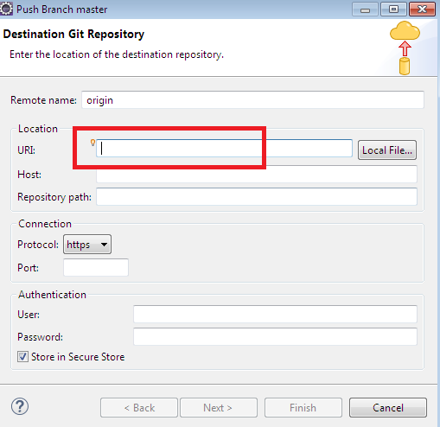

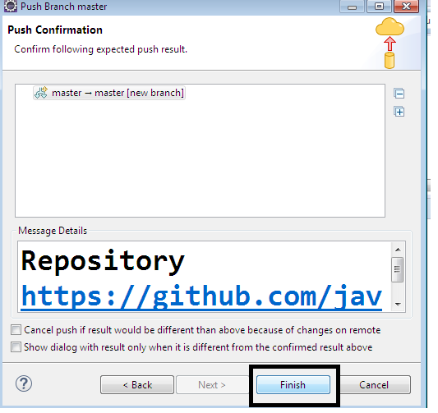

Shows as below:

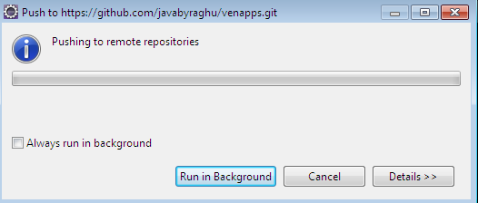

On success:

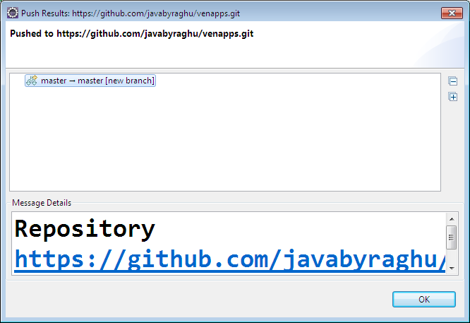

Come back to browser and refresh:

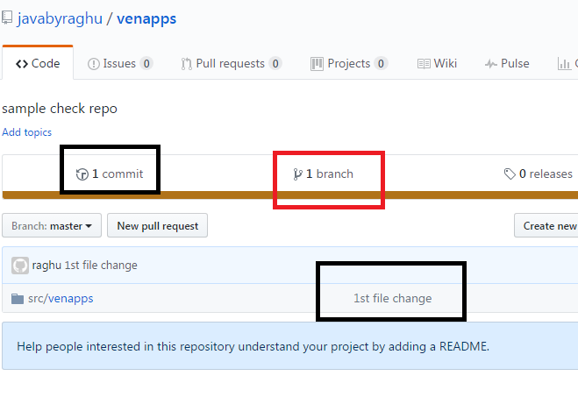

Click on src/venapp>Employee.java

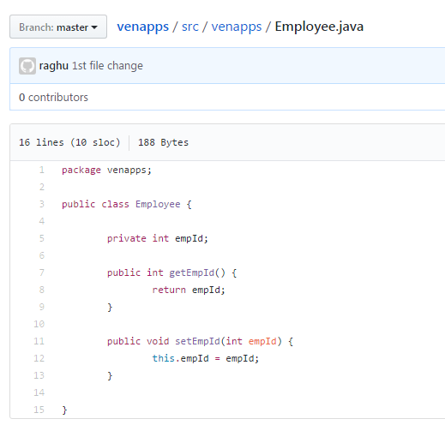

Right click on project: pull and then rebase for other update:

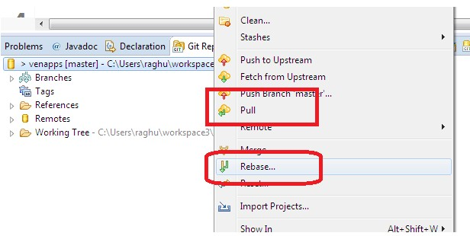

After Ading file to staging ,double click on that to comapre with Old one (previous one)looks as :

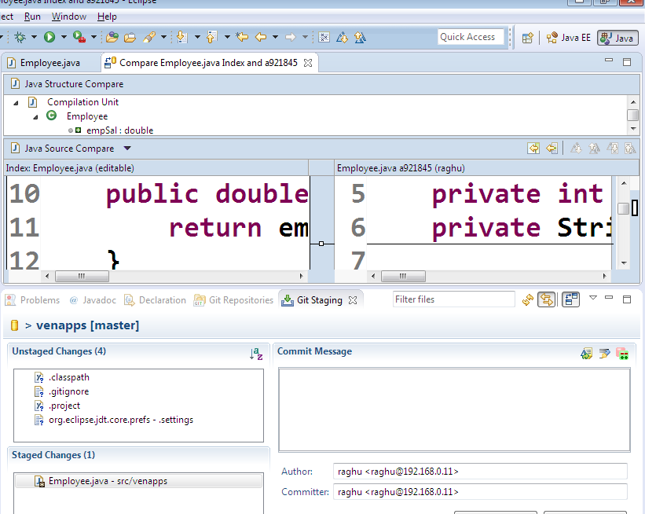

To see history:

Right click on File (ex: Employee.java)> Team>Showin History

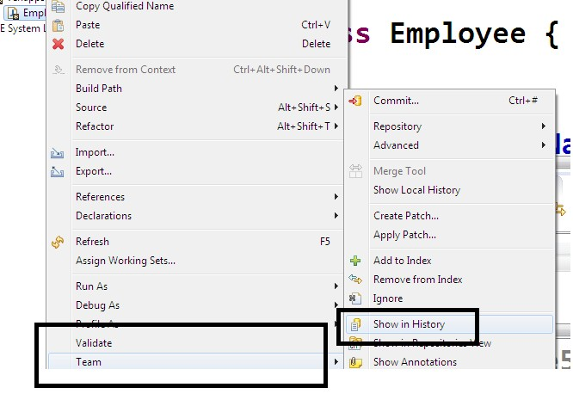

View history:

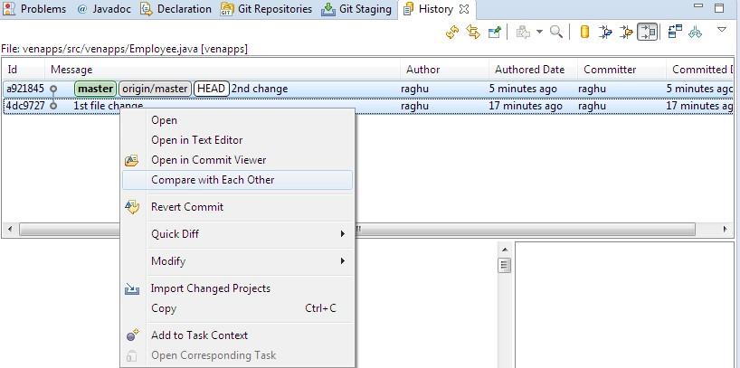

# ** GIT Merge Conflicts **

If any file code is modified(added/removed) then file version will be changed.

ex: Employee.java = Version#1

* 1. class Employee 2. {

3.

4. }

Employee.java = Version#2

1. class Employee 2. {

1. + int empId;
2. + String empName; - } 5.+ }

V#2 = V#1 [+3,-1].

Git manages version management automatically Here programmer do not need to remember any version number.

** On git pull & rebase, local repository and remote repository versions will become equal.

1. Repositories
2. right click on project
3. "pull" option
4. again right click
5. "rebase" option.

**Merge conflict example:**

Step#1: Dev#1 has done git pull & rebase Step#2: Dev#2 has done git pull & rebase Step#3: Dev#1 modified Employee.java

(that is changed to Version#2) and did add/commit/push.

Now git has Employee.java Version#2 Step#4: Dev#2 Still working with old code

of Employee.java (Version#1).

File modified and did add/commit/ push, then git shows

Git - Version Conflict: Dev#2 Employee.java(version#1) not matched with Git Repo Employee.java (Version#2). Please update before commit/push.

To Resolve merge conflict steps are.

* project -> right click -> reset
* project -> right click -> pull & rebase
* project -> right click -> merge

Now code will be updated to V#2,

write your code, then >>> add/commit/push.