BUILDING BUS RESERVATION SYSTEM

NAME: MAHESH.T

COLLEGE NAME: ANNAI MATHAMMAL SHEELA ENGINEERING COLLEGE

REG NO: 620221104015 COLLEGE CODE: 6202



ABSTRACT

This project introduces an update to the software program “Online Bus Ticket Reservation System ”as it should be used in the bus system, the area used reserved seats, booking cancellations and various types of route inquiries used for security quick booking.

OBTRS is designed to manage and compile a traditional database, ticket booking and bus tracking and departure made. Maintains all customer details, bus details, booking details. In order to achieve the design, Imo Transport Company (ITC) was selected as case study because of its importance in Imo State .

PROBLEM STATEMENT

Customer has to go to the counter to buy bus ticket or ask for bus schedule. Furthermore, customers need to pay cash when they buy the bus ticket and sometimes needs to queue up long time to get the bus ticket. Besides that, customer also not allowed to buy bus ticket through telephone and the bus company’s telephone always-busy line.

PROJECT OVERVIEW

A project overview statement should be clear and concise, providing just enough information to give key stakeholders a general idea of what the project is about and why it is important without getting into too much detail.

The purpose of an overview statement is to get everyone on the same page about the basics of the project before more detailed planning begins.

TECHNOLOGY VIEW

The technology vision statement is a compelling, succinct statement that has been created with input and approval from all members of your technology team.

FRONT END

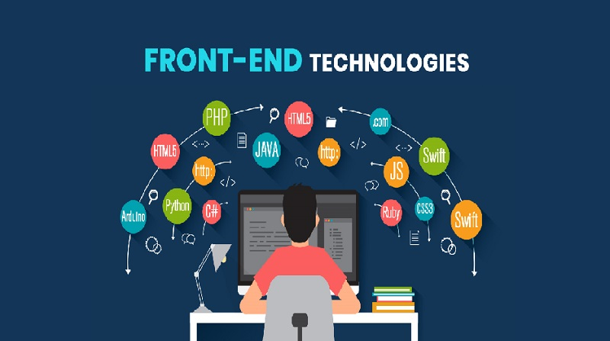

BACK END



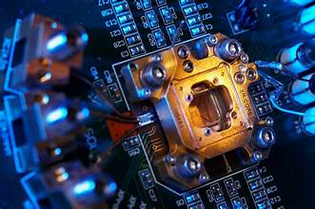

 Bus reservation system modeling & result

The system of collecting data for research project is known as research methodology. The data may be collected for either theoretical or practical research for example management research may be strategically conceptualized along with operational planning oral interview. method and change management. Information which was used for this study was carried out byoral interview.

RESULT

Research and development are continuous processes; this is the same in computer and software development. However, this work is recommended for Imo Transport Company Limited, Owerri, since their operation are still carried out manually and it can also be useful to other Bus Transportation industries whose processes are still manually done.

SCREEEN SHOT

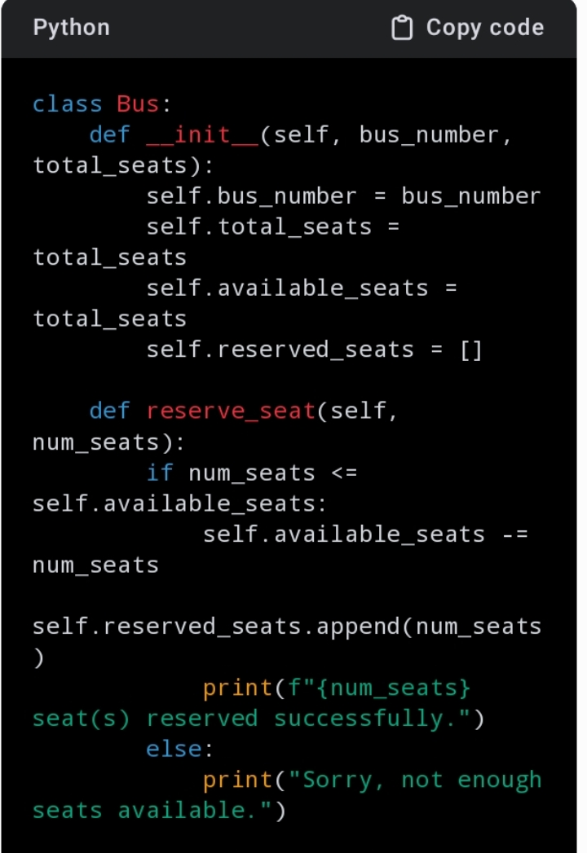

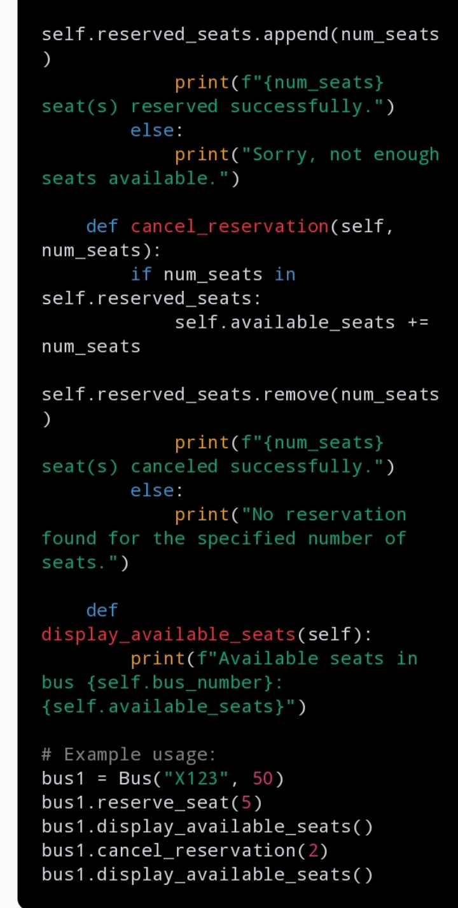

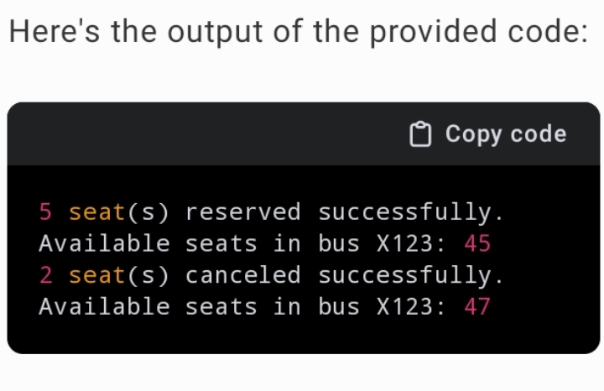

**FUTURE ENHANCEMENT**

**1. Advanced Inventory Control**

### 2. Comprehensive and Well-Documented APIs for Integration

### 3. On-Board Registration

### 4. Omnichannel Sales Management in Real-Time

### 5. Capability of Self-Service

### 6. Passenger Information in Real-Time

### 7. Advanced fare Administration

### 8. The Current State of Digital Marketing Tools

**9. Capability for Business Analysis**

**CONCLUSION**

Here all the information about customer that made reservation can be gotten just by clicking a button system, with this new some of the

difficulties encountered with the manual system are overcome. It will also reduce the workload of the staff, reduce the time used for making reservation at the bus terminal and also increase efficiency. The application also has the ability to update records in various files automatically thereby relieving the company’s staff the stress of working from file security of data.

**THANK YOU**