Definition of machine learning

Machine learning is a subset of artificial intelligence (AI) that allows computers to learn and improve from data without being explicitly programmed.

**Types of Machine Learning**

There are several types of machine learning, each with special characteristics and applications. Some of the main types of machine learning algorithms are as follows:

1. Supervised Machine Learning
2. Unsupervised Machine Learning
3. Semi-Supervised Machine Learning
4. Reinforcement Learning



*Types of Machine Learning*

**1. Supervised Machine Learning**

[Supervised learning](https://www.geeksforgeeks.org/supervised-machine-learning/) is defined as when a model gets trained on a **“Labelled Dataset”**. Labelled datasets have both input and output parameters. In **Supervised Learning** algorithms learn to map points between inputs and correct outputs. It has both training and validation datasets labelled.

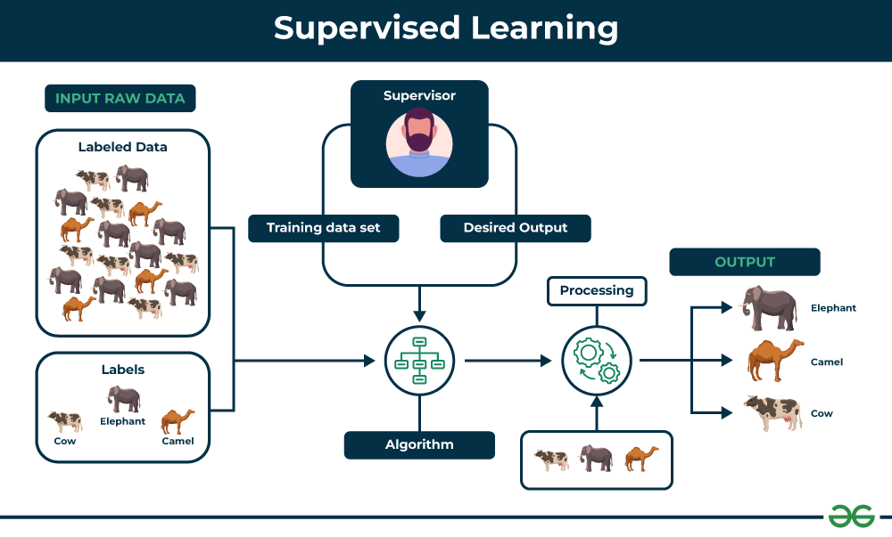

*Supervised Learning*

Let’s understand it with the help of an example.

**Example:**Consider a scenario where you have to build an image classifier to differentiate between cats and dogs. If you feed the datasets of dogs and cats labelled images to the algorithm, the machine will learn to classify between a dog or a cat from these labeled images. When we input new dog or cat images that it has never seen before, it will use the learned algorithms and predict whether it is a dog or a cat. This is how **supervised learning** works, and this is particularly an image classification.

There are two main categories of supervised learning that are mentioned below:

* [Classification](https://www.geeksforgeeks.org/getting-started-with-classification/)
* [Regression](https://www.geeksforgeeks.org/types-of-regression-techniques/)

**Classification**

[**Classification**](https://www.geeksforgeeks.org/getting-started-with-classification/)deals with predicting **categorical** target variables, which represent discrete classes or labels. For instance, classifying emails as spam or not spam, or predicting whether a patient has a high risk of heart disease. Classification algorithms learn to map the input features to one of the predefined classes.

Here are some classification algorithms:

* [**Logistic Regression**](https://www.geeksforgeeks.org/understanding-logistic-regression/)
* [**Support Vector Machine**](https://www.geeksforgeeks.org/support-vector-machine-algorithm/)
* [**Random Forest**](https://www.geeksforgeeks.org/random-forest-regression-in-python/)
* [**Decision Tree**](https://www.geeksforgeeks.org/decision-tree/)
* [**K-Nearest Neighbors (KNN)**](https://www.geeksforgeeks.org/k-nearest-neighbours/)
* [**Naive Bayes**](https://www.geeksforgeeks.org/naive-bayes-classifiers/)

**Regression**

[**Regression**](https://www.geeksforgeeks.org/regression-classification-supervised-machine-learning/), on the other hand, deals with predicting **continuous** target variables, which represent numerical values. For example, predicting the price of a house based on its size, location, and amenities, or forecasting the sales of a product. Regression algorithms learn to map the input features to a continuous numerical value.

Here are some regression algorithms:

* [**Linear Regression**](https://www.geeksforgeeks.org/ml-linear-regression/)
* [**Polynomial Regression**](https://www.geeksforgeeks.org/videos/polynomial-regression-algorithm-machine-learning/)
* [**Ridge Regression**](https://www.geeksforgeeks.org/videos/lasso-ridge-regression-algorithm-machine-learning/)
* [**Lasso Regression**](https://www.geeksforgeeks.org/videos/lasso-ridge-regression-algorithm-machine-learning/)
* [**Decision tree**](https://www.geeksforgeeks.org/decision-tree-introduction-example/)
* [**Random Forest**](https://www.geeksforgeeks.org/random-forest-regression-in-python/)

**Advantages of Supervised Machine Learning**

* **Supervised Learning** models can have high accuracy as they are trained on **labelled data**.
* The process of decision-making in supervised learning models is often interpretable.
* It can often be used in pre-trained models which saves time and resources when developing new models from scratch.

**Disadvantages of Supervised Machine Learning**

* It has limitations in knowing patterns and may struggle with unseen or unexpected patterns that are not present in the training data.
* It can be time-consuming and costly as it relies on**labeled**data only.
* It may lead to poor generalizations based on new data.

**Applications of Supervised Learning**

Supervised learning is used in a wide variety of applications, including:

* **Image classification**: Identify objects, faces, and other features in images.
* **Natural language processing:** Extract information from text, such as sentiment, entities, and relationships.
* **Speech recognition**: Convert spoken language into text.
* **Recommendation systems**: Make personalized recommendations to users.
* **Predictive analytics**: Predict outcomes, such as sales, customer churn, and stock prices.
* **Medical diagnosis**: Detect diseases and other medical conditions.
* **Fraud detection**: Identify fraudulent transactions.
* **Autonomous vehicles**: Recognize and respond to objects in the environment.
* **Email spam detection**: Classify emails as spam or not spam.
* **Quality control in manufacturing**: Inspect products for defects.
* **Credit scoring**: Assess the risk of a borrower defaulting on a loan.
* **Gaming**: Recognize characters, analyze player behavior, and create NPCs.
* **Customer support**: Automate customer support tasks.
* **Weather forecasting**: Make predictions for temperature, precipitation, and other meteorological parameters.
* **Sports analytics**: Analyze player performance, make game predictions, and optimize strategies.

**2. Unsupervised Machine Learning**

[Unsupervised Learning](https://www.geeksforgeeks.org/unsupervised-machine-learning-the-future-of-cybersecurity/) Unsupervised learning is a type of machine learning technique in which an algorithm discovers patterns and relationships using unlabeled data. Unlike supervised learning, unsupervised learning doesn’t involve providing the algorithm with labeled target outputs. The primary goal of Unsupervised learning is often to discover hidden patterns, similarities, or clusters within the data, which can then be used for various purposes, such as data exploration, visualization, dimensionality reduction, and more.

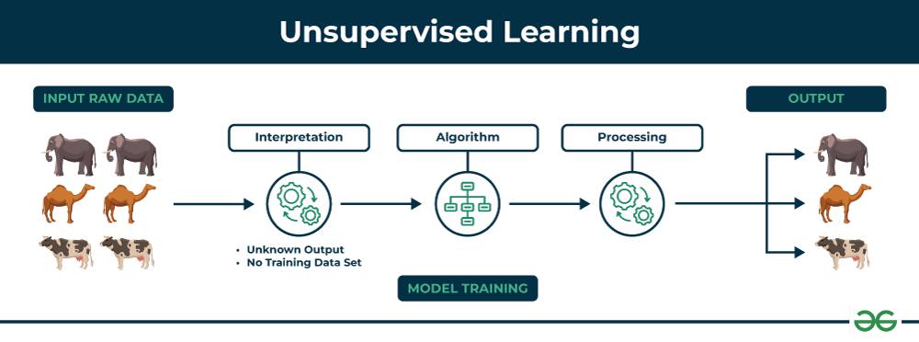

*Unsupervised Learning*

Let’s understand it with the help of an example.

**Example:**Consider that you have a dataset that contains information about the purchases you made from the shop. Through clustering, the algorithm can group the same purchasing behavior among you and other customers, which reveals potential customers without predefined labels. This type of information can help businesses get target customers as well as identify outliers.

There are two main categories of unsupervised learning that are mentioned below:

* [Clustering](https://www.geeksforgeeks.org/clustering-in-machine-learning/)
* [Association](https://www.geeksforgeeks.org/association-rule/)

**Clustering**

[Clustering](https://www.geeksforgeeks.org/clustering-in-machine-learning/) is the process of grouping data points into clusters based on their similarity. This technique is useful for identifying patterns and relationships in data without the need for labeled examples.

Here are some clustering algorithms:

* [**K-Means Clustering algorithm**](https://www.geeksforgeeks.org/k-means-clustering-introduction/)
* [**Mean-shift algorithm**](https://www.geeksforgeeks.org/ml-mean-shift-clustering/)
* [**DBSCAN Algorithm**](https://www.geeksforgeeks.org/dbscan-clustering-in-ml-density-based-clustering/)
* [**Principal Component Analysis**](https://www.geeksforgeeks.org/principal-component-analysis-pca/)
* [**Independent Component Analysis**](https://www.geeksforgeeks.org/ml-independent-component-analysis/)

**Association**

[Association rule learn](https://www.geeksforgeeks.org/association-rule/)ing is a technique for discovering relationships between items in a dataset. It identifies rules that indicate the presence of one item implies the presence of another item with a specific probability.

Here are some association rule learning algorithms:

* [**Apriori Algorithm**](https://www.geeksforgeeks.org/apriori-algorithm/)
* [**Eclat**](https://www.geeksforgeeks.org/ml-eclat-algorithm/)
* [**FP-growth Algorithm**](https://www.geeksforgeeks.org/frequent-pattern-growth-algorithm/)

**Advantages of Unsupervised Machine Learning**

* It helps to discover hidden patterns and various relationships between the data.
* Used for tasks such as**customer segmentation, anomaly detection,**and **data exploration**.
* It does not require labeled data and reduces the effort of data labeling.

**Disadvantages of Unsupervised Machine Learning**

* Without using labels, it may be difficult to predict the quality of the model’s output.
* Cluster Interpretability may not be clear and may not have meaningful interpretations.
* It has techniques such as[autoencoders](https://www.geeksforgeeks.org/auto-encoders/) and [dimensionality reduction](https://www.geeksforgeeks.org/dimensionality-reduction/) that can be used to extract meaningful features from raw data.

**Applications of Unsupervised Learning**

Here are some common applications of unsupervised learning:

* **Clustering**: Group similar data points into clusters.
* **Anomaly detection**: Identify outliers or anomalies in data.
* **Dimensionality reduction**: Reduce the dimensionality of data while preserving its essential information.
* **Recommendation systems**: Suggest products, movies, or content to users based on their historical behavior or preferences.
* **Topic modeling**: Discover latent topics within a collection of documents.
* **Density estimation**: Estimate the probability density function of data.
* **Image and video compression**: Reduce the amount of storage required for multimedia content.
* **Data preprocessing**: Help with data preprocessing tasks such as data cleaning, imputation of missing values, and data scaling.
* **Market basket analysis**: Discover associations between products.
* **Genomic data analysis**: Identify patterns or group genes with similar expression profiles.
* **Image segmentation**: Segment images into meaningful regions.
* **Community detection in social networks**: Identify communities or groups of individuals with similar interests or connections.
* **Customer behavior analysis**: Uncover patterns and insights for better marketing and product recommendations.
* **Content recommendation**: Classify and tag content to make it easier to recommend similar items to users.
* **Exploratory data analysis (EDA)**: Explore data and gain insights before defining specific tasks.

**3. Semi-Supervised Learning**

[Semi-Supervised learning](https://www.geeksforgeeks.org/ml-semi-supervised-learning/)is a machine learning algorithm that works between the [supervised and unsupervised](https://www.geeksforgeeks.org/supervised-unsupervised-learning/) learning so it uses both **labelled and unlabelled** data. It’s particularly useful when obtaining labeled data is costly, time-consuming, or resource-intensive. This approach is useful when the dataset is expensive and time-consuming. Semi-supervised learning is chosen when labeled data requires skills and relevant resources in order to train or learn from it.

We use these techniques when we are dealing with data that is a little bit labeled and the rest large portion of it is unlabeled. We can use the unsupervised techniques to predict labels and then feed these labels to supervised techniques. This technique is mostly applicable in the case of image data sets where usually all images are not labeled.

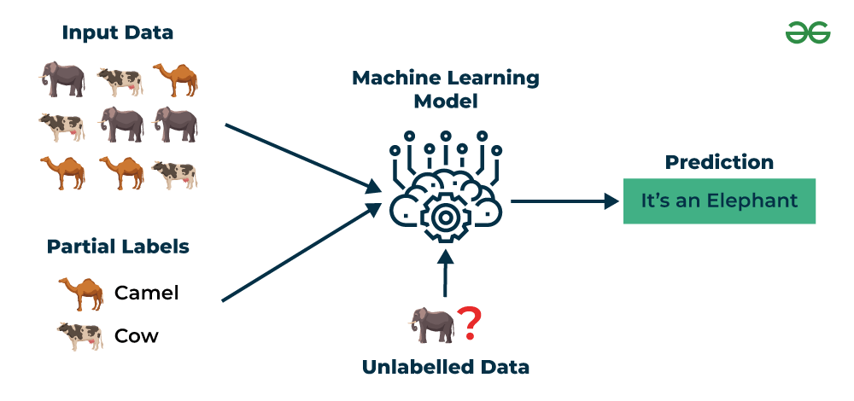

*Semi-Supervised Learning*

Let’s understand it with the help of an example.

**Example**: Consider that we are building a language translation model, having labeled translations for every sentence pair can be resources intensive. It allows the models to learn from labeled and unlabeled sentence pairs, making them more accurate. This technique has led to significant improvements in the quality of machine translation services.

**Types of Semi-Supervised Learning Methods**

There are a number of different semi-supervised learning methods each with its own characteristics. Some of the most common ones include:

* **Graph-based semi-supervised learning:** This approach uses a graph to represent the relationships between the data points. The graph is then used to propagate labels from the labeled data points to the unlabeled data points.
* **Label propagation:** This approach iteratively propagates labels from the labeled data points to the unlabeled data points, based on the similarities between the data points.
* **Co-training:** This approach trains two different machine learning models on different subsets of the unlabeled data. The two models are then used to label each other’s predictions.
* **Self-training:** This approach trains a machine learning model on the labeled data and then uses the model to predict labels for the unlabeled data. The model is then retrained on the labeled data and the predicted labels for the unlabeled data.
* [**Generative adversarial networks (GANs)**](https://www.geeksforgeeks.org/generative-adversarial-network-gan/)**:** GANs are a type of deep learning algorithm that can be used to generate synthetic data. GANs can be used to generate unlabeled data for semi-supervised learning by training two neural networks, a generator and a discriminator.

**Advantages of Semi- Supervised Machine Learning**

* It leads to better generalization as compared to **supervised learning,** as it takes both labeled and unlabeled data.
* Can be applied to a wide range of data.

**Disadvantages of Semi- Supervised Machine Learning**

* **Semi-supervised**methods can be more complex to implement compared to other approaches.
* It still requires some **labeled data** that might not always be available or easy to obtain.
* The unlabeled data can impact the model performance accordingly.

**Applications of Semi-Supervised Learning**

Here are some common applications of semi-supervised learning:

* **Image Classification and Object Recognition**: Improve the accuracy of models by combining a small set of labeled images with a larger set of unlabeled images.
* **Natural Language Processing (NLP)**: Enhance the performance of language models and classifiers by combining a small set of labeled text data with a vast amount of unlabeled text.
* **Speech Recognition:** Improve the accuracy of speech recognition by leveraging a limited amount of transcribed speech data and a more extensive set of unlabeled audio.
* **Recommendation Systems**: Improve the accuracy of personalized recommendations by supplementing a sparse set of user-item interactions (labeled data) with a wealth of unlabeled user behavior data.
* **Healthcare and Medical Imaging**: Enhance medical image analysis by utilizing a small set of labeled medical images alongside a larger set of unlabeled images.

**4. Reinforcement Machine Learning**

[Reinforcement machine learning](https://www.geeksforgeeks.org/what-is-reinforcement-learning/)algorithm is a learning method that interacts with the environment by producing actions and discovering errors. **Trial, error, and delay** are the most relevant characteristics of reinforcement learning. In this technique, the model keeps on increasing its performance using Reward Feedback to learn the behavior or pattern. These algorithms are specific to a particular problem e.g. Google Self Driving car, AlphaGo where a bot competes with humans and even itself to get better and better performers in Go Game. Each time we feed in data, they learn and add the data to their knowledge which is training data. So, the more it learns the better it gets trained and hence experienced.

Here are some of most common reinforcement learning algorithms:

* [**Q-learning:**](https://www.geeksforgeeks.org/q-learning-in-python/) Q-learning is a model-free RL algorithm that learns a Q-function, which maps states to actions. The Q-function estimates the expected reward of taking a particular action in a given state.
* [**SARSA (State-Action-Reward-State-Action):**](https://www.geeksforgeeks.org/sarsa-reinforcement-learning/) SARSA is another model-free RL algorithm that learns a Q-function. However, unlike Q-learning, SARSA updates the Q-function for the action that was actually taken, rather than the optimal action.
* [**Deep Q-learning**](https://www.geeksforgeeks.org/deep-q-learning/)**:** Deep Q-learning is a combination of Q-learning and deep learning. Deep Q-learning uses a neural network to represent the Q-function, which allows it to learn complex relationships between states and actions.

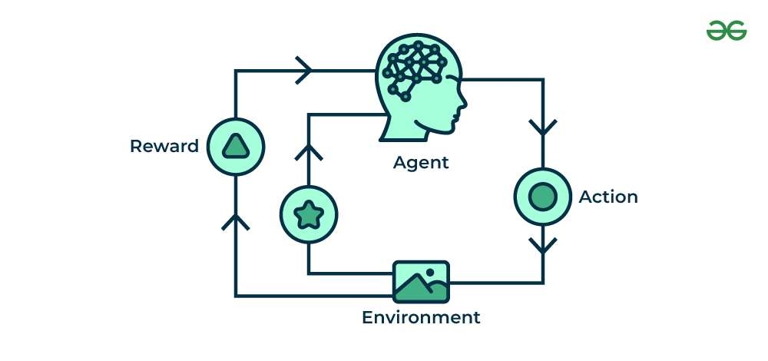

*Reinforcement Machine Learning*

Let’s understand it with the help of examples.

**Example:**Consider that you are training an [AI](https://www.geeksforgeeks.org/artificial-intelligence-an-introduction/) agent to play a game like chess. The agent explores different moves and receives positive or negative feedback based on the outcome. Reinforcement Learning also finds applications in which they learn to perform tasks by interacting with their surroundings.

**Types of Reinforcement Machine Learning**

There are two main types of reinforcement learning:

**Positive reinforcement**

* Rewards the agent for taking a desired action.
* Encourages the agent to repeat the behavior.
* Examples: Giving a treat to a dog for sitting, providing a point in a game for a correct answer.

**Negative reinforcement**

* Removes an undesirable stimulus to encourage a desired behavior.
* Discourages the agent from repeating the behavior.
* Examples: Turning off a loud buzzer when a lever is pressed, avoiding a penalty by completing a task.

**Advantages of Reinforcement Machine Learning**

* It has autonomous decision-making that is well-suited for tasks and that can learn to make a sequence of decisions, like robotics and game-playing.
* This technique is preferred to achieve long-term results that are very difficult to achieve.
* It is used to solve a complex problems that cannot be solved by conventional techniques.

**Disadvantages of Reinforcement Machine Learning**

* Training Reinforcement Learning agents can be computationally expensive and time-consuming.
* Reinforcement learning is not preferable to solving simple problems.
* It needs a lot of data and a lot of computation, which makes it impractical and costly.

**Applications of Reinforcement Machine Learning**

Here are some applications of reinforcement learning:

* **Game Playing**: RL can teach agents to play games, even complex ones.
* **Robotics**: RL can teach robots to perform tasks autonomously.
* **Autonomous Vehicles**: RL can help self-driving cars navigate and make decisions.
* **Recommendation Systems**: RL can enhance recommendation algorithms by learning user preferences.
* **Healthcare**: RL can be used to optimize treatment plans and drug discovery.
* **Natural Language Processing (NLP)**: RL can be used in dialogue systems and chatbots.
* **Finance and Trading**: RL can be used for algorithmic trading.
* **Supply Chain and Inventory Management**: RL can be used to optimize supply chain operations.
* **Energy Management**: RL can be used to optimize energy consumption.
* **Game AI**: RL can be used to create more intelligent and adaptive NPCs in video games.
* **Adaptive Personal Assistants**: RL can be used to improve personal assistants.
* **Virtual Reality (VR) and Augmented Reality (AR):** RL can be used to create immersive and interactive experiences.
* **Industrial Control**: RL can be used to optimize industrial processes.
* **Education**: RL can be used to create adaptive learning systems.
* **Agriculture**: RL can be used to optimize agricultural operations.
* **What is correlation?**
* Correlation is a key statistical concept that researchers employ to analyze connections within their data. It helps us to Understand the Relationship Between Variables
* In research, we often study how different factors relate to each other. The connection between two or more variables is known as their correlation. Correlation refers to the degree to which the variables change together or co-vary.
* It is not enough to simply examine how one variable increases or decreases independently. Correlation looks at the simultaneous fluctuations in both or all variables measured. A high correlation indicates the variables tend to move in tandem. A low correlation means the variables are not closely associated in their fluctuations.
* Knowing the correlation helps uncover important relationships between elements we are investigating. It provides insight into how changes in one variable may correlate with or predict changes in another. As researchers we rely on correlation to better understand the links between different phenomena.
* The correlation coefficient quantifies the strength and direction of the correlation. Values closer to **1** or **-1** represent stronger correlations, while those closer to 0 indicate little connection between the variables.

**Why correlation is important for machine learning?**

It is important for machine learning engineers to understand the correlation between variables in their models for several key reasons:

**1. Feature selection**

which is the process of choosing which variables or features to use in the model. **Highly correlated features provide redundant information**, so feature selection aims to remove uninformative features to simplify models.

By analyzing correlations, researchers can identify redundant features and select a minimal set of important features that best represent the target variable. **This prevents overfitting** and improves a model’s ability to generalize. Feature selection using correlation analysis helps machine learning engineers build more accurate and efficient models by focusing only on the most informative variables correlated to the predicted output.

**2. Reduce Bias**

Correlation analysis is also important for ensuring model fairness and avoiding bias. When certain features are highly correlated with sensitive attributes like **gender**or **ethnicity**, it can inadvertently encode biases into machine learning models if not properly addressed.

**3. Multicollinearity**

Another important aspect of analyzing feature correlations is detecting multicollinearity. Multicollinearity occurs when two or more predictor variables in a model are highly linearly correlated with each other. It can negatively impact models by increasing variance and making it difficult to determine the significance and effect of individual predictors.

**4. Interpretability and Debugging**

Understanding correlations also aids in interpreting machine learning models. As models become increasingly complex with many interacting variables, it can be difficult to explain why a model makes certain predictions.

**Measures of Correlation**

**1. Pearson’s correlation coefficient**

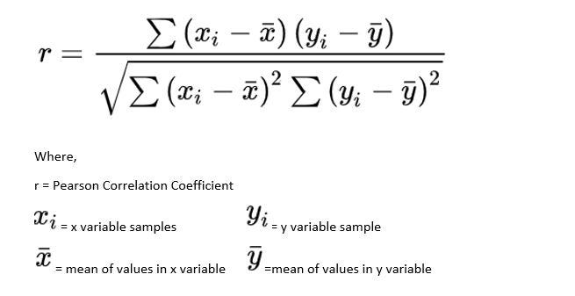

To calculate Pearson’s r, a line of best fit is determined for the two variables using linear regression. This regression line represents the linear relationship that best predicts the values of one variable based on the other. The correlation coefficient is then computed based on how far each data point deviates from this regression line. Data points that lie exactly on the line have a deviation of zero, while points farther away have higher deviations. Pearson’s r factors in both the direction and magnitude of all these deviations to produce a measure between -1 and 1, indicating the overall linear association between the variables. A value closer to the extremes represents less deviation and stronger linear correlation, while a value near zero suggests the data are poorly described by a linear relationship.

So simply, the Pearson correlation coefficient, r, indicates how far away all these data points are to this line of best fit.

**2. Spearman’s correlation coefficient**

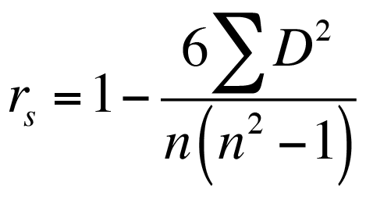

Spearman’s, rs , assesses how well an arbitrary monotonic function describes the relationship between two variables, rather than specifically testing for a linear association. A monotonic relationship is one where as one variable increases or decreases, the other variable consistently increases or decreases. This allows Spearman’s correlation to identify nonlinear relationships that may not be evident when using Pearson’s r. It does so by first ranking all data points in each variable from smallest to largest value, then calculating r using these ranks rather than the original measurements. As such, Spearman’s rs is more flexible and can identify more complex monotonic correlations beyond linear trends alone

**comparing Pearson and Spearman correlations**

The main difference between Pearson’s r and Spearman’s rs is that r only considers linear relationships, while rs detects monotonic associations between variables regardless of whether they follow a straight line pattern. Pearson’s is more appropriate when the variables are expected to have a linear relationship. Spearman’s is preferable when the relationship may be nonlinear but still consistently increasing or decreasing. Another key distinction is that Pearson’s requires continuous variables, whereas Spearman’s can handle ordinal data as well. So Spearman’s correlation offers a more general approach at the cost of being less sensitive for linear trends compared to Pearson’s r.

**The Limitations of Correlation**

While correlation analysis is useful for identifying relationships between variables, it is important to note that correlation does not necessarily imply causation. Simply because two factors vary together based on the available data does not mean that one factor causes changes in the other. There could be some third, underlying variable influencing both.

**Case Study: House Price Prediction Using Machine Learning**

**Problem Statement:**

Predicting house prices accurately is crucial for both buyers and sellers in the real estate market. Traditional methods often rely on manual appraisals, which can be time-consuming and subjective. Machine learning offers a data-driven approach to automate and improve the accuracy of house price predictions.

**Dataset:**

The dataset used for this case study is the Ames Housing Dataset, a widely used benchmark dataset in the machine learning community. It contains detailed information about 1,460 residential homes sold in Ames, Iowa, between 2006 and 2010. The dataset includes a variety of features, such as:

* **Location:** Neighborhood, lot size, street type
* **Property:** Number of bedrooms and bathrooms, living area, basement size, garage size
* **Quality:** Overall quality and condition ratings, year built, remodeling date

**Methodology:**

1. **Data Preprocessing:**
   * Handle missing values: Impute missing values using appropriate techniques like mean imputation, median imputation, or more sophisticated methods like KNN imputation.
   * Feature engineering: Create new features that might be relevant for price prediction, such as:
     + Age of the house
     + Total living area
     + Number offireplaces
   * Encode categorical variables: Convert categorical variables into numerical representations using one-hot encoding or label encoding.
   * Scale numerical features: Standardize or normalize features to ensure they are on a similar scale.
2. **Model Selection:**
   * Choose appropriate machine learning algorithms for regression:
     + Linear Regression: A simple and interpretable model.
     + Decision Tree Regression: Captures non-linear relationships in the data.
     + Random Forest Regression: An ensemble of decision trees, often providing better accuracy.
     + Support Vector Regression (SVR): Finds the best hyperplane to separate the data.
     + Artificial Neural Networks: Powerful models capable of learning complex patterns.
3. **Model Training and Evaluation:**
   * Split the dataset into training and testing sets.
   * Train each model on the training data.
   * Evaluate the performance of each model on the testing data using metrics such as:
     + Mean Squared Error (MSE)
     + Root Mean Squared Error (RMSE)
     + R-squared
     + Mean Absolute Error (MAE)
4. **Model Tuning and Selection:**
   * Fine-tune the hyperparameters of each model using techniques like grid search or random search.
   * Select the best-performing model based on the evaluation metrics.

**Results:**

The results will vary depending on the specific algorithms, hyperparameters, and data preprocessing techniques used. In general, ensemble methods like Random Forest often perform well on this task. The chosen model can then be used to predict house prices for new, unseen data.

**Conclusion:**

This case study demonstrates the effectiveness of machine learning for house price prediction. By leveraging the power of data and advanced algorithms, it is possible to build accurate and reliable predictive models that can benefit both buyers and sellers in the real estate market.

**Note:** This is a simplified overview. A real-world case study would involve more in-depth analysis, including feature selection, outlier detection, model interpretability, and potential deployment of the model in a production environment.

Sources and related content

**Case Study: Hotel Recommendation System Using Machine Learning**

**Problem Statement:**

In the competitive hospitality industry, providing personalized recommendations to customers is crucial for enhancing user experience and driving revenue. Traditional recommendation systems often rely on basic filtering techniques, which may not be effective in capturing complex user preferences and diverse hotel attributes. Machine learning offers a powerful solution to develop sophisticated recommendation systems that can provide highly accurate and relevant recommendations.

**Dataset:**

This case study utilizes a hypothetical dataset containing information about users, hotels, and their interactions. The dataset includes:

* **User Data:** User demographics (age, gender, location), travel history, booking preferences (price range, star rating, amenities), and reviews/ratings.
* **Hotel Data:** Hotel attributes (location, price, star rating, amenities, room types, photos), reviews/ratings, and popularity metrics.
* **Interaction Data:** User-hotel interactions, such as bookings, searches, and wishlists.

**Methodology:**

1. **Data Preprocessing:**
   * **Data Cleaning:** Handle missing values, remove duplicates, and address inconsistencies in the data.
   * **Feature Engineering:** Create new features that may be relevant for recommendations, such as:
     + User's preferred amenities based on past bookings
     + Hotel's popularity score based on review sentiment and booking frequency
     + User's distance from the hotel
   * **Data Transformation:** Convert categorical variables into numerical representations using techniques like one-hot encoding or label encoding.
2. **Model Selection:**
   * **Collaborative Filtering:**
     + **User-Based:** Recommend hotels that similar users have liked.
     + **Item-Based:** Recommend hotels similar to those the user has interacted with before.
   * **Content-Based Filtering:** Recommend hotels based on user preferences and hotel attributes.
   * **Hybrid Approach:** Combine collaborative and content-based filtering for a more comprehensive approach.
3. **Model Training and Evaluation:**
   * Split the dataset into training and testing sets.
   * Train the selected model(s) on the training data.
   * Evaluate the performance of the models using metrics such as:
     + Precision
     + Recall
     + F1-score
     + Mean Reciprocal Rank (MRR)
     + Normalized Discounted Cumulative Gain (NDCG)
4. **Model Tuning and Selection:**
   * Fine-tune the hyperparameters of the models using techniques like grid search or random search.
   * Select the best-performing model based on the evaluation metrics.

**Results:**

The results will vary depending on the specific algorithms, hyperparameters, and data preprocessing techniques used. A well-trained machine learning model can significantly improve the accuracy and relevance of hotel recommendations, leading to increased user satisfaction and engagement.

**Conclusion:**

This case study demonstrates the potential of machine learning in developing effective hotel recommendation systems. By leveraging user data, hotel information, and advanced algorithms, it is possible to create personalized recommendations that cater to individual preferences and enhance the overall travel experience.

**Note:** This is a simplified overview. A real-world case study would involve more in-depth analysis, including feature selection, outlier detection, model interpretability, and potential deployment of the model in a production environment.

Sources and related content

**Case Study: Customer Segmentation for a Retail Company Using Machine Learning**

**Problem Statement:**

A large retail company wants to improve its customer targeting and personalization efforts. By understanding customer segments, the company can tailor marketing campaigns, product offerings, and customer service to individual needs, increasing customer satisfaction and loyalty.

**Dataset:**

The dataset used for this case study includes customer demographic information, purchase history, browsing behavior, and customer service interactions.

**Methodology:**

1. **Data Preprocessing:**
   * **Data Cleaning:** Handle missing values, remove duplicates, and address inconsistencies in the data.
   * **Feature Engineering:** Create new features that may be relevant for customer segmentation, such as:
     + **Recency:** Time since the last purchase
     + **Frequency:** Number of purchases in a specific period
     + **Monetary Value:** Total amount spent
     + **Customer Lifetime Value (CLTV)**
     + **Purchase Categories:** Most frequently purchased product categories
     + **Browsing Behavior:** Time spent on website, pages visited, products viewed
2. **Model Selection:**
   * **K-Means Clustering:** A popular unsupervised learning algorithm that groups customers based on similarities in their behavior and attributes.
   * **Hierarchical Clustering:** Creates a hierarchical tree of clusters, allowing for more flexible segmentation.
   * **DBSCAN (Density-Based Spatial Clustering of Applications with Noise):** Identifies clusters based on the density of data points.
3. **Model Training and Evaluation:**
   * **Training:** Train the selected model(s) on the preprocessed data.
   * **Evaluation:** Evaluate the quality of the clusters using metrics such as:
     + **Silhouette Score:** Measures how similar a data point is to its own cluster compared to other clusters.
     + **Davies-Bouldin Index:** Measures the average similarity between clusters.
     + **Calinski-Harabasz Index:** Measures the ratio of between-cluster variance to within-cluster variance.
4. **Interpretation and Actionable Insights:**
   * Analyze the characteristics of each customer segment.
   * Develop targeted marketing campaigns for each segment.
   * Tailor product offerings and recommendations to specific customer needs.
   * Optimize customer service strategies for different segments.

**Results:**

The retail company successfully identified four distinct customer segments:

* **High-Value Customers:** Frequent buyers with high spending and CLTV.
* **Potential Customers:** New customers with moderate spending potential.
* **At-Risk Customers:** Customers with declining purchase frequency and spending.
* **Inactive Customers:** Customers who have not made a purchase in a long time.

**Conclusion:**

By leveraging machine learning for customer segmentation, the retail company gained valuable insights into customer behavior and preferences. This enabled the company to implement targeted marketing campaigns, improve customer retention, and increase overall profitability.

**Note:** This is a simplified overview. A real-world case study would involve more in-depth analysis, including feature selection, outlier detection, model interpretability, and potential deployment of the model in a production environment.

**What is AdaBoost**

AdaBoost short for Adaptive Boosting is an ensemble learning used in machine learning for classification and regression problems. The main idea behind AdaBoost is to iteratively train the weak classifier on the training dataset with each successive classifier giving more weightage to the data points that are misclassified. The final AdaBoost model is decided by combining all the weak classifier that has been used for training with the weightage given to the models according to their accuracies. The weak model which has the highest accuracy is given the highest weightage while the model which has the lowest accuracy is given a lower weightage