**HouseKeeper Scheduling System**

**Environment**   
  
Spring Boot:

Project: Maven  
Language: Java  
Spring Boot: 2.7.15  
Packaging: Jar  
Java: 8  
Group & Package Name: com.example  
ArtifactID: application name + app eg: HouseKeeper  
Dependencies: As Required  
  
Eclipse/STS   
  
MSQL:  
Version 8.0.33  
  
username: root  
password: 12345  
  
Schema Name: housekeeper

**Services**

1 . Admin:

Fields: admin_id Integer, username String, password String, hostel String.

Note :

Application name:

getAdmin

saveAdmin

checkAdminLogin

getAdminById/{ admin_id}

2 . CleanRequest:

Fields: request_id long, date date, cleanTime localtime, feedback_status Boolean, rollnumber Integer, worker_id Integer

Note :

Application name:

submitRequest/{rollno}

requestCount/{rollno}

getCleanRequestByRollnumber/{rollno}

getAllCleanRequestByHostel/{hostel}

getAllCleanRequestCountByHostel/{hostel}

getRequestById/{id}

allotHouseKeeper/{cleanRequestId}/{workerId}

3. Feedback:

Fields: feedback_id long , rollnumber Integer , request_id Integer , feedback String.

Note :

Application name:

submitFeedback/{request_id}

getFeedbackCount/{hostel}

getFeedbackCountByRollnumber/{rollnumber}

getAllFeedbackByHostel/{hostel}

4. Student:

Fields: rollnumber Integer , password String , floor Integer , hostel String , room String.

Note :

Application name:

saveStudent/{hostel}

getStudent/{rollno}

getAllStudent

checkUserLogin

updateStudentProfile/{rollnumber}

changePasswordOfStudent/{rollnumber}

5. Worker:

Fields: worker_id long , name String , floor Integer , hostel String

Note :

Application name:

registerWorker/{hostel}

getHouseKeeperByfloor/{floor}/{hostel}

Screenshots:

saveAdmin

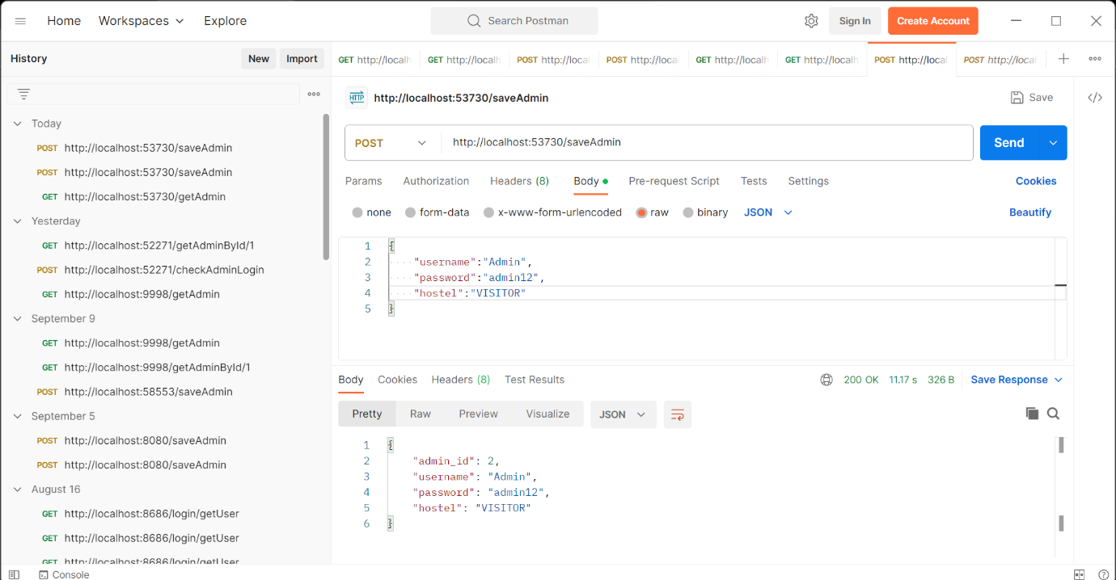

checkAdminLogin

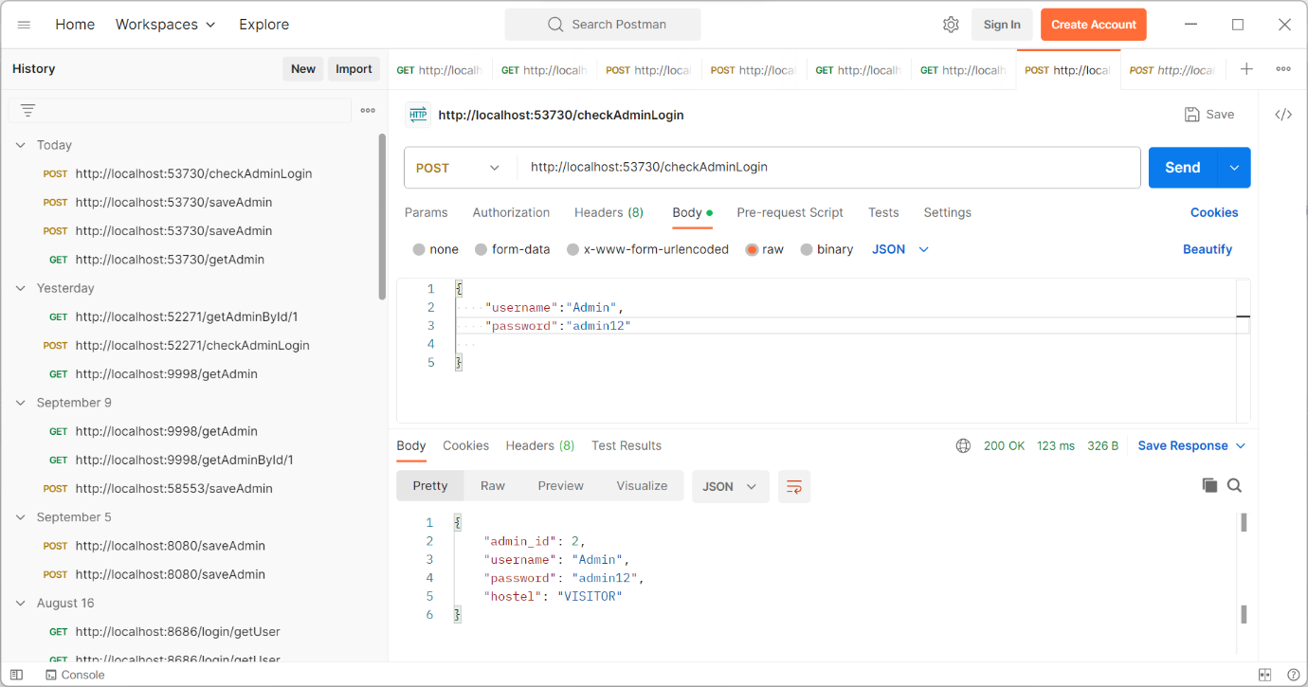

Savestudent/VISITOR

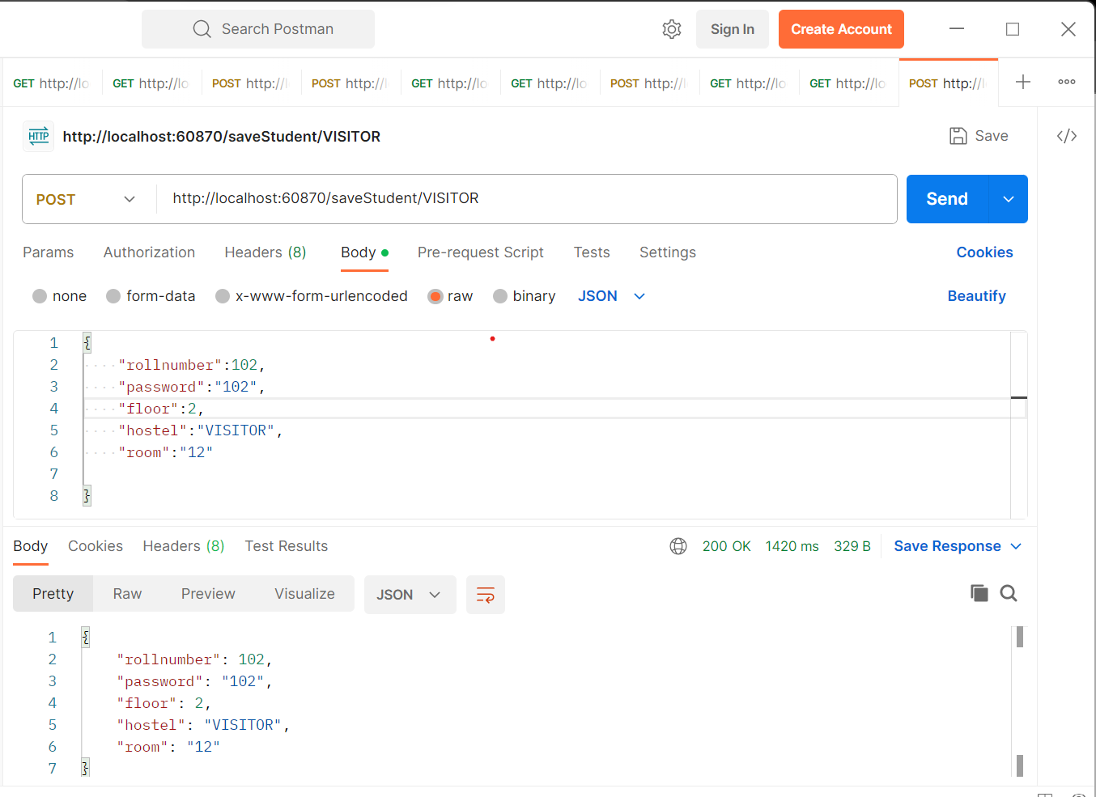

CheckUserLogin

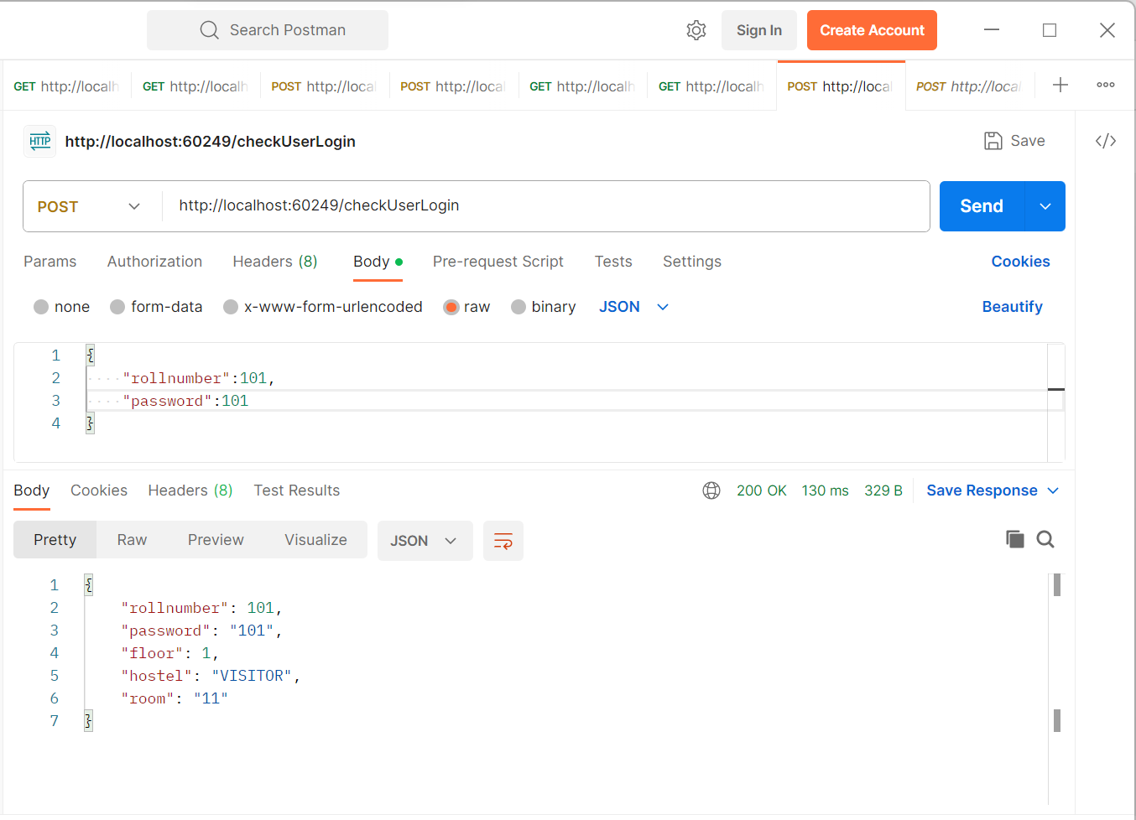

UpadateStudentProfile/101

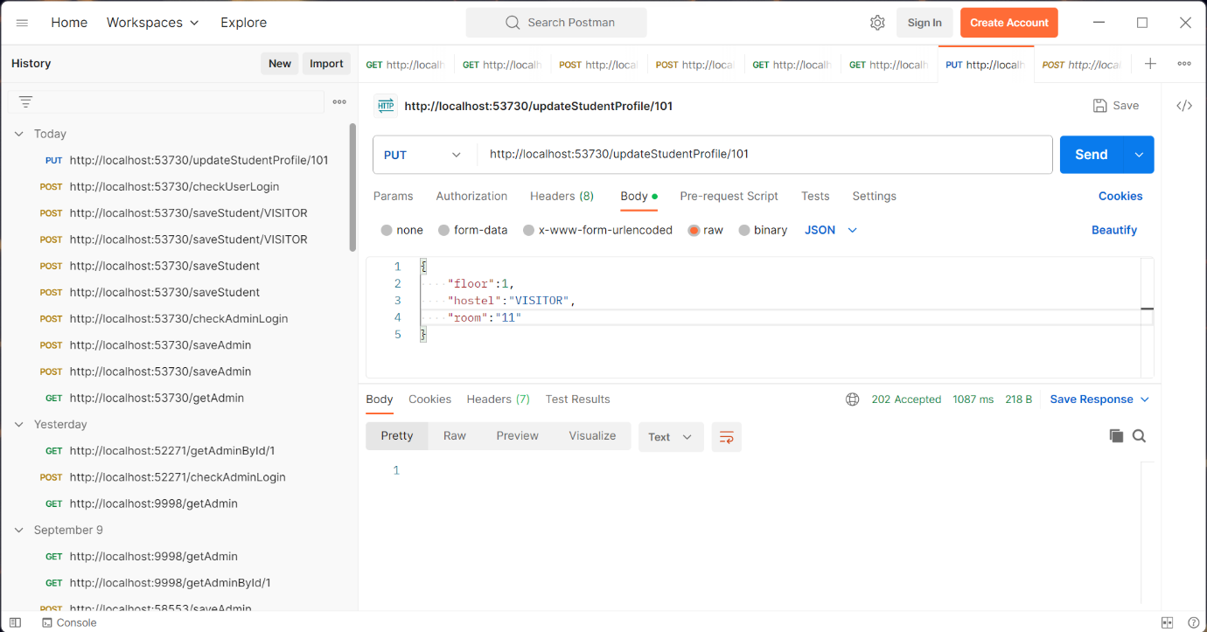

registerWorker/VISITOR

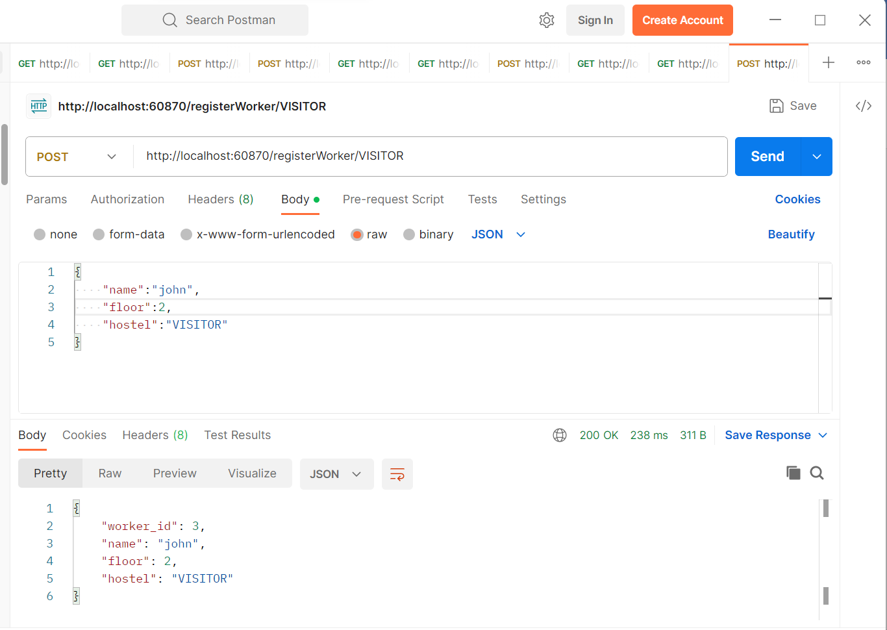

submitRequest/101

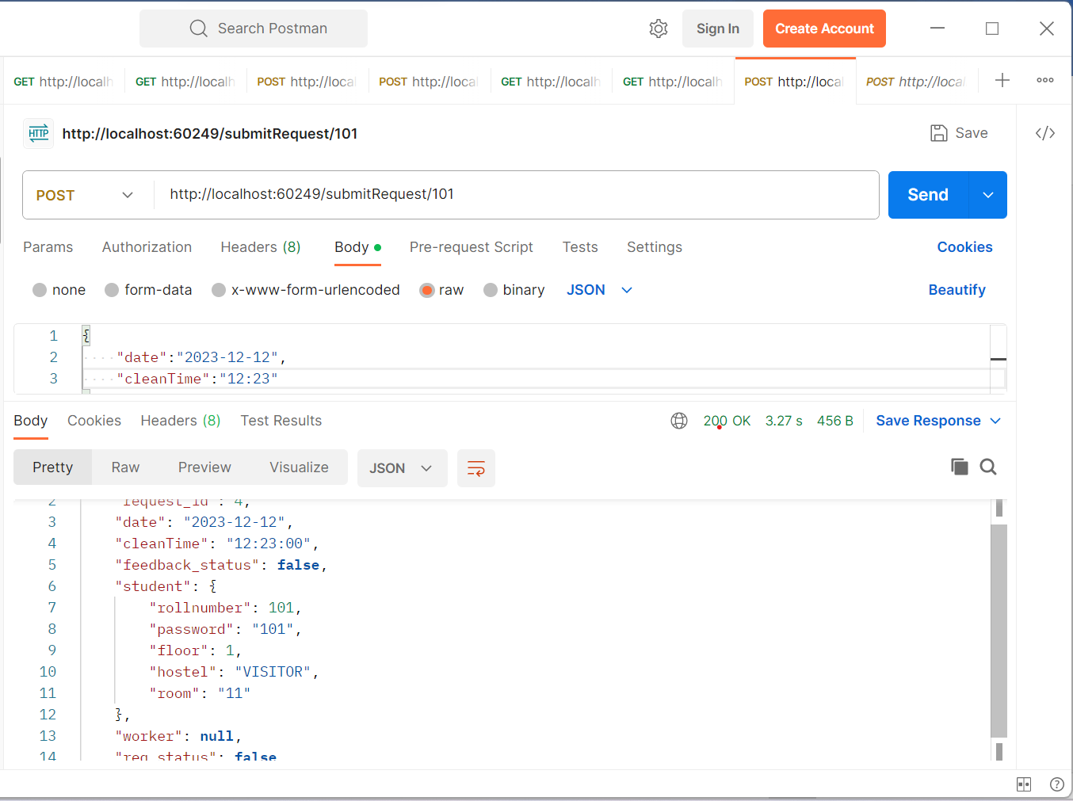

allotHouseKeeper/4/1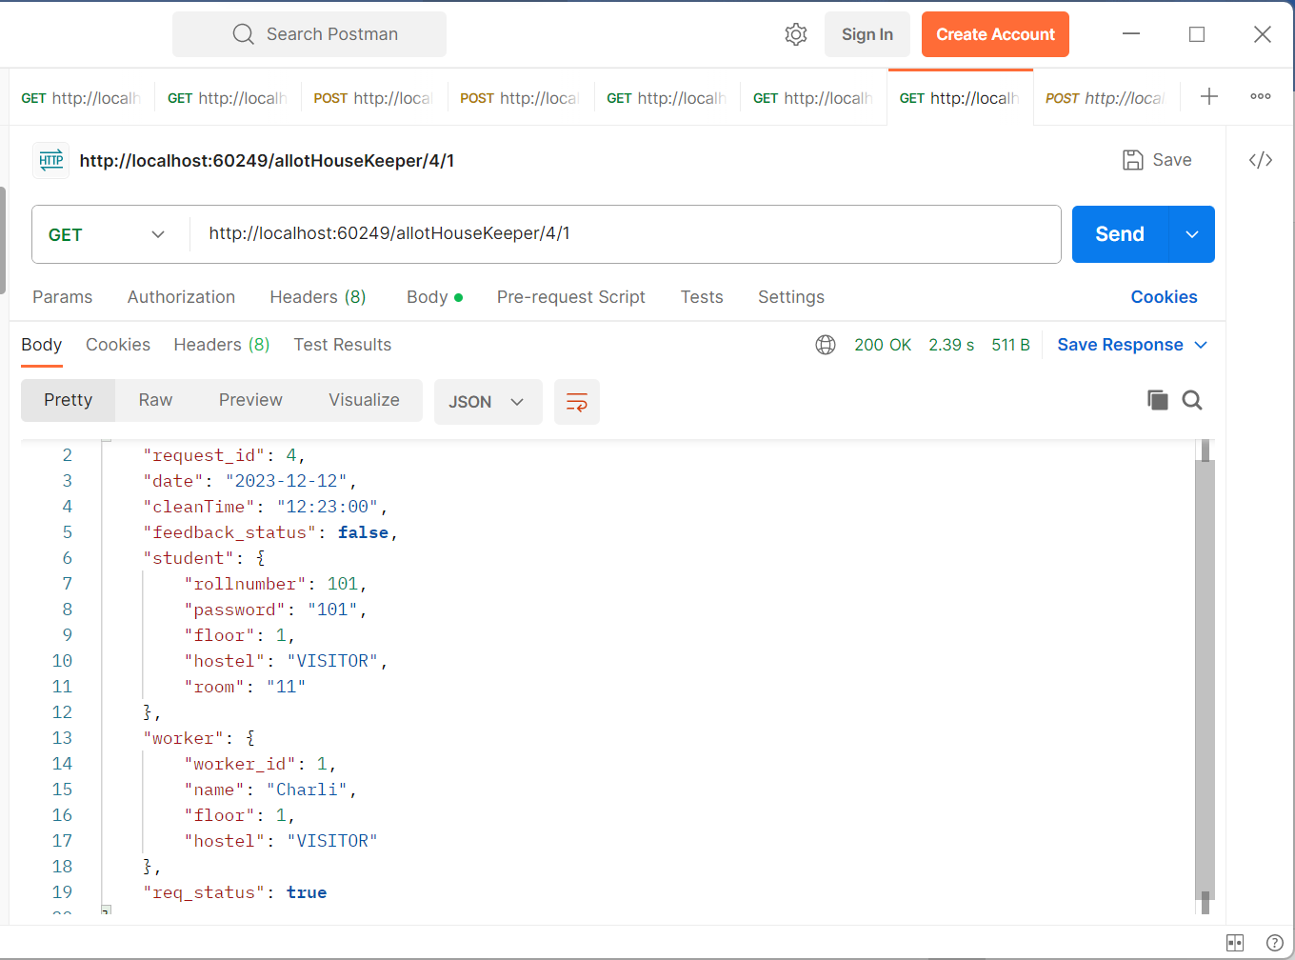getStudent/101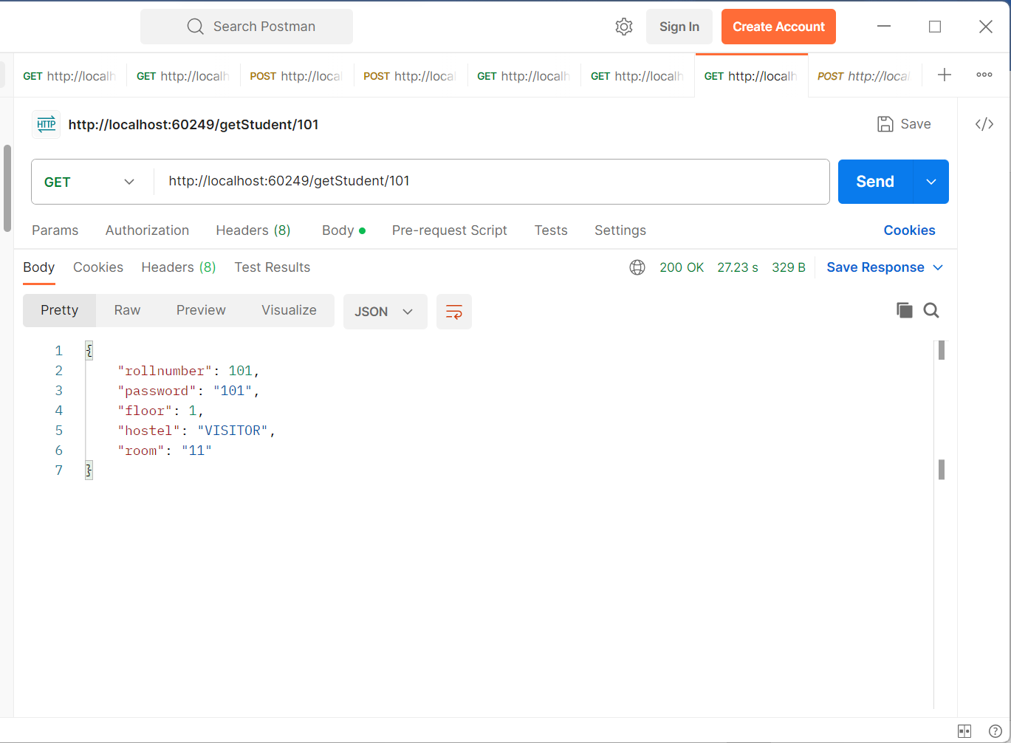

getHouseKeeperByFloor/2/VISITOR

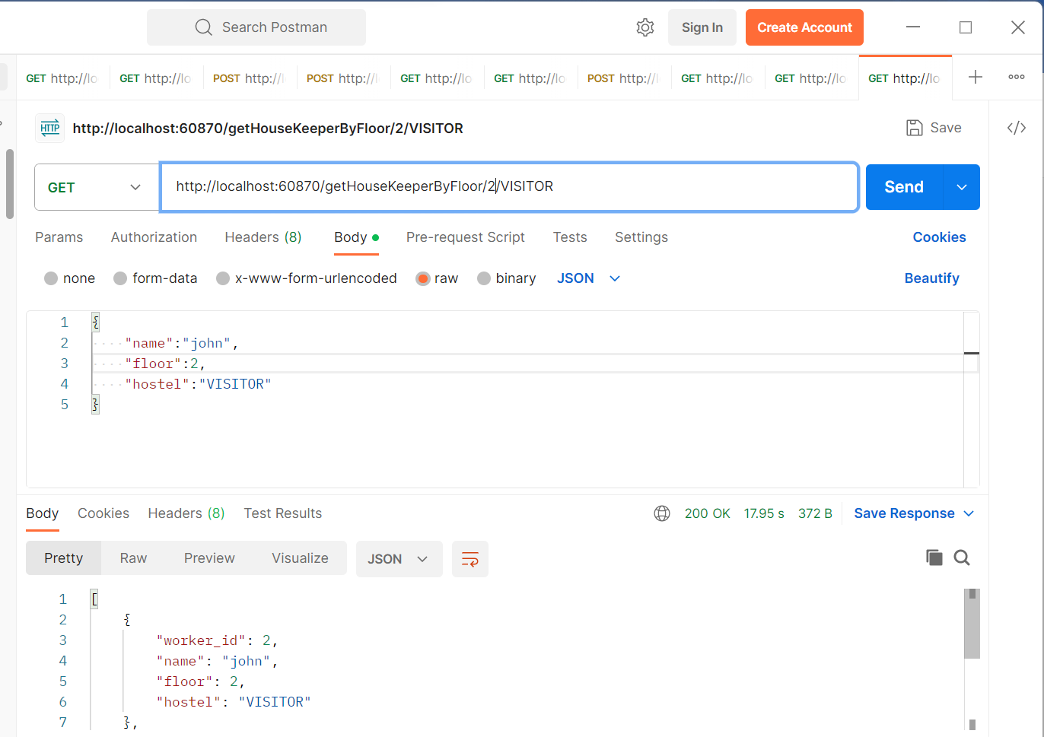

getAllCleanRequestByHostel/VISITOR

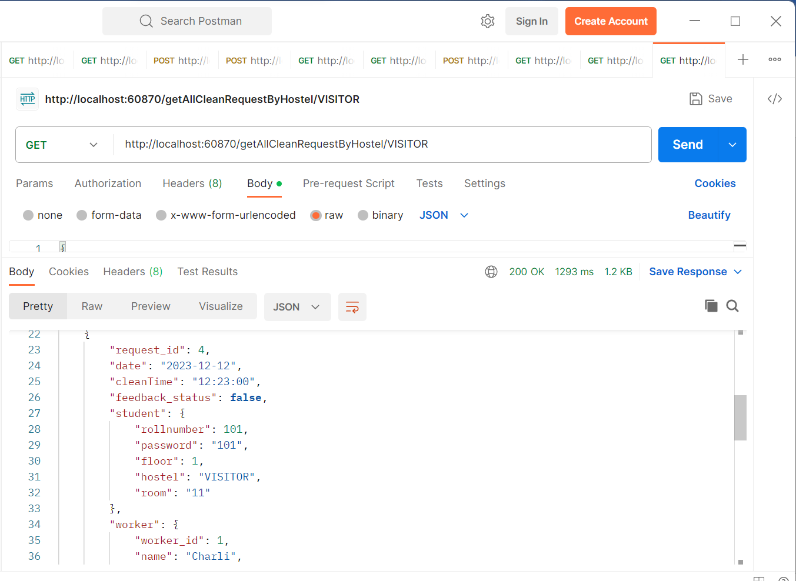

getFeedbackCount/VISITOR

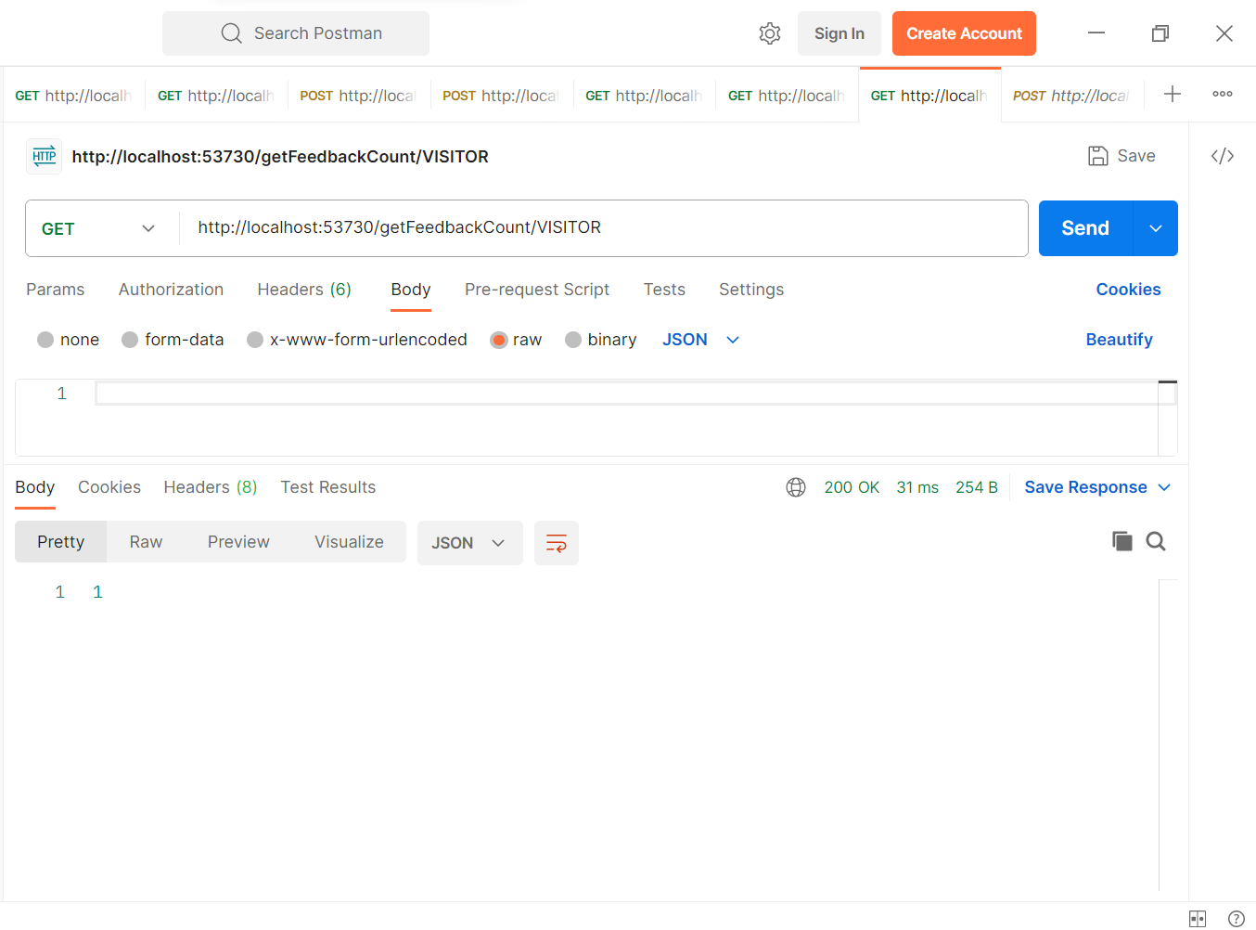

EurekaServer

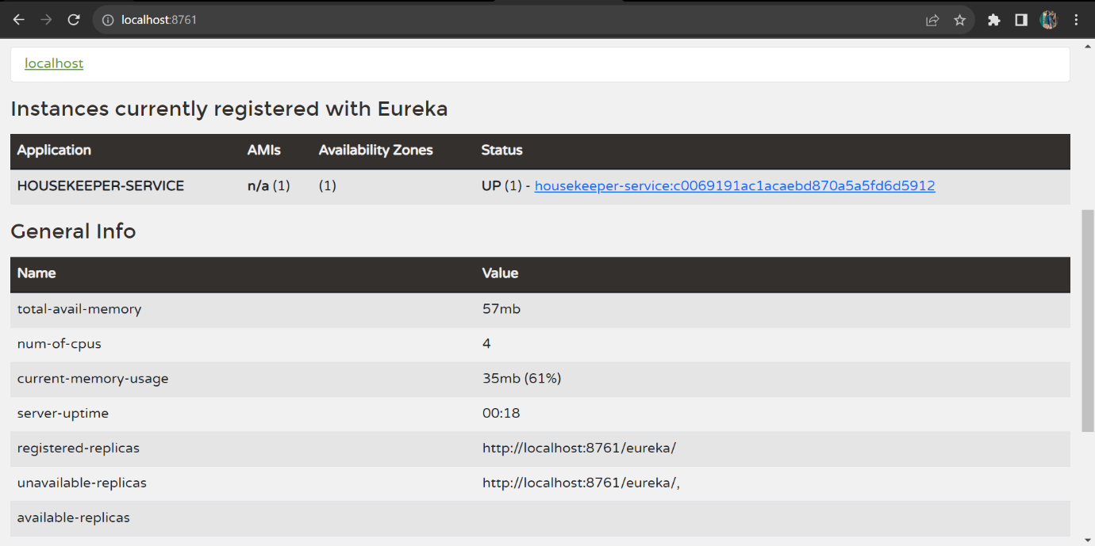

getAdmin

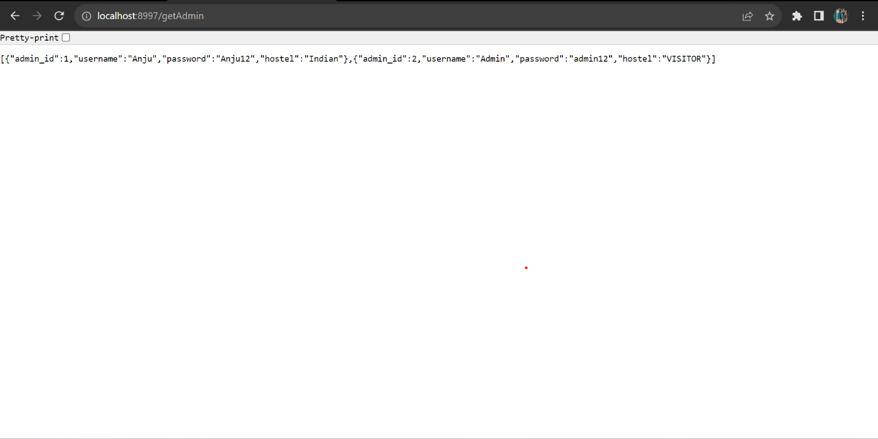

getAllStudent

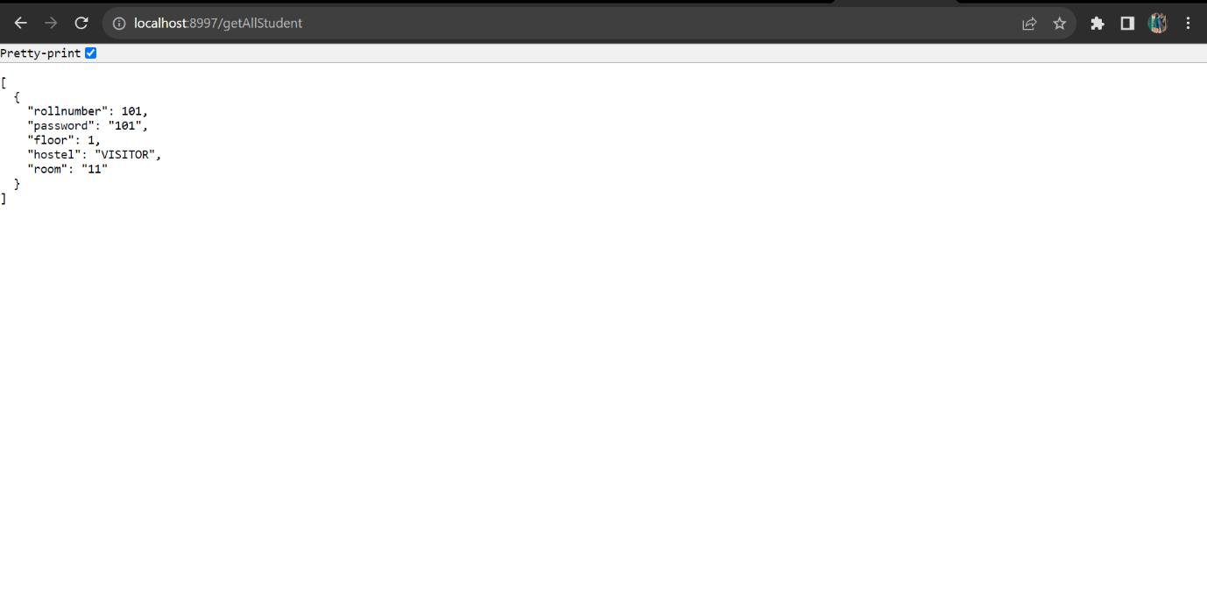

getAdminById/1

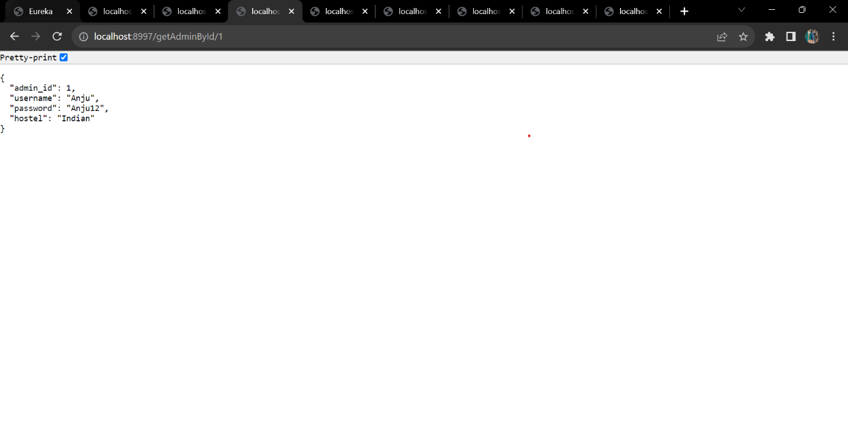

getAdminById/3

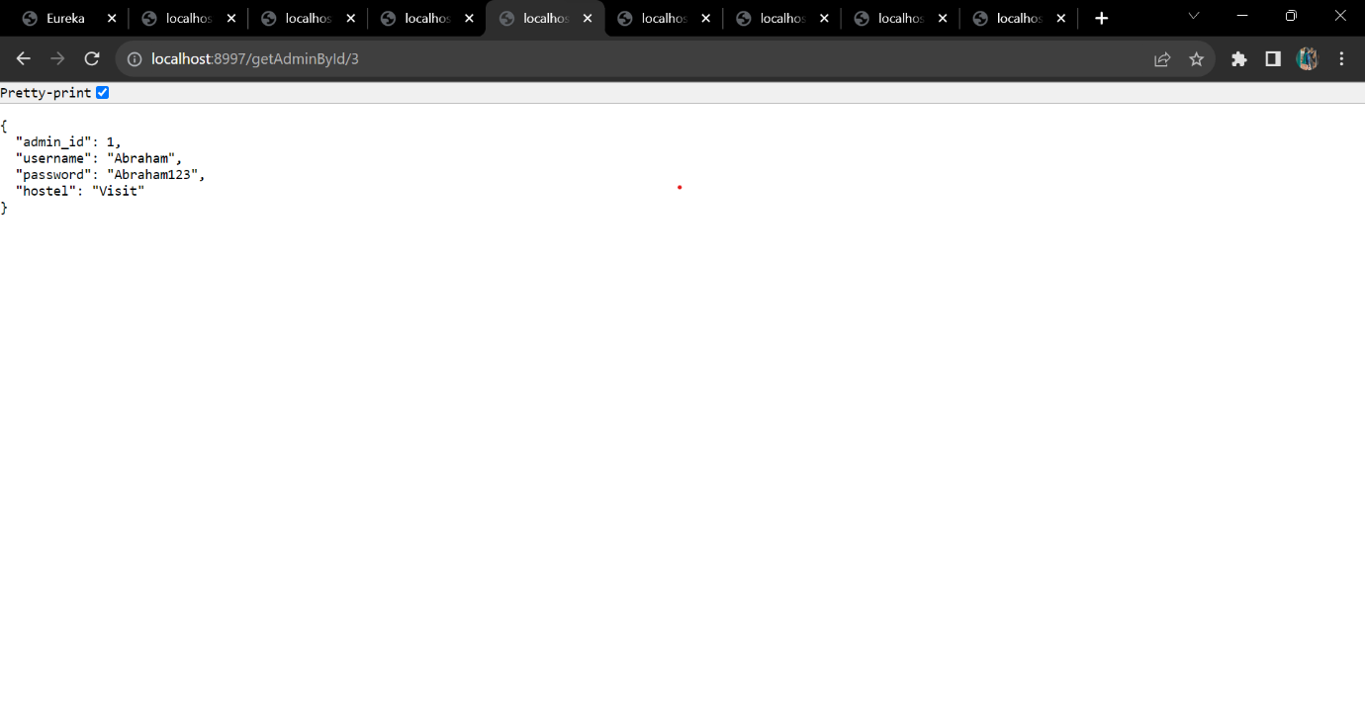

Actuator

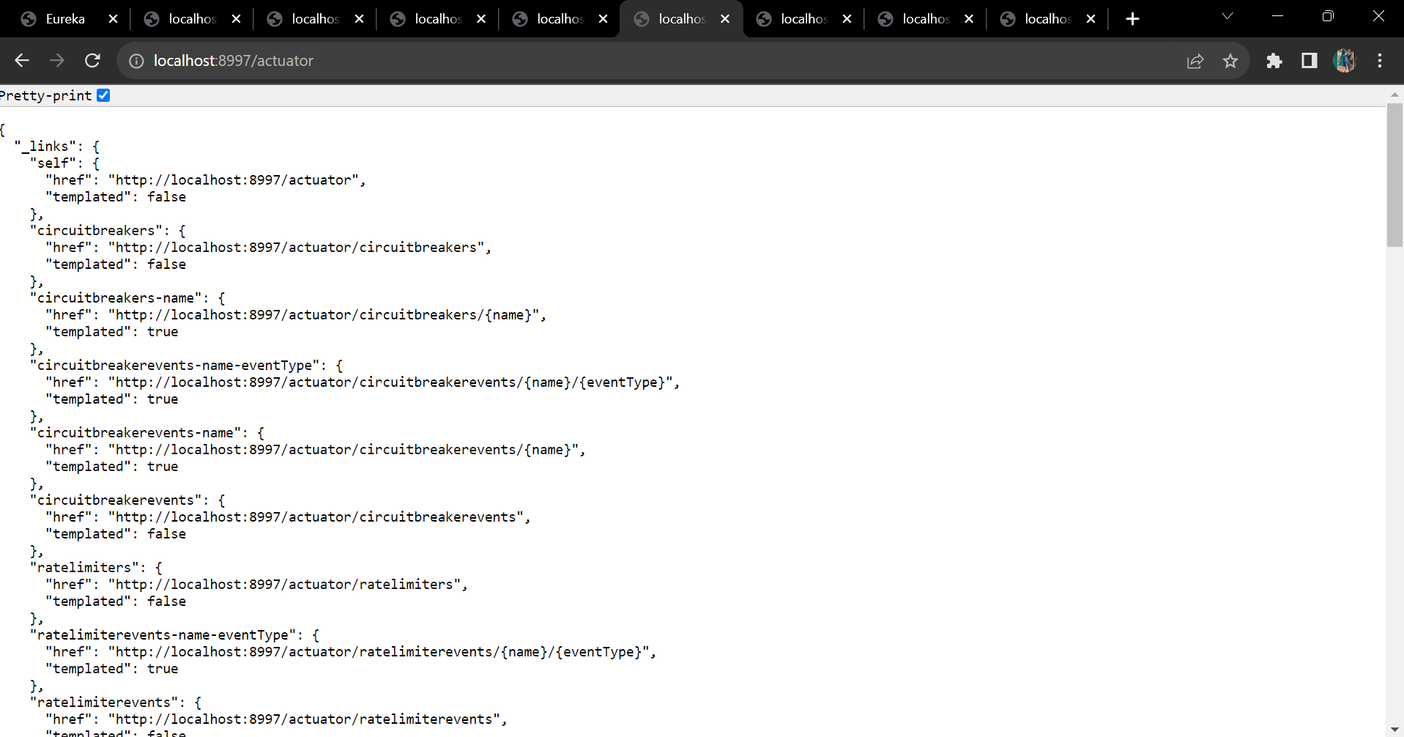

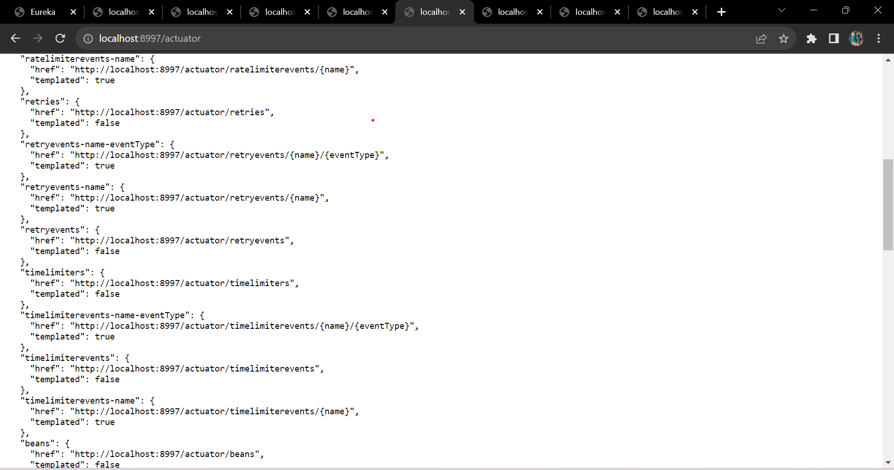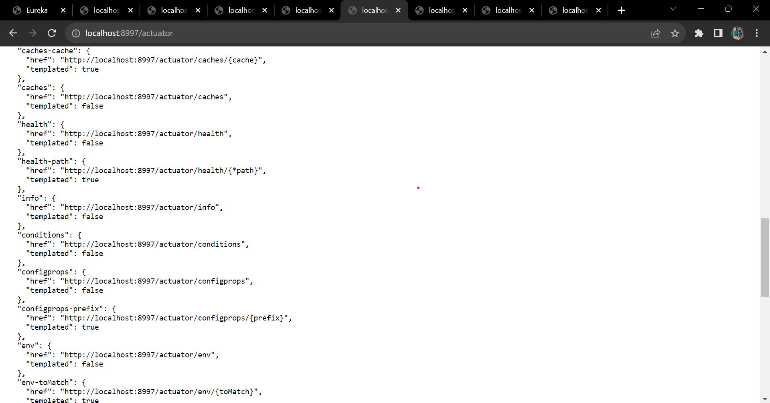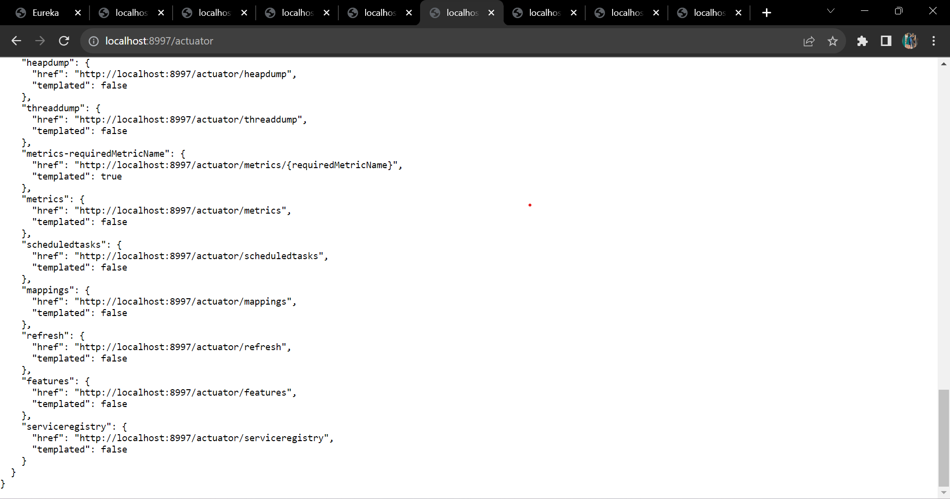

circuitbreakers

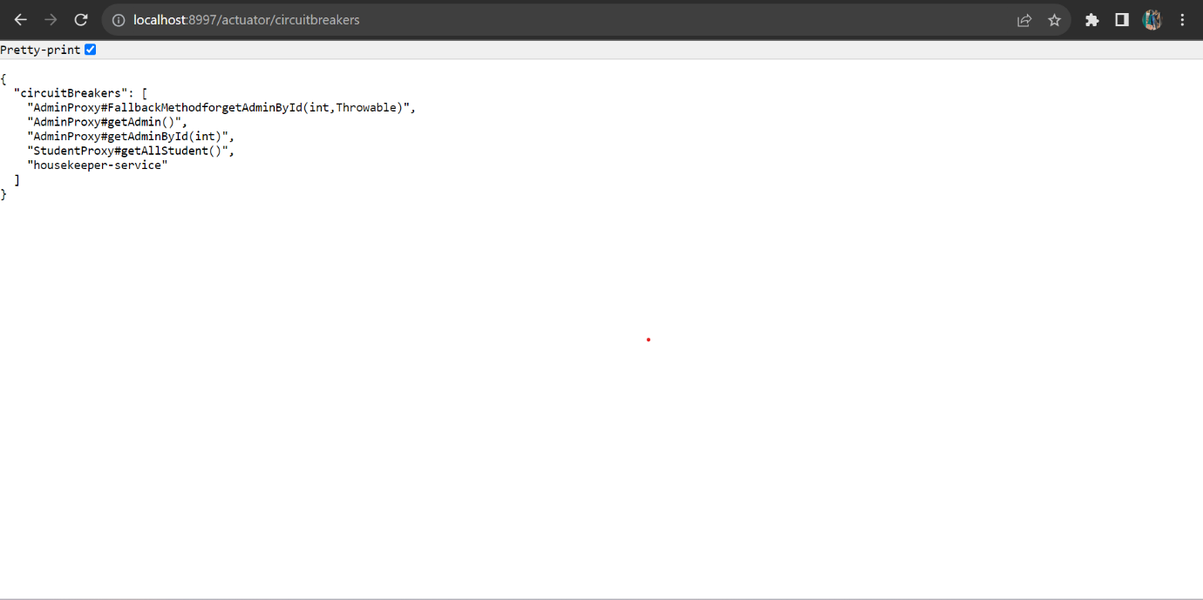

retries

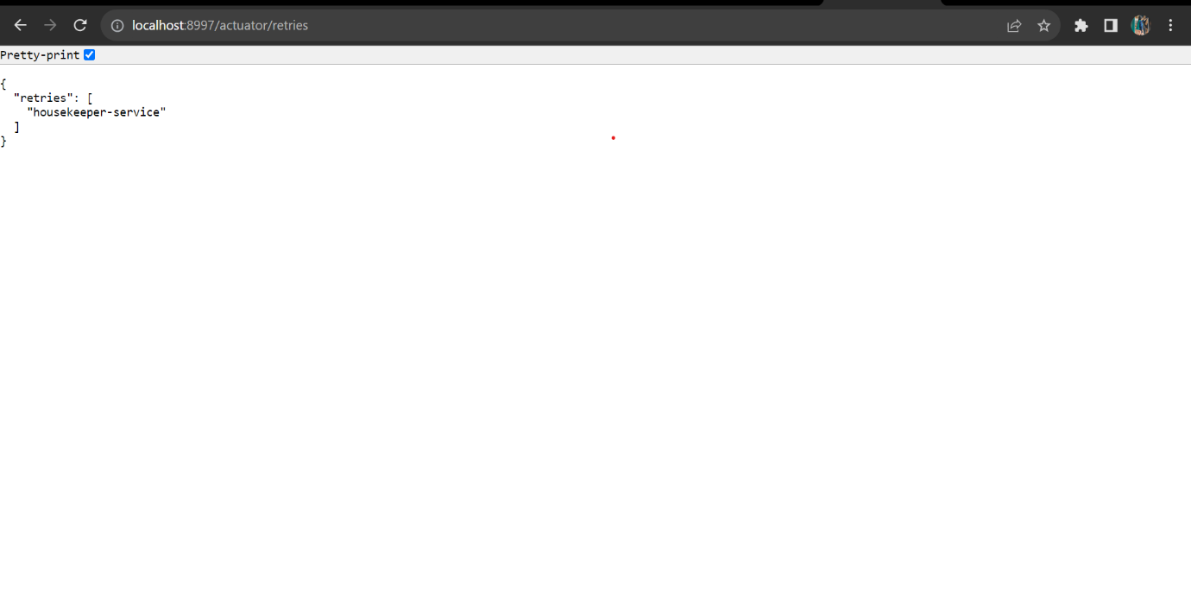

getStudent/101

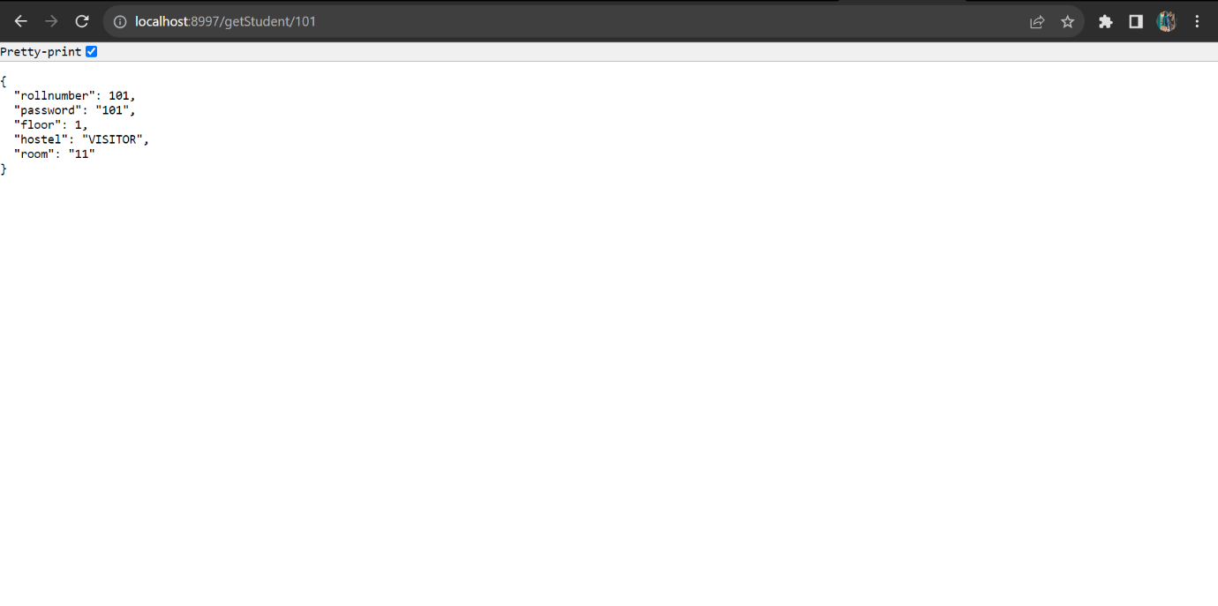

getStudent/1

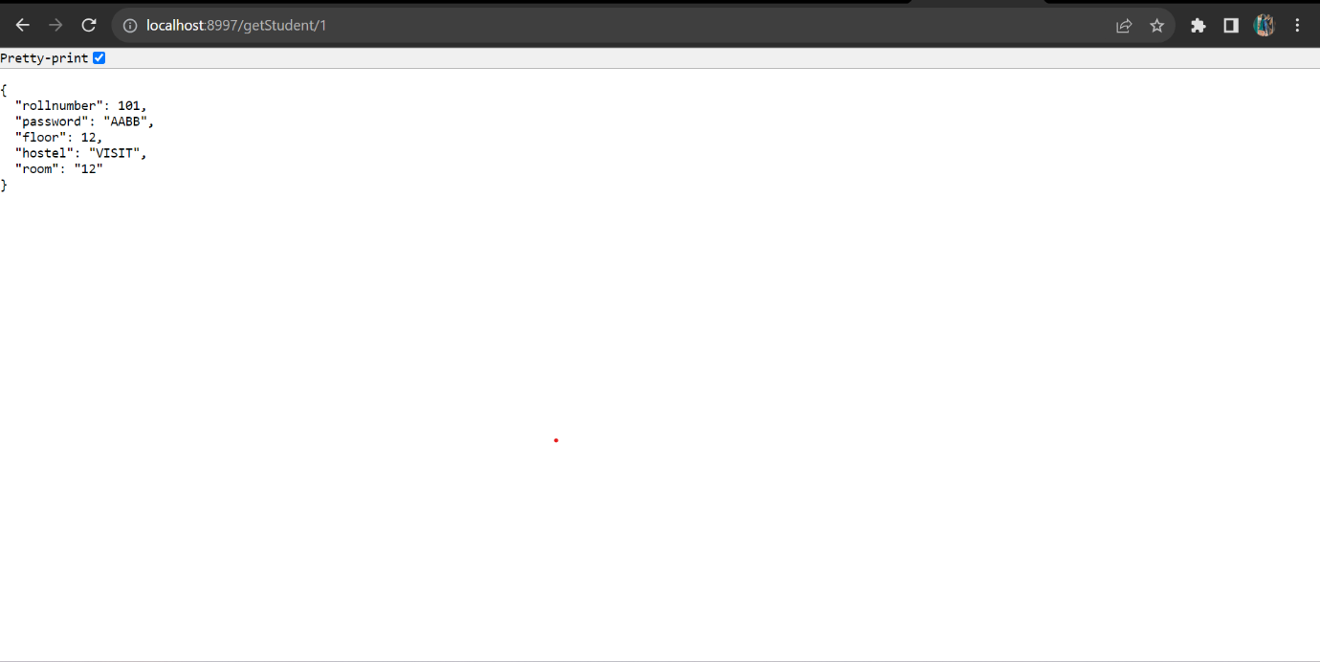

getHouseKeeperByFloor/1/VISITOR

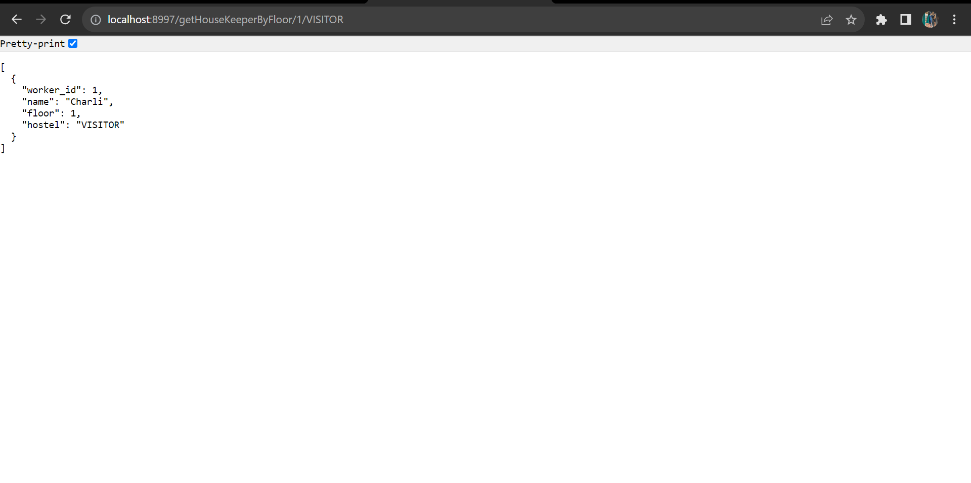

getAllCleanRequestByHostel/VISITOR

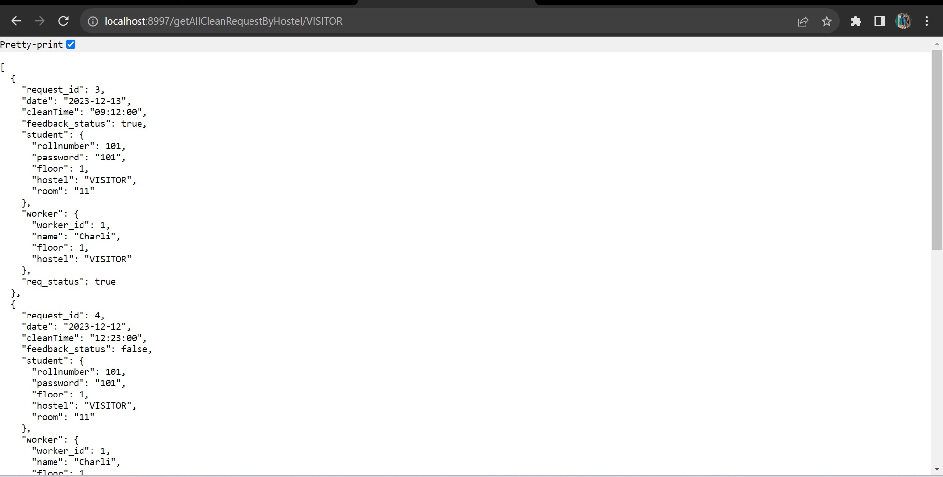

getFeedbackCount/VISITOR

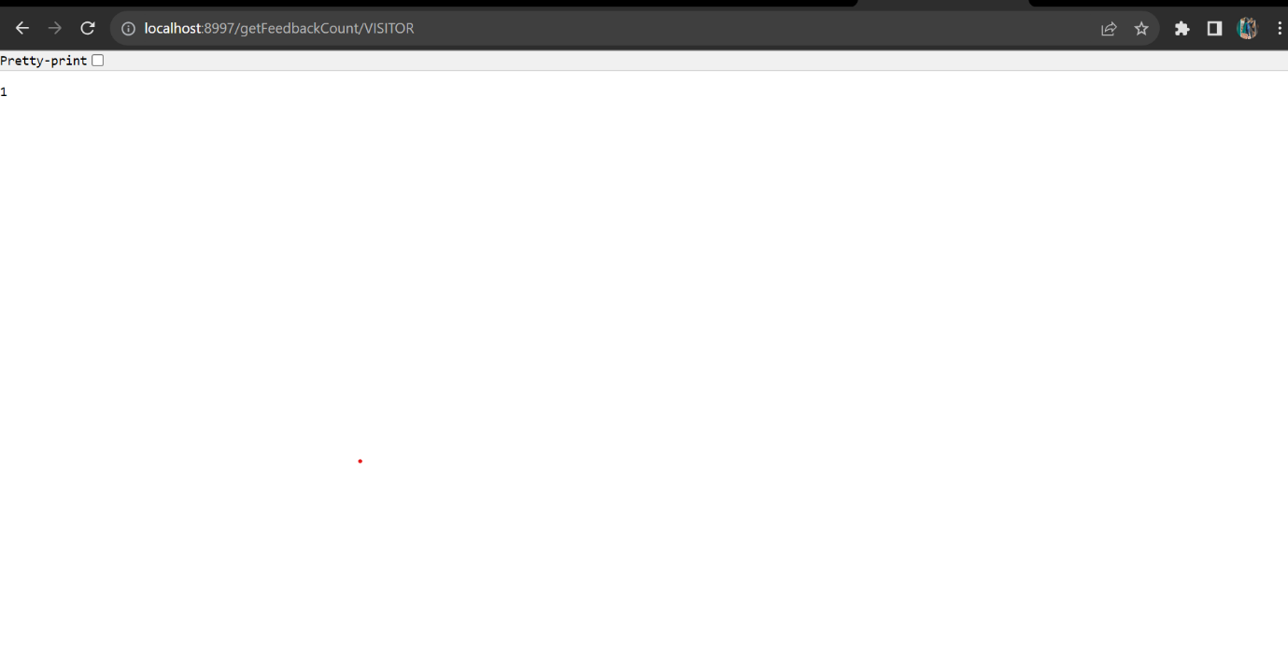

Zipkin Dashboard:

