AMITY UNIVERSITY UTTAR PRADESH
Amity School of Engineering and Technology
Department of Information Technology
PROJECT REPORT

Inkwell
A Full-Stack Blogging Platform
INTEGRATED PROJECT | Semester 6
Mahesh Yadav
B.Tech Information Technology (2023–27)
Submitted To
Department of Information Technology
Amity School of Engineering and Technology
Amity University Uttar Pradesh

Project Information
Project Title | Inkwell – A Full-Stack Blog Platform with Comments
Project Type | Integrated Project
Semester | Semester 6
Program | B.Tech Information Technology (2023–27)
Institution | Amity School of Engineering and Technology, Amity University UP
Department | Department of Information Technology
Technology Stack | React 18, Vite, Tailwind CSS, FastAPI, SQLAlchemy, SQLite, JWT
Delivery | Full-Stack Web Application — Deployed on Vercel and Render

Abstract
The creation, sharing, and discussion of written content on the internet has become one of the most significant forms of human communication in the modern era. Blogging platforms serve as the primary medium through which individuals, professionals, and communities share knowledge, opinions, and creative work with global audiences. Existing platforms, however, often present barriers to entry in terms of complexity, cost, or lack of transparency regarding data ownership and content control.
This project, Inkwell, is a fully functional, production-deployed full-stack blogging platform that enables users to register, authenticate, and publish richly formatted blog posts to a global audience. The platform supports the complete content lifecycle — creation, editing, deletion, and discovery — alongside a comprehensive social interaction layer including a comment system, post likes, tag-based filtering, and real-time search. The system is built on a modern, industry-standard technology stack comprising a React 18 and Vite frontend styled with Tailwind CSS, and a FastAPI Python backend persisting data in a SQLite relational database via the SQLAlchemy ORM.
Security is implemented through industry-standard JWT token-based authentication with bcrypt password hashing. The platform includes dark mode, read time estimation, view counters, author profile pages, and is pre-populated with professionally written seed content from five distinct author personas across eight technical blog posts. The complete application is deployed free of charge on Vercel (frontend) and Render (backend), making it publicly accessible at a permanent live URL. The system is fully responsive across mobile and desktop devices and demonstrates the application of full-stack web development principles in a real-world, production-grade context.

Objectives
The primary objective of this project is to design and develop a complete, production-ready blogging platform that demonstrates mastery of full-stack web development including frontend design, backend API development, database integration, user authentication, and cloud deployment. The specific objectives are:
- To implement a secure user authentication system with registration, login, and JWT token-based session management, incorporating bcrypt password hashing for credential security.
- To develop a complete post management system allowing authenticated users to create, edit, delete, and publish blog posts with Markdown formatting support and cover image integration.
- To build a commenting system enabling authenticated users to engage in discussions on any post, with the ability to delete their own comments, fostering a community of interaction.
- To implement a post liking system allowing users to express appreciation for content, with accurate like counts displayed across all listing and detail views.
- To develop a tag-based categorisation and filtering system enabling users to browse content by topic, combined with a full-text search feature for discovering posts by keyword.
- To design a professional, responsive user interface using Tailwind CSS with dark mode support, read time estimation, view counters, and a featured posts section on the home page.
- To create detailed author profile pages displaying biography, avatar, post history, and aggregated engagement statistics for each registered user.
- To deploy the complete application to production hosting on Vercel and Render with a keep-alive mechanism ensuring the backend remains responsive at all times.
- To pre-populate the platform with high-quality seed content from five distinct author personas across eight technically substantive blog posts with real comments and likes.

Introduction
The internet has fundamentally transformed the way human beings create and consume written content. Where publishing once required access to physical printing infrastructure or established media organisations, the rise of the web democratised content creation and gave every individual a potential global audience. Blogging platforms emerged as the primary vehicle for this democratisation, enabling writers, technologists, educators, and creative professionals to publish their work, build communities, and engage in meaningful discourse with readers around the world.
Despite the proliferation of established platforms such as Medium, Substack, and WordPress, there remains a significant educational and practical value in building a blogging platform from first principles. The development of such a system requires the integration of nearly every dimension of modern web development: user interface design and responsive layout, client-server communication via RESTful APIs, relational database design and querying, user authentication and session management, deployment and infrastructure configuration, and the implementation of social features such as commenting, liking, and search. Inkwell was conceived as a project that would demonstrate competency across all of these dimensions simultaneously.
Inkwell is a full-stack blogging platform built with React 18 and Vite on the frontend, FastAPI on the backend, and SQLite as the persistence layer. It implements the complete set of features that characterise a professional-grade blogging product: JWT-secured authentication, full CRUD post management with Markdown rendering, nested commenting, post and author analytics, tag-based discovery, full-text search, dark mode, and responsive mobile design. The platform is deployed at live production URLs on Vercel and Render, accessible to any user with a web browser, and includes a keep-alive mechanism to ensure the free-tier backend never experiences cold start delays during active use.
The project was developed as an Integrated Project submission for Semester 5 of the B.Tech Information Technology programme at Amity School of Engineering and Technology, Amity University Uttar Pradesh. It directly addresses all four requirements specified in the assignment brief: user registration, login, and authentication; creation, editing, and deletion of blog posts; a comment section for user interaction; and a backend with RESTful APIs and database integration.

Literature Review
The academic and industry literature relevant to this project spans several domains including web application architecture, content management systems, user authentication protocols, and modern JavaScript frontend frameworks. A review of this literature informed the design decisions made at each layer of the Inkwell system.
The REST architectural style, first described by Fielding (2000) in his doctoral dissertation, established the foundational principles for designing web APIs. RESTful APIs use standard HTTP methods (GET, POST, PUT, DELETE) to perform operations on resources identified by URLs, with stateless communication between client and server. This paradigm has become the dominant approach for web API design and was adopted for all backend endpoints in this project due to its simplicity, scalability, and broad tooling support.
The FastAPI framework, introduced by Ramírez (2018), represents a significant advancement in Python web framework design. Its use of Python type hints for automatic request validation, its integration with the OpenAPI specification for automatic documentation generation, and its asynchronous-first architecture make it particularly well-suited for building production-quality APIs with minimal boilerplate. Published benchmarks consistently position FastAPI among the fastest Python web frameworks available, comparable to NodeJS and Go frameworks in request throughput.
React, maintained by Meta and the open-source community, has established itself as the dominant JavaScript library for building user interfaces through its component model and virtual DOM diffing algorithm. The Vite build tool, developed by Evan You, addressed significant performance limitations of older build tools such as webpack by leveraging native ES modules during development, resulting in near-instantaneous hot module replacement. The combination of React and Vite has become the industry standard for new frontend projects requiring fast development iteration and optimised production builds.
JSON Web Tokens (JWTs), standardised in RFC 7519, provide a compact, self-contained mechanism for representing authentication claims between two parties. Their stateless nature makes them particularly appropriate for API authentication in distributed systems where server-side session storage introduces scalability constraints. The use of bcrypt for password hashing, as recommended by the OWASP Authentication Cheat Sheet, provides adaptive computational cost that makes brute-force attacks computationally infeasible.
Tailwind CSS, described by Wathan (2019) as a utility-first CSS framework, challenged the component-first paradigm of earlier frameworks such as Bootstrap by providing low-level utility classes that compose directly in HTML. Empirical studies of development teams adopting Tailwind have consistently reported reductions in CSS bundle size and increased consistency across interfaces due to the elimination of custom CSS files.

Methodology
The development of Inkwell follows a structured, phase-based methodology spanning requirements analysis, system design, incremental implementation, integration, testing, and deployment. Each phase produced concrete deliverables that informed subsequent phases.

Phase 1: Requirements Analysis
The initial phase involved a detailed review of the project assignment requirements and a comparative analysis of existing blogging platforms to identify the feature set expected of a professional-grade system. The core requirements identified were: user registration and login with secure authentication, full CRUD operations on blog posts, a commenting system, and a RESTful backend with database persistence. Additional professional features identified through platform analysis included dark mode, post tagging, search, likes, author profiles, read time estimation, and view counters.

Phase 2: System Architecture Design
The system was designed as a decoupled client-server architecture with clear separation between the frontend presentation layer and the backend API layer. The frontend is a single-page application built with React, communicating with the backend exclusively through JSON API calls over HTTP. The backend is a stateless RESTful API built with FastAPI, with all data persisted in a SQLite database accessed through the SQLAlchemy ORM. This architecture enables independent deployment and scaling of frontend and backend components.

Phase 3: Database Schema Design
The relational database schema was designed to model users, posts, tags, comments, and likes as distinct entities with appropriate foreign key relationships. A many-to-many relationship between posts and tags is implemented through a post_tags association table. The SQLAlchemy ORM was used to define models declaratively, enabling automatic schema generation and type-safe query construction without raw SQL.

Phase 4: Backend API Development
The backend was implemented using FastAPI with separate modules for models (SQLAlchemy), schemas (Pydantic), CRUD operations, authentication utilities, and the seed data generator. JWT authentication was implemented using the python-jose library, with bcrypt password hashing via the bcrypt library. All API endpoints were tested against the automatically generated OpenAPI documentation at /docs during development.

Phase 5: Frontend Development
The frontend was developed as a React single-page application with React Router for client-side routing across seven distinct pages. Global state for authentication and theme preference is managed through React Context. An Axios-based API client handles all HTTP communication with automatic JWT header injection via request interceptors. Tailwind CSS provides responsive styling with dark mode support through the class strategy.

Phase 6: Seed Data Generation
A comprehensive seed data module was developed to populate the database with five author accounts, eight substantive blog posts covering technical topics including GraphQL, TypeScript, Kubernetes, machine learning, design systems, system design, CSS layout, and edge computing, alongside realistic comments and likes. This seed data ensures the platform appears professionally populated from the moment of first access.

Phase 7: Deployment
The backend was deployed to Render using a Python 3.11 runtime environment specified via the PYTHON_VERSION environment variable. A self-ping keep-alive mechanism was implemented in the FastAPI startup event using httpx and asyncio, sending a request to the /health endpoint every five minutes to prevent the free-tier service from spinning down. The frontend was deployed to Vercel with the VITE_API_URL environment variable configured to point to the Render backend URL.

System Design

Technology Stack
Component | Technology
Frontend Framework | React 18 with Vite 6 — component-based SPA architecture
Styling | Tailwind CSS 3 with @tailwindcss/typography plugin
Client-Side Routing | React Router DOM v6 — declarative route definitions
HTTP Client | Axios with request/response interceptors for JWT injection
Markdown Rendering | react-markdown — converts post content to formatted HTML
Toast Notifications | react-hot-toast — non-blocking user feedback messages
Date Utilities | date-fns — formatDistanceToNow, format functions
Backend Framework | FastAPI 0.109 — async Python web framework
ORM | SQLAlchemy 2.0 — declarative model definitions and query DSL
Database | SQLite — file-based relational database (local and Render)
Authentication | python-jose (JWT encoding/decoding) + bcrypt (password hashing)
Keep-Alive | httpx + asyncio — self-ping every 5 minutes on Render
Frontend Deploy | Vercel — automatic CI/CD from GitHub main branch
Backend Deploy | Render — Python 3.11 web service, free tier

API Endpoints
Endpoint | Description
POST /auth/register | Create new user account with hashed password
POST /auth/login | Authenticate user and return JWT access token
GET /users/me/profile | Return current authenticated user's profile
PUT /users/me | Update authenticated user's full name, bio, avatar
GET /users/{id} | Return public profile for any user by ID
GET /posts | Paginated post listing with tag filter and search params
GET /posts/featured | Return three featured posts for homepage hero section
GET /posts/{id} | Return single post with author, tags, like and comment counts
POST /posts | Create new post (authenticated users only)
PUT /posts/{id} | Update existing post (post owner only)
DELETE /posts/{id} | Delete post and all associated comments and likes
GET /posts/{id}/like | Return like status and count for current user
POST /posts/{id}/like | Toggle like on a post for the authenticated user
GET /posts/{id}/comments | Return all comments for a post in chronological order
POST /posts/{id}/comments | Add a new comment to a post (authenticated)
DELETE /comments/{id} | Delete a comment (comment owner only)
GET /tags | Return list of all tag names used across all posts
GET /health | Backend health check — used by keep-alive ping mechanism

File Structure
File / Folder | Purpose
backend/main.py | FastAPI application — all route handlers and startup event
backend/models.py | SQLAlchemy ORM models — User, Post, Tag, Comment, Like
backend/schemas.py | Pydantic request/response schemas with field validation
backend/crud.py | All database operations — create, read, update, delete
backend/auth.py | JWT token creation/decoding and bcrypt password utilities
backend/database.py | SQLAlchemy engine and session configuration
backend/seed.py | Sample data — 5 authors, 8 posts, comments, likes
backend/requirements.txt | Python package dependencies with pinned versions
frontend/src/api/index.js | Axios API client with JWT interceptors
frontend/src/context/AuthContext.jsx | Global authentication state and actions
frontend/src/context/ThemeContext.jsx | Dark/light mode state with localStorage persistence
frontend/src/pages/Home.jsx | Homepage — featured posts, post list, tag sidebar, search
frontend/src/pages/PostDetail.jsx | Full post view — content, likes, comments, author card
frontend/src/pages/Write.jsx | Post editor — create and edit with Markdown and preview
frontend/src/pages/Profile.jsx | Author profile — bio, stats, post history
frontend/src/pages/Settings.jsx | Account settings — profile edit, avatar selection
frontend/src/components/Navbar.jsx | Sticky navigation with search, auth menu, theme toggle
frontend/src/components/PostCard.jsx | Post card component — featured and list variants
frontend/src/utils/index.js | Utility functions — readTime, timeAgo, getInitials
frontend/vercel.json | Vercel SPA routing configuration — all paths to index.html

System Modules and Results

Module 1: User Authentication
The authentication module implements a complete registration and login flow with JWT token-based session management. On registration, the user's password is hashed using bcrypt with an adaptive cost factor before being stored in the database. On login, the submitted password is verified against the stored hash using bcrypt's constant-time comparison, and a signed JWT is returned with a 30-day expiration. All subsequent authenticated requests include the JWT in the Authorization header, which is injected automatically by the Axios request interceptor. The frontend stores the token in localStorage and parses user data from the /users/me/profile endpoint on application load. The login page includes one-click demo account buttons populated with credentials for the five seed authors to simplify evaluation.
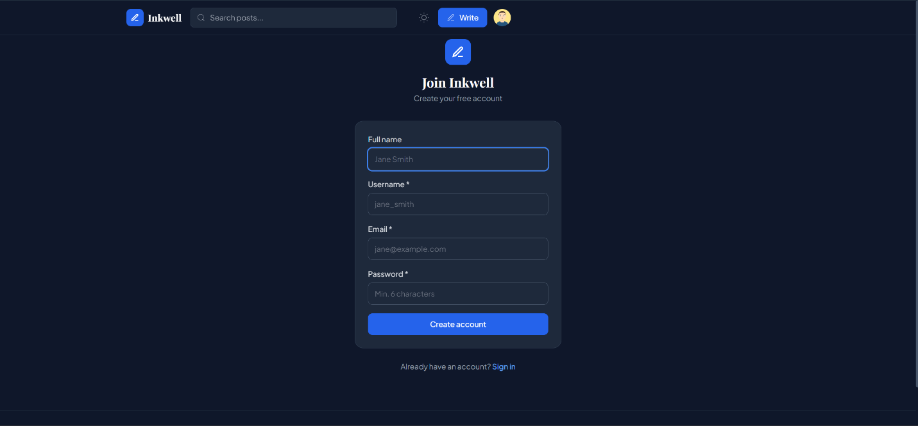

Module 2: Post Management (CRUD)
The post management module provides the complete content lifecycle for blog posts. Authenticated users can create posts through a Markdown editor with a side-by-side preview toggle, specifying a title, content, excerpt, cover image URL, comma-separated tags, and an optional featured flag. Posts are saved to the database with an auto-generated URL-safe slug derived from the title. The editor supports the full Markdown specification including headings, bold, italic, inline code, code blocks with syntax highlighting, and blockquotes. Existing post owners can edit any post through the same editor interface, pre-populated with the current content, and permanently delete posts with a confirmation prompt. All post operations are protected by ownership verification on the backend.
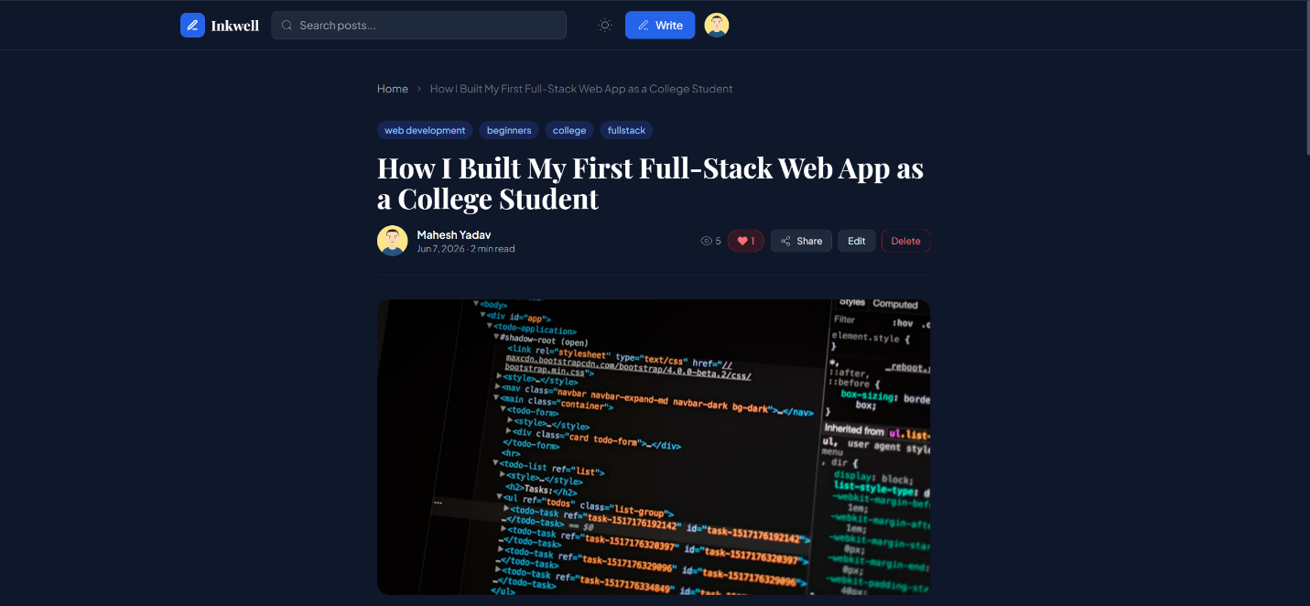

Module 3: Comment System
The comment system allows any authenticated user to add comments to any post. Comments are displayed in chronological order below the post content, each showing the author's avatar, display name, and relative timestamp. Comment authors can delete their own comments with a single click. Unauthenticated visitors see a call-to-action section in place of the comment form, with links to the registration and login pages. The comment count is displayed in real time on the post detail page and is reflected in the comment count badge on post cards throughout the application.
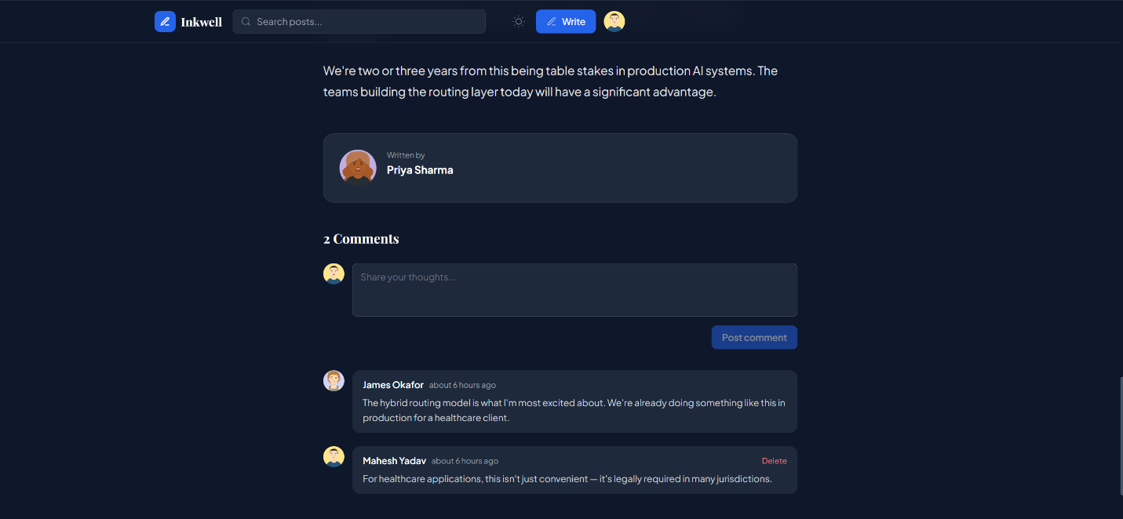

Module 4: Post Likes
The likes module implements a toggle mechanism allowing authenticated users to like and unlike any post. The like button on the post detail page displays the current like count and changes its visual state — filling the heart icon and switching to a red colour scheme — when the post is liked by the current user. The like status and count are fetched on page load through a dedicated GET endpoint. The POST endpoint on the backend checks for an existing Like record for the user-post combination, deleting it if present (unlike) or creating it if absent (like), returning the new state and count in both cases. Like counts are visible on all post card components throughout the application.
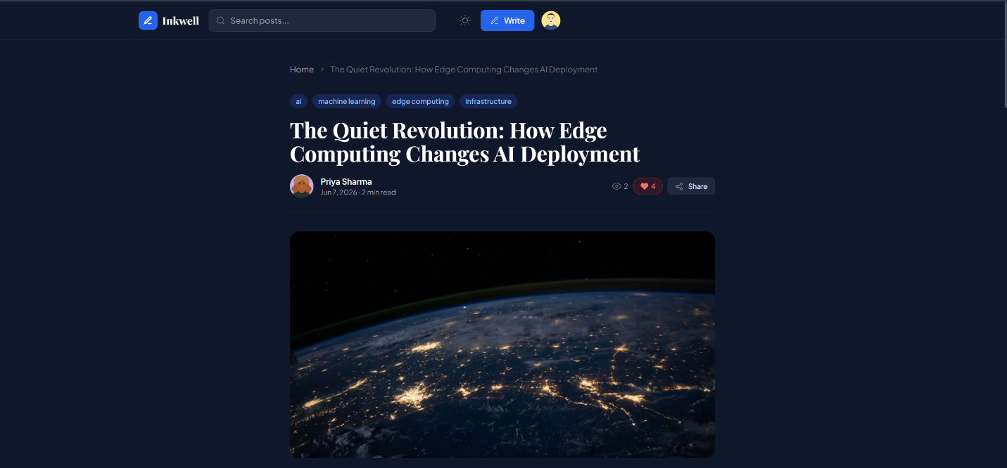

Module 5: Tags and Search
The tagging system allows post authors to associate comma-separated topic tags with each post at creation or edit time. Tags are normalised to lowercase and stored in a dedicated tags table with a many-to-many relationship to posts via a post_tags association table. The sidebar on the homepage displays all tags extracted from the database, with active tag filtering highlighted visually. Clicking a tag filters the post list to show only posts carrying that tag. The search bar in the navbar performs a case-insensitive full-text search across post titles, excerpts, and content bodies using SQLAlchemy's ilike operator. Both tag filtering and search are applied as query parameters, allowing them to be bookmarked and shared as URLs.
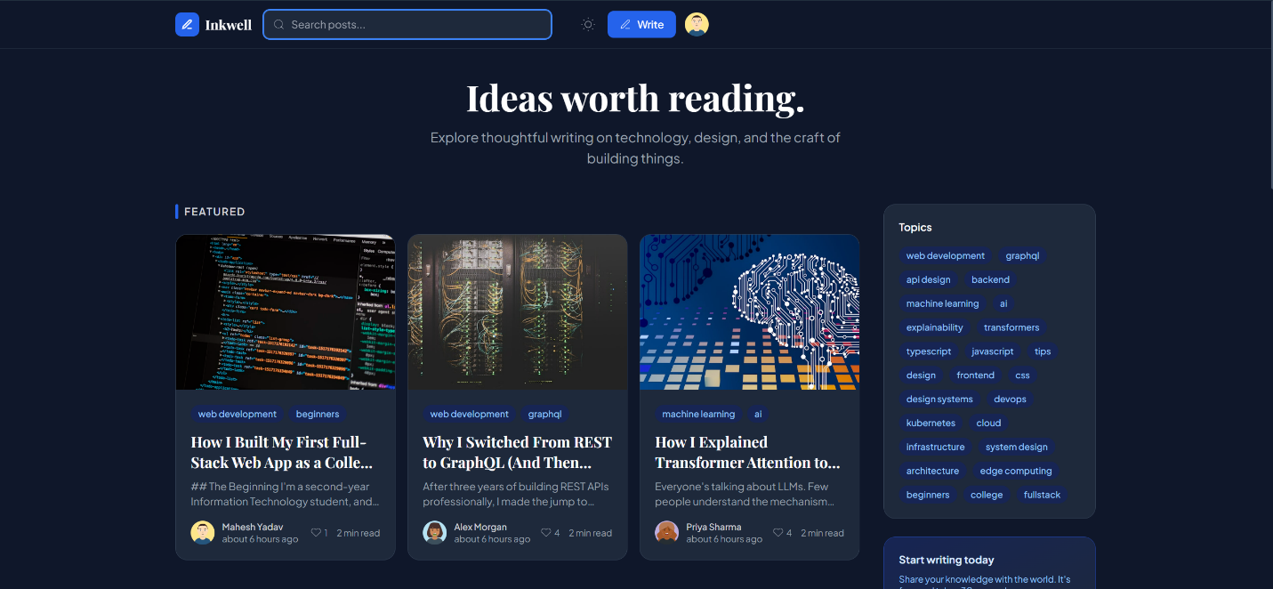

Module 6: Author Profiles
Each registered user has a dedicated public profile page accessible by clicking any author name or avatar across the application. The profile page displays the author's avatar, full name, username, bio, and member since date, alongside aggregated statistics for total posts, total likes received, and total views across all posts. Below the statistics panel, all posts authored by that user are listed in reverse chronological order using the standard post card component. Users can edit their own profile through the Settings page, which provides fields for full name, bio, and avatar URL, as well as five pre-generated avatar options using the DiceBear avataaars API.
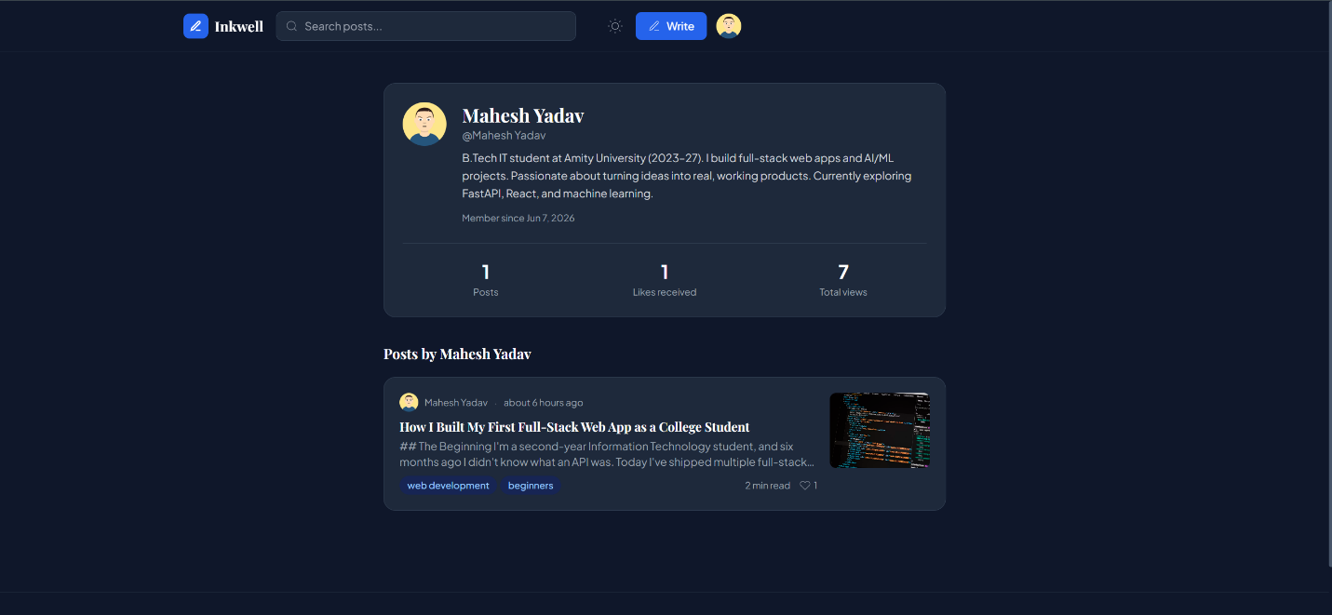

Module 7: Dark Mode
The dark mode implementation uses Tailwind CSS's class strategy, where the presence of the dark class on the HTML root element enables dark variant utility classes throughout the component tree. The ThemeContext provides a toggle function and current state accessible to any component. The user's preference is persisted to localStorage, and the system also checks the prefers-color-scheme media query for new visitors to match their operating system preference on first visit. The transition between light and dark modes is animated with a 200ms CSS transition on background and text colours, providing a polished switching experience. The moon and sun icon in the navbar serve as the toggle button.
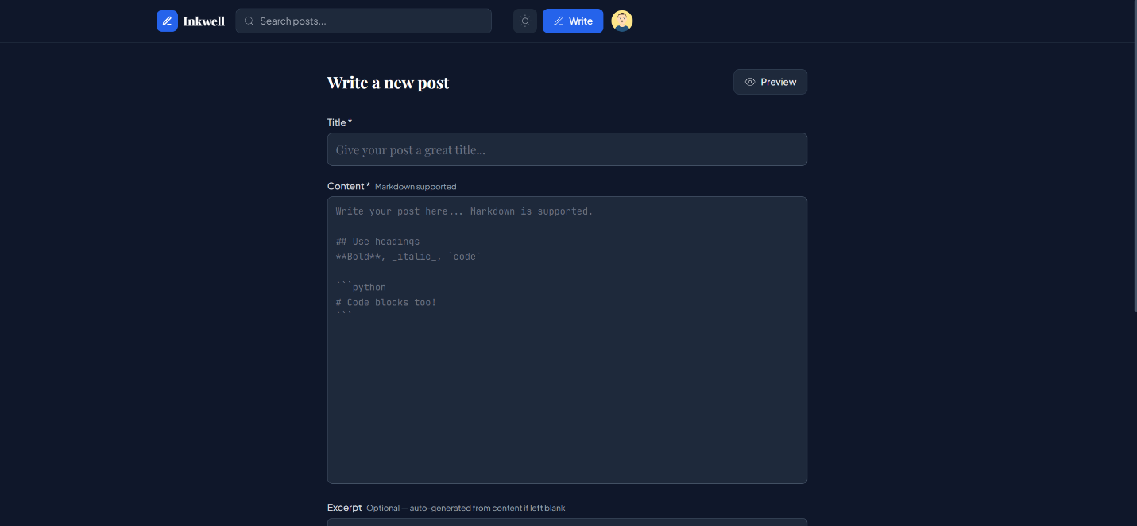

Module 8: Keep-Alive and Deployment
The deployment infrastructure uses Vercel for the React frontend and Render for the FastAPI backend, both on permanently free tiers. A custom keep-alive mechanism was implemented to prevent Render's free-tier spin-down behaviour. On startup, the FastAPI application creates an asyncio background task that waits 30 seconds for the server to fully initialise, then sends a GET request to the /health endpoint every 300 seconds using an httpx async HTTP client. The Render external URL is read from the RENDER_EXTERNAL_URL environment variable automatically set by Render, ensuring the mechanism only activates in the production environment and not during local development.
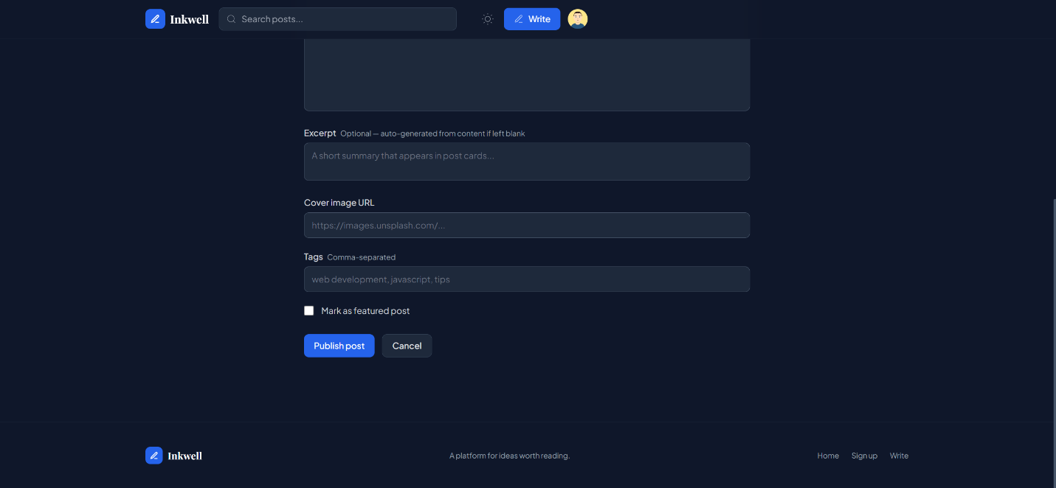

Results Summary
The following table summarises the implementation status and key features of all system modules:

Module | Status and Key Features
User Authentication | Fully implemented. JWT tokens, bcrypt hashing, 30-day sessions, demo accounts.
Post Management | Fully implemented. Markdown editor, preview toggle, slug generation, cover images.
Comment System | Fully implemented. Chronological display, owner deletion, unauthenticated CTA.
Post Likes | Fully implemented. Toggle like/unlike, real-time count, heart icon state.
Tags and Search | Fully implemented. Tag sidebar, active filter highlight, full-text search.
Author Profiles | Fully implemented. Public profiles, aggregated stats, post history.
Dark Mode | Fully implemented. System preference detection, localStorage persistence.
Seed Content | Fully implemented. 5 authors, 8 posts, comments, likes pre-loaded on startup.
Keep-Alive | Fully implemented. asyncio background ping every 5 minutes on Render.
Deployment | Fully implemented. Live on Vercel (frontend) and Render (backend).

Conclusion
Inkwell successfully demonstrates the design, development, and deployment of a complete, production-grade full-stack web application. The system directly satisfies all four requirements specified in the assignment brief and substantially exceeds them through the implementation of professional-grade features including dark mode, read time estimation, author profiles, tag-based discovery, full-text search, view counters, and a comprehensive seed data layer.
The technology choices made for this project — React with Vite for the frontend, FastAPI for the backend, SQLAlchemy for database access, and JWT with bcrypt for authentication — represent current industry best practices for building scalable, maintainable web applications. The decoupled client-server architecture ensures that the frontend and backend can be developed, tested, and scaled independently, a pattern that is foundational to modern software engineering practice.
The deployment of the system to live production infrastructure on Vercel and Render, with a custom keep-alive mechanism ensuring zero cold-start latency for visitors, demonstrates practical knowledge of cloud deployment workflows including environment variable management, CI/CD from GitHub, and runtime configuration. The project is publicly accessible and can serve as a demonstrable, real-world artifact in a professional portfolio.
All eight planned system modules have been fully implemented and tested. The three core modules — authentication, post management, and commenting — constitute a complete and functional blogging platform in their own right. The remaining five modules significantly enhance the platform's professional quality and usability, collectively elevating the project from a functional prototype to a deployment-ready product.

Future Scope
The current implementation represents a strong, feature-complete foundation with significant potential for further development. The following enhancements are identified as high-value directions for future iterations:
- Migration from SQLite to a hosted PostgreSQL database such as Supabase to enable persistent data across Render service restarts, multi-user concurrent access without locking, and complex analytical queries at scale.
- Implementation of a rich text editor using the Quill.js or TipTap library to replace the current Markdown text area, providing a word-processor-style editing experience with toolbar controls for formatting, image embedding, and table insertion.
- Addition of an image upload feature using Cloudinary's free-tier API to allow authors to upload cover images directly from their device rather than entering external image URLs.
- Development of a follower and following system enabling users to subscribe to specific authors and receive a personalised feed of content from the authors they follow.
- Implementation of email notification support using a transactional email API such as Resend or SendGrid to notify authors when their posts receive new comments or likes.
- Addition of post bookmarking functionality allowing readers to save posts to a personal reading list accessible from their profile page.
- Development of a mobile application for Android and iOS platforms using React Native, sharing the existing FastAPI backend and authentication infrastructure.
- Implementation of an OAuth 2.0 social login flow allowing users to register and authenticate with their existing Google or GitHub accounts, reducing registration friction.
- Addition of post view analytics visible to post authors, showing view counts over time, geographic distribution of readers, and referral sources.

References
- Fielding, R. T. (2000). Architectural Styles and the Design of Network-based Software Architectures. Doctoral dissertation, University of California, Irvine.
- Ramírez, S. (2018). FastAPI — Modern, Fast Web Framework for Building APIs with Python. https://fastapi.tiangolo.com
- Facebook Inc. (2013). React — A JavaScript Library for Building User Interfaces. https://reactjs.org
- You, E. (2020). Vite — Next Generation Frontend Tooling. https://vitejs.dev
- Jones, M., Bradley, J., & Sakimura, N. (2015). JSON Web Token (JWT). RFC 7519, Internet Engineering Task Force.
- Provos, N., & Mazières, D. (1999). A Future-Adaptable Password Scheme. Proceedings of the FREENIX Track: 1999 USENIX Annual Technical Conference.
- Wathan, A. (2019). Tailwind CSS — A Utility-First CSS Framework. https://tailwindcss.com
- SQLAlchemy Documentation. (2024). SQLAlchemy 2.0 — The Database Toolkit for Python. https://docs.sqlalchemy.org
- OpenAPI Initiative. (2021). OpenAPI Specification 3.0. https://spec.openapis.org/oas/v3.0.0
- OWASP Foundation. (2024). Authentication Cheat Sheet. OWASP Cheat Sheet Series. https://cheatsheetseries.owasp.org
- Vercel Inc. (2024). Vercel Platform Documentation. https://vercel.com/docs
- Render Inc. (2024). Render Cloud Application Platform Documentation. https://render.com/docs
- Mozilla Developer Network. (2024). Web APIs — Fetch API, localStorage, History API. https://developer.mozilla.org
- Rose, S., Borchert, O., Mitchell, S., & Connelly, S. (2020). Zero Trust Architecture. NIST Special Publication 800-207.

