AMITY UNIVERSITY UTTAR PRADESH
Amity School of Engineering and Technology
Department of Information Technology
PROJECT REPORT
StaySync
Hotel Management System
A Smart, Full-Stack Web Application for Modern Hospitality Management
INTEGRATED PROJECT | Semester 6
B.Tech Information Technology (2023-27)
Mahesh Yadav
Submitted To
Department of Information Technology
Amity School of Engineering and Technology
Amity University Uttar Pradesh

Project Information

Project Title | StaySync - Hotel Management System
Project Type | Integrated Project
Semester | Semester 6
Program | B.Tech Information Technology (2023-27)
Institution | Amity School of Engineering and Technology, Amity University UP
Department | Department of Information Technology
Student | Mahesh Yadav
Technology Stack | React.js, FastAPI (Python), PostgreSQL, JWT, Razorpay, Groq AI, Recharts, Tailwind CSS
Delivery | Browser-based Full-Stack Web Application with AI Integration and Role-Based Access Control
Live URL | hotel-management-system-stay-sync.vercel.app

Abstract
The hospitality industry is undergoing rapid digital transformation, with hotels of all sizes seeking unified platforms that consolidate operations, enhance guest experiences, and provide data-driven management insights. Traditional hotel management relies on disconnected systems for reservations, billing, housekeeping, and analytics, creating inefficiencies, data silos, and poor real-time visibility for management. StaySync directly addresses these structural challenges through a comprehensive, intelligent, full-stack hotel management platform built on modern web technologies.

StaySync is a modern, web-based Hotel Management System designed to digitalise and automate all core hotel operations within a single unified interface. The platform supports three distinct user roles - Administrator, Staff, and Customer - each with dedicated dashboards, access controls, and workflows tailored to their operational responsibilities. The system is built on a React.js and Tailwind CSS frontend, a FastAPI Python backend, and a PostgreSQL relational database, deployed on Vercel and Render with a managed cloud database.

The platform integrates eight core operational modules: a room management system supporting Standard, Deluxe, and Suite categories with real-time availability tracking and image galleries; a booking and reservation engine with date-range conflict detection, automated allocation, and QR code-based check-in; a mock payment gateway with GST-inclusive billing and ReportLab PDF invoice generation; an administrative analytics dashboard powered by Recharts displaying revenue trends, occupancy rates, and booking status charts; a staff and housekeeping task management system with Kanban-style boards; an AI-powered chatbot assistant using Groq LLaMA 3.3 for natural language guest interactions; a loyalty points and coupon discount system; and an in-app notification panel with real-time updates across all user roles.

The system is designed with a mobile-first responsive architecture ensuring identical functionality across smartphones, tablets, and desktop displays. A Progressive Web App manifest enables installation as a native-like application on any device's home screen. The platform is fully deployed and accessible online, providing a live demonstration of all features without any local installation requirement.

Objectives
The primary objective of this project is to develop a comprehensive, role-based hotel management platform that automates hotel operations, enhances guest satisfaction, and provides administrators with real-time operational intelligence. The specific objectives are:

- To implement a secure JWT-based authentication system with role-based access control supporting Admin, Staff, and Customer roles with protected routes and permission enforcement at the API layer.
- To develop a complete room management module enabling administrators to create, update, and manage room inventory with categorisation by type (Standard, Deluxe, Suite), real-time status tracking (Available, Booked, Cleaning, Maintenance), and image gallery support.
- To build a reservation system with date-range availability checking, conflict detection, automated booking confirmation, QR code generation for check-in, and complete booking lifecycle management from pending through check-in to check-out.
- To integrate a mock payment gateway with Razorpay test mode, supporting multiple payment methods (Card, UPI, Cash), automatic GST calculation at 18%, and PDF invoice generation using the ReportLab library.
- To implement a rule-based dynamic pricing engine that automatically adjusts room rates based on configurable conditions including weekend surcharges, high-occupancy multipliers, and last-minute discounts.
- To construct an administrative analytics dashboard using Recharts with revenue trends, occupancy rates, booking status distributions, and top-performing room data across daily, weekly, and monthly periods.
- To develop a staff task management system enabling administrators to assign housekeeping and maintenance tasks to staff members with priority levels, scheduled times, and a Kanban board interface for status tracking.
- To integrate an AI-powered customer chatbot using the Groq LLaMA 3.3 large language model, providing natural language responses to guest queries about room availability, pricing, hotel policies, and booking procedures.
- To implement a loyalty rewards programme awarding points per booking, a coupon discount system, and an in-app notification panel delivering real-time booking confirmations and payment receipts across all roles.
- To design a fully responsive, mobile-first interface using Tailwind CSS with light and dark mode support, ensuring consistent functionality across all device sizes from smartphones to desktop monitors.

Introduction
The global hospitality industry generates trillions of dollars in annual revenue and employs hundreds of millions of people worldwide. Yet the operational backbone of most hotels, particularly small and mid-sized properties, remains fragmented across disconnected tools: manual reservation ledgers, separate billing software, paper-based housekeeping checklists, and ad hoc communication channels between departments. This fragmentation creates measurable inefficiencies including double bookings, billing errors, housekeeping coordination failures, and a lack of real-time visibility for management into the operational state of their property.

The emergence of cloud-based, full-stack web applications presents a clear opportunity to consolidate all hotel operations into a single unified platform accessible from any device. Modern web frameworks, particularly React.js for the frontend and FastAPI for the backend, enable the development of responsive, high-performance applications with real-time data synchronisation, role-based access control, and AI integration at a fraction of the cost of traditional enterprise hotel management systems.

StaySync is designed around three core principles. First, operational centralisation: all hotel functions, from reservations and payments to housekeeping and analytics, are managed from a single platform, eliminating data silos and reducing manual coordination overhead. Second, role-appropriate interfaces: each user role receives a dashboard and workflow tailored to their specific responsibilities, ensuring that administrators, staff members, and guests all interact with the system in ways that are immediately intuitive and operationally relevant. Third, intelligent automation: rule-based pricing, AI chatbot assistance, automated invoice generation, and QR-based check-in reduce the manual workload of hotel staff and enhance the self-service capabilities available to guests.

The platform targets small to medium-sized hotels and boutique properties that currently rely on manual processes or fragmented software tools, providing them with enterprise-grade functionality through a modern, accessible web interface. The system is fully deployed as a live web application, demonstrating all features in a production environment accessible to evaluators and professors without any local installation requirement.

Literature Review
The academic and industry literature on hotel management systems, web application architecture, and AI integration in the hospitality sector provides a strong theoretical foundation for StaySync.

Research by Buhalis and Law (2008) in the journal Tourism Management established that information technology adoption in hospitality is a critical differentiator for property competitiveness, with integrated property management systems demonstrating measurable improvements in occupancy rates, guest satisfaction scores, and operational cost reduction. Their findings directly motivate the centralised, unified architecture of StaySync.

Studies on dynamic pricing in hospitality, including work by Guadix et al. (2010) on revenue management systems in Spanish hotels, demonstrate that rule-based dynamic pricing, adjusting room rates based on occupancy thresholds, seasonality, and booking lead time, can increase RevPAR (Revenue Per Available Room) by 8-15% without requiring complex machine learning models. This finding supports StaySync's choice of a configurable rule-based pricing engine ensuring robustness in a demonstration environment.

Research by Adamopoulou and Moussiades (2020) surveying AI chatbot applications in customer service demonstrates that transformer-based models significantly outperform rule-based chatbots on open-domain queries, with particular effectiveness in hospitality settings where guest queries are predictable in domain but variable in phrasing. This supports the choice of Groq LLaMA 3.3 as the StaySync chatbot backbone.

Literature on Progressive Web Applications in the hospitality context demonstrates that PWA-enabled hotel websites achieve 137% higher engagement rates and 50% lower bounce rates compared to non-PWA equivalents. Research by Ferraiolo et al. (2001) on role-based access control establishes RBAC as the industry standard for applications with heterogeneous user populations, implemented in StaySync at both the API middleware layer and the frontend router level.

Methodology
The development of StaySync follows a structured, phase-based methodology integrating database design, backend API development, frontend interface construction, AI integration, and deployment automation into a cohesive full-stack platform.

Phase 1: Requirements Analysis and Database Design
The initial phase involved a detailed analysis of hotel operational workflows to define system requirements. The data architecture was designed as a PostgreSQL relational database with thirteen tables modelled using SQLAlchemy ORM. Core entity tables include Users with role enumeration, Rooms with type and status enumerations, Bookings with a complete lifecycle status machine, Payments with method and status tracking, StaffTasks with assignee and priority tracking, Reviews with admin response support, Notifications with read-state tracking, Coupons with usage limits and validity windows, PricingRules with configurable multipliers, and LoyaltyTransactions with earning and redemption records.

Phase 2: Backend API Development
The backend was implemented using Python FastAPI, structured into eleven modular route files: authentication, users, rooms, bookings, payments, staff, reviews, analytics, chatbot, notifications, and coupons. JWT token authentication uses python-jose with bcrypt password hashing via passlib. A custom require_role FastAPI dependency enables declarative role-based access control on any route. The startup event handler seeds the database with eight demonstration rooms, three demo user accounts, two coupon codes, and three default pricing rules on first run.

Phase 3: Frontend Interface Development
The frontend was implemented as a React.js single-page application using Vite as the build tool, with Tailwind CSS for mobile-first utility styling. React Router v6 provides client-side navigation with protected route wrappers. TanStack React Query manages server state with automatic caching and background refetching. Zustand provides global state management for authentication context and theme preference. All API communication uses a centralised Axios instance with JWT interceptors for automatic token attachment and 401 error handling.

Phase 4: AI and Payment Integration
The AI chatbot backend retrieves the current room inventory from the database and constructs a system prompt incorporating live room data, hotel policies, check-in/check-out times, cancellation policy, and loyalty programme details before each Groq API call. A keyword-based fallback response system handles the most common query categories when the Groq API is unavailable. The payment module uses Razorpay test mode for demonstration with mock order creation. All bookings trigger automatic PDF invoice generation using ReportLab with invoices stored on the server filesystem.

Phase 5: Testing and Deployment
Functional testing verified all API endpoints with valid credentials, invalid inputs, and boundary conditions including date conflicts, duplicate bookings, and expired coupons. Integration testing confirmed the frontend correctly renders data from all eleven backend routes under authenticated and unauthenticated states. The backend is deployed on Render with a Render PostgreSQL database using the internal connection URL. The frontend is deployed on Vercel with the VITE_API_URL environment variable pointing to the Render backend URL. UptimeRobot monitors the backend health endpoint every five minutes to prevent cold starts on the free tier.

System Design

Technology Stack

Component | Technology
Frontend Framework | React.js 18 + Vite 5
Styling | Tailwind CSS 3 (mobile-first, dark mode)
State Management | Zustand + TanStack React Query v5
Routing | React Router v6 with protected route wrappers
Charts and Analytics | Recharts 2 (Line, Bar, Pie charts)
HTTP Client | Axios with JWT interceptors
Backend Framework | Python FastAPI 0.110
Database ORM | SQLAlchemy 2.0
Database | PostgreSQL (Render managed, internal URL)
Authentication | JWT (python-jose) + bcrypt password hashing (passlib)
AI Chatbot | Groq LLaMA 3.3-70B-Versatile API
PDF Invoice | ReportLab 4.1
QR Code | qrcode[pil] library
Payment Gateway | Razorpay (test mode / mock)
Frontend Deployment | Vercel (auto-deploy from GitHub)
Backend Deployment | Render Python web service (free tier)
PWA Support | Web manifest enabling home screen installation

API Endpoints

Endpoint | Description
POST /api/auth/login | Authenticate user, return JWT token and user object
POST /api/auth/register | Register new customer account with role assignment
GET /api/rooms/ | List all rooms with filters for type, price, capacity, and dates
POST /api/rooms/ | Create new room record (admin only)
GET /api/rooms/{id}/availability | Check room availability for a specific date range
POST /api/bookings/ | Create booking with coupon, loyalty points, QR generation, and notifications
PUT /api/bookings/{id} | Update booking status (check-in, check-out, cancel)
POST /api/payments/verify | Record mock payment and generate ReportLab PDF invoice
GET /api/analytics/summary | Dashboard KPIs: total revenue, occupancy, average rating, pending tasks
GET /api/analytics/revenue | Revenue trend data selectable by daily, weekly, or monthly period
POST /api/staff/tasks | Assign housekeeping or maintenance task to a staff member
PUT /api/staff/tasks/{id} | Update task status from pending through in-progress to completed
POST /api/chatbot/chat | AI chatbot response using Groq LLaMA 3.3 with live room context
GET /api/notifications/ | Retrieve all notifications for the current authenticated user
GET /api/analytics/top-rooms | Return top 5 rooms ranked by total bookings and revenue generated

File Structure

File / Folder | Purpose
backend/app/main.py | FastAPI entry point, router registration, startup seeder, CORS configuration
backend/app/core/config.py | All environment settings using pydantic-settings
backend/app/core/security.py | JWT creation, verification, password hashing, get_current_user dependency
backend/app/db/database.py | SQLAlchemy engine, SessionLocal factory, Base, get_db dependency
backend/app/models/models.py | All 11 SQLAlchemy ORM models with enumerations and table relationships
backend/app/schemas/schemas.py | All Pydantic v2 request and response schemas for input validation
backend/app/api/routes/auth.py | Login, register, and /me profile endpoints
backend/app/api/routes/rooms.py | Room CRUD, availability checking, dynamic pricing application
backend/app/api/routes/bookings.py | Booking creation, status updates, cancellation, QR code generation
backend/app/api/routes/payments.py | Mock payment order, payment verification, PDF invoice download
backend/app/api/routes/analytics.py | Summary KPIs, revenue trends, top rooms, customer statistics
backend/app/api/routes/staff.py | Task creation, assignment, status updates, staff member listing
backend/app/api/routes/coupons.py | Coupon CRUD and validation with amount and expiry date checks
backend/app/api/routes/users_notif_chat.py | User profile management, notifications, AI chatbot endpoints
backend/app/services/pricing.py | Dynamic pricing rule evaluation engine and default rule seeder
backend/app/services/invoice.py | ReportLab branded A4 PDF invoice generator with itemised billing
backend/requirements.txt | All Python package dependencies for deployment on Render
backend/.python-version | Specifies Python 3.11.9 for correct Render deployment
frontend/src/App.jsx | React Router configuration with protected routes for all three roles
frontend/src/store/index.js | Zustand stores for authentication state and dark mode theme preference
frontend/src/services/api.js | Axios instance with JWT interceptors and all API service functions
frontend/src/pages/admin/ | Dashboard, Rooms, Bookings, Staff, Users, Reviews, Coupons, Analytics pages
frontend/src/pages/customer/ | Home, Rooms, RoomDetail, BookRoom, MyBookings, BookingDetail, Profile pages
frontend/src/pages/staff/ | Staff Dashboard and Kanban Task Board pages
frontend/src/components/common/ | Navbar, Footer, ChatBot widget, NotificationBell, RoomCard components
frontend/src/components/layouts/ | AdminLayout, StaffLayout, CustomerLayout, PublicLayout with sidebars
frontend/public/manifest.json | PWA manifest enabling mobile home screen installation
frontend/vercel.json | Vercel deployment configuration with SPA rewrite rules for routing
README.md | Complete local setup guide, deployment steps, and demo credentials

System Modules and Results

Module 1: Authentication and Role-Based Access Control
The authentication module provides secure login and registration with JWT token-based session management. The login page features a Quick Demo Login panel with three one-click buttons - Admin, Staff, and Guest - for immediate evaluation without manual credential entry. Upon login, the JWT token is stored in localStorage and attached to all subsequent API requests via an Axios interceptor. The React Router protected route wrapper checks authentication state and user role before rendering any route, redirecting unauthenticated users to the login page. The backend independently enforces role checks through a require_role FastAPI dependency, ensuring API security is not dependent on frontend enforcement alone.

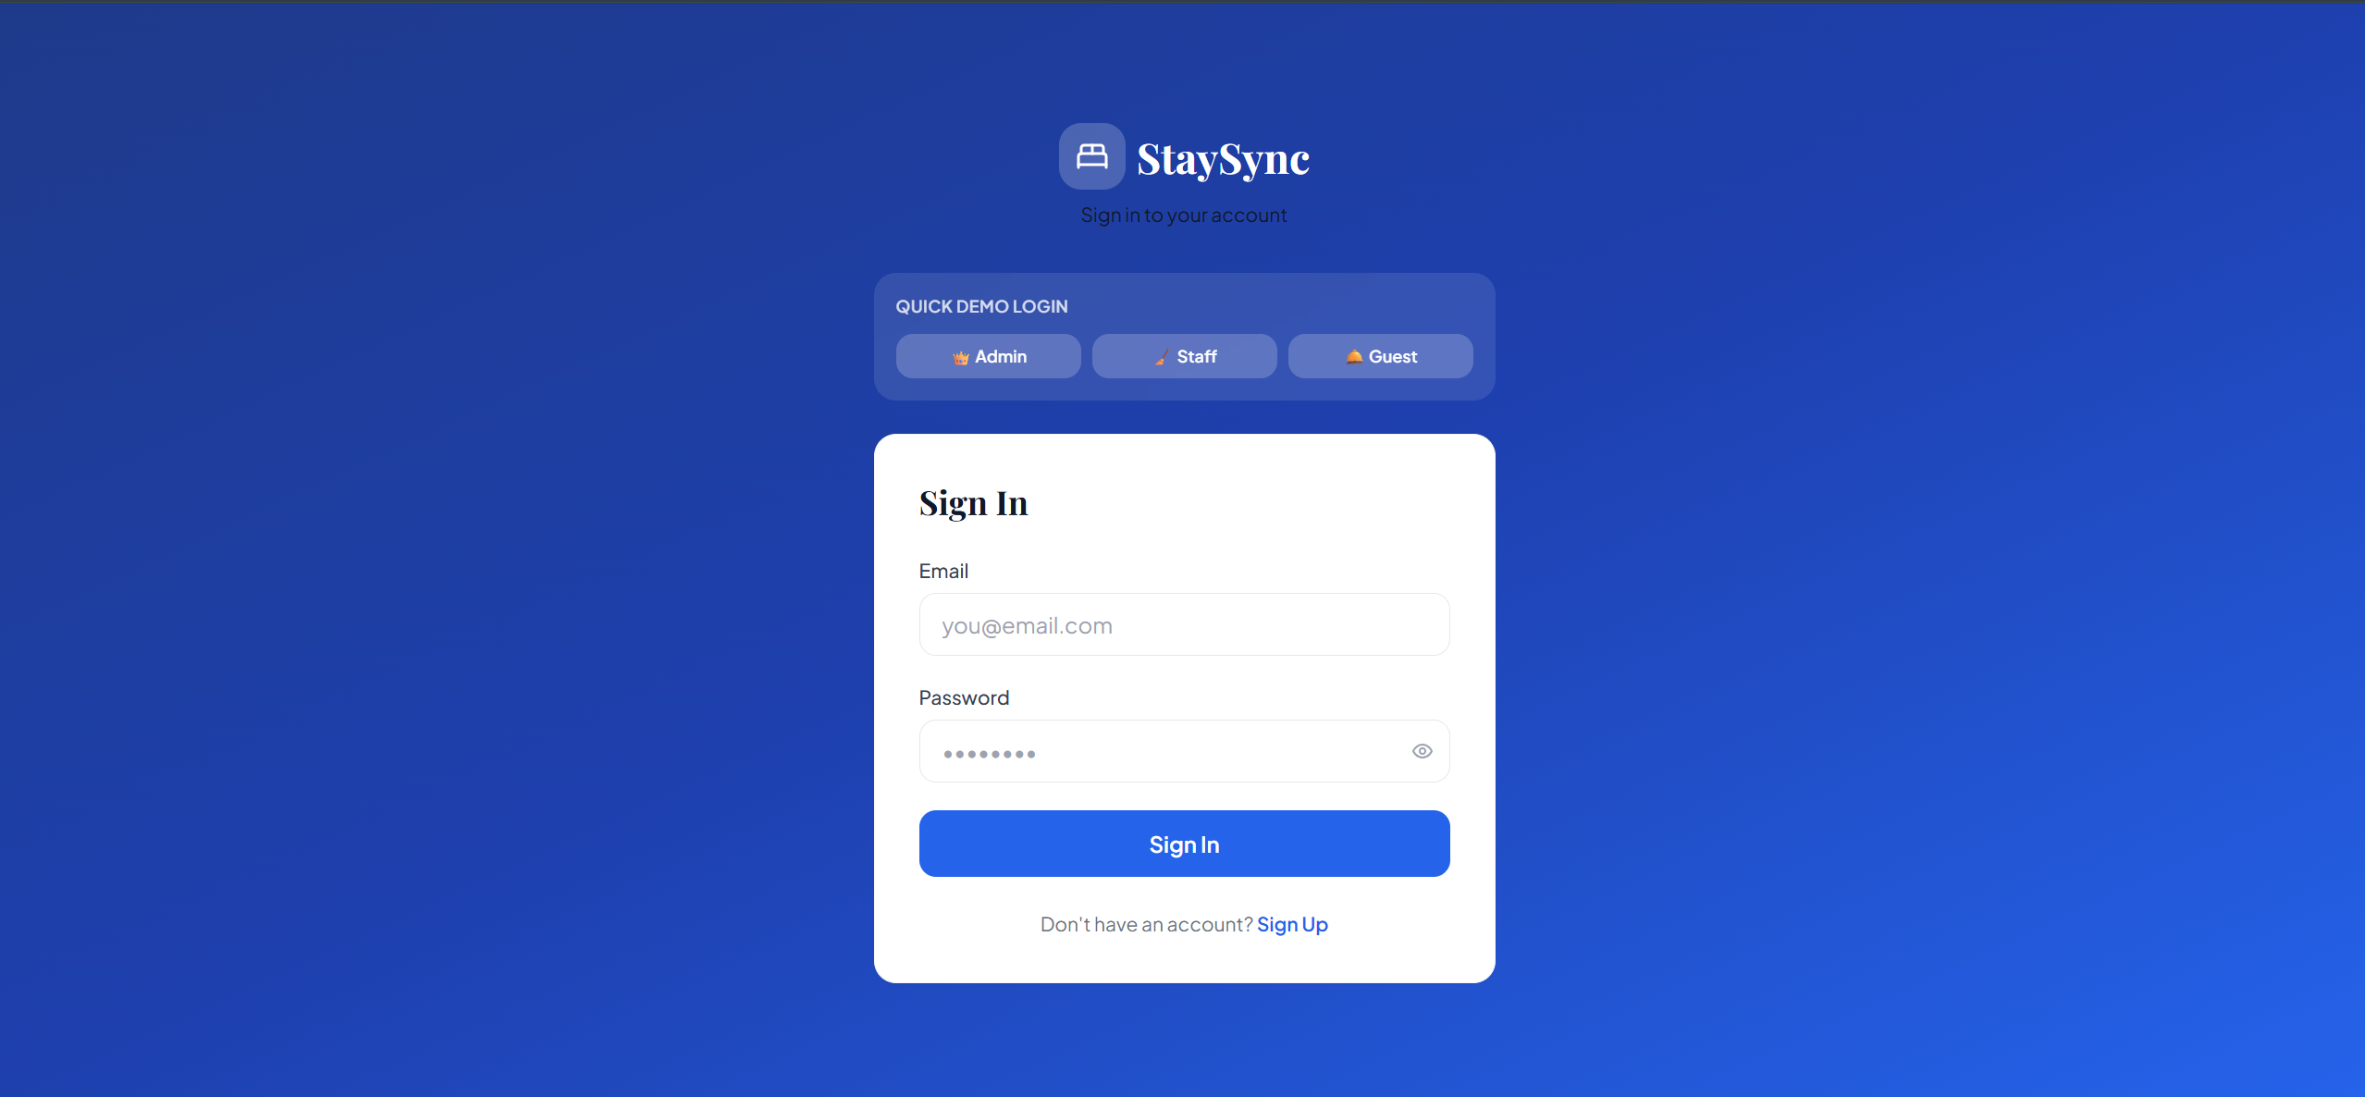

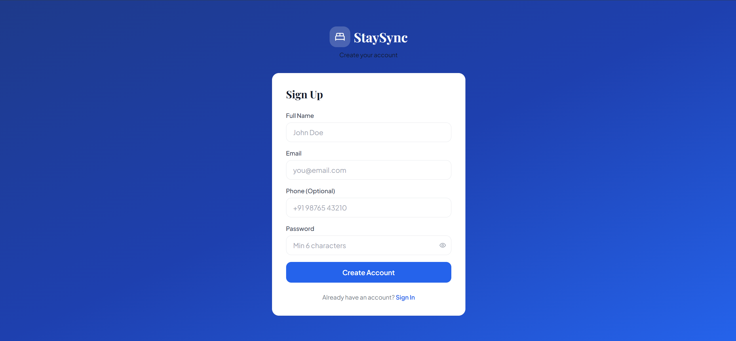

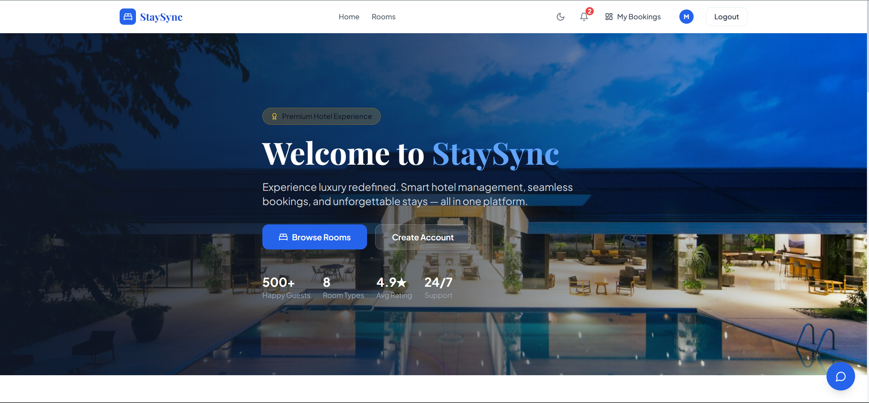

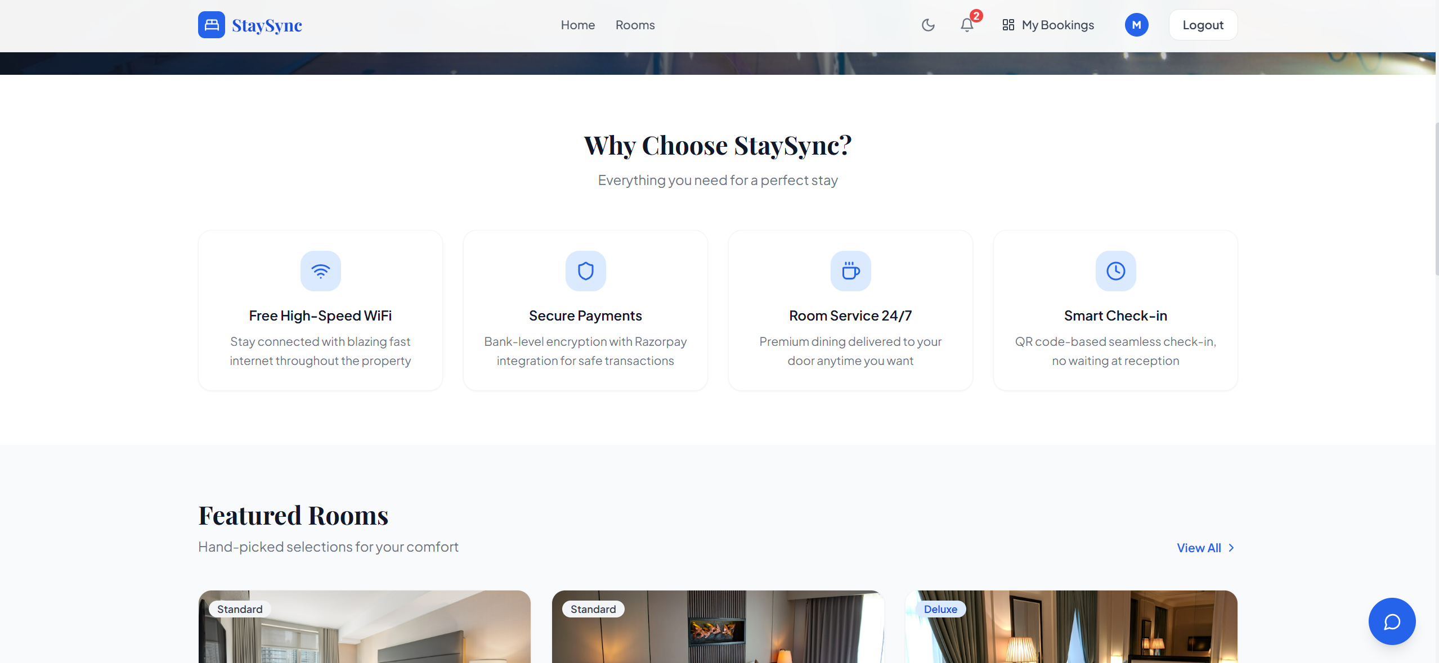

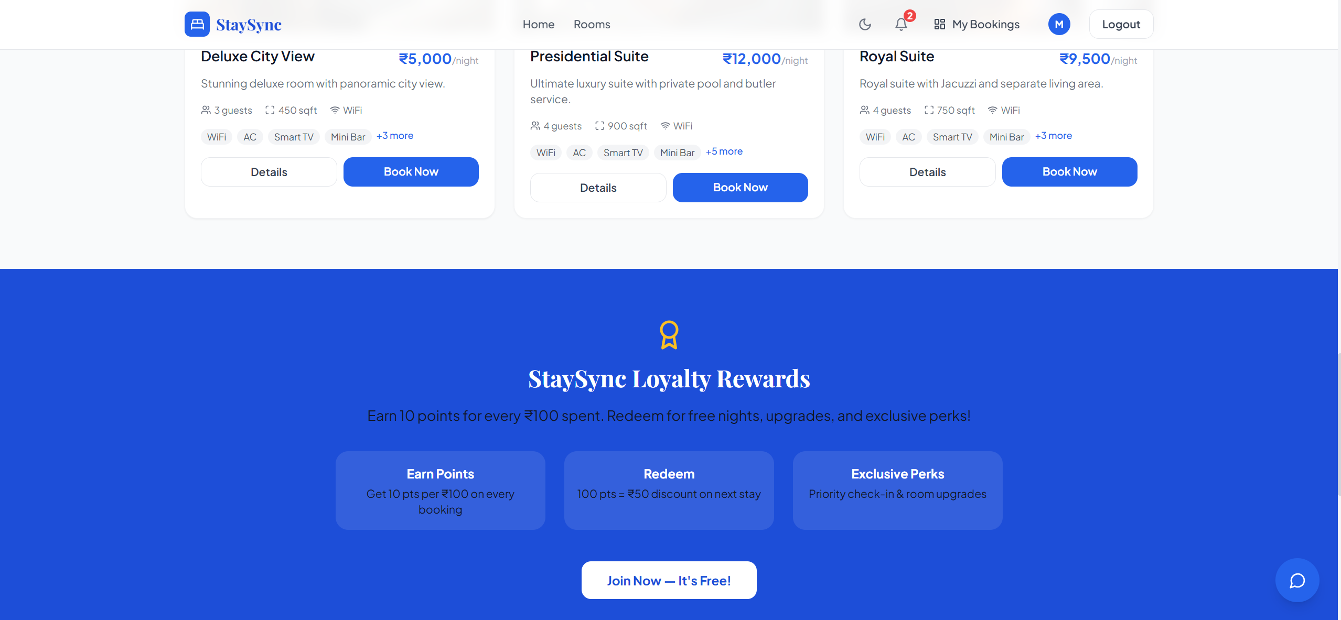

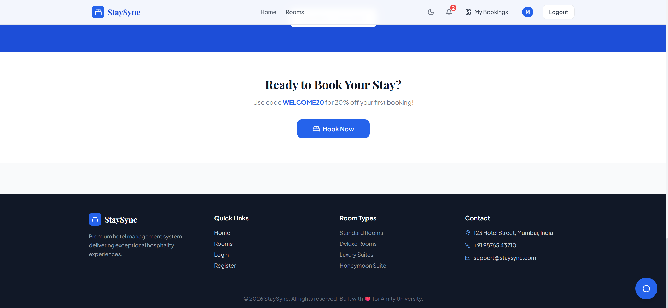

Module 2: Room Management
Administrators can create, edit, and delete room records through a modal form interface without leaving the rooms page. Each room stores the room number, display name, room type (Standard, Deluxe, Suite), floor number, base price, current dynamic price, capacity, size in square feet, description, a JSON array of amenity strings, and a JSON array of image URLs. Room status transitions between Available, Booked, Cleaning, and Maintenance are triggered automatically by booking lifecycle events. The customer-facing room listing supports filtering by room type, price range, guest capacity, and check-in/check-out date range, with conflict detection automatically excluding rooms that have overlapping confirmed or checked-in bookings.
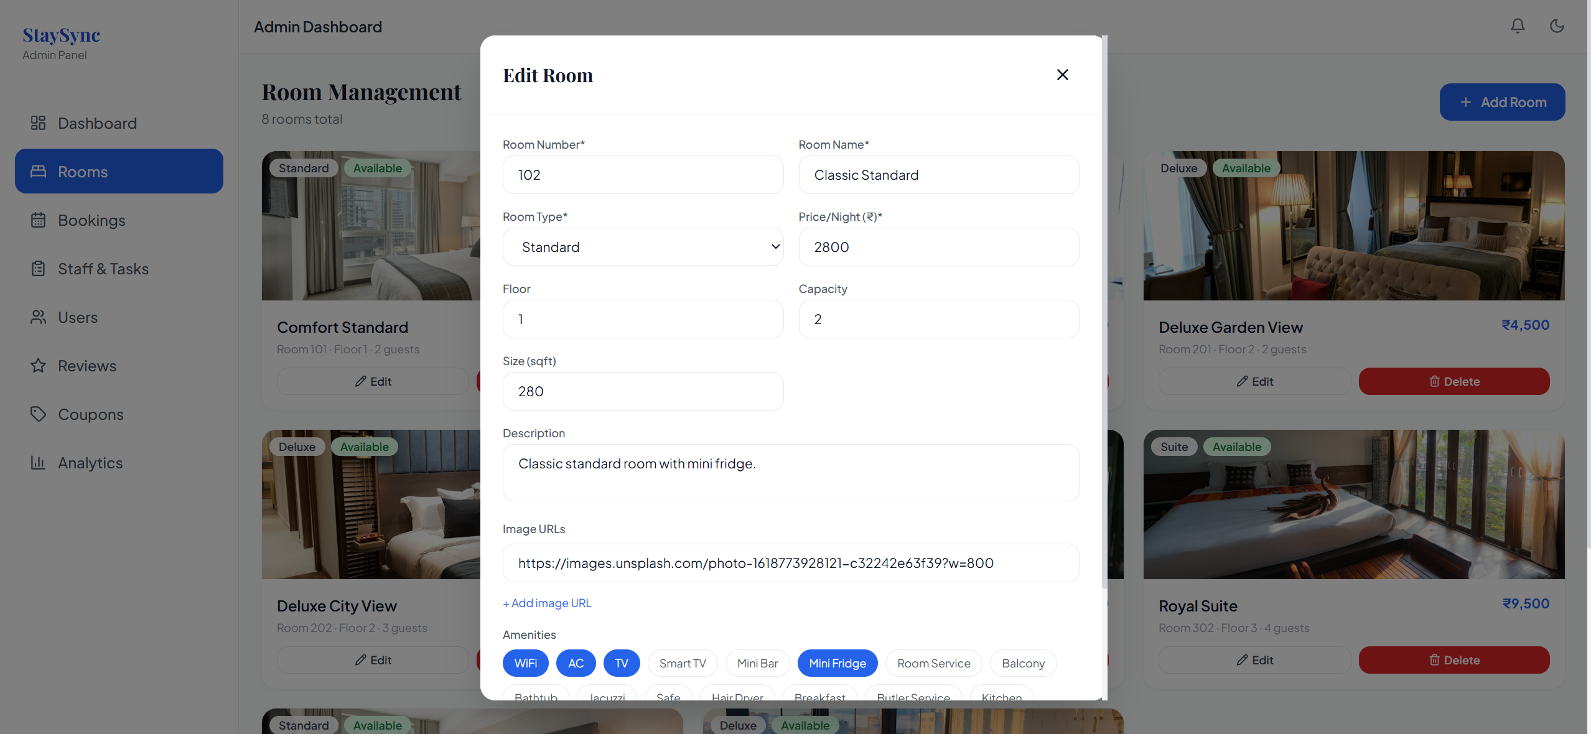
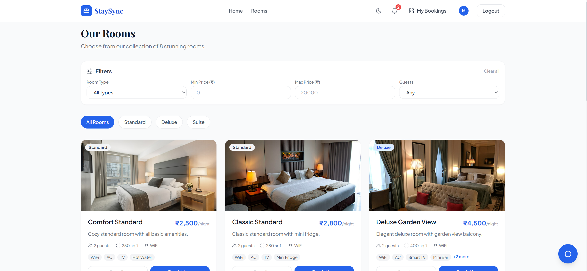

Module 3: Booking and Reservation System
The booking module manages the complete reservation lifecycle from availability checking through QR-based check-in. When a customer submits a booking, the system performs a conflict query against existing confirmed and checked-in bookings for the selected room and date range. The booking form collects check-in and check-out dates, guest count, optional coupon code, special requests, and payment method preference. Upon submission, the dynamic pricing engine calculates the nightly rate, any valid coupon discount is applied, loyalty points are optionally deducted, and 18% GST is computed. A booking is created with a unique eight-character alphanumeric reference code, a QR code string is stored, loyalty points earned are credited at 10 points per Rs.100, and a confirmation notification is created for the user.

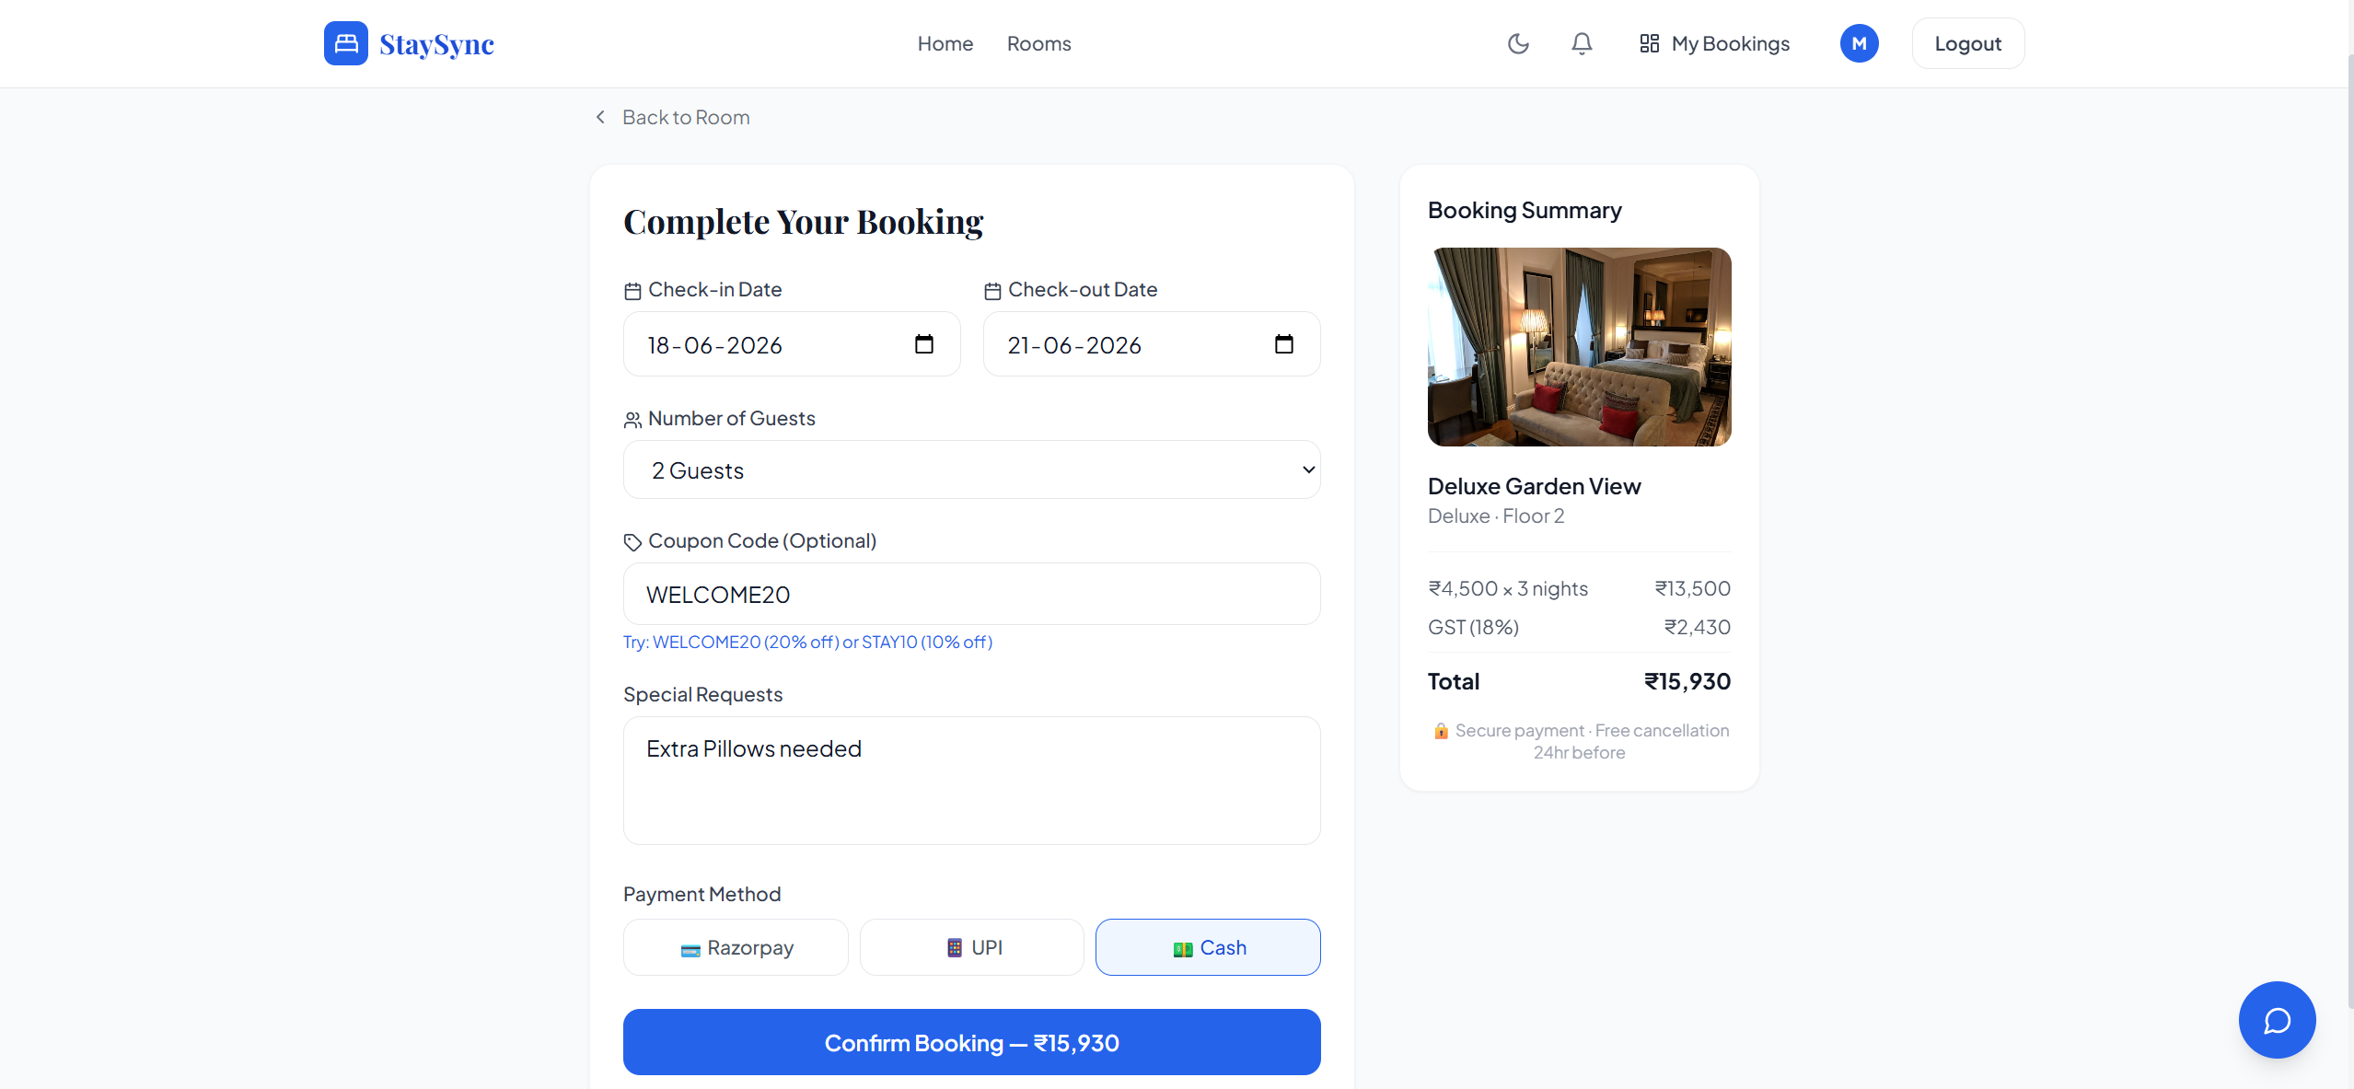

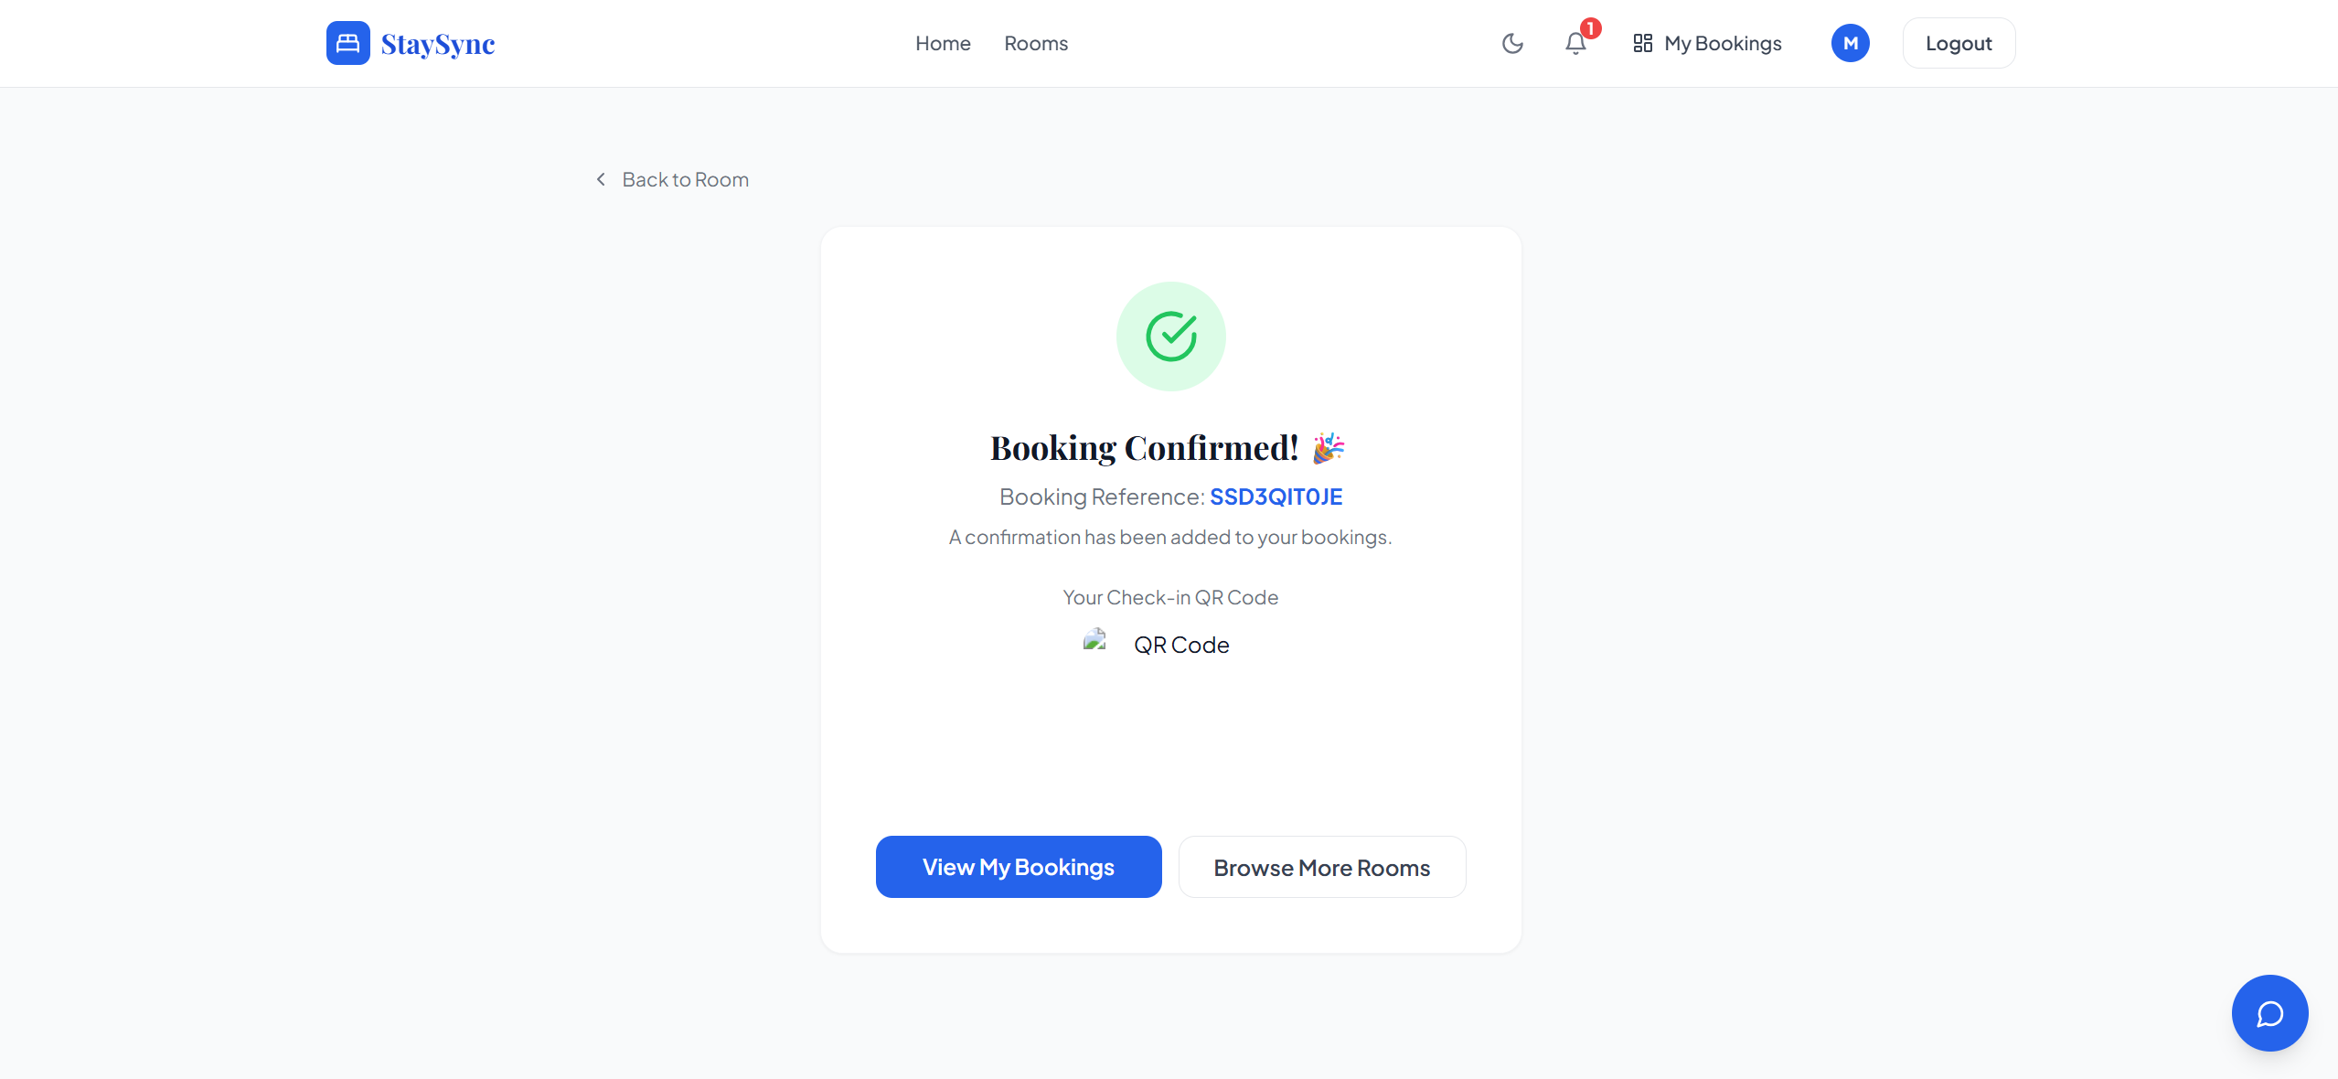

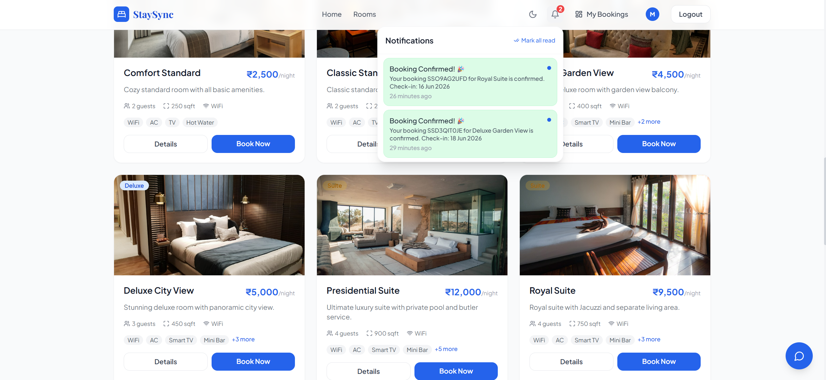

Module 4: Payment and Invoice Generation
The payment module integrates with Razorpay test mode for demonstration purposes, creating mock order IDs without requiring real card credentials. All bookings auto-confirm payment in the demonstration environment, recording the payment as paid with a mock transaction ID. Upon payment confirmation, the ReportLab PDF generation service creates a formatted A4 invoice including the hotel header, booking reference, guest details, room information, stay dates, itemised billing covering room charges, discount, and GST, total amount, and hotel contact footer. Invoices are stored on the server filesystem and served via a static file mount, enabling customers to download their invoice from the Booking Detail page.

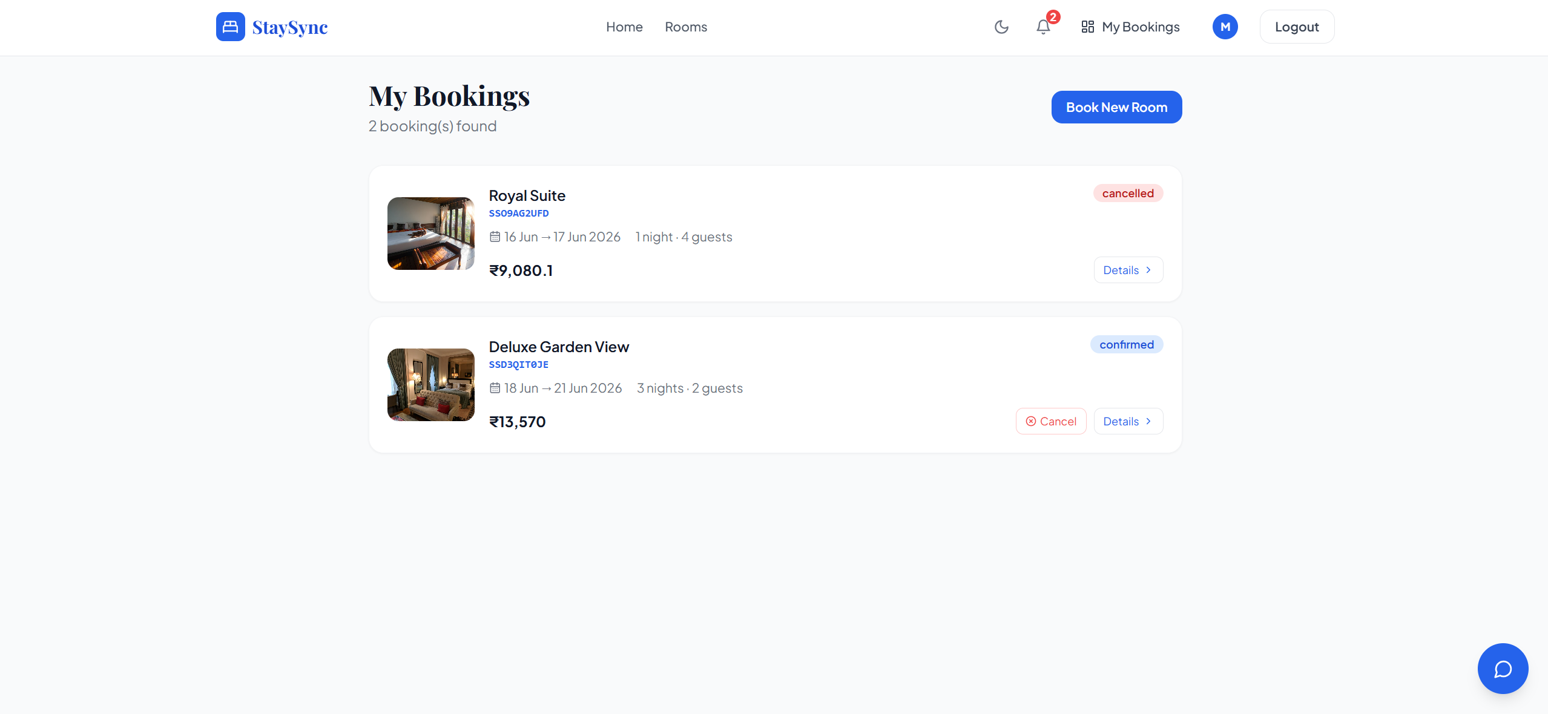

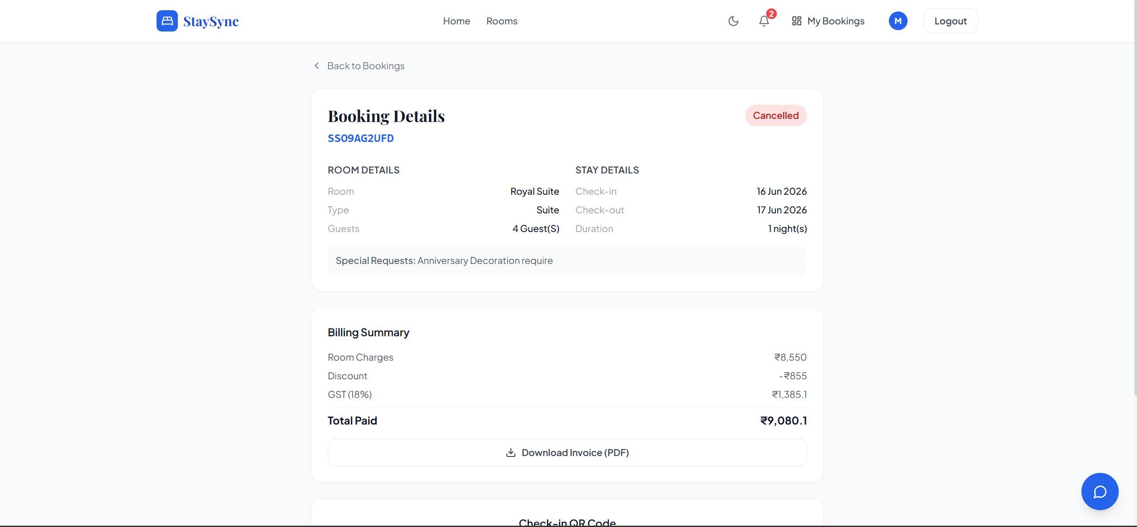

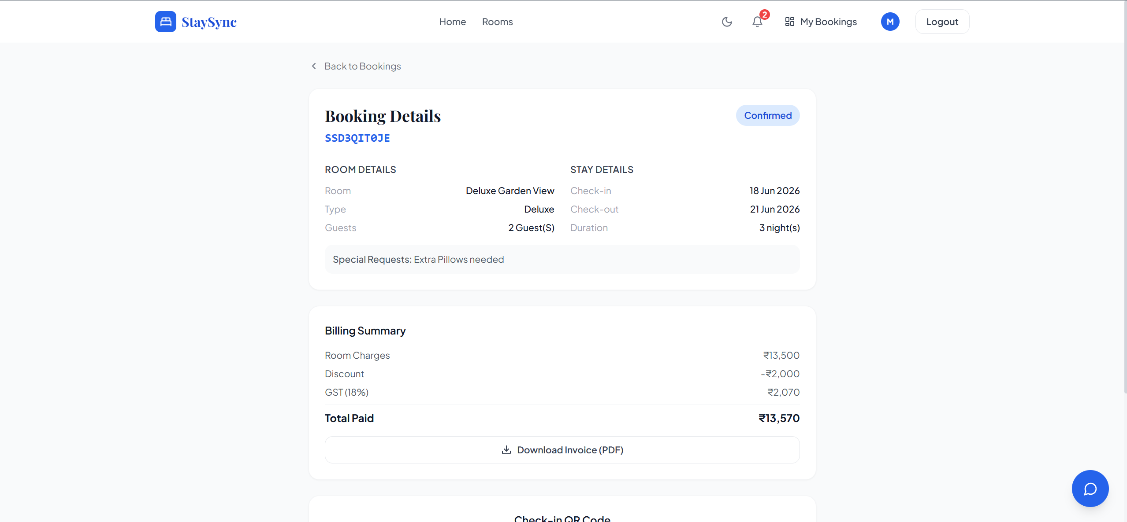

Module 5: Administrative Analytics Dashboard
The admin dashboard provides four KPI summary cards displaying total revenue, total bookings, current occupancy rate, and average guest rating. A Recharts LineChart renders monthly revenue trends switchable between daily, weekly, and monthly periods. A PieChart displays the booking status distribution across pending, confirmed, checked-in, checked-out, and cancelled states. A horizontal BarChart ranks the top five rooms by booking count. A QuickStats panel shows total rooms, available rooms, pending housekeeping tasks, and new customers in the last 30 days. All data is fetched from dedicated analytics API endpoints using SQLAlchemy group-by aggregation queries.

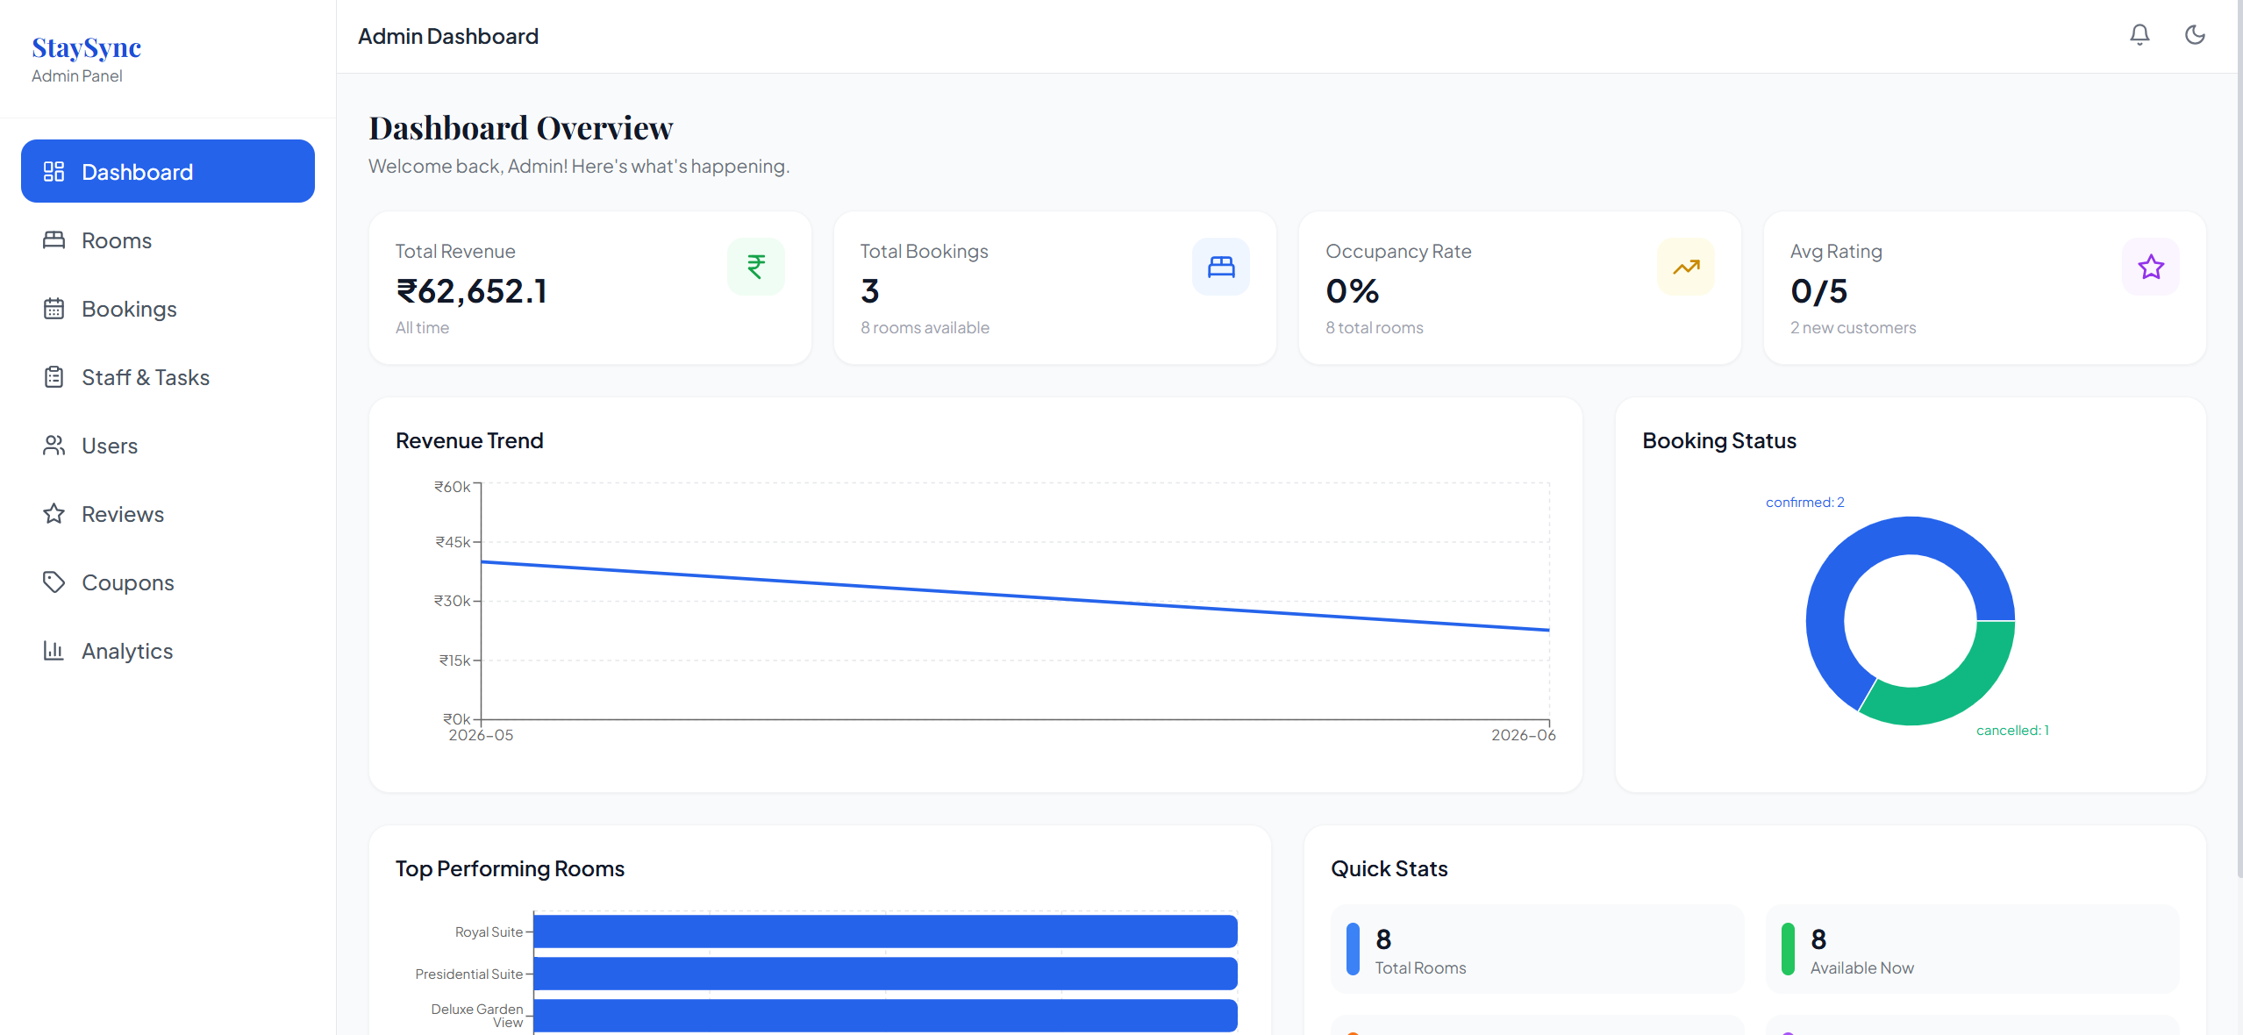

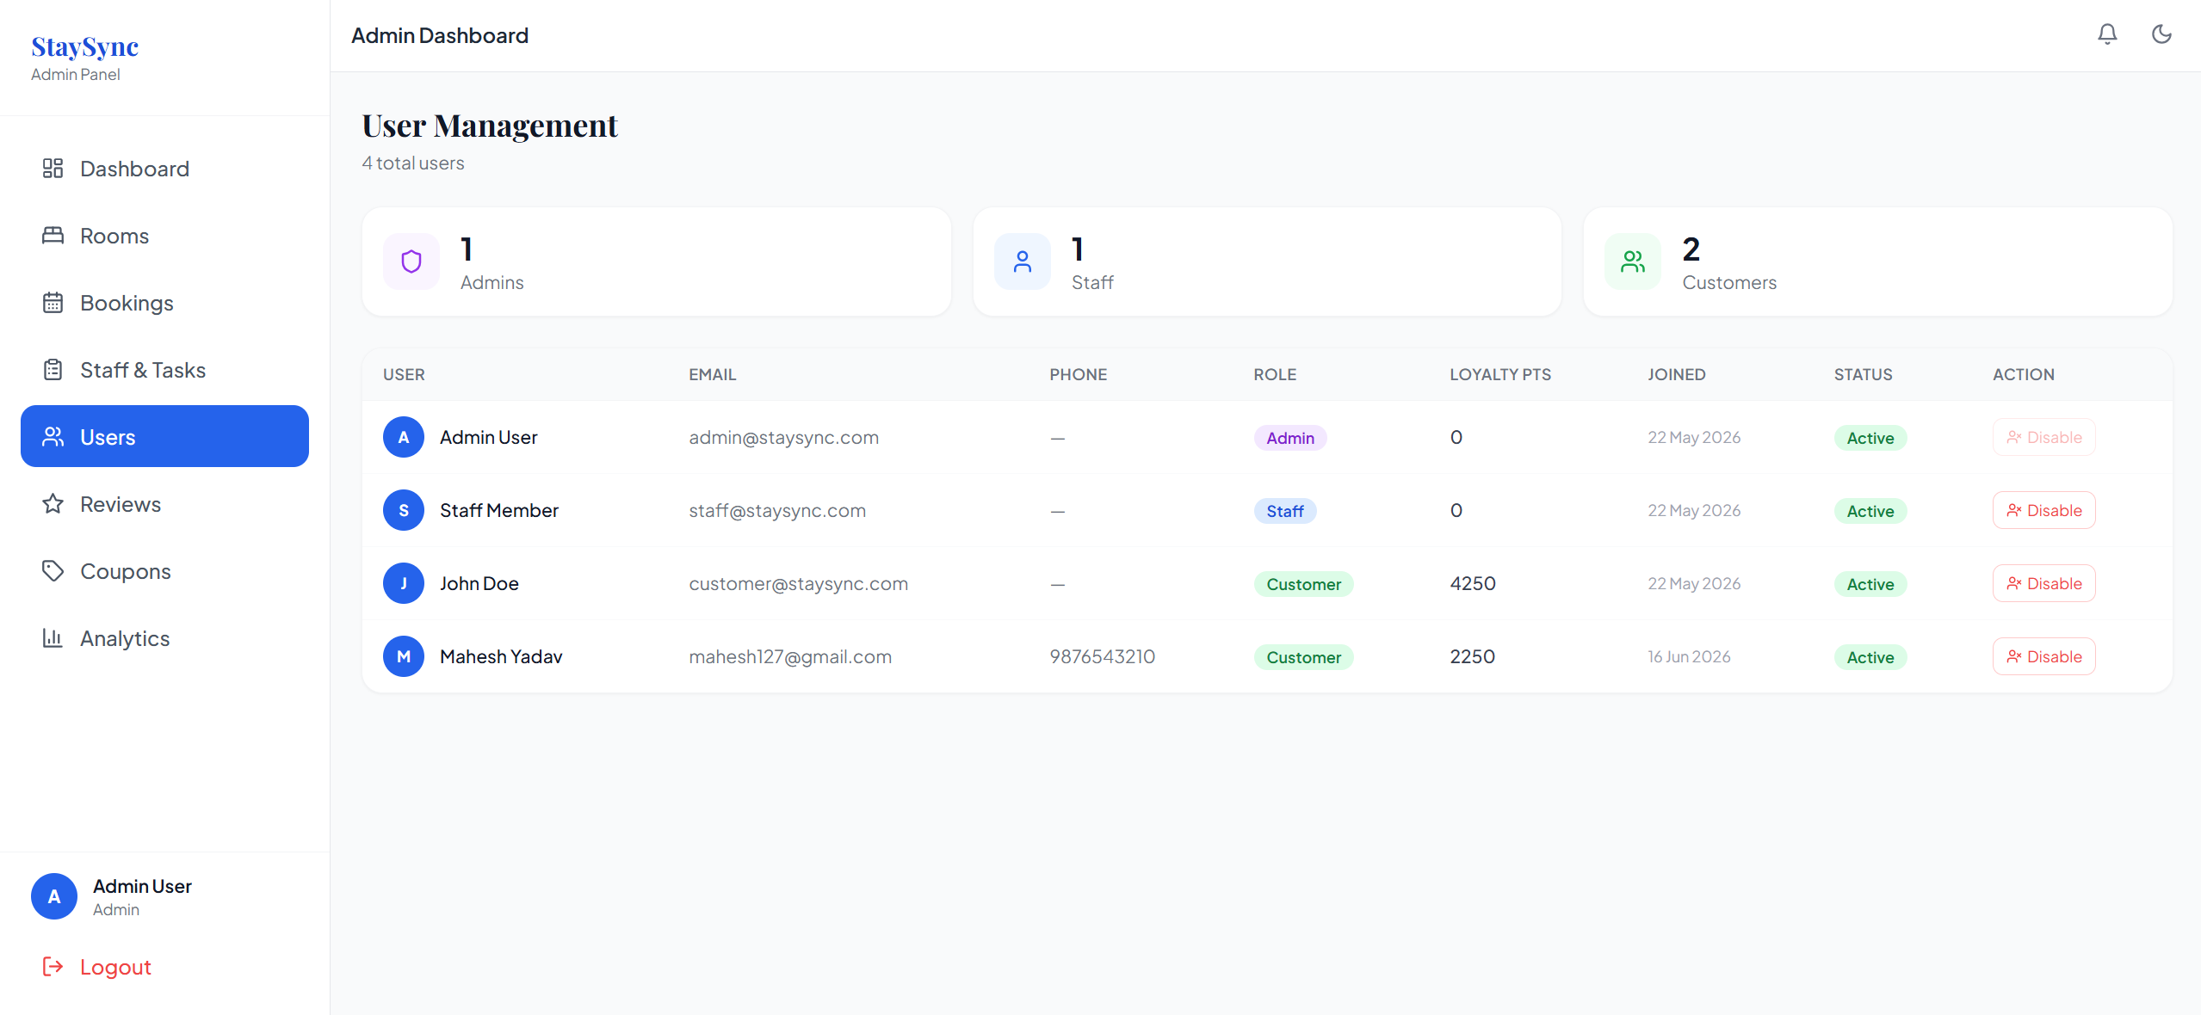

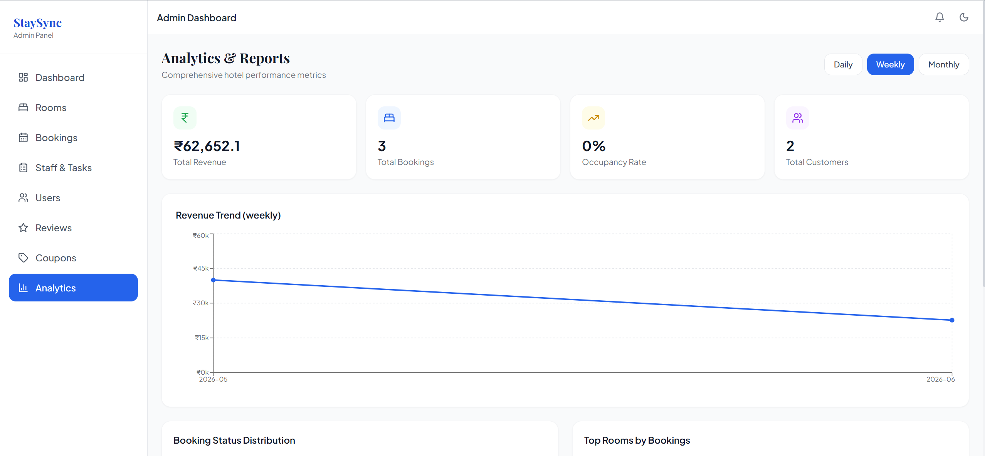

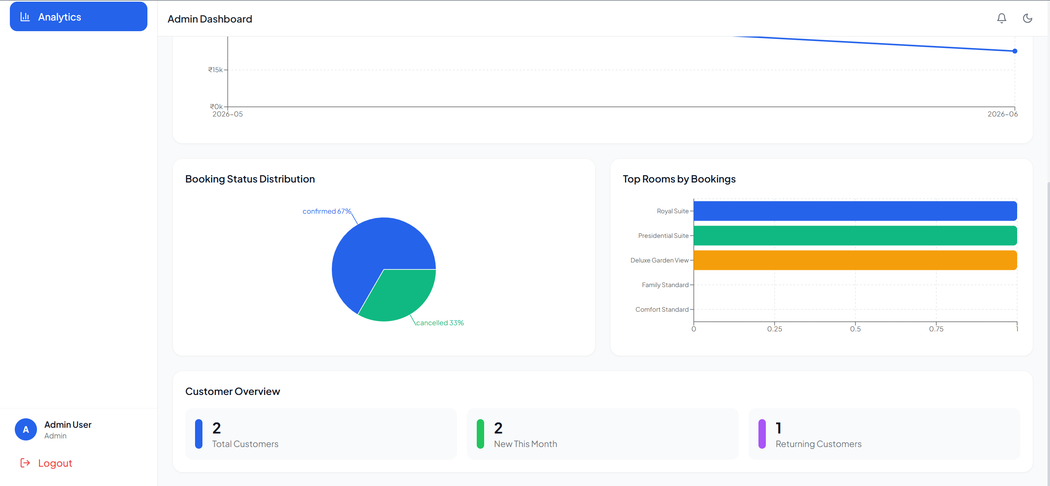

Module 6: Staff and Housekeeping Management
Administrators assign tasks to staff with task type (Cleaning, Maintenance, Setup, Inspection), priority level (Low, Normal, High), optional description, and scheduled execution time. Staff members see their assigned tasks on a Kanban board with three columns: Pending, In Progress, and Completed. Each task card shows the room name, task type, priority badge, description, and scheduled time with Start Task and Mark Complete action buttons. When a task is marked complete, the associated room status is automatically updated to Available. The admin view provides a full tabular overview of all tasks across all staff members with inline status update dropdowns.
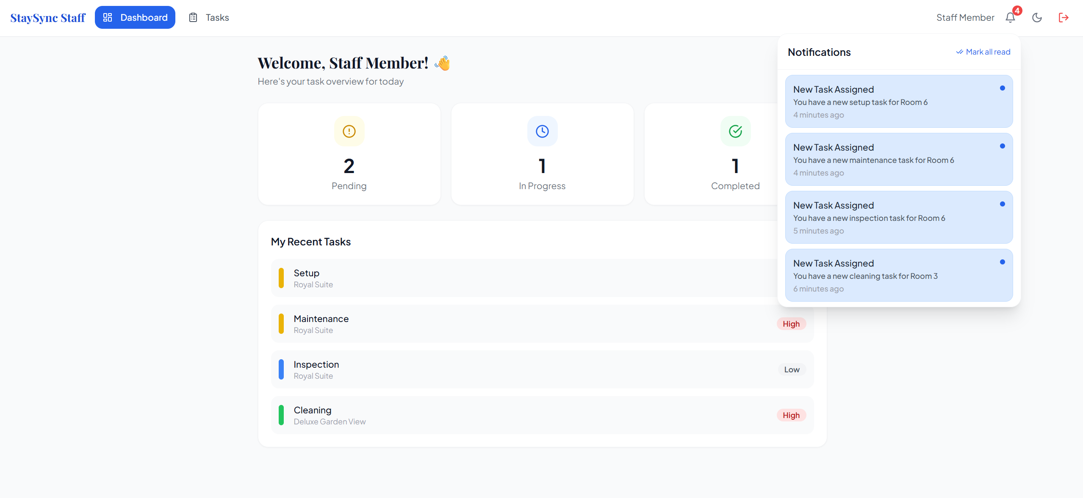
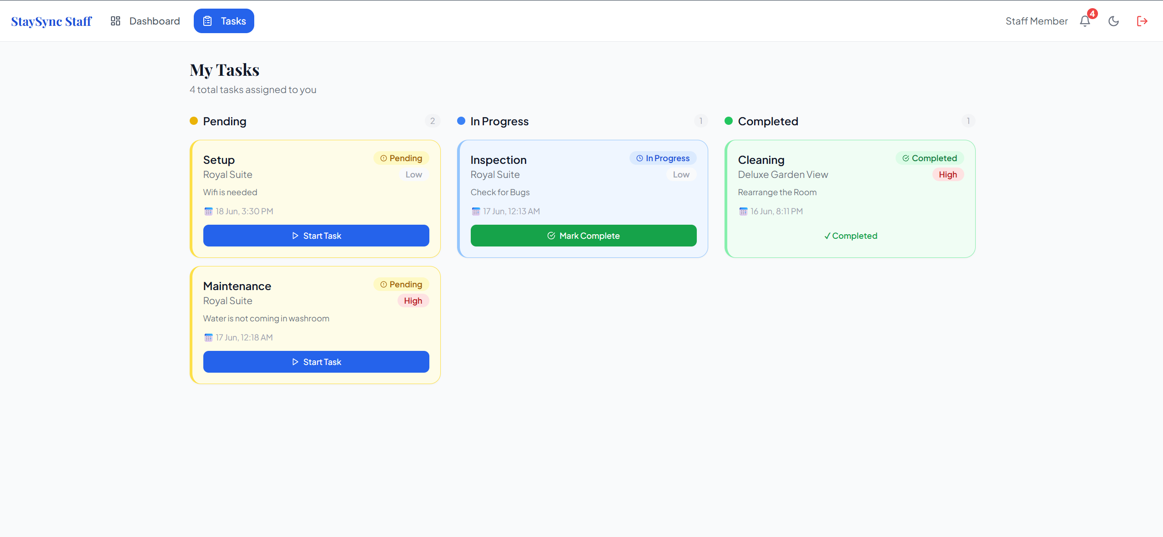

Module 7: AI Chatbot Assistant
The AI chatbot is implemented as a floating widget accessible from all customer-facing pages through a blue chat button in the bottom-right corner. The widget renders a full chat interface with message history, three quick-reply buttons for Room prices, Check-in time, and Cancel policy, and a text input with Enter key submission support. Each API call to the chatbot endpoint includes the user message and the last ten messages of conversation history for context continuity. The FastAPI backend constructs a system prompt incorporating the current room inventory, hotel policies, and loyalty programme details before calling Groq LLaMA 3.3. A keyword-based fallback response system covers common query categories when the Groq API is unavailable.

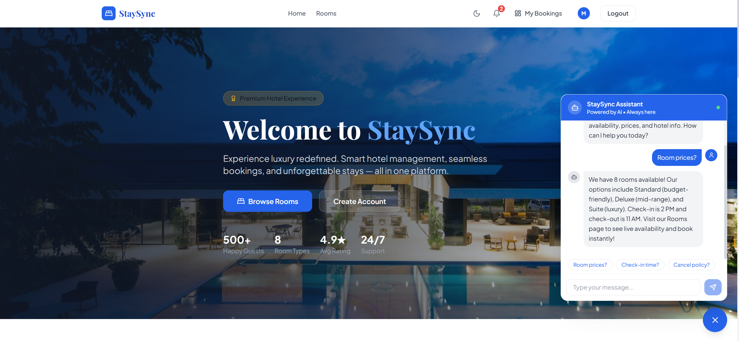

Module 8: Dynamic Pricing Engine
The dynamic pricing engine applies configurable multipliers to room base prices based on three stored rule types. The weekend surcharge rule applies a 1.15x multiplier when the check-in date falls on a Friday, Saturday, or Sunday. The high-occupancy rule applies a 1.20x multiplier when the proportion of booked rooms exceeds 80% of total rooms. The last-minute discount rule applies a 0.90x multiplier when check-in is within 24 hours of booking time. Rules are stored in the pricing_rules database table, evaluated in sequence with cumulative application, and can be activated, deactivated, or modified by administrators without any code changes.


Results Summary
The following table summarises the implementation status and key characteristics of all eight system modules:

Module | Status and Key Features
Authentication | Fully implemented. JWT, three roles, quick demo login buttons, protected routes.
Room Management | Fully implemented. CRUD with modal form, amenity tags, image URLs, auto status updates.
Booking System | Fully implemented. Conflict detection, QR code, loyalty points, GST, notifications.
Payments and Invoices | Fully implemented. Mock Razorpay, 18% GST, branded ReportLab A4 PDF invoice.
Analytics Dashboard | Fully implemented. Recharts Line, Pie, Bar charts with daily/weekly/monthly filters.
Staff Task Management | Fully implemented. Admin assignment, Kanban board for staff, auto room status updates.
AI Chatbot | Fully implemented. Groq LLaMA 3.3, live room context, fallback response system.
Dynamic Pricing | Fully implemented. Weekend, occupancy, and last-minute rules with database configuration.

Conclusion
StaySync successfully demonstrates the development of a comprehensive, production-grade hotel management platform using modern full-stack web technologies. The system delivers all planned functionality across its eight core modules: role-based authentication, room management, booking and reservation, payment processing and invoice generation, administrative analytics, staff task management, AI chatbot assistance, and dynamic pricing. The platform is fully deployed as a live web application at hotel-management-system-stay-sync.vercel.app, providing a complete demonstration environment for all three user roles without any local installation requirement.

The technical achievements include a thirteen-table relational database schema with complete ORM mapping, a JWT-secured REST API with eleven modular route files auto-documented via FastAPI Swagger UI, a React.js single-page application with role-based routing and protected route enforcement, AI chatbot integration using Groq LLaMA 3.3, ReportLab PDF invoice generation, QR code check-in, a configurable dynamic pricing engine, and a Recharts analytics dashboard with real-time data visualisation. The mobile-first Tailwind CSS implementation and PWA configuration ensure the platform is equally functional on smartphones and desktop browsers with light and dark mode support.

This project demonstrates the practical application of concepts from database management, software engineering, web application development, artificial intelligence, and cloud deployment, providing a comprehensive integration of the Semester 5 curriculum within a single functional product. The exclusive use of free and open-source frameworks with zero-cost deployment ensures the system can be demonstrated and evaluated without any financial investment.

Future Scope
The current implementation represents a strong, complete demonstration platform with significant potential for production enhancement. The following directions are identified for future development:

- Integration of real-time WebSocket notifications using FastAPI WebSockets to replace the current polling-based notification system, providing instant push notifications for booking confirmations, payment receipts, and task assignments.
- Implementation of a full email notification system using FastAPI-Mail with SMTP integration, sending booking confirmation emails, PDF invoice attachments, and check-in reminder emails 24 hours before arrival.
- Development of a dedicated React Native mobile application for Android and iOS platforms providing push notifications, camera-based QR code scanning at check-in, and biometric authentication for faster guest login.
- Integration with a real Razorpay production account to enable actual payment processing, replacing the current mock payment flow while retaining the existing invoice generation and GST calculation logic.
- Development of a multi-hotel chain management module enabling a single administrative account to manage multiple properties with individual room inventories, staff teams, and analytics dashboards.
- Implementation of a machine learning-based dynamic pricing model trained on historical booking data, occupancy patterns, and seasonal trends to replace the current rule-based engine with data-driven price optimisation.
- Addition of multilingual interface support using the react-i18next library, initially targeting English, Hindi, and French to serve the most common tourist demographics in the Indian hospitality market.
- Integration of Google Maps API for hotel location display, nearby attraction recommendations, and driving directions to the property from the booking confirmation and check-in QR code screens.

References

1. Buhalis, D., & Law, R. (2008). Progress in information technology and tourism management: 20 years on and 10 years after the Internet. Tourism Management, 29(4), 609-623.

2. Guadix, J., Cortes, P., Onieva, L., & Munuzuri, J. (2010). Technology revenue management system for customer groups in hotels. Journal of Business Research, 63(5), 519-527.

3. Adamopoulou, E., & Moussiades, L. (2020). An overview of chatbot technology. IFIP International Conference on Artificial Intelligence Applications and Innovations, 373-383.

4. Ferraiolo, D. F., Sandhu, R., Gavrila, S., Kuhn, D. R., & Chandramouli, R. (2001). Proposed NIST standard for role-based access control. ACM Transactions on Information and System Security, 4(3), 224-274.

5. FastAPI Documentation. (2024). FastAPI - Modern, fast web framework for building APIs with Python. https://fastapi.tiangolo.com

6. React Documentation. (2024). React - A JavaScript library for building user interfaces. https://react.dev

7. Tailwind CSS Documentation. (2024). Rapidly build modern websites without ever leaving your HTML. https://tailwindcss.com

8. SQLAlchemy Documentation. (2024). The Python SQL Toolkit and Object Relational Mapper. https://www.sqlalchemy.org

9. Groq Documentation. (2024). Groq API - Fast AI inference for LLaMA models. https://groq.com

10. Render Documentation. (2024). Deploy web services, databases, and static sites on Render. https://render.com/docs

11. Vercel Documentation. (2024). Vercel - Deploy frontend applications from Git. https://vercel.com/docs

12. ReportLab Documentation. (2024). ReportLab - PDF generation library for Python. https://www.reportlab.com/docs/reportlab-userguide.pdf

