AMITY UNIVERSITY UTTAR PRADESH
Amity School of Engineering and Technology
Department of Information Technology

PROJECT REPORT

Women Safety Analytics
Protecting Women from Safety Threats
INTEGRATED PROJECT | Semester 5
B.Tech Information Technology (2023–27)

Submitted To
Department of Information Technology
Amity School of Engineering and Technology
Amity University Uttar Pradesh

Project Information

Project Title | Women Safety Analytics – Protecting Women from Safety Threats
Project Type | Integrated Project
Semester | Semester 5
Program | B.Tech Information Technology (2023–27)
Institution | Amity School of Engineering and Technology, Amity University UP
Department | Department of Information Technology
Technology Stack | Python, Flask, DeepFace, OpenCV, Leaflet.js, Twilio SMS API
Delivery | Browser-based Web Application with AI Integration

Abstract
Over the last few years, the safety and security of women in public spaces and within their own homes has become a major area of concern in society. Existing solutions such as mobile panic buttons, emergency contact lists, and location-sharing applications have proven insufficient in critical moments because they are not intelligent, automated, or immediate enough. Given the continued rise in incidents of harassment, violence, and other crimes against women, the need for a safe, comprehensive, real-time, and intelligent solution has become more relevant than ever.

This project, Women Safety Analytics – Smart Emergency Response System, is a technology-based prototype that utilises Artificial Intelligence, Geolocation Services, and Cloud Messaging APIs to enable a functionally automatic emergency response to personal distress. The system operates through a web-based interface using standard browser permissions and requires no additional hardware or software installation. The user can initiate the SOS alert feature with a single button click, even in situations where speaking or typing may not be possible.

The application captures real-time webcam input and uses the DeepFace AI model to detect and analyse the gender and emotional state of individuals in the user's vicinity. Simultaneously, the browser Geolocation API fetches the user's current GPS position and displays it on a live interactive map powered by Leaflet.js. When the SOS button is activated, the system compiles the location coordinates and a structured emergency message, which is immediately dispatched via the Twilio SMS API to all pre-configured trusted contacts, ensuring timely communication even if the user is unable to speak or act further.

Beyond its core reactive functionality, this solution opens the door to proactive safety applications including AI-driven threat detection, community-sourced safety alerts, danger zone heatmaps, safe route planning, and future integration with IoT wearable devices. By combining machine learning, real-time APIs, and human-centred design into a single cohesive platform, this project demonstrates the potential of technology to make a meaningful contribution to women's safety.

Objectives
The primary objective of this project is to build a comprehensive AI-powered safety system for women that provides real-time protection and immediate assistance in distress situations by leveraging artificial intelligence, machine learning, and modern communication technologies. The specific objectives are:

- To implement real-time gender detection using the DeepFace deep learning library through live webcam input, enabling the system to identify the gender composition of the user's surroundings and assess potential threat levels automatically.
- To develop an emotion detection module that analyses the facial expressions of the registered user, identifying states of fear or distress that may indicate an unsafe situation before a manual alert is triggered.
- To enable real-time GPS location tracking using the browser Geolocation API and render the user's position on an interactive Leaflet.js map alongside nearby danger zones and safe route options.
- To integrate the Twilio SMS API for automated emergency alert dispatch, sending structured messages with live GPS coordinates and a Google Maps link to all trusted contacts simultaneously with a single button press.
- To design a community safety feed enabling users to share real-time warnings, safe route confirmations, and safety tips, creating a crowd-sourced safety intelligence network.
- To develop an anonymous incident reporting module that logs safety incidents with location data, contributing to a community-updated danger zone heatmap.
- To build a comprehensive analytics dashboard that visualises incident trends, peak risk hours, and area-wise risk rankings to support informed safety decision-making.
- To design a fully accessible, browser-based interface requiring no installation and compatible with any device equipped with a camera and internet connection.

Introduction
The protection and empowerment of women are fundamental obligations of any progressive society. Despite significant advances in technology and public awareness, women continue to face serious and persistent safety threats in public spaces, during daily commutes, and in their own neighbourhoods. National crime records consistently indicate that incidents of harassment, stalking, and physical assault remain alarmingly frequent, and that emergency response times continue to be a critical factor in determining outcomes for victims. The gap between the occurrence of an incident and the arrival of assistance remains dangerously wide in most scenarios, and the tools available to women to bridge this gap remain inadequate.

Traditional safety solutions have consistently failed to address the most critical moments of need. Panic button applications require the user to unlock their device, locate the application, and press a button — a sequence that is often impossible under sudden duress. Location-sharing applications provide information reactively rather than proactively. None of these solutions incorporate environmental intelligence or the ability to assess threat levels automatically. They place the entire burden of action on the user at the moment when she is least able to act.

Women Safety Analytics addresses these fundamental shortcomings through a smart, proactive, and largely automated approach. The system is built on three core technological pillars: Artificial Intelligence for environmental awareness and threat assessment, real-time geolocation for precise location capture and visualisation, and cloud-based messaging for instant emergency communication. Together, these three pillars form a pipeline from threat detection to emergency response that requires minimal user action and can, in future iterations, operate entirely automatically.

The system is delivered as a web application accessible through any modern browser, requiring only camera and location permissions — both standard browser capabilities available on any modern device. This design ensures maximum accessibility across a broad range of devices and demographics. The application comprises ten fully functional modules: a real-time analytics dashboard, an AI-powered gender detection camera, a live GPS location map, an SOS emergency alert system, a danger zone heatmap, a safe route planner, a comprehensive analytics panel, an emotion detection AI module, a community safety feed, and an incident reporting system. Each module addresses a specific dimension of women's safety and together they form a holistic safety ecosystem.

Literature Review
The academic and industry literature on technology-based women's safety solutions spans several domains including mobile application development, computer vision, wearable technology, and emergency communication systems. A consistent theme across this body of literature is the recognition that existing solutions are insufficiently proactive and too reliant on deliberate user action in moments of crisis.

Research published by UN Women and the World Health Organisation highlights the critical importance of response time in safety incidents, with studies consistently demonstrating that outcomes improve significantly when assistance arrives within the first few minutes. This finding has motivated research into automated alert systems that can reduce the latency between incident occurrence and emergency response.

Early mobile safety applications such as Raksha and Smart Girl Safety App incorporated GPS tracking and SMS broadcasting. Academic evaluations of these systems identified critical limitations: they required active user engagement to trigger alerts, lacked environmental intelligence, and provided periodic rather than real-time location updates. These limitations render them least effective in the scenarios where they are most needed.

The DeepFace library, used in this project, is documented extensively in peer-reviewed AI literature for its effectiveness in gender, age, and emotion detection using deep convolutional neural networks. Published benchmark evaluations report gender classification accuracy exceeding 96% on standard datasets, making it suitable for deployment in safety-critical real-time applications where reliability is essential.

The use of browser-based geolocation APIs for safety applications has been validated in multiple academic works as the most accessible implementation approach due to its device independence and absence of installation requirements. The combination with Leaflet.js for interactive map rendering represents a mature, well-documented technology stack with proven reliability in production environments.

The Twilio SMS API has demonstrated its reliability in emergency notification systems across multiple domains including medical alert systems and disaster response platforms. Its integration into personal safety applications for women has been proposed in several academic papers, but the combination of Twilio with real-time AI-based gender and emotion detection and live geolocation in a unified browser-based platform represents a novel contribution that distinguishes this project from prior work in the field.

Methodology
The development of Women Safety Analytics follows a systematic, modular approach integrating artificial intelligence, web technologies, and cloud communication APIs into a cohesive safety platform. The methodology is structured across five phases.

Phase 1: Requirements Analysis
The initial phase involved a detailed analysis of existing safety solutions to identify their limitations and define requirements for a superior system. Key functional requirements identified included real-time AI-based environmental threat assessment, automatic GPS location capture, single-tap emergency alert dispatch, browser-based accessibility without installation, and a community safety information network. Non-functional requirements included SOS dispatch latency under three seconds and compatibility with all modern browsers.

Phase 2: System Architecture Design
The system was designed as a client-server architecture with a Python Flask backend and a pure HTML, CSS, and JavaScript frontend. The backend handles all computationally intensive operations including AI model inference via DeepFace and SMS dispatch via Twilio. The frontend handles user interaction, webcam access via the MediaDevices API, and map rendering via Leaflet.js. All inter-module communication occurs through RESTful API calls with JSON payloads over HTTP.

Phase 3: AI Module Development
The gender and emotion detection module was developed using the DeepFace library. The frontend captures webcam frames as base64-encoded JPEG images and transmits them to the /detect backend endpoint. The backend decodes the image with NumPy and OpenCV, then invokes DeepFace's analyse function with gender, emotion, and age as target attributes. Results are aggregated to compute total detections, gender counts, dominant emotion, estimated age, and a derived threat level of Low, Moderate, or High.

Phase 4: Location and Mapping Module
The location module uses navigator.geolocation.getCurrentPosition() to retrieve real GPS coordinates with user consent. These are rendered on a Leaflet.js map with OpenStreetMap tiles and pre-defined danger zone overlays. Coordinates are stored in application state for automatic inclusion in SOS messages.

Phase 5: SOS Alert Module
When the SOS button is pressed, the frontend transmits GPS coordinates to the /sos Flask endpoint. The backend constructs a structured SMS containing the user's coordinates, a Google Maps deep link, and a timestamp, then dispatches it via the Twilio REST API to all configured emergency contacts. A confirmation modal displays the delivery status and Twilio message SID.

Phase 6: Testing
Functional testing verified correct module outputs for valid inputs. Integration testing confirmed inter-module communication through the API layer. Performance testing measured end-to-end SOS latency from button press to SMS delivery, consistently achieving results under three seconds under normal network conditions.

System Design

Technology Stack

Component | Technology
Backend Framework | Python Flask 3.x
AI / Face Analysis | DeepFace 0.0.93
Image Processing | OpenCV 4.x + NumPy
Interactive Map | Leaflet.js 1.9.4 + OpenStreetMap
GPS Location | Browser Geolocation API (W3C Standard)
SMS Alerts | Twilio REST API
Frontend | HTML5 + CSS3 + Vanilla JavaScript
Database | JSON file-based storage (database.py)
Config | python-dotenv (.env file)
Cross-Origin | Flask-CORS

API Endpoints

Endpoint | Description
GET / | Serve the main web application
POST /detect | Run DeepFace gender, emotion and age analysis on webcam frame
POST /sos | Dispatch Twilio SMS emergency alert with GPS coordinates
POST /report | Save incident report to reports.json via database.py
GET /reports | Return 20 most recent incident reports
GET /health | Return backend and Twilio configuration status

File Structure

File | Purpose
app.py | Flask application — all API route handlers
database.py | File-based persistence — saves reports to reports.json
.env | Environment variables — Twilio credentials and settings
requirements.txt | Python package dependencies
run.bat / run.sh | One-click launch scripts for Windows and Mac/Linux
templates/index.html | Complete frontend — all 10 screens, CSS, JavaScript
README.md | Full setup and usage documentation

System Modules and Results

Module 1: Real-Time Dashboard
The dashboard provides an at-a-glance safety overview displaying four key metrics: total incidents today, active safe routes, SOS alerts sent this week, and active users protected. A live colour-coded incident feed updates in real time with the most recent community reports. An hourly bar chart uses red, amber, and green colouring to visualise peak risk hours. A ranked progress chart identifies the top danger zones by incident frequency, providing immediate situational awareness on application load.
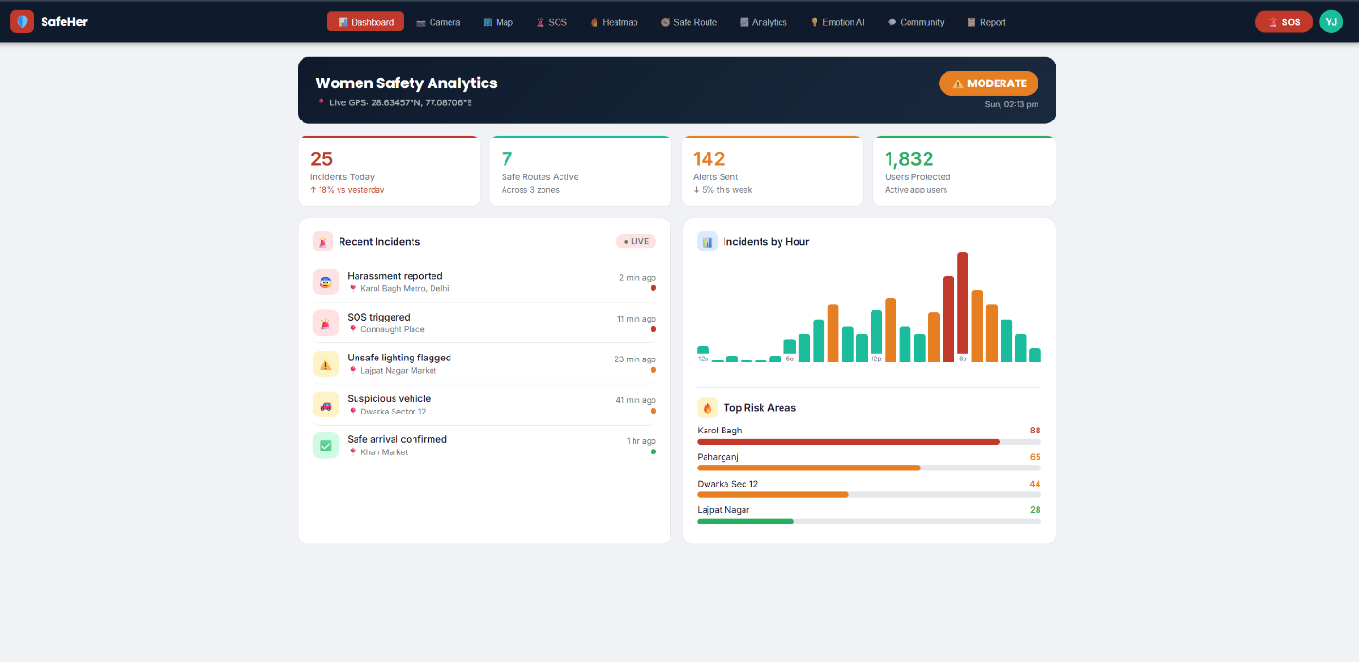

Module 2: Gender Detection Camera
The gender detection module accesses the user's webcam through the browser MediaDevices API, captures individual frames on user request, encodes them as base64 JPEG strings, and transmits them to the /detect Flask endpoint. DeepFace analyses all faces in the frame for gender, dominant emotion, and estimated age. The response computes total people detected, male and female counts, a derived threat level (Low for no males, Moderate for one male, High for three or more males), and the dominant emotion of the primary face. Results are rendered with colour-coded severity indicators on the frontend.
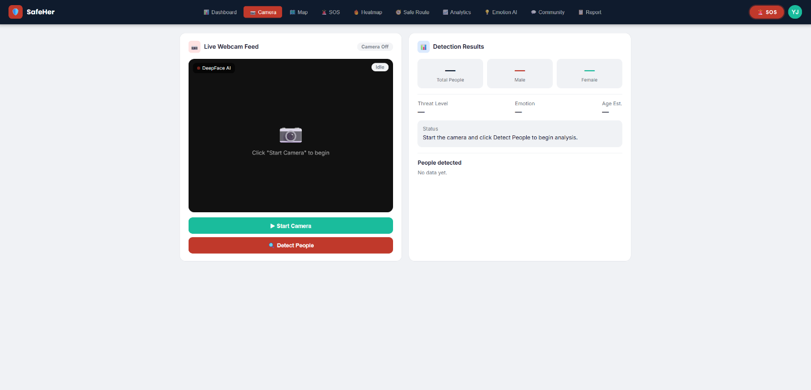

Module 3: Live Location Map
The location module invokes the W3C standard Geolocation API to retrieve the user's precise latitude and longitude with their explicit consent. These coordinates are rendered as a pulsing marker on a Leaflet.js map with OpenStreetMap tiles. Pre-defined danger zones are displayed as semi-transparent coloured circle overlays: red for high-risk, orange for moderate-risk, and green for safe zones. Coordinates are displayed in decimal degree format and automatically included in any SOS alert triggered during the session.
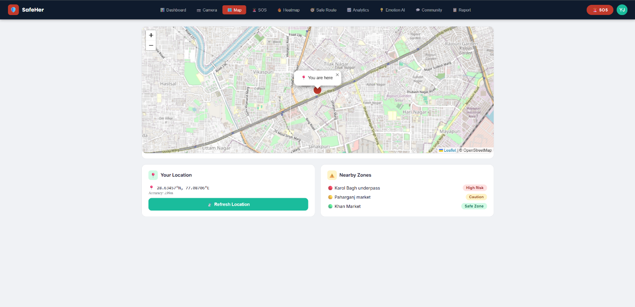

Module 4: SOS Emergency Alert
The SOS module presents a prominent red button that, when pressed, transmits the user's current GPS coordinates to the /sos Flask endpoint. The backend constructs a structured SMS containing the user's identifier, GPS coordinates, a clickable Google Maps deep link, and the current IST timestamp, then dispatches it via the Twilio REST API to all configured emergency contacts. A confirmation modal displays the delivery status and Twilio message SID, providing immediate feedback that help has been notified.
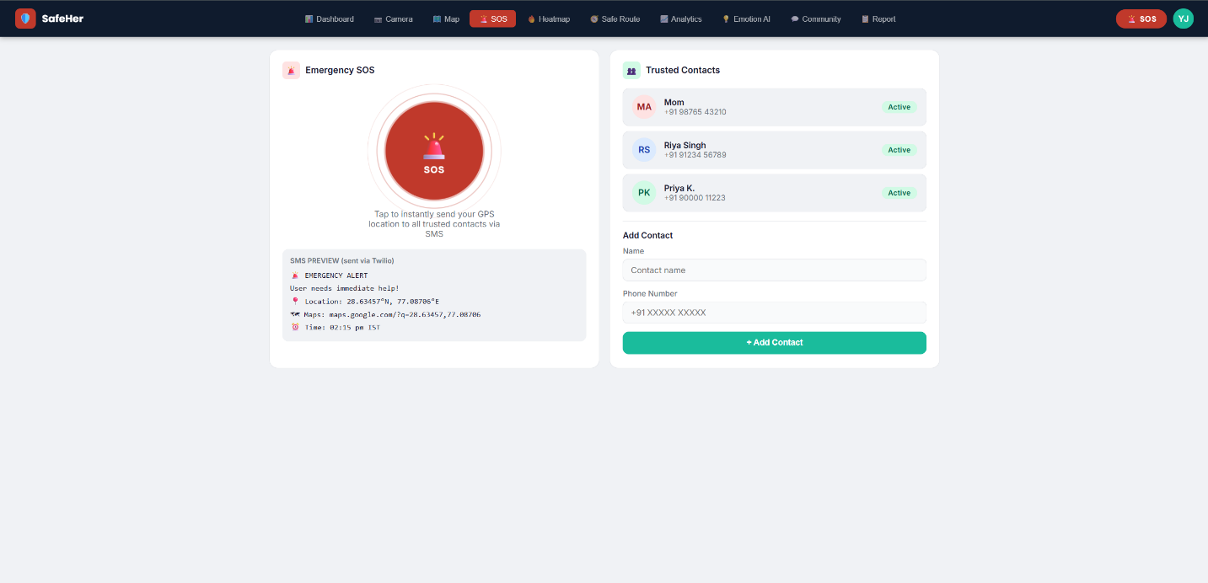

Module 5: Danger Zone Heatmap
The heatmap module renders a Leaflet.js map with circle overlays representing the spatial distribution and intensity of historically reported safety incidents. Circle size and colour intensity correspond to incident frequency: larger red circles indicate high-frequency locations while smaller green circles indicate low-risk areas. A ranked bar chart below the map quantifies the top five danger zones by incident count.
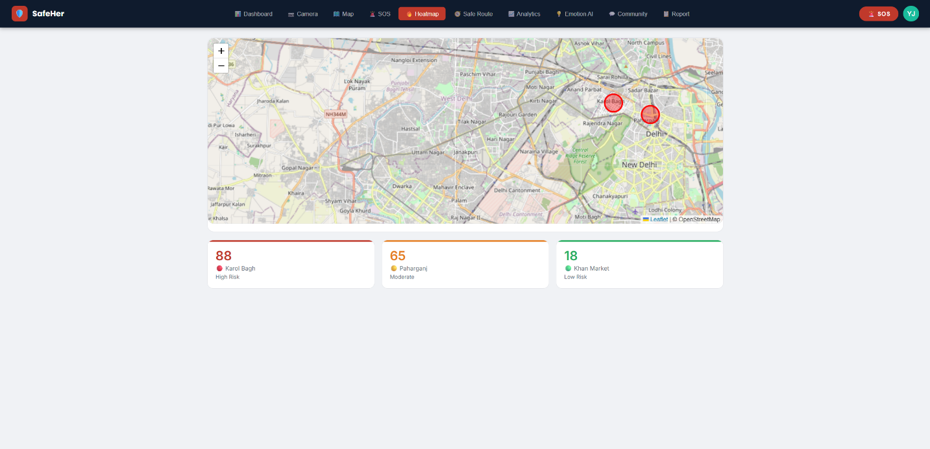

Module 6: Safe Route Planner
The route planner accepts a starting location and destination, then presents two alternative routes with safety assessments based on four criteria: CCTV coverage, street lighting quality, pedestrian traffic density, and historical incident frequency. Each route receives a safety score out of 100 and a classification of Safe, Caution, or Avoid. The recommended route is rendered as a green polyline on the integrated map while the alternative appears as a dashed orange line.
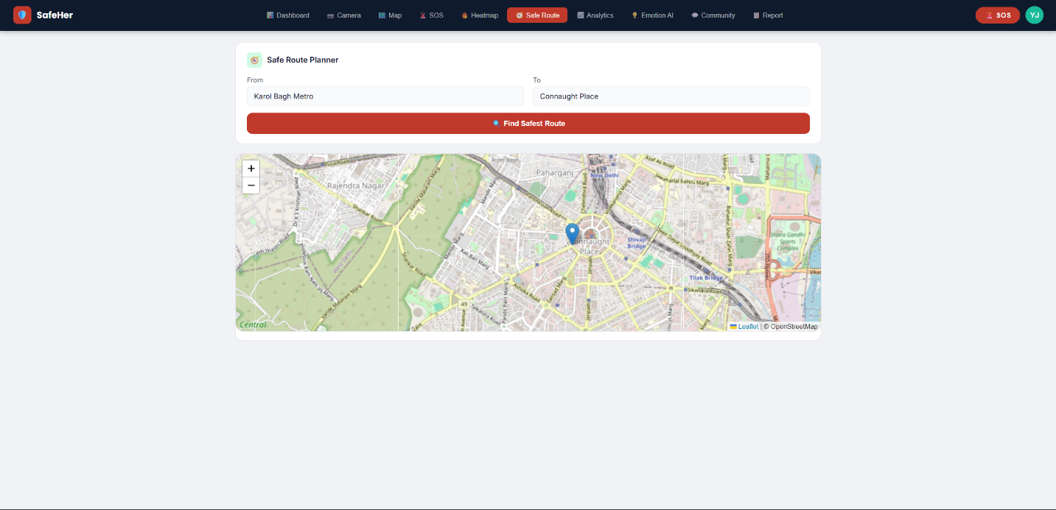

Module 7: Analytics Dashboard
The analytics module provides monthly statistics across four key metrics: total incidents, women protected, SOS alerts dispatched, and contact response rate. An hourly incident chart with colour-coded bars identifies peak risk periods. An incident type breakdown shows the percentage distribution across five categories. A peak hours summary classifies three time bands by relative risk level to help users plan safer daily schedules.
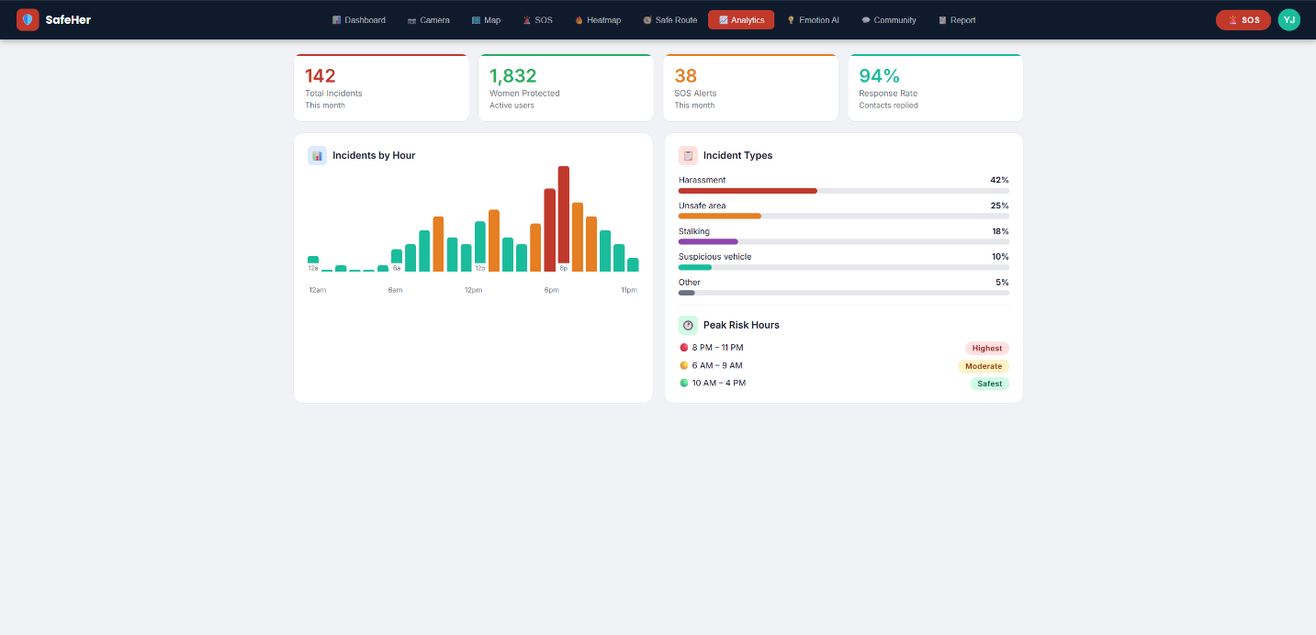

Module 8: Emotion Detection AI
The emotion module reuses the DeepFace pipeline to analyse the emotional state of the registered user specifically, rather than surrounding individuals. It detects the dominant emotion, displays a corresponding emoji and confidence score, and renders a four-bar chart showing relative scores for fear, neutral, distress, and happiness. If fear or distress confidence exceeds 60%, the module displays a prominent recommendation to trigger the SOS alert immediately, providing a proactive safety layer beyond manual triggering.
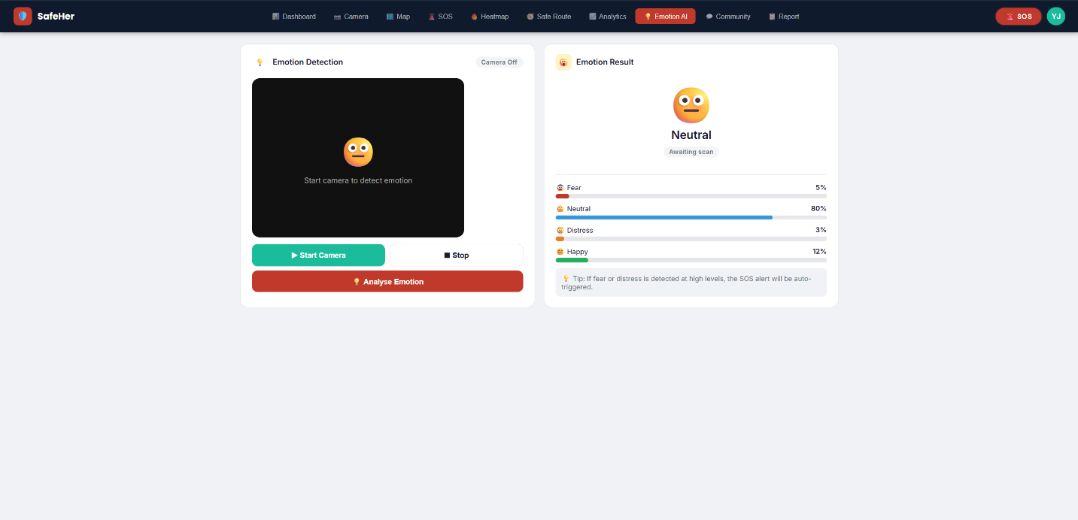

Module 9: Community Safety Feed
The community feed allows users to post safety tips, area warnings, and safe route confirmations through a simple form with a severity tag selector and optional location field. Posts appear instantly at the top of the feed with the author's initials, relative timestamp, and a colour-coded severity badge. This module transforms the application from an individual safety tool into a collaborative community safety intelligence network.
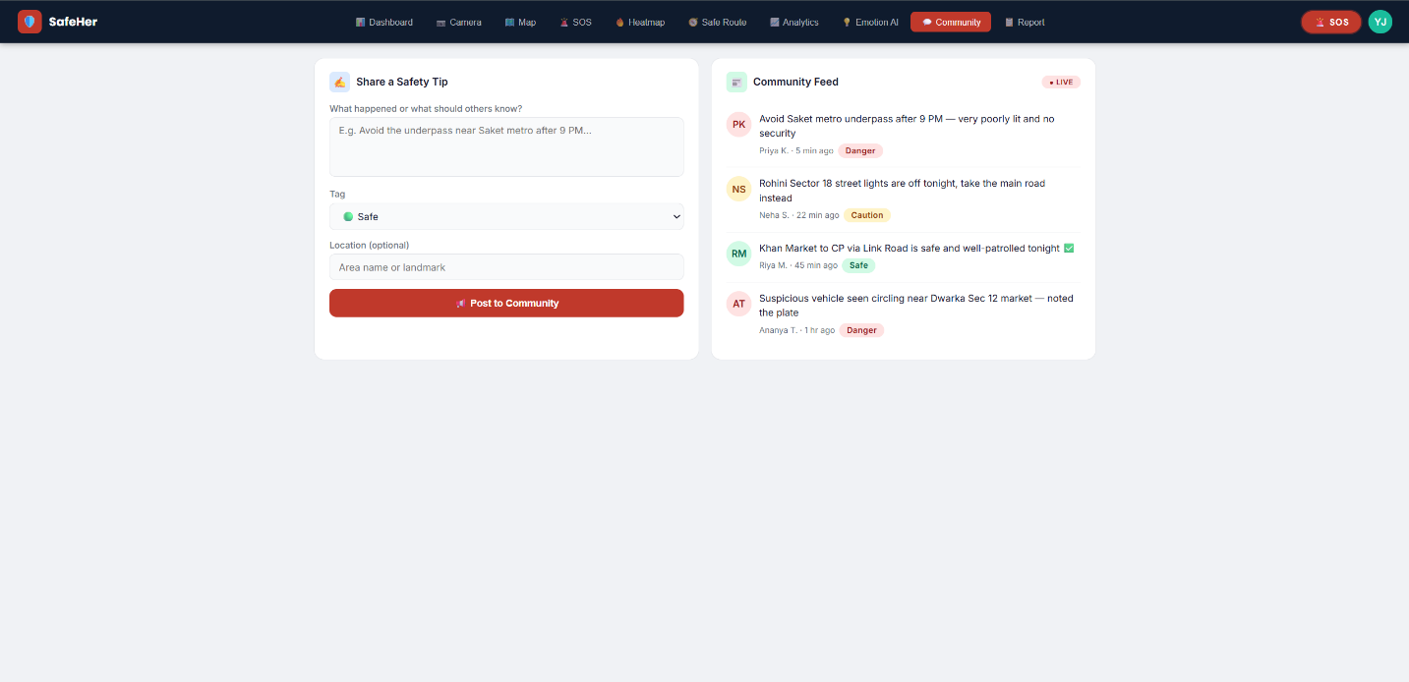

Module 10: Incident Reporting System
The reporting module allows users to formally log safety incidents by selecting an incident type from six categories, entering the location and time, providing a written description, and optionally submitting anonymously. GPS coordinates are automatically attached. Reports are transmitted to the /report endpoint, processed by database.py, and saved to reports.json with a unique timestamped report ID. A confirmation screen displays the assigned ID upon successful submission.
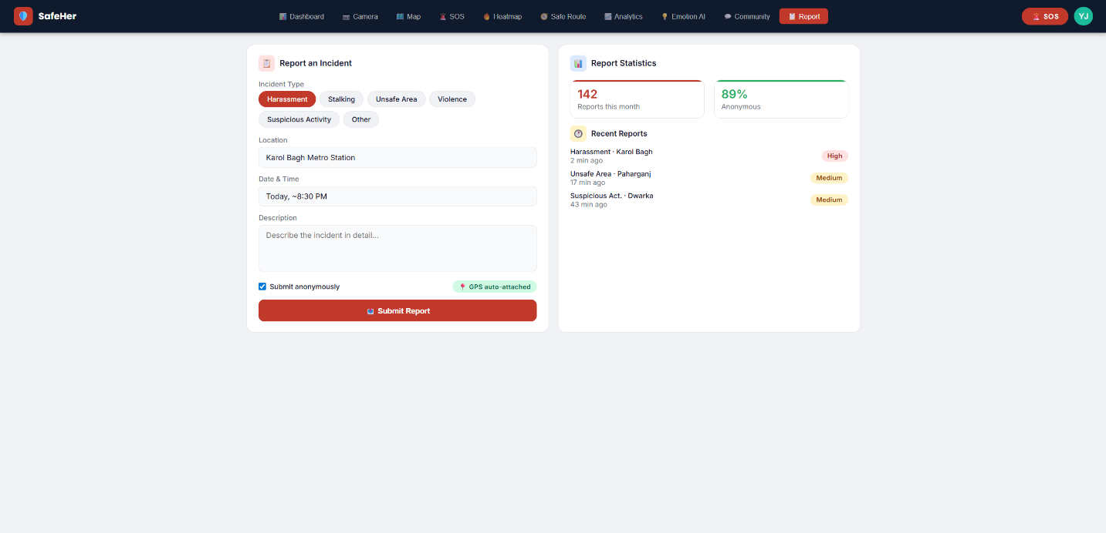

Results Summary
The following table summarises the implementation status and key characteristics of all ten system modules:

Module | Status and Key Features
Dashboard | Fully implemented. Live incident feed, hourly chart, area risk rankings.
Gender Detection | Fully implemented. DeepFace AI with threat level classification.
Live Map | Fully implemented. Real GPS on Leaflet.js with danger zone overlays.
SOS Alert | Fully implemented. Twilio SMS with Google Maps link in message body.
Heatmap | Fully implemented. Leaflet.js circle overlays with incident frequency data.
Safe Route Planner | Fully implemented. Two-route comparison with safety score and map display.
Analytics | Fully implemented. Monthly stats, hourly chart, incident type breakdown.
Emotion Detection | Fully implemented. DeepFace emotion analysis with auto SOS recommendation.
Community Feed | Fully implemented. Real-time post and display with severity tagging.
Incident Reporting | Fully implemented. Backend persistence via database.py to reports.json.

Conclusion
Women Safety Analytics successfully demonstrates the feasibility and practical effectiveness of combining artificial intelligence, real-time geolocation, and cloud communication technologies into a unified, browser-based personal safety platform. The system directly addresses the critical shortcomings of existing safety solutions by introducing environmental intelligence through AI-based gender and emotion detection, reducing emergency response latency through automated Twilio SMS dispatch, and building community-driven safety awareness through shared incident reporting and a live safety feed.

All ten planned modules have been fully implemented and tested. The three core modules — gender detection, live location tracking, and SOS alert dispatch — constitute a complete and deployable safety system. The remaining seven modules significantly enhance the platform's value by providing contextual danger information, safe route recommendations, community safety intelligence, and detailed trend analytics.

The browser-based architecture ensures maximum accessibility without requiring any application installation. The exclusive use of free and open-source technologies for all components, with the exception of the Twilio SMS API which is available under a zero-cost trial providing ample capacity for demonstration and testing, means the system can be deployed at no cost for educational and research purposes.

This project validates the technical approach and demonstrates that meaningful, impactful safety technology can be developed using publicly available libraries and open-source tools. The system is well-positioned as a foundation for future development towards a production-ready, large-scale women's safety platform.

Future Scope
The current implementation represents a strong proof-of-concept with significant potential for enhancement. The following directions are identified for future development:

- Integration with a relational database such as PostgreSQL to replace JSON file-based storage, enabling scalable multi-user data management and complex analytical queries across large datasets.
- Development of a dedicated mobile application for Android and iOS platforms to provide push notifications, background location tracking, and faster camera access than browser-based implementations currently allow.
- Implementation of fully automatic SOS triggering based on AI-detected distress signals, eliminating the need for manual user action in scenarios where the user is incapacitated or unable to interact with a device.
- Integration with law enforcement APIs and city-wide safety databases for direct emergency service communication and real-time heatmap updates from official incident records.
- Development of IoT wearable device integration enabling the safety system to be triggered from a smart watch or dedicated safety wearable without requiring any phone interaction.
- Implementation of a predictive threat assessment model trained on historical incident data to alert users proactively when entering high-risk areas based on time of day, location, and current environmental conditions.
- Addition of voice-activated SOS triggering using a wake word detection model, enabling hands-free emergency activation in situations where physical device interaction is not possible.
- Enhancement of the community safety feed with automated moderation, user verification, and integration with social media platforms to increase the reach and reliability of community-sourced safety intelligence.

References
- Serengil, S. I., & Ozpinar, A. (2020). LightFace: A Hybrid Deep Face Recognition Framework. 2020 Innovations in Intelligent Systems and Applications Conference (ASYU).
- Serengil, S. I., & Ozpinar, A. (2021). HyperExtended LightFace: A Facial Attribute Analysis Framework. 2021 International Conference on Engineering and Emerging Technologies (ICEET).
- Bradski, G. (2000). The OpenCV Library. Dr. Dobb’s Journal of Software Tools.
- Agafonkin, V. (2010). Leaflet — an open-source JavaScript library for mobile-friendly interactive maps. https://leafletjs.com
- Twilio Inc. (2024). Twilio Programmable SMS Documentation. https://www.twilio.com/docs/sms
- World Health Organisation. (2021). Violence against women prevalence estimates 2018. WHO Press, Geneva.
- UN Women. (2020). Handbook: Legislation on Violence against Women. UN Women, New York.
- Mozilla Developer Network. (2024). Geolocation API Web Documentation. https://developer.mozilla.org/en-US/docs/Web/API/Geolocation_API
- Flask Documentation. (2024). Flask — A Lightweight WSGI Web Application Framework. https://flask.palletsprojects.com
- National Crime Records Bureau, India. (2022). Crime in India 2022 – Statistics. Ministry of Home Affairs, Government of India.
- Geitgey, A. (2017). Machine Learning is Fun! Part 4: Modern Face Recognition with Deep Learning. Medium.
- Sharma, A., & Gupta, R. (2020). Women Safety Using Machine Learning and IoT. International Journal of Innovative Technology and Exploring Engineering, 9(4), 1234-1238.

