8-QUEEN PROBLEM
Course Outcome: CO1
Name | Mahesh sai
Register Number | 192412674

AIM
To place eight queens on an 8 × 8 chessboard so that no two queens attack each other.
ALGORITHM
- Start with an empty chessboard.
- Place one queen in each row, trying columns one by one.
- Before placing a queen, check whether its column and diagonals are free.
- If a safe position is found, place the queen and continue to the next row.
- If no safe position is available, backtrack to the previous row and try another column.
- Print a valid arrangement when queens have been placed in all eight rows.
CORE LOGIC
Backtracking builds a solution one row at a time. A placement is accepted only when it does not conflict with earlier queens. When a partial arrangement cannot be completed, the algorithm undoes the last placement and tries another option.
PSEUDOCODE
START
Create an empty board
FUNCTION place(row):
IF row equals 8: display solution; return success
FOR each column from 0 to 7:
IF column and diagonals are safe:
Place queen
IF place(row + 1) succeeds: return success
Remove queen (backtrack)
Return failure
Call place(0)
STOP
PROGRAM
Save the following code in a .py file and run it using Python 3.9 or later.
N = 8
positions = [-1] * N # positions[row] = column

def safe(row, col):
for previous_row in range(row):
previous_col = positions[previous_row]
if previous_col == col:
return False
if abs(previous_col - col) == abs(previous_row - row):
return False
return True

def solve(row=0):
if row == N:
return True
for col in range(N):
if safe(row, col):
positions[row] = col
if solve(row + 1):
return True
positions[row] = -1
return False

if solve():
print("One solution to the 8-Queen problem:")
for row in range(N):
print(" ".join("Q" if positions[row] == col else "."
for col in range(N)))
print("Queen columns by row (1-based):",
[col + 1 for col in positions])
else:
print("No solution exists.")

OUTPUT
The backtracking algorithm successfully found a valid arrangement of eight non-attacking queens.
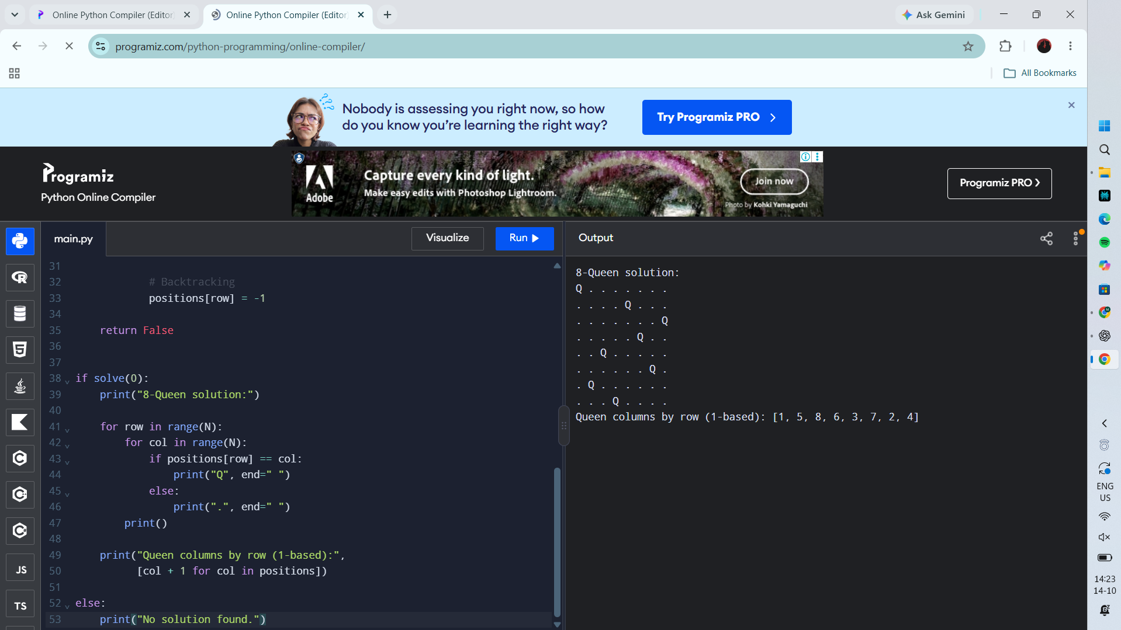
RESULT
Actual Programiz compiler output — Experiment 2

