MISSIONARIES AND CANNIBALS PROBLEM
Course Outcome: CO3
Name | Mahesh sai
Register Number | 192412674

AIM
To transport three missionaries and three cannibals across a river safely using a boat that can carry at most two people.
ALGORITHM
- Represent each state as (missionaries on the left bank, cannibals on the left bank, boat position).
- Start with all six people on the left bank and the boat on the left.
- Generate boat trips carrying one or two people.
- Reject states where cannibals outnumber missionaries on either bank when missionaries are present.
- Use BFS to find a safe sequence of crossings until everyone reaches the right bank.
CORE LOGIC
The problem is a state-space search with safety constraints. BFS explores valid states and records each state's parent so a shortest valid sequence of crossings can be reconstructed.
PSEUDOCODE
START
Set initial state (3, 3, Left) and goal (0, 0, Right)
Initialize BFS queue and parent map
WHILE queue is not empty:
Remove a state
IF it equals the goal: reconstruct path
Generate all one- or two-person boat trips
Keep only legal, safe, unvisited states
Record parent and enqueue each state
Display crossing sequence
STOP
PROGRAM
Save the following code in a .py file and run it using Python 3.9 or later.
from collections import deque

START = (3, 3, 0) # boat: 0 = left, 1 = right
GOAL = (0, 0, 1)
BOAT_LOADS = [(1, 0), (2, 0), (0, 1), (0, 2), (1, 1)]

def valid(m_left, c_left):
m_right, c_right = 3 - m_left, 3 - c_left
if not (0 <= m_left <= 3 and 0 <= c_left <= 3):
return False
if not (0 <= m_right <= 3 and 0 <= c_right <= 3):
return False
if m_left > 0 and c_left > m_left:
return False
if m_right > 0 and c_right > m_right:
return False
return True

queue = deque([START])
parent = {START: None}
move_used = {}
while queue:
state = queue.popleft()
if state == GOAL:
break
m, c, boat = state
for dm, dc in BOAT_LOADS:
if boat == 0:
nxt = (m - dm, c - dc, 1)
direction = "Left -> Right"
else:
nxt = (m + dm, c + dc, 0)
direction = "Right -> Left"
if valid(nxt[0], nxt[1]) and nxt not in parent:
parent[nxt] = state
move_used[nxt] = (dm, dc, direction)
queue.append(nxt)

if GOAL in parent:
path = []
state = GOAL
while state is not None:
path.append(state)
state = parent[state]
path.reverse()
for i, state in enumerate(path):
m, c, boat = state
print(f"State {i}: left bank M={m}, C={c}; "
f"right bank M={3-m}, C={3-c}; "
f"boat={'Left' if boat == 0 else 'Right'}")
if i > 0:
dm, dc, direction = move_used[state]
print(f" Crossing: {dm} missionary(ies), "
f"{dc} cannibal(s), {direction}")
else:
print("No safe solution found.")

OUTPUT
BFS found a safe sequence of river crossings that transports all missionaries and cannibals without violating the safety rules.
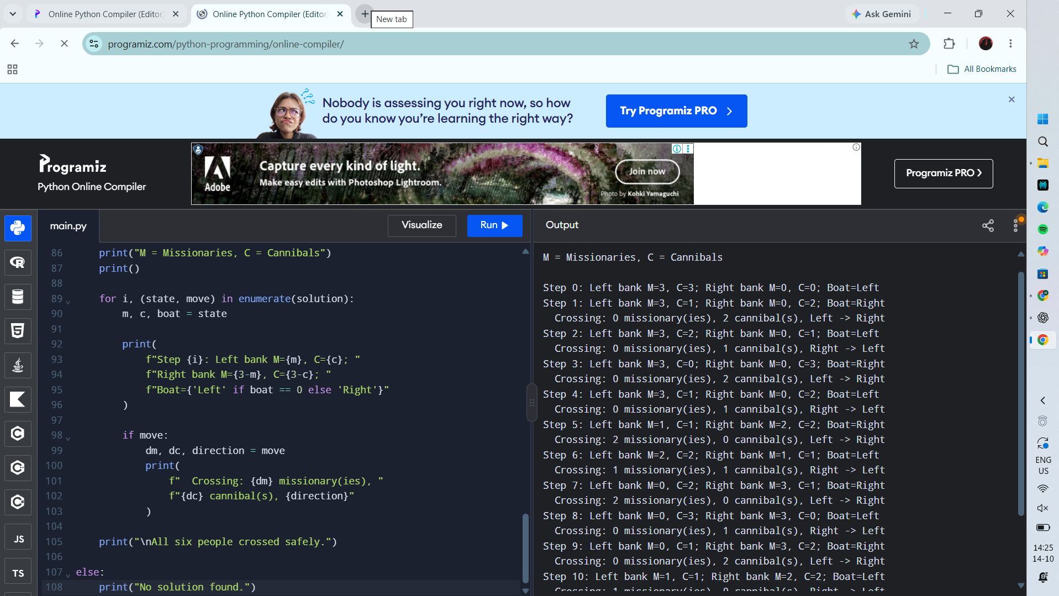
RESULT
Actual Programiz compiler output — Experiment 5

