VACUUM CLEANER PROBLEM
Course Outcome: CO3
Name | Mahesh Sai
Register Number | 192412674

AIM
To model a simple two-room vacuum-cleaner agent that senses room conditions, cleans dirty rooms, and moves between rooms until both are clean.
ALGORITHM
- Represent the environment as two rooms, A and B, each marked Dirty or Clean.
- Place the vacuum agent in room A.
- Sense the current room's condition.
- If the current room is dirty, clean it.
- If the current room is clean and the other room is dirty, move to the other room.
- Stop when both rooms are clean.
CORE LOGIC
The agent uses condition-action rules based on its current location and the room states. The program demonstrates a simple reflex agent in a deterministic two-room environment.
PSEUDOCODE
START
Set rooms A and B to Dirty; agent starts at A
WHILE any room is Dirty:
IF current room is Dirty: clean it
ELSE IF other room is Dirty: move to the other room
Display final room states
STOP
PROGRAM
Save the following code in a .py file and run it using Python 3.9 or later.
rooms = {"A": "Dirty", "B": "Dirty"}
location = "A"
step = 1

print("Initial state:", rooms, "| Agent at:", location)
while "Dirty" in rooms.values():
if rooms[location] == "Dirty":
rooms[location] = "Clean"
print(f"Step {step}: Clean room {location}")
else:
other = "B" if location == "A" else "A"
if rooms[other] == "Dirty":
location = other
print(f"Step {step}: Move to room {location}")
step += 1

print("Final state:", rooms)
print("Both rooms are clean.")

OUTPUT
The vacuum-cleaner agent cleaned both rooms by applying simple condition-action rules.
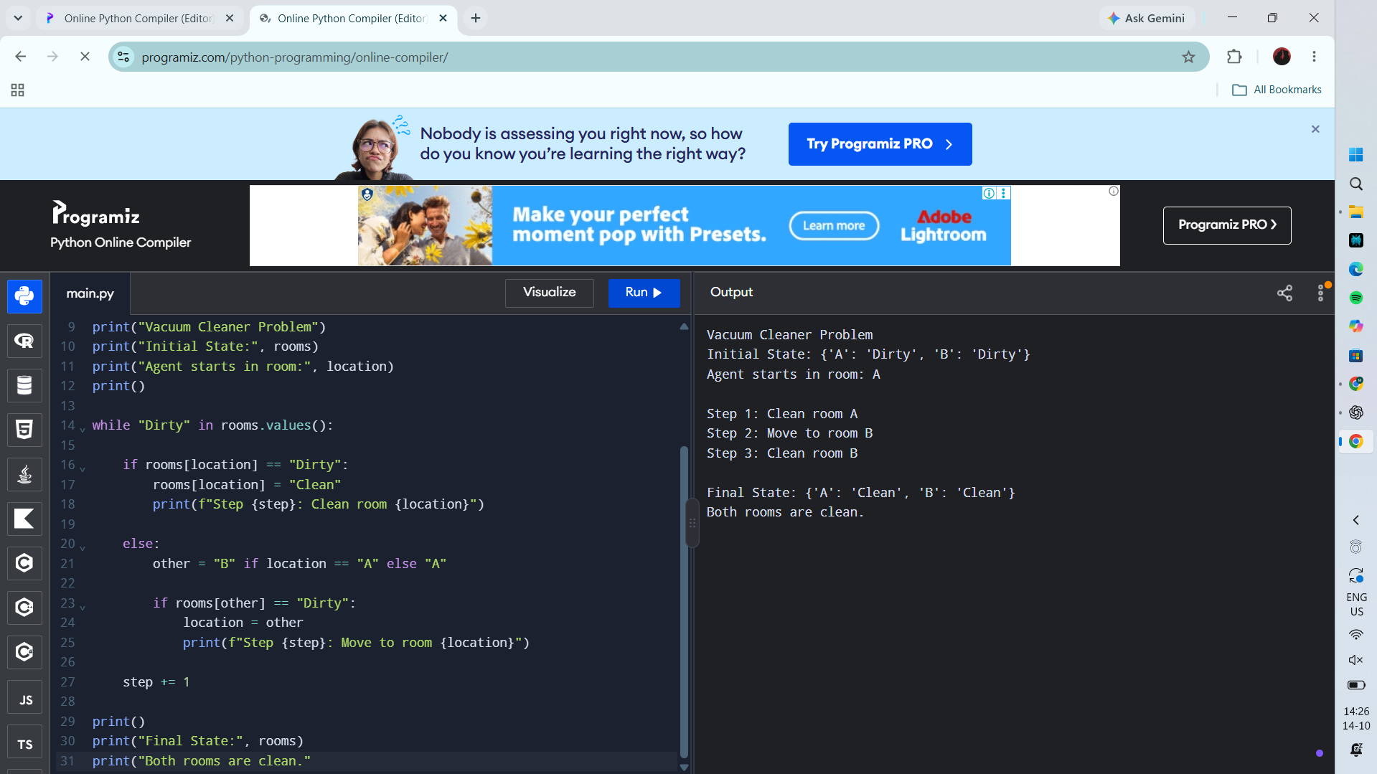
RESULT
Actual Programiz compiler output — Experiment 6

