BREADTH FIRST SEARCH (BFS)
Course Outcome: CO3
Name | Mahesh Sai
Register Number | 192412674

AIM
To implement Breadth-First Search to traverse a graph from a given starting vertex.
ALGORITHM
- Represent the graph using an adjacency list.
- Place the starting vertex in a queue and mark it visited.
- Remove the front vertex from the queue and add it to the traversal order.
- Visit each unvisited adjacent vertex, mark it visited, and add it to the queue.
- Repeat until the queue is empty.
CORE LOGIC
BFS explores all immediate neighbours before moving to vertices at the next level. With an unweighted graph, it can also find shortest paths measured by number of edges.
PSEUDOCODE
START
Create queue with start vertex; mark it visited
WHILE queue is not empty:
Remove front vertex and append it to traversal order
FOR each neighbour:
IF neighbour is not visited: mark visited and enqueue
Display traversal order
STOP
PROGRAM
Save the following code in a .py file and run it using Python 3.9 or later.
from collections import deque

graph = {
"A": ["B", "C"],
"B": ["A", "D", "E"],
"C": ["A", "F"],
"D": ["B"],
"E": ["B", "F"],
"F": ["C", "E"]
}

def bfs(graph, start):
visited = {start}
queue = deque([start])
order = []
while queue:
vertex = queue.popleft()
order.append(vertex)
for neighbour in graph[vertex]:
if neighbour not in visited:
visited.add(neighbour)
queue.append(neighbour)
return order

print("BFS traversal:", " -> ".join(bfs(graph, "A")))

OUTPUT
The graph was traversed successfully using BFS in level-by-level order.
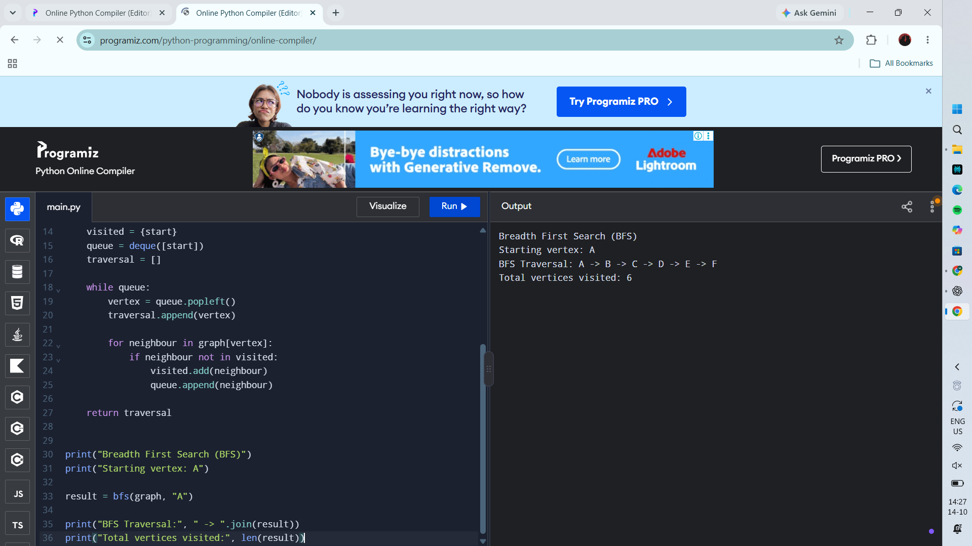
RESULT
Actual Programiz compiler output — Experiment 7

