DEPTH FIRST SEARCH (DFS)
Course Outcome: CO4
AIM
To implement Depth First Search (DFS) to traverse a graph by exploring one branch as deeply as possible before backtracking.
ALGORITHM
- Represent the graph using an adjacency list.
- Start at the specified vertex and mark it as visited.
- Visit an unvisited adjacent vertex recursively.
- Continue exploring until no unvisited adjacent vertex remains, then backtrack.
- Display the traversal order and the number of vertices visited.
CORE LOGIC
DFS explores a path deeply before considering alternative branches. A visited set prevents repeated visits and avoids cycles. The recursive function uses the call stack to backtrack when a vertex has no unvisited neighbours.
PSEUDOCODE
START
Create an empty visited set and traversal list
FUNCTION visit(vertex):
Mark vertex as visited and append it to traversal
FOR each neighbour of vertex:
IF neighbour is not visited, call visit(neighbour)
Call visit(start vertex)
Display traversal and number of visited vertices
STOP
PROGRAM
graph = {
"A": ["B", "C"],
"B": ["A", "D", "E"],
"C": ["A", "F"],
"D": ["B"],
"E": ["B", "F"],
"F": ["C", "E"]
}

def dfs(graph, start):
visited = set()
traversal = []

def visit(vertex):
visited.add(vertex)
traversal.append(vertex)

for neighbour in graph[vertex]:
if neighbour not in visited:
visit(neighbour)

visit(start)
return traversal

print("Depth First Search (DFS)")
print("Starting vertex: A")

result = dfs(graph, "A")

print("DFS Traversal:", " -> ".join(result))
print("Total vertices visited:", len(result))
OUTPUT
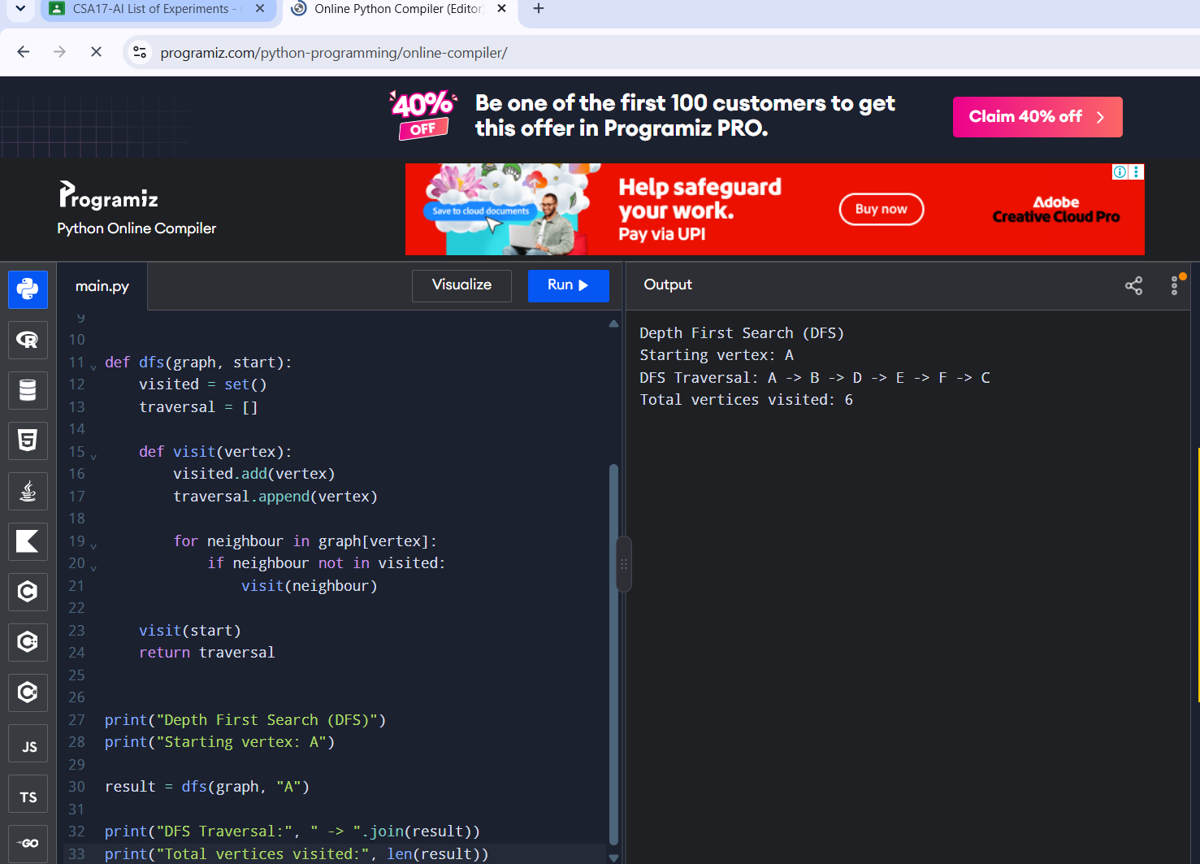
Actual Programiz compiler output
RESULT
The DFS algorithm successfully traversed all six vertices of the graph in depth-first order.

