EXPERIMENT 9: TRAVELLING SALESMAN PROBLEM
CO4
AIM
Find a minimum-cost tour that visits each city once and returns to the start.
ALGORITHM
1. Enumerate every permutation of cities excluding the start
2. compute each tour cost
2. retain the cheapest tour.
CORE LOGIC
Brute-force exhaustive search compares all possible tours, which is practical only for small numbers of cities.
PSEUDOCODE
START
Prepare the inputs and required data structures
Apply the algorithm to the input
Compute and display the result
STOP
PROGRAM
from itertools import permutations
cities = ["A", "B", "C", "D"]
distance = {
"A":{"A":0,"B":10,"C":15,"D":20},
"B":{"A":10,"B":0,"C":35,"D":25},
"C":{"A":15,"B":35,"C":0,"D":30},
"D":{"A":20,"B":25,"C":30,"D":0}
}
start = "A"
best_tour = None
best_cost = float("inf")
for order in permutations(city for city in cities if city != start):
tour = (start,) + order + (start,)
cost = sum(distance[tour[i]][tour[i+1]] for i in range(len(tour)-1))
if cost < best_cost:
best_cost = cost
best_tour = tour
print("Travelling Salesman Problem")
print("Starting city:", start)
print("Optimal tour:", " -> ".join(best_tour))
print("Minimum travel cost:", best_cost)
OUTPUT
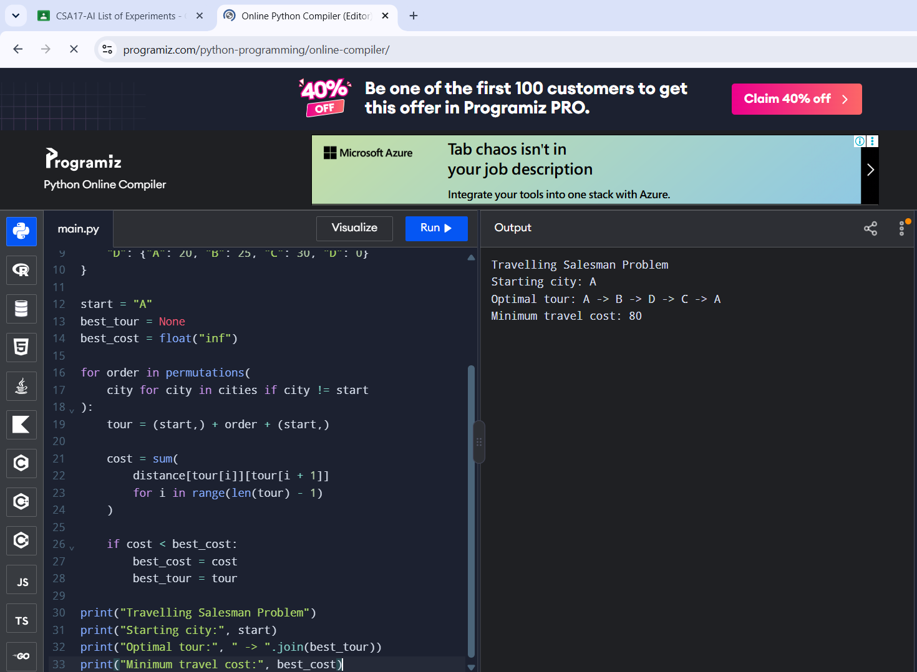
RESULT
A minimum-cost tour of cost 80 was identified.

