EXPERIMENT 10: A* ALGORITHM
CO4
AIM
Find a low-cost path between a start and goal using A* search.
ALGORITHM
1. Create a weighted graph and heuristics
2. expand the lowest f=g+h state from a priority queue
2. stop when the goal is reached.
CORE LOGIC
A* combines the path cost so far with a heuristic estimate of remaining cost. An admissible heuristic supports optimality under appropriate search conditions.
PSEUDOCODE
START
Prepare the inputs and required data structures
Apply the algorithm to the input
Compute and display the result
STOP
PROGRAM
import heapq
graph = {
"A":{"B":1,"C":4},
"B":{"A":1,"C":2,"D":5},
"C":{"A":4,"B":2,"D":1},
"D":{"B":5,"C":1}
}
heuristic = {"A":4,"B":3,"C":1,"D":0}
def astar(start, goal):
queue = [(heuristic[start], 0, start, [start])]
visited = set()
while queue:
f, cost, node, path = heapq.heappop(queue)
if node == goal:
return path, cost
if node in visited:
continue
visited.add(node)
for neighbour, distance in graph[node].items():
if neighbour not in visited:
new_cost = cost + distance
heapq.heappush(queue, (new_cost + heuristic[neighbour],
new_cost, neighbour, path+[neighbour]))
return None, float("inf")
path, cost = astar("A", "D")
print("A* Algorithm")
print("Start node: A")
print("Goal node: D")
print("Optimal path:", " -> ".join(path))
print("Total path cost:", cost)
OUTPUT
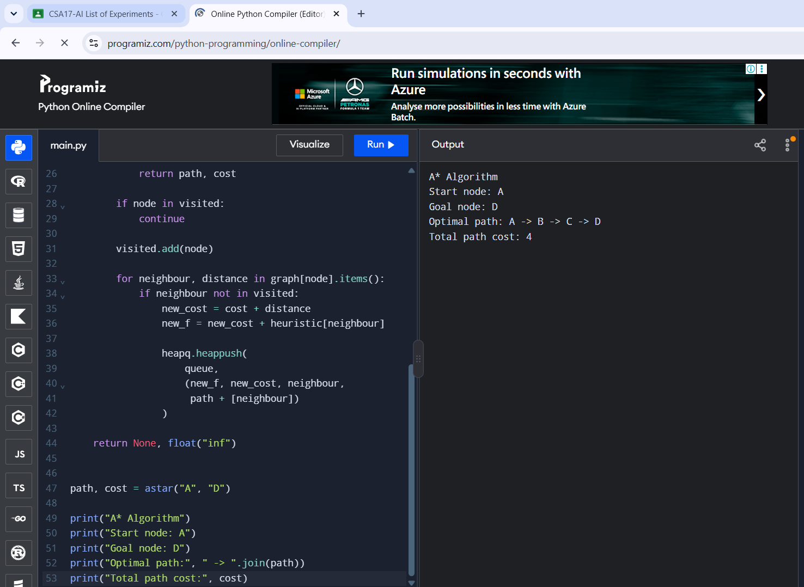
RESULT
The program found A -> B -> C -> D with total cost 4.

