EXPERIMENT 11: MAP COLORING USING CSP
CO5
AIM
Assign colors to map regions so adjacent regions have different colors.
ALGORITHM
1. List regions, colors and adjacency
2. assign colors recursively
2. reject conflicts and backtrack when needed.
CORE LOGIC
Constraint satisfaction uses backtracking to search assignments while enforcing the adjacency rule.
PSEUDOCODE
START
Prepare the inputs and required data structures
Apply the algorithm to the input
Compute and display the result
STOP
PROGRAM
regions = ["A", "B", "C", "D"]
colors = ["Red", "Green", "Blue"]
neighbors = {"A":["B","C"], "B":["A","C","D"],
"C":["A","B","D"], "D":["B","C"]}
assignment = {}
def is_valid(region, color):
for neighbor in neighbors[region]:
if neighbor in assignment and assignment[neighbor] == color:
return False
return True
def solve():
if len(assignment) == len(regions):
return True
for region in regions:
if region not in assignment:
break
for color in colors:
if is_valid(region, color):
assignment[region] = color
if solve():
return True
del assignment[region]
return False
print("Map Coloring using CSP")
if solve():
for region in regions:
print(f"Region {region}: {assignment[region]}")
print("Constraint satisfied: No adjacent regions share a color.")
else:
print("No solution found.")
OUTPUT
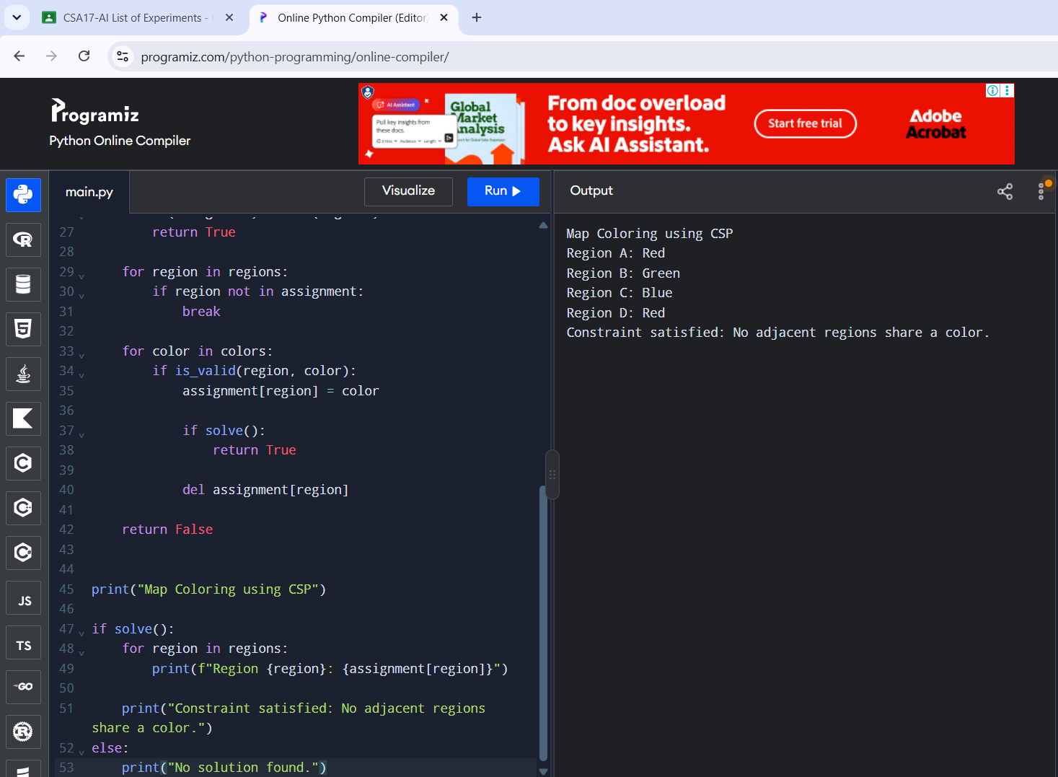
RESULT
All adjacent regions were assigned different colors.

