EXPERIMENT 12: TIC-TAC-TOE GAME
CO3
AIM
Simulate moves in a Tic-Tac-Toe game with a rule-based computer player.
ALGORITHM
1. Initialize the board
2. alternate sample player and computer moves
2. check winning lines
2. display the resulting board and status.
CORE LOGIC
The computer prioritizes winning, then blocking, then preferred empty squares. The fixed sample moves stop early and display an incomplete-game status.
PSEUDOCODE
START
Prepare the inputs and required data structures
Apply the algorithm to the input
Compute and display the result
STOP
PROGRAM
board = [" "] * 9
WINNING_LINES = [(0,1,2),(3,4,5),(6,7,8),
(0,3,6),(1,4,7),(2,5,8),
(0,4,8),(2,4,6)]
def print_board():
for i in range(0, 9, 3):
print(" | ".join(board[i:i+3]))
if i < 6:
print("--+---+--")
def check_winner():
for a,b,c in WINNING_LINES:
if board[a] == board[b] == board[c] != " ":
return board[a]
return None
def find_move(player):
for i in range(9):
if board[i] == " ":
board[i] = player
if check_winner() == player:
board[i] = " "
return i
board[i] = " "
return None
def computer_move():
move = find_move("O")
if move is not None:
return move
move = find_move("X")
if move is not None:
return move
for i in [4,0,2,6,8,1,3,5,7]:
if board[i] == " ":
return i
return None
print("Tic-Tac-Toe Game")
print("Player: X | Computer: O")
print()
player_moves = [0,1,2,3,6]
for move in player_moves:
if board[move] != " " or check_winner():
break
board[move] = "X"
print("Player chooses position:", move+1)
if check_winner():
break
computer = computer_move()
if computer is not None:
board[computer] = "O"
print("Computer chooses position:", computer+1)
if check_winner():
break
print()
print_board()
winner = check_winner()
if winner == "X":
print("Player wins!")
elif winner == "O":
print("Computer wins!")
else:
print("Game ended in a draw or incomplete state.")
OUTPUT
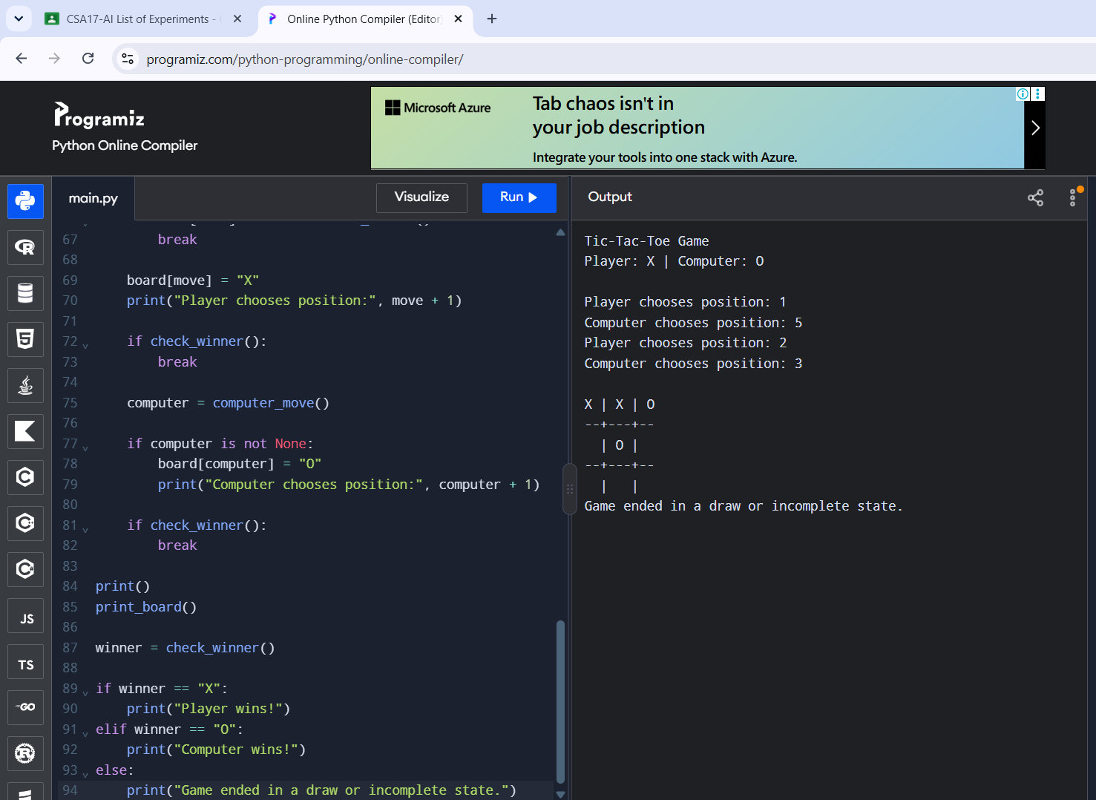
RESULT
The rule-based game was demonstrated; the fixed move sequence ended before game completion.

