EXPERIMENT 13: MINIMAX ALGORITHM
CO3
AIM
Compute an optimal game-tree score using Minimax.
ALGORITHM
1. Recursively evaluate leaf values
2. maximize at one level and minimize at the next
2. return the root score.
CORE LOGIC
Minimax assumes two adversarial players and selects moves based on alternating maximum and minimum evaluations.
PSEUDOCODE
START
Prepare the inputs and required data structures
Apply the algorithm to the input
Compute and display the result
STOP
PROGRAM
def minimax(depth, node, maximizing, scores, max_depth):
if depth == max_depth:
return scores[node]
if maximizing:
best = float("-inf")
for i in range(2):
value = minimax(depth+1, node*2+i, False,
scores, max_depth)
best = max(best, value)
return best
else:
best = float("inf")
for i in range(2):
value = minimax(depth+1, node*2+i, True,
scores, max_depth)
best = min(best, value)
return best
scores = [3,5,2,9,12,5,23,23]
max_depth = 3
print("Minimax Algorithm")
print("Leaf node scores:", scores)
best_score = minimax(0,0,True,scores,max_depth)
print("Optimal score:", best_score)
OUTPUT
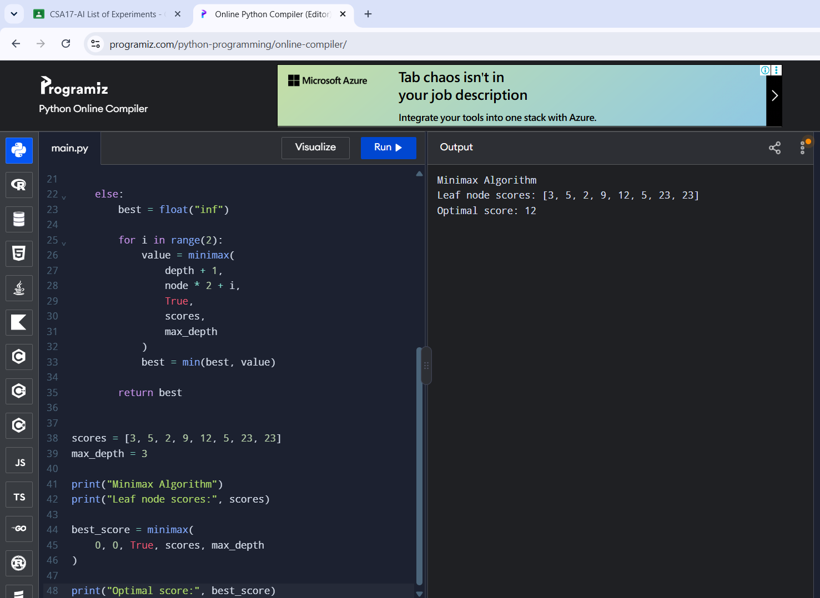
RESULT
Minimax evaluated the game tree and returned score 12.

