EXPERIMENT 14: ALPHA-BETA PRUNING ALGORITHM
CO3
AIM
Optimize Minimax search using alpha-beta pruning.
ALGORITHM
1. Track alpha and beta bounds while recursively evaluating game-tree nodes
2. prune when beta is no greater than alpha.
CORE LOGIC
Alpha-beta pruning skips branches that cannot change the final Minimax choice while preserving its result.
PSEUDOCODE
START
Prepare the inputs and required data structures
Apply the algorithm to the input
Compute and display the result
STOP
PROGRAM
def alpha_beta(depth, node, maximizing, scores,
alpha, beta, max_depth):
if depth == max_depth:
return scores[node]
if maximizing:
best = float("-inf")
for i in range(2):
value = alpha_beta(depth+1,node*2+i,False,
scores,alpha,beta,max_depth)
best = max(best,value)
alpha = max(alpha,best)
if beta <= alpha:
break
return best
else:
best = float("inf")
for i in range(2):
value = alpha_beta(depth+1,node*2+i,True,
scores,alpha,beta,max_depth)
best = min(best,value)
beta = min(beta,best)
if beta <= alpha:
break
return best
scores = [3,5,2,9,12,5,23,23]
max_depth = 3
print("Alpha-Beta Pruning Algorithm")
print("Leaf node scores:", scores)
best_score = alpha_beta(0,0,True,scores,
float("-inf"),float("inf"),max_depth)
print("Optimal score:", best_score)
print("Alpha-Beta pruning completed successfully.")
OUTPUT
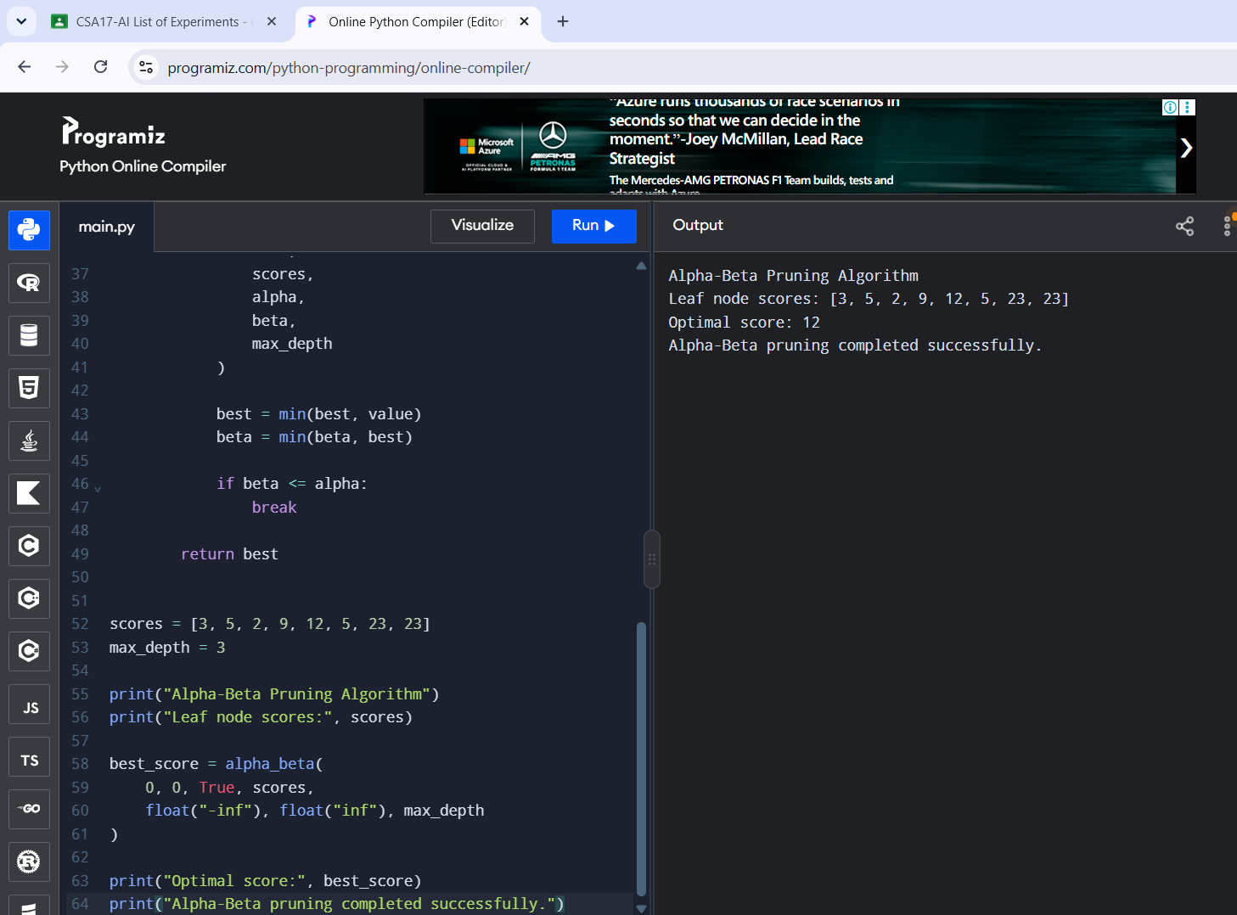
RESULT
Alpha-beta pruning returned optimal score 12.

