EXPERIMENT 15: DECISION TREE CLASSIFIER
CO4
AIM
Demonstrate a decision rule that classifies samples using their features.
ALGORITHM
1. Create labeled examples
2. apply a feature-based decision rule
2. compare predictions to labels
2. classify a new sample.
CORE LOGIC
This is a manually specified one-split decision tree rather than a tree learned by scikit-learn. Its reported accuracy is on the training data only.
PSEUDOCODE
START
Prepare the inputs and required data structures
Apply the algorithm to the input
Compute and display the result
STOP
PROGRAM
data = [(1,1,"Yes"),(1,0,"Yes"),(0,1,"No"),
(0,0,"No"),(1,1,"Yes"),(0,1,"No")]
print("Decision Tree Classifier")
print("Training samples:",len(data))
print()
print("Decision Tree:")
print("Feature 1?")
print(" If Feature 1 = 1: Class = Yes")
print(" If Feature 1 = 0: Class = No")
print()
correct = 0
print("Training Results:")
for f1,f2,actual in data:
predicted = "Yes" if f1 == 1 else "No"
print("Features:",(f1,f2),"| Actual:",actual,
"| Predicted:",predicted)
if predicted == actual:
correct += 1
accuracy = correct / len(data) * 100
print()
print("Correct predictions:",correct)
print("Training accuracy:",accuracy,"%")
sample = (1,0)
prediction = "Yes" if sample[0] == 1 else "No"
print("New sample:",sample)
print("Predicted class:",prediction)
OUTPUT
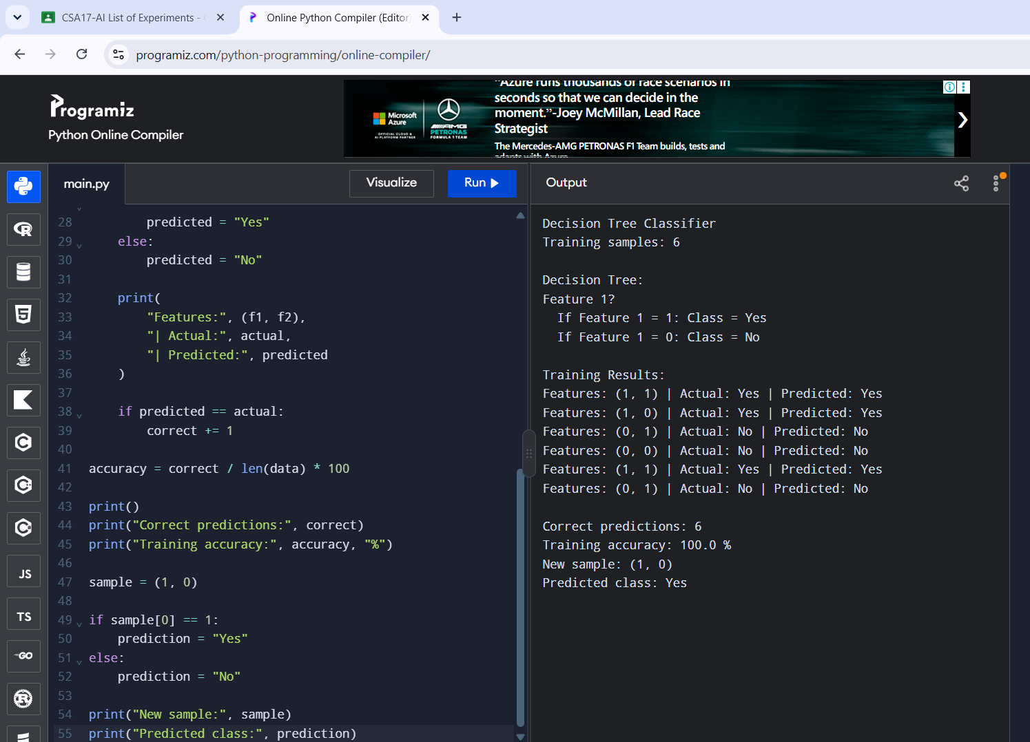
RESULT
The manual decision tree correctly classified all six training examples.

