EXPERIMENT 16: FEEDFORWARD NEURAL NETWORK
CO4
AIM
Compute the forward pass of a small neural network.
ALGORITHM
1. Define input values and fixed weights
2. compute sigmoid activations for hidden neurons
2. calculate output activation and class.
CORE LOGIC
A feedforward network applies weighted sums and nonlinear activations layer by layer. This example uses fixed weights and does not train them.
PSEUDOCODE
START
Prepare the inputs and required data structures
Apply the algorithm to the input
Compute and display the result
STOP
PROGRAM
import math
def sigmoid(x):
return 1 / (1 + math.exp(-x))
inputs = [1,0]
w1 = [[0.5,0.4],[0.3,0.7]]
w2 = [0.6,0.8]
hidden = []
for i in range(2):
total = inputs[0]*w1[i][0] + inputs[1]*w1[i][1]
hidden.append(sigmoid(total))
output_sum = hidden[0]*w2[0] + hidden[1]*w2[1]
output = sigmoid(output_sum)
print("Feedforward Neural Network")
print("Input values:",inputs)
print("Hidden layer outputs:")
for i,value in enumerate(hidden):
print("Neuron",i+1,":",round(value,4))
print("Final output:",round(output,4))
if output >= 0.5:
print("Predicted class: 1")
else:
print("Predicted class: 0")
OUTPUT
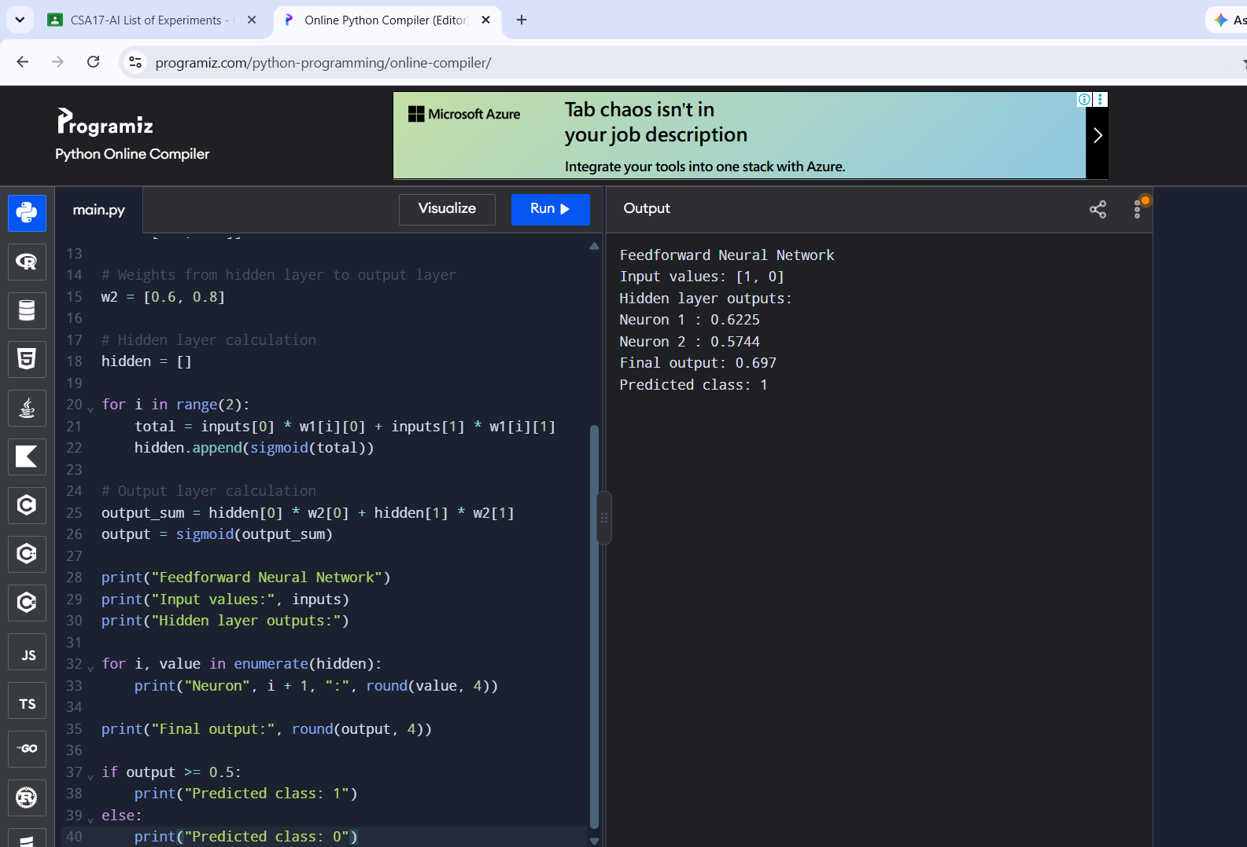
RESULT
The fixed-weight network produced output 0.697 and predicted class 1.

