“LockedMe !”

Sprint Information:

The Locked Me project has been completed in 3 sprints of 1 week duration each

Sprint 1 :

* Created the Main Method to include the Welcome Note and the Developer Details
* Created loop to perform the various related Operations

Sprint 2 :

* Created a new Object Operations and created the Create Read and Delete file instances
* Worked on Create new file method and handled all its Exceptions
* Worked on Read Existing file method and handled all its Exceptions
* Worked on Delete Existing file method and handled all its Exceptions

Sprint 3:

* Worked on listing the files in the Directory
* Worked on Successfully exiting the application
* Created and added the instance of listing the file and Exiting the application for the Operations Object

Application Flowchart:

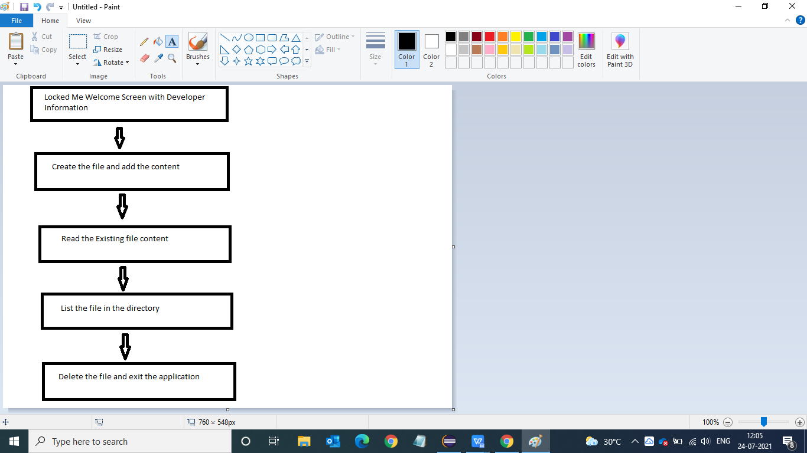

Code Module:

Two separate class are made to accommodate the functionality of the application

Main Class : This class contains the Welcome note and the Developer Details along with the loop to obtain data from the user and perform the various related operations

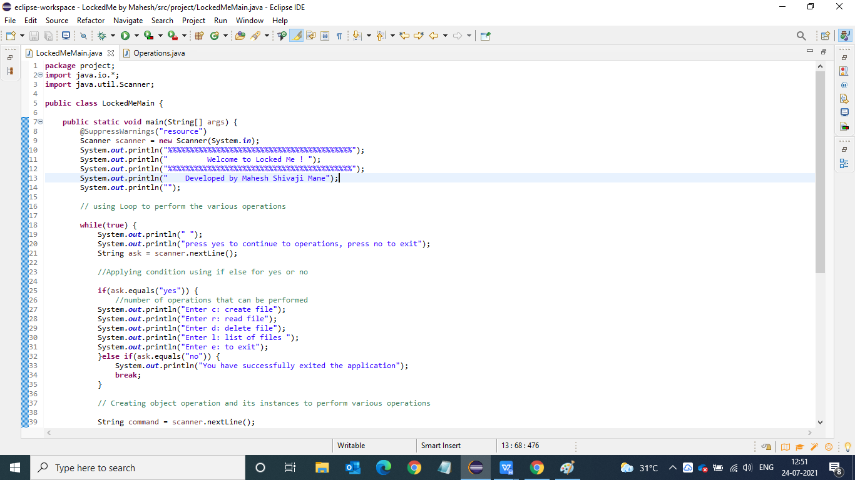

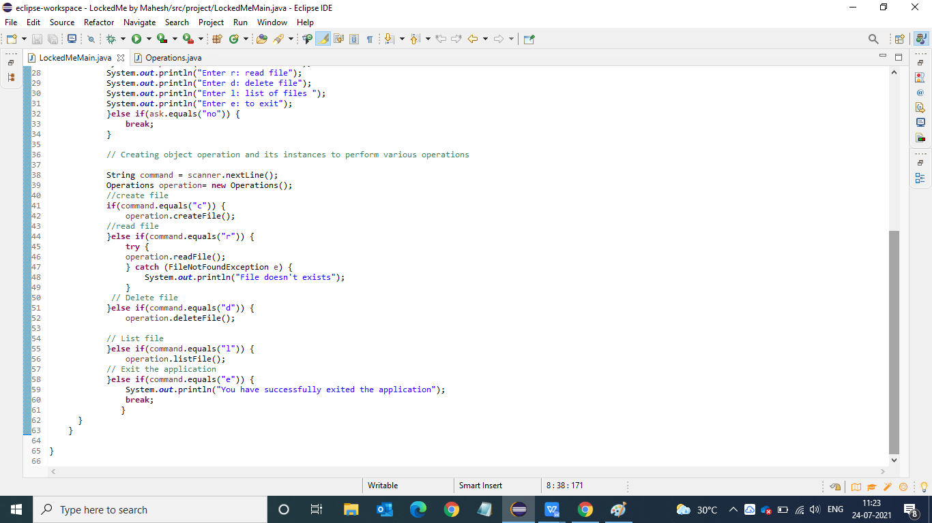

Operation Class : This class contain the detailed code to perform the Particular functions of the application such as Create, Read , Delete and List the files in the directory.

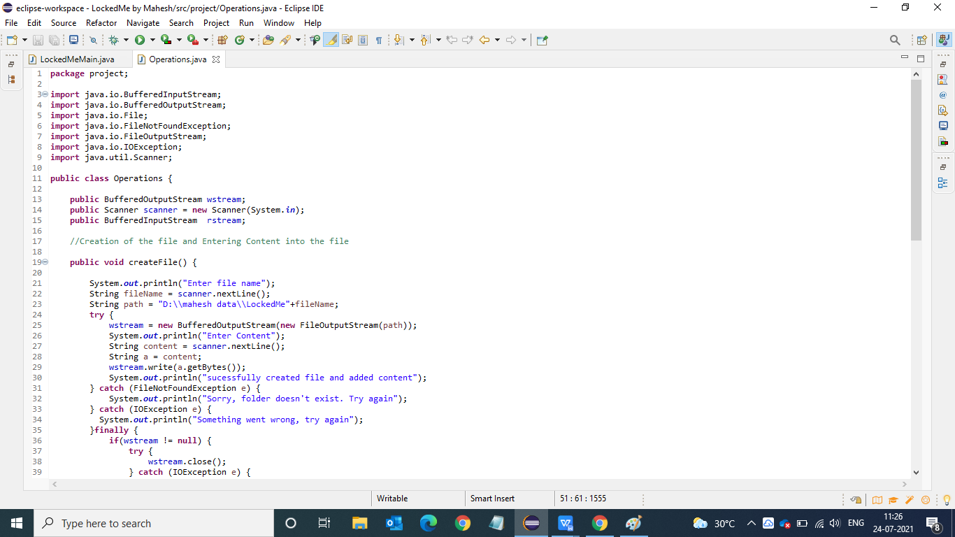

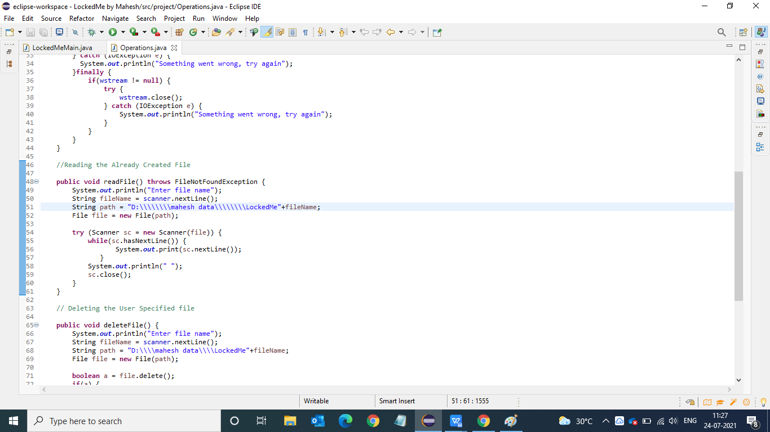

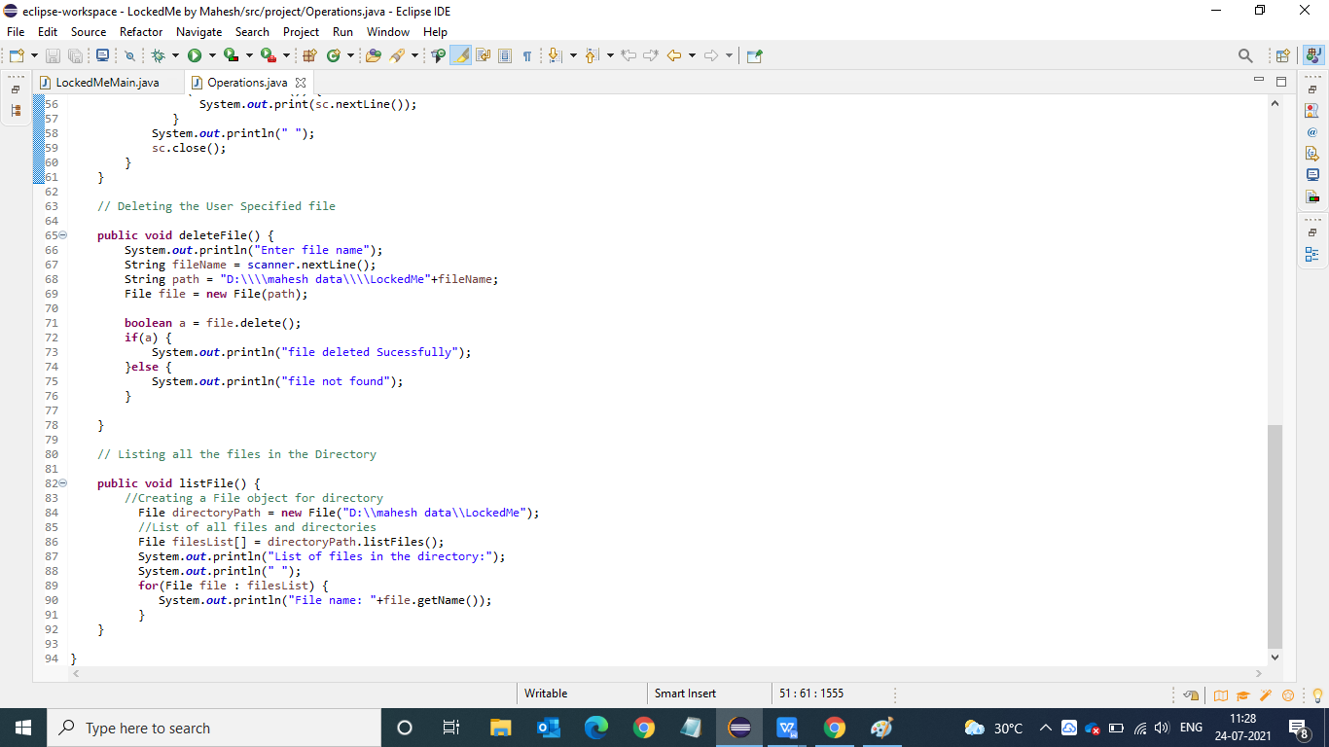

Application Flow with Console Screenshots:

* Welcome Screen with Developer Information

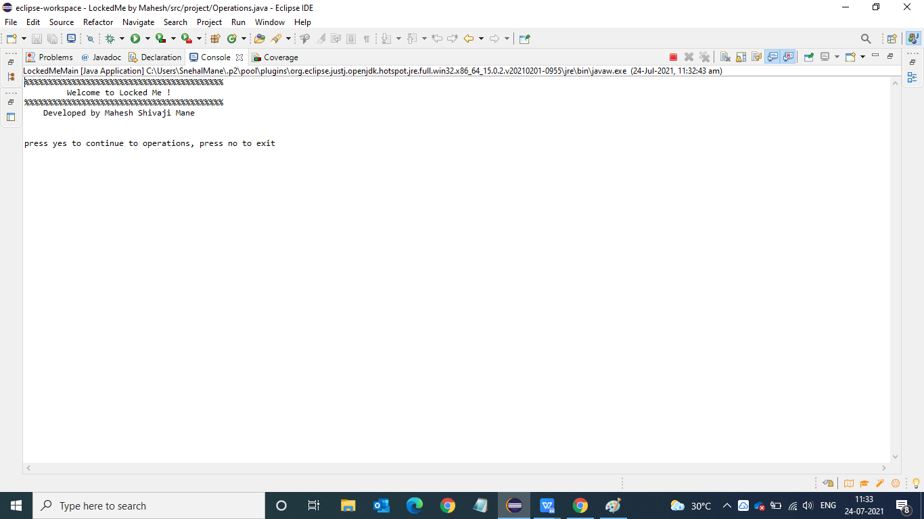

* Display of Various Operations after Pressing ‘yes’

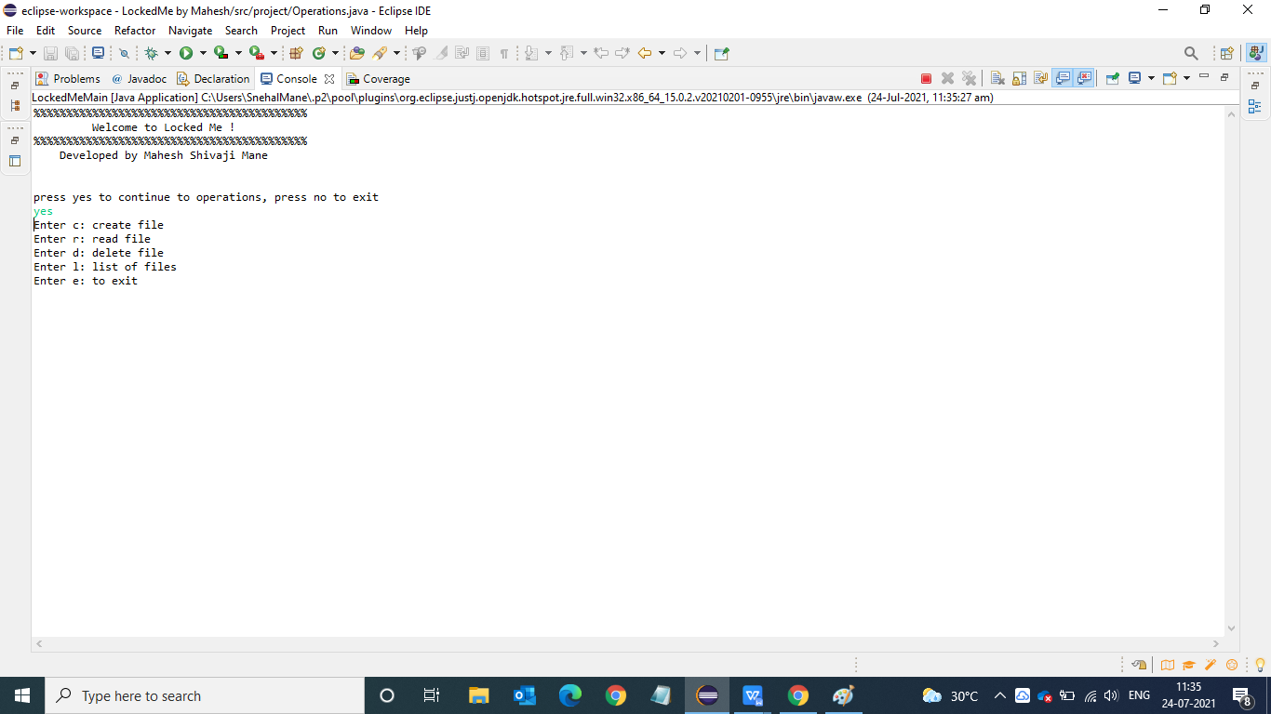

* And Exiting the application if the user presses “no’

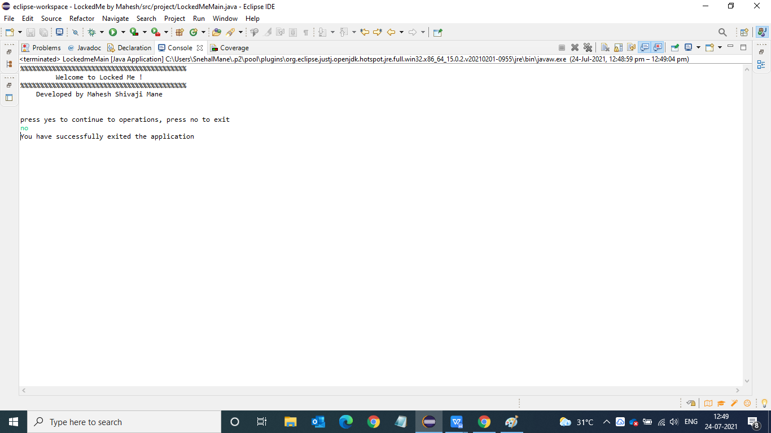

* To Create the file, type c and enter the content you will get the message of successful creation of file.

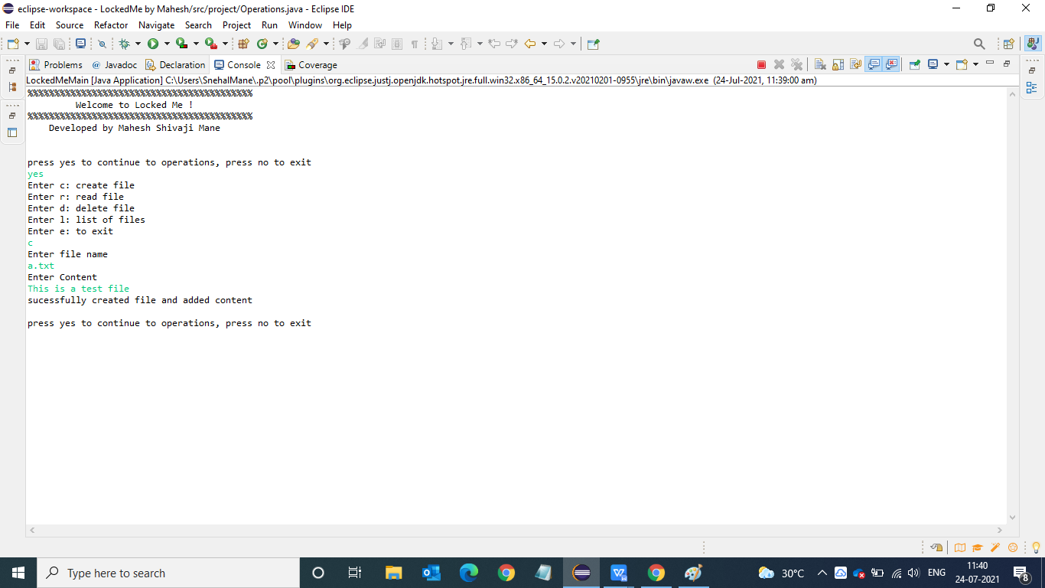

* To Read the Existing file type r and the content in the file will be displayed on the console

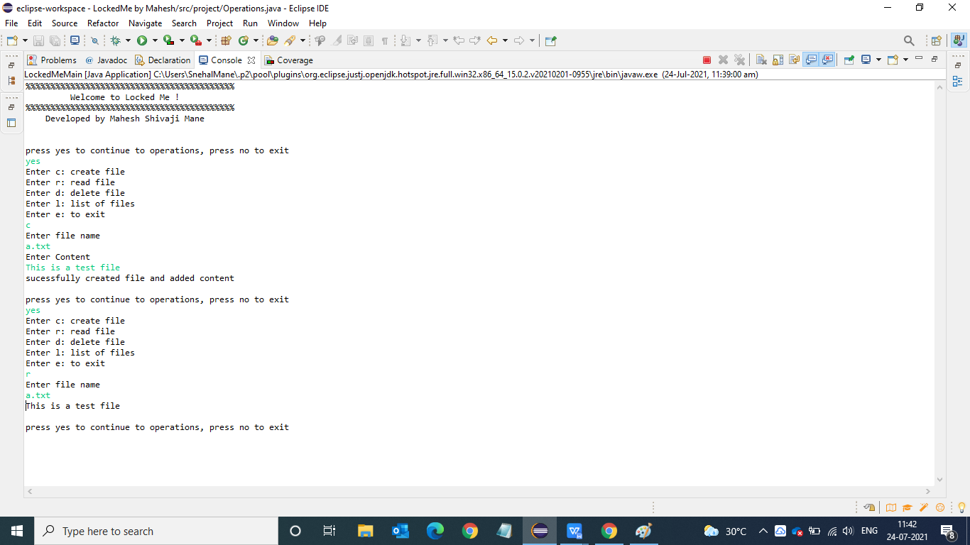

* To list the file in the Directory type l and the list of file in the directory will be displayed

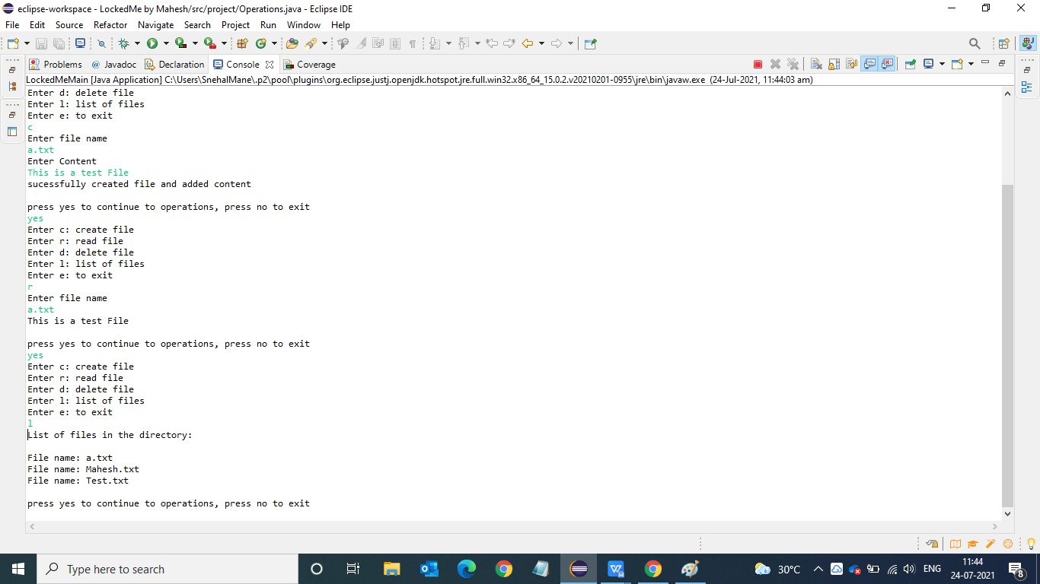

* To Delete the Exising file type d and the file will be successfully deleted

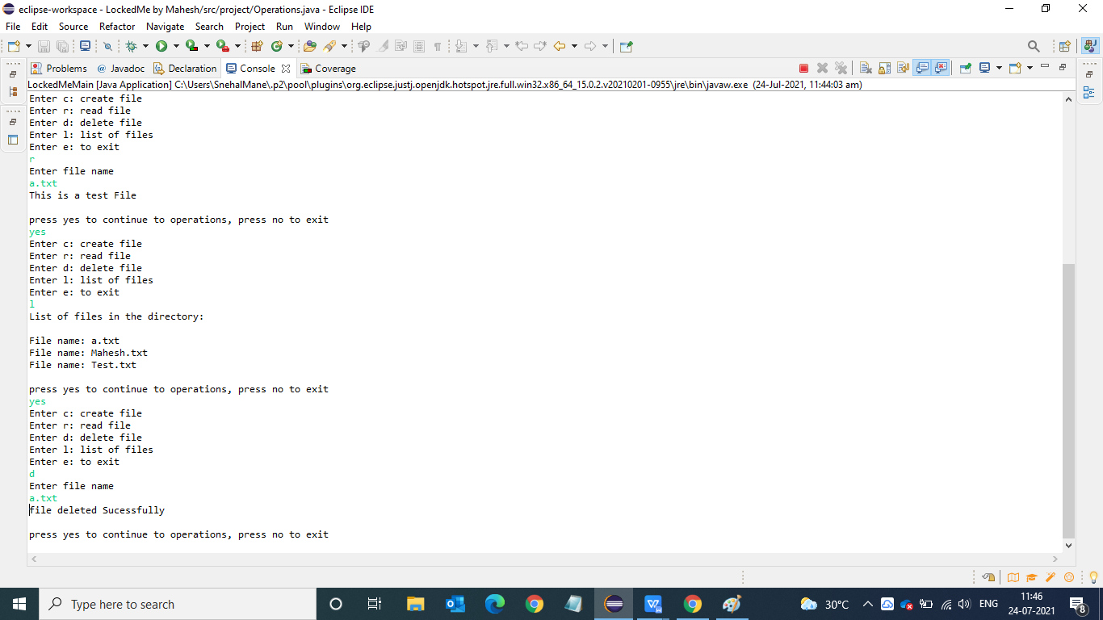

* To Exit the application press e and you will successfully be exited out of the application

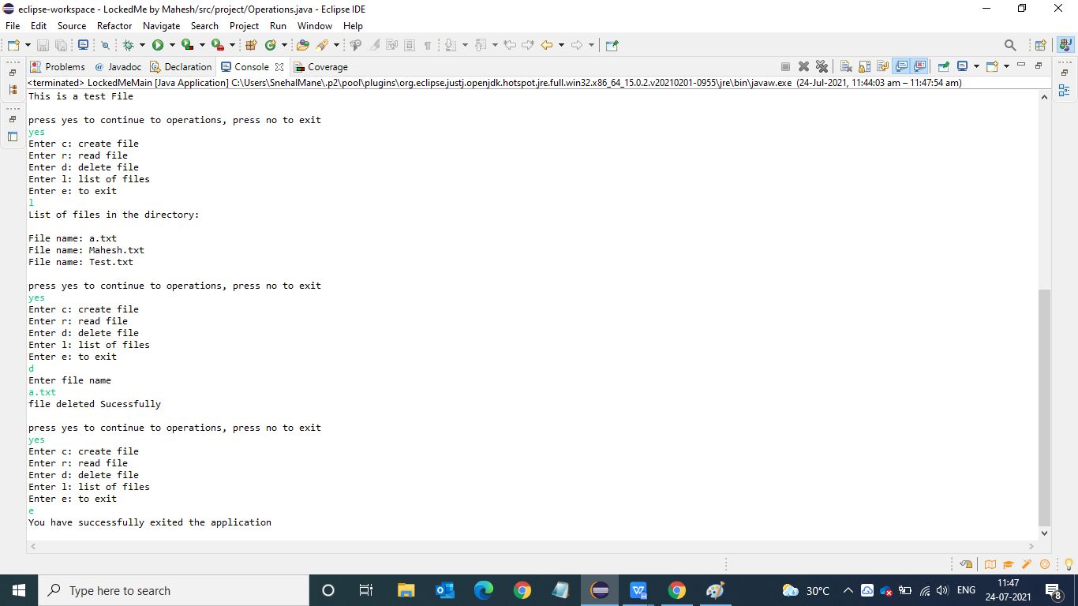

Various Exception Cases:

While reading the file If the User enters the different file name not in the directory then the user gets “file does n’t exist” message

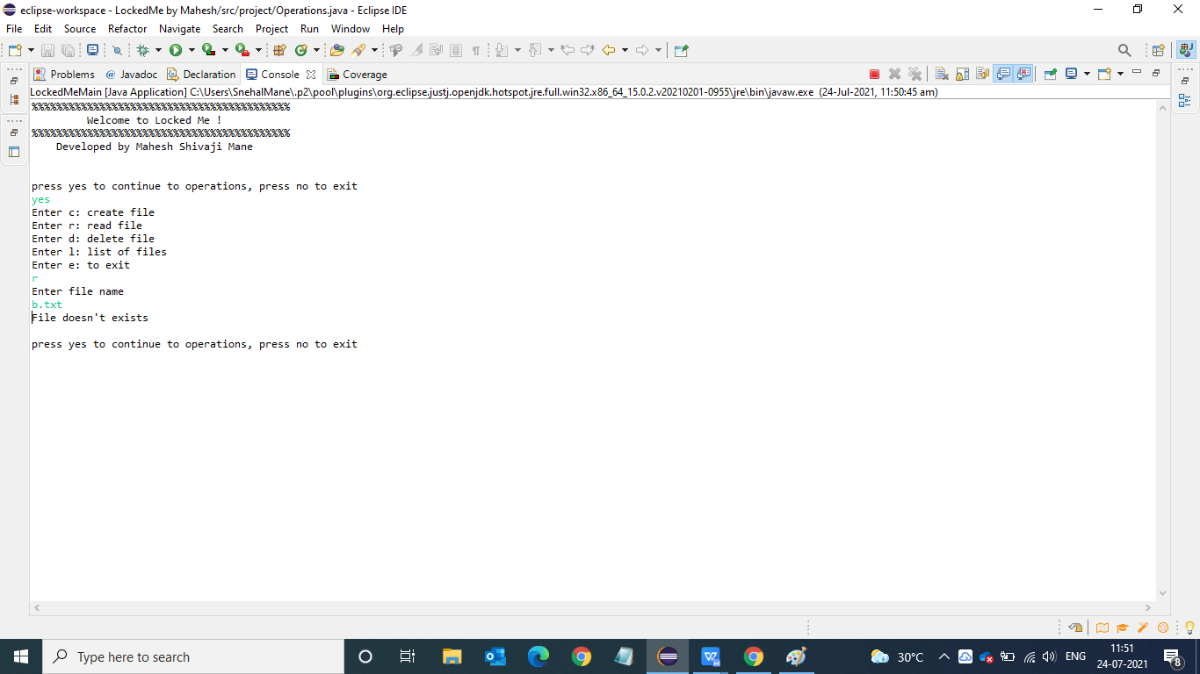

While deleting the file, If the file to be deleted does not exist then the user may get “file not found “ message

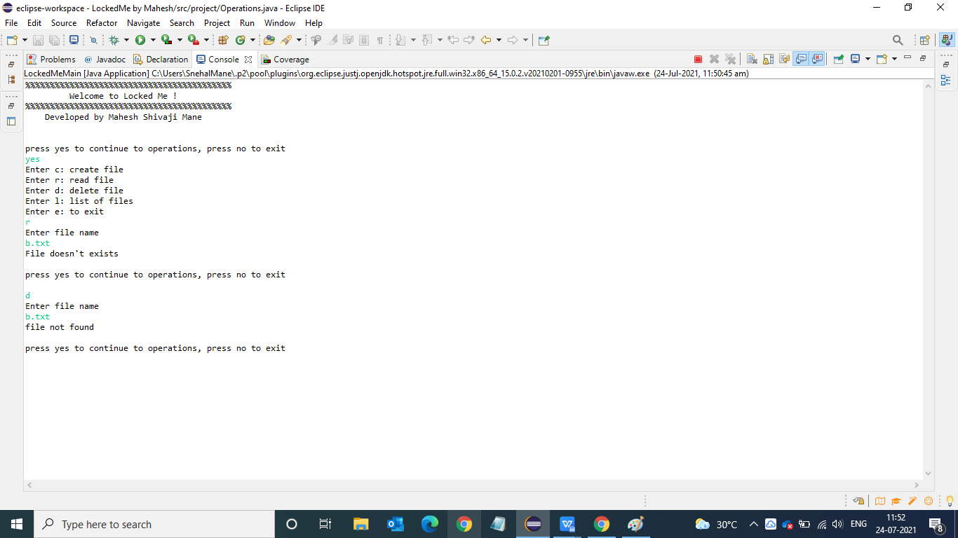

Concepts Used:

* Main Class Creation and Operation Object Creation
* While loop is used in Main Method to loop the Operation as many times as required by the user and an option to either continue yes or no.
* If - else if is used to enable the user to perform various operation as per his requirement.
* Break is used to exit the application with the message that you have successfully exited the application.
* File Input Output and File Handling
* While loop is used in Main Method to loop the Operation as many times as required by the user with an option of yes or no to either continue to exit the application.
* Create File : Use of Buffered Output Stream to write and create the file , Use of Scanner (System.in ) to Accept information from the User.
* Read File : Scanner with file class to read the existing file.
* Delete File : File class and its method .delete() to delete the file as entered by the user.
* List file : Created an array to hold the file object and rendered it with for Each method.