AU Bank End-to-End Insurance Platform — Solution Vision
  - Architecture pre-approval document | AU Bank End-to-End Insurance Platform
DRAFT FOR REVIEW - NOT APPROVED - NOT AUTHORISED FOR DEVELOPMENT

Version | 0.1 | Date | 17 August 2026
Document owner | Mahesh, Principal Insurance Platform Architect | Approval state | Pending
Purpose | Define the intended end-to-end solution, its boundary, objectives and design principles | Next action | Stakeholder review and recorded decision

1. Vision
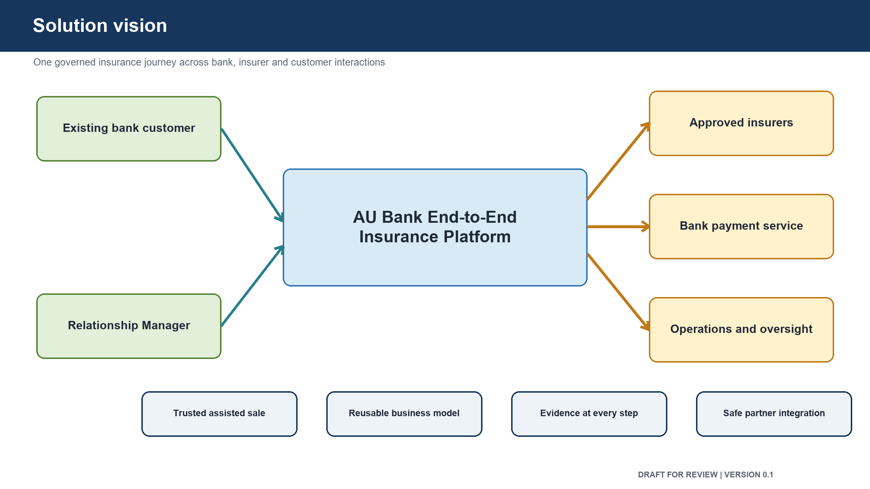
Figure: Solution vision overview
Create one bank-owned insurance platform that lets customers and Relationship Managers complete an insurance journey from discovery to an issued and reconciled policy, while the bank retains clear ownership of the customer experience, business rules, evidence and operational status.
The platform will support assisted, self-service and combined journeys over time. It will support multiple insurance lines and partners without allowing a partner's technical format to control the bank's customer journey.

2. Problems to solve
- The bank loses visibility when a customer is redirected to an external partner.
- Customer, Relationship Manager and operations teams do not have one reliable journey status.
- Consent, suitability, payment, issuance and reconciliation evidence are spread across systems.
- Partner differences make it difficult to add products and insurers consistently.
- Failures between quotation, proposal, payment and issuance require manual investigation.
- Product, customer and operational reporting cannot be trusted without clear data ownership.

3. Objectives
- Give the bank continuous visibility from lead creation to policy issuance and reconciliation.
- Make suitability and consent mandatory parts of the sales journey.
- Keep premium payment on the customer's own device.
- Provide a consistent bank journey across insurers and insurance lines.
- Preserve clear ownership of each business rule and each important item of data.
- Record every regulated action so it can be reconstructed later.
- Allow failed or interrupted journeys to be resumed safely.
- Isolate partner changes so that the bank journey does not need to be redesigned.
- Provide measurable service, security, recovery and customer outcomes.
- Deliver the smallest safe first release and expand from evidence.

4. People and organisations served
- Existing and future bank customers
- Relationship Managers and branch managers
- Bank insurance operations teams
- Compliance, risk, audit and security teams
- Product and business teams
- Finance and reconciliation teams
- Partner insurers and insurance service providers
- Platform support and engineering teams

5. End-to-end business scope
The target platform covers:
- customer identification and profile retrieval;
- lead creation, assignment, resumption and status;
- need analysis and suitability;
- consent and required disclosures;
- product catalogue, eligibility and product restrictions;
- quotation, comparison and selection;
- proposal capture and supporting documents;
- identity and verification checks;
- underwriting status and additional requirements;
- payment initiation and reconciliation;
- policy issuance, document access and confirmation;
- servicing, renewal, cancellation and refund;
- claims initiation or hand-off;
- operations work queues and exception handling;
- audit evidence, compliance reporting and management information;
- partner, payment, identity, messaging and bank-system connections.

6. First release boundary
The first release proves one complete sale:
- one Relationship Manager;
- one existing bank customer;
- one Term Life product;
- one selected insurer;
- Relationship Manager assisted journey;
- customer-confirmed consent;
- suitability completed before quotation;
- proposal submission and underwriting tracking;
- payment completed on the customer's device;
- policy issued and payment reconciled;
- complete audit evidence.
The first release does not include broad self-service, multiple insurance lines, full claims handling, large-scale campaign management, advanced management reporting or multi-partner routing.

7. Design principles
- The bank owns the customer journey and the meaning of its business data.
- Business ownership is defined before software boundaries are chosen.
- The first release stays small enough to prove the full journey safely.
- External partner formats are translated at the platform boundary.
- Each business area owns its rules and its official data.
- No business area reads or changes another area's data directly.
- Suitability is required before a quotation is produced.
- Consent is required before a proposal is submitted.
- Payment is performed only by the customer on the customer's device.
- A policy is not treated as sold until issuance and payment reconciliation are confirmed.
- Personal and financial data remain protected, traceable and stored in India.
- Failures, retries, duplicate requests and interrupted journeys are designed explicitly.
- Security, operations and testing requirements are included before development starts.
- New technical complexity is added only when a measured need justifies it.

8. Expected outcomes
- Higher completion of suitable insurance journeys
- Lower manual effort for status tracking and reconciliation
- Faster addition of products and insurers
- Fewer payment and issuance disputes
- Complete evidence for customer, audit and regulatory questions
- Clear responsibility for defects, data and business rules
- Reliable measurement of journey conversion and failure points

9. Decisions requested
- Confirm the target platform vision.
- Confirm the first release boundary.
- Confirm the bank-owned journey and data principle.
- Confirm suitability, consent, customer-device payment and reconciliation as mandatory controls.
- Confirm phased delivery rather than building every target capability in the first release.

Approval control: review comments and recommendations do not constitute approval. The decision remains Pending until the named human stakeholder records a decision, date and signature.

10. Review and sign-off
Stakeholder | Review responsibility | Decision | Name | Date | Comments
Product Owner | Business vision, scope, actors and outcomes | Pending
Principal Architect | End-to-end structure and design principles | Pending
Chief Technology Officer | Technical direction and investment alignment | Pending
Compliance and Risk Head | Regulatory and customer-protection outcomes | Pending
Security Head | Security principles and protected-data posture | Pending
Delivery Head | Delivery feasibility and phased plan | Pending

11. Version history
Version | Date | Change | Approval state
0.1 | 17 August 2026 | Initial pre-approval draft | Not approved

