AU Bank End-to-End Insurance Platform — Business Capability Map
  - Architecture pre-approval document | AU Bank End-to-End Insurance Platform
DRAFT FOR REVIEW - NOT APPROVED - NOT AUTHORISED FOR DEVELOPMENT

Version | 0.1 | Date | 17 August 2026
Document owner | Product Owner for business meaning; Principal Architect for solution alignment | Approval state | Pending
Purpose | Identify the capabilities required by the platform and show where each capability belongs | Next action | Stakeholder review and recorded decision

1. Capability map
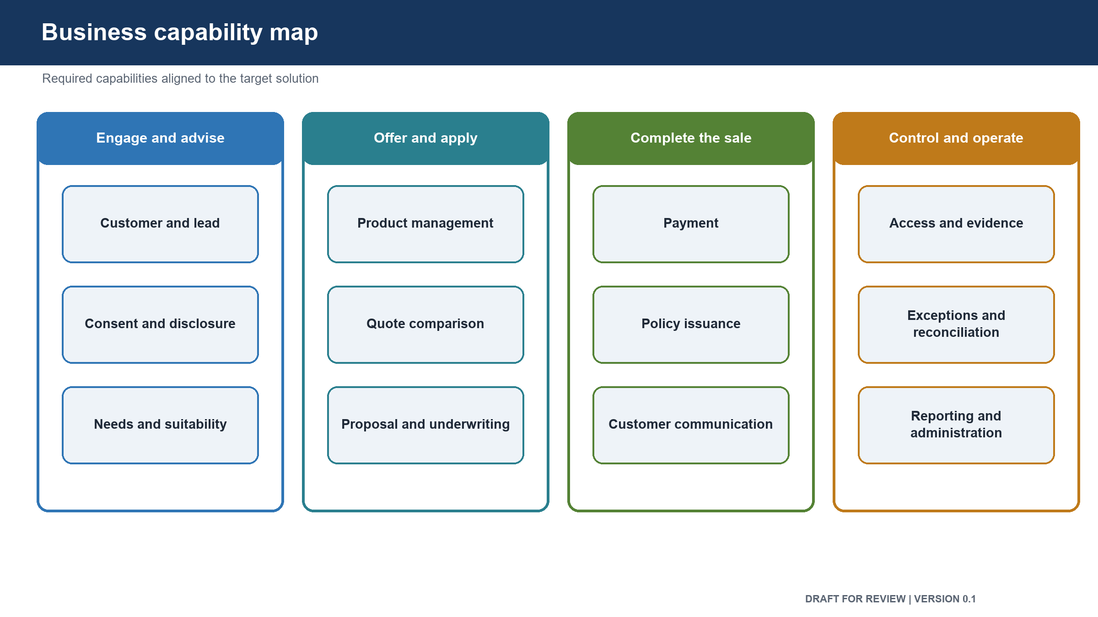
Figure: Business capability map

Capability group | Required capabilities | Target solution area | First release position
Customer and relationship management | Customer lookup, customer profile, lead creation, assignment, resumption, Relationship Manager workspace | Customer, Lead and Relationship Manager Workspace | Customer lookup and assisted journey included; broader lead management later
Advice and customer protection | Need analysis, suitability, consent, disclosures, evidence capture | Suitability and Consent | Included
Product management | Insurer and product catalogue, eligibility, product restrictions, pricing inputs, product activation | Product Catalogue | One Term Life product from one insurer
Quotation | Quote request, partner routing, quote collection, comparison, expiry and re-quote | Quotation and Partner Integration | Included
Proposal | Proposal capture, documents, validation, submission and status | Proposal and Underwriting Tracking | Included
Underwriting | Requirements, medical or financial evidence status, insurer decision tracking | Proposal and Underwriting Tracking | Status tracking only; insurer keeps underwriting decision
Payment | Payment session, customer delivery, callback, uncertain-state handling and reconciliation | Payment and Reconciliation | Included
Policy | Issuance confirmation, policy record, document access and sold-status decision | Policy and Issuance | Included
Policy servicing | Endorsement, nominee change, cancellation, refund and service request tracking | Policy Servicing | Later release
Renewal | Renewal notice, quote, payment and confirmation | Renewal | Later release
Claims | Claim notification, document collection, insurer hand-off and status visibility | Claims | Later release
Journey control | End-to-end stage, resumption, failure handling and manual intervention | Journey Coordination | Included
Partner management | Partner onboarding, product connection, service limits, credentials and support contacts | Partner Integration | One selected integration route
Identity and access | Workforce sign-in, customer confirmation, permissions, branch and insurer access | Identity and Access | Workforce access and customer confirmation included
Audit and compliance | Attributable evidence, consent history, suitability history, sales reconstruction and retention | Audit and Compliance Evidence | Included
Communications | One-time password, payment link, status messages and reminders | Communications | Transaction messages only
Operations | Work queues, failed-journey recovery, reconciliation breaks and support actions | Operations Work Management | Minimum journey and payment exceptions
Reporting | Sales funnel, completion, failure points, insurer performance and compliance reporting | Reporting and Information | Pilot measures only
Administration | Products, rules, access, templates and reference information | Administration and Configuration | Controlled files for the first release; user interface later
Platform operation | Build, release, monitoring, alerting, backup, restore and incident response | Shared Platform Services | Required before production use

2. Capability ownership
Capability | Business owner | Main collaborators
Customer and lead management | Product and Sales | Customer Operations, Architecture, Data
Suitability and consent | Product | Compliance, Security, Architecture, Quality
Product catalogue and quotation | Product | Architecture, Partner Management, Engineering
Proposal and underwriting tracking | Product | Partner Insurer, Compliance, Operations
Payment and reconciliation | Product and Finance | Architecture, Security, Operations, Data
Policy and servicing | Product and Operations | Partner Insurer, Finance, Data
Identity and access | Security and Technology | Product, Architecture, Operations
Audit and compliance evidence | Compliance and Risk | Security, Architecture, Data, Quality
Platform operation | Technology Operations | Architecture, Engineering, Security, Data
Reporting and outcomes | Product | Finance, Operations, Data, Delivery

3. Alignment rules
- One business capability may use more than one software component.
- One software component may support closely related capabilities.
- A capability name does not automatically justify a separately deployed service.
- The official owner of a business rule also owns changes to its meaning.
- Technical ownership does not replace business ownership.
- Shared reporting may read approved copies of data but does not become the owner of that data.
- A partner may supply facts and decisions within its role, but it does not own the bank's journey.

4. Capability gaps requiring stakeholder decisions
Gap | Decision needed | Decision owner
Customer sign-in for self-service journeys | Choose the customer identity approach before self-service starts | Product, Security and Architecture
Suitability rules | Approve inputs, outcomes, validity and evidence | Product and Compliance
Consent rules | Approve wording, customer confirmation, validity and withdrawal | Product and Compliance
Product matrix | Confirm the first insurer, product and eligibility boundary | Product
Payment reconciliation | Confirm settlement timing, break handling and Finance ownership | Finance and Product
Retention | Confirm retention and disposal periods by data class | Compliance, Data and Security
Claims boundary | Confirm whether the platform tracks, starts or manages claims | Product

Approval control: review comments and recommendations do not constitute approval. The decision remains Pending until the named human stakeholder records a decision, date and signature.

5. Review and sign-off
Stakeholder | Review responsibility | Decision | Name | Date | Comments
Product Owner | Capability completeness, priority and release scope | Pending
Business Analysis Lead | Process, rule and information completeness | Pending
Principal Architect | Alignment to target solution | Pending
Chief Technology Officer | Strategic technology alignment | Pending
Delivery Head | Delivery sequence and dependency feasibility | Pending

6. Version history
Version | Date | Change | Approval state
0.1 | 17 August 2026 | Initial pre-approval draft | Not approved

