AU Bank End-to-End Insurance Platform — Business Domain and Ownership Model
  - Architecture pre-approval document | AU Bank End-to-End Insurance Platform
DRAFT FOR REVIEW - NOT APPROVED - NOT AUTHORISED FOR DEVELOPMENT

Version | 0.1 | Date | 17 August 2026
Document owner | Mahesh, Principal Insurance Platform Architect | Approval state | Pending
Purpose | Define the core business areas, their ownership boundaries and their interactions | Next action | Stakeholder review and recorded decision

1. Ownership model
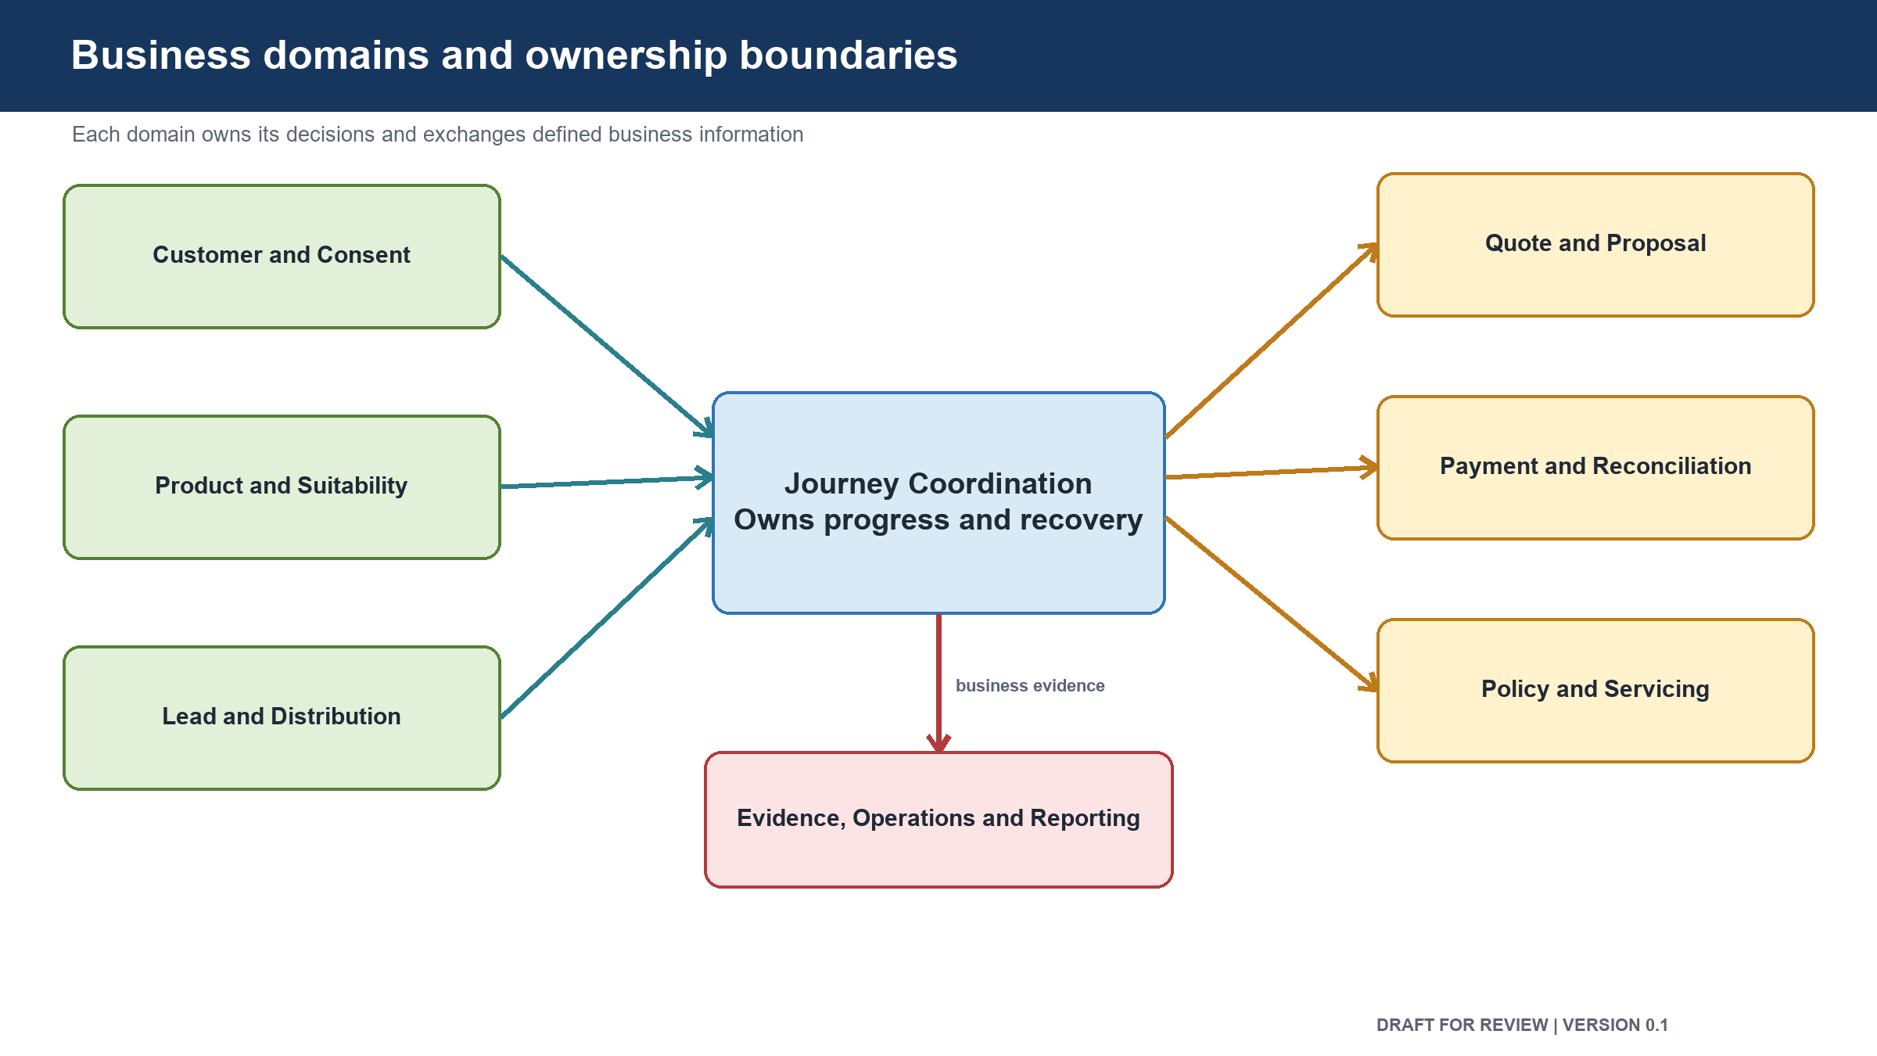
Figure: Business domains and ownership boundaries
Each business area owns a distinct set of rules and data. Other areas request information or an action through an agreed service boundary. They do not read or change another area's stored data directly.

Business area | Responsibility | Owns | Does not own | Main interactions
Identity and Access | Sign-in, session and permissions | Workforce identity links, roles, branch and insurer access | Customer, policy or payment data | Relationship Manager Workspace and all protected business areas
Relationship Manager Workspace | Present the assisted sales journey | Screen state and server-held user session | Insurance business decisions | Identity, Journey Coordination and business areas
Customer | Provide the bank customer view needed for insurance | Customer snapshot, source and freshness | Core bank customer master | Core banking, Lead and Journey Coordination
Lead | Manage sales opportunity ownership and progress | Lead, assignment, source and lead status | Customer master or insurance journey state | Customer, Relationship Manager Workspace and Journey Coordination
Consent | Record customer permission and disclosures | Consent wording version, customer confirmation, time and status | Suitability or proposal rules | Journey Coordination, Proposal and Audit
Suitability | Decide whether the proposed insurance path is suitable | Inputs, rule version, result, reasons and validity | Product catalogue or insurer underwriting | Product Catalogue, Quotation, Journey Coordination and Audit
Product Catalogue | Define products the bank may offer | Product, insurer, eligibility, channel and effective dates | Live quote or proposal state | Suitability, Quotation and Administration
Journey Coordination | Track end-to-end progress and recovery | Journey stage, references, next action and failure state | Another area's business decision or detailed records | All journey business areas and Operations
Quotation | Request and manage insurance offers | Quote request, offer, expiry, status and selected offer | Suitability result or partner product definition | Suitability, Product Catalogue, Partner Integration and Journey Coordination
Proposal and Underwriting Tracking | Capture and track the application | Proposal, documents, submission and insurer requirements | Insurer underwriting decision | Consent, Quotation, Partner Integration and Journey Coordination
Payment and Reconciliation | Manage the premium payment state | Payment session, payment result, settlement and reconciliation state | Policy issuance | Customer payment device, bank payment service, Policy and Finance
Policy and Issuance | Confirm and expose the issued policy | Policy record, issue status, document references and sold-status evidence | Payment settlement | Payment, Partner Integration, Operations and Audit
Partner Integration | Connect the platform to insurers and service providers | Partner routing, translated messages, partner request status and technical correlation | Bank business rules or journey meaning | Quotation, Proposal, Policy and external partners
Communications | Deliver required customer and staff messages | Message request, channel, delivery status and template version | Payment or journey decisions | Consent, Payment, Policy and Operations
Audit and Compliance Evidence | Preserve attributable evidence | Actor, action, time, purpose, before-and-after meaning and evidence chain | Operational business decisions | Every regulated business area
Operations Work Management | Manage manual recovery and exception work | Work item, owner, deadline, action and closure evidence | Source business state | Journey Coordination, Payment, Policy, Audit and Communications
Reporting and Information | Provide approved measures and management views | Reporting copies, measures and calculation versions | Source transaction records | All business areas through approved information feeds
Administration and Configuration | Manage controlled reference information | Approved configuration, rule publication and effective dates | Business approval of a product or compliance rule | Product Catalogue, Consent, Suitability, Identity and Communications

2. Interaction rules
- The Relationship Manager Workspace sends requests through a server-side session layer.
- Every protected business area checks the user and the requested action.
- Journey Coordination records progress and references; it does not copy another area's decision.
- Quotation cannot proceed without a valid suitability result.
- Proposal submission cannot proceed without valid consent.
- Payment information is handled by the bank payment service, not by the Relationship Manager.
- Policy issuance cannot be treated as sold until payment reconciliation is confirmed.
- All insurer communication passes through Partner Integration.
- Regulated actions produce a durable audit record.
- Failed automatic recovery creates an owned operations task.
- Reporting receives approved copies and cannot update transaction data.

3. Primary business interaction
- A Relationship Manager signs in and selects an existing bank customer.
- Customer information is retrieved and a journey is opened.
- The customer's need is assessed.
- Suitability is evaluated and recorded.
- Consent is confirmed by the customer.
- Eligible products are selected from the catalogue.
- Quotation requests are sent through Partner Integration.
- Offers are returned in the bank's common format.
- The customer selects an offer and the proposal is completed.
- Underwriting progress and further requirements are tracked.
- The customer receives a payment request on the customer's device.
- Payment is confirmed and reconciled.
- Policy issuance is confirmed and the document becomes available.
- Audit evidence is checked before the journey is marked complete.

4. Boundary decisions requiring approval
Decision | Proposed position | Required reviewers
Journey ownership | Journey Coordination owns progress and references only | Product, Architecture and Engineering
Partner isolation | All insurer and provider traffic passes through Partner Integration | Architecture, Security and Operations
Data ownership | Each business area owns its official records and rules | Architecture, Data and Product
Payment isolation | Relationship Manager devices cannot perform premium payment | Product, Security, Compliance and Architecture
Audit evidence | Regulated evidence cannot be changed or deleted during its required retention period | Compliance, Security, Data and Architecture
Reporting | Reporting uses approved copies and has no write access to transaction areas | Product, Data, Security and Architecture

Approval control: review comments and recommendations do not constitute approval. The decision remains Pending until the named human stakeholder records a decision, date and signature.

5. Review and sign-off
Stakeholder | Review responsibility | Decision | Name | Date | Comments
Product Owner | Business meaning and journey behaviour | Pending
Principal Architect | Ownership boundaries and interactions | Pending
Engineering Head | Implementation feasibility | Pending
Data and Database Architect | Data ownership and integrity | Pending
Security Head | Access and protected-data boundaries | Pending
Compliance and Risk Head | Consent, suitability, payment and evidence boundaries | Pending
Quality Lead | Boundary and failure-path testability | Pending

6. Version history
Version | Date | Change | Approval state
0.1 | 17 August 2026 | Initial pre-approval draft | Not approved

