AU Bank End-to-End Insurance Platform — High-Level Design
  - Architecture pre-approval document | AU Bank End-to-End Insurance Platform
DRAFT FOR REVIEW - NOT APPROVED - NOT AUTHORISED FOR DEVELOPMENT

Version | 0.1 | Date | 17 August 2026
Document owner | Mahesh, Principal Insurance Platform Architect | Approval state | Pending
Purpose | Describe the system setting, major components, information flow, integrations and key design decisions | Next action | Stakeholder review and recorded decision

1. Design scope
The design covers a bank-owned insurance distribution platform supporting customer and Relationship Manager journeys from customer identification through policy issuance and payment reconciliation. It provides one consistent business model while connecting to bank systems, insurers, payment services and communications providers.
The first release is an assisted Term Life sale for an existing bank customer through one selected insurer. The design allows later expansion without requiring every future capability in the first release.

2. System context
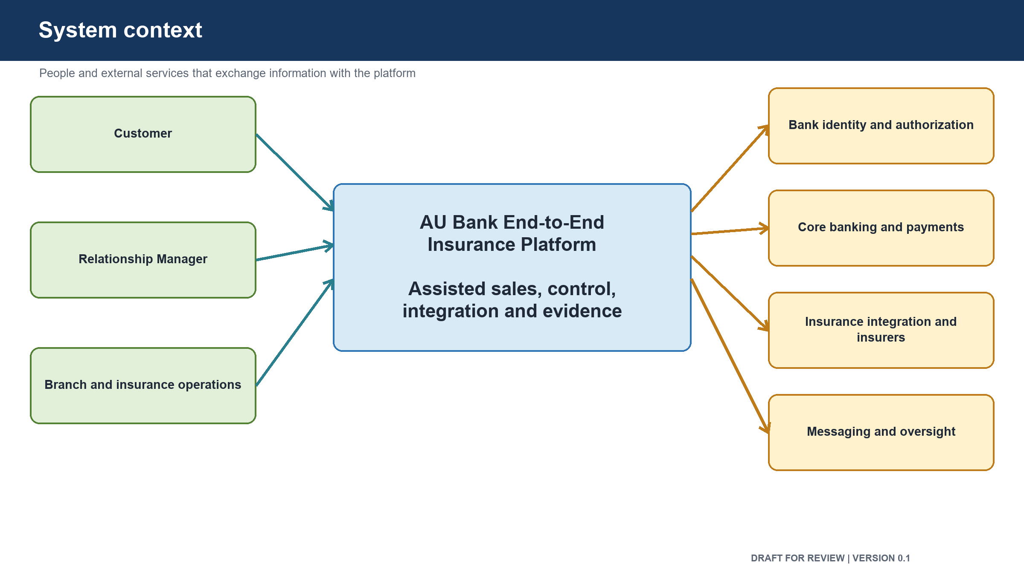
Figure: System context

External party or system | Relationship with the platform
Customer | Confirms consent, receives messages, completes payment and receives policy information
Relationship Manager | Starts and manages the assisted sales journey
Branch and insurance operations | Handles exceptions, follow-up and reconciliation breaks
Bank workforce identity service | Confirms staff identity
Bank authorization service | Decides what a staff member may view or do
Core banking system | Supplies verified existing-customer information
Insurance integration provider | Connects the bank to insurer quotation, proposal and policy services
Partner insurer | Supplies products, quotes, underwriting status and policy issuance
Bank payment service | Hosts the customer payment experience and provides payment and settlement results
Messaging service | Sends one-time passwords, payment links and status messages
Compliance, audit and risk teams | Review retained evidence and control outcomes

3. Major architecture components
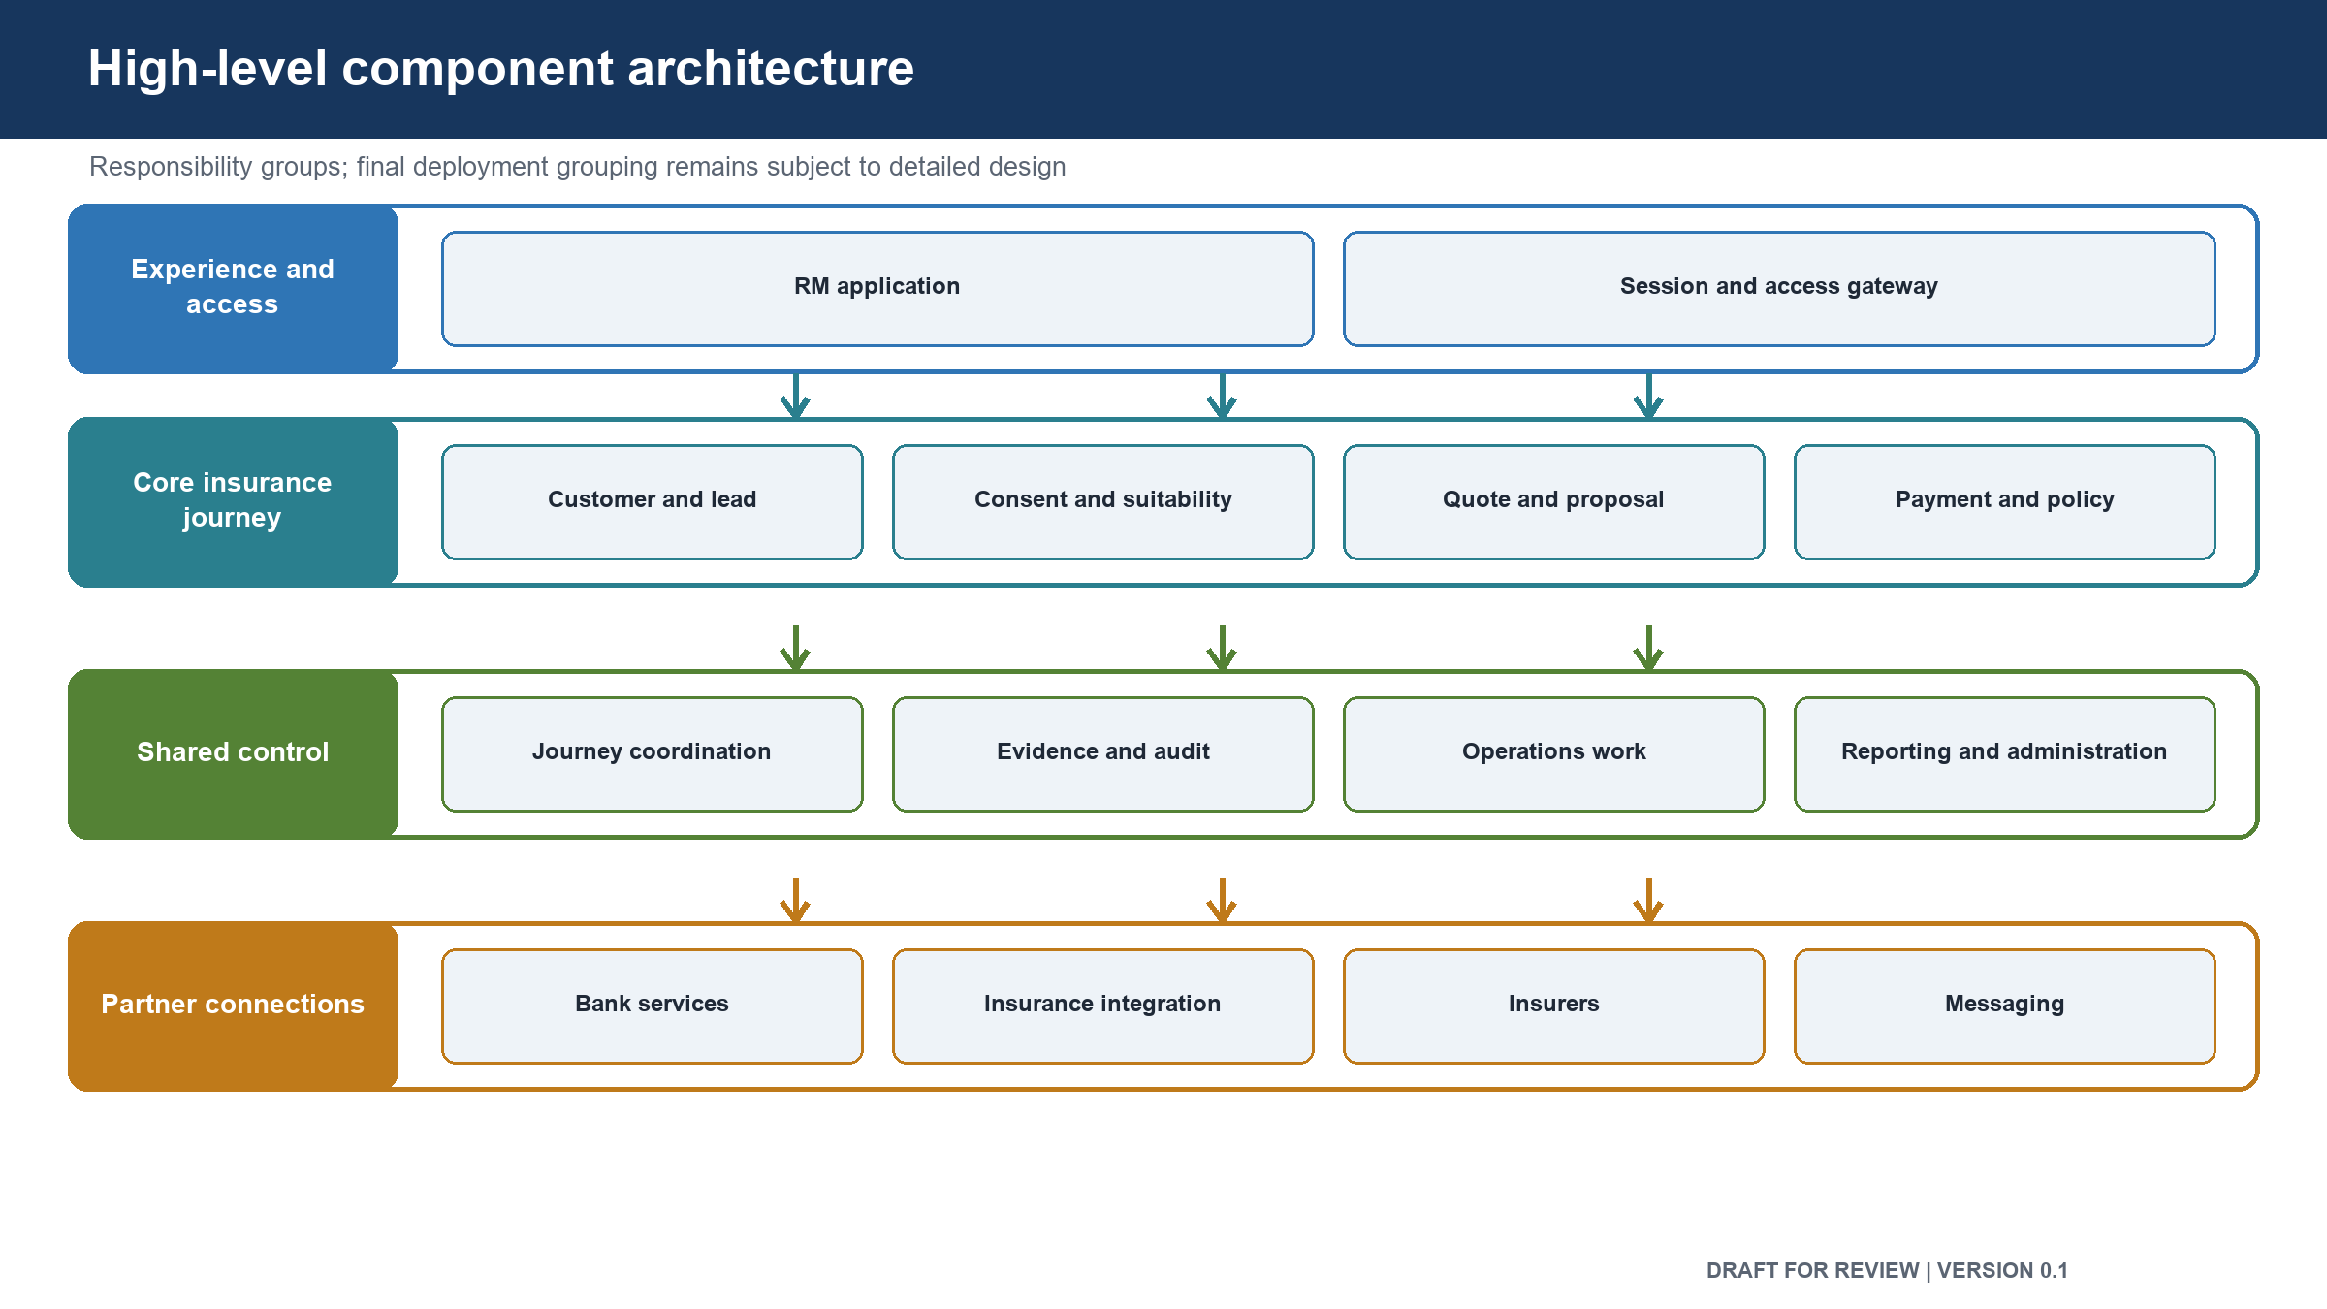
Figure: High-level component architecture

Component | Main responsibility
Relationship Manager Application | Presents the assisted journey
Session and Access Gateway | Holds the staff session securely and checks access before requests reach business services
Customer Service | Retrieves and stores the insurance-use customer snapshot
Lead Service | Manages sales opportunities and assignment
Consent Service | Records customer permission and disclosure evidence
Suitability Service | Evaluates need and suitability before quotation
Product Catalogue | Holds products the bank has approved for sale
Journey Coordinator | Tracks progress, resumption and manual recovery
Quotation Service | Requests, receives and normalises offers
Proposal and Underwriting Service | Captures proposals and tracks insurer requirements and decisions
Payment and Reconciliation Service | Creates payment sessions and resolves payment and settlement state
Policy and Issuance Service | Confirms issued policies and determines whether the sale is complete
Partner Integration Service | Routes and translates insurer and provider requests
Audit and Evidence Service | Stores attributable records that cannot be altered during their retention period
Communications Service | Sends required customer and staff messages
Operations Work Service | Creates and tracks manual recovery tasks
Reporting Service | Produces approved business and control measures
Administration Service | Publishes approved products, rules, templates and reference information

The components describe responsibility boundaries. Final deployment grouping may combine closely related components where separate deployment provides no clear benefit.

4. Hosting and network design
- Customer and Relationship Manager requests enter through one protected public entry point.
- Business services run on private networks and cannot be reached directly from the internet.
- Data stores run on private networks and are reachable only by their owning service.
- Each business service receives a separate identity and the minimum access it needs.
- Personal, financial and audit data are stored and backed up only in India.
- Secrets and encryption keys are held in managed secure stores, not in application files.
- Production capacity is spread across more than one location within the primary India region.
- A secondary India region is used for recovery.
- Only the customer reaches the payment page; the Relationship Manager application cannot take payment details.

5. End-to-end information flow
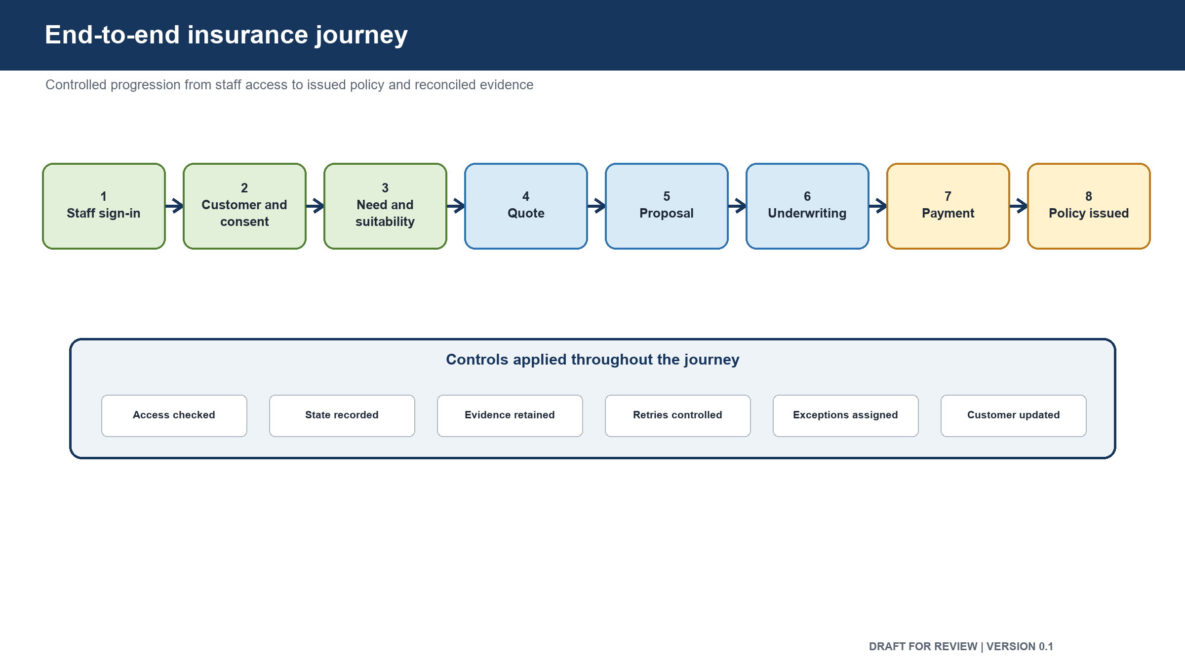
Figure: End-to-end insurance journey

Step | Flow | Result
1 | Relationship Manager signs in through the bank workforce identity service | A server-held session is created
2 | The application checks the Relationship Manager's role, branch, insurer scope and certification | Access is allowed or denied
3 | Customer details are requested from core banking | A time-stamped customer snapshot is created
4 | A lead or journey is opened | Journey ownership and current stage are recorded
5 | Need and suitability information is captured | A versioned suitability result is stored
6 | The customer confirms consent using a one-time password | Consent evidence is stored
7 | Eligible products are selected and quotes are requested | Partner requests are sent through the integration service
8 | Partner responses are translated into the bank's common offer format | Offers can be compared consistently
9 | The selected offer is used to prepare and submit a proposal | Submission and underwriting status are tracked
10 | When payment is allowed, a payment request is sent to the customer's device | The bank payment service handles payment details
11 | Payment result and settlement information are received | Uncertain or unmatched payments enter reconciliation
12 | Policy issuance is confirmed through the integration service | Policy data and document references are stored
13 | Issuance, reconciliation and audit completeness are checked | The journey is marked complete only when all checks pass

6. Integration design
Integration | Direction | Method | Failure handling
Workforce identity | Platform to bank identity | Immediate request | Access is denied if identity cannot be confirmed
Authorization | Platform to bank authorization | Immediate request | Access is denied if a decision is unavailable
Core banking | Platform to core banking | Immediate request | A recent approved snapshot may be used; otherwise the journey waits
Insurance provider | Platform through integration service | Submission followed by status checks | No blind resubmission; status is recovered using the existing request reference
Payment service | Platform and customer to bank payment service | Session request, customer payment, confirmed callback and settlement file | Unknown states are reconciled; payment is never assumed successful
Messaging | Platform to messaging service | Delivery request | Failure creates an operations task and does not silently discard the message
Audit evidence | Business services to audit service | Durable queued record | Business action is retained for retry; journey completion waits for required evidence

7. Data design
- Each business area owns its official data.
- Other areas use service requests or approved reporting copies.
- Direct access to another area's database is not allowed.
- Partner messages are translated before they enter the bank business model.
- Highly sensitive proposal and payment information is encrypted.
- Audit, consent and suitability evidence is append-only.
- Duplicate business requests return the original result when the same request is repeated.
- A repeated request with changed content is rejected.
- Reporting data is read-only and cannot change transaction records.

8. Reliability and recovery
- Requests waiting for an immediate user response have clear time limits.
- Long-running quote, proposal and issuance work is tracked by status rather than holding a user connection open.
- Automatic retries are used only when repeating an action is safe.
- Payment and proposal submissions are not repeated blindly.
- One failing insurer is isolated so it cannot consume all partner connection capacity.
- Service and database backups are encrypted and tested through restore exercises.
- The primary recovery target is to restore core sale services within one hour with no more than five minutes of transaction loss.
- Audit evidence is designed for no loss during a regional recovery.
- Payment reconciliation, not database restoration, determines whether money was captured.
- Failed automatic recovery creates a named operations task.

9. Key design decisions
Decision | Proposed position | Reason | Approval state
Journey ownership | The bank owns the journey and business meaning | Prevents partner systems from controlling customer behaviour | Pending
Delivery scope | Prove one assisted Term Life journey first | Reduces risk while proving the complete path | Pending
Business boundaries | Separate ownership by responsibility and data | Makes rules, changes and failures accountable | Pending
Deployment | Combine or separate components only when ownership, scale or failure isolation requires it | Avoids unnecessary operational complexity | Pending
Partner access | All insurer communication passes through one integration boundary | Isolates partner formats and credentials | Pending
User access | Staff credentials remain on the server side | Reduces credential exposure on devices | Pending
Suitability | A valid suitability result is mandatory before quotation | Protects the customer and bank | Pending
Consent | Valid customer consent is mandatory before proposal submission | Preserves evidence and customer control | Pending
Payment | Payment is completed only on the customer's device | Separates the sales role from payment authorization | Pending
Sale completion | Issuance, reconciliation and audit evidence are all required | Prevents false or disputed sales reporting | Pending
Data location | Regulated data remains in India | Meets bank and regulatory expectations | Pending
Shared messaging platform | Deferred until measured demand justifies it | Keeps the first release simpler to operate | Pending

10. Open design decisions
- Customer identity for future self-service journeys
- Final product and insurer list for the first release
- Approved consent and suitability rules
- Payment settlement timing and reconciliation ownership
- Data retention and disposal periods
- Partner service limits and planned maintenance windows
- Final component deployment grouping
- Recovery capacity and cost approval

Approval control: review comments and recommendations do not constitute approval. The decision remains Pending until the named human stakeholder records a decision, date and signature.

11. Review and sign-off
Stakeholder | Review responsibility | Decision | Name | Date | Comments
Chief Technology Officer | Technical direction and investment alignment | Pending
Principal Architect | Overall structure, boundaries and decisions | Pending
Product Owner | Scope, journey and business behaviour | Pending
Engineering Head | Build feasibility and engineering standards | Pending
Security Head | Access, data protection and security risk | Pending
Data and Database Architect | Data ownership, integrity and recovery | Pending
Compliance and Risk Head | Regulatory controls and evidence | Pending
Reliability and Operations Head | Operability, recovery and capacity | Pending
Quality Lead | Testability and evidence approach | Pending

12. Version history
Version | Date | Change | Approval state
0.1 | 17 August 2026 | Initial pre-approval draft | Not approved

