AU Bank End-to-End Insurance Platform — Security Design Review
  - Architecture pre-approval document | AU Bank End-to-End Insurance Platform
DRAFT FOR REVIEW - NOT APPROVED - NOT AUTHORISED FOR DEVELOPMENT

Version | 0.1 | Date | 17 August 2026
Document owner | Security Head for security decision; Principal Architect for solution structure | Approval state | Pending
Purpose | Review access control, data protection, compliance needs and security risks before development | Next action | Stakeholder review and recorded decision

1. Review position
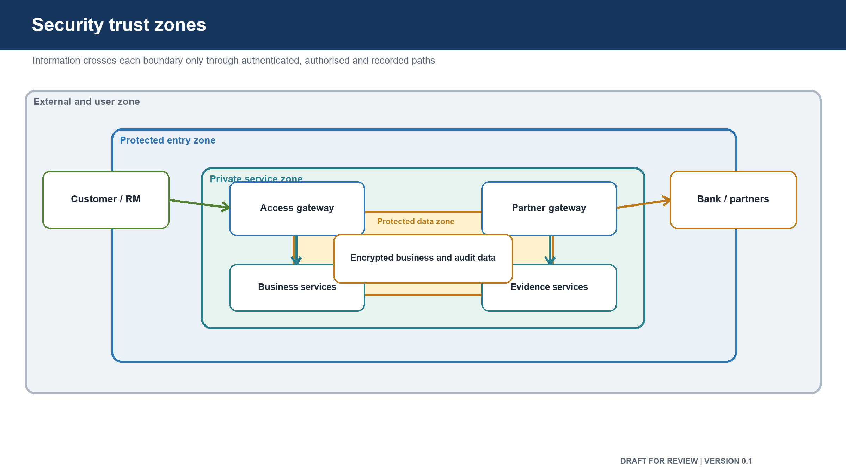
Figure: Security trust zones
The proposed design includes the required security structure, but it has not received Security or Compliance approval. Development affecting customer identity, access, personal data, consent, suitability, payment, partner credentials or audit evidence must not treat this draft as a signed security decision.

2. Information requiring protection
Information | Protection need
Customer identity and contact information | Restricted to approved staff and business purposes
Financial and income information | Strong access control, encryption and audit
Health and underwriting information | Highest restriction and minimum collection
Consent and suitability evidence | Cannot be changed after issue; full history retained
Proposal and policy documents | Encrypted, access recorded and shared only for the journey
Payment references and reconciliation records | Protected from alteration and duplicate processing
Staff identity, role and certification | Server-verified; never trusted from device input
Partner credentials and encryption keys | Kept in secure managed stores with rotation and emergency removal
Audit records | Append-only and protected from update or deletion

3. Access control review
Control | Proposed design | Review state
Staff sign-in | Bank workforce identity confirms the user | Pending confirmation
Device credentials | Long-lived access credentials are not stored in the Relationship Manager application | Pending confirmation
Permission checks | Role, branch, hierarchy, insurer access, assignment and certification are checked | Pending confirmation
Default action | Access is denied unless an explicit permission is returned | Pending confirmation
Double checking | The entry gateway and the owning business service both check access | Pending confirmation
Customer confirmation | One-time password confirms consent; payment service confirms the paying customer | Pending decision for broader self-service
Service identity | Each service receives a distinct identity and only the access it needs | Pending confirmation
Privileged changes | High-risk access and bulk changes require a second approver | Pending confirmation
Revocation | Suspended users, expired certification and removed access take effect without a long cache delay | Pending confirmation

4. Data protection review
- All external and internal connections carrying protected data are encrypted.
- Stored personal, financial, health, proposal and policy data are encrypted.
- Encryption keys are separated from the stored data.
- Each business service uses its own database access.
- Production data stores are private and cannot be reached from the internet.
- Personal and sensitive information must not appear in application logs.
- Partner request and response bodies are not written to ordinary logs.
- Stored partner payloads and documents are encrypted and access is recorded.
- Backups, logs and archives remain in India.
- Retention and disposal are controlled by the approved data schedule.
- Audit, consent and suitability evidence cannot be changed after it is recorded.
- Lower environments use generated or masked information and never receive live customer data.

5. Customer-protection and compliance controls
Control | Required outcome | Status
Suitability | No quotation without a valid suitability result | Designed; Product and Compliance approval pending
Consent | No proposal without valid customer consent | Designed; Product and Compliance approval pending
Sales attribution | Staff and distributor identity are inserted by the server | Designed; Security review pending
Payment separation | Relationship Manager cannot enter or authorize customer payment | Designed; Security and Compliance review pending
Payment correctness | Charged amount must match the selected premium | Designed; Finance and Quality review pending
Policy sold status | Requires issuance, reconciliation and complete audit evidence | Designed; Product and Finance approval pending
Data location | Protected data, backups, logs and archives remain in India | Designed; Compliance confirmation pending
Evidence retention | Required evidence is retained and protected against alteration | Designed; retention period approval pending

6. Main security threats and planned protections
Threat | Possible impact | Planned protection | Remaining action
Stolen staff session | Unauthorized customer or policy access | Server-held session, short lifetime, device binding and revocation | Security review and test
Changed role or branch information from a device | Unauthorized sale or data access | Permissions resolved by the server | Negative access tests
Direct access to a business service | Bypass of entry checks | Private services, service identity and repeated access checks | Network and access test
Customer search abuse | Large-scale exposure of customer information | Rate limits, purpose checks, narrow results and audit | Product and Security review
Partner credential theft | Fraudulent partner calls attributed to the bank | Secure storage, rotation, fixed outbound route and emergency removal | Rotation exercise
Partner response manipulation | Incorrect quote, proposal or policy state | Encrypted connection, validation and translation at the boundary | Contract and tampering tests
Personal information in logs | Data exposure | Structured logging, field masking and automated log scan | Automated proof
Cross-service data access | Unauthorized changes and unclear ownership | Separate service identities and data stores | Access-policy test
Forged payment result | False payment or policy issuance | Authenticated callback, transaction matching and reconciliation | Payment security test
Payment on staff device | Customer-protection breach | No staff payment route; customer-only link and recorded channel | End-to-end negative test
Replayed request | Duplicate proposal or payment | Request key, stored result and duplicate-content check | Duplicate-request tests
Audit deletion or alteration | Loss of evidence | Insert-only access, locked archive and deletion-refusal test | Data and Security approval
One partner overload | Wider platform outage | Separate partner connection limits and isolation | Load and failure test
Harmful software dependency | Platform compromise | Dependency, source and application security scanning | Delivery pipeline evidence

7. Open security risks
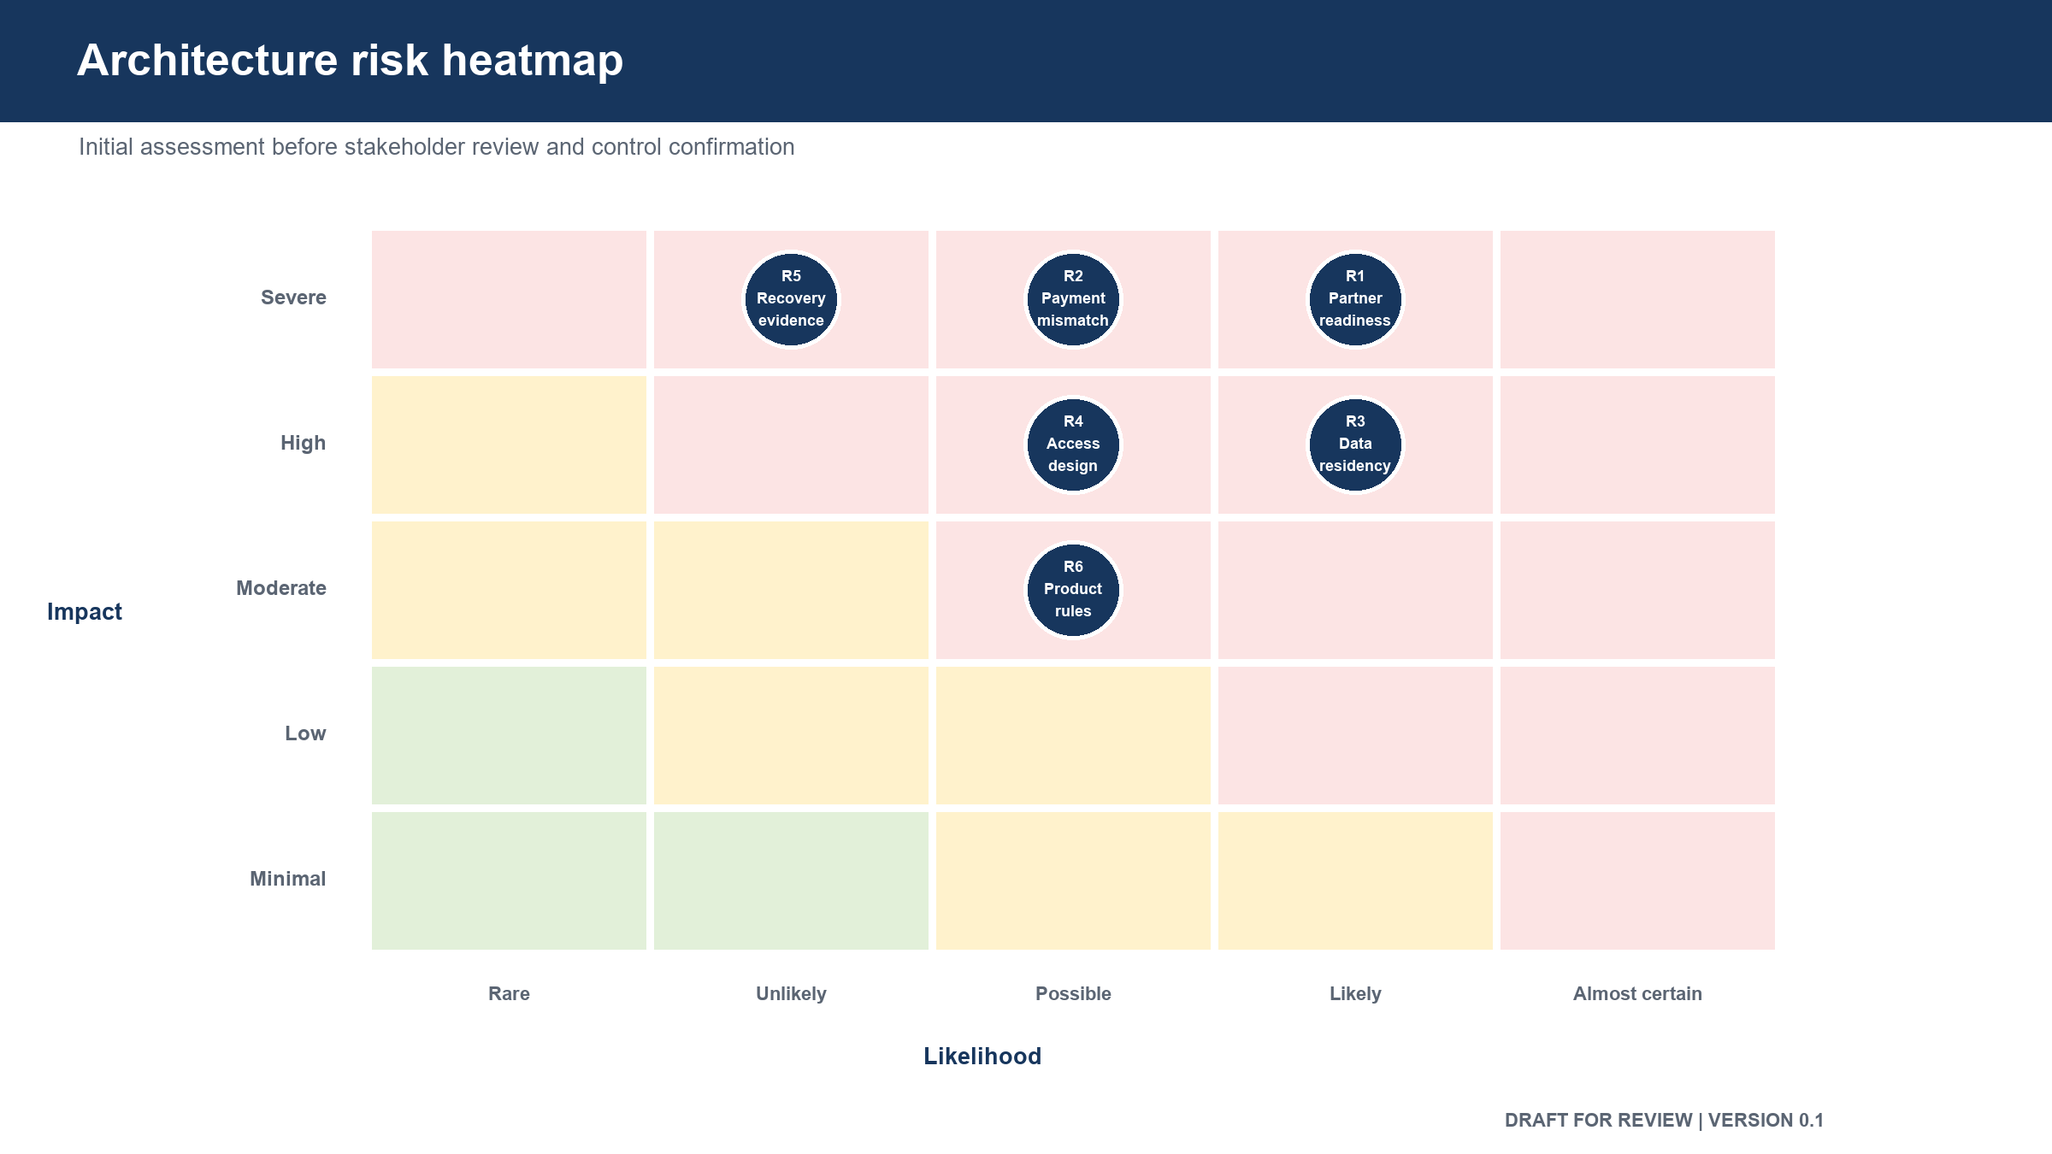
Figure: Initial architecture risk heatmap

ID | Open risk | Required decision or evidence | Owner
SEC-01 | Customer identity for self-service is not selected | Approve identity and recovery approach before self-service | Product, Security and Architecture
SEC-02 | Consent and suitability rule sets are not approved | Obtain Product and Compliance decisions | Product and Compliance
SEC-03 | Partner credential rotation is not proven | Complete a rotation and emergency-removal exercise | Security and Operations
SEC-04 | Prevention of personal data in logs is not proven | Run an automated full-journey log scan | Engineering, Security and Quality
SEC-05 | Payment callback protection is not proven | Execute forged, replayed and delayed callback tests | Security, Engineering and Quality
SEC-06 | Audit immutability is not proven | Attempt update and deletion and retain the evidence | Data, Security and Quality
SEC-07 | Final retention periods are not approved | Approve retention and disposal schedule | Compliance and Data
SEC-08 | Partner security and service limits are not confirmed | Complete partner assessment and operating agreement | Security, Operations and Product

8. Security review outcome
Item | Outcome
Architecture security input | Prepared
Security Head review | Pending
Compliance and Risk review | Pending
Human security sign-off | Pending
Permission to treat design as approved | No

Approval control: review comments and recommendations do not constitute approval. The decision remains Pending until the named human stakeholder records a decision, date and signature.

9. Review and sign-off
Stakeholder | Review responsibility | Decision | Name | Date | Comments
Security Head | Security outcome, risks and required controls | Pending
Compliance and Risk Head | Regulatory permissibility and evidence | Pending
Principal Architect | Structural response to security requirements | Pending
Product Owner | Legitimate purpose and customer behaviour | Pending
Data and Database Architect | Data protection, access and recovery | Pending
Engineering Head | Control implementation feasibility | Pending
Reliability and Operations Head | Runtime protection, monitoring and recovery | Pending
Quality Lead | Security test coverage and evidence | Pending

10. Version history
Version | Date | Change | Approval state
0.1 | 17 August 2026 | Initial pre-approval security review | Not approved

