AU Bank End-to-End Insurance Platform — Technical Risks, Dependencies and Assumptions
  - Architecture pre-approval document | AU Bank End-to-End Insurance Platform
DRAFT FOR REVIEW - NOT APPROVED - NOT AUTHORISED FOR DEVELOPMENT

Version | 0.1 | Date | 17 August 2026
Document owner | Mahesh, Principal Insurance Platform Architect | Approval state | Pending
Purpose | Make architecture risks, dependencies, assumptions and mitigation actions explicit before development | Next action | Stakeholder review and recorded decision

1. Technical risks
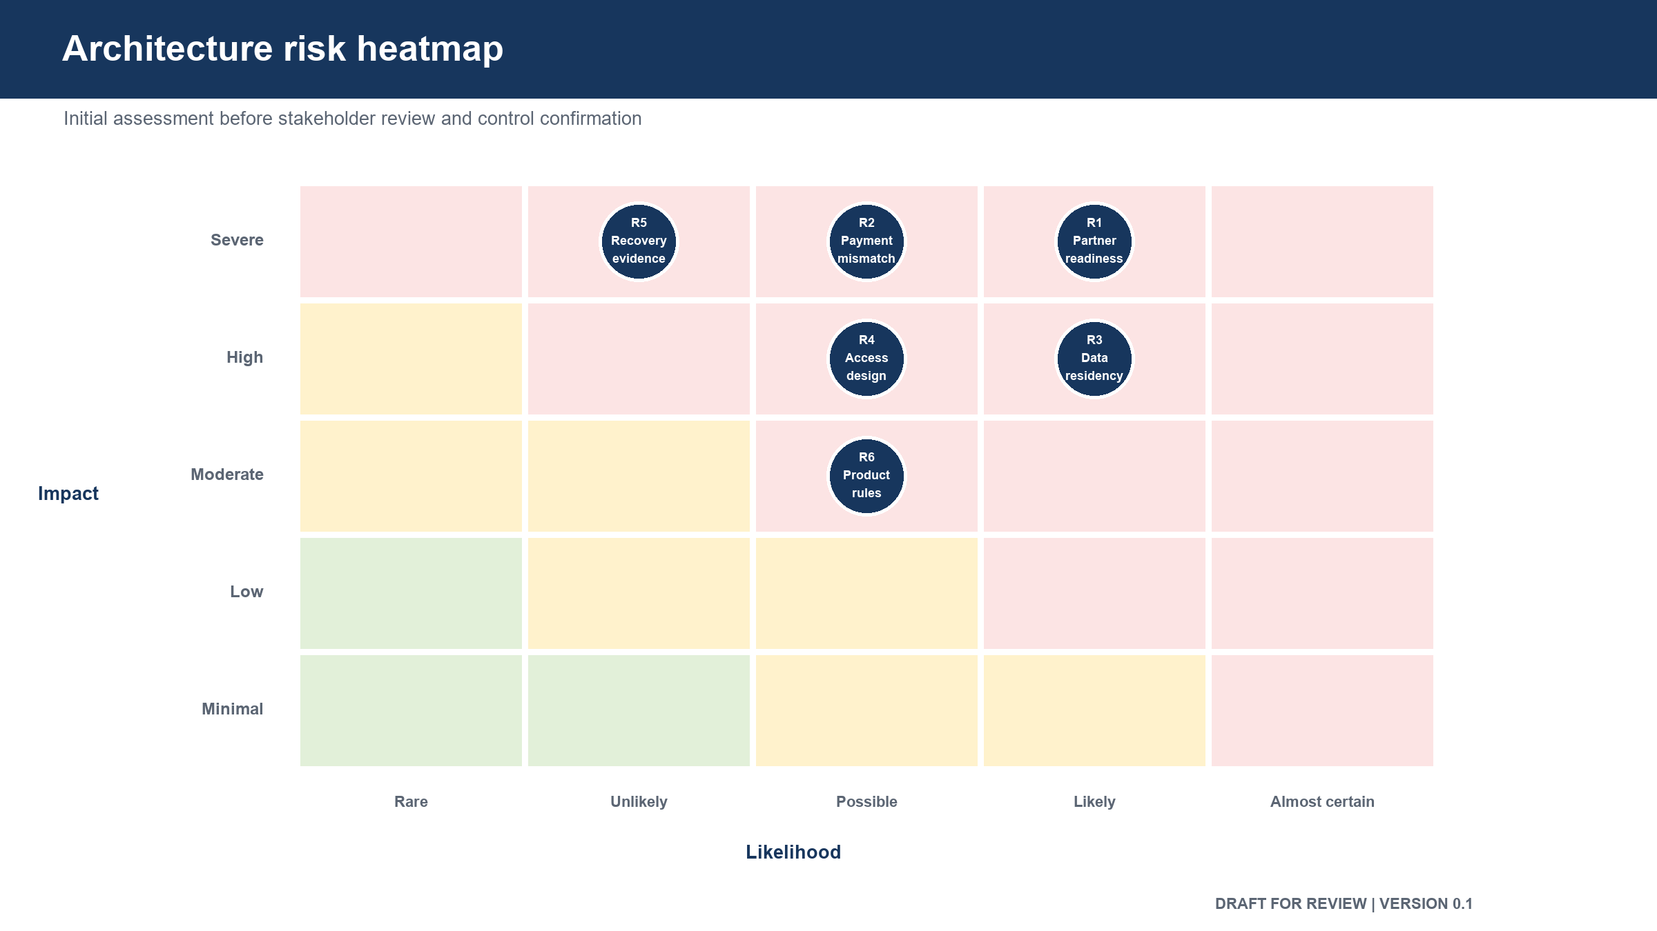
Figure: Initial architecture risk heatmap

ID | Risk | Likelihood | Impact | Mitigation action | Owner | Status
R-01 | Customer identity for self-service is not agreed | High | High | Keep first release assisted; approve the self-service identity approach before expansion | Product, Security and Architecture | Open
R-02 | Consent or suitability rules remain unresolved | High | Critical | Complete rule approval before building affected journey controls | Product and Compliance | Open
R-03 | Partner service limits and maintenance windows are unknown | Medium | High | Obtain written limits; configure safe request and connection limits | Product and Operations | Open
R-04 | Partner delays make the Relationship Manager journey unusable | Medium | High | Return an acknowledgement, track status, isolate partner capacity and support resume | Architecture and Operations | Open
R-05 | Duplicate proposal or payment requests create financial or customer harm | Medium | Critical | Require a request key, retain the first result and reject changed replays | Engineering and Quality | Open
R-06 | Payment result remains uncertain after a missing or delayed callback | Medium | Critical | Match settlement information, create an exception task and never assume success | Finance, Operations and Engineering | Open
R-07 | Policy is reported as sold before issuance or reconciliation | Medium | Critical | Require issuance, payment reconciliation and audit completeness before completion | Product, Finance and Architecture | Open
R-08 | Personal or health information appears in logs | Medium | Critical | Block body logging, mask protected fields and run automated log scans | Security, Engineering and Quality | Open
R-09 | Audit evidence can be changed or deleted | Low | Critical | Use insert-only access, locked storage and deletion-refusal tests | Data, Security and Quality | Open
R-10 | Too many independently deployed components create delivery and support burden | Medium | High | Combine components unless ownership, scale or failure isolation proves a need | Architecture, Engineering and Operations | Open
R-11 | A shared database weakens ownership and increases change risk | Medium | High | Give each business area controlled data ownership; prohibit direct cross-area access | Architecture and Data | Open
R-12 | Partner formats leak into the bank business model | Medium | High | Translate partner messages at the integration boundary and test replacement | Architecture and Engineering | Open
R-13 | Delivery begins before automated quality and security checks work | High | High | Make the build, test and security checks a development-entry condition | Engineering, Security and Quality | Open
R-14 | Backup exists but cannot be restored within the business need | Medium | Critical | Perform and time restore and regional recovery exercises | Data and Operations | Open
R-15 | Platform capacity is increased without checking database or partner limits | Medium | High | Base capacity changes on business load, measured bottleneck and downstream limits | Operations, Data and Architecture | Open
R-16 | Retention or data-location rules are implemented incorrectly | Medium | Critical | Approve the data schedule and automatically verify storage location and disposal | Compliance, Data and Security | Open
R-17 | Core banking, payment or insurer access is delayed | High | High | Name owners, required dates, test alternatives and delivery impact | Delivery and external system owners | Open
R-18 | Rules change without version history | Medium | High | Publish approved rule versions with effective dates and preserve prior versions | Product, Compliance and Administration | Open

2. Dependencies
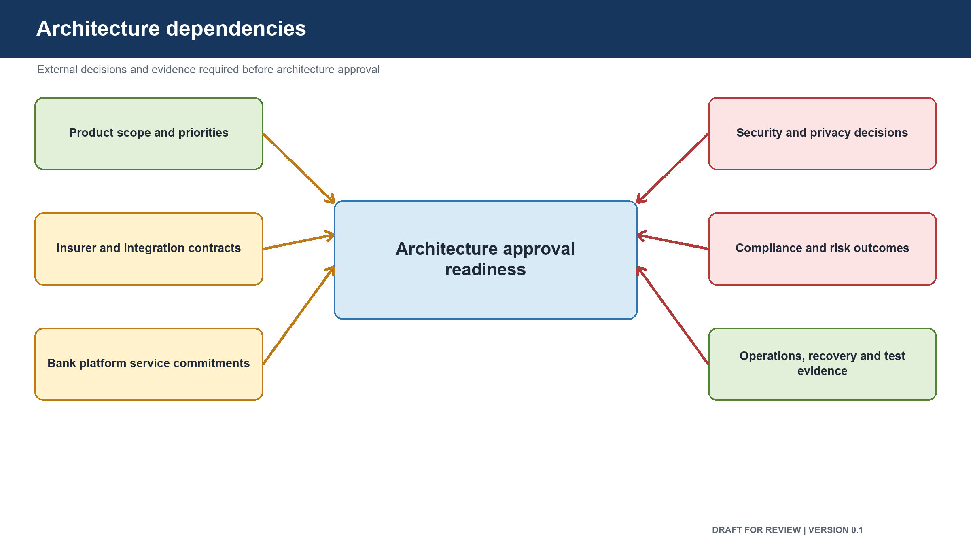
Figure: Architecture dependencies

ID | Dependency | Needed for | Provider or owner | Required evidence | State
D-01 | Product vision and first release scope approval | All architecture decisions | Product Owner and Chief Technology Officer | Signed scope and outcome | Pending
D-02 | Consent rule approval | Consent and proposal controls | Product and Compliance | Signed rule set | Pending
D-03 | Suitability rule approval | Suitability and quotation controls | Product and Compliance | Signed rule set | Pending
D-04 | First product and insurer matrix | Catalogue, suitability, quote and proposal | Product | Approved product matrix | Pending
D-05 | Workforce identity and permission service | Relationship Manager access | Security and Identity team | Agreed interface and test environment | Pending
D-06 | Core banking customer service | Existing-customer lookup | Core banking owner | Interface, access and test data | Pending
D-07 | Insurance provider access | Quote, proposal and policy | Partner owner | Contract, credentials, limits and sandbox | Pending
D-08 | Payment service access | Customer payment and reconciliation | Payments and Finance | Contract, callback protection and settlement format | Pending
D-09 | Messaging service | Consent and payment messages | Messaging owner | Contract, sender approval and test account | Pending
D-10 | India-based environments | Development, testing and production | Technology Operations | Environment and network readiness | Pending
D-11 | Secure key and secret service | All protected connections | Security and Operations | Access, rotation and recovery procedure | Pending
D-12 | Automated build and test service | Safe development and evidence | Engineering, Security and Quality | Green run and demonstrated failure blocking | Pending
D-13 | Data classification and retention schedule | Storage, backup, archive and disposal | Compliance, Data and Security | Approved schedule | Pending
D-14 | Test data and partner test accounts | End-to-end testing | Quality and partner owners | Generated data and active accounts | Pending
D-15 | Operations ownership and support process | Failure and manual recovery | Reliability and Operations | Work queue, support contacts and response targets | Pending

3. Assumptions
ID | Assumption | Impact if false | Validation owner | State
A-01 | The first release is one assisted Term Life sale for an existing bank customer | Scope and component sequence change | Product Owner | Unconfirmed
A-02 | One selected insurer is sufficient to prove the first journey | Partner routing scope increases | Product Owner | Unconfirmed
A-03 | The customer can receive a one-time password and payment link on a personal device | Consent and payment design changes | Product and Operations | Unconfirmed
A-04 | The bank payment service supplies authenticated callbacks and settlement information | Payment recovery design changes | Payments and Security | Unconfirmed
A-05 | The integration provider supports request tracking after an uncertain submission | Duplicate and recovery risk increases | Partner owner | Unconfirmed
A-06 | Protected platform data can be hosted and recovered entirely within India | Hosting and recovery design changes | Compliance and Operations | Unconfirmed
A-07 | Initial transaction volume is modest and correctness is a greater risk than throughput | Initial capacity and cost change | Product and Operations | Unconfirmed
A-08 | Staff identity includes branch, role, insurer access and certification status | Permission model needs another information source | Security and Product | Unconfirmed
A-09 | Consent, suitability and audit evidence require long-term retention and protection from alteration | Storage and cost design changes | Compliance and Data | Unconfirmed
A-10 | The bank accepts a phased platform rather than every insurance line and journey at launch | Programme scope and funding change | Chief Technology Officer and Product Owner | Unconfirmed

4. Required mitigation decisions
Decision | Decision owner | Current state
Approve the first release boundary | Product Owner and Chief Technology Officer | Pending
Approve consent and suitability rules | Product Owner and Compliance Head | Pending
Approve customer identity direction | Product Owner, Security Head and Principal Architect | Pending
Approve payment and reconciliation ownership | Product Owner and Finance | Pending
Approve data classification, location and retention | Compliance, Security and Data | Pending
Approve component grouping and partner boundary | Principal Architect and Engineering Head | Pending
Approve recovery targets and operating model | Reliability Head, Data Architect and Principal Architect | Pending
Approve security controls and residual risk | Security Head and accountable human risk owner | Pending

Approval control: review comments and recommendations do not constitute approval. The decision remains Pending until the named human stakeholder records a decision, date and signature.

5. Review and sign-off
Stakeholder | Review responsibility | Decision | Name | Date | Comments
Principal Architect | Technical risk and architecture mitigation | Pending
Product Owner | Scope, business assumptions and customer impact | Pending
Chief Technology Officer | Strategic dependencies and technical risk appetite | Pending
Engineering Head | Build and delivery risk | Pending
Security Head | Security risk and mitigations | Pending
Data and Database Architect | Data integrity, capacity and recovery risk | Pending
Compliance and Risk Head | Regulatory assumptions and risk | Pending
Reliability and Operations Head | External limits, recovery and support risk | Pending
Quality Lead | Test and evidence risk | Pending
Delivery Head | Dependency ownership and delivery impact | Pending

6. Version history
Version | Date | Change | Approval state
0.1 | 17 August 2026 | Initial pre-approval register | Not approved

